Algorithm2: Particle Swarm Optimization,PSO

Input : Road model(或者叫 车手道路混合模型之类的),particle number N,iteration number T,dimension D

//Object Fuction:

Output:Optimal particle (position) gBest

For i= 0 to N − 1 do

For d= 0 to D − 1 do

Initialize velocity Vid randomly within permissible range

Initialize velocity Xid randomly within permissible range

//Initialize velocity Vi and position Xi for particle i

//Calculate fitness value for particle i based on Mroad and set pBesti=Xi

End for

End for

gBest=min{ pBesti}

Iteration k=1

Do

For i= 0 to N − 1 do

Calculate fitness value for particle i based on Mroad

If the fitness value fit is better than pBesti in history

Set current fitness as the pBesti

End if

If the fitness value fit is better than gBest

Set current fitness as the gBest

End if

End for

For i= 0 to N − 1 do

Calculate fitness value for particle i based on Mroad

If the fitness value fit is better than pBesti in history

Set current fitness as the pBesti

End if

If the fitness value fit is better than gBest

Set current fitness as the gBest

End if

End for

For i= 0 to N − 1 do

For d= 0 to D − 1 do

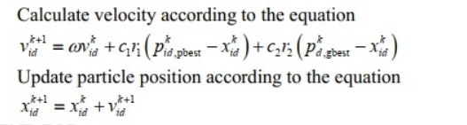End for

End for

K=k+1

WHILE maximum iteration or minimum error criteria are not attained