Amazon Prime Content Analysis Dashboard

Capstone Project: Data Visualization Tools
Name: Husnain Khan
Tool Used: Microsoft Power BI
Dataset Used: Amazon Prime TV Shows and Movies Dataset

1 Project overview :
This project aims to transform exploratory data analysis into an interactive business dashboard using Microsoft Power BI. The objective is to analyze Amazon Prime content data and present meaningful insights through visual storytelling, KPIs, and interactive filters.
2 Dataset Description :
The dataset contains information about movies and TV shows available on Amazon Prime. It includes details such as title type (Movie/Show), release year, genre, IMDb rating, and other metadata.
The dataset was previously cleaned and structured during the Exploratory Data Analysis (EDA) project to ensure it is ready for visualization.

3 Dashboard Objective :
The main objective of this dashboard is to:

• Analyze the distribution of Movies vs TV Shows
• Understand content growth over the years
• Identify top genres by content count
• Analyze IMDb rating distribution
• Enable user interaction using filters and slicers

The dashboard is designed to provide clear, interactive, and business-focused insights.

4 Dashboard Visuals and insights :

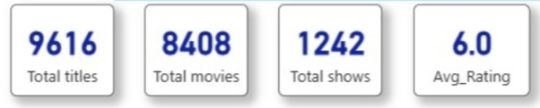
4.1 KPI Cards (Total Titles, Total Movies, Total Shows, Average Rating) :

- Why this visual was chosen:

KPI cards are used to provide a quick summary of the most important metrics in the dataset. They help users immediately understand the overall scale of content available on Amazon Prime.

- Insight conveyed:
The dashboard shows the total number of titles, total movies, total TV shows, and the average IMDb rating. This helps in understanding the content volume and overall quality level.

- Business impact:

These KPIs allow decision-makers to quickly evaluate platform content strength, compare movie vs show distribution, and assess average audience satisfaction levels.

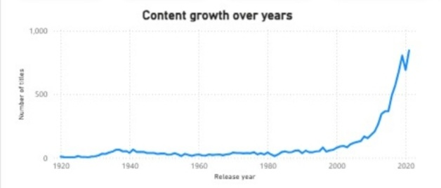
4.2 Line Chart – Content Growth Over Years

- Why this visual was chosen:

A line chart is ideal for showing trends over time. It clearly represents how content has grown across different years.

Insight conveyed:

The chart highlights a significant increase in content production in recent years, especially after 2000. This indicates aggressive expansion in content acquisition or production.

Business impact:

Understanding content growth trends helps management evaluate expansion strategies and plan future content investments.

4.3 Bar Chart – Top Genres by Content Count
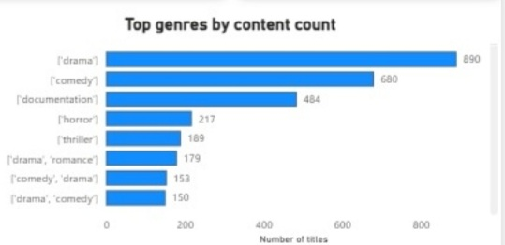

- Why this visual was chosen:

Bar charts are effective for comparing categories. It allows easy comparison between different genres.

- Insight conveyed:

The chart identifies the most dominant genres on the platform, helping understand viewer content focus areas.

- Business impact:

This insight supports strategic content acquisition decisions by focusing on high-demand genres.

4.4 IMDb Rating Distribution

- Why this visual was chosen:
A histogram is useful for understanding the distribution of numerical values. It helps analyze how IMDb ratings are spread across different ranges.

- Insight conveyed:
Most content falls within the mid-range ratings (around 5 to 7). Very high-rated and very low-rated content is comparatively less.

- Business impact:
This insight helps evaluate overall content quality. It also indicates whether the platform should invest more in high-quality, critically acclaimed content.

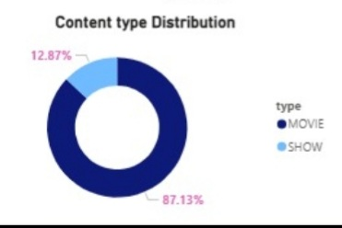
4.5 Donut Chart – Content Type Distribution

- Why this visual was chosen:

A donut chart clearly shows proportional distribution between categories. It is ideal for showing the percentage split between Movies and TV Shows.

- Insight conveyed:

The dashboard shows that Movies form a larger percentage of the total content compared to TV Shows.

- Business impact:

This insight helps management understand content composition and decide whether to balance investments between movies and shows.

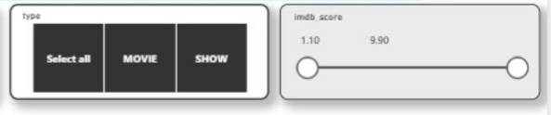
4.6 Interactive Filters (Type and IMDb Rating Slicers)

- Why this visual was chosen:

Interactive slicers allow users to dynamically filter and explore the dashboard. This improves usability and user engagement.

- Insight conveyed:

Users can filter content by type (Movie/Show) and IMDb rating range to perform focused analysis.

- Business impact:

Interactive dashboards enable decision-makers to quickly analyze specific segments without needing separate reports, improving data-driven decision-making efficiency.

5 Dashboard screenshots :

Figure 1: Default Dashboard View (No Filters Applied)

This figure shows the complete dashboard in its default state without applying any filters.
It presents overall KPIs, content growth trends, genre distribution, rating distribution, and content type composition. This view provides a comprehensive summary of the entire dataset.
This baseline view helps decision-makers understand the overall structure and performance before applying any filters.
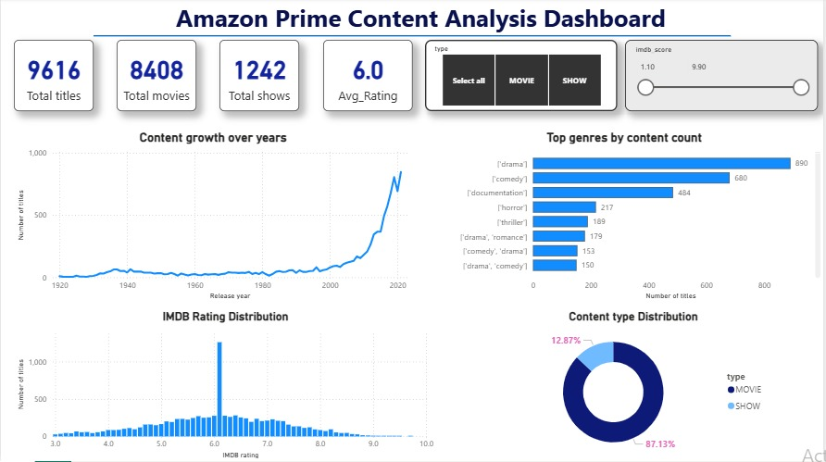

Figure 2: Dashboard with Movie Filter Applied
This figure shows the dashboard after applying the "Movie" filter from the content type slicer.
All visuals dynamically update to reflect only movie-related data. KPIs, genre distribution, and rating analysis adjust accordingly.

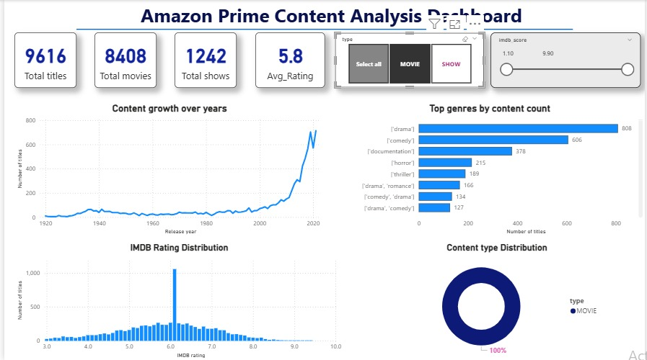

This shows that number of Movies are high but the average rating of movies are lower than overall average ratings

Figure 3: Dashboard with TV Show Filter Applied

This figure represents the dashboard view after selecting the "TV Show" filter.

The visuals update to display only TV show data, allowing comparison between Movies and Shows. This helps identify differences in content volume, genre dominance, and rating trends.

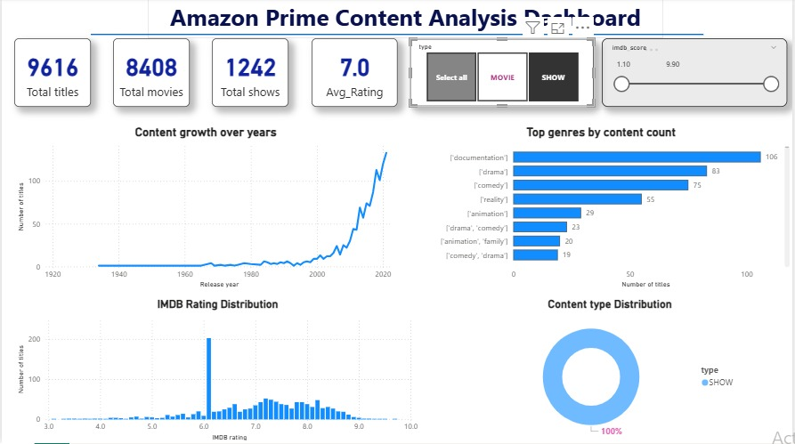

This shows that although the number of TV shows are less , but the average rating is more than overall average .

Figure 4: Dashboard with IMDb Rating Range Filter Applied

This figure shows the dashboard after applying an IMDb rating range filter.
The dashboard now displays content within a selected rating range, helping analyze high-rated or low-rated segments separately.
This feature allows management to evaluate quality-focused content strategies.
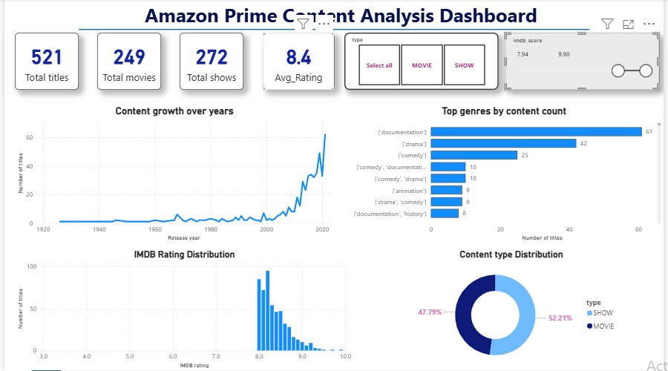

This shows that as we see from imdb score , higher score has fewer titles , and among these the share of TV shows are high , it js clearly visible in the donut chart of content type distribution.

Figure 5: Dashboard with Multiple Filters Applied

This figure demonstrates the dashboard with combined filters (Content Type and IMDb Rating).
All visuals update simultaneously, showcasing the interactive capability of the dashboard. This allows users to perform advanced segmented analysis.
Such interactivity enhances decision-making efficiency and makes the dashboard business-ready.

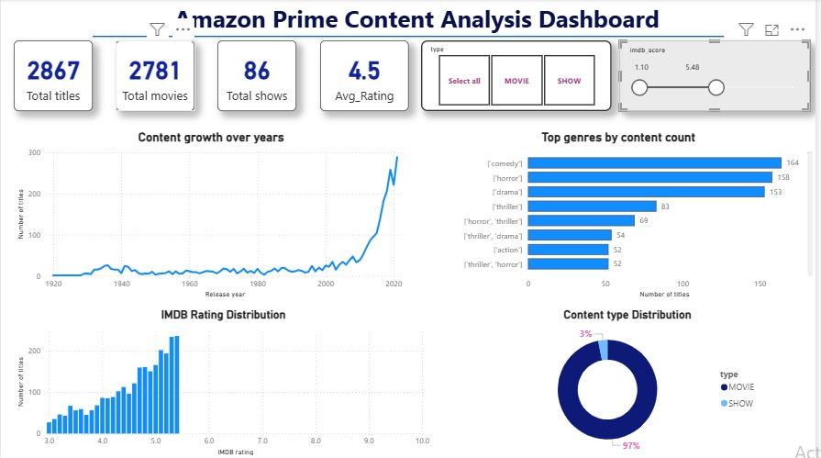

6 Key Insights :

• Amazon Prime has a significantly larger number of Movies compared to TV Shows.
• Content production and addition increased rapidly after the year 2000, showing platform expansion.
• Certain genres dominate the platform, indicating viewer demand patterns.
• Most content falls within mid-range IMDb ratings, suggesting average overall content quality.
• Interactive filtering allows deeper analysis of specific segments such as high-rated movies or only TV shows.

7 Business Impact Summary :

The dashboard enables data-driven decision-making by providing a clear overview of content distribution, quality, and growth trends.

It helps management:
• Evaluate content investment strategies
• Identify dominant genres
• Understand audience satisfaction through ratings
• Monitor content growth patterns
• Perform dynamic analysis using filters

Overall, this interactive dashboard supports strategic planning and content optimization decisions.

8 Project Links :

Dashboard Link:
(To be added after publishing Power BI report)

Video Presentation Link:
(To be added after uploading the recorded video)

