Name : M. Husnain Afzal
Reg : 2025-546
Sec : CS-H2

Task-01
Code:
// --- Task:01 ---
bool enqueue(std::string data)
{
// First we check if there is size to add a new node or not ?
if (size >= capacity)
{
std::cout << "ERROR: Can not enqueue while size is full\n";
return false;
}
Node *entry = new Node;
entry->data = data;
// Check if this is the first entry
if (this->front == nullptr)
{
this->front = entry;
this->rear = entry;
size++;
return true;
}
// else add a new node in the list
entry->prev = this->rear;

// Update the pointer of the rear to this new entry
this->rear->next = entry;
this->rear = entry;

// Update the size
this->size++;
// Finally return success
return true;
}

Demo-Code-Task-01:
Queue q(3);

q.enqueue("Hello");
q.enqueue("Data");
q.enqueue("Structures");
q.enqueue("Overflow"); // fails: capacity is 3

Output
Output of Task-01:
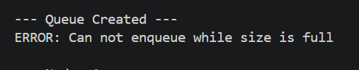

Task-02
Code:
// --- Task:02 ---
bool dequeue()
{
// First check if a node exists in the list or not
if (size <= 0)
{
std::cout << "ERROR: Can not dequeue on a empty queue\n";
return false;
}
// Else first save the pointer to the next node, then delete the old head
Node *new_front = this->front->next;
delete this->front;

// Update members
this->front = new_front;
if (this->front)
this->front->prev = nullptr;
else
this->rear = nullptr; // Queue is empty
this->size--;

// Return success
return true;
}
Demo-Code-Task-02:
q.display();
q.dequeue(); // removes "Hello"
q.display();

Output
Output of Task-02:
On 1st display there were 3 nodes, then dequeue was called and display showed only 2 nodes afterwards.
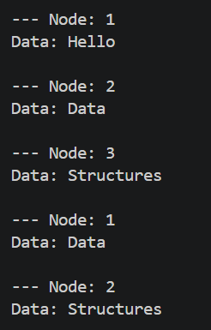

Task-03
Code:
// --- Task:03 ---
void display()
{
// Initial Check
if (size <= 0)
return;

// Make a pointer that will traverse the list
Node *traversing_ptr = this->front;
int count = 0;
while (traversing_ptr)
{
// Print data
std::cout << "\n--- Node: " << ++count << std::endl;
std::cout << "Data: " << traversing_ptr->data << std::endl;
// Update the pointer
traversing_ptr = traversing_ptr->next;
}
return;
}
Demo-Code-Task-03:
q.display();
q.dequeue(); // removes "Hello"
q.display();

Output
Output of Task-03:
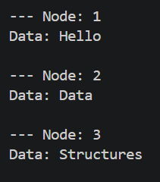

Task-04
Code:
// --- Task:04 ---
int length_of_string()
{
Node *traversing_ptr = this->front;
int count = 0;
int char_count = 0;
// Traverse the front
while (traversing_ptr)
{
// Print data
std::cout << "\nNode: " << ++count << std::endl;
std::cout << "Data: " << traversing_ptr->data << std::endl;
std::cout << "No-of-characters: " << traversing_ptr->data.size() << std::endl;
// Update count and move pointer forward
char_count += traversing_ptr->data.size();
traversing_ptr = traversing_ptr->next;
// delete the current front
this->dequeue();
}
std::cout << "\n --- The total characters in " << count << " Nodes are " << char_count << std::endl;
return char_count;
}
Demo-Code-Task-04:
int total = q.length_of_string(); // prints each node, dequeues all
cout << "Total characters: " << total << endl; // 4 + 10 = 14

Output
Output of Task:04:
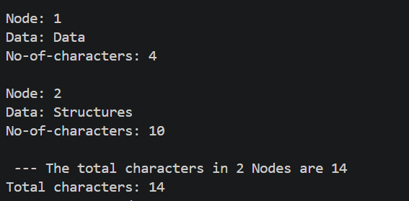
NOTE: The code file with the tasks and the main function which was used to generate these outputs is also attached.

