Name : M. Husnain Afzal
Reg: 2025-546
Sec: CS-H2

Task-01
Code:
// --- Task-01 ---
int countNodes(Node *head)
{
int count = 0;
Node *traversing_ptr = head;
// Loop through each node, until the last one, and add to count in all.
while (traversing_ptr != nullptr)
{
count++;
traversing_ptr = traversing_ptr->next;
}
return count;
}

After making 4 individual Node objects and linking them together, the function show the following result.
Output:
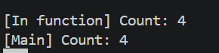
Task-02
Code:
// --- Task-02 ---
bool isListEmpty(Node *head)
{
return head == nullptr;
}

Again, as in the code file attached after making and linking 4 individual Node objects.
Output:
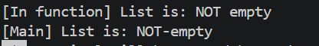

Task-03
Code:
// --- Task-03 ---
void delete_value(Node *&head, int value)
{
// if linked list is empty
if (head == nullptr)
return;
// if value is at head
if (head->data == value)
{
Node *temp = head;
head = head->next;
delete temp;
return;
}
// General case: delete middle or last node
Node *last_node = nullptr;
Node *traversing_node = head;
while (traversing_node != nullptr)
{
if (traversing_node->data == value)
break;

last_node = traversing_node;
traversing_node = traversing_node->next;
}
// Value not found
if (traversing_node == nullptr)
return;
// Unlink and delete
last_node->next = traversing_node->next;
delete traversing_node;
}

Output:
After we have linked 4 nodes, I will delete the 3rd one and show the output, by using the count nodes function to show that, this function works.
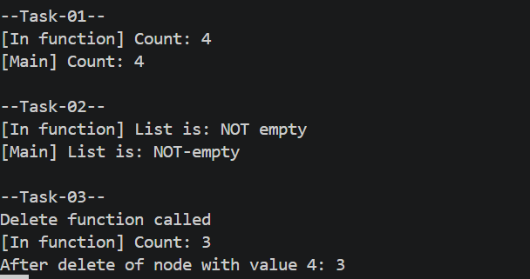

NOTE:
The code file with the tasks and the main function which was used to generate these outputs are also attached.

