Name : M. Husnain Afzal
Reg: 2025-546
Sec: CS-H2

Task-01 (I)
Code:
// --- Task-01 [ I ] ---
void push_back(const int &value)
{
// If empty, just push_front
if (head == nullptr)
{
push_front(value);
return;
}
// Else move to the last node
Node *traversing_ptr = head;
while (traversing_ptr->next != nullptr)
{
traversing_ptr = traversing_ptr->next;
}

Node *temp = new Node;
// Update poiters of both node-updated. Last and old-Last.
temp->value = value;
temp->prev = traversing_ptr;
traversing_ptr->next = temp;

size++;
}
Task-01 (II)
Code:
// --- Task-01 [ I I ] ---
// TASK:1 (ii) Print all nodes.
void print_all()
{
if (head == nullptr)
return;

Node *traversing_ptr = head;
int count = 0;
std::cout << "\n\n---------------------------------\n";
std::cout << "--- ALL NODES PRINTED ---\n\n";
while (traversing_ptr != nullptr)
{
cout << "[Node: " << ++count << " ]\n";
cout << "Value: " << traversing_ptr->value << std::endl;
cout << "Node's Address: " << traversing_ptr << std::endl;
cout << "Prev Node: " << traversing_ptr->prev << std::endl;
cout << "Next Node: " << traversing_ptr->next << std::endl
<< std::endl;

// Move the pointer to the next node
traversing_ptr = traversing_ptr->next;
}
return;
}

Task-01 (III)
Code:
// --- Task-01 [ I I I ] ---
// TASK:1 (iii) Delete node with value 'value'
bool delete_node(const int &value, Node *start_from = nullptr)
{
// 1. If list is empty
if (head == nullptr)
return false;

// 2. If value is somewhere in between the list
Node *traversing_ptr = (start_from != nullptr) ? start_from : head;

while (traversing_ptr != nullptr)
{
if (traversing_ptr->value == value)
break;
traversing_ptr = traversing_ptr->next;
}
// 3. If we reached the end without finding the value node
if (traversing_ptr == nullptr)
return false;

// 4. Found the node to delete, unlink it.
unlink(traversing_ptr);
return true;
}

Demo-Code-Task-01:
// EXERCISE 1: add / delete / display
cout << "\n---- EXERCISE 1 ----\n";
Doubly list;
list.push_back(10);
list.push_back(20);
list.push_back(30);
list.push_back(40);
cout << "After push_back 10, 20, 30, 40:\n";
list.print_values();

list.delete_node(20);
cout << "\nAfter delete_node(20):\n";
list.print_values();

cout << "\nprint_all():";
list.print_all();

Output:
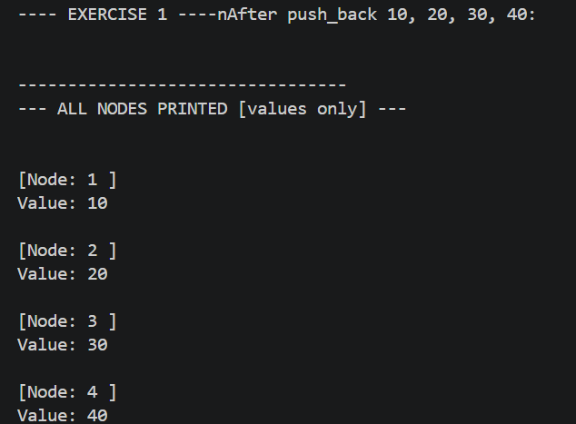
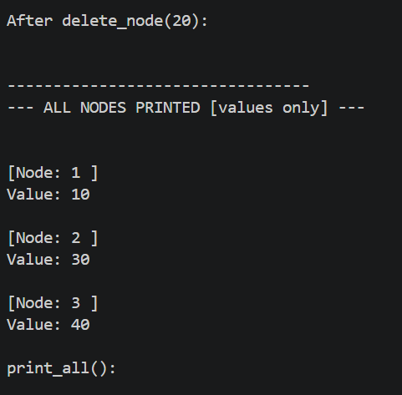
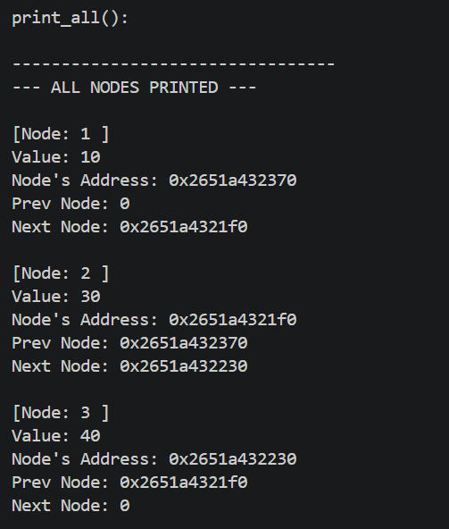

Task-02
Code:
// TASK:2 Check palindromes using the prev pointer in doubly
bool is_palindrome()
{
// CHECK:0
if (head == nullptr)
return true;
Node *front = head;
Node *back = head;
// First we get the correct value/last node's address in 'back' ptr;
while (back->next != nullptr)
back = back->next;
// Now the iteration step
while (front != back && back->next != front)
{
// Value check
if (front->value != back->value)
return false;

// Move the pointers
front = front->next;
back = back->prev;
}
return true;
}

Demo-Code-Task-02:
// EXERCISE 2: palindrome check
cout << "\n---- EXERCISE 2 ----\n";

Doubly p1; // 1 2 3 4 5
for (int v : {1, 2, 3, 4, 5})
p1.push_back(v);
cout << "Original List:\n";
p1.print_values();
cout << (p1.is_palindrome() ? "Linked list is a palindrome.\n" : "Linked list is not a palindrome.\n");

Doubly p2; // 1 2 2 1
for (int v : {1, 2, 2, 1})
p2.push_back(v);
cout << "\nOriginal List:\n";
p2.print_values();
cout << (p2.is_palindrome() ? "Linked list is a palindrome.\n" : "Linked list is not a palindrome.\n");

Output:
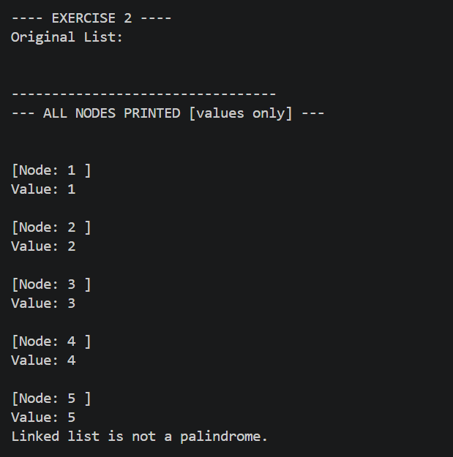
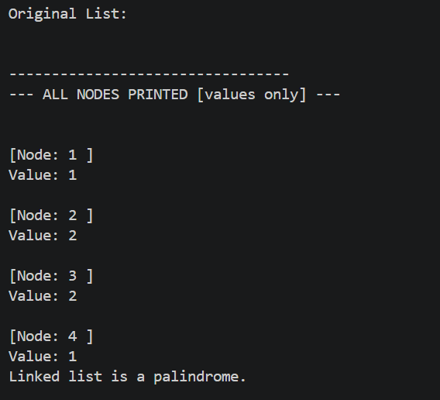

Task-03
Code:
// --- Task-03 ---
// TASK:3 Delete all occurances in the list
void remove_duplicates()
{
if (head == nullptr)
return;
// The outer loop/ The nodes movement, from 1st to 2nd etc
for (Node *current = head; current != nullptr; current = current->next)
{
Node *running = current->next;
// The inner loop/ Check for all duplicates and unlinks/deletes them.
while (running != nullptr)
{
Node *next = running->next; // save before a possible delete
if (running->value == current->value)
unlink(running);
running = next;
}}}

Demo-Code-Task-03:
// EXERCISE 3: remove duplicates
cout << "\n---- EXERCISE 3 ----\n";

Doubly d1; // 1 2 3 3 4
for (int v : {1, 2, 3, 3, 4})
d1.push_back(v);
cout << "Original List:\n";
d1.print_values();
d1.remove_duplicates();
cout << "After removing duplicate elements from the said doubly list:\n";
d1.print_values();

Output:
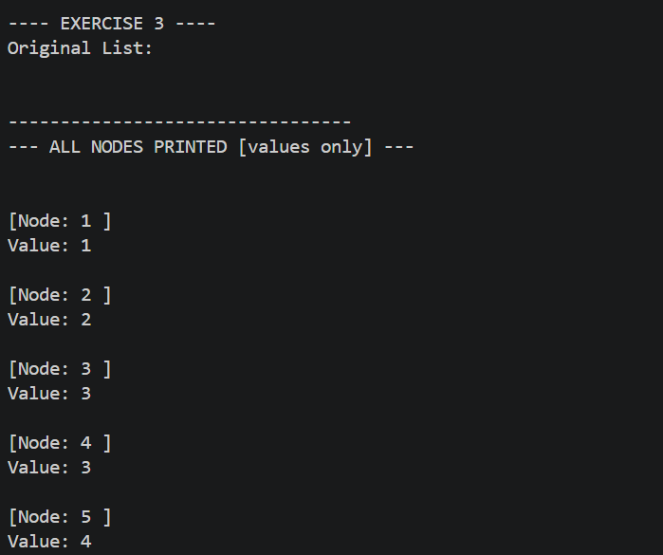

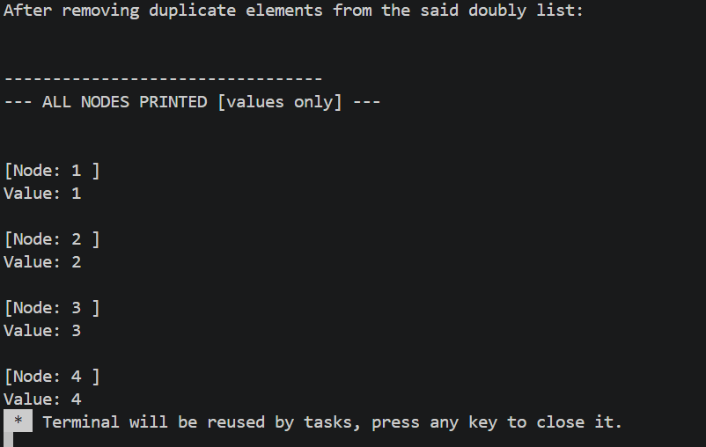

NOTE:
The code file with the tasks and the main function which was used to generate these outputs are also attached.

