

HAMARAY BACHCHEY

WEBSITE WITH REPORT



December 21, 2021

**MEMBER NAME AND IDS**

* **MALIK AFRASAYAB AFZAL I190627**
* **HUSNAIN ZAHID I192193**
* **MUHAMMAD HASSAN RANA I190511**

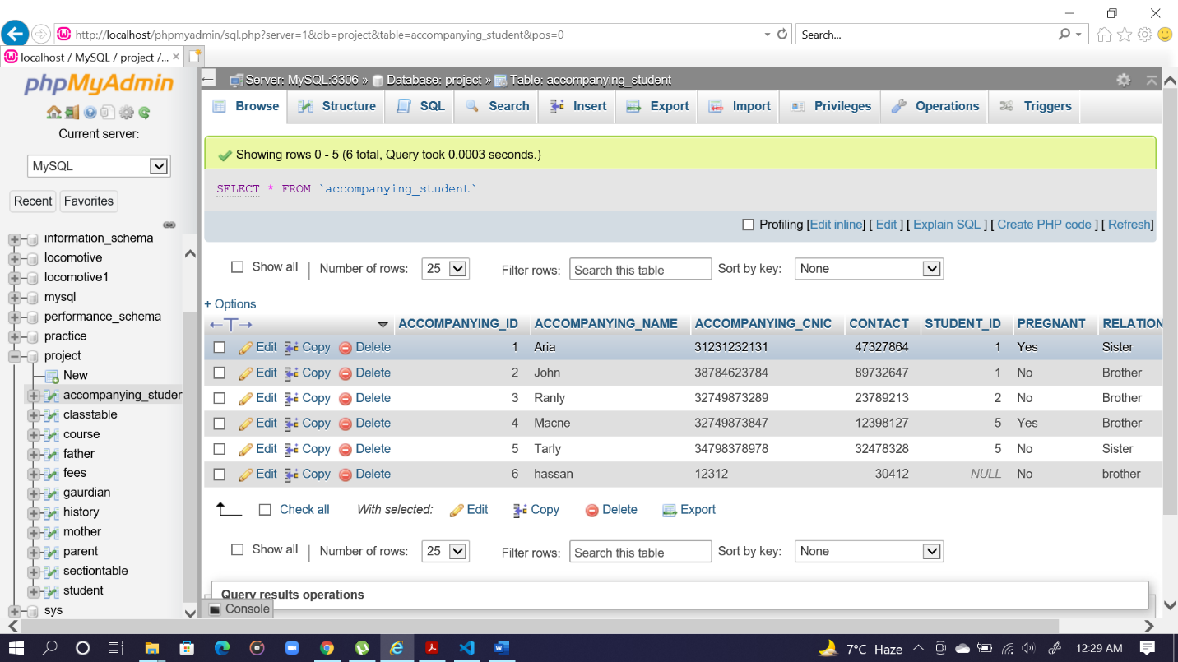**DATA IN TABLES**

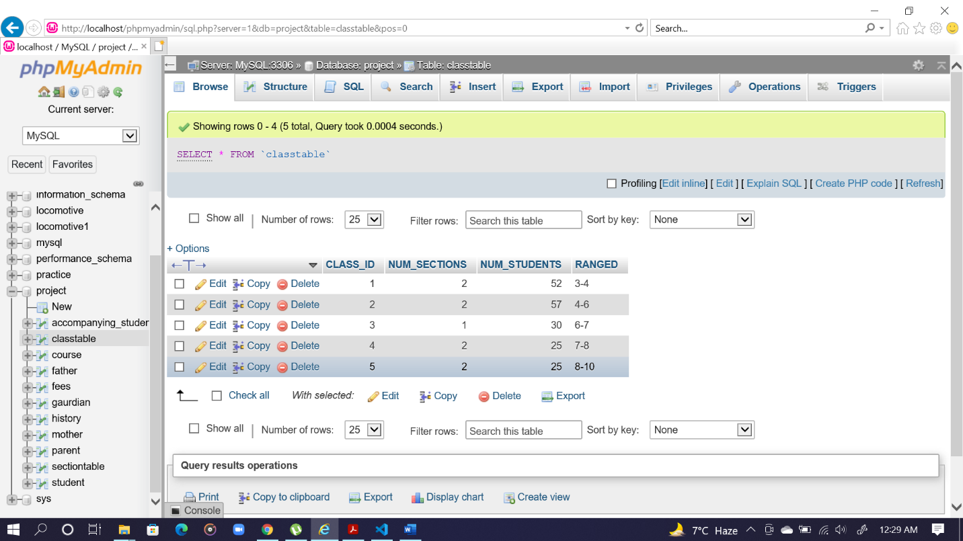

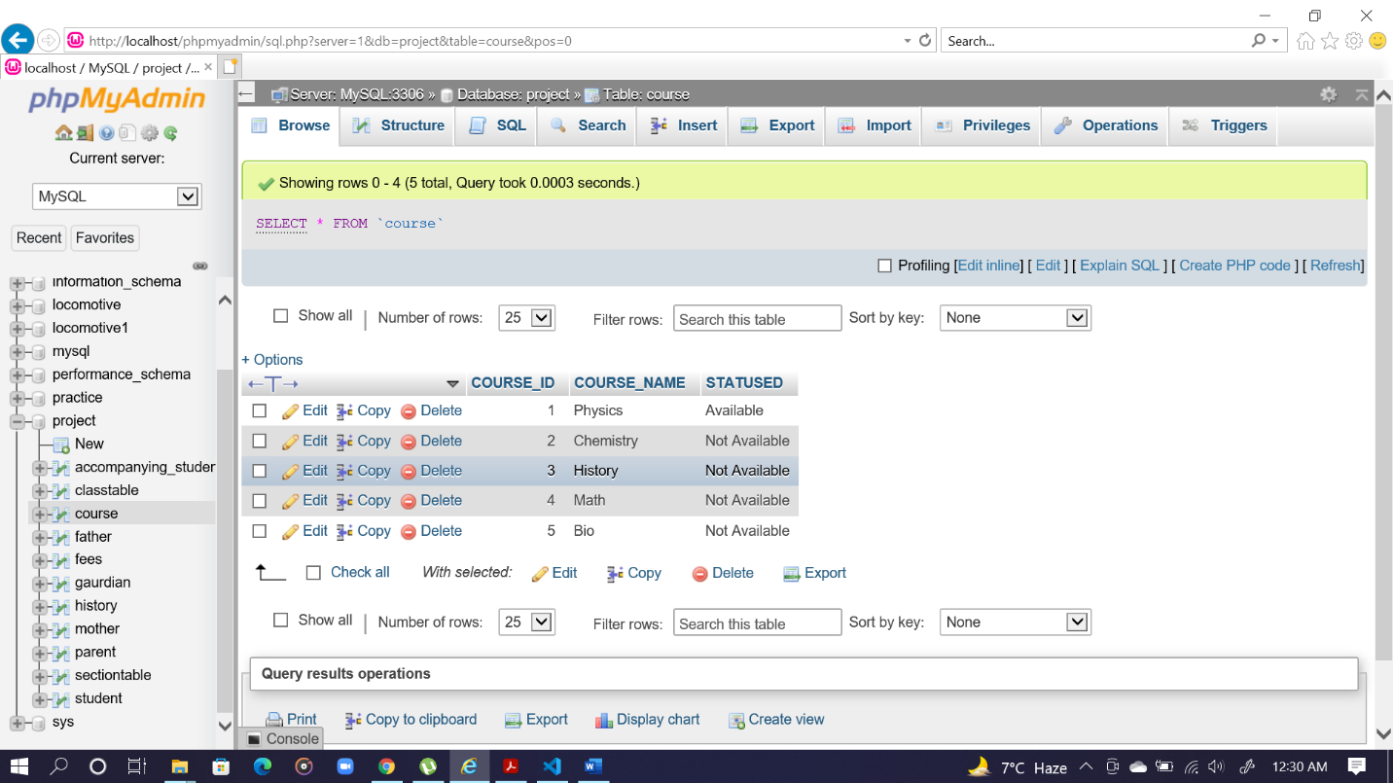

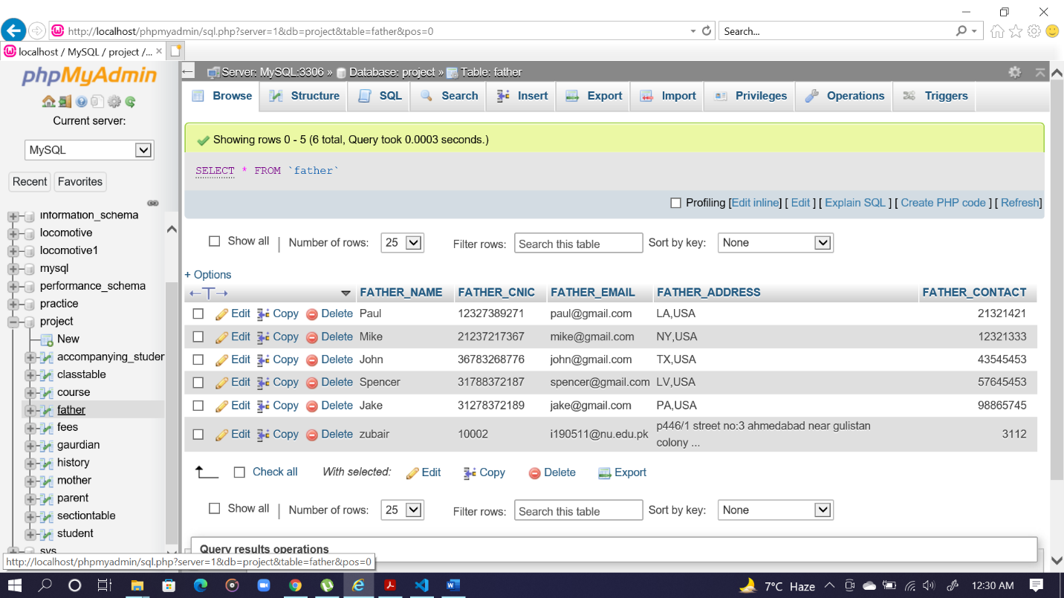

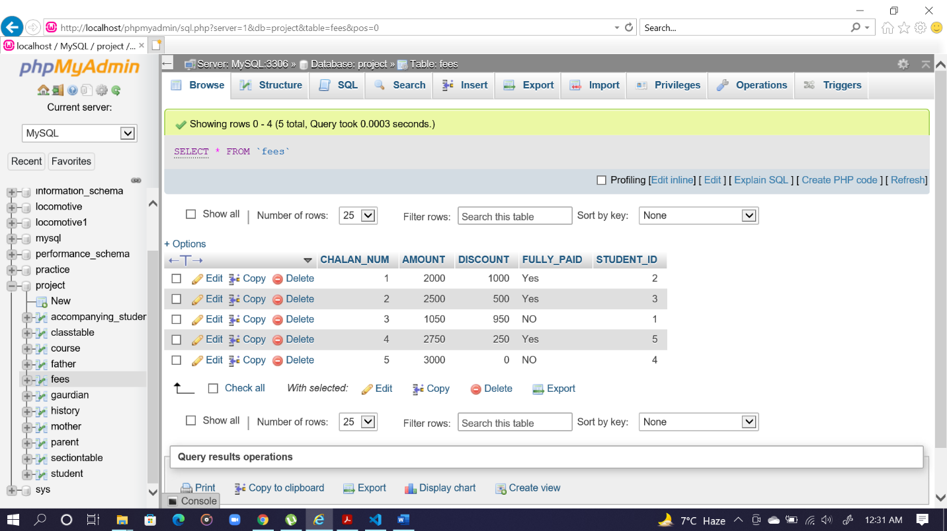

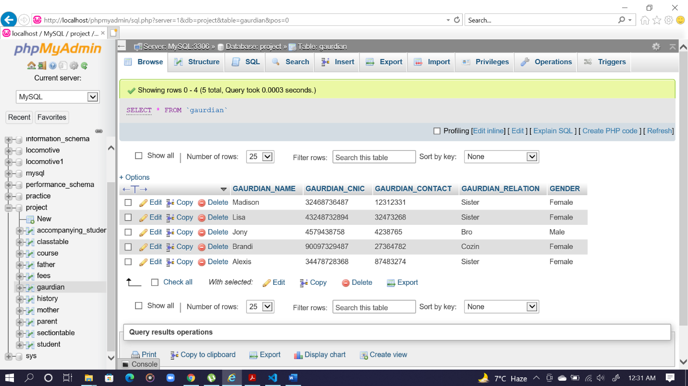

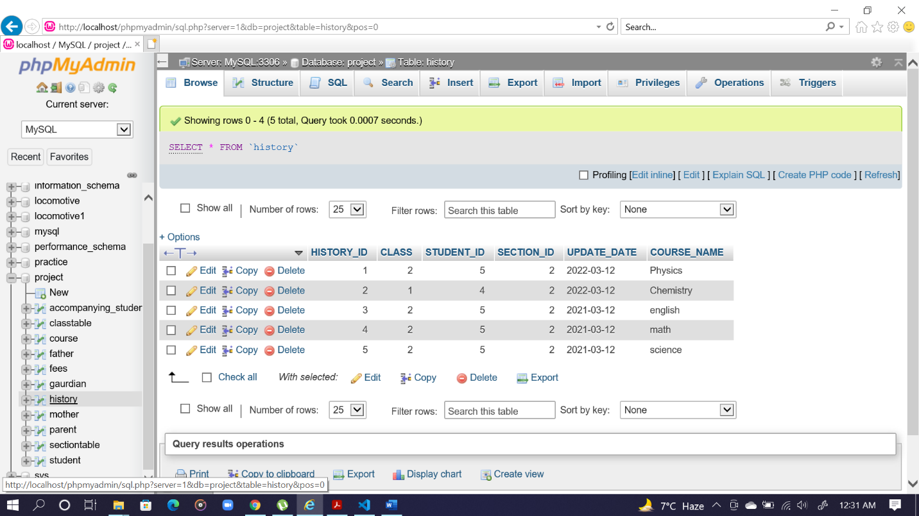

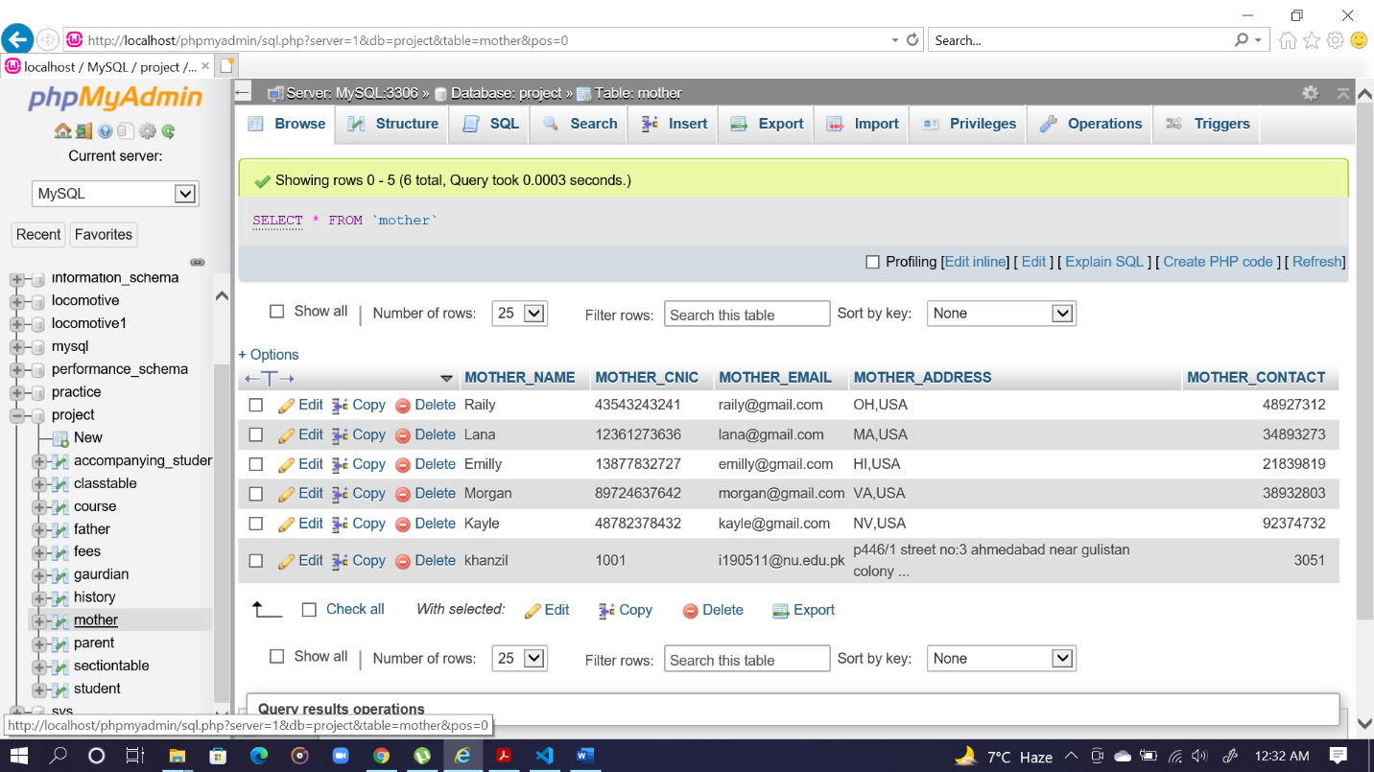

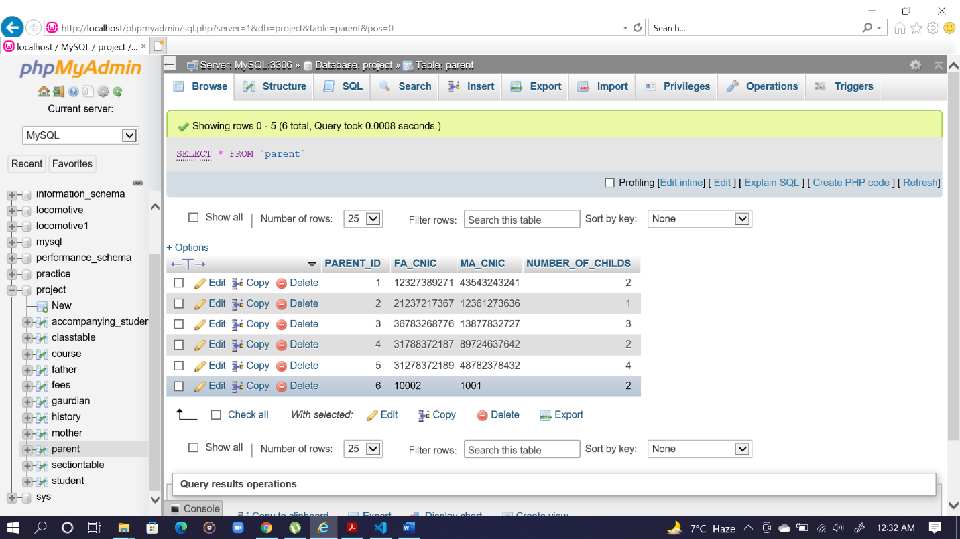

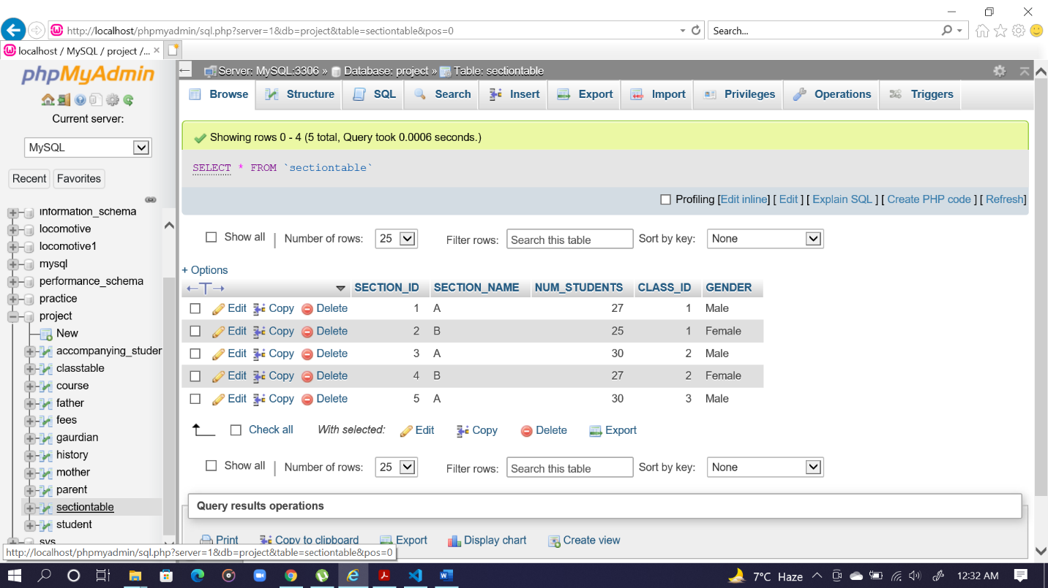

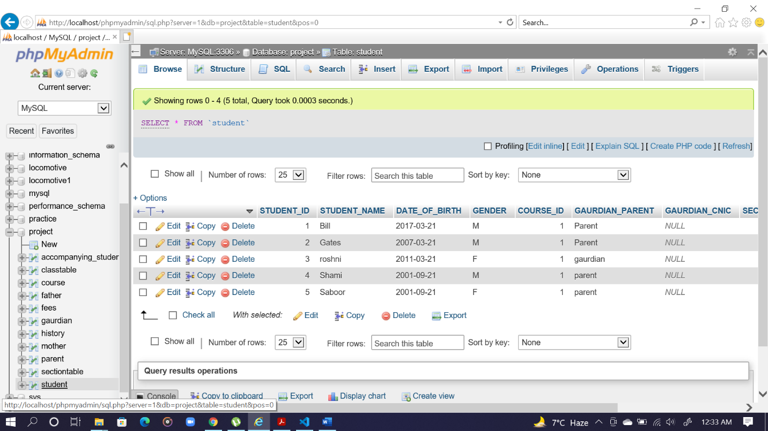

**DELETION**

If u want to delete some thing the best way is go on phpMyAdmin select your table and then click on ok you row would be deleted and If u want to delete some thing on website that we should create then simply press the delete button when the data delete refresh your screen and then see data is deleted.

Example of deletion:

DELETE from fees where STUDENT_ID = $stdid";

**Tables Creation**

**GAURDIAN TABLE:**

[CREATE](http://localhost/phpmyadmin/url.php?url=https://dev.mysql.com/doc/refman/5.5/en/create-table.html) [TABLE](http://localhost/phpmyadmin/url.php?url=https://dev.mysql.com/doc/refman/5.5/en/create-table.html) GAURDIAN( GAURDIAN_NAME [varchar](http://localhost/phpmyadmin/url.php?url=https://dev.mysql.com/doc/refman/5.5/en/string-types.html)(100) [NOT](http://localhost/phpmyadmin/url.php?url=https://dev.mysql.com/doc/refman/5.5/en/logical-operators.html#operator_not) NULL, GAURDIAN_CNIC [varchar](http://localhost/phpmyadmin/url.php?url=https://dev.mysql.com/doc/refman/5.5/en/string-types.html)(100) [NOT](http://localhost/phpmyadmin/url.php?url=https://dev.mysql.com/doc/refman/5.5/en/logical-operators.html#operator_not) NULL, GAURDIAN_CONTACT [varchar](http://localhost/phpmyadmin/url.php?url=https://dev.mysql.com/doc/refman/5.5/en/string-types.html)(100) [NOT](http://localhost/phpmyadmin/url.php?url=https://dev.mysql.com/doc/refman/5.5/en/logical-operators.html#operator_not) NULL, GAURDIAN_RELATION [varchar](http://localhost/phpmyadmin/url.php?url=https://dev.mysql.com/doc/refman/5.5/en/string-types.html)(100) [NOT](http://localhost/phpmyadmin/url.php?url=https://dev.mysql.com/doc/refman/5.5/en/logical-operators.html#operator_not) NULL, PRIMARY KEY(GAURDIAN_CNIC) )

[ALTER](http://localhost/phpmyadmin/url.php?url=https://dev.mysql.com/doc/refman/5.5/en/alter-table.html) [TABLE](http://localhost/phpmyadmin/url.php?url=https://dev.mysql.com/doc/refman/5.5/en/alter-table.html) gaurdian ADD GENDER [varchar](http://localhost/phpmyadmin/url.php?url=https://dev.mysql.com/doc/refman/5.5/en/string-types.html)(10)

**FATHER TABLE:**

[CREATE](http://localhost/phpmyadmin/url.php?url=https://dev.mysql.com/doc/refman/5.5/en/create-table.html) [TABLE](http://localhost/phpmyadmin/url.php?url=https://dev.mysql.com/doc/refman/5.5/en/create-table.html) FATHER( FATHER_NAME [varchar](http://localhost/phpmyadmin/url.php?url=https://dev.mysql.com/doc/refman/5.5/en/string-types.html)(1000) [NOT](http://localhost/phpmyadmin/url.php?url=https://dev.mysql.com/doc/refman/5.5/en/logical-operators.html#operator_not) NULL, FATHER_CNIC [varchar](http://localhost/phpmyadmin/url.php?url=https://dev.mysql.com/doc/refman/5.5/en/string-types.html)(1000) [NOT](http://localhost/phpmyadmin/url.php?url=https://dev.mysql.com/doc/refman/5.5/en/logical-operators.html#operator_not) NULL, FATHER_EMAIL [varchar](http://localhost/phpmyadmin/url.php?url=https://dev.mysql.com/doc/refman/5.5/en/string-types.html)(1000), FATHER_ADDRESS [varchar](http://localhost/phpmyadmin/url.php?url=https://dev.mysql.com/doc/refman/5.5/en/string-types.html)(1000), FATHER_CONTACT [int](http://localhost/phpmyadmin/url.php?url=https://dev.mysql.com/doc/refman/5.5/en/numeric-types.html), Primary key (FATHER_CNIC) )

**MOTHER TABLE:**

[CREATE](http://localhost/phpmyadmin/url.php?url=https://dev.mysql.com/doc/refman/5.5/en/create-table.html) [TABLE](http://localhost/phpmyadmin/url.php?url=https://dev.mysql.com/doc/refman/5.5/en/create-table.html) MOTHER( MOTHER_NAME [varchar](http://localhost/phpmyadmin/url.php?url=https://dev.mysql.com/doc/refman/5.5/en/string-types.html)(1000) [NOT](http://localhost/phpmyadmin/url.php?url=https://dev.mysql.com/doc/refman/5.5/en/logical-operators.html#operator_not) NULL, MOTHER_CNIC [varchar](http://localhost/phpmyadmin/url.php?url=https://dev.mysql.com/doc/refman/5.5/en/string-types.html)(1000) [NOT](http://localhost/phpmyadmin/url.php?url=https://dev.mysql.com/doc/refman/5.5/en/logical-operators.html#operator_not) NULL, MOTHER_EMAIL [varchar](http://localhost/phpmyadmin/url.php?url=https://dev.mysql.com/doc/refman/5.5/en/string-types.html)(1000), MOTHER_ADDRESS [varchar](http://localhost/phpmyadmin/url.php?url=https://dev.mysql.com/doc/refman/5.5/en/string-types.html)(1000), MOTHER_CONTACT [int](http://localhost/phpmyadmin/url.php?url=https://dev.mysql.com/doc/refman/5.5/en/numeric-types.html), Primary key (MOTHER_CNIC)

**PARENT TABLE:**

[CREATE](http://localhost/phpmyadmin/url.php?url=https://dev.mysql.com/doc/refman/5.5/en/create-table.html) [TABLE](http://localhost/phpmyadmin/url.php?url=https://dev.mysql.com/doc/refman/5.5/en/create-table.html) PARENT( PARENT_ID [int](http://localhost/phpmyadmin/url.php?url=https://dev.mysql.com/doc/refman/5.5/en/numeric-types.html) [NOT](http://localhost/phpmyadmin/url.php?url=https://dev.mysql.com/doc/refman/5.5/en/logical-operators.html#operator_not) NULL AUTO_INCREMENT, FA_CNIC [varchar](http://localhost/phpmyadmin/url.php?url=https://dev.mysql.com/doc/refman/5.5/en/string-types.html)(1000), MA_CNIC [varchar](http://localhost/phpmyadmin/url.php?url=https://dev.mysql.com/doc/refman/5.5/en/string-types.html)(1000), NUMBER_OF_CHILDS [int](http://localhost/phpmyadmin/url.php?url=https://dev.mysql.com/doc/refman/5.5/en/numeric-types.html), PRIMARY KEY(PARENT_ID), FOREIGN KEY (FA_CNIC) REFERENCES father(FATHER_CNIC), FOREIGN KEY (MA_CNIC) REFERENCES mother(MOTHER_CNIC) )

**CLASSTABLE TABLE:**

[CREATE](http://localhost/phpmyadmin/url.php?url=https://dev.mysql.com/doc/refman/5.5/en/create-table.html) [TABLE](http://localhost/phpmyadmin/url.php?url=https://dev.mysql.com/doc/refman/5.5/en/create-table.html) CLASSTABLE( CLASS_ID [int](http://localhost/phpmyadmin/url.php?url=https://dev.mysql.com/doc/refman/5.5/en/numeric-types.html) [NOT](http://localhost/phpmyadmin/url.php?url=https://dev.mysql.com/doc/refman/5.5/en/logical-operators.html#operator_not) NULL AUTO_INCREMENT, NUM_SECTIONS [int](http://localhost/phpmyadmin/url.php?url=https://dev.mysql.com/doc/refman/5.5/en/numeric-types.html) [NOT](http://localhost/phpmyadmin/url.php?url=https://dev.mysql.com/doc/refman/5.5/en/logical-operators.html#operator_not) NULL, NUM_STUDENTS [int](http://localhost/phpmyadmin/url.php?url=https://dev.mysql.com/doc/refman/5.5/en/numeric-types.html) [NOT](http://localhost/phpmyadmin/url.php?url=https://dev.mysql.com/doc/refman/5.5/en/logical-operators.html#operator_not) NULL, RANGED [varchar](http://localhost/phpmyadmin/url.php?url=https://dev.mysql.com/doc/refman/5.5/en/string-types.html)(10), PRIMARY KEY(CLASS_ID) )

**SECTIONTABLE TABLE:**

[CREATE](http://localhost/phpmyadmin/url.php?url=https://dev.mysql.com/doc/refman/5.5/en/create-table.html) [TABLE](http://localhost/phpmyadmin/url.php?url=https://dev.mysql.com/doc/refman/5.5/en/create-table.html) SECTIONTABLE( SECTION_ID [int](http://localhost/phpmyadmin/url.php?url=https://dev.mysql.com/doc/refman/5.5/en/numeric-types.html) [NOT](http://localhost/phpmyadmin/url.php?url=https://dev.mysql.com/doc/refman/5.5/en/logical-operators.html#operator_not) NULL AUTO_INCREMENT, SECTION_NAME [varchar](http://localhost/phpmyadmin/url.php?url=https://dev.mysql.com/doc/refman/5.5/en/string-types.html)(10) [NOT](http://localhost/phpmyadmin/url.php?url=https://dev.mysql.com/doc/refman/5.5/en/logical-operators.html#operator_not) NULL, NUM_STUDENTS [int](http://localhost/phpmyadmin/url.php?url=https://dev.mysql.com/doc/refman/5.5/en/numeric-types.html) [NOT](http://localhost/phpmyadmin/url.php?url=https://dev.mysql.com/doc/refman/5.5/en/logical-operators.html#operator_not) NULL, CLASS_ID [int](http://localhost/phpmyadmin/url.php?url=https://dev.mysql.com/doc/refman/5.5/en/numeric-types.html), GENDER [varchar](http://localhost/phpmyadmin/url.php?url=https://dev.mysql.com/doc/refman/5.5/en/string-types.html)(10), PRIMARY KEY(SECTION_ID), FOREIGN KEY (CLASS_ID) REFERENCES classtable(CLASS_ID) )

**COURSE TABLE:**

[CREATE](http://localhost/phpmyadmin/url.php?url=https://dev.mysql.com/doc/refman/5.5/en/create-table.html) [TABLE](http://localhost/phpmyadmin/url.php?url=https://dev.mysql.com/doc/refman/5.5/en/create-table.html) COURSE( COURSE_ID [int](http://localhost/phpmyadmin/url.php?url=https://dev.mysql.com/doc/refman/5.5/en/numeric-types.html) [NOT](http://localhost/phpmyadmin/url.php?url=https://dev.mysql.com/doc/refman/5.5/en/logical-operators.html#operator_not) NULL AUTO_INCREMENT, COURSE_NAME [varchar](http://localhost/phpmyadmin/url.php?url=https://dev.mysql.com/doc/refman/5.5/en/string-types.html)(55) [NOT](http://localhost/phpmyadmin/url.php?url=https://dev.mysql.com/doc/refman/5.5/en/logical-operators.html#operator_not) NULL, STATUSED [varchar](http://localhost/phpmyadmin/url.php?url=https://dev.mysql.com/doc/refman/5.5/en/string-types.html)(15), PRIMARY KEY(COURSE_ID) )

**STUDENT TABLE:**

[CREATE](http://localhost/phpmyadmin/url.php?url=https://dev.mysql.com/doc/refman/5.5/en/create-table.html) [TABLE](http://localhost/phpmyadmin/url.php?url=https://dev.mysql.com/doc/refman/5.5/en/create-table.html) STUDENT( STUDENT_ID [int](http://localhost/phpmyadmin/url.php?url=https://dev.mysql.com/doc/refman/5.5/en/numeric-types.html) [NOT](http://localhost/phpmyadmin/url.php?url=https://dev.mysql.com/doc/refman/5.5/en/logical-operators.html#operator_not) NULL AUTO_INCREMENT, STUDENT_NAME [varchar](http://localhost/phpmyadmin/url.php?url=https://dev.mysql.com/doc/refman/5.5/en/string-types.html)(1000)[NOT](http://localhost/phpmyadmin/url.php?url=https://dev.mysql.com/doc/refman/5.5/en/logical-operators.html#operator_not) NULL, DATE_OF_BIRTH [DATE](http://localhost/phpmyadmin/url.php?url=https://dev.mysql.com/doc/refman/5.5/en/date-and-time-types.html) [NOT](http://localhost/phpmyadmin/url.php?url=https://dev.mysql.com/doc/refman/5.5/en/logical-operators.html#operator_not) NULL, GENDER [varchar](http://localhost/phpmyadmin/url.php?url=https://dev.mysql.com/doc/refman/5.5/en/string-types.html)(2) [NOT](http://localhost/phpmyadmin/url.php?url=https://dev.mysql.com/doc/refman/5.5/en/logical-operators.html#operator_not) NULL, COURSE_ID [int](http://localhost/phpmyadmin/url.php?url=https://dev.mysql.com/doc/refman/5.5/en/numeric-types.html), GAURDIAN_PARENT [varchar](http://localhost/phpmyadmin/url.php?url=https://dev.mysql.com/doc/refman/5.5/en/string-types.html)(20) [NOT](http://localhost/phpmyadmin/url.php?url=https://dev.mysql.com/doc/refman/5.5/en/logical-operators.html#operator_not) NULL, GAURDIAN_CNIC [varchar](http://localhost/phpmyadmin/url.php?url=https://dev.mysql.com/doc/refman/5.5/en/string-types.html)(20), SECTION_ID [int](http://localhost/phpmyadmin/url.php?url=https://dev.mysql.com/doc/refman/5.5/en/numeric-types.html), LAST_DATE [DATE](http://localhost/phpmyadmin/url.php?url=https://dev.mysql.com/doc/refman/5.5/en/date-and-time-types.html), PARENT_ID [int](http://localhost/phpmyadmin/url.php?url=https://dev.mysql.com/doc/refman/5.5/en/numeric-types.html), PRIMARY KEY (STUDENT_ID), FOREIGN KEY (PARENT_ID) REFERENCES parent(PARENT_ID), FOREIGN KEY (SECTION_ID) REFERENCES sectiontable(SECTION_ID), FOREIGN KEY (GAURDIAN_CNIC) REFERENCES gaurdian(GAURDIAN_CNIC), FOREIGN KEY (COURSE_ID) REFERENCES course(COURSE_ID) )

**ACCOMPANYING_STUDENT TABLE:**

[CREATE](http://localhost/phpmyadmin/url.php?url=https://dev.mysql.com/doc/refman/5.5/en/create-table.html) [TABLE](http://localhost/phpmyadmin/url.php?url=https://dev.mysql.com/doc/refman/5.5/en/create-table.html) ACCOMPANYING_STUDENT( ACCOMPANYING_ID [int](http://localhost/phpmyadmin/url.php?url=https://dev.mysql.com/doc/refman/5.5/en/numeric-types.html) [NOT](http://localhost/phpmyadmin/url.php?url=https://dev.mysql.com/doc/refman/5.5/en/logical-operators.html#operator_not) NULL AUTO_INCREMENT, ACCOMPANYING_NAME [varchar](http://localhost/phpmyadmin/url.php?url=https://dev.mysql.com/doc/refman/5.5/en/string-types.html)(255) [NOT](http://localhost/phpmyadmin/url.php?url=https://dev.mysql.com/doc/refman/5.5/en/logical-operators.html#operator_not) NULL, ACCOMPANYING_CNIC [varchar](http://localhost/phpmyadmin/url.php?url=https://dev.mysql.com/doc/refman/5.5/en/string-types.html)(1000) [NOT](http://localhost/phpmyadmin/url.php?url=https://dev.mysql.com/doc/refman/5.5/en/logical-operators.html#operator_not) NULL, CONTACT [int](http://localhost/phpmyadmin/url.php?url=https://dev.mysql.com/doc/refman/5.5/en/numeric-types.html), STUDENT_ID [int](http://localhost/phpmyadmin/url.php?url=https://dev.mysql.com/doc/refman/5.5/en/numeric-types.html), PREGNANT [varchar](http://localhost/phpmyadmin/url.php?url=https://dev.mysql.com/doc/refman/5.5/en/string-types.html)(10), RELATION [varchar](http://localhost/phpmyadmin/url.php?url=https://dev.mysql.com/doc/refman/5.5/en/string-types.html)(50), REASON [varchar](http://localhost/phpmyadmin/url.php?url=https://dev.mysql.com/doc/refman/5.5/en/string-types.html)(10), PRIMARY KEY (ACCOMPANYING_ID), FOREIGN KEY (STUDENT_ID) REFERENCES student(STUDENT_ID) )

**FEES TABLE:**

[CREATE](http://localhost/phpmyadmin/url.php?url=https://dev.mysql.com/doc/refman/5.5/en/create-table.html) [TABLE](http://localhost/phpmyadmin/url.php?url=https://dev.mysql.com/doc/refman/5.5/en/create-table.html) FEES( CHALAN_NUM [int](http://localhost/phpmyadmin/url.php?url=https://dev.mysql.com/doc/refman/5.5/en/numeric-types.html) [NOT](http://localhost/phpmyadmin/url.php?url=https://dev.mysql.com/doc/refman/5.5/en/logical-operators.html#operator_not) NULL AUTO_INCREMENT, AMOUNT [int](http://localhost/phpmyadmin/url.php?url=https://dev.mysql.com/doc/refman/5.5/en/numeric-types.html) [NOT](http://localhost/phpmyadmin/url.php?url=https://dev.mysql.com/doc/refman/5.5/en/logical-operators.html#operator_not) NULL, DISCOUNT [int](http://localhost/phpmyadmin/url.php?url=https://dev.mysql.com/doc/refman/5.5/en/numeric-types.html) [NOT](http://localhost/phpmyadmin/url.php?url=https://dev.mysql.com/doc/refman/5.5/en/logical-operators.html#operator_not) NULL, FULLY_PAID [varchar](http://localhost/phpmyadmin/url.php?url=https://dev.mysql.com/doc/refman/5.5/en/string-types.html)(100), STUDENT_ID [int](http://localhost/phpmyadmin/url.php?url=https://dev.mysql.com/doc/refman/5.5/en/numeric-types.html), PRIMARY KEY (CHALAN_NUM), FOREIGN KEY (STUDENT_ID) REFERENCES student(STUDENT_ID) )

**HISTORY TABLE:**

[CREATE](http://localhost/phpmyadmin/url.php?url=https://dev.mysql.com/doc/refman/5.5/en/create-table.html) [TABLE](http://localhost/phpmyadmin/url.php?url=https://dev.mysql.com/doc/refman/5.5/en/create-table.html) HISTORY( HISTORY_ID [int](http://localhost/phpmyadmin/url.php?url=https://dev.mysql.com/doc/refman/5.5/en/numeric-types.html) [NOT](http://localhost/phpmyadmin/url.php?url=https://dev.mysql.com/doc/refman/5.5/en/logical-operators.html#operator_not) NULL AUTO_INCREMENT, CLASS [int](http://localhost/phpmyadmin/url.php?url=https://dev.mysql.com/doc/refman/5.5/en/numeric-types.html) [NOT](http://localhost/phpmyadmin/url.php?url=https://dev.mysql.com/doc/refman/5.5/en/logical-operators.html#operator_not) NULL, STUDENT_ID [int](http://localhost/phpmyadmin/url.php?url=https://dev.mysql.com/doc/refman/5.5/en/numeric-types.html) [NOT](http://localhost/phpmyadmin/url.php?url=https://dev.mysql.com/doc/refman/5.5/en/logical-operators.html#operator_not) NULL, SECTION_ID [int](http://localhost/phpmyadmin/url.php?url=https://dev.mysql.com/doc/refman/5.5/en/numeric-types.html) [NOT](http://localhost/phpmyadmin/url.php?url=https://dev.mysql.com/doc/refman/5.5/en/logical-operators.html#operator_not) NULL, UPDATE_DATE [DATE](http://localhost/phpmyadmin/url.php?url=https://dev.mysql.com/doc/refman/5.5/en/date-and-time-types.html), COURSE_NAME [varchar](http://localhost/phpmyadmin/url.php?url=https://dev.mysql.com/doc/refman/5.5/en/string-types.html)(55), PRIMARY KEY (HISTORY_ID), FOREIGN KEY (STUDENT_ID) REFERENCES student(STUDENT_ID) )

**INSERTION IN TABLES**

**GAURDIAN TABLE:**

INSERT INTO Gaurdian (GAURDIAN_NAME,GAURDIAN_CNIC,GENDER,GAURDIAN_CONTACT,GAURDIAN_RELATION) VALUES ('Madison',32468736487,'Female', 12312331,'Sister');

INSERT INTO Gaurdian (GAURDIAN_NAME,GAURDIAN_CNIC,GENDER,GAURDIAN_CONTACT,GAURDIAN_RELATION)VALUES ('Lisa',43248732894,'Female', 32473268,'Sister');

INSERT INTO Gaurdian (GAURDIAN_NAME,GAURDIAN_CNIC,GENDER,GAURDIAN_CONTACT,GAURDIAN_RELATION) VALUES ('Jony',4579438758,'Male', 4238765,'Bro');

INSERT INTO Gaurdian (GAURDIAN_NAME,GAURDIAN_CNIC,GENDER,GAURDIAN_CONTACT,GAURDIAN_RELATION)VALUES ('Brandi',90097329487,'Female', 27364782,'Cozin');

INSERT INTO Gaurdian (GAURDIAN_NAME,GAURDIAN_CNIC,GENDER,GAURDIAN_CONTACT,GAURDIAN_RELATION)VALUES ('Alexis',34478728368,'Female', 87483274,'Sister');

**FATHER TABLE:**

INSERT INTO Father(FATHER_NAME,FATHER_CNIC,FATHER_EMAIL,FATHER_CONTACT,FATHER_ADDRESS) VALUES ('Paul',12327389271,'paul@gmail.com',21321421,'LA,USA');

INSERT INTO Father(FATHER_NAME,FATHER_CNIC,FATHER_EMAIL,FATHER_CONTACT,FATHER_ADDRESS) VALUES ('Mike',21237217367,'mike@gmail.com',12321333,'NY,USA');

INSERT INTO Father(FATHER_NAME,FATHER_CNIC,FATHER_EMAIL,FATHER_CONTACT,FATHER_ADDRESS) VALUES ('John',36783268776,'john@gmail.com',43545453,'TX,USA');

INSERT INTO Father(FATHER_NAME,FATHER_CNIC,FATHER_EMAIL,FATHER_CONTACT,FATHER_ADDRESS) VALUES ('Spencer',31788372187,'spencer@gmail.com',57645453,'LV,USA');

INSERT INTO Father(FATHER_NAME,FATHER_CNIC,FATHER_EMAIL,FATHER_CONTACT,FATHER_ADDRESS) VALUES ('Jake',31278372189,'jake@gmail.com',98865745,'PA,USA');

**MOTHER TABLE:**

INSERT INTO Mother(MOTHER_NAME,MOTHER_CNIC,MOTHER_EMAIL,MOTHER_CONTACT,MOTHER_ADDRESS) VALUES ('Raily',43543243241,'raily@gmail.com',48927312,'OH,USA');

INSERT INTO Mother(MOTHER_NAME,MOTHER_CNIC,MOTHER_EMAIL,MOTHER_CONTACT,MOTHER_ADDRESS) VALUES ('Lana',12361273636,'lana@gmail.com',34893273,'MA,USA');

INSERT INTO Mother(MOTHER_NAME,MOTHER_CNIC,MOTHER_EMAIL,MOTHER_CONTACT,MOTHER_ADDRESS) VALUES ('Emilly',13877832727,'emilly@gmail.com',21839819,'HI,USA');

INSERT INTO Mother(MOTHER_NAME,MOTHER_CNIC,MOTHER_EMAIL,MOTHER_CONTACT,MOTHER_ADDRESS) VALUES ('Kayle',48782378432,'kayle@gmail.com',92374732,'NV,USA');

**PARENT TABLE:**

INSERT INTO Parent(FA_CNIC,MA_CNIC,NUMBER_OF_CHILDS)

VALUES ('12327389271','43543243241',2);

INSERT INTO Parent(FA_CNIC,MA_CNIC,NUMBER_OF_CHILDS)

VALUES ('21237217367','12361273636',1);

INSERT INTO Parent(FA_CNIC,MA_CNIC,NUMBER_OF_CHILDS)

VALUES ('36783268776','13877832727',3);

INSERT INTO Parent(FA_CNIC,MA_CNIC,NUMBER_OF_CHILDS)

VALUES ('31788372187','89724637642',2);

INSERT INTO Parent(FA_CNIC,MA_CNIC,NUMBER_OF_CHILDS)

VALUES ('31278372189','48782378432',4);

**CLASSTABLE TABLE:**

INSERT INTO classtable(NUM_SECTIONS,NUM_STUDENTS,RANGED)

VALUES (2,50,'3-4');

INSERT INTO classtable(NUM_SECTIONS,NUM_STUDENTS,RANGED)

VALUES (2,57,'4-6');

INSERT INTO classtable(NUM_SECTIONS,NUM_STUDENTS,RANGED)

VALUES (1,30,'6-7');

INSERT INTO classtable(NUM_SECTIONS,NUM_STUDENTS,RANGED)

VALUES (2,25,'7-8');

INSERT INTO classtable(NUM_SECTIONS,NUM_STUDENTS,RANGED)

VALUES (2,25,'8-10');

**SECTIONTABLE TABLE:**

INSERT INTO sectiontable(SECTION_NAME,NUM_STUDENTS,CLASS_ID,GENDER)

VALUES ('A',25,1,'Male');

INSERT INTO sectiontable(SECTION_NAME,NUM_STUDENTS,CLASS_ID,GENDER)

VALUES ('B',25,1,'Female');

INSERT INTO sectiontable(SECTION_NAME,NUM_STUDENTS,CLASS_ID,GENDER)

VALUES ('A',30,2,'Male');

INSERT INTO sectiontable(SECTION_NAME,NUM_STUDENTS,CLASS_ID,GENDER)

VALUES ('B',27,2,'Female');

INSERT INTO sectiontable(SECTION_NAME,NUM_STUDENTS,CLASS_ID,GENDER)

VALUES ('A',30,3,'Male');

**COURSE TABLE:**

INSERT INTO course (COURSE_NAME,STATUSED)

VALUES ('Physics','Available');

INSERT INTO course (COURSE_NAME,STATUSED)

VALUES ('Chemistry','Not Available');

INSERT INTO course (COURSE_NAME,STATUSED)

VALUES ('History','Not Available');

INSERT INTO course (COURSE_NAME,STATUSED)

VALUES ('Math','Not Available');

INSERT INTO course (COURSE_NAME,STATUSED)

VALUES ('Bio','Not Available');

**STUDENT TABLE:**

INSERT INTO student

(STUDENT_NAME,DATE_OF_BIRTH,GENDER,COURSE_ID,GAURDIAN_PARENT,GAURDIAN_CNIC,PARENT_ID,SECTION_ID)

VALUES ('Bill','2017-03-21','M',1,'Parent',NULL,2,1);

INSERT INTO student

(STUDENT_NAME,DATE_OF_BIRTH,GENDER,COURSE_ID,GAURDIAN_PARENT,GAURDIAN_CNIC,PARENT_ID,SECTION_ID)

VALUES ('Gates','2007-03-21','M',1,'Parent',NULL,2,1);

INSERT INTO student

(STUDENT_NAME,DATE_OF_BIRTH,GENDER,COURSE_ID,GAURDIAN_PARENT,GAURDIAN_CNIC,PARENT_ID,SECTION_ID)

VALUES ('roshni','2011-03-21','F',1,'gaurdian',NULL,2,1);

INSERT INTO student

(STUDENT_NAME,DATE_OF_BIRTH,GENDER,COURSE_ID,GAURDIAN_PARENT,GAURDIAN_CNIC,PARENT_ID,SECTION_ID)

VALUES ('Shami','2001-09-21','M',1,'parent',NULL,2,1);

INSERT INTO student

(STUDENT_NAME,DATE_OF_BIRTH,GENDER,COURSE_ID,GAURDIAN_PARENT,GAURDIAN_CNIC,PARENT_ID,SECTION_ID)

VALUES ('Saboor','2001-09-21','F',1,'parent',NULL,2,1);

**ACCOMPANYING TABLE:**

INSERT INTO accompanying_student (ACCOMPANYING_NAME,ACCOMPANYING_CNIC,CONTACT,PREGNANT,RELATION,REASON,STUDENT_ID) VALUES ('Aria','31231232131',47327864,'Yes','Sister','Sick',1);

INSERT INTO accompanying_student (ACCOMPANYING_NAME,ACCOMPANYING_CNIC,CONTACT,PREGNANT,RELATION,REASON,STUDENT_ID) VALUES ('John','38784623784',89732647,'No','Brother','outoftown',1);

INSERT INTO accompanying_student (ACCOMPANYING_NAME,ACCOMPANYING_CNIC,CONTACT,PREGNANT,RELATION,REASON,STUDENT_ID) VALUES ('Ranly','32749873289',23789213,'No','Brother','Sick',2);

INSERT INTO accompanying_student (ACCOMPANYING_NAME,ACCOMPANYING_CNIC,CONTACT,PREGNANT,RELATION,REASON,STUDENT_ID) VALUES ('Macne','32749873847',12398127,'Yes','Brother','outoftown',5);

INSERT INTO accompanying_student (ACCOMPANYING_NAME,ACCOMPANYING_CNIC,CONTACT,PREGNANT,RELATION,REASON,STUDENT_ID)

VALUES ('Tarly','34798378978',32478328,'No','Sister','Sick',5);

**FEES TABLE:**

INSERT INTO fees(AMOUNT,DISCOUNT,FULLY_PAID,STUDENT_ID)

VALUES (2000,1000,'Yes',2);

INSERT INTO fees(AMOUNT,DISCOUNT,FULLY_PAID,STUDENT_ID)

VALUES (2500,500,'Yes',3);

INSERT INTO fees(AMOUNT,DISCOUNT,FULLY_PAID,STUDENT_ID)

VALUES (1050,950,'NO',1);

INSERT INTO fees(AMOUNT,DISCOUNT,FULLY_PAID,STUDENT_ID)

VALUES (2750,250,'Yes',5);

INSERT INTO fees(AMOUNT,DISCOUNT,FULLY_PAID,STUDENT_ID)

VALUES (3000,0,'NO',4);

**HISTORY TABLE:**

INSERT INTO History (CLASS,STUDENT_ID,SECTION_ID,UPDATE_DATE,COURSE_NAME)

VALUES (2,5,2,'2022-3-12','Physics');

INSERT INTO History (CLASS,STUDENT_ID,SECTION_ID,UPDATE_DATE,COURSE_NAME)

VALUES (1,4,2,'2022-3-12','Chemistry');

INSERT INTO History (CLASS,STUDENT_ID,SECTION_ID,UPDATE_DATE,COURSE_NAME)

VALUES (2,5,2,'2021-3-12','english');

INSERT INTO History (CLASS,STUDENT_ID,SECTION_ID,UPDATE_DATE,COURSE_NAME)

VALUES (2,5,2,'2021-3-12','math');

INSERT INTO History (CLASS,STUDENT_ID,SECTION_ID,UPDATE_DATE,COURSE_NAME)

VALUES (2,5,2,'2021-3-12','science');

**Queries**

[SELECT](http://localhost/phpmyadmin/url.php?url=https://dev.mysql.com/doc/refman/5.5/en/select.html) * FROM `student`

[select](http://localhost/phpmyadmin/url.php?url=https://dev.mysql.com/doc/refman/5.5/en/select.html) m.MOTHER_NAME, f.FATHER_NAME from mother m, father f, parent p where m.MOTHER_CNIC = p.MA_CNIC and p.FA_CNIC = f.FATHER_CNIC

[select](http://localhost/phpmyadmin/url.php?url=https://dev.mysql.com/doc/refman/5.5/en/select.html) s.STUDENT_NAME,g.GAURDIAN_NAME,g.GAURDIAN_RELATION from student s,gaurdian g where s.GAURDIAN_CNIC = g.GAURDIAN_CNIC

[select](http://localhost/phpmyadmin/url.php?url=https://dev.mysql.com/doc/refman/5.5/en/select.html) s.STUDENT_NAME,s.GENDER,f.FATHER_NAME,m.MOTHER_NAME from student s,mother m,father f,parent p where s.PARENT_ID = p.PARENT_ID [and](http://localhost/phpmyadmin/url.php?url=https://dev.mysql.com/doc/refman/5.5/en/logical-operators.html#operator_and) p.FA_CNIC = f.FATHER_CNIC [and](http://localhost/phpmyadmin/url.php?url=https://dev.mysql.com/doc/refman/5.5/en/logical-operators.html#operator_and) p.MA_CNIC = m.MOTHER_CNIC

[select](http://localhost/phpmyadmin/url.php?url=https://dev.mysql.com/doc/refman/5.5/en/select.html) s1.STUDENT_NAME as STUDENT,s2.STUDENT_NAME as SIBLING,sec1.CLASS_ID as STUDENT_CLASS,sec2.CLASS_ID as HIS_SIBLING_CLASS from student s1,student s2,sectiontable sec1,sectiontable sec2 where s1.PARENT_ID = s2.PARENT_ID [and](http://localhost/phpmyadmin/url.php?url=https://dev.mysql.com/doc/refman/5.5/en/logical-operators.html#operator_and) s1.STUDENT_ID <> s2.STUDENT_ID [and](http://localhost/phpmyadmin/url.php?url=https://dev.mysql.com/doc/refman/5.5/en/logical-operators.html#operator_and) s1.SECTION_ID = sec1.SECTION_ID [and](http://localhost/phpmyadmin/url.php?url=https://dev.mysql.com/doc/refman/5.5/en/logical-operators.html#operator_and) s2.SECTION_ID = sec2.SECTION_ID [and](http://localhost/phpmyadmin/url.php?url=https://dev.mysql.com/doc/refman/5.5/en/logical-operators.html#operator_and) s2.STUDENT_ID > s1.STUDENT_ID group by sec1.CLASS_ID,s1.STUDENT_NAME,s2.STUDENT_NAME,sec2.CLASS_ID

[select](http://localhost/phpmyadmin/url.php?url=https://dev.mysql.com/doc/refman/5.5/en/select.html) sec1.CLASS_ID as STUDENT_CLASS,s1.STUDENT_NAME as STUDENT from student s1 ,sectiontable sec1 where s1.SECTION_ID = sec1.SECTION_ID [and](http://localhost/phpmyadmin/url.php?url=https://dev.mysql.com/doc/refman/5.5/en/logical-operators.html#operator_and) s1.STUDENT_ID [IN](http://localhost/phpmyadmin/url.php?url=https://dev.mysql.com/doc/refman/5.5/en/comparison-operators.html#function_in) ([select](http://localhost/phpmyadmin/url.php?url=https://dev.mysql.com/doc/refman/5.5/en/select.html) STUDENT_ID from student where STUDENT_ID [Not](http://localhost/phpmyadmin/url.php?url=https://dev.mysql.com/doc/refman/5.5/en/logical-operators.html#operator_not) [IN](http://localhost/phpmyadmin/url.php?url=https://dev.mysql.com/doc/refman/5.5/en/comparison-operators.html#function_in) ([select](http://localhost/phpmyadmin/url.php?url=https://dev.mysql.com/doc/refman/5.5/en/select.html) STUDENT_ID from history where UPDATE_DATE < '2020-01-01')) group by sec1.CLASS_ID,s1.STUDENT_NAME

[select](http://localhost/phpmyadmin/url.php?url=https://dev.mysql.com/doc/refman/5.5/en/select.html) s.STUDENT_NAME,s.GENDER,f.FATHER_NAME,m.MOTHER_NAME from student s,mother m,father f,parent p where s.PARENT_ID = p.PARENT_ID [and](http://localhost/phpmyadmin/url.php?url=https://dev.mysql.com/doc/refman/5.5/en/logical-operators.html#operator_and) p.FA_CNIC = f.FATHER_CNIC [and](http://localhost/phpmyadmin/url.php?url=https://dev.mysql.com/doc/refman/5.5/en/logical-operators.html#operator_and) p.MA_CNIC = m.MOTHER_CNIC [and](http://localhost/phpmyadmin/url.php?url=https://dev.mysql.com/doc/refman/5.5/en/logical-operators.html#operator_and) s.STUDENT_ID [IN](http://localhost/phpmyadmin/url.php?url=https://dev.mysql.com/doc/refman/5.5/en/comparison-operators.html#function_in) ([select](http://localhost/phpmyadmin/url.php?url=https://dev.mysql.com/doc/refman/5.5/en/select.html) STUDENT_ID from student where STUDENT_ID [Not](http://localhost/phpmyadmin/url.php?url=https://dev.mysql.com/doc/refman/5.5/en/logical-operators.html#operator_not) [IN](http://localhost/phpmyadmin/url.php?url=https://dev.mysql.com/doc/refman/5.5/en/comparison-operators.html#function_in) ([select](http://localhost/phpmyadmin/url.php?url=https://dev.mysql.com/doc/refman/5.5/en/select.html) STUDENT_ID from history where UPDATE_DATE< '2019-01-01'))

[select](http://localhost/phpmyadmin/url.php?url=https://dev.mysql.com/doc/refman/5.5/en/select.html) CLASS,COURSE_NAME,SECTION_ID,UPDATE_DATE from history where STUDENT_ID = 5

**Queries in Report**

INSERT INTO mother(MOTHER_Name,MOTHER_CNIC,MOTHER_EMAIL,MOTHER_CONTACT,MOTHER_ADDRESS) VALUES

('$MOTHERNAME','$MOTHERCNIC','$MOTHEREMAIL', $MOTHERCONTACT,'$MOTHERADDRESS');

INSERT INTO father(FATHER_NAME,FATHER_CNIC,FATHER_EMAIL,FATHER_CONTACT,FATHER_ADDRESS) VALUES

('$FATHERNAME','$FATHERCNIC','$FATHEREMAIL', $FATHERCONTACT,'$FATHERADDRESS');

INSERT INTO Parent(FA_CNIC,MA_CNIC,NUMBER_OF_CHILDS) VALUES

('$FATHERCNIC','$MOTHERCNIC',$CHILDS);

INSERT INTO gaurdian (GAURDIAN_Name,GAURDIAN_CNIC,GENDER,GAURDIAN_CONTACT,GAURDIAN_RELATION) VALUES

('$gname','$gcnic','$ggender', $gcontact,'$grelation');

SELECT COURSE_ID from COURSE where STATUSED = 'Available’;

UPDATE classtable SET NUM_STUDENTS = NUM_STUDENTS + 1 where CLASS_ID =".$RSARR['CLASS_ID']."”;

SELECT MAX(STUDENT_ID) MAX from student

INSERT INTO fees (AMOUNT,DISCOUNT,FULLY_PAID,STUDENT_ID) VALUES (4500,0,'Yes',$stdid);

SELECT STUDENT_ID, STUDENT_NAME , DATE_OF_BIRTH, GENDER from student where STUDENT_ID =".$input;

UPDATE student SET STUDENT_NAME='".$_POST['stdname']."', DATE_OF_BIRTH ='".$_POST['dob']."', GENDER = ".$_POST['gender']." where STUDENT_ID = ".$_POST['stdid']."";

DELETE from accompanying_gaurdian where STUDENT_ID = $stdid";

DELETE from fees where STUDENT_ID = $stdid";

DELETE from history where STUDENT_ID = $stdid";

DELETE from student where STUDENT_ID = $stdid";

SELECT* from student where STUDENT_ID = $no and STUDENT_NAME='$name' and SECTION_ID=$sec

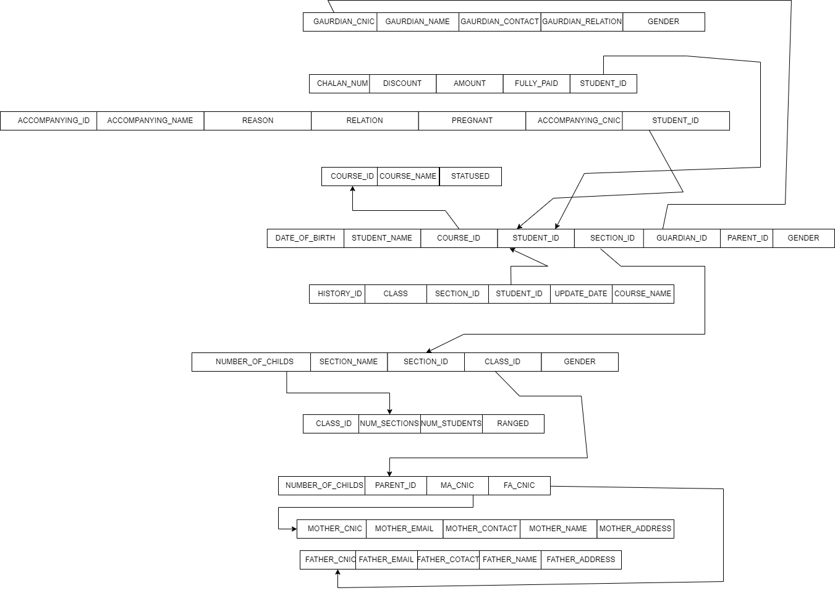

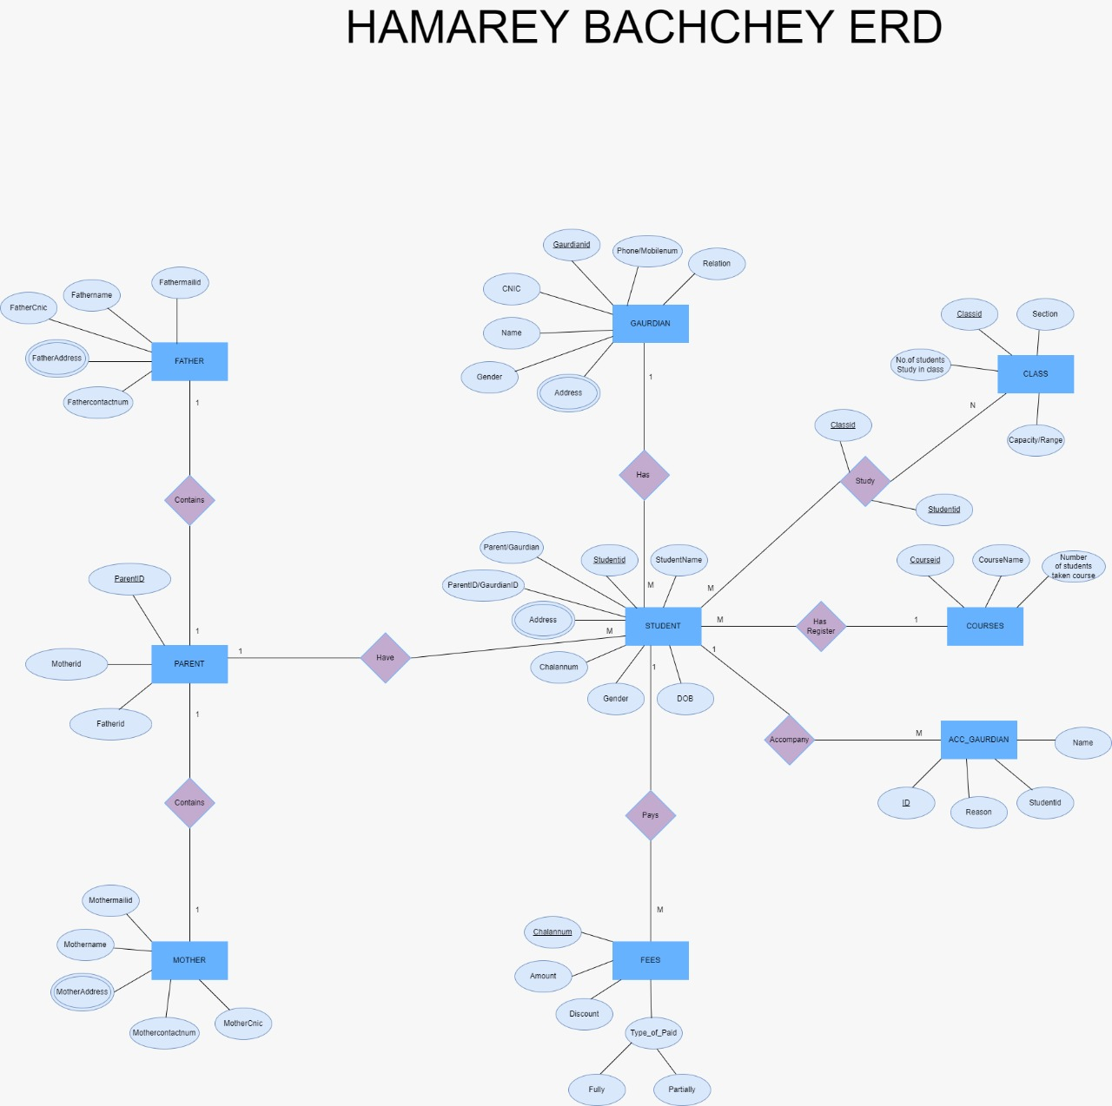

Some important links that help me in this project:

<https://getbootstrap.com/>

<https://www.w3schools.com/php/>

<https://www.youtube.com/watch?v=a_qREkJ78f4&list=PL0b6OzIxLPbyrzCMJOFzLnf_-_5E_dkzs&ab_channel=YahooBaba>’

THANK YOU