Vision Document

Course Instructor:

**Ms Nigar Azhar**

Lab Instructor:

**Miss Laiba Imran**

Submitted By:

**Zarnab Ali(22i-2471)**

**Husnain (22i-1537)**

Date:

**06/06/2024**

Spring 2024



**Department of Software Engineering**

FAST – National University of Computer & Emerging Sciences

Table of Contents

1 Document Version 3

2 Introduction 4

2.1 Purpose 4

2.2 Scope 4

2.3 Definitions, Acronyms, and Abbreviations 4

2.4 References 4

**3 Positioning 4**

3.1 Business Opportunity 4

3.2 Problem Statement 5

3.3 Position Statement 5

**4 Business Case and Target Audience 6**

4.1 Business Case 6

4.2 Target Audience 6

5 Stakeholders and User Description 7

5.1 Market Demographics 7

5.2 Stakeholder Summary 7

5.3 User Summary 8

5.4 User Environment 8

5.5 Stakeholder Profiles 8

5.5.1 8

5.5.2 8

5.5.3 8

5.6 User Profiles 8

5.7 Key Stakeholder or User Needs 8

5.8 Alternatives and Competition 8

**6 High Level Features 9**

6.1 Inmate Tracking: 9

6.2 Secure Identification: 9

6.3 Record-Keeping: 9

6.4 Visitations Management: 9

6.5 Medical Records Management: 9

6.6 Program Coordination: 9

6.7 Incident Reporting: 9

6.8 Resource Allocation: 9

6.9 Compliance Monitoring: 10

6.10 Analytics and Reporting: 10

6.11 Integration with External Systems: 10

6.12 Security Measures: 10

6.13 Remote Access: 10

6.14 Scalability: 10

7 Product Overview 10

7 Dependencies and Constraints 11

8 Cost and Pricing 12

9 Licensing and Installation 12

# **1 Document Version**

|  |  |  |  |
| --- | --- | --- | --- |
| **Version** | **Date** | **Description** | **Authors** |
| V1.0 | \ | Initial Vision Document |  |
| V2.0 |  | Refined Vision Document |  |

# **2 Introduction**

## 2.1 Purpose

This system is designed from both perspectives i-e(patient and the health care provider) offering features to manage your medical prescription, medication reminders and symptom based recommendations, the principle/primary purpose is to improve patient health through the efficient tracking of medications and reminders, in summary providing convenience and ease of use.

The purpose of this document is to collect, analyze, and define high-level needs and features of thePMS. It focuses on the capabilities needed by the stakeholders, and the target users, and why these needs exist. The details of how the PMS fulfills these needs are detailed in the use-case and supplementary specifications.

## 2.2 Scope

The Pharmacy Management System's functionality includes a range of features that are necessary for efficient medication administration.Prescription reminders, medication history monitoring, symptom-based medicine recommendations for common illnesses, refill notifications for your remaining medication, keep track of medicine consumption, dosage adjustment alerts, interaction warnings, and access to pharmaceutical education resources are just a few examples. The system's purpose is to enhance overall healthcare outcomes and experiences by satisfying the needs of a diverse group of users, such as patients, caregivers, and healthcare professionals.

## 2.3 Definitions,and Abbreviations

* Medication Adherence: The degree to which individuals take their prescriptions as directed by their doctors is known as medication adherence (PMS: Pharmacy Management System).
* Interaction Warnings: Alerts based on a user's prescription schedule suggesting possible interactions between drugs.
* Dosage Adjustment Alerts: Notifications when a dosage has to be changed due to modifications in the patient's condition or other circumstances.
* Caregiver: A person, who is taking care of his/her family member or loved ones. And they are looking after the patient
* Educational Resources: Tips and trick section on which and what medications to take based on the symptoms of the user

## 2.4 Business Opportunity

Introducing the Pharmacy Management System (PMS) which has transformed the way how we take and manage our medication needs Including very unique features like prescription reminders and customizable options, it ensures better adherence to speedy recovery of patient, addressing and fulfilling the demand for advanced drug management solutions and making patient well being the utmost priority

## 2.5 Problem Statement

|  |  |
| --- | --- |
| **The problem of** | the issue of people having long-term illnesses not taking their medications as prescribed, which leads to poor health outcomes and higher healthcare expenses. |
| **affects** | Patients with long-term illnesses who find it difficult to follow their prescribed schedules for a number of reasons, including forgetfulness, treatment plans that are too complicated, or a lack of awareness on the significance of adherence. |
| **the impact of which is** | Poor health outcomes, a higher chance of illness progression, hospital stays, and complications, which lower patients' quality of life and raise costs for both individuals and healthcare systems. |
| **a successful solution will be** | development of an all-inclusive Pharmacy Management System (PMS) that offers support tools, instructional materials, and customized prescription reminders in an effort to increase medication compliance, improve patient outcomes, and save healthcare expenditures. |

|  |  |
| --- | --- |
| **The problem of** | The problem of inadequate access to reliable medication information and guidance for patients seeking over-the-counter remedies for common ailments, leading to inappropriate self-medication practices and potential health risks. |
| **affects** | Consumers who rely on over-the-counter medications and home remedies for symptom relief without adequate knowledge or guidance on proper usage, potential side effects, and interactions with other medications. |
| **the impact of which is** | Increased risk of medication misuse, adverse reactions, drug interactions, and delays in seeking appropriate medical care, exacerbating health issues and potentially leading to serious complications. |
| **a successful solution will be** | Development of a user-friendly Pharmacy Management System (PMS) with features to provide personalized symptom-based medication recommendations, access to reliable medication information, and educational resources to empower consumers to make informed decisions about self-medication and seek timely medical advice when necessary. |

# 

## 2.6 Title

Pharmacy Management System (PMS)

# **3 USE CASES:**

USE CASE : 1

|  |  |
| --- | --- |
| **Section** | **Content** |
| **ID** | UC-01 |
| **Name** | Manage Medication Reminders |
| **Scope** | Pharmacy Management System |
| **Level** | Healthcare Provider |
| **Primary Actor** | Patient |
| **Stakeholders and Interests** | 1. Patients: Interested in receiving timely medication reminders to ensure adherence to their prescribed treatment plan.  2. Caregivers: Interested in assisting patients, such as family members or healthcare aides, in managing medication reminders effectively. |
| **Pre-Conditions** | 1. Patient's prescription data is stored accurately in the system.  2. Patient has a registered account and is logged into the system. |
| **Post-Conditions**  **Main Scenarios** | Reminders set successfully and accurately  **User System** |
| 1. Patient accesses the  System display login screen for  system.  patient to enter credentials  Patient enters username and  password to log in  System verifies credentials and  grants access to reminders.  .  2. Patient sets up  System provides option to set up  customized  medication reminders.  medication reminders |

|  |  |
| --- | --- |
|  | based on dosage and  Patient selects medication  schedule  reminder settings. Patient inputs  medication name, dosage,  frequency, and reminder times.  System saves reminder settings  for future use.  3. Reminders are  System triggers  triggered at the  notifications/alerts at specified  specified times.  reminder times.  Patient receives reminders  through app or preferred  notification method.  Patient acknowledges  reminders and takes medication  as scheduled. |
| **Extensions** | - Reminder not acknowledged: System prompts patient to confirm acknowledgment.  - Reminder update required: Patient can adjust reminder settings as needed. |
| **Special**  **Requirements** | User-friendly interface for reminder management |
| **Technology and**  **Data Variations** | SMS, Email reminders |
| **Frequency of**  **Occurrence** | Daily |
| **Open Issues** | Ensure compatibility with various mobile devices and operating systems for optimal user experience.  Investigate potential integration with wearable technology for seamless medication reminder delivery. |

USE CASE : 2

|  |  |
| --- | --- |
| **Section** | **Content** |
| **ID** | UC-02 |
| **Name** | View Detailed Medication History |
| **Scope** | Pharmacy Management System |
| **Level** | User |
| **Primary Actor** | Pharmacist |
| **Stakeholders and Interests**  **Pre-Conditions** | 1. Pharmacists: Interested in accessing comprehensive medication history for patient care.  2. Physicians: Interested in reviewing past  prescriptions and medication adjustments for treatment planning.  1. Patient's comprehensive medication history is accurately stored in the system.  2. Pharmacist or physician has a registered account and is logged into the system. |
| **Post-Conditions**  **Main Scenarios** | Access to detailed and up-to-date medication history **User System** |

|  |  |
| --- | --- |
|  | System displays a login screen for  1. Pharmacists access  pharmacists to enter credentials.  the system.  Pharmacist enters username and  password to log in.  System verifies credentials and  grants access to the system  System provides an option to  2. Pharmacists  search for a patient's medication  retrieve a patient's  history.  complete medication  history including past  Pharmacists enter patient's  prescriptions, dosage  information (e.g., name, ID) to  adjustments, and  retrieve records.  adverse reactions.  System retrieves and displays the  patient's complete medication  history. |
| **Extensions** | History not available: Pharmacist requests patient for missing information.  History update required: Pharmacist updates history based on new data. |
| **Special**  **Requirements** | Secure access to sensitive patient data |
| **Technology and**  **Data Variations** | Access via desktop or mobile app |
| **Frequency of**  **Occurrence** | As needed |
| **Open Issues** | -Implement strong data encryption methods to safe patient privacy and meet data protection regulations. - Explore alternatives for seamless interaction with electronic health record (EHR) systems to increase medication history accessibility and accuracy. |

**USE CASE : 3**

|  |
| --- |
| **Section Content** |
| **ID** UC-03 |
| **Name** Generate Medication Adherence Reports |
| **Scope** Pharmacy Management System |
| **Level** Administrator |
| **Primary Actor** Healthcare Administrator |
| **Stakeholders and Interests** 1. Hospital Administrators: Interested in monitoring medication  adherence rates for quality  improvement.  2. Pharmacy Managers: Interested in  identifying trends and patient  outcomes for resource allocation.  **Pre-Conditions** System contains updated medication adherence data  **Post-Conditions** Accurate and insightful reports on medication adherence generated  **Main Scenarios User System**  1. Administrator  accesses the  reporting module.  2. Administrator  generates reports  on medication  adherence rates, |

|  |
| --- |
| refill trends, and  patient outcomes.  3. Reports are  exported for  analysis and  decision-making  purposes. |
| **Extensions** - Customization of report formats: Administrator selects specific parameters  for report generation.  - Data export options: Reports can be  exported in various formats for sharing. |
| **Special Requirements** Integration with reporting tools for efficient data analysis  **Technology and Data Variations** Reporting tools integrated within the system |
| **Frequency of Occurrence** Weekly  **Open Issues** Determine the threshold for low stock items to trigger procurement actions.  Ensure seamless integration with  procurement systems for efficient  medication replenishment processes. |

**USE CASE : 4**

|  |
| --- |
| **Section Content** |
| **ID** UC-04  **Name** Customize Medication Dosage Alerts |

|  |
| --- |
| **Scope** Pharmacy Management System |
| **Level** User |
| **Primary Actor** Patient |
| **Stakeholders and Interests** Patients, Caregivers` |
| **Pre-Conditions** Patient's prescription details are stored in the system |
| **Post-Conditions** Dosage alerts set up accurately and timely |
| **Main Scenarios User System**  1.Patient Access  System displays  the system  login screen  Patient logs in with  credentials  System grands  access  2. Patient  System provide  configures  option to set up  personalized  alerts  dosage adjustment  alerts based on  Patient input  health conditions  conditions or  or physician  recommendations.  recommendations.  System saves alert  3. Alerts triggered  settings..  for dosage  When  modifications.  modifications are  System monitors  needed, alerts are  conditions  triggered. |

|  |
| --- |
| Patient receives  alerts. |
| **Extensions** 1. Alert not acknowledged: System prompts patient to confirm  acknowledgment.  2. Alert customization needed: Patient  can modify alert settings as per  changing requirements. |
| **Special Requirements** Clear instructions for dosage adjustment notifications  **Technology and Data Variations** In-app notifications, SMS alerts **Frequency of Occurrence** As per prescription changes  **Open Issues** -Ensure the system accurately interprets physician recommendations or health  conditions for alert customization.  - Investigate the possibility of integrating  with wearable devices for real-time  monitoring and alert delivery. |

**USE CASE : 5**

|  |
| --- |
| **Section Content** |
| **ID** UC-05 |
| **Name** Monitor Medication Inventory Levels |
| **Scope** Pharmacy Management System |
| **Level** Pharmacy Staff |

|  |
| --- |
| **Primary Actor** Pharmacist |
| **Stakeholders and Interests** Pharmacists, Pharmacy Managers |
| **Pre-Conditions** System integrated with inventory management module |
| **Post-Conditions** Accurate tracking of medication stock levels |
| **Main Scenarios User System**  1. Pharmacists  3. System  access the  generates alerts for  inventory module  low stock or  within the system.  expiring  medications.  2. Pharmacists  monitor  medication stock  levels, expiration  dates, and  restocking  requirements.  **Extensions** - Stock level critical: Pharmacist receives urgent notification for restocking.  - Expiring medications identified:  Pharmacist initiates disposal process for  expired drugs. |
| **Special Requirements** Real-time inventory updates and notifications |
| **Technology and Data Variations** Barcode scanning for inventory management |
| **Frequency of Occurrence** Daily |
| **Open Issues** - Determine the threshold for low stock levels to trigger alerts for restocking.  - Explore options for integrating with |

|  |
| --- |
| suppliers for automatic replenishment of  medication stock. |

**USE CASE : 6**

|  |
| --- |
| **Section Content** |
| **ID** UC-06 |
| **Name** Provide Symptom-Based Medication Recommendations |
| **Scope** Pharmacy Management System |
| **Level** Healthcare Provider |
| **Primary Actor** Physician |
| **Stakeholders and Interests** Physicians, Nurses  **Pre-Conditions** Patient symptoms inputted into the system  **Post-Conditions** Accurate and relevant medication suggestions based on symptoms  **Main Scenarios User System**  1. Physician logs  into the system.  2. Physicians  enter patient  symptoms or  diagnosis  information. |

|  |
| --- |
| 3. System  generates tailored  medication  recommendations  for the patient. |
| **Extensions** - Inaccurate recommendations: Physician reviews and updates symptom  data for better suggestions.  - Patient-specific allergies detected:  System provides alternative medication  options.  **Special Requirements** Integration with symptom databases for accurate suggestions  **Technology and Data Variations** Symptom checker tool within the system |
| **Frequency of Occurrence** As needed for patient consultations  **Open Issues** - Ensure the integration with symptom databases is regularly updated to reflect  current medical knowledge.  - Investigate the feasibility of  incorporating machine learning  algorithms to enhance the accuracy of  medication recommendations based on  symptom data. |

**USE CASE : 7**

|  |
| --- |
| **Section Content** |

|  |
| --- |
| **ID** UC-07 |
| **Name** Facilitate Electronic Prescription Submission |
| **Scope** Pharmacy Management System |
| **Level** Healthcare Provider |
| **Primary Actor** Physician |
| **Stakeholders and Interests** Physicians, Pharmacists |
| **Pre-Conditions** Physician has access to electronic prescription submission feature  **Post-Conditions** Seamless transmission of prescriptions to the pharmacy system |
| **Main Scenarios User System**  1. Physician  accesses the  electronic  prescription  module.  2. Physicians  input patient  prescription details  electronically.  3. System  receives and  processes the  prescription for  pharmacy  fulfillment. |

|  |
| --- |
| **Extensions** Prescription not received: Physician verifies transmission status and  resubmits if necessary.  - Prescription errors detected: System  flags errors for physician correction  before processing. |
| **Special Requirements** Secure transmission protocols for patient data protection |
| **Technology and Data Variations** Electronic submission interface with pharmacy systems |
| **Frequency of Occurrence** With each new prescription issuance |

**Open Issues** - Ensure compatibility with various electronic health record (EHR) systems to

facilitate seamless prescription

submission.

- Investigate measures to mitigate

potential data breaches during the

transmission of sensitive patient

information.

**USE CASE : 8**

|  |
| --- |
| **Section Content** |
| **ID** UC-08 |
| **Name** Schedule Medication Refill Reminders |
| **Scope** Pharmacy Management System |
| **Level** Administrator |

|  |  |
| --- | --- |
| **Primary Actor** Patient | |
| **Stakeholders and Interests** Patients , Medical Staff , Pharmacy Staff | |
| **Pre-Conditions** Patient prescription data is available in the system | |
| **Post-Conditions** Medication refill reminders scheduled for patients | |
| **Main Scenarios User+system**  1. Patient accesses the medication  refill module.System displays a login  screen for the patient to enter  credentials.  Patient logs in with a username and  password.  System verifies credentials and grants  access to the module.  2. Patient selects the option to  schedule refill reminders. System  provides an option to access refill  reminder settings.  Patient navigates to the refill reminder  section.  3. Patient inputs prescription details  and refill frequency. System  presents a form for the patient to input  prescription details.  Patient fills out the form with  medication details and refill frequency.  4. System validates prescription data  and schedules reminders. System |  |
|  |

|  |
| --- |
| verifies prescription details and  calculates refill dates.  System schedules refill reminders  based on specified frequency.  5. Patient receives confirmation of  scheduled refill reminders.  System notifies patient that refill  reminders have been successfully  scheduled.  Patient acknowledges receipt of  confirmation.  **Extensions** If prescription data is invalid or incomplete:  System notifies patient to review and  correct prescription details.  Patient updates prescription information  and retries scheduling refill reminders.  **Special Requirements** The system must accurately calculate refill dates based on prescription details  and refill frequency.  Reminders should be scheduled at  convenient times to ensure patient  adherence. |
| **Technology and Data Variations** The system should support integration with electronic prescription systems for  automatic refill scheduling. |
| **Frequency of Occurrence** Whenever you add a reminder for you medicine dosage |

|  |
| --- |
| **Open Issues** Determine optimal refill amount options to accommodate different medication  regimens.  Ensure seamless integration with patient  communication channels for timely  delivery of refill reminders. |

**USE CASE : 9**

|  |
| --- |
| **Section Content** |
| **ID** UC-09 |
| **Name** Update Patient Profile Information |
| **Scope** Pharmacy Management System |
| **Level** User |
| **Primary Actor** Patient |
| **Stakeholders and Interests** Patients, Pharmacy Staff |

**Pre-Conditions** Patient is logged into the system

**Post-Conditions** Patient profile information is updated accurately

**Main Scenarios User System**

1. Patient

accesses the

profile

settings

|  |
| --- |
| within the  system.  1. System  2. Patient  validates the  selects the  updated  option to  information  update  and saves  personal  changes to  information.  the patient's  3. Patient  profile.  modifies  relevant  profile  details such  as contact  information,  address, and  insurance  information.. |
| **Extensions** Invalid information: System prompts patient to correct any invalid or  incomplete details. |
| User-friendly interface for profile  **Special Requirements**  management, data validation  mechanisms. |
| **Technology and Data Variations** Form-based input for profile updates, real-time validation. |
| **Frequency of Occurrence** As needed for profile changes. |
| **Open Issues** 1. Data Security: Ensure robust security measures are in place to  protect sensitive patient  information during profile  updates. |

|  |
| --- |
| 2. Data Validation: Implement  effective validation mechanisms to  verify the accuracy and  completeness of the updated  profile information.  3. User Authentication: Enhance user  authentication methods to  prevent unauthorized access to  patient profile settings. |

**USE CASE : 10**

|  |
| --- |
| **Section Content** |
| **ID** UC-10  **Name** Search for Medication Information **Scope** Pharmacy Management System |
| **Level** User |
| **Primary Actor** Patient, Pharmacist |
| **Stakeholders and Interests** Patients, Pharmacists, Physicians  **Pre-Conditions** Patient or pharmacist is logged into the system  **Post-Conditions** Relevant medication information is retrieved and displayed  **Main Scenarios User System**  1. User accesses the  System  medication search  retrieves and  feature within the  displays  system.  relevant |

|  |  |
| --- | --- |
| 2. User enters the  name or generic  description of the  medication they  wish to search for. | information about the  medication, including  dosage,  usage  instructions, side effects, and  contraindica tions. |
| **Extensions** Medication not found: System provides alternative suggestions or prompts user  to refine search criteria.. | |
| **Special Requirements** Comprehensive medication database, efficient search algorithms.  **Technology and Data Variations** Database integration for medication information, search functionality. | |
| **Frequency of Occurrence** As needed for medication inquiries.  **Open Issues** 1. Data Accuracy: Regularly update the medication database to  ensure the accuracy and relevance  of medication information.  2. Search Algorithm Optimization:  Continuously refine the search  algorithms to improve the  accuracy and speed of medication  searches. | |

Use case Diagram:

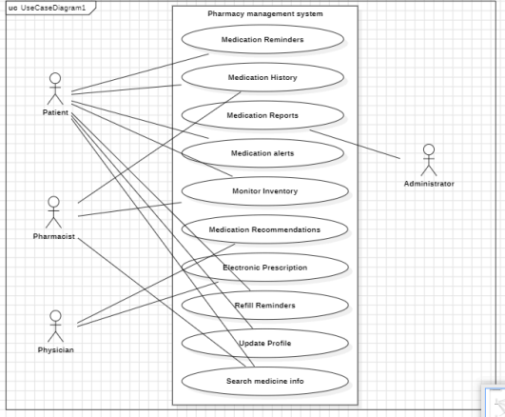

Domain Model Diagram:

# **4Diagrams: USE CASE : 01**

# **­­­**

# **SSD for Manage Medication Reminders**

# 

# 

# **SD : 01 (Setup Medication Reminder)**

# 

# **SD : 02 (Input Medication Details)**

# 

# **SD : 03 (Save Reminder Settings)**

# 

# **USE CASE : 02**

# **SSD for View Detailed Medication History**

# 

# 

# **SD : 01 (Request Medication History) (4)**

# 

# **SD : 02 (Filter Medication History) (5)**

# 

# **SD : 03 (View Detailed History) (5)**

# 

# **USE CASE : 03**

# **SSD for Generate Medication Adherence Reports**

# 

# 

# **SD: 01 (Access reporting module) (6)**

# 

# **SD : 02 (Generate medication reports) (7)**

# 

# **SD : 03 (select report format)**

# 

# **SD : 04 (export reports)**

# 

# 

# **USE CASE : 04**

# **SSD for Customize Medication Dosage Alerts**

# 

# **SD : 01 (Provide options for setup report) (8)**

# 

# **SD : 02 (input recommendations) (9)**

# 

# **SD : 03 (save alert settings)**

# 

# **USE CASEL :05**

# **SSD For Monitor Medication Inventory Levels**

# 

# 

# **SD : 01 (Check Medication inventory level) (10)**

# 

# **SD : 02 (Alert low level) (11)**

# 

# **SD : 03 (restock and update level)**

# 

# 

# **USE CASE: 06**

# **SSD for Provide Symptom-Based Medication Recommendations**

# 

# 

# **SD: 01 (enter patient symptoms) (12)**

# 

# **SD: 01 (retrieve relevant symptom reports)**

# 

# **SD: 03 (generate recommendations)**

# 

# **USE CASE : 07**

# **SSD for Facilitate Electronic Prescription Submission**

# 

# 

# **SD : 01 (13)**

# 

# **SD : 02 (14)**

# 

# **SD : 03**

# 

# **USE CASE :08**

# **SSD for Schedule Medication Refill Reminders**

# 

# 

# **SD : 01**

# 

# **SD : 02**

# 

# **SD : 03**

# 

# **USE CASE : 09**

# **SSD for Update Patient Profile Information**

# 

# 

# **SD : 01**

# 

# **SD : 02**

# 

# **SD : 03**

# 

# **USE CASE : 10**

# **SSD for Update Patient Profile Information**

# 

# 

# **SD : 01**

# 

# **SD : 02 d**

# 

# **Updated Use Case diagram:**

# **Domain Model DIAGRAM**

# 

# **CLASS DIAGRAM**

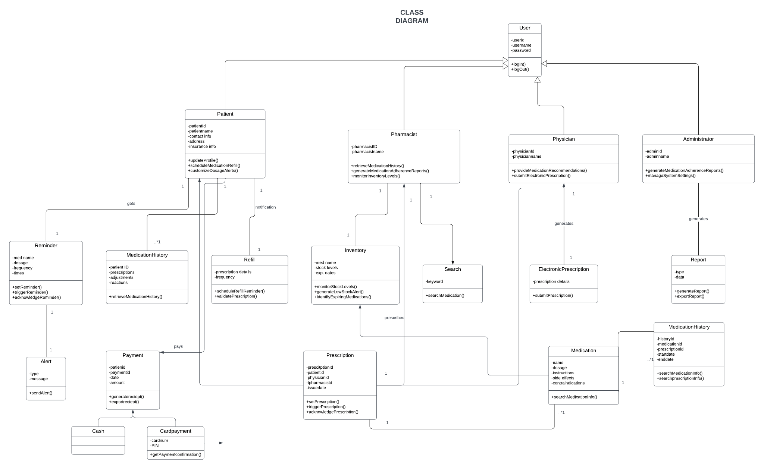

Package Diagram:

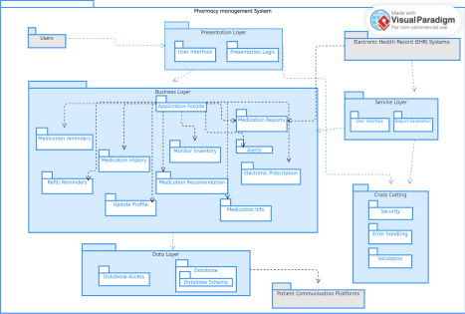

Deployment Diagram:

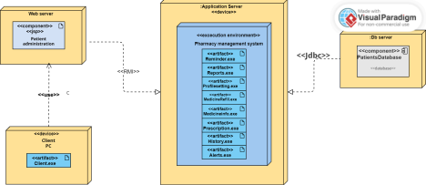Block Diagram:

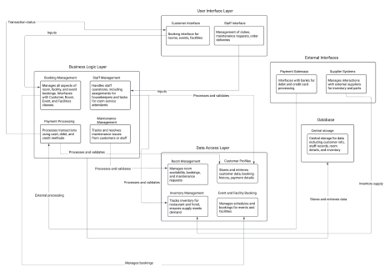

Component Diagram:

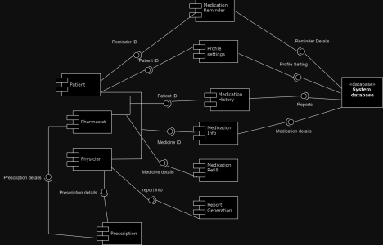

# **6 Work div:**

|  |  |
| --- | --- |
|  | Work done |
| Husnain | Patient side, word file |
| Zarnab | Doctor side, Login/ regisration, ,integration |