CSC418 DevOps - Lab Midterm Examination
Assignment Submission Portal with Automated Testing
Item | Details
Student | Husnain
Registration No. | FA23-BSE-003/ATK
University | COMSATS University Islamabad, Attock Campus
Course | CSC418 DevOps
Submission date | [SUBMISSION_DATE]
GitHub repository | [REPO_URL]
GitHub Pages URL (bonus) | [PAGES_URL]

Note on screenshots: Figures 1, 2, 6, 17 and 18 below are real captures taken from a local run of the delivered project. The other figures show GitHub, tunnel and email screens that can only be captured from your own account; they appear as placeholders of the form [SCREENSHOT_n: insert FILE here]. Instructions for inserting them are in Appendix C. Delete this note before submitting.

Table of Contents
1. Introduction and Scenario
2. Requirements Mapping
3. System Design
4. Implementation
5. Automated Tests
6. Continuous Integration Pipeline
7. Test Report and Local Receiver
8. Setup and Execution Guide
9. Demonstration and Results
10. Bonus Tasks
11. Troubleshooting
12. Conclusion
Appendix A: Source Code Listings
Appendix B: Evidence File Names
Appendix C: Screenshot Insertion Instructions

1. Introduction and Scenario
A department needs a simple assignment submission portal. Earlier updates occasionally broke the submission feature, so every code change must now be tested automatically, and the instructor needs a local record of the test results. This project delivers a portal built with Python and Flask, a set of automated tests, a GitHub Actions pipeline that runs on every push, and a local HTTP receiver that stores the test report as test-report.json on the instructor's computer.
Objectives:
- Build a portal that accepts a name, registration number, assignment title and submission URL, validates the input, saves valid submissions and displays them.
- Keep the application, tests, pipeline configuration and receiver in one GitHub repository with a README.
- Run at least three automated tests on every push and fail the pipeline when a test fails.
- Send a JSON test report with real results to a local receiver for both passing and failing runs.
- Demonstrate a passing run, a failing run caused by a defect, and a fixed run.
- Bonus: conditional deployment to GitHub Pages and an email report.

2. Requirements Mapping
Exam requirement | Marks | Where it is satisfied
1. Develop the submission portal | 8 | app/app.py, app/validation.py, app/templates/index.html
2. Maintain the project on GitHub, with README | 4 | Repository [REPO_URL]; README.md
3. Run automated tests on every push (3 test cases) | 10 | tests/test_submissions.py; .github/workflows/ci.yml (on: push)
4. Send report to localhost and save JSON | 14 | scripts/build_report.py; receiver/receiver.py; RECEIVER_URL secret
5. Demonstrate the complete workflow | 4 | Section 9: pass, fail, fix
Bonus: conditional deployment to GitHub Pages | 5 | deploy job in ci.yml; docs/index.html
Bonus: email report | 5 | scripts/send_email.py; email step in ci.yml

3. System Design

3.1 Architecture
The workflow of the system is as follows.
- The developer pushes a commit to GitHub.
- GitHub Actions starts the workflow on a hosted runner.
- The runner installs dependencies and runs pytest, which writes results.xml.
- scripts/build_report.py reads results.xml and the GitHub environment variables and writes report.json.
- The runner POSTs report.json to the public tunnel URL stored in the RECEIVER_URL secret.
- The tunnel forwards the request to the receiver on the developer's computer (localhost port 5001).
- The receiver saves the body as test-report.json.
- If tests failed, the job is marked failed. If tests passed on main, the deploy job publishes docs/ to GitHub Pages.

3.2 Technologies
Component | Technology
Language / web framework | Python 3.12, Flask
Testing | pytest with JUnit XML output
CI | GitHub Actions (ubuntu-latest)
Receiver | Python standard library http.server
Tunnel | [TUNNEL_TOOL_USED] (cloudflared or ngrok)
Static demo hosting | GitHub Pages
Email | SMTP over SSL (smtplib)

3.3 Project structure
app/ Flask application
app.py routes: GET / and POST /submit
validation.py required-field and URL validation
templates/index.html page template
tests/ pytest tests and fixture
receiver/receiver.py local HTTP receiver
scripts/build_report.py builds report.json from results.xml
scripts/send_email.py bonus: email report
docs/index.html bonus: static demo for GitHub Pages
.github/workflows/ci.yml CI pipeline
evidence/ screenshots

4. Implementation

4.1 Application
The Flask application exposes two routes. GET / renders the form and the list of saved submissions. POST /submit reads the four form fields, trims whitespace, validates them, and either re-renders the page with the error messages and HTTP status 400, or appends the submission to a JSON file and redirects to the list. The storage path comes from the SUBMISSIONS_FILE environment variable (default submissions.json) or from the create_app argument, which lets the tests use a temporary file.

4.2 Validation rules
- Name, registration number, assignment title and submission URL are all required. An empty or whitespace-only value produces the message "<Field> is required".
- The URL must use the http or https scheme and contain a host name. Otherwise the message "Submission URL is invalid (must start with http:// or https://)" is shown.
- A rejected submission is never saved.

4.3 Portal screenshots
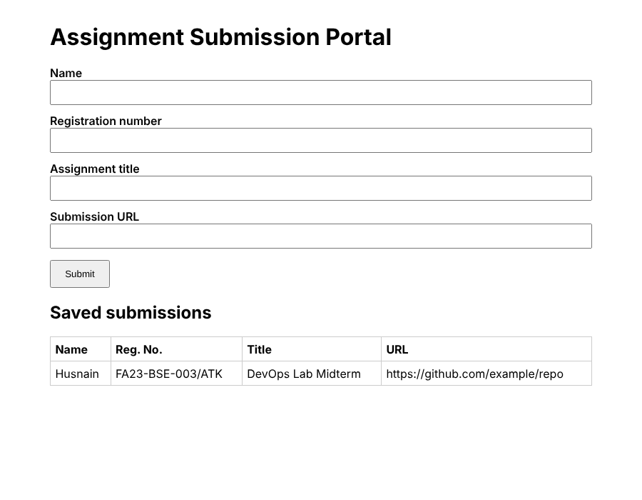
Figure 1: Portal with a saved submission
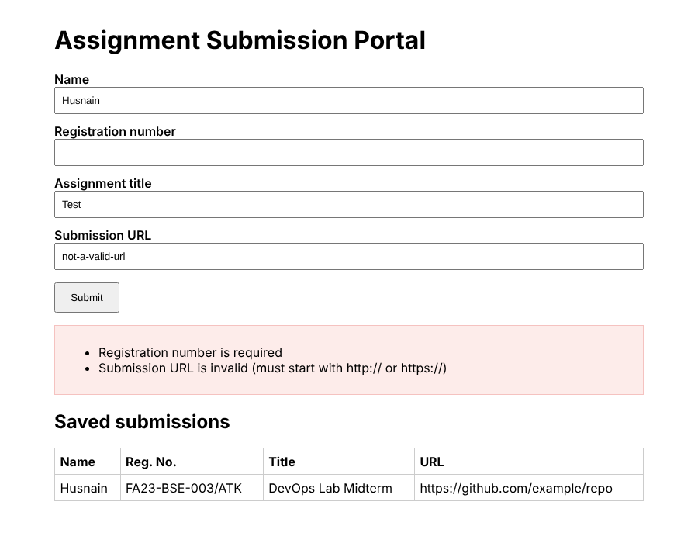
Figure 2: Validation messages for a missing registration number and an invalid URL

5. Automated Tests
The three required test cases are implemented with pytest and the Flask test client. Each test uses a temporary storage file, so tests do not affect real data and do not depend on each other.
Test function | Scenario | Expected result
test_valid_submission_is_saved_and_listed | Complete details and a valid URL | HTTP 200 after redirect; title and URL appear in the list
test_missing_registration_number_is_rejected | Registration number is empty | HTTP 400; message "Registration number is required"; nothing saved
test_invalid_url_is_rejected_and_not_saved | URL is "not-a-valid-url" | HTTP 400; message "Submission URL is invalid"; nothing saved

Results come from actually executing pytest. A failing test makes pytest exit with a non-zero code and the workflow fails the job. The figures below are local runs of the same tests.
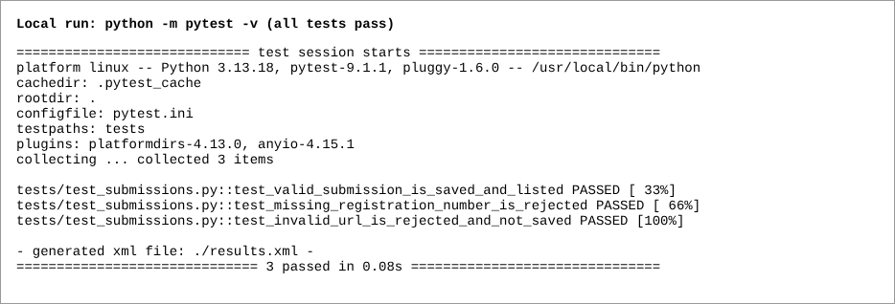
Figure 3: Local run: all three tests pass
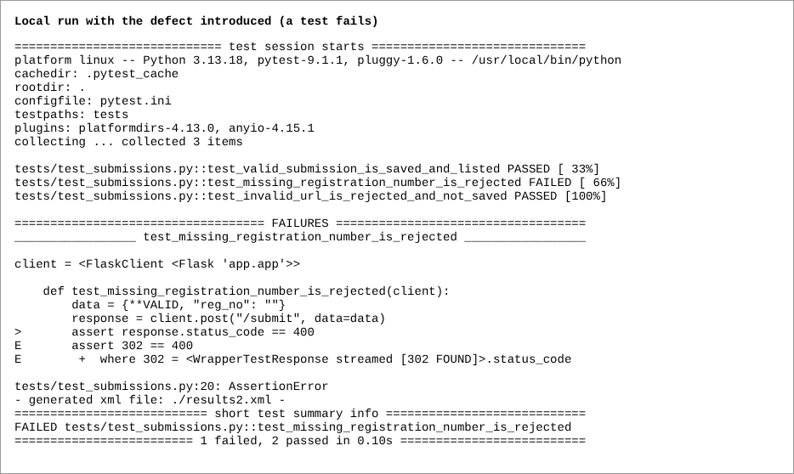
Figure 4: Local run after introducing the defect: one test fails

6. Continuous Integration Pipeline
The pipeline is defined in .github/workflows/ci.yml and is triggered by every push (on: push).

6.1 Job "test"
- Check out the repository (actions/checkout).
- Set up Python 3.12.
- Install dependencies from requirements.txt.
- Run pytest with --junitxml=results.xml. The step uses continue-on-error so the report steps still run when a test fails.
- Build report.json (always runs).
- Send the report to the receiver with curl (always runs, so failing runs are also delivered).
- Email the report if the EMAIL_TO secret is set (bonus).
- Final step: if the pytest step failed, exit 1. This is what turns a failing test into a failed pipeline.

6.2 Job "deploy" (bonus)
The deploy job declares needs: test and the condition github.ref == refs/heads/main. When the test job fails, the deploy job is skipped, so the previously published Pages site stays unchanged. When it runs, it uploads the docs/ folder as a Pages artifact and deploys it.

6.3 Secrets
Secret | Required | Purpose
RECEIVER_URL | Yes | Public tunnel URL of the local receiver, including a path such as /report
EMAIL_TO | Bonus | Email recipient
SMTP_HOST | Bonus | SMTP server, e.g. smtp.gmail.com
SMTP_USER | Bonus | Sender address
SMTP_PASSWORD | Bonus | App password; never stored in the repository

7. Test Report and Local Receiver

7.1 Report content
Field | Source
repository | GITHUB_REPOSITORY
branch | GITHUB_REF_NAME
commit_sha | GITHUB_SHA
run_id | GITHUB_RUN_ID
timestamp | UTC time when the report is built
tests[].name / result / failure_message | pytest results.xml
total, passed, failed | computed from the test list
overall_status | "passed" only if every test passed, otherwise "failed"

7.2 Receiver
receiver/receiver.py is a small HTTP server that listens on port 5001 (configurable with PORT). It answers GET requests with a status message and, for each POST, parses the JSON body and writes it to test-report.json (configurable with REPORT_FILE). Invalid JSON is rejected with status 400. Each saved report is logged with its status and commit.

7.3 Reaching the computer from GitHub
A GitHub-hosted runner's localhost is the runner itself, so a tunnel exposes the local receiver on a public URL. The tunnel and the receiver must both stay running during the demonstration. Free tunnel URLs change when restarted, so the RECEIVER_URL secret must be updated after every restart.
[SCREENSHOT_5: insert 05_receiver_and_tunnel_running.png here]
Figure 5: Receiver and tunnel running in two terminals
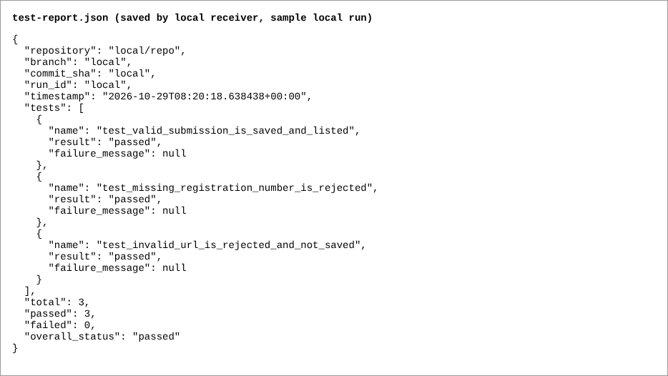
Figure 6: test-report.json saved by the local receiver
This capture is from a local sample run (repository and commit show "local"). Replace it with the file produced by a real GitHub run if you wish.

8. Setup and Execution Guide

8.1 Prerequisites
- Python 3.10 or newer, Git, a GitHub account, and cloudflared or ngrok.
- On Windows use PowerShell or Git Bash; use py if python is not found.

8.2 Run the application
python -m venv .venv
.venv\Scripts\Activate.ps1 (Windows PowerShell)
source .venv/bin/activate (macOS / Linux)
pip install -r requirements.txt
python -m app.app (open http://127.0.0.1:5000)

8.3 Run the tests
python -m pytest -v

8.4 Start the receiver and the tunnel
python receiver/receiver.py
cloudflared tunnel --url http://localhost:5001 (second terminal)
or: ngrok http 5001

Copy the public URL and add a path, for example https://<tunnel-host>/report. Store it as the RECEIVER_URL secret.

8.5 Create the repository and push
git init
git add .
git commit -m "Initial commit: portal, tests, CI, receiver"
git branch -M main
git remote add origin https://github.com/<USER>/<REPO>.git
git push -u origin main

Use a public repository so GitHub Pages works on a free account. Add the secrets before the first push.
[SCREENSHOT_3: insert 03_github_repo.png here]
Figure 7: GitHub repository with folders and README
[SCREENSHOT_4: insert 04_actions_run_list.png here]
Figure 8: GitHub Actions run list

9. Demonstration and Results

9.1 Run 1: all tests pass
Command: git commit --allow-empty -m "Demo run 1: passing" followed by git push.
Commit: [COMMIT_SHA_RUN_1] Run ID: [RUN_ID_1] Result: [RESULT, e.g. 3 passed, 0 failed]
[SCREENSHOT_7: insert 07_run1_pass_actions.png here]
Figure 9: Run 1: passing pipeline in GitHub Actions
[SCREENSHOT_8: insert 08_run1_pass_json.png here]
Figure 10: Run 1: local test-report.json with overall_status "passed"

9.2 Run 2: a defect is introduced (tests fail)
The defect removes the registration number from the required fields:
sed -i 's/"reg_no", //' app/validation.py (Git Bash / macOS / Linux)
(Get-Content app/validation.py) -replace '"reg_no", ', '' | Set-Content app/validation.py (PowerShell)
git commit -am "Introduce defect: skip reg_no validation"
git push

Defect description: [DESCRIBE_DEFECT] Commit: [COMMIT_SHA_RUN_2] Run ID: [RUN_ID_2] Result: [RESULT, e.g. 2 passed, 1 failed]
Expected behaviour: the missing-registration test fails because the application accepts the submission (HTTP 302 instead of 400). The pipeline turns red, the report is still delivered, and the JSON shows overall_status "failed" with the failure message.
[SCREENSHOT_9: insert 09_run2_fail_actions.png here]
Figure 11: Run 2: failing pipeline in GitHub Actions
[SCREENSHOT_10: insert 10_run2_fail_json.png here]
Figure 12: Run 2: local test-report.json with overall_status "failed" and failure message

9.3 Run 3: the defect is fixed
git revert HEAD --no-edit
git push

Commit: [COMMIT_SHA_RUN_3] Run ID: [RUN_ID_3] Result: [RESULT]
[SCREENSHOT_11: insert 11_run3_fixed_actions.png here]
Figure 13: Run 3: passing pipeline after the fix
[SCREENSHOT_12: insert 12_run3_fixed_json.png here]
Figure 14: Run 3: local test-report.json back to "passed"

9.4 Summary of runs
Run | Change | Pipeline | overall_status | Passed / Failed
1 | Clean code | [Green] | passed | [3 / 0]
2 | Defect introduced | [Red] | failed | [2 / 1]
3 | Defect reverted | [Green] | passed | [3 / 0]

10. Bonus Tasks
Delete this section if the bonus tasks are not attempted.

10.1 Conditional deployment to GitHub Pages (5 marks)
Set Settings > Pages > Source to GitHub Actions. On a push to main with all tests passing, the deploy job publishes docs/index.html, a static demo that validates input in the browser (no server storage). On a failing run the deploy job is skipped and the published version is unchanged. Deployed URL: [PAGES_URL]
[SCREENSHOT_13: insert 13_pages_site.png here]
Figure 15: Deployed GitHub Pages site
[SCREENSHOT_14: insert 14_pages_deploy_skipped_on_fail.png here]
Figure 16: Deploy job skipped on the failing run

10.2 Email report (5 marks)
scripts/send_email.py sends an email containing the commit identifier, branch, run ID, overall result, test counts, each test result and the JSON report as an attachment. It runs after passing and failing runs. SMTP settings come only from CI secrets (for Gmail, use an app password).
[SCREENSHOT_15: insert 15_email_pass.png here]
Figure 17: Email received for the passing run
[SCREENSHOT_16: insert 16_email_fail.png here]
Figure 18: Email received for the failing run

11. Troubleshooting
Problem | Likely cause and fix
Run is red but all tests passed | The send-report step failed: receiver or tunnel not running, or RECEIVER_URL is outdated. Restart, update the secret and re-run.
test-report.json not updated | Receiver not running, wrong URL, or the tunnel restarted.
curl error 22 in the log | Receiver returned an error or the URL is wrong. Open the URL in a browser; it should answer "receiver is running".
Deploy job skipped on a passing run | Push was not to main, or Pages source is not GitHub Actions.
No email | EMAIL_TO not set, wrong SMTP host, or an app password is required.
ModuleNotFoundError: app | Run commands from the project root.
Port already in use | Use another port with the PORT variable and tunnel that port.

12. Conclusion
The project delivers a working submission portal and an automated quality gate: every push is tested, a failing test fails the pipeline, and real test results are delivered to a local JSON file for both passing and failing runs. The demonstration of a passing, failing and corrected run shows that the pipeline detects defects automatically. [ADD_ANY_LIMITATIONS, e.g. tunnel URL changes on restart; JSON file storage is not suitable for heavy use.]

Appendix A: Source Code Listings

.github/workflows/ci.yml
name: CI

on:
push:

permissions:
contents: read

jobs:
test:
runs-on: ubuntu-latest
env:
EMAIL_TO: ${{ secrets.EMAIL_TO }}
SMTP_HOST: ${{ secrets.SMTP_HOST }}
SMTP_USER: ${{ secrets.SMTP_USER }}
SMTP_PASSWORD: ${{ secrets.SMTP_PASSWORD }}
steps:
- uses: actions/checkout@v4

- uses: actions/setup-python@v5
with:
python-version: "3.12"

- name: Install dependencies
run: pip install -r requirements.txt

- name: Run tests
id: tests
run: python -m pytest -v --junitxml=results.xml
continue-on-error: true

- name: Build JSON report
if: always()
run: python scripts/build_report.py

- name: Send report to local receiver
if: always()
run: |
curl -fsS --retry 3 -X POST \
-H "Content-Type: application/json" \
--data @report.json \
"${{ secrets.RECEIVER_URL }}"

- name: Email report (bonus, runs only if EMAIL_TO secret is set)
if: always() && env.EMAIL_TO != ''
run: python scripts/send_email.py

- name: Fail the job if tests failed
if: always() && steps.tests.outcome == 'failure'
run: |
echo "Tests failed"
exit 1

# Bonus: deploy the static demo only when ALL tests passed on main.
deploy:
needs: test
if: github.ref == 'refs/heads/main'
runs-on: ubuntu-latest
permissions:
pages: write
id-token: write
environment:
name: github-pages
url: ${{ steps.deployment.outputs.page_url }}
steps:
- uses: actions/checkout@v4
- uses: actions/upload-pages-artifact@v3
with:
path: docs
- id: deployment
uses: actions/deploy-pages@v4

app/app.py
"""Assignment submission portal (Flask)."""
import json
import os

from flask import Flask, redirect, render_template, request, url_for

from .validation import validate

def create_app(storage_path=None):
app = Flask(__name__)
app.config["STORAGE"] = storage_path or os.environ.get("SUBMISSIONS_FILE", "submissions.json")

def load():
try:
with open(app.config["STORAGE"], encoding="utf-8") as f:
return json.load(f)
except (FileNotFoundError, json.JSONDecodeError):
return []

def save(items):
with open(app.config["STORAGE"], "w", encoding="utf-8") as f:
json.dump(items, f, indent=2)

@app.get("/")
def index():
return render_template("index.html", submissions=load(), errors=[], form={})

@app.post("/submit")
def submit():
form = {k: (request.form.get(k) or "").strip() for k in ("name", "reg_no", "title", "url")}
errors = validate(form)
if errors:
return render_template("index.html", submissions=load(), errors=errors, form=form), 400
items = load()
items.append(form)
save(items)
return redirect(url_for("index"))

return app

if __name__ == "__main__":
create_app().run(host="127.0.0.1", port=5000, debug=False)

app/validation.py
"""Input validation for the assignment submission portal."""
from urllib.parse import urlparse

REQUIRED_FIELDS = ("name", "reg_no", "title", "url")

LABELS = {
"name": "Name",
"reg_no": "Registration number",
"title": "Assignment title",
"url": "Submission URL",
}

def validate(data):
"""Return a list of validation messages. An empty list means the data is valid."""
errors = []
for field in REQUIRED_FIELDS:
if not (data.get(field) or "").strip():
errors.append(f"{LABELS[field]} is required")

url = (data.get("url") or "").strip()
if url:
parsed = urlparse(url)
if parsed.scheme not in ("http", "https") or not parsed.netloc:
errors.append("Submission URL is invalid (must start with http:// or https://)")
return errors

tests/conftest.py
import pytest

from app.app import create_app

@pytest.fixture
def client(tmp_path):
app = create_app(storage_path=str(tmp_path / "submissions.json"))
app.config["TESTING"] = True
return app.test_client()

tests/test_submissions.py
VALID = {
"name": "Test Student",
"reg_no": "FA00-XXX-000/ATK",
"title": "Midterm Lab",
"url": "https://github.com/example/repo",
}

def test_valid_submission_is_saved_and_listed(client):
response = client.post("/submit", data=VALID, follow_redirects=True)
assert response.status_code == 200
page = client.get("/").data
assert b"Midterm Lab" in page
assert b"https://github.com/example/repo" in page

def test_missing_registration_number_is_rejected(client):
data = {**VALID, "reg_no": ""}
response = client.post("/submit", data=data)
assert response.status_code == 400
assert b"Registration number is required" in response.data
assert b"Midterm Lab" not in client.get("/").data

def test_invalid_url_is_rejected_and_not_saved(client):
data = {**VALID, "url": "not-a-valid-url"}
response = client.post("/submit", data=data)
assert response.status_code == 400
assert b"Submission URL is invalid" in response.data
assert b"not-a-valid-url" not in client.get("/").data

scripts/build_report.py
"""Build report.json from pytest's results.xml (JUnit) plus GitHub Actions metadata."""
import json
import os
import xml.etree.ElementTree as ET
from datetime import datetime, timezone

tests = []
root = ET.parse("results.xml").getroot()
for case in root.iter("testcase"):
problem = case.find("failure")
if problem is None:
problem = case.find("error")
failed = problem is not None
tests.append({
"name": case.get("name"),
"result": "failed" if failed else "passed",
"failure_message": (problem.get("message") if failed else None),
})

passed = sum(t["result"] == "passed" for t in tests)
report = {
"repository": os.environ.get("GITHUB_REPOSITORY", "local/repo"),
"branch": os.environ.get("GITHUB_REF_NAME", "local"),
"commit_sha": os.environ.get("GITHUB_SHA", "local"),
"run_id": os.environ.get("GITHUB_RUN_ID", "local"),
"timestamp": datetime.now(timezone.utc).isoformat(),
"tests": tests,
"total": len(tests),
"passed": passed,
"failed": len(tests) - passed,
"overall_status": "passed" if tests and passed == len(tests) else "failed",
}

with open("report.json", "w", encoding="utf-8") as f:
json.dump(report, f, indent=2)
print(json.dumps(report, indent=2))

receiver/receiver.py
"""Local HTTP receiver: saves the POSTed CI test report as test-report.json.

Run: python receiver/receiver.py
Env: PORT (default 5001), REPORT_FILE (default test-report.json)
"""
import json
import os
from http.server import BaseHTTPRequestHandler, HTTPServer

PORT = int(os.environ.get("PORT", "5001"))
REPORT_FILE = os.environ.get("REPORT_FILE", "test-report.json")

class Handler(BaseHTTPRequestHandler):
def _reply(self, code, message):
body = json.dumps({"message": message}).encode()
self.send_response(code)
self.send_header("Content-Type", "application/json")
self.send_header("Content-Length", str(len(body)))
self.end_headers()
self.wfile.write(body)

def do_GET(self):
self._reply(200, "receiver is running")

def do_POST(self):
length = int(self.headers.get("Content-Length", 0))
raw = self.rfile.read(length)
try:
report = json.loads(raw)
except json.JSONDecodeError:
self._reply(400, "body is not valid JSON")
return
with open(REPORT_FILE, "w", encoding="utf-8") as f:
json.dump(report, f, indent=2)
print(f"[receiver] saved {REPORT_FILE}: status={report.get('overall_status')} "
f"commit={str(report.get('commit_sha'))[:7]}", flush=True)
self._reply(200, f"saved to {REPORT_FILE}")

def log_message(self, fmt, *args):
print("[receiver]", fmt % args, flush=True)

if __name__ == "__main__":
print(f"[receiver] listening on 0.0.0.0:{PORT}, writing {REPORT_FILE}", flush=True)
HTTPServer(("0.0.0.0", PORT), Handler).serve_forever()

scripts/send_email.py
"""Bonus: email the test report (SMTP settings come from environment variables / CI secrets)."""
import json
import os
import smtplib
from email.message import EmailMessage

report = json.load(open("report.json", encoding="utf-8"))
msg = EmailMessage()
msg["Subject"] = f"[CI] {report['overall_status'].upper()} - {report['repository']} @ {report['commit_sha'][:7]}"
msg["From"] = os.environ["SMTP_USER"]
msg["To"] = os.environ["EMAIL_TO"]

lines = [
f"Commit: {report['commit_sha']}",
f"Branch: {report['branch']}",
f"Run ID: {report['run_id']}",
f"Result: {report['overall_status']}",
f"Total: {report['total']} Passed: {report['passed']} Failed: {report['failed']}",
"",
]
for t in report["tests"]:
extra = f" - {t['failure_message']}" if t["failure_message"] else ""
lines.append(f"{t['result'].upper():7} {t['name']}{extra}")
msg.set_content("\n".join(lines))
msg.add_attachment(json.dumps(report, indent=2).encode(), maintype="application",
subtype="json", filename="test-report.json")

with smtplib.SMTP_SSL(os.environ["SMTP_HOST"], int(os.environ.get("SMTP_PORT", "465"))) as s:
s.login(os.environ["SMTP_USER"], os.environ["SMTP_PASSWORD"])
s.send_message(msg)
print("email sent")

Appendix B: Evidence File Names
Figure placeholder | File in evidence/ | Content
SCREENSHOT_1 | 01_portal_form_and_list.png | Portal with saved submission (included)
SCREENSHOT_2 | 02_validation_message.png | Validation message (included)
SCREENSHOT_3 | 03_github_repo.png | Repository
SCREENSHOT_4 | 04_actions_run_list.png | Actions tab
SCREENSHOT_5 | 05_receiver_and_tunnel_running.png | Receiver and tunnel
SCREENSHOT_6 | 06_json_file_contents.png | test-report.json (local sample included)
SCREENSHOT_7 | 07_run1_pass_actions.png | Run 1 pipeline
SCREENSHOT_8 | 08_run1_pass_json.png | Run 1 JSON
SCREENSHOT_9 | 09_run2_fail_actions.png | Run 2 pipeline
SCREENSHOT_10 | 10_run2_fail_json.png | Run 2 JSON
SCREENSHOT_11 | 11_run3_fixed_actions.png | Run 3 pipeline
SCREENSHOT_12 | 12_run3_fixed_json.png | Run 3 JSON
SCREENSHOT_13 | 13_pages_site.png | Bonus: Pages site
SCREENSHOT_14 | 14_pages_deploy_skipped_on_fail.png | Bonus: deploy skipped
SCREENSHOT_15 | 15_email_pass.png | Bonus: email, pass
SCREENSHOT_16 | 16_email_fail.png | Bonus: email, fail
- | 17_local_tests_pass.png | Local pytest pass (included)
- | 18_local_tests_fail.png | Local pytest fail (included)

Appendix C: Screenshot Insertion Instructions
Delete this appendix and the note on the first page before submitting.
- Take each screenshot and save it in the evidence/ folder using the file name in Appendix B.
- In this document find the line [SCREENSHOT_n: insert FILE here] and delete it.
- With the cursor on that empty centered line choose Insert > Pictures > This Device and select the file.
- Make sure the layout is In Line with Text and the width is at most 6 inches (Picture Format > Size).
- Keep the "Figure n" caption below the picture; it already describes the image.
- Replace every remaining bracketed value such as [REPO_URL], [COMMIT_SHA_RUN_1] and [RESULT] with real values.
- Search the document for "[" to confirm no placeholder remains, then export to PDF if your instructor asks for it.

