**Getting Invitation on HackTheBox.gr**

[May 15, 2017](http://stoner1337.blogspot.com/2017/05/getting-invitation-on-hacktheboxgr.html)

As surfing twitter , i got the link https://www.hackthebox.gr/en and which says "

**Hack The Box**

An online platform to test and advance your skills in penetration testing and cyber security."

[[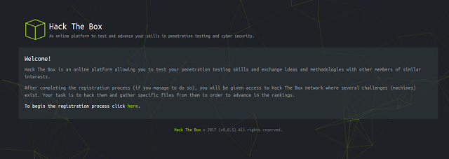](https://1.bp.blogspot.com/-JQ7xJ8Z_Kq8/WRnDM2DXIxI/AAAAAAAAAAM/UjnqYh5m5Jw8vspdviIRHv6T6so13OP-gCLcB/s1600/Screenshot%2Bfrom%2B2017-05-15%2B20-44-07.png)](https://1.bp.blogspot.com/-JQ7xJ8Z_Kq8/WRnDM2DXIxI/AAAAAAAAAAM/UjnqYh5m5Jw8vspdviIRHv6T6so13OP-gCLcB/s1600/Screenshot%2Bfrom%2B2017-05-15%2B20-44-07.png)

But , for registration it says like "After completing the registration process (if you manage to do so), " Oh ! something fishy , huh ?

https://www.hackthebox.gr/en/invite

First rule : , always check the source code , and so did I :D

https://www.hackthebox.gr/js/inviteapi.min.js

**var _0x1f0f=** ["\x50\x4F\x53\x54","\x6A\x73\x6F\x6E","\x2F\x6 .................. x1f0f[3]]

For seeing what js is saying, just opened the console and typed

**_0x1f0f**

[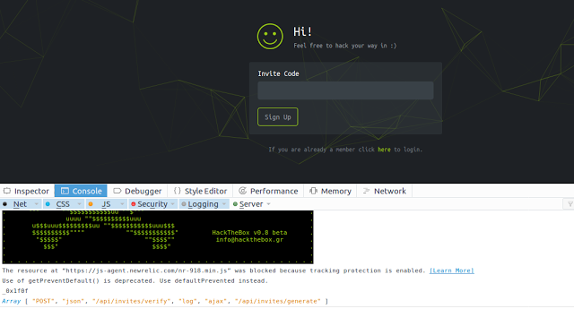](https://1.bp.blogspot.com/-Wz-KMAONHEU/WRnFUJjQdqI/AAAAAAAAAAY/RksiYuuFp8s2daiZuBeOlB46uaVjtX4SgCLcB/s1600/Screenshot%2Bfrom%2B2017-05-15%2B20-56-36.png)

Light up that somky burp ,,,,,, intercept then send do repeater ,

**POST /api/invites/generate HTTP/1.1**

**Response:**

HTTP/1.1 200 OK   
Date: Mon, 15 May 2017 15:38:44 GMT   
Content-Type: application/json   
Connection: close   
Vary: Accept-Encoding   
Cache-Control: no-cache, private   
X-RateLimit-Limit: 60   
X-RateLimit-Remaining: 59   
Strict-Transport-Security: max-age=63072000; includeSubdomains;   
X-Frame-Options: DENY   
Server: cloudflare-nginx   
CF-RAY: 35f72f988a116fc0-SIN   
Content-Length: 189   
  
{"success":1,"data":{"code":"ATNCD-EOWAR-JAGFH-WAHHT-LBONN","used":0,"ip_address":"xxx.xxx.xxx.xxx","updated_at":"2017-05-15 18:38:44","created_at":"2017-05-15 18:38:44","id":2467},"0":200}

**Enjoy !!!!**

**Stay hIGH :3**