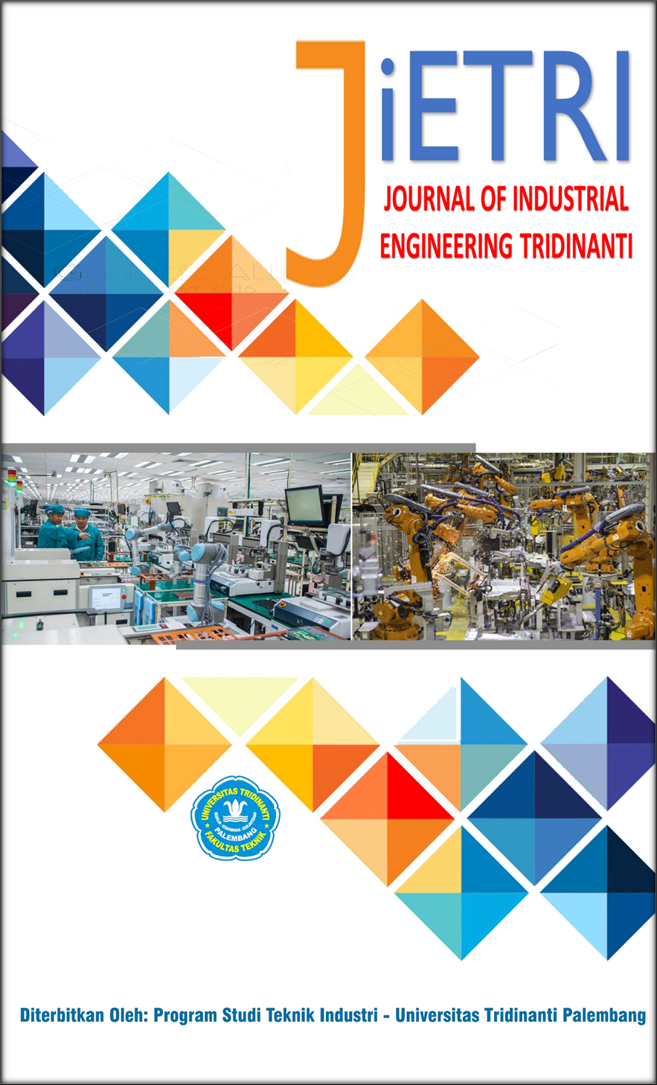

JOURNAL OF INDUSTRIAL ENGINEERING TRIDINANTI

e-ISSN: 2988-2303

http://jietri.univ-tridinanti.ac.id

Integrating Lean Production, Value Stream Mapping, and Industry 4.0 for Logistics Performance Improvement in the Automotive Industry: A Conceptual Framework

Muhammad Wahid Malik Aljabar^{*1}, Tolu Tamalika²
¹Program Studi Teknik Industri, Fakultas Teknik, Universitas Borobudur
²Program Studi Teknik Industri, Fakultas Teknik, Universitas Tridinanti
ARTICLE INFO |  | ABSTRAK
Article history:  Diterima xx-xx-xx  Diperbaiki xx-xx-xx  Disetujui xx-xx-xx |  | This study develops a conceptual framework integrating Lean Production, Value Stream Mapping (VSM), Industry 4.0 capability, and information quality to enhance production logistics integration and logistics performance in the automotive industry. The motivation of this study arises from the fragmented nature of existing literature, where Lean Production, digital transformation, and logistics optimization are often discussed separately without a unified conceptual structure. The automotive industry, characterized by high complexity and dynamic supply chain interactions, requires a more integrated approach to improve efficiency and responsiveness across production and logistics systems.The study employs a conceptual paper approach based on literature synthesis to identify key relationships among Lean Production, Value Stream Mapping, Industry 4.0 capability, information quality, production logistics integration, and logistics performance. Lean Production focuses on waste reduction and process efficiency, while Value Stream Mapping supports the visualization of material and information flows to identify inefficiencies. Industry 4.0 capability enhances real-time data integration and system connectivity, improving information quality and decision-making processes. These elements collectively contribute to strengthening production logistics integration as a central mechanism for improving logistics performance. The proposed conceptual framework suggests that Lean Production, Value Stream Mapping, Industry 4.0 capability, and information quality positively influence production logistics integration, which in turn enhances logistics performance. The integration of lean and digital capabilities provides a more comprehensive approach to managing material flow, information flow, and operational coordination in automotive manufacturing systems. This study contributes to the literature by providing a unified conceptual model that bridges lean manufacturing and Industry 4.0 in the context of logistics systems, offering a foundation for future empirical validation and industrial application.
Keywords:
Lean Production; Value Stream Mapping; Industry 4.0; Information Quality

Introduction
1.1 Background
The automotive industry is a manufacturing sector characterized by high levels of competition and significant process complexity [1]. Production activities in this industry involve various interconnected processes, from material procurement and production processes, quality control, component distribution, and logistics system management [2][3]. This complexity requires automotive companies to maintain operational efficiency and ensure the smooth flow of materials and information to optimally achieve production targets. Furthermore, increasing market demands for product quality, on-time delivery, and production flexibility are driving companies to continuously improve their manufacturing systems. This makes production and logistics process efficiency a crucial factor in enhancing the competitiveness of the automotive industry [4].
Lean production is one approach widely used to improve operational efficiency in the manufacturing industry [5]. The lean production concept focuses on eliminating waste, increasing value-added activities, and optimizing production and logistics process flows. This approach evolved from lean manufacturing principles, which emphasize continuous improvement to create a more effective and responsive production system. Lean production is implemented not only in production but also in logistics systems and supply chain management, as all operational activities are interconnected and support a smooth manufacturing process [6]. By implementing lean production, companies are expected to reduce waste, increase productivity, and accelerate process flow within production and logistics systems [7].
To support lean production implementation, value stream mapping (VSM) is a widely used method for mapping material flow and information flow within manufacturing processes [8]. This method helps companies identify bottlenecks, delays, waiting times, and non-value-added activities that impact operational efficiency [9]. Through comprehensive process visualization, companies can understand the relationship between production and logistics activities more systematically. Furthermore, value stream mapping plays a role in improving coordination between material flow and information flow, thus supporting production logistics integration within the manufacturing system. Therefore, the use of value stream mapping is crucial in efforts to improve the effectiveness of logistics systems in the automotive industry [10].
The development of Industry 4.0 has also transformed modern production and logistics systems through the use of digital technology and real-time information integration [11]. The Industry 4.0 concept emphasizes the use of information quality, production control, data integration, and monitoring systems to support the effectiveness of manufacturing operations. The presence of digital technology enables companies to obtain faster, more accurate, and more integrated information, thus supporting more responsive operational decision-making. Furthermore, the implementation of Industry 4.0 is also considered capable of strengthening the implementation of lean production because companies can increase visibility into overall production and logistics activities. Therefore, the integration of lean production and Industry 4.0 is a strategic approach to improving logistics performance in the automotive industry [12].
Although research on lean production, value stream mapping, logistics systems, supply chain management, and Industry 4.0 has grown rapidly, studies that integrate all these concepts within a single conceptual framework are still relatively limited, particularly in the automotive industry context. Some studies focus more on increasing production efficiency and reducing waste, while others focus more on the digitalization of manufacturing systems and information control [13]. However, improving logistics performance is not only influenced by material flow efficiency, but also by information flow synchronization, information quality, and integrated coordination of production and logistics processes [14]. Therefore, it is necessary to develop a conceptual framework that can explain the relationship between lean production, value stream mapping, Industry 4.0 capability, information quality, and production logistics integration to support improved logistics performance in the automotive industry.

1.2 Problem Formulation
Research on lean production, logistics systems, value stream mapping, and Industry 4.0 in the automotive industry shows that each concept is still largely studied in isolation [15]. Lean manufacturing studies generally focus on waste reduction and increased production process efficiency, while research related to Industry 4.0 focuses more on the use of digital technology, information quality, and production control to support manufacturing and logistics activities [16]. This situation indicates that the integration of lean approaches and digital capabilities in supporting logistics performance has not been comprehensively explained [17]. Furthermore, value stream mapping is still primarily used as a tool for mapping production processes rather than as an integrative approach capable of connecting material flow and information flow within a manufacturing logistics system. However, improving logistics performance in the automotive industry requires synchronization between production activities, information flow, and comprehensive logistics coordination. Therefore, a conceptual framework is needed that can explain the relationship between lean production, value stream mapping, Industry 4.0 capability, information quality, and production logistics integration in improving logistics performance in the automotive industry.

1.3 Research Objectives and Benefits
This research aims to develop a conceptual framework that integrates lean production, value stream mapping, Industry 4.0 capability, information quality, and production logistics integration in the context of improving logistics performance in the automotive industry. Furthermore, this research aims to explain the relationships between variables that play a role in supporting the synchronization of material flow, information flow, and logistics activities within the manufacturing system. Through the development of this conceptual framework, this research is expected to provide a more structured overview of the integration of lean approaches and digital capabilities in supporting operational efficiency in the automotive industry [18]. Theoretically, this research is expected to strengthen the development of lean production and Industry 4.0 studies through an integrative approach in manufacturing logistics systems. This research also contributes to broadening understanding of the role of value stream mapping and information quality in supporting production logistics integration. Practically, the research results are expected to serve as a reference for automotive manufacturing companies in understanding the importance of integration between production systems, information technology, and logistics activities to improve efficiency, process coordination, and overall logistics performance.

Research Methodology
This study uses a conceptual paper approach with a literature-based analysis method to develop a conceptual framework regarding the integration of lean production, value stream mapping, Industry 4.0 capability, information quality, and production logistics integration in improving logistics performance in the automotive industry. The conceptual paper approach was chosen because this study focuses on developing conceptual relationships between variables based on a synthesis of relevant literature, rather than on direct empirical testing. Through this approach, the study aims to build a more structured theoretical understanding of the integration of lean and digital manufacturing approaches in manufacturing logistics systems.
Data sources in this study were obtained from Scopus-indexed scientific publications related to lean production, value stream mapping, logistics systems, supply chain management, Industry 4.0, production control, information quality, and automotive manufacturing. The literature used consisted of journal articles and conference papers relevant to the research topic. All documents were analyzed to identify dominant research themes, relationships between variables, and research development directions related to improving logistics performance in the automotive industry.
The research phase begins with the identification of literature based on the relevance of the research topic and keywords. This is followed by a classification and grouping of the literature based on key themes, such as lean production, logistics systems, value stream mapping, Industry 4.0, and production logistics integration. Following the grouping process, the research continues with a conceptual analysis to identify interrelationships between variables and identify research gaps in previous research. This analysis serves as the basis for developing the research's conceptual framework.

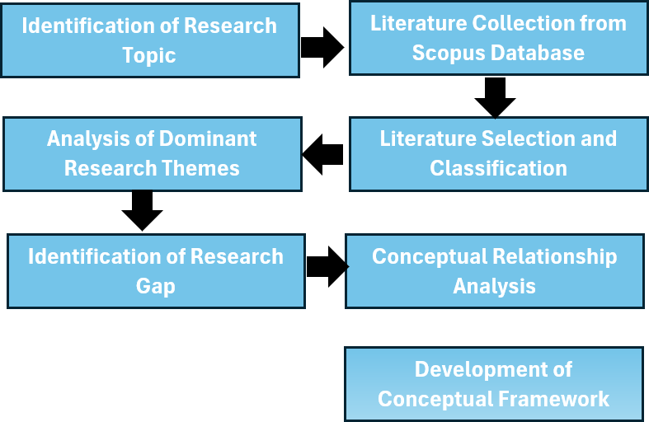
Fig. 1. Research Flow Diagram

In this study, lean production, value stream mapping, Industry 4.0 capability, and information quality are positioned as the main variables influencing production logistics integration and logistics performance. The relationships between these variables are analyzed theoretically based on a synthesis of the reviewed literature. The resulting conceptual framework is then used to explain how the integration of a lean approach and digital capabilities can support increased logistics system effectiveness in the automotive industry.
The results of this study include the development of a conceptual framework that illustrates the relationships between lean production, value stream mapping, Industry 4.0 capability, information quality, production logistics integration, and logistics performance. This framework is expected to serve as a theoretical basis for further research, particularly empirical research aimed at examining the relationships between these variables in the context of the automotive manufacturing industry.

Result and Discussion
4.1 Dominant Research Themes
Literature analysis shows that research in the automotive industry is dominated by lean production, logistics systems, supply chain management, value stream mapping, and Industry 4.0. The primary focus of research generally relates to increasing operational efficiency, reducing waste, optimizing material flow, and improving coordination of production and logistics processes. Furthermore, several studies emphasize the importance of information integration and production control in supporting the effectiveness of modern manufacturing systems.
Lean production is one of the most frequently discussed topics in automotive manufacturing research. Most studies explain that implementing lean production can improve process efficiency by eliminating non-value-added activities, reducing waiting times, and increasing the smoothness of production flow. Furthermore, the lean approach is also associated with improved logistics performance due to its ability to improve material flow coordination and reduce waste in operational activities.
Research related to value stream mapping shows that the method is widely used to map material flow and information flow within production systems. The use of VSM helps companies identify bottlenecks, delays, and process flow imbalances that impact the effectiveness of logistics systems. However, most studies still use VSM as a production process analysis tool and have not developed the approach in the context of comprehensive logistics and information system integration.s

Table.1 Dominant Research Themes
Main Theme | Research Focus
Lean Production | Waste reduction, efficiency
Value Stream Mapping | Material & information flow
Industry 4.0 | Digital integration
Information Quality | Data accuracy & visibility
Logistics Performance | Operational efficiency

The Dominant Research Themes table shows that research in the automotive industry is dominated by lean production, value stream mapping, logistics systems, Industry 4.0, and logistics performance. These results indicate that the focus of research remains on improving operational efficiency, integrating production and logistics processes, and utilizing digital technology to support modern manufacturing systems.
Furthermore, the development of Industry 4.0 demonstrates increasing attention to the use of digital technology to support manufacturing and logistics activities. Research related to Industry 4.0 generally discusses information quality, production control, data integration, and monitoring systems to increase visibility and responsiveness in operational processes. The presence of digital technology is considered capable of strengthening the implementation of lean production because companies can obtain information more quickly, accurately, and integratedly to support operational decision-making.
Based on the results of the literature synthesis, it is understood that the relationship between lean production, value stream mapping, Industry 4.0 capability, and information quality is strongly linked in supporting production logistics integration and logistics performance. However, research integrating all these variables within a single conceptual framework is still relatively limited. Therefore, this study develops a conceptual model that connects all these variables as a basis for understanding improved logistics performance in the automotive industry.

4.2 Proposed Conceptual Framework
The conceptual framework developed in this study explains that lean production, value stream mapping, Industry 4.0 capability, and information quality are the main factors influencing production logistics integration. Furthermore, production logistics integration plays a role in supporting improved logistics performance in the automotive industry.
Within this framework, lean production is positioned as an approach focused on reducing waste and increasing the efficiency of production and logistics processes. Meanwhile, value stream mapping serves as a tool to identify the relationship between material flow and information flow, enabling companies to understand points of inefficiency within operational systems. Furthermore, Industry 4.0 capability and information quality support real-time information integration, thereby enhancing coordination and visibility in production and logistics activities.
Through the integration of all these variables, companies are expected to be able to more effectively synchronize production, information, and logistics activities. Therefore, improved logistics performance is influenced not only by material flow efficiency but also by the company's ability to integrate information systems, production control, and logistics coordination.
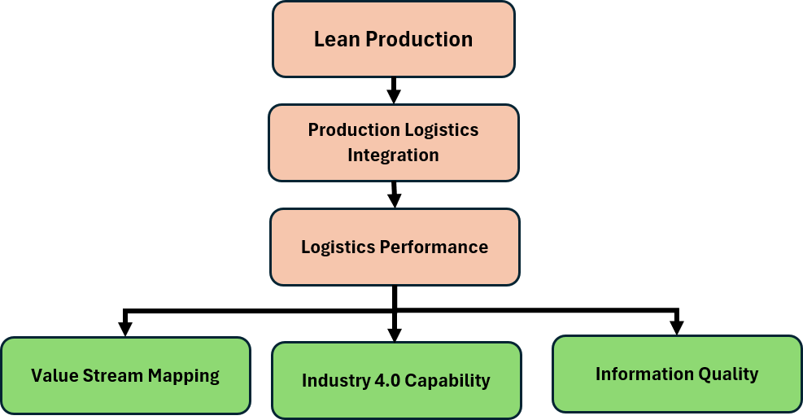
Fig. 2. Proposed Conceptual Framework

The proposed conceptual framework illustrates the relationship between lean production, value stream mapping, Industry 4.0 capability, and information quality on production logistics integration and logistics performance. The conceptual framework demonstrates that the integration of lean approaches and digital capabilities plays a critical role in improving the effectiveness of logistics systems in the automotive industry.

4.3 Research Gap and Novelty
The literature analysis shows that most previous studies still discuss lean production, value stream mapping, and Industry 4.0 separately. Lean production research focuses more on process efficiency and waste reduction, while Industry 4.0 research emphasizes digitalization and technology integration within manufacturing systems. Furthermore, research related to value stream mapping is generally used as a tool for mapping production processes without directly linking it to logistics system integration and information quality.
Based on these conditions, the novelty of this research lies in the development of a conceptual framework that integrates lean production, value stream mapping, Industry 4.0 capability, information quality, and production logistics integration into a single conceptual model to improve logistics performance in the automotive industry. This research also positions production logistics integration as a connecting variable between the lean approach and digital capabilities in supporting the effectiveness of manufacturing logistics systems.
Table 2, research gap and novelty, shows that most previous studies still discuss lean production, value stream mapping, and Industry 4.0 separately. Therefore, this research offers novelty in the form of developing a conceptual framework that integrates all these variables within the context of production logistics integration and logistics performance in the automotive industry.

Table 2. Research Gap and Novelty
Previous Studies | Research Gap | Research Novelty
Studies focus on lean production implementation | Limited integration with digital manufacturing systems | Integration of lean production and Industry 4.0 capability
Studies emphasize Industry 4.0 and automation | Limited discussion on logistics integration | Focus on production logistics integration
Studies use Value Stream Mapping mainly for process mapping | Limited integration between material flow and information flow | Integrated perspective of material and information flow

Conclusion
The conclusion is written in narrative form, not in a formal context. This research has successfully developed a conceptual framework that integrates lean production, value stream mapping, Industry 4.0 capability, information quality, and production logistics integration in the context of improving logistics performance in the automotive industry. The literature synthesis results indicate that previous research has largely discussed lean production, value stream mapping, and Industry 4.0 separately. However, the effectiveness of logistics systems in the manufacturing industry is influenced not only by material flow efficiency but also by information quality, process coordination, and overall production system integration.
The conceptual framework developed in this research demonstrates that lean production, value stream mapping, Industry 4.0 capability, and information quality have a mutually supportive relationship in improving production logistics integration. Furthermore, production logistics integration plays a role in supporting improved logistics performance through synchronization between material flow, information flow, and manufacturing operational activities. Thus, the integration of lean approaches and digital capabilities is a crucial factor in supporting logistics system effectiveness in the automotive industry.
The main contribution of this research lies in the development of a conceptual model that connects lean production, value stream mapping, Industry 4.0 capability, information quality, production logistics integration, and logistics performance within a single, integrated framework. In addition to providing theoretical contributions to the development of lean and digital manufacturing studies, this research also provides a foundation for further research to empirically test the relationships between the developed variables. Furthermore, the resulting conceptual framework is expected to serve as a reference for automotive manufacturing companies in improving the integration of production and logistics systems in a more effective and coordinated manner.

Reference

[1] V. Swarnakar and S. Vinodh, “Deploying Lean Six Sigma framework in an automotive component manufacturing organization,” Int. J. Lean Six Sigma, vol. 7, no. 3, pp. 267–293, 2016, doi: 10.1108/IJLSS-06-2015-0023.
[2] Y. T. Jou, R. M. Silitonga, M. C. Lin, R. Sukwadi, and J. Rivaldo, “Application of Six Sigma Methodology in an Automotive Manufacturing Company: A Case Study,” Sustain., vol. 14, no. 21, pp. 1–27, 2022, doi: 10.3390/su142114497.
[3] A. Fitra, S. Suhendra, A. P. Riandani, and D. Maryadi, “Perkembangan Logistik di Industri Perakitan Mobil,” Lentera Pengabdi., vol. 2, no. 01, pp. 15–23, 2024, doi: 10.59422/lp.v2i01.201.
[4] I.-R. Puiu, I. M. Petre, and M. Boșcoianu, “Targeting Toward Optimal Inventory in Automotive Industry—An Analysis Based on Six Sigma Methodology,” Logistics, vol. 10, no. 1, p. 8, 2025, doi: 10.3390/logistics10010008.
[5] D. Maryadi, M. L. Singgih, and D. S. Dewi, “Integrating Lean Six Sigma Indicators into Business Intelligence Systems : A Systematic Review across Sectors and Metrics,” 2025 9th Int. Conf. Inf. Technol. Inf. Syst. Electr. Eng., no. 2021, pp. 42–47, 2025, doi: 10.1109/ICITISEE68184.2025.11355031.
[6] D. Maryadi, R. A. N. Moulita, M. L. King, and R. M. Veranika, “Value Stream Mapping for Warehouse Process in Automotive Manufacturing Case,” vol. 12, no. February 2019, pp. 89–97, 2024.
[7] D. Maryadi, “Lean Six Sigma DMAIC Implementation to reduce Total Lead Time Internal Supply Chain Process,” pp. 2086–2096, 2021.
[8] J. I. Manajemen, “Improvement Performa Gudang Medium Mile dengan Menggunakan Value Stream Mapping Case Study : Warehouse Medium Mile di Kota Palembang,” vol. 3, no. 1, pp. 40–48, 2023.
[9] L. M. Syikilili and M. L. Singgih, “A Systematic Review of Lean Six Sigma and HACCP Integration in the Food Industry : Toward Manufacturing Excellence and Compliance,” vol. 13, pp. 50–58, 2026, doi: 10.18502/jfqhc.13.1.21380.
[10] D. Maryadi, A. Azrin, and S. Suhendra, “Improving Quality Control in Cup Beverage Production Using the Six Sigma Method,” vol. 5, no. 2, pp. 219–228, 2024.
[11] F. Hecklau, M. Galeitzke, S. Flachs, and H. Kohl, “Holistic Approach for Human Resource Management in Industry 4.0,” Procedia CIRP, vol. 54, pp. 1–6, 2016, doi: 10.1016/j.procir.2016.05.102.
[12] D. Approach, “Evaluation of Supply Chain Flexibility in Automobile Industry with Fuzzy Evaluation of Supply Chain Flexibility in Automobile Industry with Fuzzy DEMATEL Approach,” Glob. J. Flex. Syst. Manag., no. July, 2018, doi: 10.1007/s40171-018-0195-7.
[13] A. D. Makwana and G. S. Patange, “A methodical literature review on application of Lean & Six Sigma in various industries,” Aust. J. Mech. Eng., vol. 19, no. 1, pp. 107–121, 2021, doi: 10.1080/14484846.2019.1585225.
[14] M. KAMIŃSKA, “Improvement of warehouse processes by implementation of lean six sigma in global supply chain,” Sci. Pap. Silesian Univ. Technol. Organ. Manag. Ser., vol. 2021, no. 154, pp. 81–94, 2021, doi: 10.29119/1641-3466.2021.154.7.
[15] O. Morales Matamoros, J. G. Takeo Nava, J. J. Moreno Escobar, and B. A. Ceballos Chávez, “Artificial Intelligence for Quality Defects in the Automotive Industry: A Systemic Review,” Sensors, vol. 25, no. 5, pp. 1–39, 2025, doi: 10.3390/s25051288.
[16] A. Anđelković, M. Radosavljević, and D. Stošić, “Effects of Lean Tools in Achieving Lean Warehousing,” Econ. Themes, vol. 54, no. 4, pp. 517–534, 2017, doi: 10.1515/ethemes-2016-0026.
[17] E. Oey and M. Nofrimurti, “Lean implementation in traditional distributor warehouse - A case study in an FMCG company in Indonesia,” Int. J. Process Manag. Benchmarking, vol. 8, no. 1, pp. 1–15, 2018, doi: 10.1504/IJPMB.2018.088654.
[18] R. Godina, B. G. R. Silva, and P. Espadinha-Cruz, “A DMAIC integrated fuzzy fmea model: A case study in the automotive industry,” Appl. Sci., vol. 11, no. 8, 2021, doi: 10.3390/app11083726.

