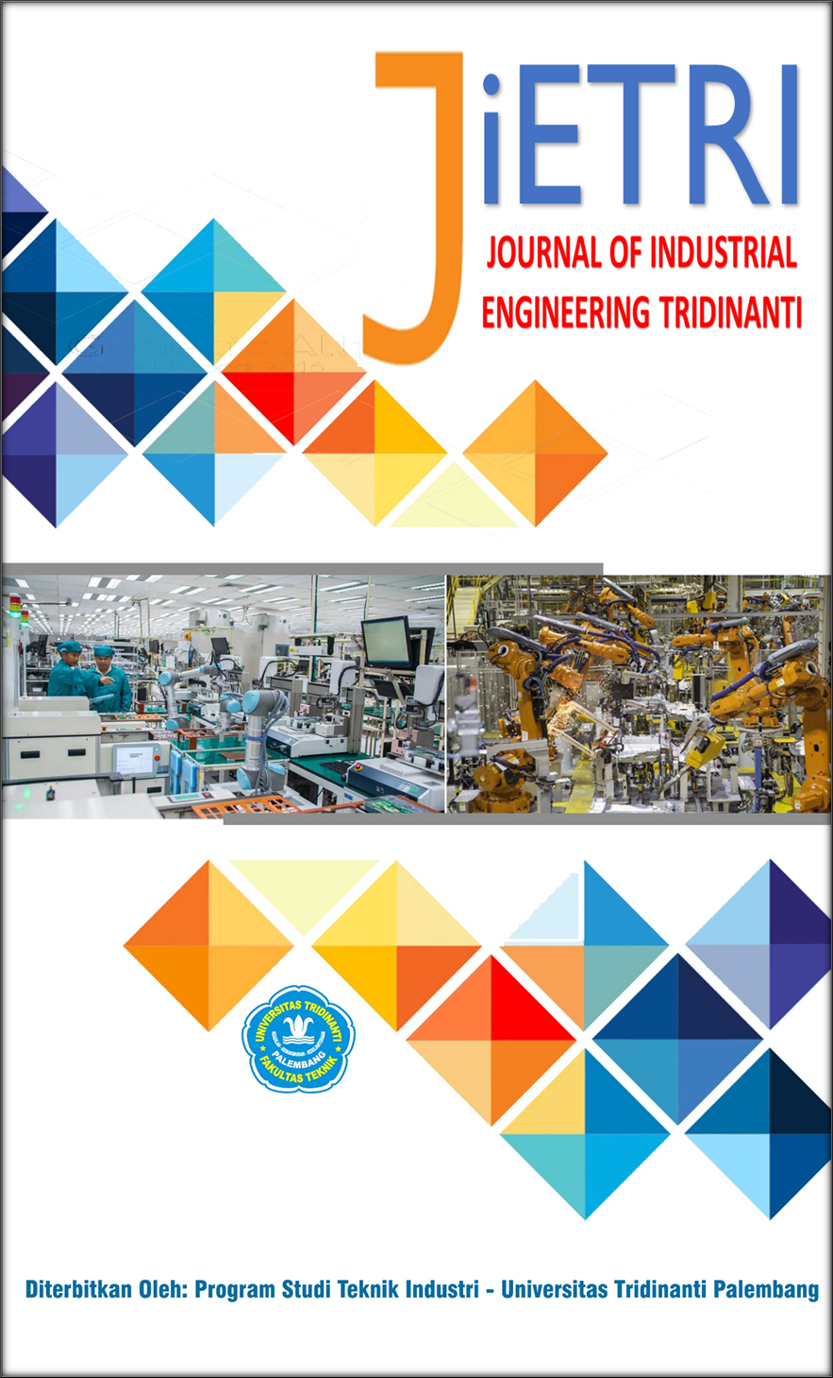

JOURNAL OF INDUSTRIAL ENGINEERING TRIDINANTI

e-ISSN: 2988-2303

http://jietri.univ-tridinanti.ac.id

From Lean Value Stream to Circular Value Stream Architecture (CVSA): A Conceptual Framework for Sustainable and Regenerative Supply Chain Transformation
Adi Fitra^{*1}, Penulis², Penulis³
¹Program Studi Teknik Industri, Fakultas Teknik, Universitas Pelita Bangsa
²Program Studi Teknik Mesin, Fakultas Teknik, Universitas Pelita Bangsa
³Program Studi Teknik Elektro, Fakultas Teknik, Universitas Pelita Bangsa
ARTICLE INFO |  | ABSTRAK
Article history:  Diterima xx-xx-xx  Diperbaiki xx-xx-xx  Disetujui xx-xx-xx |  | This study proposes a novel conceptual framework called Circular Value Stream Architecture (CVSA) to extend the conventional role of Value Stream Mapping (VSM) from a process improvement tool into an integrated value architecture. The novelty lies in introducing a regenerative perspective that combines Flow Efficiency, Sustainability Creation, Resource Circularity, and Regenerative Feedback within a single conceptual structure. Existing studies have progressively incorporated sustainability, circularity, and system transformation perspectives into Lean and VSM; however, these developments remain fragmented and primarily additive, limiting their ability to establish an integrated value generation mechanism. To address this gap, this study employed a conceptual synthesis approach using a literature-derived dataset as the basis for concept extraction, concept clustering, relationship abstraction, and framework construction. No empirical testing, simulation, statistical validation, or bibliometric analysis was conducted because the objective was theory development. The proposed framework suggests that value should no longer be interpreted as a final operational outcome but as a continuously renewed process. Nevertheless, the framework remains conceptual and requires future research to develop measurement models, empirical validation, and implementation studies across different operational contexts.
Keyword:
Circular Value Stream Architecture; Value Stream Mapping; Lean; Sustainability; Value Regeneration; Conceptual Framework

Introduction
In recent decades, the increasing complexity of manufacturing and supply chain systems has pushed organizations to focus not only on achieving high output but also on sustaining performance [1], [2]. This shift has led to the evolution of process improvement approaches from an efficiency-oriented focus to a long-term value-creation focus [3], [4]. In this context, Lean has become one of the most widely used approaches, providing systematic principles for eliminating non-value-added activities [5], [6] and improving process flow [7], [8]. One of the most prominent instruments within the Lean paradigm is Value Stream Mapping (VSM), a visual method for understanding the relationships among activities by mapping material and information flows [9], [10], [11]. The popularity of VSM demonstrates that organizations still view the ability to read and improve process flows as a key foundation for operational transformation [12].
However, the literature identified in the articles in the dataset indicates that VSM's function is beginning to expand. While it was previously used primarily to identify waste and accelerate production throughput, more recent publications have begun to integrate sustainability considerations into the value mapping framework [13]. The research focus is no longer limited to operational efficiency but is increasingly considering the impact of resource use, process sustainability, and long-term consequences on production systems and supply chains. This shift indicates that value creation is no longer understood narrowly as increased productivity but is increasingly linked to an organization's ability to sustain the system [14].
At the same time, developments in the circular economy and circular supply chain issues are beginning to challenge the linear paradigm inherent in most Lean and VSM implementations [15], [16]. The linear approach tends to view process flow as a one-way transformation from input to output, with the primary goal of minimizing losses and increasing flow velocity. However, recent literature is beginning to demonstrate that value doesn't end when a product is finished or delivered to the customer [17], [18], [19]. Materials, energy, information, and operational decisions are considered capable of re-entering the system and generating new value. Thus, the discussion of efficiency is shifting toward how a system can sustain and continuously renew its value creation [9], [20].
Furthermore, several recent publications on the dataset have begun to incorporate themes such as digitalization, artificial intelligence integration, sustainability enhancement, and reverse supply chain as part of operational transformation. However, these developments tend to be separate [21]. Some studies focus on enhancing analytical capabilities through technology; others add sustainability indicators to existing tools; and still others discuss circularity as an independent domain [22]. This situation demonstrates that, despite the expanding scope of research, there is no apparent conceptual structure that unifies these developments into a single, integrated value-creation logic.
This situation indicates a significant research gap that warrants further discussion. Based on a synthesis of articles in the dataset, most Value Stream Mapping developments still maintain their basic function as a process diagnostic and evaluation tool [23], [24]. Sustainability is often added only as a performance indicator, while circularity is often positioned as an additional mechanism outside the primary value stream. As a result, existing conceptual developments have not significantly changed how operating systems are designed; rather, they have simply expanded the variables observed within the same system [25], [26].
Another gap is the lack of clear integration among flow efficiency, sustainability, and the system's ability to generate value repeatedly [27]. Lean literature still focuses on internal process optimization, while circular supply chain literature emphasizes resource return and return flows [28], [29], [30]. Furthermore, sustainability research often stops at impact measurement without explaining how operational structures must change to achieve sustainability systematically [31], [32]. This fragmentation suggests the need for a new conceptual framework that goes beyond simply adding elements to VSM and transforms its underlying logic to better adapt to the needs of modern systems.

Table 1. Evolution of Value Stream Research Identified
Research Evolution | Primary Orientation | Contribution | Remaining Limitation
Lean–VSM | Waste elimination | Process efficiency | Linear value logic
Sustainability–VSM | Environmental integration | Extended performance | Sustainability as add-on
Circular Supply Chain | Resource recirculation | Closed-loop flow | Weak integration with VSM
Emerging Digital Approaches | Decision enhancement | System visibility | No unified architecture

Table 2. Identified Research Gaps
Existing Studies | Current Focus | Missing Element | Proposed Direction
Lean–VSM | Efficiency | Circularity | CVSA
Sustainability Studies | Performance | System redesign | Architecture
Circular Studies | Reverse flow | Integrated value creation | Unified framework

To provide a more systematic overview of the research's position, a synthesis of the literature developments contained in the dataset was conducted. The identification results indicate that the research focus has shifted from an efficiency-based orientation based on Lean-Value Stream Mapping to a broader integration of sustainability, circularity, and system transformation. However, this development remains partial and has not yet produced a framework that integrates process flow, value creation, and regenerative mechanisms into a single conceptual structure. Therefore, Table 1 summarizes the evolution of research directions, while Table 2 presents the research gaps that formed the basis for developing the Circular Value Stream Architecture (CVSA) framework in this study.
Based on this background, this study begins with two main questions. First, how can the concept of Value Stream Mapping be extended beyond its traditional role as a waste-identification tool to serve as a mechanism for sustainable value creation? Second, how can conceptual architecture be designed to integrate flow efficiency, sustainability, and circularity into a single, interconnected structure? These questions were chosen because changes in the current operational environment indicate that organizational success is no longer solely determined by the ability to accelerate processes but also by the ability to sustain a continuous cycle of value creation. To answer these questions, this study aims to develop a new concept called Circular Value Stream Architecture (CVSA). This concept is a theoretical development of Value Stream Mapping, shifting the orientation from flow mapping to value architecture design. CVSA integrates four main elements: flow efficiency, sustainable value creation, resource circularity, and regenerative feedback mechanisms within a single conceptual framework. Unlike empirical research that focuses on testing relationships between variables, this study aims to build a new theoretical foundation through conceptual synthesis based on patterns of literature development in datasets, serving as a basis for future research.

Research Method
This research uses a conceptual paper approach, with the primary goal of developing a new conceptual framework without conducting empirical testing, simulations, experiments, or statistical validation. Unlike quantitative research that seeks to prove relationships between variables, or bibliometric research that focuses on mapping publication structures, conceptual research places the process of theory synthesis and reconstruction as the primary source of scientific contribution. Therefore, this research is not directed at producing a predictive model or measuring the magnitude of the influence between constructs, but rather at constructing a new conceptual structure based on patterns of knowledge development that have emerged in literature. This approach was chosen because the research objective is to expand the function of Value Stream Mapping into a more comprehensive value architecture by integrating concepts that have been developed but are still scattered.
The source of the concept development is a dataset of articles exported from the Scopus database, which is used as the unit of conceptual analysis. This dataset is not treated as an object for bibliometric calculations or statistical analysis, but rather as a basis for understanding the direction of development of ideas emerging in relevant research themes. The analysis focuses on articles discussing Lean, Value Stream Mapping, sustainability, circularity, supply chain, and operating system transformation. The use of this dataset aims to ensure that the concept development process is based on patterns that emerge in the literliteraturevoid the creation of models that are overly speculative or unrelated to existing research developments.
The conceptual framework development process is carried out through a series of conceptual synthesis stages. The first stage is concept extraction, which identifies the main themes, development orientations, and contribution directions of each article in the dataset. The second stage is concept clustering, which groups logically related concepts into larger domains to observe their integration patterns. The third stage is relationship abstraction, which examines how these concepts interact, complement each other, and identify unexplored areas for development. The final stage is framework construction, which develops a new theoretical structure that explains the relationships among elements more integratively than existing approaches.
In the conceptual abstraction process, this study uses the principles of internal consistency and theoretical continuity as the basis for model development. Internal consistency is used to ensure that all constructed constructs are logically related and do not conflict with the conceptual foundations derived from previous literature. Meanwhile, theoretical continuity is used to ensure that newly developed concepts remain within the academic trajectory of scientific evolution. With this approach, this research does not arbitrarily create new variables but rather builds a framework by combining and repositioning the functions of concepts that have emerged in previous research, resulting in a structure with a stronger theoretical position.

Table 3. Concept Development Stages
Stage | Activity | Expected Output
Concept Extraction | Identify dominant concepts | Concept inventory
Concept Clustering | Group related ideas | Thematic domains
Relationship Abstraction | Identify conceptual links | Integration logic
Framework Construction | Build architecture | CVSA

The result of this methodological process is a new conceptual model, the Circular Value Stream Architecture (CVSA). This model is a theoretical representation that explains how flow efficiency, sustainable value creation, resource circularity, and regenerative mechanisms can be positioned within an interconnected system. Because this research does not aim to provide empirical evidence, the primary output is not performance measurements or hypothesis testing, but rather conceptual propositions and theoretical structure that can serve as a foundation for subsequent quantitative research and implementation studies.

Result and Discussion

Conceptual Pattern Identified from Existing Literature
The results of the synthesis of the articles in [1] indicate that research on Lean, Value Stream Mapping (VSM), sustainability, and operating system transformation has experienced a fairly clear expansion in scope but has not undergone a fundamental change in conceptual structure. In the earlier research group, the dominant focus was still on increasing efficiency through waste identification and improving process flows using Lean and VSM approaches. As organizations' needs for long-term performance grew, research began to integrate the sustainability dimension to broaden the definition of value, which had previously focused only on productivity and efficiency. Furthermore, more recent publications began to show the emergence of themes of circularity, reverse flow, and the use of technology as a means of expanding the system's ability to maintain performance. Although the direction of these developments indicates a shift from an operational orientation to a systemic orientation, most research still maintains an additive development pattern, namely adding new elements to an existing framework without changing the basic logic of value creation. As a result, efficiency, sustainability, and circularity develop as layers that stand side by side, rather than as mechanisms that work in an integrated system.
This pattern demonstrates that the remaining potential for theoretical contribution lies not in the addition of new constructs, but in the ability to restructure existing relationships between concepts to form a more coherent structure. The literature review reveals that Lean and VSM already have a strong foundation in managing process flows, while sustainability broadens the orientation toward desired outcomes, and circularity introduces a perspective on the sustainability of resource flows. However, there is no framework yet available to explain how these three domains can form a mutually reinforcing cycle of value creation. This situation indicates a shift in research needs from a mapping-based approach to an architecture-based approach. Therefore, this study argues that further conceptual development does not require additional analytical tools but rather a reconstruction of the Value Stream Mapping function to shift it from an instrument for identifying waste to a mechanism for managing efficiency, sustainability, and value re-creation within a single, connected conceptual structure. To clarify the conceptual evolution and identify the remaining integration space across the reviewed literature, the extracted patterns are summarized in Table 4.

Table 4. Concept Extraction and Integration Opportunity
Concept Domain | Existing Orientation | Current Contribution | Remaining Opportunity
Lean–VSM | Flow efficiency | Waste reduction | Expand value logic
Sustainability | Long-term performance | Extended evaluation | Structural integration
Circularity | Resource recirculation | Closed-loop thinking | Value regeneration
Emerging Technologies | System support | Decision enhancement | Adaptive architecture

Development of Circular Value Stream Architecture (CVSA)
Based on the conceptual patterns identified in the previous subchapter, this study proposes a new framework called Circular Value Stream Architecture (CVSA) as an effort to reconstruct the role of Value Stream Mapping from an efficiency mapping tool to a sustainable value creation architecture. The development of this concept departs from the finding that existing literature has succeeded in expanding research orientation through the integration of sustainability, circularity, and system transformation approaches, but still maintains a fragmented thinking structure so that the relationships between elements have not formed a complete value creation mechanism. Therefore, CVSA is not developed as a new method that replaces Lean or VSM, but rather as a conceptual layer that changes the way operating systems are understood and designed. In this framework, value is no longer seen as the end result of the process flow, but as an entity that is continuously maintained, expanded, and reshaped through interactions between system components. The CVSA structure is built through four main interconnected constructs, namely Flow Efficiency, Sustainability Creation, Resource Circularity, and Regenerative Feedback. Flow Efficiency maintains the foundation of Lean in managing process smoothness and reducing value loss during operations. Sustainability Creation expands the system's purpose beyond simply generating operational outputs to maintaining long-term performance sustainability. Resource Circularity introduces a mechanism for regenerating value through reuse and extending resource lifecycles. Meanwhile, Regenerative Feedback acts as an adaptive mechanism that ensures the entire system's ability to renew itself repeatedly. With this structure, CVSA shifts the traditional logic focused on eliminating waste toward a new logic that places value stream sustainability at the core of operating system transformation.
Figure 3 presents the proposed Circular Value Stream Architecture (CVSA), illustrating the transition from a linear value stream perspective to a regenerative architecture in which operational flow, sustainability creation, and circular resource logic continuously reinforce value generation. Table 5 summarizes the functional role of each construct within CVSA and demonstrates how the proposed architecture extends the conventional efficiency-oriented view to a continuous value-regeneration mechanism.
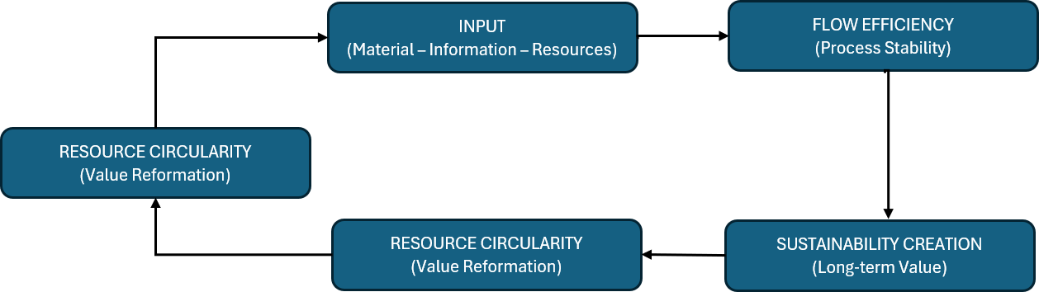

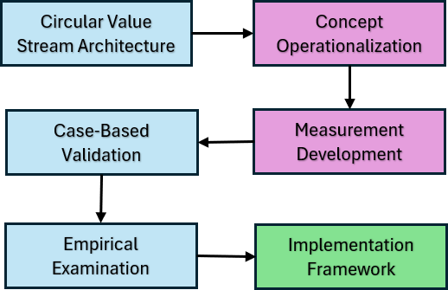
Figure 1. Circular Value Stream Architecture (CVSA)

Figure 2. Future Research Direction Based on CVSA

Table 5. Constructs of Circular Value Stream Architecture
Construct | Core Role | System Orientation | Expected Contribution
Flow Efficiency | Maintain process continuity | Operational | Reduced value loss
Sustainability Creation | Extend system outcomes | Strategic | Long-term value
Resource Circularity | Recreate resource utility | Circular | Extended value lifecycle
Regenerative Feedback | Sustain adaptation | Dynamic | Continuous renewal

Theoretical Interpretation and Contribution
The main theoretical contribution of this research lies in the shift in perspective on the function of Value Stream Mapping in the context of operating system and supply chain transformation. While most previous research positions VSM as a tool for waste identification and process efficiency improvement, Circular Value Stream Architecture (CVSA) expands its role to a framework that explains how value is sustainably maintained and recreated. This change is important because the results of the literature synthesis indicate that the integration of sustainability and circularity has so far been pursued by adding elements to existing systems, rather than by reconstructing the value-creation structure itself. Through CVSA, efficiency is no longer understood as the goal, but as a starting point that enables sustainability and value re-creation to occur simultaneously. Thus, this research does not offer a new stand-alone construct but rather establishes a new conceptual relationship among process flow, outcome sustainability, resource circularity, and regenerative mechanisms, resulting in an architecture that shifts the orientation from waste reduction to continuous value regeneration. Theoretically, this approach creates space for subsequent research to develop measurement mechanisms, implementation models, and to empirically test the proposed conceptual structure without altering the integrative foundation established in this research.

Conceptual Propositions and Future Research Direction
Given the development of the Circular Value Stream Architecture (CVSA), this study presents a set of conceptual propositions that explain the direction of theoretical relationships among elements within the framework while also opening space for further research. Unlike hypotheses in empirical research, the propositions in this study are not intended to be proven at this stage but rather to clarify the conceptual mechanisms underlying the formation of the proposed value architecture. Based on the CVSA structure, this study proposes four main propositions, namely: (P1) the higher the integration of stream efficiency, the greater the system's ability to sustain repeated value creation; (P2) system sustainability does not emerge as an independent outcome but as a consequence of the interaction between efficiency and circularity mechanisms; (P3) circularity expands the boundaries of value creation from operational activities to resource reuse cycles; and (P4) regenerative feedback enables the system to sustain adaptation and continuous value renewal. These four propositions emphasize that value is no longer the final output of the process, but rather an entity that is constantly moving and being reshaped through relationships among constructs. Thus, further research can focus on developing measurement indicators, conducting implementation case studies, and conducting empirical testing to evaluate the validity of the proposed relationships without altering the basic theoretical structure established in this study. Figure 4 presents the proposed pathway for extending the conceptual framework into future empirical and implementation-oriented studies while preserving the theoretical structure introduced in this research.

Conclusion
This study introduced the Circular Value Stream Architecture (CVSA) as a new conceptual framework developed by synthesizing concepts identified in the literature dataset. The framework was proposed in response to the observed limitation in existing studies, in which Lean, Value Stream Mapping, sustainability, and circularity have evolved independently, without forming an integrated value-creation structure. Rather than introducing additional operational tools or performance indicators, CVSA repositions Value Stream Mapping from a process-oriented improvement instrument into a broader architecture for managing and sustaining value generation. Through this perspective, value is no longer viewed as a static outcome of operational activities but as a continuously maintained and renewed process.
The proposed framework consists of four interconnected constructs: Flow Efficiency, Sustainability Creation, Resource Circularity, and Regenerative Feedback. Together, these constructs provide a conceptual explanation of how operational systems may evolve beyond efficiency-focused improvement toward continuous value regeneration. The contribution of this study, therefore, lies in extending the theoretical boundaries of Value Stream Mapping and offering a new integrative foundation for future research. Since this research is conceptual in nature, future studies are encouraged to develop measurement mechanisms, implementation models, and empirical validation approaches to examine the applicability and robustness of the proposed framework across different operational

Referensi

[1] D. Maryadi, R. A. N. Moulita, M. L. King, and R. M. Veranika, “Value Stream Mapping for Warehouse Process in Automotive Manufacturing Case,” vol. 12, no. February 2019, pp. 89–97, 2024.
[2] A. Fitra, A.Rochim, D.Maryadi, “Lean Six Sigma in Supply Chain Management : A Systematic Literature Review of Research Trends and Performance Impacts ( 2020 – 2025 ),” vol. 03, 2025.
[3] D. Maryadi, M. L. Singgih, and D. S. Dewi, “Integrating Lean Six Sigma Indicators into Business Intelligence Systems : A Systematic Review across Sectors and Metrics,” 2025 9th Int. Conf. Inf. Technol. Inf. Syst. Electr. Eng., no. 2021, pp. 42–47, 2025, doi: 10.1109/ICITISEE68184.2025.11355031.
[4] T. Tamalika, D. Maryadi, Azhari “Unpacking Lean Six Sigma Practice : A Systematic Literature Review of Performance Outcomes and Implementation,” vol. 4, no. 1, pp. 333–344, 2025.
[5] S. Oliver, V. P. Marketing, V. Corporation, R. Handfield, and C. Editor, “[David_Bamford,_Paul_Forrester]_Essential_Guide_to(b-ok.cc)”.
[6] F. Longo and Modeling, “39 : Operational Strategies and Internal Logistic Costs Analysis in a Real Warehouse Based on Modeling & Simulation,” Nose Tip Reg. Detect. 3D Facial Model across Large Pose Var. Facial Expr., vol. 7, no. 4, pp. 1–9, 2010.
[7] D. Maryadi, “Lean Six Sigma DMAIC Implementation to reduce Total Lead Time Internal Supply Chain Process,” pp. 2086–2096, 2021.
[8] D. Maryadi, T. Tamalika, R. A. N. Moulita, and T. P. O. Sianipar, “IMPLEMENTASI QUALITY FUNCTION DEPLOYMENT ( QFD ) PADA USAHA KECIL MENENGAH ( UKM ) ANGKRINGAN,” vol. 12, pp. 140–146, 2024.
[9] D. Klimecka-Tatar, “Value Stream Mapping as Lean Production tool to improve the production process organization - Case study in packaging manufacturing,” Prod. Eng. Arch., vol. 17, no. 17, pp. 40–44, 2017, doi: 10.30657/pea.2017.17.09.
[10] H. H. Purba, Mukhlisin, and S. Aisyah, “Productivity improvement picking order by appropriate method, value stream mapping analysis, and storage design: A case study in automotive part center,” Manag. Prod. Eng. Rev., vol. 9, no. 1, pp. 71–81, 2018, doi: 10.24425/119402.
[11] W. Faulkner and F. Badurdeen, “Sustainable Value Stream Mapping (Sus-VSM): methodology to visualize and assess manufacturing sustainability performance,” J. Clean. Prod., vol. 85, pp. 8–18, Dec. 2014, doi: 10.1016/J.JCLEPRO.2014.05.042.
[12] M. V. Hernandez Marquia, P. Zwolinski, and F. Mangione, “Application of Value Stream Mapping tool to improve circular systems,” Clean. Eng. Technol., vol. 5, p. 100270, 2021, doi: 10.1016/j.clet.2021.100270.
[13] M. Salwin, I. Jacyna-Gołda, M. Bańka, D. Varanchuk, and A. Gavina, “Using value stream mapping to eliminate waste: A case study of a steel pipe manufacturer,” Energies, vol. 14, no. 12, 2021, doi: 10.3390/en14123527.
[14] D. M. Utama and M. Abirfatin, “Sustainable Lean Six-sigma: A new framework for improve sustainable manufacturing performance,” Clean. Eng. Technol., vol. 17, no. October, p. 100700, 2023, doi: 10.1016/j.clet.2023.100700.
[15] A. Sasikumar, P. Acharya, M. Nair, and A. Ghafar, “Applying lean Six Sigma for waste reduction in a bias tyre manufacturing environment,” Cogent Bus. Manag., vol. 10, no. 2, 2023, doi: 10.1080/23311975.2023.2228551.
[16] S. Kumar, V. Swarnakar, R. K. Phanden, D. Khanduja, and A. Chakraborty, “Role of Lean Six Sigma in manufacturing setting: a systematic literature review and agenda for future research,” TQM J., vol. 36, no. 7, pp. 1996–2047, 2024, doi: 10.1108/TQM-12-2022-0338.
[17] T. Tamalika, D. Maryadi, R. A. N. Moulita, A. Fitra, A. Malik, and I. Aziz, “Jurnal Pengabdian Pengenalan Material Requirement Planning ( MRP ) Untuk Penjadwalan Produksi Di Usaha Pempek Skala Rumah Tangga,” vol. 2, pp. 1–8, 2024.
[18] A. Dhinar, F. A. ;Wardhani, and D. ;Maryadi, “Analisis Pengendalian Persediaan Barang Gudang Ban Luar dan Ban Dalam Menggunakan Metode Economic Order Quantity (EOQ),” JIETRI J. Ind. Egineerig Tridinanti, vol. 01, no. 01, 2023.
[19] A. Fitra, S. Suhendra, A. P. Riandani, and D. Maryadi, “Perkembangan Logistik di Industri Perakitan Mobil,” Lentera Pengabdi., vol. 2, no. 01, pp. 15–23, 2024, doi: 10.59422/lp.v2i01.201.
[20] D. Knoll, G. Reinhart, and M. Prüglmeier, “Enabling value stream mapping for internal logistics using multidimensional process mining,” Expert Syst. Appl., vol. 124, pp. 130–142, 2019, doi: 10.1016/j.eswa.2019.01.026.
[21] P. Ketchanchai, K. Tangchaidee, and N. Kongprasert, “Lean Warehouse Management through Value Stream Mapping: A Case Study of Sugar Manufacturing Company in Thailand,” 2021 IEEE 8th Int. Conf. Ind. Eng. Appl. ICIEA 2021, pp. 192–196, 2021, doi: 10.1109/ICIEA52957.2021.9436732.
[22] L. M. Syikilili and M. L. Singgih, “A Systematic Review of Lean Six Sigma and HACCP Integration in the Food Industry : Toward Manufacturing Excellence and Compliance,” vol. 13, pp. 50–58, 2026, doi: 10.18502/jfqhc.13.1.21380.
[23] I. Vicente, R. Godina, and A. Teresa Gabriel, “Applications and future perspectives of integrating Lean Six Sigma and Ergonomics,” Saf. Sci., vol. 172, no. November 2023, 2024, doi: 10.1016/j.ssci.2024.106418.
[24] V. Yadav and P. Gahlot, “Green Lean Six Sigma sustainability-oriented framework for small and medium enterprises,” Int. J. Qual. Reliab. Manag., vol. 39, no. 7, pp. 1787–1807, 2022, doi: 10.1108/IJQRM-08-2021-0297.
[25] A. Ariffien, I. Adriant, and J. A. Nasution, “Lean Six Sigma Analyst in Packing House Lembang Agriculture Incubation Center (LAIC),” J. Phys. Conf. Ser., vol. 1764, no. 1, pp. 0–9, 2021, doi: 10.1088/1742-6596/1764/1/012043.
[26] A. Bancovich Erquínigo, J. OrtizPorras, H. Quintana Saavedra, P. Crispin Chamorro, R. Manrique Alva, and P. Vilca Carhuapuma, “Green lean method to identify ecological waste in a nectar factory,” Int. J. Prod. Manag. Eng., vol. 11, no. 2, pp. 197–207, 2023, doi: 10.4995/ijpme.2023.19598.
[27] A. Abideen and F. B. Mohamad, “Improving the performance of a Malaysian pharmaceutical warehouse supply chain by integrating value stream mapping and discrete event simulation,” J. Model. Manag., vol. 16, no. 1, pp. 70–102, 2021, doi: 10.1108/JM2-07-2019-0159.
[28] J. Antony, J. Lancastle, O. McDermott, S. Bhat, R. Parida, and E. A. Cudney, “An evaluation of Lean and Six Sigma methodologies in the national health service,” Int. J. Qual. Reliab. Manag., vol. 40, no. 1, pp. 25–52, 2023, doi: 10.1108/IJQRM-05-2021-0140.
[29] J. Antony, M. Sony, and L. Gutierrez, “An Empirical Study Into the Limitations and Emerging Trends of Six Sigma: Findings From a Global Survey,” IEEE Trans. Eng. Manag., vol. 69, no. 5, pp. 2088–2101, 2022, doi: 10.1109/TEM.2020.2995168.
[30] J. Antony, O. McDermott, M. Sony, M. M. Fernandes, and R. V. C. Ribeiro, “A study on the Ishikawa’s original basic tools of quality control in South American companies: results from a pilot survey and directions for further research,” TQM J., vol. 33, no. 8, pp. 1770–1786, 2021, doi: 10.1108/TQM-01-2021-0004.
[31] S. Rajak, P. Kumar, A. Modi, V. Swarnakar, J. Antony, and M. Sony, “An assessment of barriers to integrate lean six sigma and industry 4.0 in manufacturing environment: case based approach,” Int. J. Comput. Integr. Manuf., vol. 38, no. 3, pp. 386–407, 2024, doi: 10.1080/0951192X.2024.2335969.
[32] M. S. Kaswan, R. Rathi, J. A. Garza-Reyes, and J. Antony, Green Lean Six Sigma sustainability – oriented project selection and implementation framework for manufacturing industry, vol. 14, no. 1. 2023. doi: 10.1108/IJLSS-12-2020-0212.

