Exploring “HOTS” Based Questions in the Reading Section of the English Textbook Based on the “Emancipated” Curriculum Used for Teaching 7th-grade Students of Junior High School and Teachers’ Perceptions At SMP N 27 Palembang And MTs 1 Palembang

ABSTRACT: This study investigates the extent to which reading questions in the English for Nusantara textbook align with Higher-Order Thinking Skills (HOTS) based on the Emancipated Curriculum for 7th-grade junior high school students. Using an embedded mixed-methods approach, the researcher conducted content analysis of reading questions and gathered data from classroom observations and teacher interviews. The results reveal that only 20% of the textbook’s reading questions meet HOTS criteria (analyzing, evaluating, creating), with 80% still dominated by Lower-Order Thinking Skills (LOTS). Teachers expressed positive perceptions toward HOTS implementation, though they faced challenges such as students' limited vocabulary and reading skills. Findings highlight the need for more contextual HOTS questions and continuous teacher support.
Keywords: HOTS, Reading Comprehension, Textbook Analysis, Emancipated Curriculum, English for Nusantara.

Menjelajahi Pertanyaan Berbasis HOTS pada Bagian Membaca Buku Teks Bahasa Inggris Berdasarkan Kurikulum “Emancipated” yang Digunakan untuk Mengajar Siswa Kelas 7 SMP dan Persepsi Guru di SMP N 27 Palembang dan MTs 1 Palembang
ABSTRAK: Penelitian ini mengkaji sejauh mana pertanyaan bacaan dalam buku teks English for Nusantara sesuai dengan Keterampilan Berpikir Tingkat Tinggi (HOTS) berdasarkan Kurikulum Merdeka untuk siswa kelas 7 sekolah menengah pertama. Dengan menggunakan pendekatan campuran terintegrasi, peneliti melakukan analisis konten terhadap pertanyaan bacaan dan mengumpulkan data dari observasi kelas serta wawancara guru. Hasil penelitian menunjukkan bahwa hanya 20% pertanyaan membaca dalam buku teks memenuhi kriteria HOTS (menganalisis, mengevaluasi, menciptakan), sementara 80% masih didominasi oleh Keterampilan Berpikir Tingkat Rendah (LOTS). Guru-guru mengungkapkan persepsi positif terhadap implementasi HOTS, meskipun mereka menghadapi tantangan seperti keterbatasan kosakata dan keterampilan membaca siswa. Temuan ini menyoroti kebutuhan akan pertanyaan HOTS yang lebih kontekstual dan dukungan berkelanjutan bagi guru.
Kata Kunci: HOTS, Pemahaman Membaca, Analisis Buku Teks, Kurikulum Mandiri, Bahasa Inggris untuk Nusantara
INTRODUCTION
R
eading is one of the fundamental skills in English language learning, involving comprehension, analysis, and interpretation of meaning (Grabe & Stoller, 2013). Under the Emancipated Curriculum, learning is directed toward developing Higher-Order Thinking Skills (HOTS) such as analyzing, evaluating, and creating (Anderson & Krathwohl, 2001), to prepare students for critical thinking and problem-solving.
However, several studies indicate that the implementation of HOTS in textbooks remains limited. Utami et al. (2022) and Hafidah (2023) found that most reading questions in English textbooks still focus on Lower-Order Thinking Skills (LOTS). In addition, teachers’ perceptions and readiness play a crucial role in the successful implementation of HOTS (Shulman, 1986; Vygotsky, 1978).
Previous studies show that English textbooks often emphasize LOTS. So, this study aims to analyze the extent to which reading questions in the English for Nusantara textbook for seventh grade facilitate HOTS and to explore teachers’ perceptions of its implementation in English language teaching.

METHODOLOGY
Research method comprises kinds of research, place and date, target, subject, procedures, instruments, data analysis, etc. The method could be written into sub-headings.
- Techniques in Collecting the Data
  - Content Analysis
The content analysis focused on 35 reading comprehension esay questions from the "English for Nusantara" textbook, published by the Ministry of Education, Culture, Research, and Technology (2022 edition). The questions were categorized based on the cognitive domains of Bloom’s Revised Taxonomy (C4: Analyzing, C5: Evaluating, C6: Creating) to assess the presence of HOTS elements.
  - Classroom Observations
Observations were conducted without intervention to assess how teachers applied HOTS-based questions in real classroom settings. The observations focused on the instructional strategies employed by teachers and the nature of student interactions with the reading tasks.
  - Semi-Structured Interviews
Interviews were conducted with five English teachers from SMP N 27 and MTs 1 Palembang. The interviews aimed to gather insights into teachers' perceptions of HOTS implementation, the challenges they face, and their experiences in teaching HOTS-based questions.
- Instruments Used in Data Collection
  - Checklist Sheet for Question Categorization
A checklist was used to classify reading questions based on Bloom's Revised Taxonomy. This helped to categorize each question under LOTS or HOTS levels.
  - Field Notes for Classroom Observations
Field notes were maintained during classroom observations to document teachers’ teaching practices, student engagement, and the implementation of HOTS-based questions.

  - Interview Guide
The interview guide was developed based on educational frameworks and included questions related to teachers' understanding of HOTS, their teaching methods, and the challenges they encounter. The guide was reviewed for conceptual clarity and relevance before use.
- Data Analysis
  - Quantitative Data Analysis
The quantitative data obtained from content analysis were analyzed using descriptive percentages to identify the proportion of HOTS vs. LOTS questions in the textbook.
  - Qualitative Data Analysis
The qualitative data from classroom observations and teacher interviews were analyzed thematically. Recurring patterns and insights were identified to better understand the challenges and perceptions of teachers regarding the implementation of HOTS.
FINDINGS AND DISCUSSION
This study revealed that the English for Nusantara textbook for seventh-grade students does not yet sufficiently support the development of higher-order thinking skills (HOTS) in the reading section. From a total of 35 reading comprehension essay questions analyzed, only 7 questions (20%) were classified as HOTS based on Bloom’s Revised Taxonomy. These included four questions at the analyzing level (C4), two at evaluating (C5), and one at creating (C6). The remaining 28 questions (80%) were categorized as lower-order thinking skills (LOTS), with the majority being remembering (C1) questions.
Table 1. The Distribution of Cognitive Levels in Reading Questions
Chapter | C1 | C2 | C3 | C4 | C5 | C6 | Total Chapter
1 | 6 | 0 | 0 | 1 | 2 | 0 | 9
2 | 12 | 1 | 1 | 1 | 0 | 1 | 16
3 | 0 | 0 | 0 | 0 | 0 | 0 | 0
4 | 6 | 2 | 0 | 2 | 0 | 0 | 10
5 | 0 | 0 | 0 | 0 | 0 | 0 | 0
Total Level | 24 | 3 | 1 | 4 | 2 | 1 | 35
Percentage | 69% | 9% | 3% | 11% | 6% | 3% | 100%

The data in Table 1 clearly illustrates that LOTS-type questions dominate the reading activities in the textbook. To visualize this further, the distribution is also presented in the pie chart below. Figure 1. Distribution of Cognitive Levels in Reading Questions
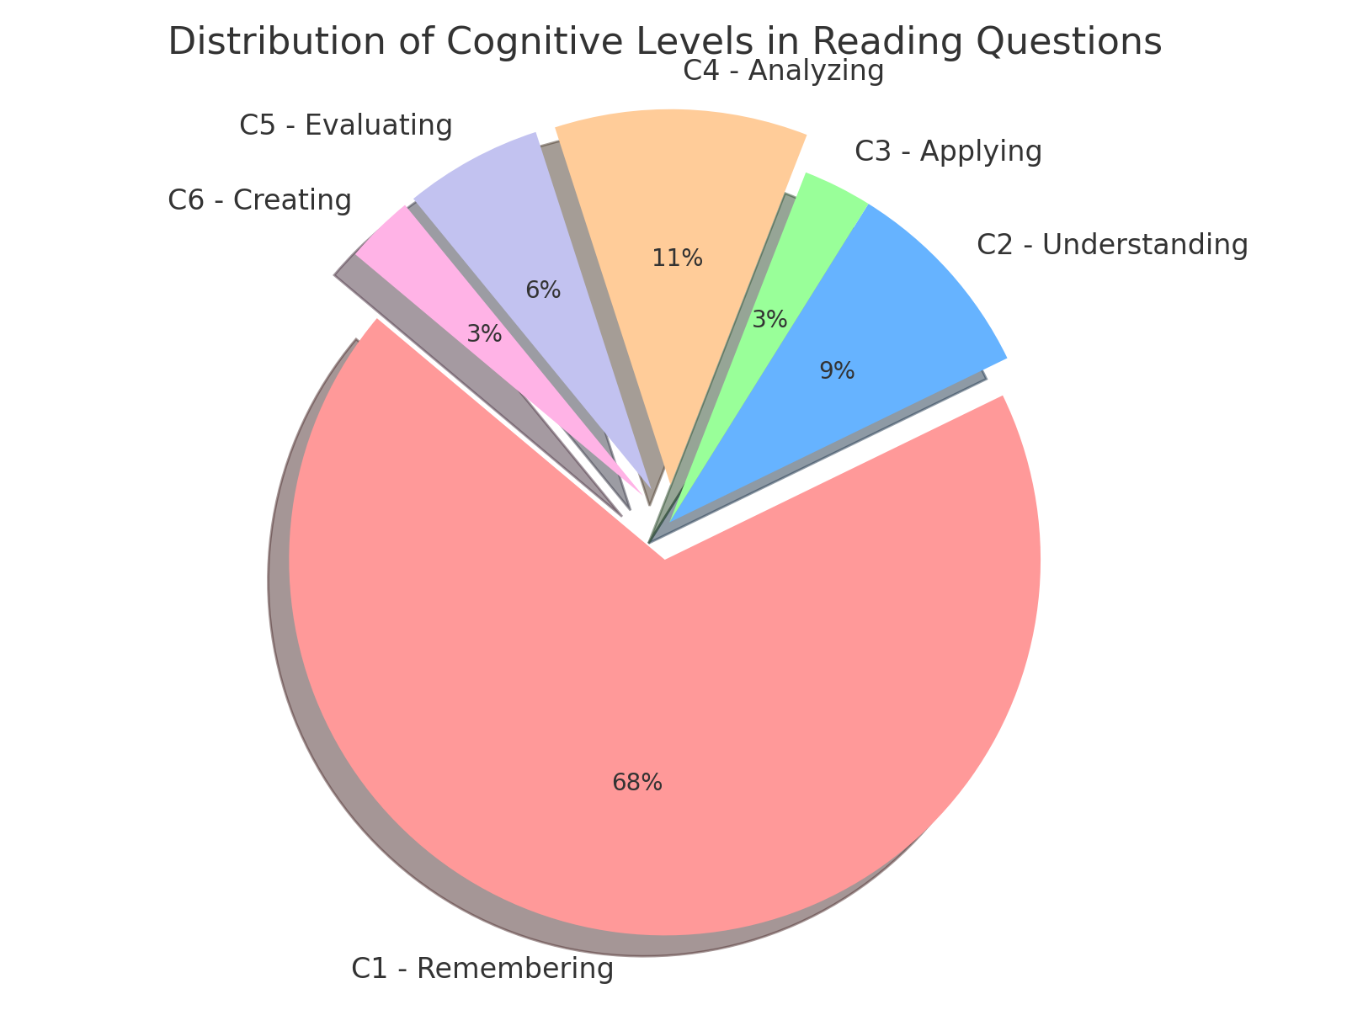
As seen in Figure 1, remembering questions (C1) constitute the vast majority at 69%, while HOTS-level questions are significantly underrepresented. This unbalanced distribution indicates a lack of emphasis on fostering students’ critical thinking, evaluation, and creativity through reading tasks, which contradicts the goals of the Emancipated Curriculum.
These findings confirm earlier research by Utami et al. (2022) and Hafidah (2023), which found that English textbooks used in Indonesian junior high schools tend to prioritize LOTS, especially in reading activities. As a result, students are not adequately challenged to engage in deeper cognitive processing during reading comprehension tasks.
In addition to textbook analysis, teacher interviews and classroom observations were conducted to gain insight into how HOTS is understood and applied in teaching. Most teachers stated that while they are confident in applying HOTS strategies, they often need to adjust the difficulty to suit students’ abilities. They recognized that many students, especially at the seventh-grade level, have limited vocabulary and find abstract questions difficult without support. Several teachers noted that HOTS questions require scaffolding and must be introduced gradually, moving from LOTS to HOTS in a step-by-step manner.
Teachers also emphasized the importance of context in reading texts. Some reported that certain reading passages in the textbook were not sufficiently relevant to students' daily lives, making it harder for them to relate to and reflect critically on the content. They agreed, however, that when implemented effectively, HOTS-based questions enhance students’ ability to think independently, evaluate ideas, and develop reasoned arguments.
Despite constraints such as time, curriculum demands, and student readiness, all teachers believed that HOTS plays a vital role in developing meaningful and student-centered learning. They recommended that future textbooks integrate more HOTS-level questions that are both challenging and contextually relatable. Furthermore, the provision of professional development and collaborative teacher support systems is seen as essential to strengthen HOTS instruction.
In conclusion, this study highlights the mismatch between the intended curriculum and textbook practice. While the Emancipated Curriculum promotes HOTS as a core component of learning, the English for Nusantara textbook has yet to fully support this shift. As Vygotsky (1978) suggests, learners can achieve higher levels of understanding with appropriate scaffolding; thus, both materials and instruction must be designed with this developmental progression in mind.
CONCLUSION
The findings of this study demonstrate that the English for Nusantara textbook for Grade 7 does not yet sufficiently reflect the cognitive demands of the Emancipated Curriculum, particularly in developing students’ higher-order thinking skills (HOTS). Although the curriculum promotes critical, evaluative, and creative thinking, the reading comprehension questions in the textbook remain largely dominated by lower-order thinking skills.
Teachers, while aware of the importance of HOTS, face challenges in implementing it due to students' limited readiness and the lack of contextual relevance in the materials. This study highlights a gap between curriculum expectations and actual learning resources in use, particularly in English language education at the junior secondary level.
The contribution of this study lies in its dual perspective, textbook analysis and teacher insight, which reveals not only the content limitations but also the instructional realities in HOTS implementation. The study underscores the need for curriculum-aligned textbooks that integrate contextualised and cognitively challenging questions, as well as professional development support for teachers.
Future studies are recommended to explore HOTS implementation across multiple grade levels, assess its impact on student outcomes, and evaluate the effectiveness of teacher interventions. Strengthening the alignment between instructional materials and national education goals remains critical for fostering critical thinking among Indonesian learners.

REFERENCE
Andaline, S (2022). An analysis of HOTS questions in English textbook “Bright” for the eighth grade of junior high school. JETLe (journal of English Language Teaching and Learning), 3(2), 139-150.
Anderson, L. W., & Krathwohl, D. R. (Eds.). (2001). A taxonomy for learning, teaching, and assessing: A revision of Bloom's taxonomy of educational objectives. Longman.
Grabe, W., & Stoller, F. L. (2013). Teaching and researching reading (2nd ed.). Routledge.
Hafidah, N. (2023). HOTS in English textbook: A content analysis of reading exercises in “Think Globally Act Locally” textbook. Journal of English Education and Teaching, 7(1), 45–54.
Kemendikbudristek. (2021). Kurikulum Merdeka: Panduan Pembelajaran dan Asesmen. Kementerian Pendidikan, Kebudayaan, Riset, dan Teknologi Republik Indonesia.
Resnick, L. B. (1987). Education and learning to think. National Academy Press.
Shulman, L. S. (1986). Those who understand: Knowledge growth in teaching. Educational Researcher, 15(2), 4–14.
Utami, N. P., Marlina, L., & Fitrawati. (2022). The representation of HOTS in English reading tasks: A content analysis of textbook for senior high school. English Language and Literature, 11(1), 78–86.
Vygotsky, L. S. (1978). Mind in society: The development of higher psychological processes. Harvard University Press.

