VOCABULARY MASTERY AND ITS INFLUENCE ON STUDENTS’ DESCRIPTIVE WRITING: A CORRELATION RESEARCH

ABSTRACT: This research aimed to determine the correlation between tenth-grade students' vocabulary mastery and their descriptive writing ability, and to determine the contribution of students' vocabulary mastery to their descriptive writing ability. The research design was a correlational study, and the population consisted of 450 tenth-grade students from 14 classes at SMA N 10 Palembang. To select the sample of this research, purposive sampling was implemented. There were 72 students as a sample from classes X.7 and X.8. The obtained data were analyzed using correlation and regression analyses. The data were obtained from writing ability and vocabulary mastery tests. The results indicated that the significant coefficient between writing ability and vocabulary mastery was 0.802, which was higher than the alpha value of 0.05. It means that vocabulary mastery and writing ability were not correlated. At that point, the correlation coefficient was 0.030, which placed it in the low category of the correlation coefficient. Subsequently, regression analysis revealed that the R-value was 0.066 and its coefficient of determination (R-squared) was 0.004. It concluded that the contribution of vocabulary mastery to writing skill was only 0.04%. In conclusion, the r-value was less than the alpha-value (0.802 > 0.05), indicating that there was no significant relationship between writing ability and vocabulary mastery. There was no contribution or interaction effect on vocabulary mastery or writing ability, since the R-value was 0.004, or only 0.04%.
Keywords: correlation, vocabulary mastery, writing ability

DAMPAK PENGUASAAN KOSAKATA TERHADAP KEMAMPUAN MENULIS MELALUI TEKS DESKRIPTIF: PENELITIAN KORELASI
ABSTRAK: Penelitian ini bertujuan untuk mengetahui apakah ada korelasi antara penguasaan kosakata siswa dan kemampuan menulis teks deskriptif untuk siswa kelas sepuluh di SMA Negeri 10 Palembang dan untuk mengetahui apakah ada kontribusi dari penguasaan kosakata siswa terhadap kemampuan menulis mereka dalam teks deskriptif pada siswa kelas sepuluh SMA Negeri 10 Palembang. Metode penelitian menggunakan penelitian kuantitatif, dan populasinya adalah siswa kelas sepuluh dengan total 450 siswa dari 14 kelas di SMA N 10 Palembang. Untuk sampel penelitian ini, teknik pengambilan sampel diterapkan. Ada 72 siswa sebagai sampel dari kelas X.7 dan X.8. Lebih baik menggunakan analisis korelasi dan analisis regresi digunakan untuk menganalisis data, yang diambil dari kemampuan menulis siswa dan tes penguasaan kosakata. Hasil penelitian menunjukkan bahwa koefisien signifikan antara kemampuan menulis dan penguasaan kosakata adalah 0.802 lebih tinggi dari nilai alpha 0,05. Ini berarti bahwa penguasaan kosakata dan kemampuan menulis tidak berkorelasi. Pada titik tersebut, koefisien korelasi adalah 0.030, yang menempatkannya dalam kategori rendah dari koefisien korelasi. Selanjutnya, analisis regresi mengungkapkan bahwa nilai korelasi data keluaran (R) adalah 0.066 dan koefisien determinasinya (R Square) adalah 0.004. Disimpulkan bahwa kontribusi penguasaan kosakata pada keterampilan menulis hanya 0.04%. Sebagai kesimpulan, nilai r lebih kecil dari nilai alpha (.802 >.05), yang menunjukkan bahwa tidak ada hubungan yang signifikan antara kemampuan menulis dan penguasaan kosakata dan Tidak ada kontribusi dan efek interaksi terhadap penguasaan kosakata dan kemampuan menulis, karena nilai R 0.004 > 0.04% hasilnya ditolak menulis hanya 0.04%. Kesimpulannya, temuan ini menunjukkan bahwa siswa yang memiliki penguasaan kosakata yang tinggi juga memiliki kemampuan menulis yang baik.
Kata Kunci: korelasi, penguasaan kosakata, kemampuan menulis
INTRODUCTION
V
ocabulary mastery is the process of developing one's ability to comprehend and use words found in a language, both orally and in writing. Mastery of language is essential; the more words one knows, the more easily one can communicate and receive information (Rahmati, 2018). Vocabulary mastery means having full knowledge and skills in words. The word “mastery” means knowing something completely or having excellent skill in a subject. Therefore, mastery in vocabulary refers to possessing a vast array of words capable of forming sentences. Laili (2022) defined vocabulary as one of the important elements of the language. At a very basic level, vocabulary connects real-world meanings with language. Schmitt & Schmitt, 2020, in Soma (2025).
According to Schmitt et al. (2020), vocabulary plays a critical part in language skills. Having a solid vocabulary helps a person learn more about language and makes their knowledge wider. Vocabulary refers to the words that a person knows and can use well. This includes individual words, words with added parts, and words made by putting together other words, each of which has its own meaning.
Writing, as a component of language skills, involves different stages in the process. The different stages of the writing process will depend on how much attention we devote to the content and length, what kind of writing we are doing, and what medium we are using. Harmer in Irawan (2023). Thus, writing is the activity of expressing ideas, thoughts, information, and knowledge and expressing one's feelings in written form, where the article is addressed to readers. Schools commonly incorporate writing activities into their teaching and learning processes, particularly in the context of English language learning. In learning English there are many materials related to writing activities; one of them is writing descriptive text. Therefore, writing skills must also be trained intensively. Writing will enhance students' creativity in self-expression, leading to more positive activities. Otherwise, writing can also be a means of entertainment for students (Pradana et al., 2020).
Writing can be defined as the activity of expressing ideas or concepts using written language as a medium of delivery (Toba et al., 2019). According to Anggraini et al. (2020), "wrote" means expressing in writing thoughts, ideas, opinions, or thoughts and feelings. According to Malik (2019), writing was an activity where you thought and felt about a topic, decided what to say, and figured out how to say it so that others could understand it clearly and easily. Writing, as a component of language skills, involves different stages in the process. The different stages of the writing process will depend on how much attention we devote to the content and length, what kind of writing we are doing, and what medium we are using (Harmer, 2004, p. 6).
Descriptive is a type of essay that students need to learn. According to Dalimunthe (2021), descriptive writing is a way to explain or show something so that it creates a clear picture in the reader's mind, giving them the impression that they can see, hear, and feel what is being explained. Ulfa et al. (2023) say that descriptive text is a paragraph that clearly explains the main idea by describing an object, place, or event in detail. This helps the reader imagine or experience what is being talked about, making it feel real and personal. Sahalluddin et al. (2023) also agree, saying that descriptive writing is a type of writing that presents a detailed description of an object, allowing readers to imagine, visualize, and even hear or feel what is being described through the words used.
The researcher observed that students at SMA Negeri 10 Palembang are afraid of learning English, and the lack of vocabulary makes it difficult for them to express their ideas. They are also confused when writing due to problems with grammar. Therefore, the students have a low level of understanding in both vocabulary and writing.
Therefore, previous research, "The Correlation Between Students' Vocabulary Mastery and Writing Skill at SMK 2 Ponorogo," was done by Laili (2022). The research results were positive; the value of 0.661 is the correlation coefficient. This demonstrates that the two variables are directly related. Previous research used the product moment table to interpret the correlation coefficient. Accordingly, throughout the 2021–2022 school year, there is a relationship between the writing abilities and vocabulary mastery of tenth-grade students at SMKN 2 Ponorogo. Therefore, the research findings are accepted.
The second is “The Correlation Between Grammatical Mastery and Descriptive Writing Mastery of the Tenth Grade Students of SMA Negeri 1 Indralaya” by Randika (2018). The result showed that there was a fair correlation between the students' grammatical mastery and their descriptive writing mastery (r=0.598 and p-value=0.000). In conclusion, there was a significant correlation between grammatical mastery and descriptive writing mastery among the tenth-grade students at SMA Negeri 1 Indralaya.
Consequently, given the explanations provided, the writer decided on a study titled “The Impact of Vocabulary Mastery on Writing Ability Through Descriptive Text: A Correlation Research.” Then, the objectives of the research are: The research aims to determine whether there is a correlation between students' vocabulary mastery and their ability to write descriptive texts for tenth grade students at SMA Negeri 10 Palembang, as well as whether students' vocabulary mastery contributes to their ability to write descriptive texts.

METHODOLOGY
1. Research Design
This research used a correlation design. Correlational research, according to Mardianti et al. (2021), is a quantitative technique intended to demonstrate the connections between two or more variables. In addition, Emizhan et al. (2022) state that correlation research is to investigate the extent to which variations in one factor correspond with variations in one or more other factors based on correlation coefficients. In correlation design, researchers used the statistical process of correlation analysis to quantify the degree of relationship between two or more variables. This degree of correlation, a numerical value, indicates the relationship between the two variables or their potential for prediction. The researcher used the correlation between two variables in this research. The research design aimed to determine whether the vocabulary mastery of tenth-grade students correlated with their ability to write descriptive texts at SMA Negeri 10. Additionally, the study aimed to investigate whether the vocabulary mastery of the tenth-grade students at SMA Negeri 10 Palembang contributed to their writing ability in descriptive texts. In this research, the independent variable was vocabulary mastery, and the dependent variable was writing ability.

2. Population and Sample
The population in this research is all of the students from the tenth grade at SMA Negeri 10 Palembang. According to Levitt (2021), a population is a region for generalization that includes an item or subject with unique qualities and traits that the researcher has chosen to study and draw conclusions from. Obilor (2023) notices that a sample is an approximate gathering of people who have similar experiences about a specific case. Afterwards, the samples in this research are from the students who belong to classes X.7 and X.8, with a total of 72 students at SMA Negeri 10 Palembang chosen by using a purposive sampling technique. These classes were selected as the sample because the English teacher for both classes informed the researcher that the students had insufficient vocabulary and weak writing skills. The teacher then chose those classes because they were the most suitable for the researcher's research material.

3. Techniques for Collecting Data
To assess vocabulary mastery and writing ability, vocabulary and writing tests were used. The purpose of the vocabulary mastery test is to measure the students' understanding of vocabulary. At the beginning of the research, the researcher distributed a tryout test consisting of 35 multiple-choice questions at X.7 and X.8 at SMA Negeri 10 Palembang. In the writing ability test, a written assessment was administered to evaluate the students' writing skills through 72 descriptive texts about people. In this test, the students are free to be creative and develop their writing with a minimum of 50 words in 40 minutes, and the questions consist of two about famous landmarks such as the Ampera Bridge and Borobudur Temple.
Before going to the data collection process, the researcher would validate the test as the instrument to find out the research question of this research because an instrument is qualified to be used after showing the data variables research correctly. The result of the validity test was that the value of the r-table lower than the r-value of the items is not valid. The researcher found the r-table was 0.235 for a sample. Initially, the instrument for the test consisted of 35 items. Based on the result of the test, they found that 3 items of instruments were not valid. Those items were 27, 28, and 29. Reliability, according to Fraenkel et al. (2012, p. 154), is the degree to which the scores obtained are consistent for each individual across several instrument administrations and item sets. The reliability test yielded a dependable coefficient of .928. Based on the interpretation of the reliability classification, it was possible to conclude that the writing test was highly reliable.

4. Techniques for Analyzing Data
Descriptive statistics of the data limit generalization to a certain observational subject. The data used differed from one group to the others.

4.1 Descriptive analysis
Descriptive analysis was used to distribute more valuable and accurate information about the nature of a certain group of subjects. Sari et al. (2021) stated that descriptive statistics are used to analyze data to elaborate on the collected data.

4.2 Normality Test
Normality test: Haryadi et al. (2022) claim that normality is used to measure whether the data are normal or not. Then, the result of the test can be called as normal if the probability is higher than 0.05, as in a normal measurement in the form of Kolmogorov-Smirnov. In the normality test, Haryadi (2022) stated that a researcher needs to use correlational statistics to elaborate and measure the degree of correlation.
4.3 Correlation Analysis
SPSS 25 is used to see the coefficient of the correlation and the influence between two variables. The researcher analyzes data using the person-product method. The correlation's significance is established by comparing the coefficient data (r value) with the significance level in percentage accessible in the product moment table (r table), where the correlation is known if the r table is less than the r data.

4.4 Regression Analysis
According to Cote (2021), the statistical method for determining the structure of an interaction between two, three, or more variables is regression analysis. In this research, regression analysis was used to examine how much vocabulary mastery contributes to writing ability. This analysis was conducted using SPSS 25.

FINDINGS AND DISCUSSION
1. Descriptive Statistic
Descriptive statistics revealed that the mean score for the vocabulary mastery test was 76.87, with a minimum score of 29, a maximum score of 97, and a standard deviation of 17.898; the mean score for the writing ability test was 77.15, with a minimum score of 70, a maximum score of 91, and a standard deviation of 4.904. The findings are presented in Table 1 below:

Table 1. Descriptive Statistics of Vocabulary Mastery and Writing Ability
 | N | Minimum | Maximum | Mean | Std. Deviation
Vocabulary | 72 | 29 | 97 | 76.87 | 17.898
Writing | 72 | 70 | 91 | 77.15 | 4.904

2. The Analysis of Frequency

The vocabulary mastery test's findings indicated that 3 students were in the destitute category, accounting for 4%. 7 students were in the poor category with a percentage of 10%. 8 students were in the average category with a percentage of 11%. 25 students were in the good category (35%) and 29 in the very good category (40%). Additionally, Table 2 displays the distribution of writing ability scores.

Table 2. Score Distribution of Vocabulary Mastery Test
Category | Score | Vocabulary Mastery
 |  | Frequency | Percentage
Very Good | 86-100 | 29 | 40%
Good | 71-85 | 25 | 35%
Average | 52-70 | 8 | 11%
Poor | 36-51 | 7 | 10%
Very Poor | 0-35 | 3 | 4%
Total |  | 72 | 100%

Additionally, Figure 1 below shows the vocabulary mastery.

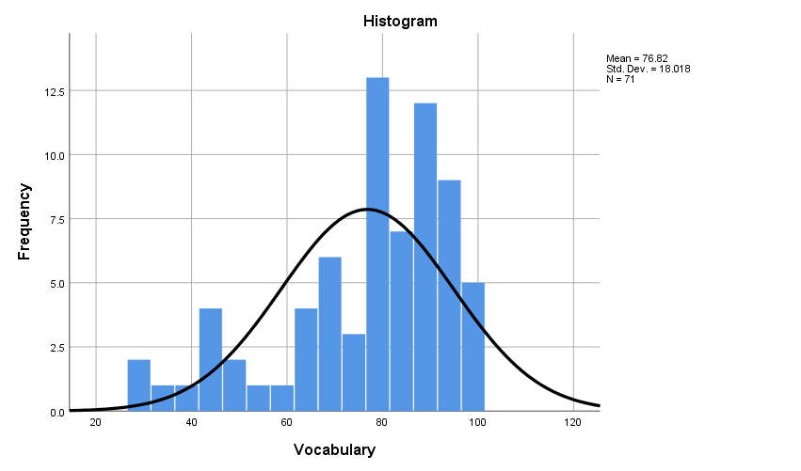
Figure 1. The Frequency Analysis of Vocabulary Mastery
The result of the writing ability test showed that 0 students were in the very poor category with a percentage of 0%. 0 students were in the poor category with a percentage of 0%. 8 students were in the average category with a percentage of 11%. 57 students were in the good category with a percentage of 79%, and 8 students were in the very good category with a percentage of 11%.
Table 3. The Score Distribution for Writing Ability
Category | Score | Writing Ability
 |  | Frequency | Percentage
Very Good | 86-100 | 7 | 10%
Good | 71-85 | 57 | 79%
Average | 52-70 | 8 | 11%
Poor | 36-51 | 0 | 0%
Very Poor | 0-35 | 0 | 0%
Total |  | 72 | 100%

Furthermore, Figure 2 below shows the writing ability.

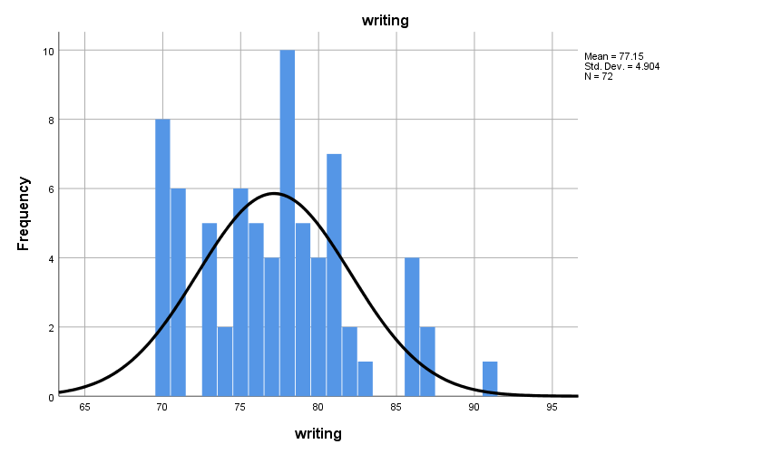

Figure 2. The Frequency Analysis of Writing Ability

3. Normality Test

In this research, to determine whether or not the data on writing ability and vocabulary mastery were distributed normally, the normality test was employed. It was calculated by using the residual normality of Kolmogorov-Smirnov that is presented in Table 4.

Table 4. The Normality Test
 |  | Unstandardized Residual
N |  | 72
Normal Parameters a, b | Mean | .0000000
 | Std. Deviation | 4.88068409
Most Extreme Differences | Absolute | .075
 | Positive | .075
 | Negative | -.062
Test Statistic |  | .075
Asymp. Sig. (2-tailed) |  | .200^{c,d}
a. Test distribution is normal.
b. Calculated from data.
c. Lilliefors Significance Correction.
d. This is a lower bound of the true significance.

It was found that the data from the normality test of vocabulary mastery and writing ability showed 0.200 > 0.05; it means that the data was normally distributed.

4. Correlation Analysis

Regression analysis was utilized in this research to look at how much vocabulary mastery contributed toward writing ability that is presented in Table 5.

Table 5. The Homogeneity Test
Model | R | R Square | Adjusted R-Square | Standard Error of the Estimate
1 | .066ª | .004 | -.010 | 18.754
a. Predictors: (Constant), writing

Based on the table above, it was found that the correlation value (R) was .066 from the output data, and the coefficient of determination (R Square) was .004. It means that the contribution of vocabulary mastery toward writing ability was .004. It could be concluded that vocabulary mastery only contributed as much as 0.04% toward writing ability.

5. Regression Analysis
Regression analysis was utilized in this research to look at how much vocabulary mastery contributed toward writing ability that is presented in Table 6.

Table 6. Regression Analysis
Model | R | R Square | Adjusted R-Square | Std. Error of the Estimate Estimate
1 | .066ª | .004 | -.010 | 18.754
a. Predictors: (Constant), writing

Based on the table above, it was found that the correlation value (R) was .066 from the output data, and the coefficient of determination (R Square) was 0.004. It means that the contribution of vocabulary mastery toward writing ability was 0.004. It could be concluded that vocabulary mastery only contributed as much as 0.04% toward writing ability.

Discussion
This study primarily aimed to examine whether vocabulary mastery significantly contributes to students’ writing ability. The findings from the correlational and regression analyses provide important insights into the strength and nature of the relationship between these two variables.
The correlational analysis revealed that the correlation coefficient (R) between vocabulary mastery and writing ability was 0.066. This value indicates a very weak positive correlation. Although the direction of the relationship is positive—meaning that higher vocabulary mastery tends to be associated with slightly higher writing scores—the magnitude of the relationship is extremely small.
A correlation coefficient close to zero suggests that the two variables are almost unrelated in practical terms. In this study, the value of 0.066 falls within the category of negligible correlation. This implies that improvements in vocabulary mastery are not strongly accompanied by improvements in writing ability among the participants.
The weak correlation indicates that vocabulary mastery, as measured in this study, does not appear to be a determining factor in explaining differences in students’ writing performance. While vocabulary is theoretically considered an essential component of writing, the statistical evidence here suggests that its direct linear relationship with writing scores is minimal.
The regression analysis further supports the findings of the correlation test. The coefficient of determination (R-squared) was 0.004. This means that vocabulary mastery explains only 0.4% of the variance in writing ability (not 0.04%, but 0.4% when expressed as a percentage).
An R-squared value of 0.004 indicates that 99.6% of the variance in writing ability is explained by other factors not included in this model. In practical terms, vocabulary mastery contributes almost nothing to predicting students’ writing performance in this sample.
Additionally, the adjusted R-squared value was negative (-0.010). A negative adjusted R-squared suggests that the regression model does not improve prediction accuracy compared to simply using the mean of the dependent variable. This further confirms that vocabulary mastery is not a meaningful predictor of writing ability in this study.
The standard error of the estimate (18.754) also indicates considerable prediction error in the regression model, reinforcing the conclusion that vocabulary mastery alone is insufficient to predict writing performance accurately.

CONCLUSION
Two conclusions could be made considering the study's findings and interpretation. First, the correlation coefficient was .030; it indicated the low category of the correlation coefficient. It could be assumed that the score of vocabulary mastery was independent of the score of writing ability. So, Ho 1 (null hypothesis) was accepted and Ha 1 (alternative hypothesis) was rejected.
Second, regression analysis revealed that the output data had a correlation value (R) of .066 and a coefficient of determination (R Square) of. 004. It indicates that mastery of language contributed. 004 to writing skill. It could conclude that the contribution of language mastery to writing skill was only 0.04%. It indicates that the null hypothesis (Ha2) was rejected and the alternative hypothesis (Ho2) was accepted.
Teachers must take an active part in encouraging students to write better and expand their vocabulary. Then, students should work harder to improve their writing and vocabulary. To succeed, students must enhance their vocabulary mastery and writing abilities. Also, the institution needs more media, and facilities should be provided by the school to assist the teaching and learning process; teachers and the institution should work together to achieve educational goals. Finally, the researcher wants to advise other researchers to be able to control the classroom situation in the learning process so that they can focus on learning and obtain satisfactory results.

REFERENCES
Adler, A. (2017). Positive education: Educating for academic success and for a fulfilling life. Papeles del Psicólogo, 38(1), 50–57.
Anggraini, R., Rozimela, Y., & Anwar, D. (2020). The effects of collaborative writing on EFL learners' writing skills and their perception of the strategy. Journal of Language Teaching and Research, 11(2), 335–341. https://doi.org/10.17507/jltr.1102.17
Cote, C. (2021, December 14). What is regression analysis in business analytics?
Dalimunthe, M. R. (2021). The effect of using sequence pictures on students’ writing descriptive text at the XI students of SMA Sista Kampus Padangsidimpuan. Jurnal Liner (Language Intelligence and Educational Research), 4(2), 13–26.
Firman, F., Mirnawati, M., Sukirman, S., & Aswar, N. (2020). The relationship between student learning types and Indonesian language learning achievement in FTIK IAIN Palopo students. Jurnal Konsepsi, 9(1), 1–12.
Fraenkel, J. R., Wallen, N. E., & Hyun, H. H. (2012). How to design and evaluate research in education (8th ed.). McGraw-Hill.
Haryadi, R. N., Endah, J., & Dalimunthe, L. (2021). The effects of vocabulary and grammar mastery on students’ writing skill in descriptive text. Journal of Literate of English Education Research Program (JLE), 2(2), 46–54.
Irawan, R. (2023). The use of short animated movies to improve students’ skill in writing descriptive text. Didascein: Journal of English Education, 4(1), 60–67.
Laili, E. N. (2022). The correlation between students’ vocabulary mastery and writing skill at SMK Negeri 2 Ponorogo (Doctoral dissertation, IAIN Ponorogo).
Malik, M. (2019). Writing skills development among students with deafness at elementary level. Bulletin of Education and Research, 41(1), 1–16.
Obilor, E. I. (2023). Convenience and purposive sampling techniques: Are they the same. International Journal of Innovative Social & Science Education Research, 11(1), 1–7.
Rahmati, U. (2018). The correlation between vocabulary mastery and students' writing skill (Doctoral dissertation, UIN Ar-Raniry Banda Aceh).
Randika, A. (2018). The correlation between grammatical mastery and descriptive writing mastery of the tenth-grade students of SMA Negeri 1 Indralaya.
Sahalluddin, M., & Akbariah, Y. (2023). Improving students’ ability in writing descriptive text through picture series. In Prosiding Seminar Nasional Pendidikan Profesi Guru (Vol. 1, No. 1, pp. 1105–1112).
Sari, S. N., & Aminatun, D. (2021). Students’ perception on the use of English movies to improve vocabulary mastery. Journal of English Language Teaching and Learning, 2(1), 16–22.
Soma, R. (2025). Using YouTube videos to enhance EFL students’ vocabulary mastery. Didascein: Journal of English Education, 6(1), 38–47.
Toba, R., & Noor, W. N. (2019). The current issues of Indonesian EFL students’ writing skills: Ability, problems, and reasons in writing comparison and contrast essay. Dinamika Ilmu, 19(1), 57–73. https://doi.org/10.21093/di.v19i1.1506
Ulfa, F., Sudrajad, W., & Sulistyaningsih, S. (2023). Increasing students’ ability to write descriptive text using the brainstorming method. International Journal of English and Applied Linguistics (IJEAL), 3(2), 109–118.

