THE RELATIONSHIP BETWEEN STUDENTS’ LEARNING MOTIVATION AND THEIR ENGLISH ACHIEVEMENT

ABSTRACT: Learning motivation is considered one of the factors that may influence students’ academic achievement, especially in learning English as a foreign language. This study aimed to investigate the relationship between students’ learning motivation and their English achievement among fourth-semester students of the English Education Department. The study employed a quantitative correlational research design. Data were collected using a learning motivation questionnaire distributed through Google Form and students’ English achievement scores obtained from academic records. The questionnaire consisted of positive and negative statements related to students’ motivation in learning English and employed a five-point Likert scale ranging from Strongly Agree to Strongly Disagree. The participants of this study were 20 fourth-semester students of the English Education Department. The data were analyzed using descriptive statistics, the Shapiro–Wilk normality test, and Spearman Rank Correlation. The findings showed that most students demonstrated high levels of learning motivation and satisfactory English achievement. The correlation analysis revealed a low positive relationship between students’ learning motivation and English achievement (ρ = 0.229). However, the significance value (p = 0.330) indicated that the relationship was not statistically significant. These findings suggest that learning motivation alone may not significantly determine students’ English achievement, as academic performance may also be influenced by other factors such as learning strategies, teaching methods, self-confidence, and classroom environment. The findings of this study are expected to contribute to English teaching practice by encouraging lecturers to maintain students’ motivation through meaningful learning activities, constructive feedback, collaborative learning, and supportive classroom environments.
Keywords: learning motivation, English achievement, correlation, EFL

HUBUNGAN ANTARA MOTIVASI BELAJAR SISWA DAN PRESTASI BAHASA INGGRIS MEREKA
ABSTRAK: Motivasi belajar dianggap sebagai salah satu faktor yang dapat mempengaruhi prestasi akademik mahasiswa, khususnya dalam pembelajaran bahasa Inggris sebagai bahasa asing. Penelitian ini bertujuan untuk mengetahui hubungan antara motivasi belajar mahasiswa dan prestasi belajar bahasa Inggris mereka pada mahasiswa semester empat Program Studi Pendidikan Bahasa Inggris. Penelitian ini menggunakan desain penelitian kuantitatif korelasional. Data dikumpulkan melalui angket motivasi belajar yang disebarkan menggunakan Google Form dan nilai prestasi bahasa Inggris mahasiswa yang diperoleh dari catatan akademik. Angket terdiri atas pernyataan positif dan negatif yang berkaitan dengan motivasi mahasiswa dalam belajar bahasa Inggris serta menggunakan skala Likert lima poin yang berkisar dari Sangat Setuju hingga Sangat Tidak Setuju. Partisipan dalam penelitian ini adalah 20 mahasiswa semester empat Program Studi Pendidikan Bahasa Inggris. Data dianalisis menggunakan statistik deskriptif, uji normalitas Shapiro–Wilk, dan Korelasi Peringkat Spearman (Spearman Rank Correlation). Hasil penelitian menunjukkan bahwa sebagian besar mahasiswa memiliki tingkat motivasi belajar yang tinggi dan prestasi bahasa Inggris yang memuaskan. Analisis korelasi menunjukkan adanya hubungan positif yang rendah antara motivasi belajar mahasiswa dan prestasi bahasa Inggris mereka (ρ = 0,229). Namun, nilai signifikansi (p = 0,330) menunjukkan bahwa hubungan tersebut tidak signifikan secara statistik. Temuan ini menunjukkan bahwa motivasi belajar saja tidak secara signifikan menentukan prestasi bahasa Inggris mahasiswa, karena prestasi akademik juga dapat dipengaruhi oleh faktor-faktor lain seperti strategi belajar, metode pengajaran, kepercayaan diri, dan lingkungan kelas. Hasil penelitian ini diharapkan dapat memberikan kontribusi terhadap praktik pengajaran bahasa Inggris dengan mendorong dosen untuk mempertahankan motivasi mahasiswa melalui kegiatan pembelajaran yang bermakna, umpan balik yang konstruktif, pembelajaran kolaboratif, dan lingkungan belajar yang mendukung.
Kata Kunci: motivasi belajar, prestasi bahasa Inggris, korelasi, EFL

INTRODUCTION
_{E}
nglish has become one of the most important international languages used in communication, education, technology, business, and global interaction. In Indonesia, English is taught as a foreign language and is considered an important subject in schools and universities. Through English learning, students are expected to develop language skills such as listening, speaking, reading, and writing. However, many students still experience difficulties in achieving satisfactory English learning outcomes.
Students’ academic achievement in English may be influenced by several internal and external factors. According to Slameto (2010), internal factors include intelligence, interest, attention, readiness, learning strategies, self-confidence, and motivation, while external factors include family environment, teaching methods, school facilities, and social interaction. Among these factors, motivation is considered one of the most influential variables because it affects students’ willingness to engage in learning activities and achieve academic goals. Woolfolk (2007) states that motivated students tend to demonstrate greater effort, persistence, and engagement during the learning process, which may positively influence their academic achievement.
Learning motivation refers to the internal and external encouragement that drives students to participate in learning activities and achieve academic goals. According to Uno (2016), learning motivation is characterized by students’ desire to succeed, learning needs and encouragement, future goals and aspirations, appreciation in learning, interesting learning activities, and a conducive learning environment. Dörnyei (2001) argues that motivation determines why learners decide to learn, how much effort they invest, and how long they sustain learning activities. Similarly, Deci and Ryan (1985) emphasize that motivation plays a crucial role in directing and maintaining students’ learning behavior. Students with strong learning motivation usually show greater enthusiasm, responsibility, persistence, and participation during classroom activities. They are also more willing to spend time practicing English skills and completing assignments seriously (Woolfolk, 2007).
In learning English as a foreign language, motivation becomes highly important because language learning requires continuous practice and active participation. Students with high motivation are generally more confident and active in using English during classroom activities. As a result, motivated students tend to achieve better academic performance compared to students with lower motivation. Gardner (2001) explains that motivation is one of the primary determinants of success in second-language acquisition because motivated learners are more willing to invest effort and maintain long-term engagement in language learning activities.
Several previous studies have reported that motivation has a positive relationship with students’ academic achievement. Gardner and Lambert (1972) found that motivated language learners tend to achieve better learning outcomes because they are more actively engaged in language-learning activities. Zimmerman (2000) reported that motivated students generally demonstrate stronger self-regulation and higher academic performance. Dörnyei (2001) also stated that learning motivation significantly contributes to students’ success in foreign language learning. Furthermore, Widiati and Cahyono (2006) highlighted the importance of motivation in supporting successful English language learning in the Indonesian context.
Although numerous studies have reported a positive relationship between learning motivation and academic achievement, the strength of this relationship may vary across educational contexts, institutions, and student characteristics. In addition, limited studies have specifically investigated the relationship between students’ learning motivation and English achievement among fourth-semester students of the English Education Department in the present research setting. Therefore, this study was conducted to provide empirical evidence regarding whether students’ learning motivation is significantly related to their English achievement in this particular context. The findings are expected to contribute to the understanding of motivational factors affecting English learning and provide practical implications for improving English teaching and learning.
Based on the explanations above, the researcher is interested in conducting a study entitled “The Relationship Between Students’ Learning Motivation and Their English Achievement.” This study aims to determine whether there is a significant relationship between students’ learning motivation and their English achievement.

METHODOLOGY
Research Design
This study employed a quantitative correlational research design. Quantitative research is used to collect and analyze numerical data statistically, while correlational research aims to determine the relationship between two variables (Creswell, 2014). In this study, students’ learning motivation was treated as the independent variable (X), while students’ English achievement was treated as the dependent variable (Y). The purpose of this study was to investigate whether there was a significant relationship between students’ learning motivation and their English achievement.
Participants
The population of this study consisted of fourth-semester students of the English Education Department. The total population was 20 students. Since the population was relatively small, all members of the population were selected as the sample. Therefore, the sample consisted of 20 fourth-semester students of the English Education Department.
The sampling technique used in this study was total sampling. According to Sugiyono (2019), total sampling is a sampling technique in which all members of the population are selected as the research sample. This technique was considered appropriate because all students met the criteria required for the study and were accessible to the researcher.
Research Procedure
The research procedure consisted of four stages. First, the researcher identified the research problem and reviewed relevant literature concerning learning motivation and English achievement. Second, the researcher prepared the research instruments and distributed the learning motivation questionnaire through Google Form. Third, the researcher collected students’ motivation data from the questionnaire and obtained students’ English achievement scores from academic records. Finally, the collected data were analyzed using descriptive statistics, normality testing, and correlation analysis to determine the relationship between students’ learning motivation and their English achievement.
Figure 1. Research Procedure
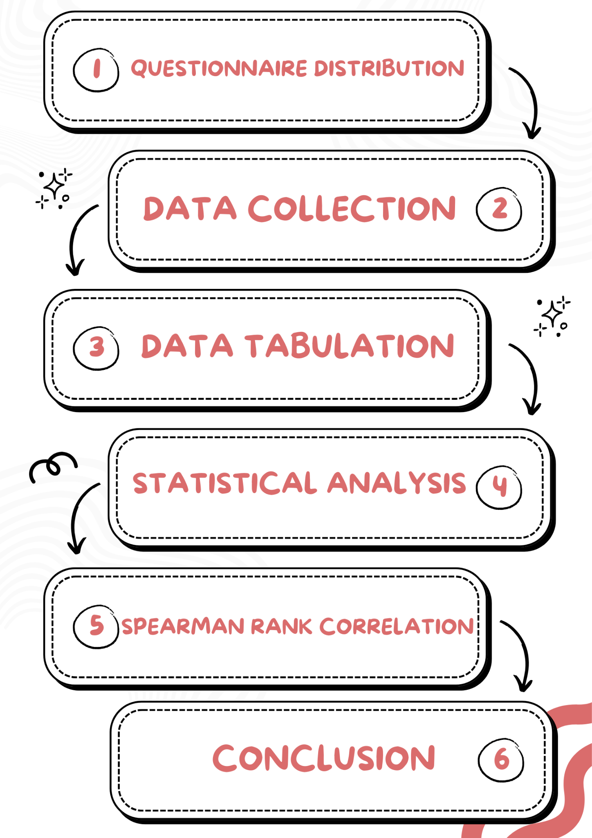
Research Instruments
This study employed two instruments corresponding to the variables investigated.
The first instrument was a learning motivation questionnaire used to measure students’ learning motivation. The questionnaire consisted of positive and negative statements based on the indicators of learning motivation proposed by Uno (2016), namely: (1) desire to succeed, (2) learning needs and encouragement, (3) future goals and aspirations, (4) appreciation in learning, (5) interesting learning activities, and (6) a conducive learning environment. The questionnaire employed a five-point Likert scale.
Table 2. Questionnaire Scale Classification
Scale | Category
5 | Strongly Agree
4 | Agree
3 | Neutral
2 | Disagree
1 | Strongly Disagree
The second instrument was students’ English achievement scores. The scores were obtained from academic records and were used to represent students’ achievement in English learning.
Data Collection Technique
The data were collected using two techniques. First, the researcher distributed the learning motivation questionnaire through Google Form to obtain information regarding students’ motivation in learning English. Second, students’ English achievement scores were collected from academic records. After all data had been collected, the researcher organized and prepared the data for analysis.
Data Analysis Technique
The data were analyzed using descriptive and inferential statistics. Descriptive statistics were used to describe students’ learning motivation and English achievement through frequencies and percentages.
Before conducting the correlation analysis, a normality test was performed using the Shapiro–Wilk test. The results indicated that the significance values of both variables were below 0.05, meaning that the data were not normally distributed. Therefore, Spearman Rank Correlation was employed to determine the relationship between students’ learning motivation and English achievement.
The significance level used in this study was 0.05.
Table 3. Correlation Coefficient Interpretation
Correlation Coefficient | Interpretation
0.00–0.20 | Very Low Correlation
0.21–0.40 | Low Correlation
0.41–0.60 | Moderate Correlation
0.61–0.80 | High Correlation
0.81–1.00 | Very High Correlation

FINDINGS AND DISCUSSION
FINDINGS
Descriptive Analysis of Students’ Learning Motivation
The students’ learning motivation data were obtained from the questionnaire completed by 20 fourth-semester students of the English Education Department. The results are presented in Table 4.
Table 4. Students’ Learning Motivation Level
Category | Frequency | Percentage
Very High | 5 | 25%
High | 10 | 50%
Moderate | 4 | 20%
Low | 0 | 0%
Very Low | 1 | 5%
Total | 20 | 100%
Based on Table 4, the majority of students demonstrated positive learning motivation. Ten students (50%) were categorized as having high motivation, while five students (25%) were categorized as having very high motivation. Four students (20%) showed moderate motivation, and only one student (5%) demonstrated very low motivation. These findings indicate that most students possessed positive attitudes toward learning English and were willing to participate actively in learning activities.
Descriptive Analysis of Students’ English Achievement
Students’ English achievement data were obtained from academic records. The results are presented in Table 5.
Table 5. Students’ English Achievement
Score Interval | Category | Frequency | Percentage
86–100 | Very Good | 12 | 60%
71–85 | Good | 8 | 40%
56–70 | Fair | 0 | 0%
41–55 | Poor | 0 | 0%
≤ 40 | Very Poor | 0 | 0%
Total | 20 | 100%
As shown in Table 5, twelve students (60%) achieved scores in the Very Good category, while eight students (40%) were classified in the Good category. No students were categorized as Fair, Poor, or Very Poor. These findings indicate that the participants generally demonstrated satisfactory achievement in English learning.
Normality Test
Before conducting the correlation analysis, a normality test was performed using the Shapiro–Wilk test to determine whether the data met the assumptions required for parametric analysis. The results are presented in Table 6.
Table 6. Normality Test Results
Variable | Statistic | Sig. Value | Interpretation
Learning Motivation | 0.873 | 0.013 | Not Normally Distributed
English Achievement | 0.787 | 0.001 | Not Normally Distributed
Based on Table 6, the significance values of both variables were lower than 0.05. Therefore, the data were not normally distributed. Consequently, Spearman Rank Correlation was used to analyze the relationship between students’ learning motivation and English achievement.
Correlation Analysis
The correlation analysis was conducted using Spearman Rank Correlation to determine the relationship between students’ learning motivation and English achievement. The results are presented in Table 7.
Table 7. Spearman Rank Correlation Result
Variables | Correlation Coefficient (ρ) | Sig. Value | Interpretation
Students’ Learning Motivation and English Achievement | 0.229 | 0.330 | Low Correlation
Table 7 shows that the correlation coefficient between students’ learning motivation and English achievement was 0.229. According to the correlation coefficient interpretation criteria, this value indicates a low positive correlation. Furthermore, the significance value obtained was 0.330, which is greater than the significance level of 0.05. This result indicates that the relationship between students’ learning motivation and English achievement was not statistically significant.
Therefore, although students with higher learning motivation tended to achieve slightly better English scores, learning motivation did not demonstrate a significant relationship with English achievement among the participants of this study. Thus, the null hypothesis (H₀) was accepted, while the alternative hypothesis (H₁) was rejected.
DISCUSSION
The findings of this study revealed that most students demonstrated high levels of learning motivation and satisfactory achievement in English learning. The majority of participants were categorized as having high or very high motivation, indicating positive attitudes toward learning English and willingness to engage in learning activities. In addition, all participants achieved scores within the good and very good categories, suggesting that they generally performed well in English learning.
The correlation analysis revealed a low positive relationship between students’ learning motivation and English achievement (ρ = 0.229). However, the significance value (p = 0.330) was higher than the significance level of 0.05, indicating that the relationship was not statistically significant. This finding suggests that although students with higher motivation tended to achieve slightly better English scores, learning motivation alone did not significantly influence English achievement among the participants in this study.
The findings partially support the theory proposed by Gardner and Lambert (1972), who argued that motivation plays an important role in second-language learning because motivated learners are more likely to participate actively in learning activities and maintain their engagement throughout the learning process. Similarly, Dörnyei (2001) emphasized that motivation influences learners’ effort, persistence, and commitment in achieving learning goals. The positive direction of the correlation found in this study is consistent with these theoretical perspectives.
However, the findings differ from those reported by Zimmerman (2000), who found that highly motivated students generally demonstrate stronger self-regulated learning behaviors and achieve better academic performance. Unlike Zimmerman’s findings, the present study did not identify a statistically significant relationship between motivation and English achievement. This difference may be attributed to the relatively small sample size and the influence of additional variables that were not examined in this study.
The findings also contrast with the theory of Deci and Ryan (1985), who emphasized that motivation, particularly intrinsic motivation, contributes substantially to successful learning outcomes. Although most students in the present study demonstrated high levels of motivation, the statistical analysis suggested that motivation alone was insufficient to explain variations in English achievement.
Furthermore, the findings support Woolfolk’s (2007) view that academic achievement is influenced by multiple psychological and environmental factors. Students’ achievement may be affected by learning strategies, self-confidence, classroom participation, teaching methods, family support, learning facilities, and exposure to English outside the classroom. Consequently, these factors may have contributed more strongly to students’ English achievement than motivation alone.
The results of this study indicate that learning motivation remains an important factor in encouraging students’ engagement and positive attitudes toward English learning. However, educators should not rely solely on motivation when attempting to improve students’ academic achievement. Effective teaching strategies, supportive learning environments, meaningful learning activities, and opportunities for active language use are also essential in promoting successful English learning outcomes.
Based on these findings, future researchers are encouraged to investigate additional variables that may influence English achievement and to involve larger samples from different educational contexts. Such studies may provide a more comprehensive understanding of the factors affecting students’ success in learning English as a foreign language.
CONCLUSION
This study aimed to investigate the relationship between students’ learning motivation and their English achievement among fourth-semester students of the English Education Department. The findings revealed that most students demonstrated high levels of learning motivation and satisfactory performance in English learning. The majority of students were categorized as having high or very high motivation, while all participants achieved scores within the good and very good categories.
The correlation analysis using Spearman Rank Correlation revealed a low positive relationship between students’ learning motivation and English achievement (ρ = 0.229). However, the significance value (p = 0.330) was higher than the significance level of 0.05, indicating that the relationship was not statistically significant. Therefore, learning motivation did not demonstrate a significant relationship with students’ English achievement among the participants of this study.
These findings suggest that although motivated students tended to obtain slightly better English scores, learning motivation alone was not a strong predictor of English achievement. Students’ academic performance may also be influenced by other factors such as learning strategies, teaching methods, classroom environment, self-confidence, language exposure, and family support.
Based on these findings, lecturers are encouraged to maintain students’ motivation through engaging learning activities, constructive feedback, collaborative learning opportunities, and supportive classroom environments. Future researchers are recommended to investigate additional variables affecting English achievement and to involve larger samples from different educational contexts in order to obtain a more comprehensive understanding of factors contributing to students’ academic success.

REFERENCE

Brown, H. D. (2000). Principles of language learning and teaching (4th ed.). Longman.

Creswell, J. W. (2014). Research design: Qualitative, quantitative, and mixed methods approaches (4th ed.). Sage Publications.

Deci, E. L., & Ryan, R. M. (1985). Intrinsic motivation and self-determination in human behavior. Plenum Press.

Dörnyei, Z. (2001). Motivational strategies in the language classroom. Cambridge University Press.

Dörnyei, Z. (2005). The psychology of the language learner: Individual differences in second language acquisition. Lawrence Erlbaum Associates.

Ellis, R. (1997). Second language acquisition. Oxford University Press.

Field, A. (2018). Discovering statistics using IBM SPSS statistics (5th ed.). Sage Publications.

Gardner, R. C. (2001). Integrative motivation and second language acquisition. University of Western Ontario.

Gardner, R. C., & Lambert, W. E. (1972). Attitudes and motivation in second-language learning. Newbury House Publishers.

Harmer, J. (2007). The practice of English language teaching (4th ed.). Pearson Education.

Maslow, A. H. (1943). A theory of human motivation. Psychological Review, 50(4), 370–396.

Nation, I. S. P. (2001). Learning vocabulary in another language. Cambridge University Press.

Richards, J. C., & Renandya, W. A. (Eds.). (2002). Methodology in language teaching: An anthology of current practice. Cambridge University Press.

Slameto. (2010). Belajar dan faktor-faktor yang mempengaruhinya. Rineka Cipta.

Sugiyono. (2019). Metode penelitian kuantitatif, kualitatif, dan R&D. Alfabeta.

Uno, H. B. (2016). Teori motivasi dan pengukurannya: Analisis di bidang pendidikan. Bumi Aksara.

Widiati, U., & Cahyono, B. Y. (2006). The teaching of EFL speaking in the Indonesian EFL context. TEFLIN Journal, 17(1), 35–44.

Woolfolk, A. (2007). Educational psychology (10th ed.). Pearson Education.

Yusuf, S. (2011). Psikologi perkembangan anak dan remaja. Remaja Rosdakarya.

Zimmerman, B. J. (2000). Self-efficacy: An essential motive to learn. Contemporary Educational Psychology, 25(1), 82–91.

