PROFILING PRE-SERVICE TEACHERS’ DIGITAL LITERACY LEVELS: A SURVEY RESEARCH

Oni Setiawan Peranginangin, Rahma Dianti, Heru Setiawan
Universitas Tridinanti
Onicoo098@gmai.com, rahma_dianti@univ-tridinanti.ac.id, herusetiawan@univ-tridinanti.ac.id
ABSTRACT: The increasing use of digital technology in higher education has made digital literacy an essential skill, especially for students who are preparing to become teachers. This study aims to profile the level and the dimensions of digital literacy among pre-service teacher students of the Faculty of Teacher Training and Education at Tridinanti University. This research used a quantitative method with a cross-sectional survey design, involving 144 pre-service teacher students selected through total sampling. Data were collected using a Digital Literacy Scale (DLS), consisting of nine dimensions of digital literacy originally proposed by Chen (2015) and operationalized in the digital literacy scale developed by Amin et al. (2021). The obtained data were analyzed using mean score and percentage analysis. The results show that, in general, students already have a good level of digital literacy. The results of the percentage analysis showed that they tend to perform well in areas such as citizenship (ethical awareness), creativity, and collaboration in digital environments. However, some aspects, particularly those related to managing information and maintaining digital connections, are still not as strong. These findings indicate that although students are quite ready to participate in technology-based learning, there is still a need to improve their ability to critically evaluate and manage information. Overall, this study highlights the importance of strengthening digital literacy as part of teacher education programs.
Keywords: digital literacy, levels, preservice teachers, higher education, domain

PROFIL TINGKAT LITERASI DIGITAL CALON GURU: SEBUAH PENELITIAN SURVEI
ABSTRAK: Meningkatnya penggunaan teknologi digital dalam pendidikan tinggi telah menjadikan literasi digital sebagai keterampilan esensial, khususnya bagi mahasiswa yang sedang mempersiapkan diri menjadi guru. Penelitian ini bertujuan untuk memprofilkan tingkat dan dimensi literasi digital pada mahasiswa calon guru di Fakultas Keguruan dan Ilmu Pendidikan Universitas Tridinanti. Penelitian ini menggunakan metode kuantitatif dengan desain survei potong lintang, melibatkan 144 mahasiswa calon guru yang dipilih melalui total sampling. Data dikumpulkan menggunakan Digital Literacy Scale (DLS) yang terdiri atas sembilan dimensi literasi digital yang awalnya dikemukakan oleh Chen (2015) dan dioperasionalisasikan dalam skala literasi digital yang dikembangkan oleh Amin dkk. (2021). Data yang diperoleh dianalisis menggunakan skor rata-rata dan analisis persentase. Hasil penelitian menunjukkan bahwa secara umum mahasiswa telah memiliki tingkat literasi digital yang baik. Analisis persentase memperlihatkan bahwa mereka cenderung unggul dalam aspek kewargaan (kesadaran etis), kreativitas, dan kolaborasi di lingkungan digital. Namun, beberapa aspek, khususnya yang berkaitan dengan pengelolaan informasi dan pemeliharaan koneksit digital, masih belum sekuat aspek lainnya. Temuan ini mengindikasikan bahwa meskipun mahasiswa cukup siap untuk berpartisipasi dalam pembelajaran berbasis teknologi, tetap diperlukan peningkatan kemampuan dalam mengevaluasi dan mengelola informasi secara kritis. Secara keseluruhan, penelitian ini menekankan pentingnya penguatan literasi digital sebagai bagian dari program pendidikan guru.
Kata Kunci: literasi digital, tingkat, calon guru, pendidikan tinggi, dimensi
INTRODUCTION
T
he rapid advancement of digital technology has reshaped how information is accessed, processed, and communicated in contemporary society. In higher education, this transformation has led to a growing emphasis on digital literacy as a fundamental competency that supports students’ academic engagement and participation in technology-mediated learning environments. Digital literacy is no longer limited to the operational use of digital tools but extends to the ability to critically evaluate information, communicate effectively, and engage responsibly in digital contexts (OECD, 2019; UNESCO, 2018).
From a conceptual perspective, digital literacy is widely understood as a multidimensional construct. It encompasses a range of competencies, including accessing, analyzing, evaluating, and creating information through digital media (Gilster, 1997). Building on this conceptualization, Chen (2015) proposed a nine-dimension framework, comprising communication, collaboration, critical thinking, creativity, citizenship, character, curation, copyright, and connectedness, that captures the cognitive, social, and behavioral dimensions individuals need to navigate complex digital environments effectively. This framework was later operationalized into a validated measurement scale by Amin et al. (2021), which forms the basis of the present study’s instrument. These competencies are particularly important in higher education, where students are required to interact with diverse digital resources and actively participate in online learning processes.
Previous studies have reported that students’ digital literacy levels vary across different contexts. Kaya and Korucuk (2022) found that university students’ digital literacy tends to be influenced by demographic and contextual factors, often resulting in uneven competency levels. Similarly, Listiana and Sari (2025) reported that students in Indonesia generally demonstrate moderate levels of digital literacy, which are often constrained by access to technology and limited digital experience. In the context of higher education, Farid et al. (2024) observed that students face challenges in evaluating the credibility of digital information, while Simanjuntak et al. (2024) highlighted that although students are proficient in using digital tools, their competencies in critical thinking and digital safety remain relatively limited.
In addition to these findings, digital literacy has also been linked to students’ ability to engage in meaningful learning processes. Malik et al. (2020) emphasize that digital literacy supports students’ learning autonomy, enabling them to manage information and learning resources more effectively. Furthermore, Hanim et al. (2025) point out that patterns of digital media use can influence how students interpret information and develop their learning strategies. This suggests that digital literacy is shaped not only by formal education but also by students’ daily interactions with digital technologies.
Despite the growing body of research, most previous studies, both internationally and within the Indonesian context (Simanjuntak et al., 2024; Listiana & Sari, 2025; Wardhani et al., 2019; Islamia & Arif, 2024), have focused on general student populations and general competencies such as information retrieval, communication, and device security, without specifically addressing the context of teacher education or examining how competencies are distributed across Chen’s (2015) nine dimensions. This represents a significant gap, considering that prospective teachers are expected not only to master digital technologies but also to model ethical, creative, and collaborative digital practices for their future students. This gap has taken on added urgency in the post-pandemic era, where the growing reliance on online platforms requires students not only to access information but also to evaluate its credibility, manage digital content, and collaborate effectively in virtual settings, competencies that a dimension-specific profile can help identify more precisely than an aggregate literacy score.
The novelty of this research lies in its application of the Digital Literacy Scale (Amin et al., 2021) across Chen’s (2015) nine dimensions to undergraduate students in a teacher education faculty. While previous studies in Indonesia have generally assessed students’ digital literacy at a broad level, this study provides a dimension-specific profile. By situating the analysis within the Faculty of Teacher Training and Education at Tridinanti University, the study contributes new empirical evidence on the digital readiness of prospective teachers. This dimension-based approach offers a more comprehensive understanding of digital literacy development and highlights specific competencies that are critical for preparing future educators to integrate technology effectively and responsibly into their teaching practice.
Based on these considerations, this study aims to investigate the level and the most dominant dimension of digital literacy among undergraduate students of the Faculty of Teacher Training and Education at Tridinanti University. By focusing on this specific context, the study seeks to provide empirical evidence that contributes to a deeper understanding of students’ digital readiness, particularly in preparing prospective teachers to face the challenges of technology-integrated education.

METHODOLOGY
- Research Design
This research used a quantitative approach with a survey design to profile the level of digital literacy among pre-service teachers at Tridinanti University. A quantitative survey design was adopted because it enables systematic, measurable data collection from a large respondent group, allowing general patterns in students’ digital literacy to be identified (Creswell, 2012). In addition, the study applied a cross-sectional design, where the data were collected at one point in time to reflect the current condition of students’ competencies.

- Research Population and Sample
The study was carried out at the Faculty of Teacher Training and Education, Tridinanti University. The participants were pre-service teacher students from the English Education Department and the Indonesian Literature and Language Education Department in the academic year 2024/2025. In this research, total sampling was applied, resulting in all 144 students participating in the study. Total sampling means that all members of the population were involved as respondents to obtain a more comprehensive representation of the data (Creswell, 2012; Cohen, Manion, & Morrison, 2007). Table 1 presents the distribution of the research population.

Table 1. Research participants
No | Department | Numbers of Participants
1 | English Education | 54
2 | Indonesian Literature & Language Education | 90
Total |  | 144

- Technique for Collecting Data
Data collection was conducted by distributing a Digital Literacy Scale (DLS) adopted from Amin et al. (2021), based on Chen’s (2015) nine-dimension framework of digital literacy. This scale has been widely used to measure digital literacy in higher education contexts. In responding to the questionnaire, the participants would assign 5 scales, starting from scale 1 to scale 5. Scale 1 assigns strongly disagree, scale 2 assigns disagree, scale 3 assigns undecided, scale 4 assigns agree, and scale 5 assigns strongly agree. The questionnaire covered nine dimensions of digital literacy, including communication, collaboration, critical thinking, creativity, citizenship, character, curation, copyright, and connectedness. Table 2 provides the item specification of the digital literacy scale.

Table 2. Item specification of digital literacy
No | Dimensions | Description | Numbers of Item
1 | Communication | online reading, writing, speaking, and listening skills | 7
2 | Collaboration | how to work with everyone online, not just with their friends | 4
3 | Critical Thinking | to solve problems, analyze deeply, and question frequently through the digital | 3
4 | Creativity | to become online content creators, not just consumers of knowledge | 3
5 | Citizenship. | to use technology responsibly and legally | 4
6 | Character | to be active advocates of online ethical practices, even if not legally required | 3
7 | Curation | to understand digital research skills and how to analyze the credibility of web content | 5
8 | Copyright | understanding, and following online and digital copyright laws | 4
9 | Connectedness | to become active participants and contribute to the global community by helping people online | 3

- Technique for Analyzing Data
The data obtained from the questionnaire were analyzed using descriptive statistics. The analysis focused on identifying the overall level of digital literacy as well as its distribution across different dimensions. Techniques such as mean scores and frequency analysis were used to interpret the findings and to highlight key patterns in the data. Through this approach, the study provides a clear overview of students’ digital literacy within the context of teacher education.
To measure the digital literacy skills of the pre-service teachers, the researchers first calculated the mean score from each student’s responses; then, the obtained mean scores of the respondents were categorized into five digital literacy levels using the class interval formula based on the range between the maximum and minimum possible scores (Sudjana, 2005). Table 3 presents the criteria for the digital literacy levels.

Table 3. Digital literacy level criteria
Mean Score | Digital Literacy Level
Very Low | 1.00-1.80
Low | 1.80-2.60
Medium | 2.61-3.40
High | 3.41-4.20
Very High | 4.21-5.00

FINDINGS AND DISCUSSION

Descriptive Data Analysis Results
To gain a comprehensive understanding of digital literacy skills among undergraduate students at Tridinanti University, a descriptive statistical analysis was conducted. This analysis presents data on the highest and lowest scores, the mean, and the standard deviation from the students’ responses. Table 4 presents the results of the descriptive data analysis.

Table 4. Descriptive data analysis
Sample | N | Highest Score | Lowest Score | Mean Score | Standard Deviation
Pre-service Teacher Students | 144 | 180 | 48 | 3.57 | 22.78

As shown in Table 4, the highest score was 180, the lowest score was 48, the mean score was 3.57, and the standard deviation was 22.78. These data profile the general condition of the pre-service teacher students at Tridinanti University. Based on the overall mean score (M = 3.57), it indicates that, in general, the pre-service teacher students of Tridinanti University were classified as high in digital literacy.

Level of Students’ Digital Literacy
Students’ digital literacy levels were analyzed using mean scores and frequency distributions derived from Likert scale responses. Scores were converted into percentages and classified according to predetermined level criteria. This classification provided a clear overview of how competencies were distributed across respondents. The results are presented in Table 5.

Table 5. The analysis results of digital literacy levels
Levels | Mean Score | Frequency | Percentage
Very Low | 1.00 – 1.80 | 4 Students | 2.78%
Low | 1.81 – 2.60 | 5 Students | 3.47%
Medium | 2.61 – 3.40 | 44 Students | 30.56%
High | 3.41 – 4.20 | 74 Students | 51.39%
Very High | 4.21 – 5.00 | 18 Students | 12.50%
Total |  | 144 Students | 100%

As shown in Table 5, more than half of the students (51.39%) fell into the high category and a further 12.50% into the very high category, meaning nearly two-thirds of respondents demonstrated strong digital literacy. Only a small minority were classified as low (3.47%) or very low (2.78%). To provide a clearer picture of this distribution, Figure 1 illustrates this distribution.

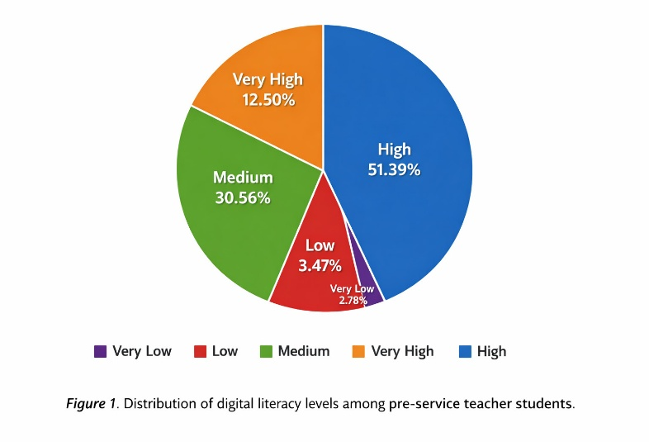
Figure 1. Digital literacy level distribution

Digital Literacy Dimensions
To identify which dimensions of digital literacy were most dominant among the pre-service teacher students at Tridinanti University, a mean score analysis was conducted. The mean score for each dimension of digital literacy was calculated, and the dimension with the highest mean score was considered the most prominent. This approach allowed the researchers to determine not only the overall level of digital literacy but also the specific areas in which students demonstrated stronger or weaker competencies. By examining the distribution of scores across dimensions, the analysis provides a clearer profile of students’ digital literacy, highlighting dominant skills such as citizenship (ethical awareness), creativity, and collaboration, while also identifying dimensions that require further reinforcement, such as curation, copyright, and connectedness (digital networking). Table 6 presents the results of the mean score analysis.

Table 6. The results of the mean score analysis
No | Dimension | Mean Score | Category
1 | Communication | 3.5 | High
2 | Collaboration | 3.8 | High
3 | Critical Thinking | 3.5 | High
4 | Creativity | 4.01 | High
5 | Citizenship. | 4.06 | High
6 | Character | 3.47 | High
7 | Curation | 3.09 | Medium
8 | Copyright | 3.16 | Medium
9 | Connectedness | 3.39 | Medium

The mean score analysis presented in Table 6 shows that the pre-service teacher students at Tridinanti University generally achieved high scores across most dimensions of digital literacy. The highest mean score was recorded in citizenship (M = 4.06), followed by creativity (M = 4.01) and collaboration (M = 3.80). These results suggest that the students demonstrate strong ethical awareness, creative engagement, and collaborative practices in digital environments. Other dimensions, such as communication (M = 3.50), critical thinking (M = 3.50), and character (M = 3.47), also fall within the high category, indicating relatively solid proficiency in these areas.
In contrast, three dimensions were categorized at the medium level: curation (M = 3.09), copyright (M = 3.16), and connectedness (M = 3.39). These findings highlight that while students are capable of accessing and using digital information, they have not yet fully mastered the skills required to critically evaluate, organize, and synthesize information, nor have they developed a strong awareness of copyright practices or global digital networking. This pattern points to areas where reinforcement is needed to ensure that students’ digital literacy extends beyond functional use toward more critical and responsible engagement. To visualize these differences more effectively, Figure 2 presents the mean scores for each dimension.

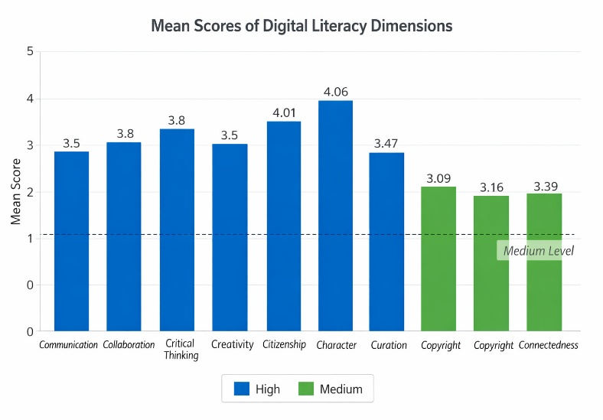
Figure 2. Mean scores of digital literacy dimensions

Discussion
The findings of this study indicate that pre-service teacher students of the Faculty of Teacher Training and Education at Tridinanti University generally demonstrate a high level of digital literacy, suggesting well-developed competencies to support academic engagement and social interaction in technology-mediated learning environments. This result aligns with previous research conducted by Dhita and Nurdiansyah (2022), which found that most FKIP students showed good to very good digital literacy skills and attitudes, while Yanti et al. (2021) similarly reported high digital literacy among Indonesian university students. These findings are further corroborated by Islamia and Arif (2024), who reported moderate to high digital literacy, particularly in information searching and communication, and by Putri and Kurniawati (2025), who found strengths in technical use, critical understanding, and communicative abilities. Together, these results reinforce the pattern that university students, including pre-service teachers, are increasingly equipped with the digital competencies needed for technology-mediated learning.
Dimension-level analysis reveals that citizenship achieved the highest mean score (M = 4.06), followed by creativity (M = 4.01) and collaboration (M = 3.80). The prominence of digital citizenship indicates that students possess a strong awareness of ethical norms, responsibilities, and appropriate behavior in digital environments. These findings are consistent with patterns reported elsewhere, where digital responsibility and ethical awareness tend to outpace more advanced critical evaluation skills (Zhao et al., 2023). This finding supports Belshaw’s (2011) emphasis on ethical and social dimensions of digital literacy and is reinforced by recent studies highlighting the importance of digital citizenship in countering misinformation and unethical online practices in higher education (Breakstone et al., 2023). High levels of creativity and collaboration further corroborate Jenkins’s (2009) theory of participatory culture, which posits that digital environments enable learners to act as content creators and collaborative participants. Recent evidence by Georgopoulou et al. (2025) similarly demonstrates that sustained exposure to digital platforms enhances students’ creative and collaborative academic practices.
In contrast, the dimensions of curation (M = 3.09), copyright (M = 3.16), and connectedness (M = 3.39) were categorized at a medium level. These results suggest that while students are capable of accessing digital information, they have not yet fully mastered the skills required to evaluate, organize, and synthesize information for academic purposes. This finding is consistent with Öncül (2021), who identified a gap between information access and information evaluation among university students. Moreover, the moderate level of copyright awareness indicates a distinction between conceptual understanding and practical application, a pattern also observed by Murray and Pérez (2022), who argued that students’ digital literacy often remains surface-level without explicit instructional support.
The communication, critical thinking, and character dimensions all achieved high mean scores (M = 3.50, 3.50, and 3.47, respectively), indicating relatively strong proficiency. The character dimension reflects students’ capacity for responsible self-management and integrity in digital contexts, closely related to, but conceptually distinct from, the citizenship dimension’s emphasis on ethical behavior toward others. Its comparatively high score suggests students are reasonably self-aware and disciplined in their digital conduct, though—as with communication and critical thinking—the absence of very high scores across these three dimensions suggests room for further development. Wineburg and McGrew (2017) emphasize that critical thinking in digital contexts requires advanced strategies such as lateral reading, which do not automatically develop through everyday technology use. This interpretation is further supported by Anthonysamy et al. (2020), who found that effective digital literacy development in higher education depends on structured self-regulated learning strategies rather than mere exposure to digital tools. Taken together, dimension-level findings demonstrate that students possess a solid foundation in digital literacy, particularly in ethical awareness, creativity, and collaboration. However, comparatively weaker performance in information curation, copyright application, and academic digital networking underscores the need for more systematic pedagogical interventions. In line with recommendations from UNESCO (2018) and the OECD (2019), digital literacy education should be embedded within the curriculum through project-based learning, explicit instruction in information evaluation, and training in intellectual property and digital networking. Such an approach would ensure that students’ digital literacy develops not only as a functional skill but also as a critical, reflective, and sustainable competence.

CONCLUSION
The overall levels of digital literacy among undergraduate students at Tridinanti University's Faculty of Teacher Training and Education were investigated in this study, which also looked at strengths and weaknesses in nine different areas. According to the results, the majority of students exhibit high levels of digital literacy, indicating that they are generally well-prepared to participate in technology-mediated learning. Dimensional-level analysis further revealed strong abilities in citizenship, creativity, and collaboration, reflecting students’ ethical awareness, active participation, and creative engagement in digital environments. On the other hand, lower results in curation, copyright, and connection point to shortcomings in information evaluation, understanding of intellectual property, and global networking. Critical thinking and communication skills were strong but lacked depth, suggesting the need for additional educational assistance.
This study’s findings are limited by its single-institution sample, cross-sectional design, and reliance on self-report data. Further research using longitudinal designs and multi-institutional samples would help strengthen the generalizability of these findings. These results suggest that teacher education programs should incorporate the development of digital literacy across their courses, considering it a multifaceted framework rather than a technical skill. It is encouraged to incorporate project- and inquiry-based learning, along with explicit training in information evaluation, copyright, and digital networking, to enhance critical thinking.

REFERENCE
Akkaya, B., et al. (2022). Digital literacy and ethical awareness in digital environments. Journal of Educational Technology, 15(2), 85–97.
Amin, H., Malik, M. A., & Akkaya, B. (2021). Development and validation of digital literacy scale (DLS) and its implication for higher education. International Journal of Distance Education and E-Learning, 7(1), 24–43.
Anthonysamy, L., Koo, A. C., & Hew, S. H. (2020). Self-regulated learning strategies in higher education: Fostering digital literacy for sustainable lifelong learning. Education and Information Technologies, 25(4), 2397–2414.
Ary, D., Jacobs, L. C., & Sorensen, C. (2010). Introduction to Research in Education (8th ed.). Belmont, CA: Wadsworth.
Belshaw, D. A. J. (2011). What is digital literacy? A pragmatic investigation (Doctoral thesis). Durham University.
Breakstone, J., Wineburg, S., Smith, M., Rapaport, A., Carle, J., Garland, M., & Saavedra, A. (2023). Developing and testing the efficacy of digital literacy lessons. AERA Open, 9, 23328584231176451. doi:10.1177/23328584231176451.
Chen, A. (2015). The 9 C’s of Digital Literacy. Alice in Wonder Tech. http://wondertechedu.blogspot.com/2015/02/the-9-cs-of-digital-literacy.html
Cohen, L., Manion, L., & Morrison, K. (2007). Research methods in education (6th ed.). Routledge.
Creswell, J. W. (2012). Educational research: Planning, conducting, and evaluating quantitative and qualitative research (4th ed.). Pearson Education.
Dhita, A. N., & Nurdiansyah, E. (2022). Literasi digital mahasiswa Jurusan Pendidikan IPS FKIP Universitas Sriwijaya. Socia: Jurnal Ilmu-Ilmu Sosial, 19(2), 71–77. https://doi.org/10.21831/socia.v19i2.40643.
Farid, Z., Zubaidah, S., & Munzil. (2024). Profile analysis of digital literacy skills of biology education students. Journal of Science Education, 12(2), 101–110.
Georgopoulou, M. S., Troussas, C., & Krouska, A. (2025). Digital literacy in higher education: Examining university students‟ competence in online information practices. Computers, 14(12), 528.
Gilster, P. (1997). Digital literacy. New York: Wiley.
Hanim, F., Ananda, S., Moulita, & Lubis, F. W. (2025). Digital media habits across generations: A study of media. SOSIOEDUKASI: Jurnal Ilmiah Ilmu Pendidikan dan Sosial, 14(2), 860–870.
Islamia, I., & Arif, A. R. (2024). Assessing digital literacy skills among Indonesian University students in the age of society 5.0. Jurnal Educative: Journal of Educational Studies, 9(2), 182-194.
Jenkins, H., Purushotma, R., Clinton, K., Weigel, M., & Robison, A. J. (2009). Confronting the challenges of participatory culture: Media education for the 21st century. MIT Press.
Kaya, M., & Korucuk, M. (2022). Examination of digital literacy levels of university students. International Journal of Educational Research Review, 7(3), 215–223.
Listiana, D., & Sari, R. (2025). Assessing students’ digital literacy levels in Indonesian context. Jurnal Pendidikan Indonesia, 14(1), 45–53.
Malik, M. A., et al. (2020). Digital literacy and student learning autonomy. International Journal of Educational Studies, 8(1), 55–63.
Murray, M. C., & Pérez, J. (2022). Digital literacy in the core: The emerging higher education landscape. Informing Science: The International Journal of an Emerging Transdiscipline, 25, 1–13.
OECD. (2019). OECD skills outlook 2019: Thriving in a digital world. Paris: OECD Publishing.
Öncül, G. (2021). Defining the need: Digital literacy skills for first-year university students. Journal of Applied Research in Higher Education, 13(4), 925–939.
Putri, S. N., & Kurniawati, J. (2025). Tingkat Literasi Digital Mahasiswa Teknik Informatika dan Ilmu Komunikasi Universitas Muhammadiyah Bengkulu: Tinjauan Berdasarkan Kompetensi Individu. Jurnal Audiens, 6(4), 707–721. https://doi.org/10.18196/jas.v6i4.678
Simanjuntak, M., et al. (2024). Dataset of digital literacy of university students in Indonesia. Data in Brief, 50, 109–115.
Sudjana. (2005). Metode Statistika (6th ed.) Bandung: Tarsito.
UNESCO. (2018). A global framework of reference on digital literacy skills for indicator 4.4.2. Paris: UNESCO.
Wardhani, P., Santoso, A., & Lestari, F. (2019). Digital information literacy among university students in Indonesia. Journal of Library and Information Science, 7(4), 112–123.
Wineburg, S., & McGrew, S. (2017). Lateral reading and the nature of expertise. Teachers College Record, 119(13), 1–40.
Yanti, N., Mulyati, Y., Sunendar, D., & Damaianti, V. (2021). Tingkat literasi digital mahasiswa Indonesia. Diksa: Pendidikan Bahasa dan Sastra Indonesia, 7(1), 22391. https://doi.org/10.33369/diksa.v7i1.22391

