
TURBULEN: JURNAL TEKNIK MESIN
UNIVERSITAS TRIDINANTI PALEMBANG

Homepage-artikel: www.univ-tridinanti.ac.id/ejournal/


PETUNJUK PENYUSUNAN NASKAH TURBULEN (Times New Roman 12pt, bold, huruf kapital)
Redaksi^{1*)},Editor² (Times New Roman 11 pt ,bold)
<satu spasi>
¹Alamat penulis , Negara (Times New Roman 10 pt ,italic)
²Alamat Penulis, Negara
^{*)}Email Penulis: jurnal.turbulen@univ-tridinanti.ac.id
<satu spasi>

INFORMASI ARTIKEL |  | ABSTRAK
Submitted:  dd/mm/yy  Revised:  dd/mm/yy  Accepted:  dd/mm/yy  Print-Published:  dd/mm/yy |  | Abstrak ditulis dalam dua bahasa (Indonesia dan Inggris) harus jelas, singkat, deskriptif dan harus memberikan pengantar singkat tentang permasalahan. Hal ini umumnya harus diikuti dengan pernyataan mengenai metodologi dan ringkasan singkat hasil. Abstrak harus diakhiri dengan komentar tentang pentingnya hasil atau kesimpulan singkat. Abstrak ditulis menggunakan font Times new roman berukuran 9 pt, Italic, sebaiknya tidak lebih dari 300 kata.  <satu spasi>  Katakunci: kata kunci 1, kata kunci 2, kata kunci 3, kata kunci 4, kata kunci 5  <satu spasi>  ABSTRACT  <satu spasi>  Abstract is written in Indonesian first and English, should be clear, concise, descriptive and provide a brief introduction to the problem. It should generally be followed by a statement of the methodology and a brief summary of the results. The abstract should end with a comment about the importance of the result or a brief conclusion. The abstract is written using a 9 pt New Times roman font, Italic, preferably no maximum to 300 words.  <satu spasi>  Keywords: keyword 1, keyword 2, keyword 3, keyword 4, keyword 5  <satu spasi>

- Introduction

In activities in the kitchen cooking water in a pot is something that is often done and will occur in the heat transfer process, but do you know what heat transfer is, Heat transfer is the process of transferring energy from objects or a system that temperature was higher to an object or another system that is low as a consequence of their driving force's different temperature. the speed of heat transfer depends on the temperature difference between the two, the greater the rate of heat transfer. there are three conditions. the greater the difference in the shape of the mechanism, the known heat transfer is conduction and convection. Heat transfer occurs in the processes of conduction, convection, and radiation. The heat transfer that occurs in the process is conduction, convection, and radiation which occur simultaneously in the process, there are three conditions. the greater the difference in the shape of the mechanism, the known heat transfer is conduction and convection. Heat transfer occurs in the processes of conduction, convection, and radiation. The heat transfer that occurs in the process is conduction, convection, and radiation that occur simultaneously in the process of boiling water in a pot that where have value heat, what if the thickness of the pot that it's different does it affect the heat that occurs, certainly affects the boiling process that occurs. The fuel for the process of boiling water in the kitchen is generally in the form of gas, the gas is in the form of LPG GAS which is often used in the kitchen, sometime after boiling water in the pot, a cooling process will occur where the water temperature will return to normal (30o C). The size of the pot is usually expressed by volume (usually between 1-8 liters). ). Based on this explanation, the author chose the final project entitled "Analysis of Pot Thickness Variations on Boiling Heat Rates and Water Cooling" This research is in order to know the value of the heat that occurs on the length of boiling time with water pending.

- Research metodelogy

The research method is experimental research, in which aluminum is made to boil water with a capacity of 1 kg. The equipment to be used during this test is as follows: Pan, LPG gas stove, Stopwatch, Measuring cup, Digital thermometer, Scales, Glass

  - The temperature looking for

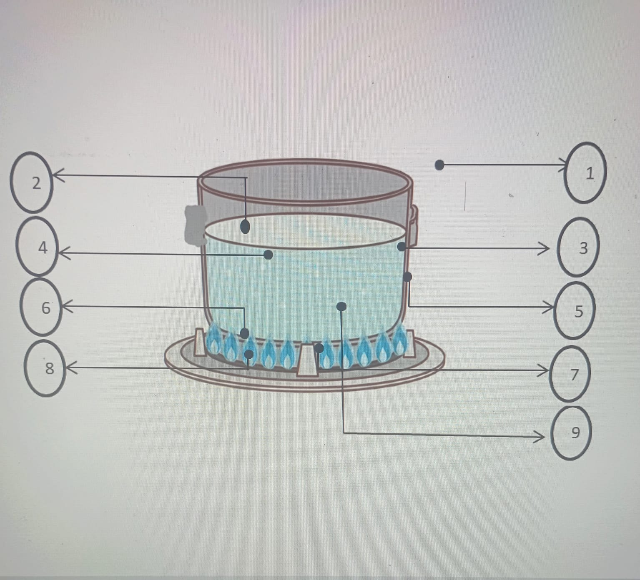
1. Tud: Air Temperature
2.Tdl:Outer Wall Temperature
3.Tdd: Inside Wall Temperature
4.Ta : Air temperature
5.Tf : Film temperature
6.Tpa:Top temperature pot
7.Tpb:Spot bottom temperature
8.Tap: Temperature fire
9.Tdla:Water outer wall temperature
<satu spasi>
Test procedure 1. Prepare tools and materials for testing.Starting from the stove, 3 kg of LPG gas, aluminum pot, measuring cup, glass thermometer, digital thermometer and also the water to be cooked.
2. After all the tools and materials are prepared, start by recording the room temperature using a digital thermometer measuring device, measuring the initial temperature of the water before cooking, and also measuring the weight of the LPG cylinder before use.
3. Enter as much water as the capacity of the aluminum pot and turn on the stove fully, then start recording the time using the stopwatch. Also record all the necessary temperatures, including air temperature, fire temperature, water temperature in the pot, and the temperature of the outside wall of the pot.
4. Doing the same thing from the start but the thickness of the pan is different
5. Recording time is stopped when the water temperature has reached 95 C.
6. Then collect and analyze the data obtained in accordance with the research objectives.
For the place and time of testing, the testing place is carried out at the Energy Conversion Laboratory of the Mechanical Engineering Study Program, Faculty of Engineering, Tridinanti University, Palembang. The time of testing will be carried out in February 2023

- RESULTS AND DISCUSSION

In this test, water is heated from the initial temperature (Ta) to the boiling point (Tb), then records all the measuring parameters needed to analyze the same parameters, including:
1. Mass of water before and after boiling point
2. Mass of LPG gas fuel before and after use
3. Time to reach the boiling point of the temperature to be tested
4. Temperature before and after boiling
5.Difference between open and closed pans
6. Comparison of temperature between open and closed pans with a thickness of 0.4, 0.6 and 0.8
7. Temperature of fire
Count includes
1. The calorific value of water
2. Hot gas stove heat
3. Loss of heat
4. Stove Efficiency
5. Coefficients
During the test, the temperature changes that occurred at several points in the test were measured and recorded as data to be used in the calculation process for installing the stove. To obtain the temperature during the heating process, a thermometer is used. The temperature data obtained is input in the table below

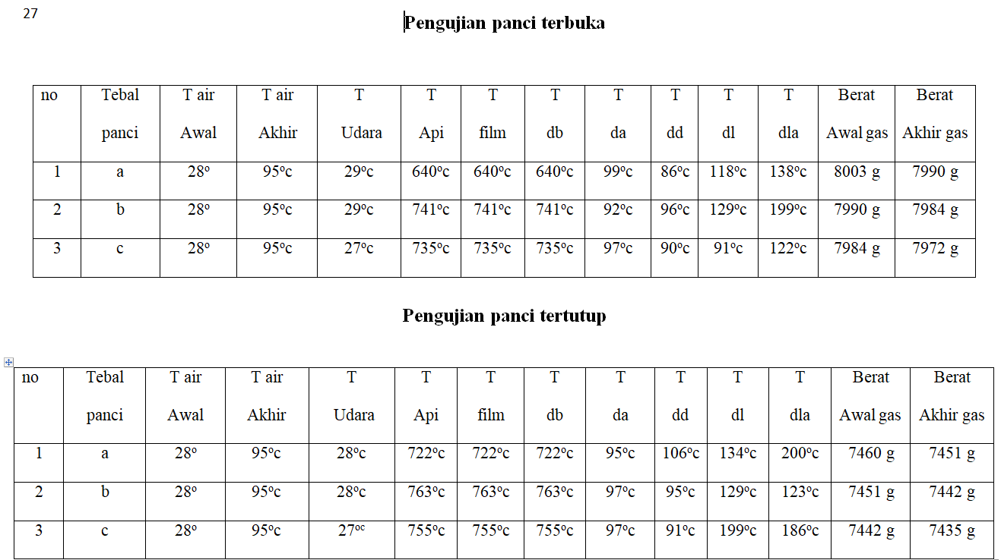
Table 3.1 measurement of temperature Data
After the measurement is carried out, the calculation is then carried out with the results entered in the following table
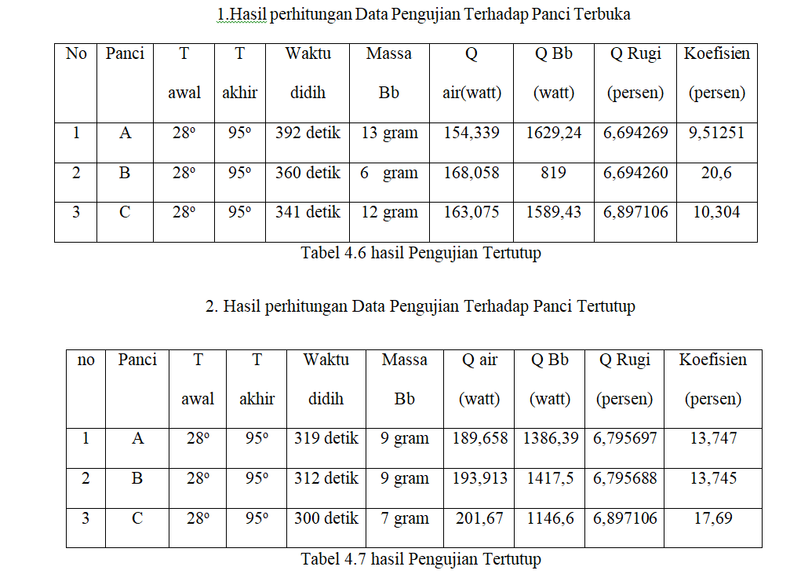
3.2 the result data of measurement and calculation

Based on testing and from the data above we can draw conclusions as explained below
a.Boiling Time
The longest boiling time occurred in the stove test with an open pan with a thickness of 0.4 mm, which was 392 seconds or also 6 minutes 32 seconds while the fastest occurred in the stove test with a closed pot with a thickness of 0.8 mm, which was 300 seconds or also 5 minutes. Here the fastest time in the test is the stove test with a closed pan with a thickness of 0.8 mm. The difference in time with the longest is 1 minute 32 seconds or also 92 seconds. Factors that cause differences in boiling time are air/room temperature because it will affect how slowly water reaches the boiling point, open and closed causes different atmospheric pressure so that water reaches the boiling point faster or slower, and the thickness of the pan which affects the heat produced by the stove to reach the water to the boiling point.
b. Fuel Consumption
The highest fuel consumption was in the stove with an open pot thickness of 0.4, which was 13 grams, while the lowest fuel consumption was in the stove with an open pot thickness of 0.6, which was 6 grams. There is a significant difference in the fuel used, it is possible that the stove and LPG gas hose affect the stove and LPG gas hose affecting fuel disposal which can cause waste or be economical in carrying out tests (cannot be calculated)
C Heat Absorbed by Water
Seen in graph 4.1 on the process of heat absorption by water in the heating process, it shows that there is an effect of the open pot and closed pot on the amount of heat absorbed in the water, so that the water boils faster. The amount of heat absorbed by water in an open pot with a thickness of 0.4 mm is 154.339 watts while in a closed pot with a thickness of 0.4 mm it is 189.658 watts. The increase in heat absorption in tests carried out in open and closed pans was caused by the presence of different atmospheric pressures. This results in more efficient or more complete combustion and a faster increase in temperature, so the heat that is used to be absorbed by the material also increases.
D Fuel Heat
The amount of fuel heat is generated from the mass amount of fuel used during the boiling process. If the longer the boiling time process that occurs, it will increase the amount of fuel used, thus causing the amount of heat released to also increase, for testing an open pan with a thickness of 0.4 mm the heat released is 1629.24 watts, and for an open pan test with a thickness of 0.4 mm the heat released is 1629.24 watts, and for Covered with a thickness of 0.4 mm, the heat released is 1386.39 watts. All of the above is related to the existence of the heating process time to reach the air to the boiling point, while the boiling that occurs also depends on the heat and the optimal combustion process of the fuel (optimal combustion).
E. Stove Efficiency
It can be seen in Graph 4.1 that efficiency increases with the use of open and closed pans. The highest efficiency occurred in the open pot test with a thickness of 0.4 mm at 9.47 watts while in the closed pan test with a thickness of 0.4 mm, it was 13.683 watts. Means that the closed pot is bigger than the open pot. By increasing the absorption of useful heat by the material, it increases the heating time and reduces fuel consumption, therefore increasing the efficiency of the stove. Efficiency is the ratio of the water absorption energy used with fuel energy during testing.
F Heat Loss
Seen in 4.4.1 Table of Test Results it can be seen that the difference in heat loss that occurs in an open pot with a thickness of 0.4 mm is 6.694269 watts while in testing a closed pot with a thickness of 0.4 mm it is 6.795697 watts, meaning that with a pan closed is larger than the open pot, caused by a difference in the initial temperature of the water which affects the heat loss that occurs
G Coefficient
As shown in Graph 4.5 on open and closed pots, the increase in the graph of the open pot is not linear, unlike that of a closed pot, the increase is linear because the lid of the pot affects the coefficient that occurs at air temperature.
H .Fuel costs
For LPG gas cylinders weighing 3000 grams the required cost is Rp. 20,000, - then the total for the open pot test as shown in 4.4.1 Table of Test Results is 31 grams, then the cost used is Rp. 240, - compared to the total for the closed pot test which is 25 grams, then the cost used is Rp. 213,- This happens because in the closed pan test the fuel consumption will be less

4.Conclusion

With the difference in the thickness of the pans of 0.4 mm, 0.6 mm and 0.8 mm and also the presence of an open and closed pan, it affects the length of the boiling process and also affects the amount of fuel expenditure that occurs. And the withdrawal of water for the open pan is linear every 0.2 mm thickness up to the boiling point, which is 95o c, the reduction in water due to evaporation that occurs is 50 milliliters
Means testing on the pan
It closes faster to the boiling point and is also more efficient. Fuel expenditure is due to the fact that the temperature in a closed pot rises faster than an open one
DAFTAR PUSTAKA
[1]. Frank P. Incropera, David P. De Witt (2002) “Fundamental of Heat Mass Transfer”, Fifth Edition. Jhon Wiley & Sons, New York. 2002.
[2]. J.P. HOLMAN, “Perpindahan Kalor”, Penerbit Erlangga, Edisi keenam, 1995.
[3]. Moran, Michael J and Shapiro Howard N. 2003. “ Fundamentals of Engineering Trehmodynamics “. Edisi 4
[4]. Cengel. Yunus A. 2002 .Heat transfer : A proctical approach. Second edition in si unit.
[5]. BSNI, Handbook Standar Nasional Indonesia Kompor Gas dan Kelengkapannya, Badan Standardisasi Nasional 2010.
[6]. Sudarno, Fadelan. Peningkatan Efisiensi Kompor LPG Dengan Menggunakan Elemen Bara Api. Jurnal Ilmiah Semesta Teknika Vol. 19 N0. 2, 165-175, November 2016.
[7]. Agung Sugeng Widodo. Efficiency Of Household Gas Stove By Optimizing Gap Of Pan And Stove Cover. ARPN Journal og Engineering and Applied Sciences, Vol. 11 No. 4, February 2016.
[8]. Badan Standardisasi Nasional. (2007). SNI 7368: 2007, Kompor Gas Bahan Bakar LPG Satu Tungku dengan Sistem Pemantik Mekanik. Jakarta.

