
TURBULEN: JURNAL TEKNIK MESIN
UNIVERSITAS TRIDINANTI PALEMBANG

Homepage-artikel: https://ejournal.univ-tridinanti.ac.id/index.php/Turbulen/index



ANALYSIS OF VARIATIONS IN PAN THICKNESS OF 0,4 MM, 0,6 MM, AND 0,8 MM ON THE HEAT RATE OF HEATING AND COOLING OF WATER
M. Fadly Mursal¹⁾, Abdul Muin^{1*)}, Sofwan Hariyady ¹⁾

^{1 ,} Universitas, Tridinanti , Indonesia
Email Corresponding^{*)}:amuin7959@gmail.com

INFORMASI ARTIKEL |  | ABSTRACT
Submitted:  dd/mm/yy  Revised:  dd/mm/yy  Accepted:  dd/mm/yy  Print-Published:  dd/mm/yy |  | The purpose of this study was to determine the effect of pan thickness of 0.4 mm, 0.6 mm, and 0.8 mm with open and closed pans. The thickness of the different pans had enough to affect the reduction of heat loss and also affect the fuel used until boiling occurs, in this case the type of fuel is LPG gas. Room temperature also affects the length of the boiling process. The open pot boiling time is A = 392 seconds, B = 360 seconds, C = 314 seconds while the closed pot boiling time is A = 319 seconds, B = 312 seconds, C = 300 seconds. The test was carried out with a load of 1 kg of boiled water. The test results show that the closed pot boils 4.3% faster than the open pot  Keywords: Heat absorbed by water, Loss of heat from the pot

- Introduction

With the current population growth, energy needs are increasing, especially in households, and gas fuel is used for cooking. In general, housewives immediately use gas stoves as they are without thinking about ways to save on the use of gas stoves (LPG) that are used by Perception of LPG. (Kotler & Keller 2006) Perception is an active process from within humans in selecting, classifying, and giving meaning to the information they receive. Perception of LPG will influence the attitudes and behavior of housewives toward the use of LPG, (Sulistyono, 2013). natural resources that cannot be renewed if continuously used will naturally run out this resource is widely used for transportation, transportation facilities are the largest energy use of oil and natural gas (Sulistyono, 2014)out.this In direct observation when using a gas stove, it can be seen that there are losses of heat energy due to radiation between the fire and the area around the stove. (Department of Coal, 1985) Gas fuel will burn under normal conditions if sufficient air is present. Radiant heat that is wasted from the surrounding fire is one of the reasons for the low efficiency of the stove. (Amiruddin, 2009) someone prefers to use LPG over kerosene with the main reasons being fast, economical, practical, and clean. Boiling water in a pot is an example of where gas fuel (LPG) will be wasted. (J.Morganti, et al., 2013) Liquefied Petroleum Gas (LPG) is a common fuel in several sectors such as households, industry and transportation. (Hermansyah & Kurniaty, 2013) LPG is a mixture of several variables, the main ones being propane (C3H8) and butane (C4H10) or a combination of the two, in which the thickness of the pot affects the length of time the water boils.
In the previous study, (Widodo, 2016) cover radiation efficiency for use on gas stoves, the purpose of this study was to determine the effect of cover materials on the efficiency of conventional gas stoves. based on further research that the covering material affects the efficiency of gas stoves, in this case, the thickness of the pan affects the length of time the boiling process takes.
Based on the explanation above, the authors chose an experimental study that would study heat and boiling time with the title "Analysis of Pot Thickness Variations on Boiling Heat Rates and Water Cooling". In this study in order to be able to known the value of the heat that occurs with respect to old boiling time with water

- Research Method

The research method is experimental research, in which alumunium is made to boil water with a capacity of 1 Kg. The equipment to be used during this test is as follows :
1. Pan
2. LPG gas stove
3. Stopwatch
4. Measuring cup
5. Digital thermometer
6. Scales
7. Thermometer glass
Testing of open and closed pans with different thicknesses is to do water test to several points to be searched for as in show in figure 2.1 in this test the water will heated from the initial air temperature to final air temperature then record all parameters measure that will be required for the analysis parameters others observed:
1. Mass of water before and after boiling
2. Mass of LPG gas fuel before and
after use
3. Time to reach boiling point
temperature to be tested
4. Air temperature before and after boiling
with open and closed pans
5. Air measurement after testing against
open and closed pot
6. Temperature measurement to 9 points againstopen and closed pot
7. The hot temperature of the fir:.
  - The temperature looking for

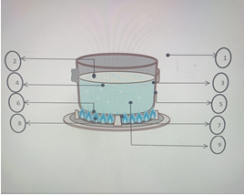
Figure 1. The temperature looking for

During the process of testing changes a temperature that occurs at several points in the test is measured and recorded as The data will be used later in the process calculations for stove fires. To obtain what the temperature during the heating process is used a measuring instrument thermometer. The temperature data obtained are entered in the table below :
1. Tud : Temperature air
2. Tdl : outer wall temperature
3. Tdd : inside wall temperature
4. Ta: air temperature
5. Tf: film Temperature
6. Tpa : Top Temperature pot
7. Tpb : Spot bottom Temperature
8. Tap: Temperature fire
9. Tdla : water outer wall temperature
Q = m.c_{p}.(t₂ ₋ t₁) ..................( Incropera end David P.DE There are several formulas used in research
Heat Mass Tranfer 2002 )
Heat is defined as a form of energy that can move or flow from an object that has excess heat to an object that lacks heat. So mathematically it can be formulated as:
(David P. De Witt,2002) Where:
Q=heat needed for heating (J)
m = mass of substance being heated (kg)
cp = specific heat of substance (J/kgC)
(t2-t1) = change in temperature (C)
Heat can be divided into 2 types:
1. Sensible heat (Heat used to raise the temperature)
2. Latent Heat (Heat used to change form)
There are two kinds of equations used in latent heat, namely:
Q = m.U.∆T...................( J.P. HOLMAN,1995)
Q = m.L........................( J.P. HOLMAN,1995)
heat capacity is the amount of heat needed to raise the temperature of an object by 1 degree Celsius.H= Q/(t2-t1) is expressed by the formula
C_{p} = Q/m.(t₂ - t₁)....................( Moran, Michael J and Shapiro Howard N. 2003)
Heat Transfer
Heat transfer is the science that studies the transfer of energy in a material that occurs due to a temperature difference
There are three mechanisms of heat transfer, namely:
1. Conduction
2. Convection and
3. Radiation

Conduction
Conduction is a temperature gradient that occurs in an object, then there will be heat transfer from areas with high temperatures to areas with low temperatures. stated in:
Qkond =-kA $\frac{∆T}{L}$ ........( Cengel. 2002) where:
k: heat conductivity of material(W/m.˚C)
$∆T$: temperature difference(˚C)
A: area in thr normal direction(m²)
L: thick material(m)

Convection
Convection is the event of heat energy transfer that propagates from a high-temperature object to a low temperature fluid or vice versa if the fluid temperature is higher. stated in Qconv = h A(Ts-T$∞$) ................................(BSNI National Standardization Agency 2010) Where:h : Koefisien heat transfer cofecition (W/m².˚C)
A : surface area convektion (m²)
Ts : solid surface temperature (˚C)
T$∞$ : fluid temperatur(˚C)

Radiation
Radiation is the transfer of heat energy that propagates directly by a temperature difference
in Qrad= AT4...................( Sudarno 2016)
Where :
: 5.669x 10-8 W/ (m2K4) which is called the Boltzmann proportionality constant
A : Surface area of ​​hot object (m2)
T4 : Body temperature ( )
Hot Hot Gas Stove
The heat input of a gas stove is the maximum consumption of gas fuel required to ignite the gas stove at a certain time. Calculate the heat of the gas as

following........(Widodo 2016)
By description:
Ql = Heat intake (kW)
mn = gas flow rate (kg/hour)
LHV = calorific value of gas (for LPG = 49.14 MJ/kg)

Stove Efficiency
Efficiency is defined by the fraction of heat input originating from the combustion process which is converted into the desired output in the form of energy absorbed by water as shown in the equation below:
$η=\frac{m_{a}C_{p}ΔT}{m_{f}{LHV}_{f}}x 100 \%$...............( BSN Badan Standardisasi Nasional. 2007)
Dimana :
η = efisiensi (%)
m_{a} = water mass(kg)
Cp = water specific heat
ΔT = difference in initial and final temperatur (ºC)
m_{f} = full mass(kg)
LHV_{f} = fuel low calorific value

Overall Heat Transfer Coefficient (U)
Is the overall flow of heat as a result of the combined processes of conduction and convection
Overall Heat Transfer is expressed by
Q$=\frac{TA-TB}{1/h1A+ ∆x+1/h2A}=\frac{A\left(TA-TB\right)}{1/h1+∆x/k+1/h2}$
Besides theat q= UA ∆T _{thorough}
So that the overall heat transfer coefficient can be expressed by
$U=\frac{1}{\frac{1}{h1}+\frac{∆x}{k}+\frac{1}{h2}}$……( Subagyo, BAHAN AJARAN PERPINDAHAN PANAS I:
UNIVERSITAS LAMBUNG MANGKURAT 2016)

3. RESULTS AND DISCUSSION
In this test the water is heated from temperature
initial (Ta) to the boiling point (Tb) , then record all
measuring parameters required for analysis
Parameters observed include:
- The amount of heat absorbed by water during
heating process from initial conditions
until the water boils
- The amount of fuel used
during the water boiling process.
- The amount of heat released by the material
burn during the heating process
- Stove power used
- Stove efficiency
- Heat loss
- Coefficient

During the change testing process temperature that occurs at several points in the test is measured and recorded as data later used in the calculation process
for determining stove performance. To obtain what is the temperature during the heating process at use a measuring thermometer. Temperature data
obtained are entered in the table below

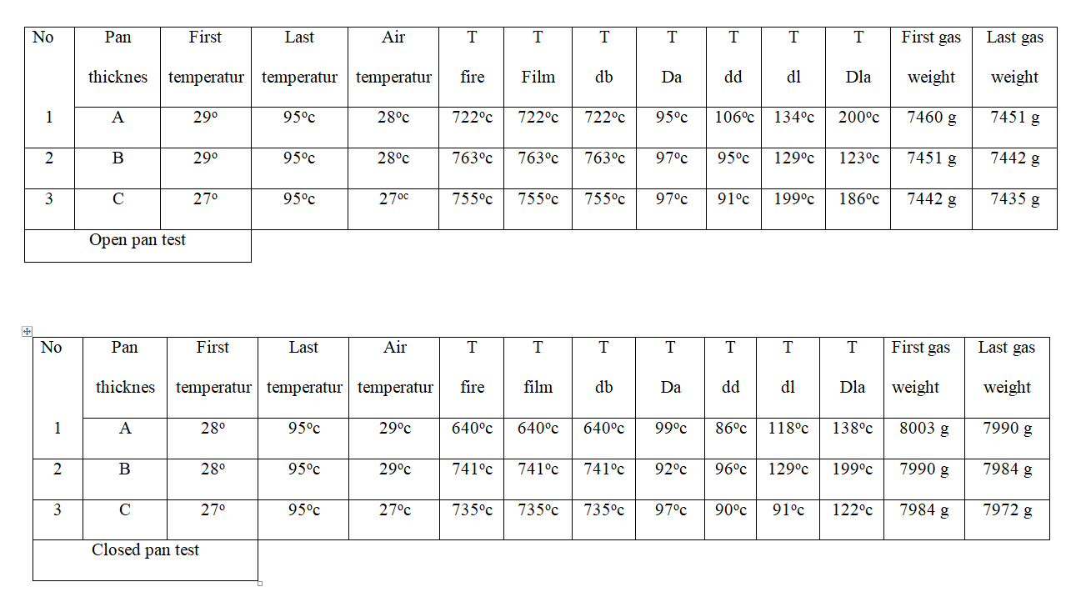
Tabel 3.1 temperature measurement

After the measurement is done, then the next
calculations are carried out with the results entered into the following table.
In the calculation here the data needed for calculating open and closed pan is as follows:
Volume pan material= 0,000103 m³
Water mass (ma)= 1,0 kg
Pan mass (mp)= 0,278266 kg
Surface area of the water wall (A)= 0,07159 m²
Heat water capacity= 4180 J/kg. C
Massa of the material pan = 2702 Kg/m³
LHV (nilai kalor gas, untuk LPG)= 49,14 MJ/kg

Open pan 0,4 MM

Water heat value (Q air)
First water temperature = 28ºC
Last water temperature = 95ºC
Temperatur api = 640ºC
Water mass = 1 Kg
Air temperature = 29ºC
Mass of used lpg used = 13 gram
Boiling time = 6 menit, 32 detik
Heat specific = 903 J/kg.K
LHV ( Lpg heat value) = 49,14 MJ/kg
So the heat absorbed by water during heating of an open pan with a thickness of 0.4 mm is:
Qk1 = m. cp .( T2-T1 )
= 1 kg x 903 J/kg K x (368-302)
= 59598 J
Waktu masak 6 menit 32 detik = 392
Daya Q air A = (59598 j)/392 = 152,035 watt
Kalor Panas Kompor Gas
- MBb = 0,013 kg
- LHV = 49,14 MJ/kg
So the heat absorbed by water during heating of an open pan with a thickness of 0.4 mm is:
QI = (1000 xMbb x LHV)/waktu
=Mbb x LHV
=0,013 kg x 49,14 MJ/ kg
=0,013 kg x 49,14 x 106
= $\frac{13}{1000}X 49, 14 X {10}^{6}\frac{13}{{10}^{3}}X 49, 14 X {10}^{6}$ $\frac{13}{1000}X 49, 14 X {10}^{6}\frac{13}{{10}^{3}}X 49, 14 X {10}^{6}$
=13x49,14x10³
= 638,82 x 10³
=638820 j
Boiling time= 6 minutes 32 second
=392 second
Heat power QABb =(638820 J)/(392 second)=1629 ,64 watt

Rugi Kalor
- R = 9,5 cm = 0,095 m
- T = 12 cm = 0,12 m
- ∆x = 0,4 mm = 0,0004 m
So the heat loss that occurs during the heating of the open pot with thickness 0,4 mm is :
A = 2 π. R.T
A = 0,0071 m2
Q= | A (Ta-Tb)
 | 1 | + | ∆x | + | 1
 | h1 |  | K |  | h2

= | 0,0071 x ( 95- 29 )
 | 1 | + | 0,0004m | + | 1
 | 20w/m |  | 237 w/m |  | 50 w/m
=$\frac{0,4686}{0,05+0,00000016+0,02}$= $\frac{0,4686}{0,07000016}$=6,69427 watt
U= | 1
 | 1 | + | ∆x | + | 1
 | h1 |  | K |  | h2

= | 1
 | 1 | + | 0,0004m | + | 1
 | 20w/m.k |  | 237 w/m.k |  | 50 w/m.k
=$\frac{1}{0,05+0,00000016+0,02}$ = $\frac{1}{0,07000016}$ =14,28568 w/m²k
q = U x A x ∆T
= 14,28568 x 0,0071 m2 x ( TA-TB )
= 14,28568 w/m2k x 0,0071 m2 ( 368-302 )
= 14,28568 w/m2k x 0,0071 m2 x 66
= 6,694269 watt

Stove efficency

ƞ =maCp ∆Tx 100 %
ƞ= | maCp∆T | = | 152,035watt | x100% | =9,33%
 | mf LHV |  | 1629,24 watt
So the efficiency of the stove that occurs during the heating of an open poan with a thickness of 0.4 mm corresponds to the above

E. cofisien

= (Q air)/(Q Bb-Q rugi) x 100 %
=(152,035 watt)/(1629,24 watt-6,694269 watt) x 100% =152,035/1622,54573 x 100 %
= 0,9370151 x 100% = 9,370151 %

Closed pan 0,4 MM

A. water heat value (Q air)
- first water temperature = 28ºC
- last water temperature = 95ºC
- fire temperature = 722ºC
- water mass = 1 Kg
- air temperature = 28ºC
- Mass of used lpg used = 9 gram
- boiling time = 5 menit 19 detik
- heat spesific = 903 J/kg.K
- LHV (nilai kalor LPG) =49,14 MJ/kg

So the heat absorbed by water during heating of an closed pan with a thickness of 0.4 mm is:
QkI = M . Cp ( TA-TB )
= 1 kg x 903 J/kg K x ( 368 – 301 )
= 60501 J
Boiling time 5 minutes 19 second =319
power Q water A = (60501 j)/319 = 189, 658 watt

B. gas stove heat
- MBb = 0,009 kg
- LHV = 49,14 MJ/kg
So the heat absorbed by water during heating of an closed pan with a thickness of 0.4 mm is

QI = (1000 x Mbb X LHV)/waktu
= Mbb x LHV
= 0,009 kg x 49, 14 MJ/kg
= 0,009 kg x 49,14 x 10⁶
= 9 x 49,14 x10⁶ = 9 x 49,14 x 10⁶
= | 9 | x 49,14 x10⁶= | 9 | x 49,14 x 10⁶
 | 1000 |  | 10³

= 9 x 49 x 10³
= 442,26 x 10³
= 44260
Boiling time = 5 minutes 19 second
= 319 second

Heat power QABB = 442260/319 = 1386, 39 Watt
C.calor loss
- R = 9,5 cm = 0,095 m
- T = 12 cm = 0,12 m
- ∆x = 0,4 mm = 0,0004 m
So the heat loss that occurs during the heating of the closed pot with thickness 0,4 mm adalah:
A = 2 π. R.T
= 6,28 x 0,095 m x 0,0004 m
A = 0,0071 m2

Q= |  | A (Ta-Tb)
 |  | 1 | + |  | ∆x |  | + | 1
 |  | h1 |  |  | k |  |  | h2
= | 0,0071 x ( 95- 29 )
 | 1 |  |  | + |  | 0,0004m |  |  |  | + | 1
 | 20w/m |  |  |  |  | 237 w/m |  |  |  |  | 50 w/m

Q=$\frac{0,4757}{0,05+0,00000016+0,02}=\frac{0,4757}{0,07000016}$=6,79569watt
U= | 1
 | 1 | + | ∆x | + | 1
 | h1 |  | k |  | h2

= | 1
 | 1 | + | 0,0004m | + | 1
 | 20w/m.k |  | 237 w/m.k |  | 50 w/m.k

$\frac{1}{0,05+0,00000016+0,02}=\frac{1}{0,07000016}$ =14,28568 w/m²k

q = U x A x ∆T
= 14, 28568 x 0,071 m2 x ( TA- TB )
= 14,28568 w/m2k x 0,0071 m2 x ( 368- 301 )
= 14,28568 w/m2k x 0,0071 m2 x 67 k
= 6,795697 watt

D. stove efficiency
So the efficiency of the stove that occurs during the heating of an closed pan with a thickness of 0.4 mm corresponds to the above
E. cofisien

$\frac{Q air}{Q Bb-Q rugi} x 100\%$
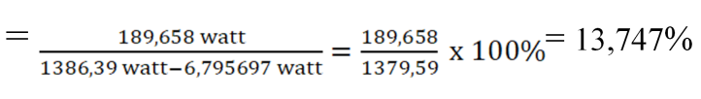

After the measurement is done, then the next
calculations are carried out with the results entered intothe following table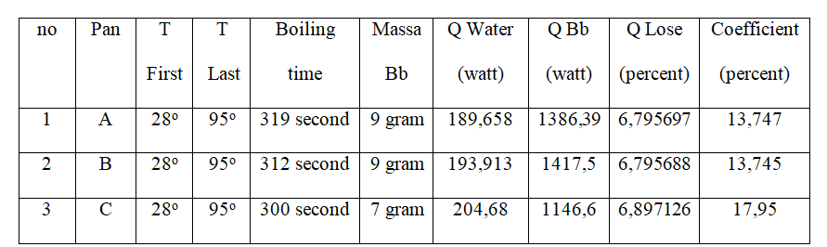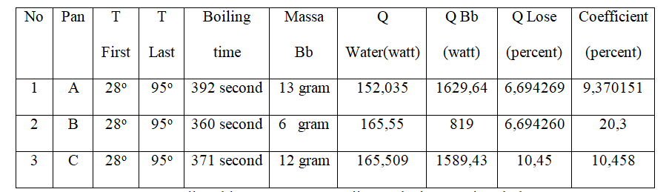
Table 3.2 data calculation and test results

Based on Testing and from the data above us
can draw conclusions explained as follows
A. Boiling Time
The longest boiling time happened in the stove test with a pan open with a thickness of 0.4 mm, that is, as long as 392 seconds or also 6 minutes 32 seconds meanwhile the fastest occurred in the stove test with a closed pan with a thickness of 0.8 mm for 300 seconds or also 5 minutes. Here fastest time is on testing is on stove test with closed pot with 0.8mm thickness. Big difference in time with the longest is 1 minute 32 seconds or also 92 seconds . Causal factors The difference in boiling time is the air temperatureroom because it will affect slow water to boiling point , open and closed causing the atmospheric pressure to be different so the water is faster or slower to the boiling point, and the thickness of the panwhich affects the heat generated by the stove to reach the water to the boiling point. which affects the heat generated by the stove to reach the water to the boiling point.
B. Fuel Consumption
The highest fuel consumption was in the stove with an open pot thickness of 0.4, which was 13 grams, while the lowest fuel consumption was in the stove with an open pot thickness of 0.6, which was 6 grams. There is a significant difference in the fuel used, it is possible that the stove and LPG gas hose affect the stove and LPG gas hose affecting fuel disposal which can cause the waste or be economical in carrying out tests (cannot be calculated)
C. Heat Absorbed by Water
Seen in graph 4.1 on the process of heat absorption by water in the heating process, and shows that there is an effect of the open pot and closed pot on the amount of heat absorbed in the water so that the water boils faster. The amount of heat absorbed by water in an open pot with a thickness of 0.4 mm is 154.339 watts while in a closed pot with a thickness of 0.4 mm, it is 189.658 watts. The increase in heat absorption in tests carried out in open and closed pans was caused by the presence of different atmospheric pressures. This results in more efficient or more complete combustion and a faster increase in temperature, so the heat that is used to be absorbed by the material also increases.
D. Fuel Heat
The amount of fuel heat is generated from the mass amount of fuel used during the boiling process. If the longer the boiling time process occurs, the amount of fuel used will increase, causing the amount of heat released to also increase, for testing an open pan with a thickness of 0.4 mm the heat released is 1629.24 watts, and for an open pan test with a thickness of 0.4 mm the heat released is 1629.24 watts covered with a thickness of 0.4 mm the heat released is 1386.39 watts. All of the above is related to the time for the heating process to reach the water to the boiling point, while the boiling that occurs also depends on the heat and the combustion process.
E. Stove Efficiency
It can be seen in Graph 4.1 that efficiency increases with the use of open and closed pans. The highest efficiency occurred in the open pan test with a thickness of 0.4 mm at 9.47 watts while in the closed pan test with a thickness of 0.4 mm, it was 13.683 watts. This means that the closed pot is bigger than the open pot. Increasing the absorption of useful heat by the material increases the heating time and reduces fuel consumption, therefore increasing the efficiency of the stove. Efficiency is the ratio of the water absorption energy used with fuel energy during testing.
F. Heat Loss
Seen in 4.4.1 Table of Test Results it can be seen that the difference in heat loss that occurs in an open pot with a thickness of 0.4 mm is 6.694269 watts while in testing a closed pot with a thickness of 0.4 mm it is 6.795697 watts, meaning that with a pan closed is greater than the open pot, caused by a difference in the initial temperature of the water which affects the heat loss that occurs
G. Coefficient
As shown in Graph 4.5 on the open and closed pans, the increase in the graph of the open pot is not linear, unlike that of a closed pot, the increase is linear because the lid of the pot affects the coefficient that occurs at water temperature.
H . Fuel costs
For LPG gas cylinders weighing 3000 grams, the required fee is Rp. 20,000, - then the total for the open pot test as shown in 4.4.1 Table of Test Results is 31 grams, then the cost used is Rp. 240, - compared to the total for the closed pot test which is 25 grams, then the cost used is Rp. 213,- This happens because in the closed pot test, the fuel consumption will be less

4. Conclusion

With the difference in the thickness of the pans of 0.4 mm, 0.6mm and 0.8mm and also the presence of an open and closed pan, it affects the length of the boiling process and also affects the amount of fuel expenditure that occurs. And the withdrawal of water for the open pan is linear every 0.2mm thickness up to the boiling point, which is 950 c, the reduction in water due to evaporation that occurs is 50milliters.
In testing open and closed pots with different thicknesses, it is true that testing on closed pots gets to the boiling point faster and is also more efficient in removing fuel because the temperature in the closed pot rises faster than the open one, the test shows that the closed pot boils 4.3% faster than an open pot

References

Agung Sugeng Widodo. Efficiency Of Household Gas Stove By Optimizing Gap Of Pan And Stove Cover. ARPN Journal og Engineering and Applied Sciences, Vol. 11 No. 4, February 2016
Amiruddin. 2009. Analisis Pengetahuan, Persepsi dan Sikap Konsumen Terhadap Produk LPG Pertamina Kemasan 3 kg (Studi Kasus di Desa Leuwiliang, Kecamatan Leuwiliang, Kabupaten Bogor, Jawa Barat) [Tesis]. Bogor: Sekolah Pascasarjana Institut Pertanian Bogor
BSN Badan Standardisasi Nasional. (2007). SNI 7368: 2007, Kompor Gas Bahan Bakar LPG Satu Tungku dengan Sistem Pemantik Mekanik. Jakarta.

BSNI, Handbook Standar Nasional Indonesia Kompor Gas dan Kelengkapannya, Badan Standardisasi Nasional 2010

Cengel. Yunus A. 2002 .Heat transfer : A proctical approach. Second edition in si unit
Department of Coal, 1985, Coal Combustion Improved techniques for efficiency, Government of India

Frank P. Incropera, David P. De Witt (2002) “Fundamental of Heat Mass Transfer”, Fifth Edition. Jhon Wiley & Sons, New York. 2002.

Hermansyah, H., & Kurniaty, I. (2013). Analisis Pemanfaatan LPG dan CNG Sebagai Bahan Bakar Kendaran Bermotor Di Wilayah Jawa Barat. Universitas Indonesia, 1-7

J.P. HOLMAN, “Perpindahan Kalor”, Penerbit Erlangga, Edisi keenam, 1995.

J.Morganti, K., Foong, T. M., J.Brear, M., Silva, G. d., Yang, Y., & L.Dryer, F. (2013). The Research and Motor Octane Numbers of Liquefied Gas (LPG). Fuel, 797-811

Kotler and Keller. (2006). Manajemen Pemasaran, Edisi 12 jilid 1, Terjemahan (Molan Benyamin). Indonesia: PT. Indeks

Moran, Michael J and Shapiro Howard N. 2003. “ Fundamentals of Engineering Trehmodynamics “. Edisi 4

Rachmat Subagyo.(2016). BAHAN AJARAN PERPINDAHAN PANAS I: UNIVERSITAS LAMBUNG MANGKURAT

Sudarno, Fadelan. Peningkatan Efisiensi Kompor LPG Dengan Menggunakan Elemen Bara Api. Jurnal Ilmiah Semesta Teknika Vol. 19 N0. 2, 165-175, November 2016.

Sulistyono. (2013). Pengurangan Subsidi BBM Fosil Sebagai Momentum Pengembangan Energi Alternatif Jenis Biofuel. Forum Teknologi, 1-8

Sulistyono. (2014). Program Diversifikasi Energi Melalui Konversi BBM ke BBG dan Kendala Perkembangannya. Forum Teknologi, 04, 27-34

