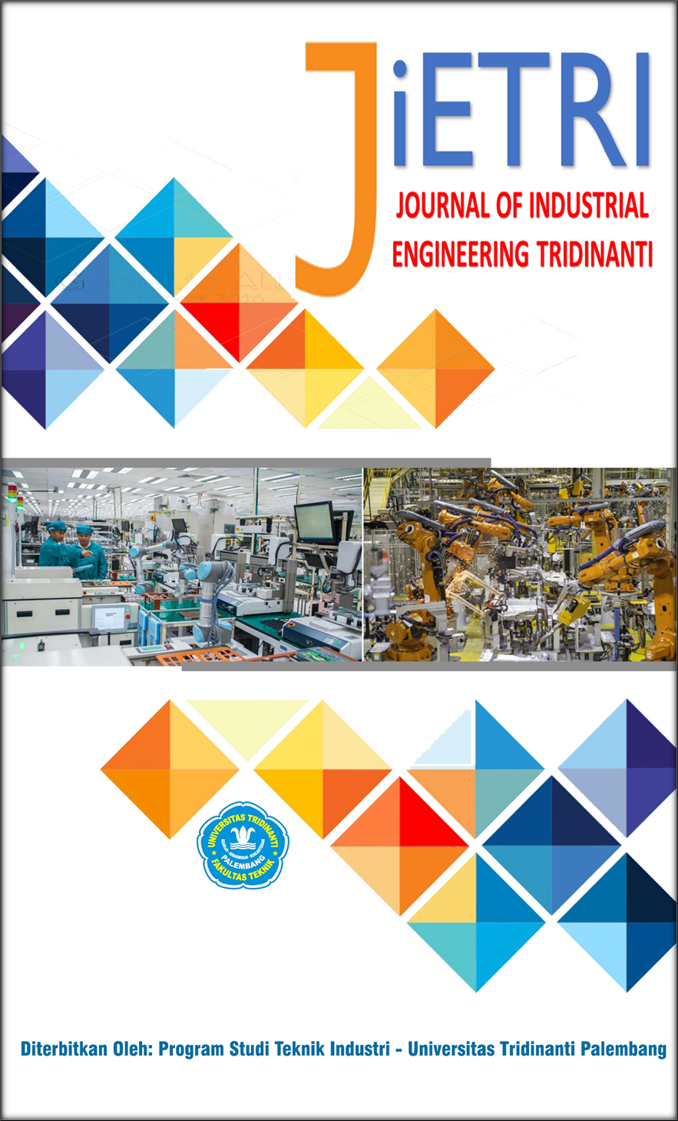

JOURNAL OF INDUSTRIAL ENGINEERING TRIDINANTI

e-ISSN: 2988-2303

http://jietri.univ-tridinanti.ac.id

A Bibliometric Analysis of Failure Mode and Effects Analysis (FMEA) Research from 2020 to 2025

Adi Fitra^{*1}, Abdul Rohim^{2,} Deri Maryadi³, Fahriza Fawwas Asrory⁴
¹Program Studi Teknik Industri, Fakultas Teknik, Universitas Pelita Bangsa
²Program Studi Teknik Industri, Fakultas Teknik, Universitas Tridinanti
³Program Studi Teknik Industri, Fakultas Teknik, Universitas Widyatama
ARTICLE INFO |  | ABSTRAK
Article history:  Diterima 20-05-2025  Diperbaiki 25-05-2025  Disetujui xx-xx-xx |  | FMEA (Failure Mode and Effects Analysis) adalah metode yang digunakan untuk mencegah kegagalan dalam proses atau sistem. Dalam lima tahun terakhir, penggunaan FMEA terus berkembang, namun belum banyak kajian yang memetakan tren dan arah penelitiannya secara menyeluruh. Penelitian ini menggunakan pendekatan bibliometrik untuk menganalisis publikasi tentang FMEA dari tahun 2020 hingga 2025. Data diambil dari database Scopus, lalu dianalisis dengan Bibliometrix (RStudio) dan VOSviewer untuk melihat tren penulis, negara, serta kata kunci yang sering digunakan. Hasil menunjukkan peningkatan jumlah publikasi secara signifikan, dengan kontribusi besar dari negara seperti Tiongkok dan India. Beberapa penulis, seperti Ni Q. dan Ji J.C., tercatat paling banyak disitasi. Selain itu, tren menunjukkan bahwa FMEA kini banyak diintegrasikan dengan metode lain seperti Lean dan Six Sigma. Penelitian ini memberikan gambaran ringkas namun bermanfaat tentang arah dan perkembangan riset FMEA terkini.
Kata Kunci:
FMEA, Bibliometric, Rstudio, VOSviewer
 |  | ABSTRACT
Keywords:  FMEA, Bibliometric, Rstudio, VOSviewer |  | FMEA (Failure Mode and Effects Analysis) is a method used to prevent failures in processes or systems. Over the past five years, the use of FMEA has continued to grow, yet few studies have comprehensively mapped its research trends and directions. This study applies a bibliometric approach to analyzing FMEA-related publications from 2020 to 2025. Data were retrieved from the Scopus database and analyzed using Bibliometrix (RStudio) and VOSviewer to identify trends in authorship, contributing countries, and frequently used keywords. The results show a significant increase in the number of publications, with major contributions from countries such as China and India. Several authors, including Ni Q. and Ji J.C., were among the most cited. Additionally, the trend indicates that FMEA is increasingly being integrated with other methods such as Lean and Six Sigma. This study provides a concise yet useful overview of the current landscape and development of FMEA research.

Introduction
In recent decades, there has been a growing emphasis on enhancing system reliability and risk control, driven by the increasing complexity of industrial processes and the evolving demands of corporate growth and business advancement [1][2][3]. One of the most widely adopted approaches for identifying potential failures and assessing their impacts is the Failure Mode and Effects Analysis (FMEA) method [4]. This method systematically assists organizations in identifying, evaluating, and prioritizing potential failures within systems, products, or processes [5]. With its strong emphasis on prevention, FMEA has become a key tool in supporting quality and safety efforts across industries. Since its introduction in the mid-20th century, industries have continuously refined and expanded its use to meet evolving demands and technological advancements. [6]. In the era of Industry 4.0, researchers have shown increasing interest in exploring how FMEA can be integrated with data-driven approaches and digital systems. This integration offers a promising way to address the growing complexity and dynamism of modern industrial environments [7]. FMEA is no longer confined to the manufacturing sector. It has expanded into various fields, including healthcare, transportation, energy, and even education [5]. This diverse range of applications highlights how flexible FMEA is in tackling risk-related challenges across different work environments [8].
As interest in FMEA continues to grow, the number of scientific publications discussing this method has steadily increased. However, only a few comprehensive studies have thoroughly examined the direction, trends, and characteristics of FMEA research over a specific time frame. In fact, a systematic mapping of the existing literature could offer clearer insights into dominant topics, collaboration patterns among authors or institutions, and unexplored areas that hold potential for future research [8]. This is where a bibliometric approach plays a crucial role in objectively mapping the knowledge landscape.
Bibliometric analysis uses bibliographic data from scientific publications to assess and illustrate the structure, dynamics, and evolution of a particular field of study [9][10]. This approach goes beyond tracking publication volume and growth; it also helps identify the most influential authors, leading journals, frequently used keywords, and the connections between emerging concepts [11]. By using tools like VOSviewer and Bibliometrix R, this analysis can be visualized to help researchers grasp the scientific ecosystem in a more intuitive and accessible way [12].
This study aims to conduct a bibliometric analysis of publications related to the FMEA method over the past five years, from 2020 to 2025. This timeframe was chosen to capture recent dynamics, including how FMEA has responded to contemporary challenges such as the global pandemic, supply chain disruptions, and the growing demand for more resilient systems. The analysis focuses on publication trends, geographic distribution, dominant keywords, and research collaborations among institutions and countries.
By presenting a comprehensive, data-driven analysis, this study aims to contribute to a deeper understanding of how FMEA has evolved and to encourage exploration of new, relevant topics. The findings can serve as a valuable reference for academics, practitioners, and policymakers in designing risk management strategies and quality improvement initiatives. Furthermore, this research has the potential to foster cross-disciplinary collaboration in building more reliable and adaptive systems for the future.

Research Method
This study adopts a bibliometric approach as the primary framework to evaluate the development of research related to the Failure Mode and Effects Analysis (FMEA) method from 2020 to 2025. This approach was chosen because it allows researchers to systematically explore publication patterns, connections among authors and institutions, and identify key topics frequently discussed in academic literature. Unlike traditional narrative reviews, which tend to be more subjective, bibliometric analysis relies on quantitative data drawn from scientific publication metadata, offering a higher degree of objectivity [13][14][15][16].
The primary data source for this study is the Scopus database, selected for its broad coverage and reliability in indexing reputable, multidisciplinary international journals. The search process used a combination of keywords such as “Failure Mode and Effects Analysis,” “FMEA,” “risk assessment,” and other relevant terms, with publication years limited to the 2020–2025 period. To ensure data quality, only peer-reviewed journal articles were included, while conference papers, books, and editorials were excluded. The search results were then exported in CSV format for further analysis.
Tahapan analisis dilakukan dengan memanfaatkan dua perangkat lunak utama, yaitu VOSviewer dan RStudio (bibliometrix package). VOSviewer digunakan untuk membangun peta visualisasi jaringan kolaborasi antar penulis, keterkaitan antar kata kunci, serta distribusi institusional dan geografis. Sementara itu, RStudio dimanfaatkan untuk analisis statistik deskriptif terhadap metadata publikasi, seperti tren jumlah publikasi per tahun, tingkat sitasi, dan produktivitas penulis. Kombinasi kedua alat ini memungkinkan eksplorasi menyeluruh baik dari sisi struktur maupun dinamika literatur terkait FMEA.
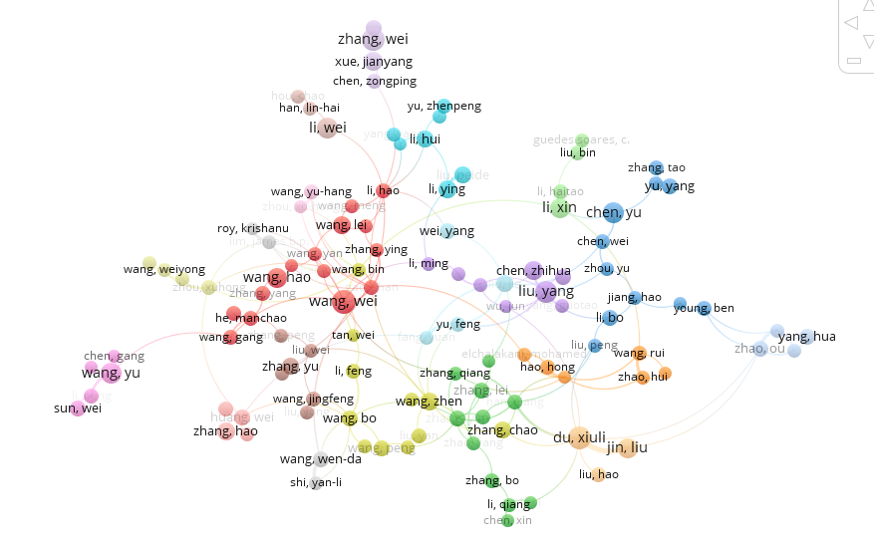
The analysis process was carried out using two main software tools: VOSviewer and RStudio (bibliometrix package). VOSviewer was used to create visual maps of collaboration networks among authors, keyword associations, and institutional and geographic distributions. Meanwhile, RStudio was employed for descriptive statistical analysis of publication metadata, such as trends in publication counts per year, citation rates, and author productivity. The combination of these tools enabled a comprehensive exploration of both the structure and dynamics of FMEA-related literature.
Figure 1. Top Keyword in FMEA Research
As a final step, the author interpreted the analysis results through a critical and reflective approach. The visual and statistical findings were not only presented in graphs and tables but also discussed contextually to understand their relevance within the evolving FMEA research landscape. In this way, the study provides not only a quantitative snapshot of the current state but also contributes to mapping the future direction of research on the FMEA method in the context of risk management and quality.
Figure 1. VosViewer Authorship
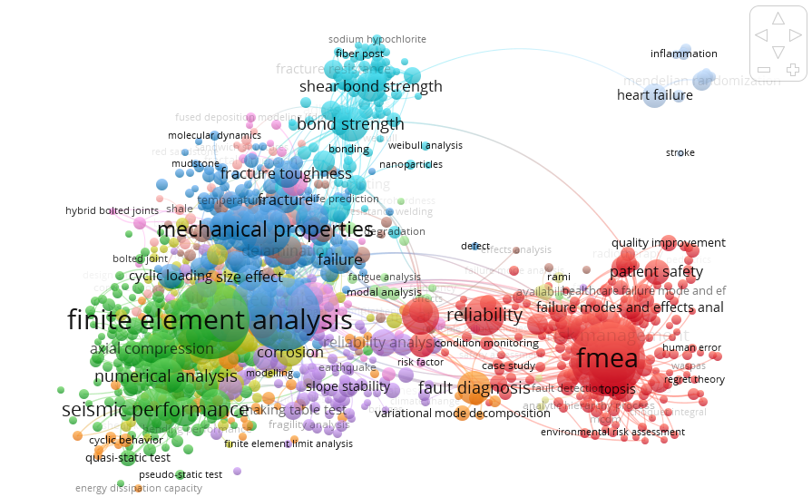
Figure 1. VosViewer Authorship

Hasil dan Pembahasan
The bibliometric analysis of 212 scientific articles retrieved from the Scopus database reveals a clear upward trend in the number of publications addressing Failure Mode and Effects Analysis (FMEA) between 2020 and 2024, peaking in 2023. Using the Bibliometrix R-package for data processing, it was observed that the majority of these publications were featured in journals focusing on industrial engineering, risk management, and systems engineering. Countries with the highest contribution to FMEA research include China, India, and the United States. At the institutional level, Tsinghua University and Politecnico di Milano emerged as key players in driving FMEA scholarship.
In terms of authorship, several prolific contributors were identified, indicating the presence of active and consistent research groups in the field. Notable names include Mangalathu S., Hwang S.-H., Jeon J.-S., Boral S., Howard I., Chaturvedi S.K., McKee K., Naikan V.N.A., Chang C.-H., Kontovas C., Yu Q., Yang Z., Ramanathan K., Ni Q., Ji J.C., Feng K., and Halkon B. Among these, the research cluster comprising Ni Q., Ji J.C., Feng K., and Halkon B. stands out as having the highest citation count. This suggests that their scholarly contributions have had a substantial impact on the development and implementation of FMEA in various industrial and engineering contexts. The high citation rates of their work reflect not only academic recognition but also methodological and practical relevance, particularly in advancing system reliability, risk mitigation, and process efficiency. A detailed visualization of this data is provided in Figure 3.
Regarding publication outlets, the journal Engineering Structures leads with the highest number of articles on FMEA (7,314), followed by Construction and Building Materials (2,925 articles), Composite Structures (2,555 articles), Thin-Walled Structures (2,491 articles), and Structures (2,333 articles). This distribution highlights a growing trend of applying FMEA beyond traditional manufacturing sectors, particularly in construction and building-related research. These findings indicate that FMEA is increasingly employed to address complex problems in structural engineering and construction reliability. Further details can be seen in Figure 5.
Additionally, five leading publishers dominate FMEA-related publications. At the top is Elsevier Ltd with 46,065 articles, followed by Elsevier BV (formerly a separate entity before integration) with 6,542 articles. Springer ranks third with 4,184 articles, followed by Springer Science and Engineering (3,974 articles), and MDPI with 3,039 articles. These figures, presented in Figure 4, underscore the role of major publishing houses in disseminating research on FMEA and related methodologies across diverse scientific disciplines.

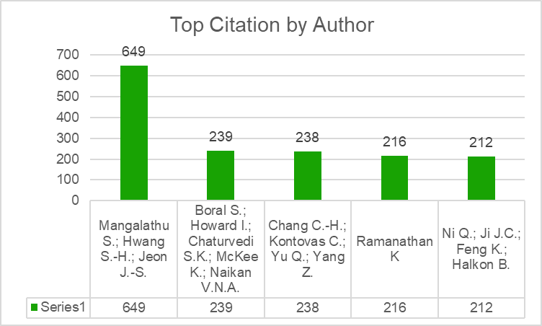
Fig.5 Top Citation by FMEA article

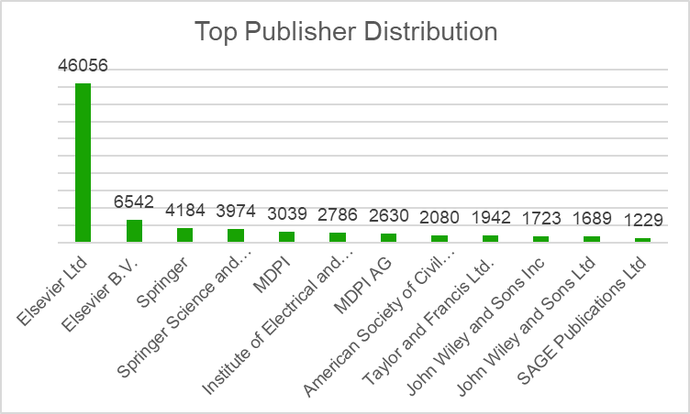
Fig.5 Top Publisher for FMEA article

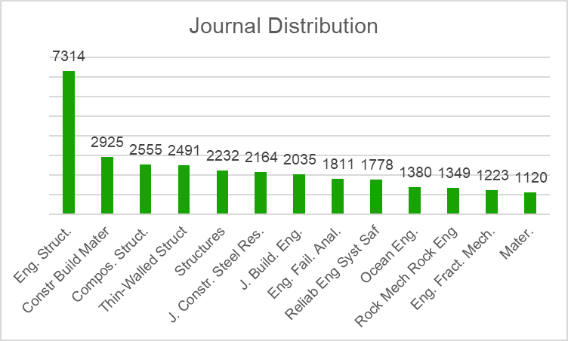
Fig.5 Journal distribution for FMEA article

Conclussion
This bibliometric analysis confirms the continued relevance and significant evolution of FMEA research between 2020 and 2025, particularly driven by advancements in computational techniques and increased interdisciplinary collaboration. The findings underscore a clear shift from traditional methodologies toward hybrid approaches integrating AI and machine learning, reflecting the necessity for higher precision and predictive capability in risk assessment practices.

Moving forward, future research is recommended to further explore the potential of emerging technologies such as blockchain and digital twins integrated within FMEA frameworks. Additionally, expanding international collaboration and cross-sectoral applications can significantly enhance the applicability and efficiency of FMEA, ensuring that it remains a robust and essential tool in managing risk and reliability across diverse industries.

Referensi
[1] S. Altuntas and S. Kansu, “An innovative and integrated approach based on SERVQUAL , QFD and FMEA for service quality improvement A case study,” 2019, doi: 10.1108/K-04-2019-0269.
[2] D. Maryadi, “Lean Six Sigma DMAIC Implementation to reduce Total Lead Time Internal Supply Chain Process,” pp. 2086–2096, 2021.
[3] D. Maryadi, T. Tamalika, R. A. N. Moulita, and T. P. O. Sianipar, “IMPLEMENTASI QUALITY FUNCTION DEPLOYMENT ( QFD ) PADA USAHA KECIL MENENGAH ( UKM ) ANGKRINGAN,” vol. 12, pp. 140–146, 2024.
[4] F. Suryani, T. Tamalika, R. A. N. Moulita, and D. D. Maryadi, “Aplikasi Failure Mode and Effect Analysis dan Reliability Centered Maintenance pada Preventive Maintenance Kendaraan Application of Failure Mode and Effect Analysis and Reliability Centered Maintenance in Preventive Maintenance of Vehicle,” vol. 01, pp. 15–23, 2023, [Online]. Available: http://jietri.univ-tridinanti.ac.id
[5] A. D. Makwana and G. S. Patange, “A methodical literature review on application of Lean & Six Sigma in various industries,” Aust. J. Mech. Eng., vol. 19, no. 1, pp. 107–121, 2021, doi: 10.1080/14484846.2019.1585225.
[6] M. L. Duc and M. N. Thu, “Application of Lean Six Sigma for Improve Productivity at The Mechanical Plant . A Case Study,” Manuf. Technol., vol. 22, no. 2, pp. 124–138, 2022, doi: 10.21062/mft.2022.028.
[7] D. M. Utama and M. Abirfatin, “Sustainable Lean Six-sigma: A new framework for improve sustainable manufacturing performance,” Clean. Eng. Technol., vol. 17, no. June, p. 100700, 2023, doi: 10.1016/j.clet.2023.100700.
[8] R. R. A. Guste, K. A. A. Mariñas, and A. K. S. Ong, “Efficiency Analysis of Die Attach Machines Using Overall Equipment Effectiveness Metrics and Failure Mode and Effects Analysis with an Ishikawa Diagram,” Machines, vol. 12, no. 7, 2024, doi: 10.3390/machines12070467.
[9] J. E. Sordan, P. C. Oprime, U. F. De Uberlandia, and P. Milano, “Lean Six Sigma in manufacturing process : a bibliometric study and research agenda,” vol. 32, no. 3, pp. 381–399, 2020, doi: 10.1108/TQM-08-2019-0207.
[10] F. J. Alarcón, M. Calero, S. Pérez-Huertas, and M. Á. Martín-Lara, “State of the Art of Lean Six Sigma and Its Implementation in Chemical Manufacturing Industry Using a Bibliometric Perspective,” Appl. Sci., vol. 13, no. 12, 2023, doi: 10.3390/app13127022.
[11] A. Niñerola, M. V. Sánchez-Rebull, and A. B. Hernández-Lara, “Six Sigma literature: a bibliometric analysis,” Total Qual. Manag. Bus. Excell., vol. 32, no. 9–10, pp. 959–980, 2021, doi: 10.1080/14783363.2019.1652091.
[12] M. Ababou, S. Chelh, and M. Elhiri, “A Bibliometric Analysis of the Literature on Food Industry Supply Chain Resilience: Investigating Key Contributors and Global Trends,” Sustain., vol. 15, no. 11, 2023, doi: 10.3390/su15118812.
[13] I. Campos-García, S. Alonso-Muñoz, R. González-Sánchez, and M. S. Medina-Salgado, “Human resource management and sustainability: Bridging the 2030 agenda,” Corp. Soc. Responsib. Environ. Manag., vol. 31, no. 3, pp. 2033–2053, 2024, doi: 10.1002/csr.2680.
[14] A. Niñerola, M. V. Sánchez-Rebull, and A. B. Hernández-Lara, “Quality improvement in healthcare: Six Sigma systematic review,” Health Policy (New. York)., vol. 124, no. 4, pp. 438–445, 2020, doi: 10.1016/j.healthpol.2020.01.002.
[15] B. Naghshineh and H. Carvalho, “Towards a practice-based framework for supply chain resilience in the context of additive manufacturing technology adoption,” Int. J. Comput. Integr. Manuf., vol. 38, no. 3, pp. 335–361, 2024, doi: 10.1080/0951192X.2024.2333011.
[16] H. Wahyuni, I. Vanany, and U. Ciptomulyono, “Food safety and halal food in the supply chain: Review and bibliometric analysis,” J. Ind. Eng. Manag., vol. 12, no. 2, pp. 373–391, 2019, doi: 10.3926/jiem.2803.

