THE INFLUENCE OF MOTIVATION, COMMUNICATION, AND ORGANIZATIONAL COMMITMENT ON PT. INTRACO PENTA WAHANA PALEMBANG EMPLOYEES' PERFORMANCE

Hernando Hendrik^{1*}, Letifa Shintawaty², Liliana, Sahila³

^{1,3} Prodi Manajemen, Faculty of Economics and Business, Universitas Tridinanti, Palembang,
South Sumatara
² Prodi Teknik Elektro, Faculty of Engineering, Universitas Tridinanti, Palembang, South Sumatara

¹⁾ Coresponding Email: hendrikhernando7@gmail.com

ARTICLE INFORMATION  Submitted:  00/00/2021  Revised:  00/00/2021  Accepted:  00/00/2021  Online-Published:  30/12/2021 |  | ABSTRACT  The purpose of this study is to find out: 1) to determine the effect of Motivation, Communication and Organizational Commitment on Performance simultaneously on Employee Performance at PT. Intraco Penta Wahana Palembang, 2) to determine the effect of partial motivation on employee performance at PT. Intraco Penta Wahana Palembang, 3) to determine the effect of partial communication on employee performance at PT. Intraco Penta Wahana Palembang. The sample in this study was employees of PT. Intraco Penta Wahana Palembang as many as 25 people from a total population of 25 people. The sampling technique uses saturated sampling. Data collection used questionnaires, validity tests and reliability tests, while data analysis was carried out using multiple regression analysis. The results of this study show that: 1) work effectiveness and loyalty simultaneously have a significant effect on employee performance at PT. Intraco Penta Wahana Palembang. It can be seen that the values of Fcalculate (7.598) > Ftable (3.42) with significance 0.003 < 0.05; 2) partial effectiveness has a significant effect on employee performance at PT. Intraco Penta Wahana Palembang. It can be seen that the calculated value of 2.095 > the ttable value of 1.71. Significance test results of 0.003 < 0.05; and 3) partial loyalty has a significant effect on employee performance at PT. Intraco Penta Wahana Palembang. It can be seen that the calculated value of 2.404 > the ttable value of 1.71. Significance test results 0.001 < 0.05  Keywords: Motivation, Communication, Organizational Commitment, Employee Performance

A. INTRODUCTION

There are internal and external goals that must be met within the company. The outcomes of this performance decide whether the company's key goals will be promptly reached, or vice versa, with targets that have been established goals that have not been met, due to subpar work results. Everything in the company environment must be able to collaborate in order to utilize current skills, because the work must be finished within the time frame that has been established.
The execution of all current work, specifically employees in the company, because existing employees are human resources both in organizations, corporations, and agencies are movers and implementers to ensure that all work is accomplished. Communication, motivation, and commitment between employees and company executives help in carrying out job so that everything runs smoothly.
Communication in a corporate organization, and more broadly in other organizational organizations, typically occurs in two contacts: communication within the firm (internal communication) and communication outside the company (internal communication). There are numerous challenges in internal communication, both vertically, horizontally, and diagonally, that cause communication not to be smooth, or in other words, a communication miss. Communication is the process of expressing information, thoughts, feelings, knowledge, and so on via symbols such as words, pictures of numbers, and so on.
The physical, social, and psychological life within the organization that influences employee performance and productivity is referred to as the work environment. The work environment is divided into two parts: the physical work environment and the non-physical work environment. Workplace conditions, lighting, hygiene, safety, ventilation, and so on are all part of the physical work environment. While the non-physical environment includes a harmonious, calm, safe, and pleasant working environment, as well as company services supplied to employees. If the work environment does not match the requirements for a workplace environment, it will affect employee work activities, making employees feel uncomfortable at work and decreasing work productivity, impeding the process of reaching organizational goals. If, on the other hand, the working environment is nice and pleasant for employees, they will feel calm, cheerful, and serene at work, allowing them to be more active in carrying out work procedures and achieving organizational goals.
PT. Intraco Penta Wahana Palembang is a corporation that specializes in expedition; this company ships commodities. Jalan Alamsyah Ratu Prawiranegara No. 9, Karang Jaya, Kec. Ilir Barat I, Palembang City is where the company is located. Communication has a significant impact on employee performance at SiCepat Ekpress.
Communication is very influential on a freight forwarding company because poor communication often results in errors when delivering goods and goods not being received by the recipient, so the couriers do not carry out SOP (Standard Operating Procedure) before the goods are received by the recipient.
Motivation, in addition to communication, is a significant aspect in improving employee performance. Motivation can be used to motivate people, build initiative, and a sense of responsibility, and encourage them to enhance their performance. A less conducive environment or a lack of appropriate communication might have a negative impact on employee performance in the workplace.
Based on the observations, the writing concluded that the company's work climate was not conducive, with many employees unable to interact effectively. And the lack of encouragement provided by superiors to employees in the organization, resulting in frequent miscommunication between coworkers as well as employees to superiors. This occurrence occurs frequently at PT. Intraco Penta Wahana Palembang, so the writer want to learn more about the company's Motivational Communication and Work Environment, as well as how it affects employee performance.
In response to the explanation above, the research titled "The Influence of Motivation, Communication, and Organizational Commitment on Employee Performance at PT. Intraco Penta Wahana Palembang" can be conducted to find out the Influence of Motivation, Communication, and Organizational Commitment on Employee Performance.
B. RESEARCH METHODS
The current investigation is meant to examine the state of the organization, specifically the Influence of Motivation, Communication, and Organizational Commitment on Employee Performance at PT Intraco Penta Wahana Palembang, utilizing quantitative research methodologies with a descriptive approach. Methods of study. Quantitative research can be defined as a positive philosophy-based research method used to analyze specific populations or samples through data gathering employing research equipment, analysis, and quantitative or statistical reporting.
The objective of the research necessitated the collection of primary and secondary data, which was then analyzed using the linear regression method, one of the statistical techniques used to determine the relationship between two or more variables so that a conclusion could be formed afterwards.

C. RESULTS AND DISCUSSION

Multiple Linear Regression Analysis is used to determine the influence or relationship linearly between two or more independent variables with one dependent variable.

The results of Multiple Liner Regression can be seen in the following table:
Table 1. Multiple Liner Regression Results

Coeffi cientsa
Model | Unstandardized  Coef f icients |  | St andardized  Coef f icients | t | Sig.
 | B | St d. Error | Beta
1 (Constant) Komunikasi Motiv asi  Lingkungan Kerja | 7,704  5,217  5,119  5,398 | 4,960  ,151  ,192  ,192 | 1,613  1,645  1,358 | 3,949  5,113  3,656  5,244 | ,000  ,001  ,000  ,001
a. Dependent Variable: Kinerja Kary awan

Based on the table above, it can be seen that the regression equation, namely:
Y = a + b1X1 + b2X2 + b2X3 + e; maka:
Y = 7,704 + 5,217X1 + 5,119X2 + 5,398X3 + e
Based on the above equation, it shows that:
a = 7,704. that is, if the variables of communication, motivation, and work environment are 0, then the employee's performance value is 7,704.
b1 = 5.217. That is, the regression coefficient of the communication variable is positive at 5.217. That is, if communication improves, it will be followed by increased employee performance, while others remain. If communication decreases, it will be followed by a decrease in employee performance.
b2 = 5.119. That is, the regression coefficient of the motivational variable is positive at 5.119. That is, if motivation increases, it will be followed by increased employee performance, while others remain. If motivation decreases, it will be followed by a decrease in employee performance.
b3 = 5.398. That is, the regression coefficient of the work environment variable is positive at 5.398. That is, if the work environment improves, it will be followed by increased employee performance, while others remain. If the work environment decreases, it will be followed by a decrease in employee performance
Statistical Hypothesis Test

The goal of hypothesis testing is to determine if the suggested null hypothesis (H0) is rejected or accepted at a certain level of significance. The T Test (partial) and the F Test (simultaneous) are used to test this hypothesis.

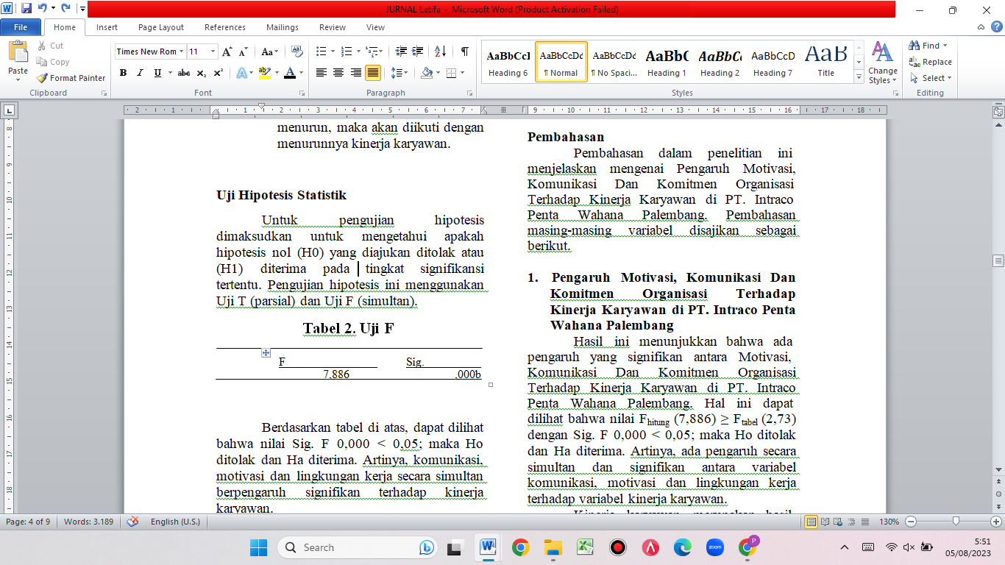

As stated in the table above, the values of Sig. F 0.000 0.05; so Ho is rejected and Ha is accepted. That is, communication, motivation, and the work environment all have an impact on employee performance.
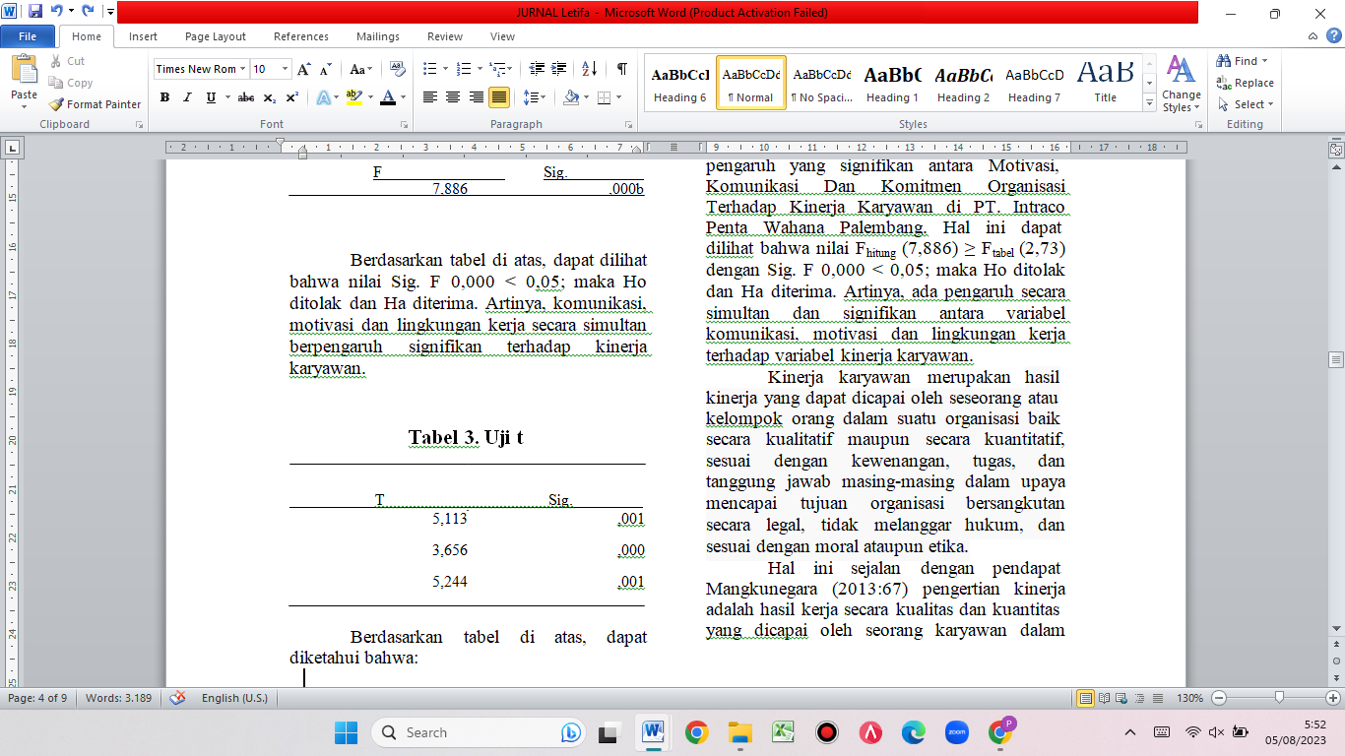
Based on the table above, it can be seen that:

- Sig value. t 0.001 < 0.05; Ho's hypothesis is rejected and Ha is accepted. That is, communication partially has a significant effect on employee performance variables with a calculated value of 5.113 ≥ a table value of 2.05.

- Sig value. t 0.000 < 0.05; Ho's hypothesis is rejected and Ha is accepted. That is, partially motivation has a significant effect on employee performance variables with a calculated value of 3.656 ≥ a table value of 2.05.

- Sig value. t 0.001 < 0.05; Ho's hypothesis is rejected and Ha is accepted. That is, partially the work environment has a significant effect on employee performance variables with a calculated value of 5.244 ≥ a table value of 2.05.

Discussion
- The Influence of Motivation, Communication and Organizational Commitment on Employee Performance at PT. Intraco Penta Wahana Palembang

These findings indicate that motivation, communication, and organizational commitment all have a substantial impact on employee performance at PT. Intraco Penta Wahana Palembang. It can be observed that the value of Fcalculate (7.886) Ftable (2.73) with Sig. F 0.000 0.05 rejects Ho and accepts Ha. That is, there is a simultaneous and considerable influence on employee performance factors from communication, motivation, and work environment variables.
Employee performance is the result of qualitative and quantitative performance achieved by a person or group of people in an organization in accordance with their respective authorities, duties, and responsibilities in an effort to achieve the goals of the organization concerned legally, without violating the law, and in accordance with morals or ethics.
This is consistent with Mangkunegara's (2013: 67) definition of performance as "the result of work in quality and quantity achieved by an employee in carrying out his own duties with the responsibilities assigned to him." Furthermore, Mathis and Jackson (in Priansa, 2014: 269) emphasize that performance is essentially what employees do or do not do in carrying out their work. Essentially, performance is something that is individual, because each employee has a varied amount of competence in performing his job. Performance is determined by a combination of skill, effort, and opportunities received through employee performance activities.
2. The Effect of Communication on Employee Performance at PT. Intraco Penta Wahana Palembang
These findings indicate that communication has a substantial impact on employee performance at PT. Intraco Penta Wahana Palembang. The value of Sig. t 0.001 0.05 indicates that Ho's hypothesis is rejected and Ha is accepted. That is, with a computed value of 5.113 and a table value of 2.05., communication has a moderately significant effect on employee performance characteristics. Communication is an essential component of organizational existence. Communication is involved in all management responsibilities, including planning, organizing, leading, and overseeing.
3. The Effect of Motivation on Employee Performance at PT. Intraco Penta Wahana Palembang
These findings indicate that motivation has a major impact on employee performance. The value of Sig. t 0.000 0.05 indicates that Ho's hypothesis is rejected and Ha is accepted. That is, with a computed value of 3.656 and a table value of 2.05., partly motivation has a considerable effect on employee performance characteristics.
Motivation is a psychological drive that pushes people to perform things in order to accomplish a specific goal. Everyone has varying degrees of motivation. The presence of motivation in a person is critical, particularly for employees. When someone is in need, the courage and willingness to accomplish something like work generally appear.
4. The Influence of the Work Environment on Employee Performance at PT. Intraco Penta Wahana Palembang
These findings indicate that the workplace environment has a major impact on employee performance. It can be observed that the value of Sig. t 0.001 0.05; Ho's hypothesis is rejected and Ha is accepted. That is, with a calculated value of 5.244 and a table value of 2.05. The work environment is a company's physical, social, and psychological existence that influences employee performance and production. Employees will quickly become bored and dissatisfied if they do not work in a pleasant setting.

D. CONCLUSIONS AND SUGGESTIONS
Conclusion
The following are some of the study's findings:
1. Employee performance at PT. Intraco Penta Wahana Palembang is influenced by communication, motivation, and the work environment all at the same time. The value of Fcalculate (7.886) Ftable (2.73) with Sig. F 0.000 0.05 may be displayed.
2. Communication has a minor impact on staff performance at PT. Intraco Penta Wahana Palembang. The calculated value is 5.113, while the t-table value is 2.05.
3. Employee performance at PT. Intraco Penta Wahana Palembang is influenced in part by motivation. The calculated value is 3.656, but the ttable value is 2.05.
4 The work environment has a minor impact on employee performance at PT. Intraco Penta Wahana Palembang Palembang. The calculated value is 5.244, and the ttable value is 2.05, as can be seen.

Suggestion

- Contribute to PT. Intraco Penta Wahana Palembang
The results of this research are expected to provide enthusiasm and reference for the Head of PT. Intraco Penta Wahana Palembang to improve the quality and quality of performance, especially for employees of PT. Intraco Penta Wahana Palembang by implementing effective communication, paying attention to providing good motivation to employees, implementing, and creating a comfortable work environment, so that welfare and peace at work will be created as desired by employees.
- For Employees
The results of this research are expected to be able to provide enthusiasm and motivation for the work of PT. Intraco Penta Wahana Palembang Palembang to further improve the quality of its work in accordance with the desired goals and this is certainly also useful for employees, namely the increase in position or salary bonus given by the Branch Head because he is happy with the work of his employees.
- For the Next Researcher
The results of this study are expected to add learning materials and broaden horizons in the field of Human Resource Management, so that further researchers can develop this research with a variety of other variables that are different and affect employee performance.

E. BIBLIOGRAPHY
Budiharjo, 2015, Panduan Praktis Penilaian Kinerja Karyawan.Jakarta : Raih Asa Sukses
Hasibuan, 2015, Manajemen Sumber Daya Manusia.Edisi Revisi : Bumi Aksara, Jakarta
Kurniawan, 2014, Metode Riset untuk Ekonomi dan Bisnis: Teori, Konsep, dan Praktik Penelitian Bisnis.Bandung : Alfabeta
Nuraini, 2013, Manajemen Sumber Daya Manusia.Pekanbaru : Yayasan Alwi Syam
Mangkunegara, 2013, Manajemen Sumber Daya Manusia.Remaja Rosdakarya, Bandung
Moorhead, 2013, Perilaku Organisasi.Jakarta : Salemba Empat
Priansa, Donni Juni, 2014, Perencanaan dan Pengembangan Sumber Daya Manusia.Bandung : Alfabeta
Siagian, Sondang P, 2014, Manajemen Sumber Daya Manusia.Jakarta : Bumi Aksana
Sunyono & Hariyanto, 2015, Implementasi Belajar & Pembelajaran.Bandung : Remaja Rosdakarya
Sunyoto, Danang. 2012. Manajemen Sumber Daya Manusia.Jakarta : PT Buku Seru
Sunyoto, Danang. 2015, Manajemen dan Pengembangan Sumber Daya Manusia.Yogyakarta : Center For Academic Publishing Service
Sugiyono, 2012, Memahami Penelitian Kualitatif. Bandung : Alfabeta
Sugiyono, 2013, Metode Penelitian Pendidikan Pendekatan Kuantitatif, Kualilatif, dan R&D. Bandung : Alfabeta
Sugiyono, 2016, Metode Penelitian Kuantitatif, Kualitatif dan R&D. Bandung : Alfabeta
Urber, Silalahi. 2016, Asas Asas Manajemen.Bandung: Refika Aditam

