THE IMPACT OF MOTIVATION AND WORK DISCIPLINE ON CV EMPLOYEE PERFORMANCE. BUMI ANGKASA SEJAHTERA PALEMBANG

Dita Marisa Putri ¹, Syahyuni ²

^{1,} STIA Satya Negara, Palembang, South Sumatra
^{2,} Prodi Manajemen, Fakultas Ekonomi dan Bisnis, niversitas Tridinanti, Palembang, South Sumatara

¹⁾Email : ditamarisa87@gmail.com , syahyuni2618@gmail.com

ARTICLE INFORMATION  Submitted:  00/00/2021  Revised:  00/00/2021  Accepted:  00/00/2021  Online-Published:  30/12/2021 |  | ABSTRACT  The purpose of this study is to analyze the effect of motivation and work discipline on the performance of CV employees. bumi angkasa sejahtera Palembang partially and simultaneously. The results of this study are Motivation and work discipline simultaneously affect the performance of CV employees. Bumi Angkasa Sejahtera Palembang which is shown by the F value count 13.820 which is greater than F table 3.17, then with a significance level of 0.000 smaller than the alpha probability level of 0.05, which means the null hypothesis (Ho) is rejected and the alternative hypothesis (Ha) is accepted, then motivation and work discipline have a significant effect on the performance of CV employees. Bumi Angkasa Sejahtera Palembang. Partially, Employee motivation CV. Bumi Angkasa Sejahtera Palembang has a positive and significant effect on employee performance as shown from the results of a multiple linear regression coefficient of 0.420 with a significance level of 0.001. Meanwhile, the work discipline of CV employees. Bumi Angkasa Sejahtera Palembang has a positive and significant effect on employee performance as shown by the results of a multiple linear regression coefficient of 0.273 with a significance level of 0.02.  Keywords: Motivation, Work Discipline, Employee Performance

A. INTRODUCTION
In carrying out its activities, a company, including manufacturing and service companies, will seek to meet previously stated goals. One thing that must be addressed is that the success of various operations within the company in reaching goals is dependent not only on excellence, available operational finances, facilities and infrastructure possessed, but also on human resource factors.
This human resource component is something that businesses must address, especially since the period of free trade is about to begin, and the environment of competence will be extremely different. This requires every business to function more efficiently, effectively, and productively. This significant level of competency will motivate each company to preserve its viability in a highly competitive environment, which in this case means that the company must pay attention to human resource concerns. So humans can be seen as a determining factor because it is handled that all innovations will be realized in an effort to realize company goals, to obtain human resources that the organization hopes can positively contribute to all company activities in achieving its goals, each employee is expected to have high work motivation, which is expected to later increase high work discipline.
Management must consider motivation if they want every employee to be enthusiastic about the tasks assigned to him. Without motivation, an employee cannot fulfill his duties to standards or even below standards because his motive and motivation at work are not met. Even if an individual possesses operational competence, if he lacks motivation to work, the ultimate outcome of his labor will be unsatisfactory.
Given the importance of motivation, the management's concern regarding the problem of employee motivation at work is to make motivational efforts for company employees through a series of certain efforts in accordance with company policy, so that employee motivation at work will be maintained. To motivate people, organizational leaders must understand their motives and motivations. One thing that must be understood is that people want to work because they want to meet their needs, both conscious and unconscious needs, in the form of material and non-material, physical and spiritual needs, and these motivations come in many forms, such as providing respectable and fair compensation, rewarding employees, and so on. This is done so that whatever the employee's need is met, and then it is expected that employees can work well and feel happy with all the tasks assigned to them. Once employees are happy with their work, they will respect each other's rights and obligations in order to create a conducive work environment, and finally, employees will voluntarily and earnestly give their best abilities in carrying out duties and responsibilities. Employees will demonstrate work discipline because they are motivated to carry out their obligations in the organization, according to the answer.
Motivation is a psychological process that creates and directs behavior in order to achieve goals (Kreitner and Kinicki, 2001: 2005). Adella Hotyda Siregar (2007) states. Work motivation is defined as a desire for a person or work, whether from within or without, to carry out work or activities with a sense of responsibility in order to attain the intended goals.
In accordance with some of the perspectives expressed above, motivation is a driving element that can create staff morale to achieve organizational goals. Motivated people will put in more effort than unmotivated folks. Companies or organizations want employees to be capable and skilled, but also to be eager to work persistently and to obtain optimum work results.
Indikator Motivasi
Maslow's hierarchy of needs was applied by the researchers in this study. According to Sofyandi and Garmiwa (2007: 102), Abraham Maslow's hierarchy of needs hypothesis contains of:
- Physiological-Need
Physiological needs are the most basic human needs, which include things like eating, drinking, housing, oxygen, and sleeping.
2. sefety-Need
If the physiological demands are generally met, the second need, namely the need for security, emerges. The desire for security involves protection against the hazards of workplace accidents, as well as guarantees for the continuation of their job and guarantees for their old age when they are no longer working.
3. Sosial-Need
If physiological requirements and a sense of security are met to a minimum, social demands, such as companionship, connection, and closer interaction with others, will emerge. The necessity for a compact work group, good supervision, joint recreation, and so on will be tied to the organization.
4. Esteem-Need
These requirements include the need to be respected, to be recognized for one's accomplishments, to be recognized for one's abilities and expertise, and to be effective at work.
5. Self-Actualization Need
Maslow's greatest hierarchy of needs is self-actualization. Self-actualization is concerned with the process of developing a person's genuine potential.
The requirement for a person to demonstrate their abilities, competence, and potential. In reality, the desire for self-actualization is boosting people's proclivity to actualize their conduct. A person driven by the need for self-actualization enjoys assignments that test his abilities and competence.
Recognizing Work Discipline
Discipline is a technique for correcting or punishing subordinates who break rules or procedures. Discipline is a type of employee self-control and regular execution that demonstrates the level of sincerity of the organization's work team (Henry Simamora.1997). Work discipline must always be maintained and enhanced in order to be better. Good discipline indicates a person's sense of responsibility for the responsibilities assigned to him. This can boost morale and help the organization meet its objectives. Employees as well as society. As a result, every manager strives to instill discipline in his or her bearers.
It is determined that comprehending work discipline is an attitude of one's readiness to comply with applicable standards and become the major capital that has a significant impact on the level of performance. Employees who lack a positive attitude toward punishment will have a negative impact on their performance.
Factors Influencing Work Discipline
There are numerous factors that influence an organization's employees' level of discipline. Hasibuan (2000: 195) outlines several variables that influence employee discipline, including aims and talents, examples of leadership, suit reciprocity, fairness, waskat, legal punishments, firmness, and human relations.
Factors Affecting Employee Performance
The work environment includes everything that occurs around employees that can interfere with his ability to do the tasks assigned to him. A work environment that receives less attention will have a negative influence and lower morale since employees feel interference while carrying out their jobs, thus they lack excitement and spend less energy and thought on their duties. As a result, everyone at work requires a positive work atmosphere.
B. RESEARCH METHODS

Instruments for research, validity tests, and reliability tests
A research instrument is a tool that researchers use to collect research data from data sources for use as samples. In the company, as well as the researcher's documents.
1. Validity Test
The term "valid instrument" refers to the measuring device used to acquire data (measure). Sugiyono (2011) defines validity as the ability of an instrument to measure what should be measured. The content validity utilized in this study describes the appropriateness of a data meter with what will be measured (Augusty Ferdinand, 2006). The decision-making framework for testing the validity of questionnaire items is as follows:
1. The variable is valid if r count is positive and r count > r table.
2. If r count and r count r table are not both positive, the variable is invalid.
If the results are substantial, then each of the question indications is correct. The SPSS program was used to perform the validity test in this study.
2. Reliability Test
Reliability means that there is a high level of data confidence if the facts obtained do not change when re-observations are made. This reliability is mostly related to researchers' capacity to search for data, respondents' ability to answer the questions asked, and researchers' ability to evaluate the responses given by respondents (Sonny Sumarsono, 2004). In this study, questionnaire reliability was determined using the Cronbach Alpha () statistical test and the SPSS for Windows application. Nunnally in (Imam Ghozali, 2006)
Techniques for Analysis Data
The data analysis method used in this study is a quantitative data analysis method, because the existing data is in the form of numbers used to determine whether hypotension is accepted or rejected, and the author also explains the causal relationship between variables through hypotension testing. The data in this study is an interval.
The regression analysis approach is used to see the elements that affect employee performance and to determine the variables that affect employee performance. Regression analysis is a type of parametric statistics. Statistical parametrics are used to examine interval and ratio data, according to Sugiyono (2010: 209). Multiple linear regression analysis was employed in the study as the regression analysis model. The collected data were analyzed using the SPSS 16.0 program using multiple linear regression analysis equations, as follows:
Y = a+BX1 + BX2 + e
This study's data writing was analyzed using two types of descriptive analysis methodologies, namely:
- Qualitative Analysis is a method of analysis that explains numerous arguments that are directly relevant to the situation. In this situation, the author employs many theories or notions concerning employee motivation and productivity, as well as the relationship between the two.
- In this study, quantitative analysis begins by collecting data and identifying variables that characterize employees' impressions of motivation and productivity in existing categories will ultimately be the overall score of respondents filling out questionnaires.

C. RESULTS AND DISCUSSION
Testing for Partial Hypothesis (t Test)
The t-test is used to test the significance of multiple linear regression coefficients partially. This significance test is carried out by comparing the significance of t-count obtained from the calculation results with t-table α = 0.05. If t-count > t-table α= 0.05 then Ho is rejected and Ha is accepted.
Based on the results of SPSS Table 4.5.1, the calculated t values for the variables motivation (X1) and work discipline (X2) are 3.459 and 2.246, respectively, which are greater than t table 2.003, as well as the probability levels of 0.001 and 0.029, which are less than the alpha probability of 0.05. This implies:
- Ho is rejected whereas Ha is accepted, indicating that the motivation variable (X1) has a positive and significant effect on CV employee performance. Palembang Bumi Angkasa Sejahtera
- Ho is rejected whereas Ha is accepted, indicating that the work discipline variable (X2) has a positive and significant effect on CV employee performance. Palembang Bumi Angkasa Sejahtera
Tabel 1 SPSS Output Results Partial Test (Test t)
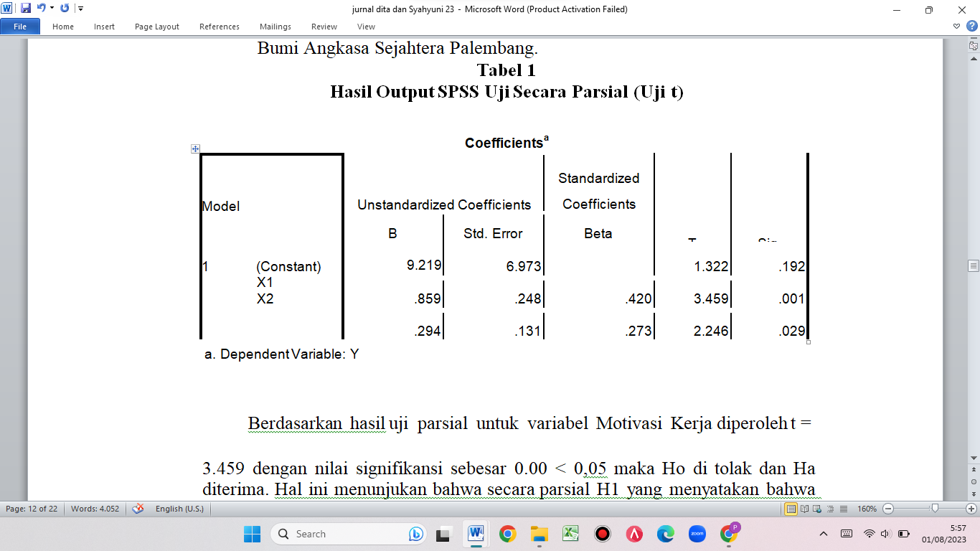
Ho is rejected whereas Ha is accepted, indicating that the work discipline variable (X2) has a positive and significant effect on CV employee performance. Palembang Bumi Angkasa Sejahtera, t = 2.246 with a significance value of 0.01 0.05 was found based on the partial test findings for the Work Discipline variable. Because the probability is less than 0.05, Ho is refused, whereas Ha is approved. This indicates that H2, which claims that Work Discipline has an effect on employee performance, is partially accepted.
F-testing for simultaneous hypotheses
Test F A regression coefficient hypothesis test was performed simultaneously at a confidence level of 95% (alpha = 0.05), thus assessing the accuracy of the effect of the motivation variable (X1) and work discipline variable (X2) combined (simultaneously) on the performance variable (Y). F calculate (motivation and work discipline) has a value of 13.820, which is greater than F table 3.17, and a probability level of 0.000, which is less than an alpha probability of 0.05, indicating that the null hypothesis (Ho) is rejected and the alternative hypothesis (Ha) accepted, implying that motivation (X1) and work discipline (X2) affect CV employee performance (Y). Palembang Bumi Angkasa Sejahtera. The anova table below shows how to run the F test:
Table 2. SPSS Output Results Simultaneous Test (Test F)
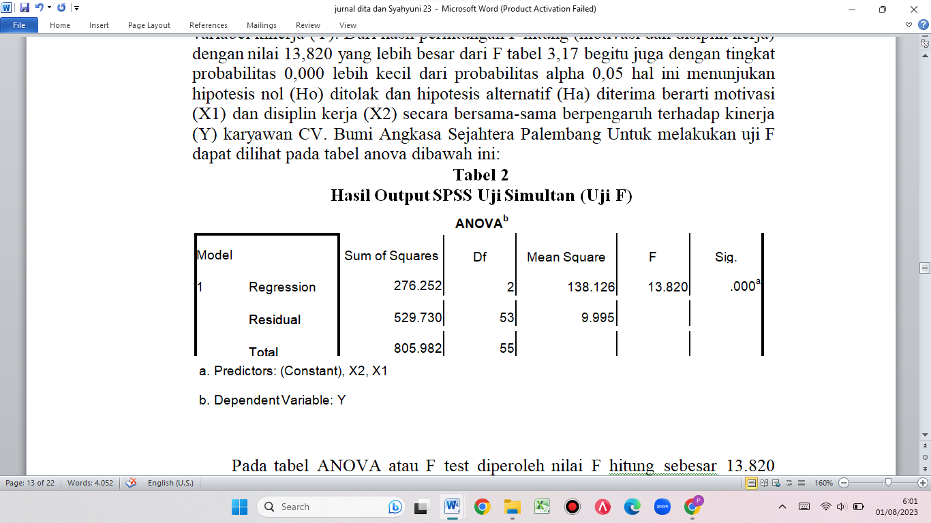
In the ANOVA table or F test, a determined F value of 13,820 with a significance level of 0.000 5% is obtained. Because the probability is less than 0.05, Ho is rejected and Ha is accepted, implying that the independent variables Motivation and Work Discipline can explain the size of the dependent variable Employee performance in this case. This demonstrates that H3, which claims that Work Motivation and Work Discipline have an impact on employee performance, is also accepted.
Coefficient of Determination Test
Coefficient of Simultaneous Determination (R2)
The significance of the independent variable's influence on the dependent variable as a whole can be seen in the summary model table below:
Table 3. Table of Multiple Determination Test Results (R2)
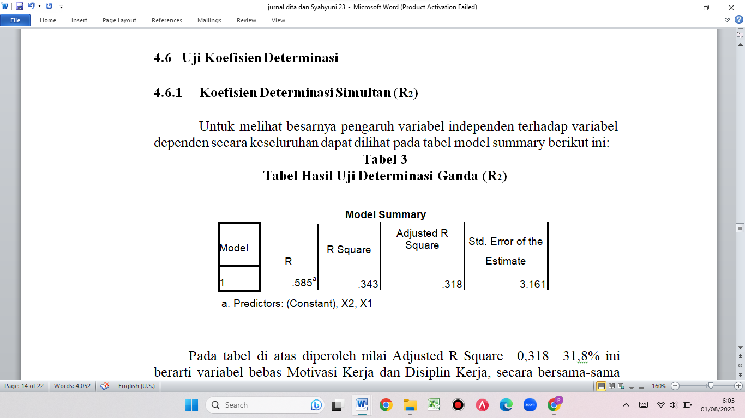
The value of Adjusted R Square = 0.318 = 31.8% in the table above indicates that the independent variables Work Motivation and Work Discipline together influence the dependent variable Employee performance by 31.8%, with the remaining 68.2% influenced by other variables not included in this study.
Coefficient of Partial Determination (r2)
In addition to performing a double determination test, it is important to determine the magnitude of the partial determination coefficient for each independent variable. This partial determination test is designed to determine how much influence each independent variable has on the dependent variable. The following table shows the influence of Work Motivation and Work Discipline on employee performance in part:
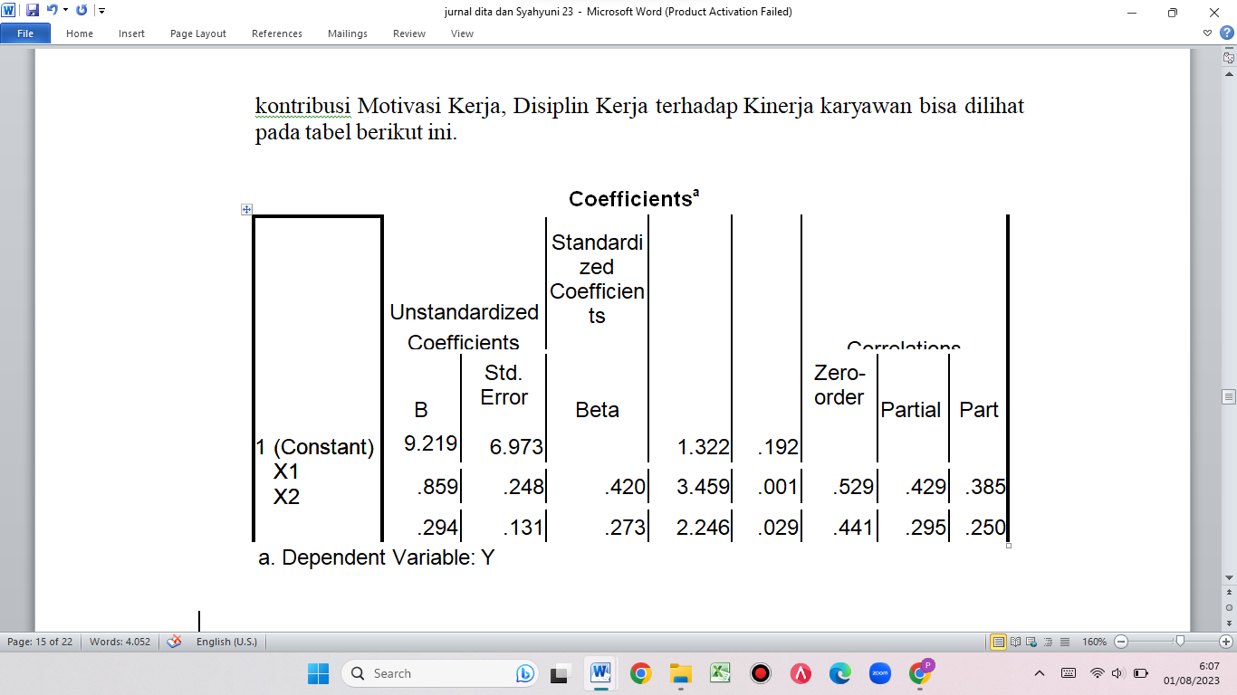
As shown in the table above, the magnitude of Partial Correlations (r2) of Work Motivation is 18.4%, which is calculated by squaring the partial correlation coefficient for the variable Work Motivation, namely (0.429).2. The percentage of Work Discipline's influence is 8.7%, as shown by the partial correlation coefficient for the variable Work Discipline squared, namely (0.295).2. This demonstrates that Work Motivation has a higher influence on employee performance than Work Discipline.
Multiple Linear Regression Analysis Results
To investigate the impact of motivation and work discipline on the performance of CV employees. Bumi Angkasa Sejahtera Palembang employed multiple linear regression analysis. Based on the study's findings, data were processed and calculated using the Statistical Package for Social Science (SPSS) 16.0, which is used to quantify the influence of independent variables on dependent variables. The following table summarizes the outcomes of data processing:
Table 4. SPSS Output Results Multiple Regression Analysis
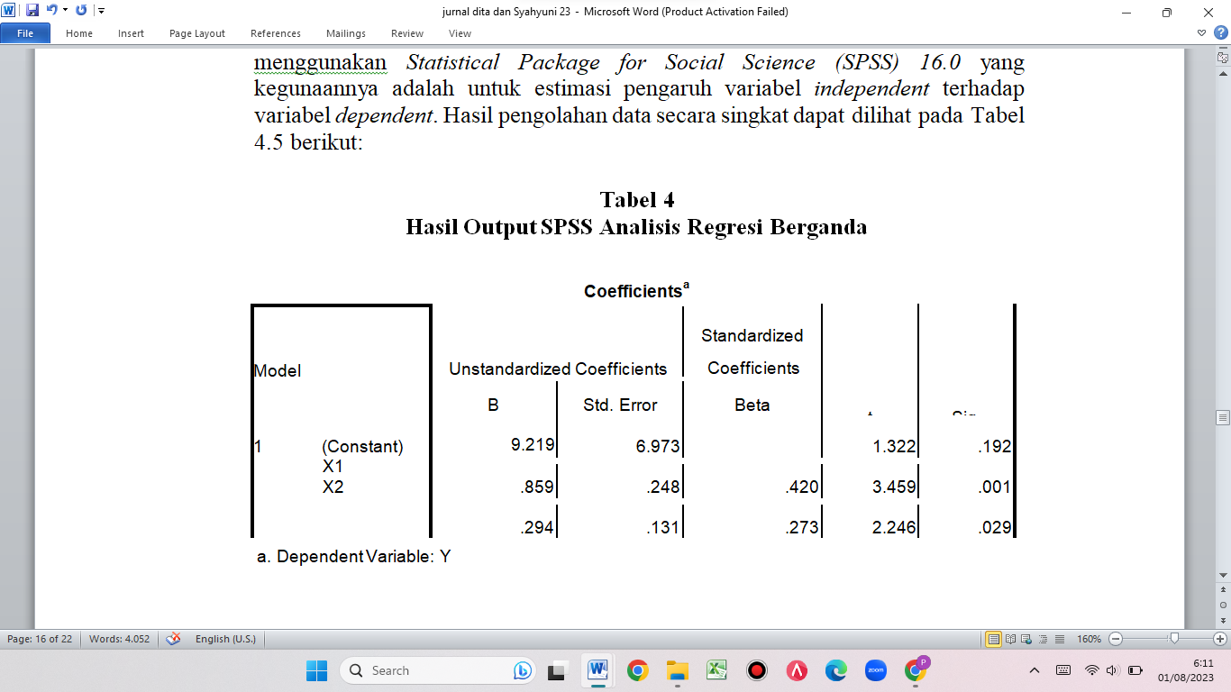
The multiple regression equation is derived from the table above as follows: Y = 9.219 + 0.859X1 + 0.294X2, where the regression equation means:
Constant = 9,219
If the variables Work Motivation and Work Discipline are both set to zero, the variable Employee Performance equals 9.219. Alternatively, if no influence is exerted by independent variables such as work motivation and work discipline, performance remains unchanged.
Coefficient of Work Motivation = 0,859
If the Work Motivation variable improves by one point but the Work Discipline variable remains constant, employee performance will increase by 0.859.
Coefficient of Work Discipline = 0,294
If the Work Discipline variable improves by one point and Motivation remains constant, employee performance will increase by 0.294.
Discussion
As shown by the results of the hypothesis measurement, motivation and work discipline have a favourable and significant effect on the performance of CV personnel. Palembang Bumi Angkasa Sejahtera In general, the most powerful influence on CV employees' performance. Work discipline is Bumi Angkasa Sejahtera Palembang.
Motivation can be defined as a person's personal circumstances that stimulate an individual's desire to carry out specific activities in order to attain goals (Handoko, 2003: 252). While work discipline is a strategy used by managers to communicate with employees in order to change behaviour and to raise knowledge and willingness to observe all corporate standards and related social norms (Rivai, 2004: 444).
Based on the results of the research on multiple linear regression data processing using SPSS 16.00, it can be shown that there is an influence between the motivation variable (X1) and performance (Y), as indicated by a number of 0.420. CV employees are becoming more motivated. Bumi Angkasa Sejahtera Palembang would also improve the performance of its personnel. The findings of this study back up Robbins' (2008: 241) assertion that employee performance is determined by the combination of ability and motivation. If anything is deficient, performance suffers. Motivation is one of the characteristics that influence employee performance.
Similarly, the work discipline variable (X2) influences performance (Y), as seen by the value 0.273. CV workers' increased work discipline. Bumi Angkasa Sejahtera Palembang will also improve employee performance. The findings of this study back up Sinungan's (2008: 148) claim that discipline fosters performance or is a key means of achieving 56 performances. High employee work discipline encourages employees to behave positively at work, such as following organizational regulations and doing duties as well as possible, so that employee performance grows in accordance with the company's goals.
Based on the perceptions of respondents in CV of motivation variables (X1), work discipline variables (X2), and performance variables (Y) contained in questionnaires administered to 56 respondents. As stated by Bumi Angkasa Sejahtera Palembang, motivation, work discipline, and staff performance are all very good categories. The Relatedness needs component had the highest average score of 4.56 in the distribution of respondents' replies to the motivation variable. This condition indicates that employees' needs have been addressed and is classed as very good. The Existensis needs dimension has the lowest motivation variable score, with an average score of 4.41. Despite being the lowest of the three dimensions, it is nonetheless considered quite good. So, it is sufficient to preserve and continue to pay attention to the total dimension of CV employee motivation. The Bumi Angkasa Sejahtera Palembang is in excellent condition.
The attendance component has the highest average score of 4.75 based on the distribution of respondents' responses to work discipline variables. The lowest possible score is 4.33. Despite having the lowest average of the five extant qualities, these two dimensions are nonetheless evaluated as very good by 58% of people. So, it doesn't really need to be improved; simply maintain and keep it in check to keep it in excellent condition.
The distribution of responses to the lowest performance variable yielded an average score of 4.53. Despite being the lowest of the five dimensions, it is nevertheless considered quite good. So that the entire dimensions of CV employee performance are sufficient to retain and keep attention. The Bumi Angkasa Sejahtera Palembang is in excellent condition.
D. CONCLUSION AND SUGGESTION

Conclusion
Based on the findings of the described research, the following conclusions can be drawn:
1. Employee performance CV. Bumi Angkasa Sejahtera Palembang is already classified as highly effective.
2. CV employees' performance is influenced by both motivation and work discipline. Bumi Angkasa Sejahtera Palembang, which is directed with a calculated F value of 13.820 greater than F table 3.17, then with a significance level of 0.000 less than the alpha probability level of 0.05, which means that the null hypothesis (Ho) is rejected and the alternative hypothesis (Ha) is accepted, then motivation and work discipline have a significant effect on CV employees' performance. Palembang Bumi Angkasa Sejahtera.
3. Employee engagement the results of a multiple linear regression coefficient of 0.420 with a significance level of 0.001 reveal that CV. Bumi Angkasa Sejahtera Palembang has a favorable and substantial effect on employee performance.
4. Employee work discipline the results of a multiple linear regression coefficient of 0.273 with a significance level of 0.02 demonstrate that CV. Bumi Angkasa Sejahtera Palembang has a favorable and substantial effect on employee performance.
Suggestion
Based on the previous conclusions, researchers can provide the following input or suggestions:
1. Employee performance CV. Bumi Angkasa Sejahtera Palembang received a rating of very good. To sustain the performance conditions of CV personnel, Bumi Angkasa Sejahtera Palembang's attention and supervision of staff performance should not be overlooked. The controlling function of the head of the representative office CV. Bumi Angkasa Sejahtera Palembang is a significant component in this regard.
2. Employee motivation CV. Bumi Angkasa Sejahtera Palembang is rated as excellent. Head of representative office CV. Bumi Angkasa Sejahtera Palembang should continue to pay attention and maintain the condition of employee motivation, which is classified as very good, by meeting the basic needs of employees in their survival, such as meeting the needs of employee life through salaries or benefits and employee life security in the future. Leaders should also maintain good communication relationships between employees and with leaders in meeting employe needs.
E. BIBLIOGRAPHY
Abdul Hakim. 2004. Statistika Deskriptif untuk Ekonomi dan Bisnis Yogyakarta: Ekonisia. Amran. 2009. Pengaruh Disiplin Kerja Terhadap Kinerja Pegawai Kantor. Departemen Sosial Kabuten Gorontalo, 4(2), 2397-2413.
Dharma, Surya. 2004. Manajemen Kinerja: Falsafah, Teori, dan Penerapannya. Jakarta: Program Pascasarjana FISIP.
Hadari. Nawawi. 2005. Penelitian Terapan.Yogyakarta: Gajah Mada University Press. Hasibuan, SP. Malayu. 2003. Manajemen Sumber Daya Manusia, Edisi Revisi. Jakarta: Bumi Aksara.
Handoko, T. Hani. 2001. Manajemen Personalia dan Sumberdaya Manusia, Edisi Kedua, BPFE, Yogyakarta.
Herzberg Dalam Siagian, Sondang P. 2002. Kiat Meningkatkan Produktivitas Kerja. Jakarta: Asdi Mahasatya
Mangkunegara, A.A. Anwar Prabu. 2008. Manajemen Sumber daya Manusia Perusahaan. Cetakan ke-8, Bandung : Rosda.
Mathis, dan Jackson. 2002. Manajemen Sumber Daya Manusia, Edisi pertama, Cetakan Pertama, Yogyakarta : Salemba Empat
Moenir. 2006. Manajemen Pelayanan Umum di Indonesia, Jakarta: Bumi Aksara
Robbins, Stephen P. dan Timothy A. Judge. 2008. Perilaku Organisasi Edisi ke-12, Jakarta: Salemba Empat.
Simamora, H. 1997. Manajemen Sumber Daya Manusia, Edisi 2, STIE YKPN, Yokyakarta.
Sugiyono.2014. Metodelogi Penelitian. Bandun g : Alfabeta
Wirawan. 2009. Evaluasi Kinerja Sumber Daya Manusia. Jakarta: Salemba Empat
Zesbendry , S.E. 2005. Pengaruh Disiplin Kerja terhadap Kinerja Pegawai. Pada Kantor Badan Pusat Statistik kabupaten Bogor. 11-1

