GENDER DIFFERENCES: POCKET MONEY AFFECTS INVESTMENT INTEREST WITH FINANCIAL LITERACY AS A MEDIATING VARIABLE

Tommy Fedian¹, Riza Syaputra², Ronald N Girsang³, Laula Dwi Martika⁴, Sri Wineh⁵, Gita Suliska⁶.
Accounting Study Program, Faculty of Economics, Muara Bungo University ¹³⁴⁵⁶
Accounting Study Program, Faculty of Economics and Business, Tridinanti University²

namirafe32@gmail.com, syahputra_riza@yahoo.com, girsangumb@gmail.com, lalamartika12cw@gmail.com, sriwineh0205@gmail.com, gita_suliska@yahoo.com,

Investment interest among university students remains relatively low, even though young people have great potential to support the growth of the capital market in Indonesia. This low interest is presumed to be influenced by financial and behavioral factors, such as pocket money and the level of financial literacy, which may differ between males and females. This study aims to analyze the effect of pocket money on students’ investment interest with financial literacy as a mediating variable and to examine the differences in influence based on gender. The research was conducted among students of the Faculty of Economics, Universitas Muara Bungo, involving 247 respondents. A quantitative explanatory approach was employed using the Partial Least Squares–Structural Equation Modeling (PLS-SEM) analysis technique with SmartPLS 4.0 software. The findings indicate that pocket money has a significant positive effect on investment interest, and financial literacy partially mediates this relationship. Furthermore, there are differences between male and female students, where males show a stronger direct effect, while females demonstrate a greater mediating role of financial literacy. The limitation of this study lies in its focus on a single university. This research contributes to strengthening financial literacy and developing investment education strategies for students in the fields of economics and finance.
Keywords: Investment Interest, Pocket Money, Financial Literacy, Gender

- Introduction
In the digital era marked by rapid advancements in information and communication technology, access to the capital market has become increasingly available to the general public. This digital transformation not only facilitates investment and transaction processes but also enhances public interest and participation, particularly among the younger generation. University students, as part of the productive age group, have emerged as a potential segment showing significant growth in the number of new investors in Indonesia’s capital market. This phenomenon aligns with the increasing awareness of the importance of financial literacy and investment from an early age. The following table presents the distribution of investors by age group along with the total value of assets owned, illustrating the dominance and rapid growth of young investors in the capital market.

Table 1. Age Groups of Investors and Their Asset Values
Age Group | Percentage of Investors | Total Asset Value (Rp Trillion) | Percentage of Total Assets
< 30 tahun | 54,33% | 42,54 | 2,95%
31-40 tahun | 24,76% | 259,89 | 12,80%
41-50 tahun | 12,21% | 187,46 | 12,25%
51-60 tahun | 5,79% | 264,27 | 16,65%
> 60 tahun | 2,96% | 905,94 | 54,55%
Source: Indonesia Central Securities Depository (KSEI), July–August 2025

In the digital era marked by rapid advancements in information and communication technology, access to the capital market has become increasingly widespread among the general public. This transformation not only facilitates investment and transaction processes but also enhances public interest and participation, particularly among the younger generation. Young investors under the age of 30 currently dominate Indonesia’s capital market, accounting for 54.33% of the total investor population. However, the asset value controlled by this group remains relatively small—only about 2.95% of the total market assets. In contrast, investors aged over 60, although representing just 2.96% of total investors, control the largest portion of assets in the Indonesian capital market, approximately 54.55%. This condition indicates a significant disparity in wealth distribution within the market. The high number of young investors is not yet matched by their financial capacity. This phenomenon suggests that while investment interest among young generations is growing rapidly, asset ownership remains dominated by older investors, who generally possess greater experience and accumulated wealth.
Investment interest is a crucial aspect of individual financial behavior that influences decisions in allocating funds to investment instruments. This interest is shaped by various psychological, social, and economic factors that form individual preferences toward investment (Lusardi, 2011; Atkinson & Messy, 2012). Studies by Lusardi and Mitchell (2011) and van Rooij et al. (2011) emphasize that investment interest is strongly linked to knowledge and experience in finance. A strong investment interest serves as a key factor in developing effective financial portfolios and long-term financial planning (Klapper et al., 2013; Lusardi, 2019).
Pocket money, especially among younger individuals such as students, functions as an essential initial capital for cultivating investment interest. Research by Gunawan and Siregar (2020) and Prasetyo et al. (2021) shows that the availability of pocket money positively correlates with an individual’s willingness and readiness to begin investing. Adequate pocket money not only provides opportunities for investment but also fosters practical financial management skills. Other studies confirm that wisely allocated pocket money can enhance investment participation among young generations (Wijaya et al., 2019; Sari & Hadi, 2022).
Financial literacy serves as a mediating variable that explains the mechanism through which pocket money influences investment interest. Financial literacy encompasses an understanding of fundamental financial concepts, risk management ability, and sound financial decision-making (Lusardi & Mitchell, 2014; OECD, 2020). Studies by Klapper et al. (2013) and Lusardi (2019) reveal that individuals with higher financial literacy are more capable of utilizing their pocket money effectively for investment activities. Thus, financial literacy acts as the bridge connecting pocket money and investment interest, where improved literacy strengthens the positive impact of pocket money on investment interest, while low literacy reduces investment motivation even when pocket money is available (Atkinson & Messy, 2012; Gunawan et al., 2021).
Gender differences also play a significant role in understanding how financial literacy mediates the relationship between pocket money and investment interest. Several studies have identified disparities in financial literacy levels between men and women, which in turn affect investment behavior (Lusardi et al., 2011; Croson & Gneezy, 2009). Sari and Hadi (2022) as well as Kalista (2024) found that women often exhibit lower financial literacy, influencing the effectiveness of pocket money in encouraging their investment interest. Conversely, men tend to demonstrate stronger investment interest, driven by higher financial literacy and greater risk tolerance (Maknickienė, 2022; InvestGlass, 2025). Therefore, the gender perspective is essential in promoting inclusive strategies for improving financial literacy and investment interest.
The objective of this study is to analyze how pocket money influences investment interest, with financial literacy acting as a mediating variable that explains this relationship, and to examine the differences in this effect from a gender perspective. This research is expected to provide deeper insights into the role of financial literacy in enhancing investment interest, particularly among young individuals who rely on pocket money as their main source of funds. Furthermore, it aims to explore how gender differences modify the effect of pocket money on investment interest through financial literacy, thereby offering a foundation for developing more effective and inclusive financial education programs tailored to the needs of each gender.

- Literature review and hypothesis/es development
- Behavioral Theory in Investment Decision-Making
Behavioral finance theory explains that investment decisions are not always rational but are influenced by various psychological and emotional biases. Among young investors, particularly university students, factors such as overconfidence, risk aversion, and status quo bias often emerge and influence their investment decisions (Istiadi, 2024; Lusardi, 2011). Students with disciplined financial management tend to make more rational investment decisions; however, emotions and cognitive attitudes still play a significant role (Istiadi, 2024). This theory highlights the importance of financial education in reducing biases and improving the quality of investment decision-making.

- Theory of Investment Interest
Investment interest among students is the result of a combination of attitude, subjective norms, and perceived behavioral control as explained in the Theory of Planned Behavior (Ajzen, 1991; Luky, 2024). A positive attitude toward investment, social encouragement from the surrounding environment, and self-confidence in controlling investment decisions are the main factors shaping students’ investment interest. Studies have shown that this interest can be enhanced through financial knowledge and practical experience related to investment (Luky, 2024).

- The Influence of Pocket Money on Investment Interest
Pocket money functions as an important financial resource for students to begin investing. Adequate pocket money provides an opportunity for students to engage in simulation and gain direct investment experience (Gunawan & Siregar, 2020; Prasetyo et al., 2021). Research also indicates that sufficient pocket money fosters readiness and confidence among students in making investment decisions, thereby positively influencing their investment interest (Wijaya et al., 2019; Sari & Hadi, 2022).

- Financial Literacy as a Mediator of the Relationship Between Pocket Money and Investment Interest
Financial literacy acts as a mediating variable that explains the mechanism through which pocket money influences investment interest. Individuals with sufficient pocket money tend to improve their financial literacy due to the need to manage their funds wisely. With higher financial literacy, they are more capable of understanding investment risks and benefits, thus showing stronger investment interest (Lusardi & Mitchell, 2014; Klapper et al., 2013). Conversely, if financial literacy is low, the positive effect of pocket money on investment interest decreases due to limited understanding in evaluating investment instruments accurately (Atkinson & Messy, 2012; OECD, 2020).

- Gender Differences in Financial Literacy Mediating the Relationship Between Pocket Money and Investment Interest
Gender differences influence the level of financial literacy, which in turn mediates the relationship between pocket money and investment interest. Males, who generally possess higher financial literacy and greater risk tolerance, tend to utilize their pocket money more effectively for investment purposes (Lusardi et al., 2011; Croson & Gneezy, 2009). On the other hand, females with lower financial literacy and higher cautiousness may experience a weaker effect of pocket money on investment interest (Sari & Hadi, 2022; Kalista, 2024). Therefore, understanding these gender differences is crucial in designing inclusive and effective financial education programs.

- Hypotheses
The hypotheses of this study are as follows:
- Pocket Money has an effect on Students’ Investment Interest.
- Financial Literacy mediates the effect of Pocket Money on Students’ Investment Interest.
- There is a difference between male and female students in the effect of Pocket Money on Students’ Investment Interest.
- There is a difference between male and female students in how Financial Literacy mediates the effect of Pocket Money on Students’ Investment Interest.
- Methodology
This study is an explanatory quantitative research aimed at explaining the effect of pocket money on students’ investment interest, with financial literacy as a mediating variable and gender as a moderating factor differentiating the relationships among variables. This approach was chosen because the research focuses on testing causal relationships and differences between groups. Data analysis was conducted using Partial Least Squares–Structural Equation Modeling (PLS-SEM) with the assistance of SmartPLS 4.0 software (Hair et al., 2021).
The population of this study consists of all students of the Faculty of Economics at Universitas Muara Bungo, with a total sample of 247 respondents, comprising 101 male students and 146 female students. The sampling technique used was purposive sampling, with criteria including active students who receive regular pocket money and possess basic knowledge of investment concepts. Data were collected using a Likert-scale questionnaire (1–5) developed based on quantitative research principles (Sugiyono, 2017). The research variables include pocket money (X) as the independent variable, financial literacy (Z) as the mediating variable, investment interest (Y) as the dependent variable, and gender (G) as a categorical variable (male and female). The three main variables are described as follows:
- Independent Variable (X): Pocket Money, with indicators of pocket money intensity, pocket money utilization, and availability of additional funds (10 items).
- Mediating Variable (Z): Financial Literacy, with indicators of understanding of savings management, investment knowledge, and risk management comprehension (7 items).
- Dependent Variable (Y): Students’ Investment Interest, with indicators of motivation, desire, and investment tendency (7 items).

Model analysis was carried out in two stages: (1) the outer model testing, to assess the validity and reliability of the indicators, and (2) the inner model testing, to examine the relationships among variables and the strength of the structural model (Ghozali, 2021). Hypothesis testing was conducted using two main models:

- Direct Effect Model
𝑌 = 𝛽₁.𝑋 + 𝜀
Explanation:
Y = Students’ Investment Interest
X = Pocket Money
β₁ = Regression coefficient representing the direct effect of pocket money on investment interest

- Mediation Model (with Financial Literacy as a Mediating Variable)
𝑍 = 𝛽₂𝑋 + 𝜀1
𝑌 = 𝛽₃𝑋 + 𝛽₄ 𝑍 + 𝜀
Explanation:
Z = Financial Literacy
X = Pocket Money
Y = Students’ Investment Interest
β₂ = Regression coefficient representing the effect of pocket money on financial literacy
β₃ = Regression coefficient representing the direct effect of pocket money on investment interest
β₄ = Regression coefficient representing the effect of financial literacy on investment interest
ε₁, ε₂ = Error terms or residuals

The mediating effect is considered significant if the indirect relationship (X → Z → Y) has a p-value < 0.05 and the indirect effect coefficient is statistically significant. Furthermore, to test Hypotheses 3 and 4, the Multi-Group Analysis (MGA) in SmartPLS 4.0 was employed. This analysis divides the dataset into two groups based on gender (male and female) and compares the path coefficient values between these groups. The difference in effects between the groups is deemed significant if the p-value of the comparison is < 0.05.
MGA is used to determine whether the relationships among variables in the model differ statistically between male and female groups, thereby providing a more comprehensive understanding of gender’s influence on investment interest.
Thus, this study not only examines the direct relationships and the mediating role of financial literacy but also analyzes gender-based differences in these relationship patterns. The results are expected to provide empirical insights into how pocket money and financial literacy contribute to enhancing students’ investment interest, as well as form the foundation for developing more effective and inclusive financial education strategies for both genders.

4 RESULTS AND DISCUSSION
4.1. Results
4.1.1. Outer Model
Outer Model Testing as Follows
- Outer Model
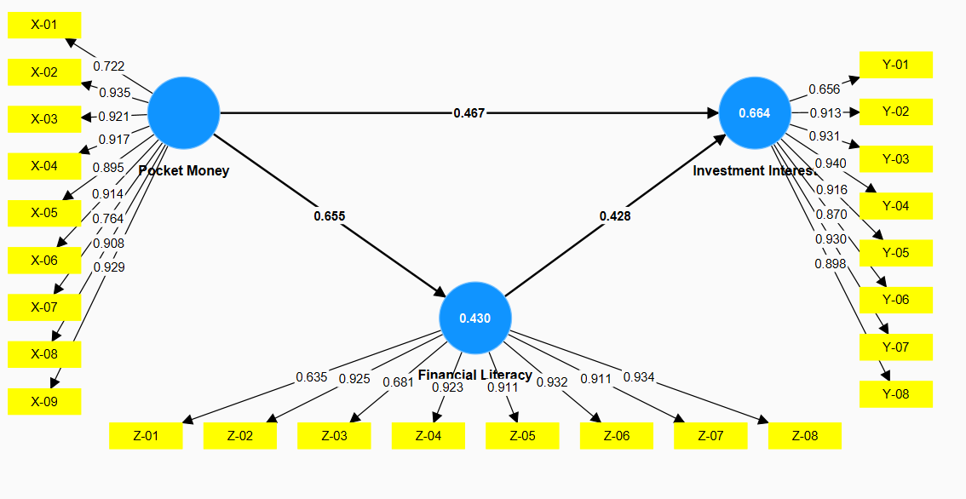
Figure 1. First Outer Loading Results
Source: Data Processing (SmartPLS 4.0, 2025)

Based on the first output of the outer model testing, the indicator items for the Financial Literacy variable (Z-01 and Z-03) and the Investment Interest variable (Y-01) have loading values lower than 0.70. A loading value of less than 0.70 indicates that the indicator is not relevant and not valid in measuring its construct (Hair et al., 2021). Therefore, the researcher conducted the next stage of testing by excluding these three indicators.
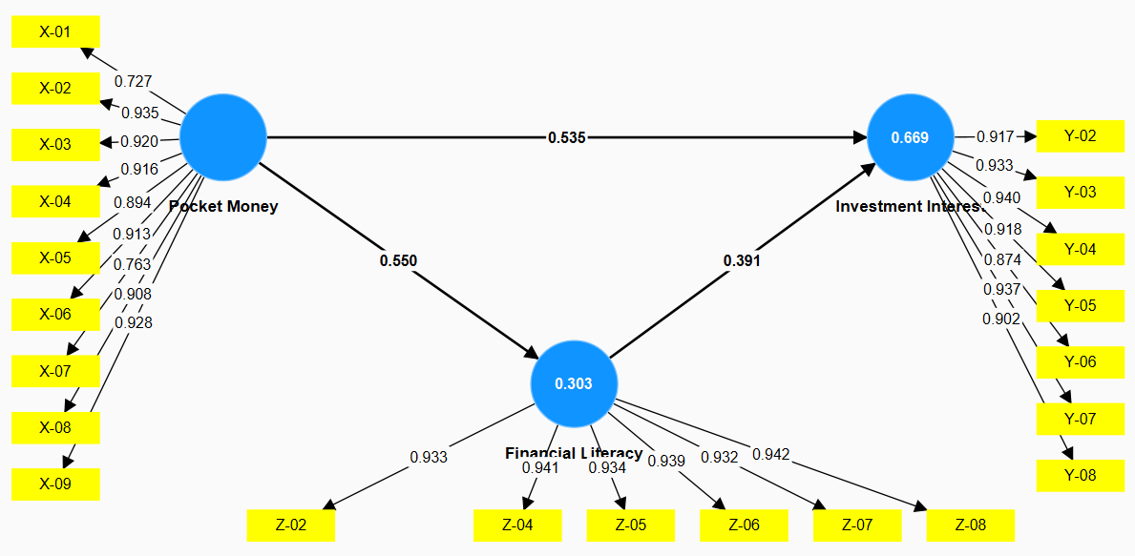
Figure 2. Second Outer Loading Results
Source: Data Processing (SmartPLS 4.0, 2025)

Figure 2 shows that all loading values are greater than 0.70 for every indicator. This indicates that each indicator is relevant and valid in measuring its respective construct (Hair et al., 2021).

- Average Variance Extracted (AVE).

Table 2. Average variance extracted (AVE)
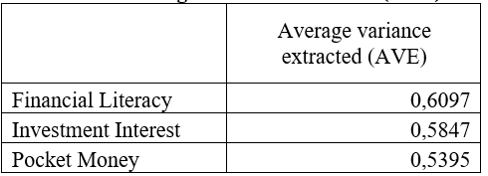
Source: Data Processing (SmartPLS 4.0, 2025)

Based on Table 2, all constructs have Average Variance Extracted (AVE) values above 0.50, namely 0.6097 for Financial Literacy, 0.5847 for Investment Interest, and 0.5395 for Allowance. This indicates that each construct meets the criteria for convergent validity as recommended by Hair et al. (2021).

- Fornell–Larcker Criterion
Table 3. Fornell–Larcker Criterion 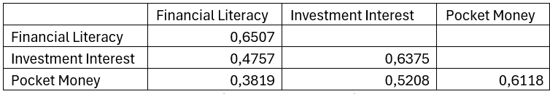
Source: Data Processing (SmartPLS 4.0, 2025)

Based on the results of the discriminant validity test using the Fornell–Larcker criterion in Table 3, the square root values of AVE (diagonal values) for each construct are greater than their correlations with other constructs. For instance, the square root of the AVE for Financial Literacy (0.6507) is higher than its correlations with Investment Interest (0.4757) and Pocket Money (0.3819). This indicates that each construct has a good ability to distinguish itself from other constructs, thereby meeting the discriminant validity criterion (Hair et al., 2021).

- Cross Loading

Tabel 4. Cross Loading
 | Financial Literacy | Investment Interest | Pocket Money
X-01 | 0,4125 | 0,6188 | 0,7049
X-02 | 0,3181 | 0,4375 | 0,6493
X-03 | 0,3326 | 0,4563 | 0,6389
X-04 | 0,3403 | 0,4382 | 0,6361
X-05 | 0,2771 | 0,4028 | 0,6208
X-06 | 0,3549 | 0,4306 | 0,6340
X-07 | 0,2361 | 0,3667 | 0,5299
X-08 | 0,3431 | 0,4313 | 0,6306
X-09 | 0,3403 | 0,4375 | 0,6444
Y-02 | 0,4500 | 0,6368 | 0,4938
Y-03 | 0,4292 | 0,6479 | 0,4701
Y-04 | 0,4465 | 0,6528 | 0,4910
Y-05 | 0,4222 | 0,6375 | 0,4660
Y-06 | 0,4479 | 0,6069 | 0,4632
Y-07 | 0,4451 | 0,6507 | 0,4917
Y-08 | 0,4132 | 0,6264 | 0,4667
Z-02 | 0,6479 | 0,4583 | 0,3604
Z-04 | 0,6535 | 0,4451 | 0,3542
Z-05 | 0,6486 | 0,4146 | 0,3319
Z-06 | 0,6521 | 0,4493 | 0,3806
Z-07 | 0,6472 | 0,4438 | 0,3333
Z-08 | 0,6542 | 0,4618 | 0,3833
Source: Data Processing (SmartPLS 4.0, 2025)

Based on the cross-loading test results presented in Table 4, each indicator shows the highest loading value on the construct it measures compared to other constructs. For instance, indicator X-01 has the highest loading on the Pocket Money construct with a value of 0.7049, indicator Y-03 has the highest loading on the Investment Interest construct with a value of 0.6479, and indicator Z-02 has the highest loading on the Financial Literacy construct with a value of 0.6479. This indicates that each indicator explains its respective construct better than other constructs, thereby confirming that the model meets the discriminant validity criteria through the cross-loading test (Hair et al., 2021).

- HTMT (Heterotrait-Monotrait Ratio).

Tabel 5. HTMT (Heterotrait-Monotrait Ratio).
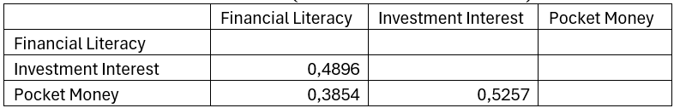Source: Data Processing (SmartPLS 4.0, 2025)

Based on Table 5, which presents the results of the HTMT (Heterotrait-Monotrait Ratio) analysis, all construct values—namely Financial Literacy, Investment Interest, and Pocket Money—are below the threshold value of 0.90, with respective values of 0.4896, 0.3854, and 0.5257. These results indicate that each construct in the model possesses good discriminant validity, meaning that the variables are sufficiently distinct from one another and do not exhibit significant multicollinearity issues (Hair et al., 2021).

- Construct Reliability
Tabel 6. Construct Reliability
 | Cronbach's alpha | Composite reliability (rho_a) | Composite reliability (rho_c)
Financial Literacy | 0,6750 | 0,6757 | 0,6785
Investment Interest | 0,6729 | 0,6729 | 0,6764
Pocket Money | 0,6688 | 0,6729 | 0,6729
Source: Data Processing (SmartPLS 4.0, 2025)

4.1.2. Inner Model
- Coefficient of Determination Test or Variance Analysis (R²)

Table 7. Results of Variance Analysis
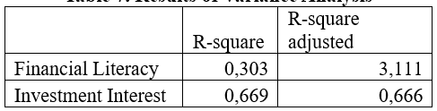
Source: Data Processing (SmartPLS 4.0, 2025)

The R-Square (R²) value indicates the proportion of variance in the dependent variable that can be explained by the independent variable(s) in the model.
- For Financial Literacy, the R² value of 0.303 means that 30.3% of the variance in financial literacy can be explained by Pocket Money, while the remaining 69.7% is explained by other factors outside the model.
- For Investment Interest, the R² value of 0.669 shows that 66.9% of the variance in students’ investment interest is explained jointly by Pocket Money and Financial Literacy.
The Adjusted R-Square accounts for sample size and the number of predictors, providing a more accurate representation of model performance.
The adjusted R² for Investment Interest (0.666) is very close to its R² (0.669), indicating that the model is stable and not overfitted.
Interpretation:
According to Hair et al. (2021), R² values above 0.67 are considered substantial, 0.33–0.67 moderate, and 0.19–0.33 weak. Therefore:
- The Financial Literacy model (0.303) indicates a weak-to-moderate level of explanatory power.
- The Investment Interest model (0.669) indicates a strong or substantial explanatory level, confirming that the model effectively captures key relationships among the variables.

- goodness of Fit (GoF)
Table 8. goodness of Fit (GoF)
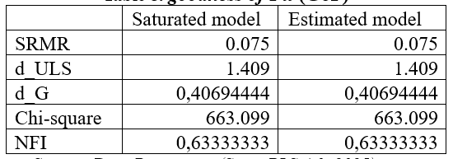
Source: Data Processing (SmartPLS 4.0, 2025)
Explanation:
- SRMR (Standardized Root Mean Square Residual).The SRMR value of 0.075 (< 0.08) indicates that the model fits the data well. A smaller SRMR value reflects a smaller difference between the observed and predicted correlations, meaning the model demonstrates good model fit.
- d_ULS (Unweighted Least Squares Discrepancy) and d_G (Geodesic Discrepancy). These indicators measure the difference between the observed covariance matrix and the model-implied covariance matrix. Lower values suggest a closer fit between the theoretical and empirical models. Here, both values (1.409 and 0.4069) demonstrate acceptable levels of fit. Chi-square (χ² = 663.099)
- The equal values for the saturated and estimated models (663.099) indicate a minimal discrepancy between the two models, suggesting that the model is stable and well-specified.
- NFI (Normed Fit Index = 0.6333)
According to Hair et al. (2021), an NFI value above 0.60 is considered acceptable in PLS-SEM. Hence, this value suggests that the model demonstrates a satisfactory level of overall fit.

4.1.3. Hypothesis Testing Using Bootstrapping (Hypotheses 1 and 2)

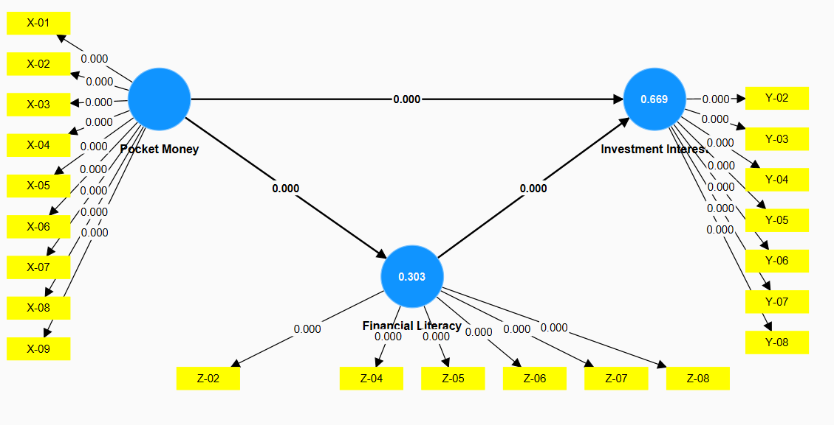
Figure 3. Bootstrapping Results
Source: Data Processing (SmartPLS 4.0, 2025)

Table 8. Results of Path Coefficients Test
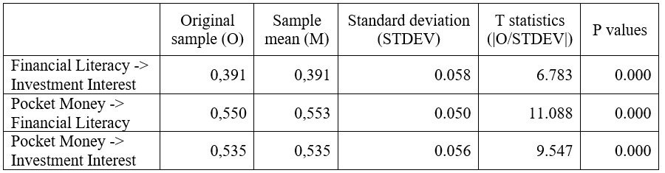
Source: Data Processing (SmartPLS 4.0, 2025)

Table 9. Results of Specific Indirect Effect Test
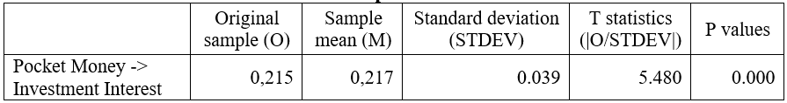
Source: Data Processing (SmartPLS 4.0, 2025)

Based on Tables 8 and 9, the following equations can be formulated:
- Direct Effect Model
$$Y=0.535X+ε$$
- Mediation Model (with Financial Literacy as Mediator)
$$Z=0.550X+ε_{1} \\ Y=0.391Z+0.535X+ε_{2}$$

Hypothesis 1: Pocket Money has an effect on Students’ Investment Interest. The Original Sample (O) value = 0.535, T-statistics = 9.547, and P-values = 0.000 (< 0.05). This result indicates that Hypothesis 1 is accepted, meaning that Pocket Money has a positive and significant effect on Students’ Investment Interest.
Hypothesis 2: Financial Literacy mediates the effect of Pocket Money on Students’ Investment Interest. Based on the Specific Indirect Effect table, the Original Sample (O) value = 0.215, T-statistics = 5.480, and P-values = 0.000 (< 0.05). This shows that the indirect effect of Pocket Money on Investment Interest through Financial Literacy is significant. Furthermore, the Path Coefficients results indicate that the direct effect of Pocket Money on Investment Interest remains significant (T = 9.547; P = 0.000). Therefore, Financial Literacy serves as a partial mediator, since both the direct and indirect effects are significant.

4.1.3. Multi-Group Analysis (Hypotheses 3 and 4)
Based on Tables 10 and 11, the results are as follows:
- Based on the results of the Multi-Group Analysis (MGA) in Table 10, it was found that there is a significant difference between male and female students in the effect of pocket money on investment interest. This is indicated by a difference value of 0.232 with a p-value (2-tailed) of 0.001 (< 0.05), meaning the difference is statistically significant. The path coefficient for male students is 0.707, while for female students it is 0.373. Thus, it can be concluded that the influence of pocket money on investment interest is stronger among male students compared to female students.
- Furthermore, based on Table 11, which presents the results of the Specific Indirect Effect test, there is a significant difference in the mediating effect of financial literacy between male and female students. The difference value is -0.224 with a p-value (2-tailed) of 0.003 (< 0.05), indicating a statistically significant difference. The mediation coefficient for female students (0.327) is higher than that for male students (0.103), suggesting that financial literacy plays a more substantial mediating role among female students in influencing the relationship between pocket money and investment interest.

Table 10. Results of Multi-Group Analysis — Path Coefficients
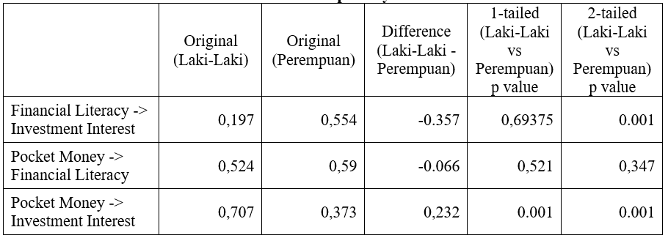
Source: Data Processing (SmartPLS 4.0, 2025)

Table 11. Results of Multi-Group Analysis — Specific Indirect Effect
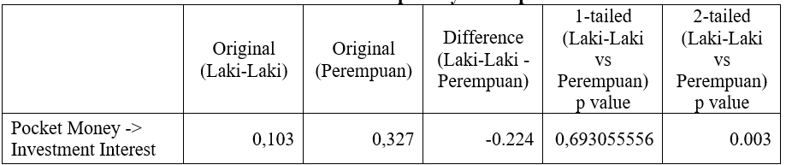
Source: Data Processing (SmartPLS 4.0, 2025)

4.2. Discussion
4.2.1. Pocket Money Influences Students’ Investment Interest
The results of the study indicate that pocket money has a positive and significant effect on students’ investment interest. The path coefficient of 0.535 with a p-value of 0.000 (< 0.05) shows that the greater the pocket money received by students, the higher their interest in investing. This finding aligns with previous studies by Gunawan and Siregar (2020) and Prasetyo et al. (2021), which explain that adequate pocket money provides students with the opportunity to manage their finances independently, including allocating a portion of their funds to investment activities. It demonstrates that pocket money serves not only as daily consumption funds but also as initial capital for students to become familiar with and participate in the capital market. Therefore, the availability of pocket money significantly encourages students’ investment interest.
From the perspective of Behavioral Theory, these findings reinforce the view that students’ investment decisions are influenced not only by economic rationality but also by psychological factors such as perceived financial sufficiency and self-efficacy in managing pocket money. Students who perceive having extra funds tend to exhibit higher confidence in financial decision-making. This phenomenon suggests that investment behavior among students is shaped by the interaction between economic capacity (amount of pocket money) and psychological factors that motivate the willingness to invest, even with limited resources (Istiadi, 2024; Lusardi, 2011).

4.2.2. Financial Literacy Mediates the Effect of Pocket Money on Investment Interest
The findings also confirm that financial literacy partially mediates the effect of pocket money on students’ investment interest. The indirect path coefficient of 0.215 with a p-value of 0.000 (< 0.05) indicates significant mediation. This means that pocket money, when managed through financial literacy skills, can strengthen students’ investment interest. Financial literacy enables students to understand risks, benefits, and investment strategies, thereby increasing their confidence and readiness to make financial decisions. These results support prior research by Lusardi and Mitchell (2014) and Klapper et al. (2013), which found that individuals with higher financial literacy are more capable of allocating available resources, including pocket money, for productive investment. Because the direct effect of pocket money on investment interest remains significant, this relationship is classified as partial mediation.
Within the Behavioral Theory framework, this mediating relationship illustrates how cognitive aspects—namely knowledge and understanding of finance—can mitigate behavioral biases commonly observed in individuals with limited funds. Financial literacy helps students avoid heuristic biases such as short-term bias and overconfidence, which often lead to investment decisions without adequate knowledge. With good financial literacy, students can think more rationally and control emotional impulses in managing pocket money, resulting in more directed and logical investment decisions (Ajzen, 1991; Istiadi, 2024).

4.2.3. Gender Differences in the Effect of Pocket Money on Investment Interest
Based on the Multi-Group Analysis (MGA), significant differences exist between male and female students in the effect of pocket money on investment interest. The difference value of 0.232 with a p-value of 0.001 indicates a statistically meaningful difference. The path coefficient for male students is 0.707, higher than for female students (0.373). This result shows that pocket money has a stronger influence on investment interest among male students.
This difference can be explained by gender-based financial behavior characteristics, where males generally have higher risk tolerance and are more active in investment decision-making than females (Croson & Gneezy, 2009; Maknickienė, 2022). From a Behavioral Theory perspective, the difference reflects distinct risk perceptions and emotional tendencies between genders. Males tend to have higher risk tolerance and are more impulsive in pursuing profit opportunities, while females are more cautious and consider financial security before making investment decisions. These psychological differences, as discussed in behavioral finance theory, are key determinants of gender-based differences in investment behavior (Istiadi, 2024; Lusardi, 2011).

4.2.4. Gender Differences in the Mediating Role of Financial Literacy
The final finding shows a significant difference between male and female students in the mediating effect of financial literacy on the relationship between pocket money and investment interest. The difference value of -0.224 with a p-value of 0.003 indicates a significant distinction, with the mediation effect being stronger for females (0.327) than males (0.103). This implies that financial literacy plays a more crucial mediating role for female students in bridging the effect of pocket money on investment interest. These results support studies by Sari and Hadi (2022) and Kalista (2024), which show that although females generally have lower financial literacy, increasing financial knowledge in this group can have a greater impact on investment interest. Therefore, financial literacy is more dominant as a mediator among female students, highlighting the importance of enhancing financial education for females to strengthen their investment motivation.
In the context of Behavioral Theory, this finding demonstrates that females with higher financial literacy can overcome psychological barriers such as loss aversion and underconfidence, which often affect their financial decisions. With increased financial literacy, females tend to make more rational and confident decisions when allocating pocket money for investment. This shows that behavioral factors, including confidence and risk perception, are important elements that strengthen the mediating effect of financial literacy for females (Ajzen, 1991; Istiadi, 2024).

Conclusion
Conclusion
- Pocket money is proven to have a positive and significant effect on students’ investment interest. The greater the amount of pocket money received, the higher the students’ tendency to start investing.
- Financial literacy partially mediates the relationship between pocket money and investment interest. This indicates that proper financial knowledge management strengthens the positive influence of pocket money on investment interest.
- There is a significant difference between male and female students in the effect of pocket money on investment interest. The effect is stronger among male students due to their higher tendency toward risk-taking.
- Financial literacy demonstrates different mediation effects across gender. The mediation is stronger among female students, indicating that improving financial literacy provides greater impact in encouraging their investment interest.

Implications
The findings of this study offer important implications for academia and practitioners, showing that gender differences play a significant role in shaping students’ investment interest—both through the direct influence of pocket money and through financial literacy as a mediator. This emphasizes that financial literacy programs cannot be designed with a “one-size-fits-all” approach, but must consider the specific needs, behavioral patterns, and confidence levels of male and female students. Academically, this study enriches the literature on gender-based behavioral finance and opens opportunities for developing more adaptive curricula and educational interventions, enabling a more effective and equitable increase in students’ investment interest.

Suggestions
Based on the research findings that reveal significant gender differences in the influence of pocket money and the mediating role of financial literacy, universities need to design financial literacy programs that are more gender-sensitive. Female students, who show a stronger reliance on financial literacy, require more intensive, practical, and continuous educational approaches to enhance their confidence and decision-making skills in investing. Meanwhile, male students should receive financial education that emphasizes risk management to prevent excessive risk-taking in investment decisions. Future studies are encouraged to expand the research population and further explore gender-based financial behavior to provide more comprehensive recommendations.

References
Ajzen, I. (1991). The theory of planned behavior. Organizational Behavior and Human Decision Processes, 50(2), 179–211. https://doi.org/10.1016/0749-5978(91)90020-T
Atkinson, A., & Messy, F. (2012). Measuring financial literacy: Results of the OECD / International Network on Financial Education (INFE) pilot study. OECD Working Papers on Finance, Insurance and Private Pensions.
Croson, R., & Gneezy, U. (2009). Gender differences in preferences. Journal of Economic Literature, 47(2), 448–474.
Ghozali, I. (2021). Partial Least Squares: Konsep, Teknik, dan Aplikasi Menggunakan Program SmartPLS 3.0 untuk Penelitian Empiris. Semarang: Badan Penerbit Universitas Diponegoro.
Gunawan, R. R., & Siregar, T. (2020). Pengaruh uang saku terhadap perilaku investasi mahasiswa. Jurnal Ekonomi dan Studi Pembangunan, 21(1), 45–58.
Hair, J. F., Hult, G. T. M., Ringle, C. M., & Sarstedt, M. (2021). A Primer on Partial Least Squares Structural Equation Modeling (PLS-SEM) (3rd ed.). Thousand Oaks, CA: SAGE Publications.
InvestGlass. (2025). Investment behavior trends in digital finance. https://www.investglass.com
Istiadi, E. (2024). Behavioral finance and student investment decision-making. Jurnal Keuangan dan Perilaku Ekonomi, 13(1), 55–68.
Kalista, N. D. (2024). Gender perspective in financial behavior: Case study on young investors. Jurnal Akuntansi dan Keuangan, 12(1), 14–29.
Klapper, L., Lusardi, A., & Van Oudheusden, P. (2013). Financial literacy around the world: Insights from the Standard & Poor's Ratings Services Global Financial Literacy Survey. World Bank.
Luky, R. (2024). Application of the Theory of Planned Behavior in student investment decisions. Jurnal Manajemen dan Bisnis, 11(2), 112–125.
Lusardi, A. (2011). Americans’ financial capability. Journal of Pension Economics & Finance, 10(4), 509–525.
Lusardi, A., & Mitchell, O. S. (2011). Financial literacy and retirement planning in the United States. Journal of Pension Economics & Finance, 10(4), 509–525.
Lusardi, A., & Mitchell, O. S. (2014). The economic importance of financial literacy: Theory and evidence. Journal of Economic Literature, 52(1), 5–44.
Maknickienė, N. (2022). Influence of gender on investment behavior: Literature review. Journal of Behavioral Finance, 23(2), 178–190.
OECD. (2020). OECD/INFE International Survey of Adult Financial Literacy Competencies.
Prasetyo, A. R., et al. (2021). Hubungan uang saku dengan minat investasi mahasiswa. Jurnal Manajemen Keuangan, 9(2), 78–89.
Sari, D. P., & Hadi, S. (2022). Literasi keuangan dan pengaruhnya terhadap minat investasi mahasiswa dari perspektif gender. Jurnal Ilmu Ekonomi, 10(3), 102–114.
Sugiyono. (2017). Metode Penelitian Kuantitatif, Kualitatif, dan R&D. Bandung: Alfabeta.
van Rooij, M., Lusardi, A., & Alessie, R. (2011). Financial literacy and stock market participation. Journal of Financial Economics, 101(2), 449–472. https://doi.org/10.1016/j.jfineco.2011.03.006
Wijaya, S. F., et al. (2019). The role of pocket money in investment interest among youths. Indonesian Journal of Economics and Finance, 5(1), 50–62.

