Transformation of Scientific Reference Management: Mendeley Socialization for Magister Management Students at Tridinanti University

Dewi Rawani¹, Imam Akbar^{2*}, Djatmiko Noviantoro³, Sasiska Rani⁴, Aida Rakhmawati⁵, Tri Woro Setiati⁶

Department Mechanical Engineering, Faculty of Engineering, Universitas Tridinanti, Palembang 30129, South Sumatra.

Department Accounting Economics, Faculty of Economics And Business, Universitas Tridinanti, Palembang 30129, South Sumatra.

Department of Architecture, Faculty of Engineering, Universitas Tridinanti, Palembang 30129, South Sumatra.

Abstrak
The ability to manage scientific references systematically is one of the important skills for postgraduate students to support the preparation of quality scientific work. The socialization program for using Mendeley software is designed to improve the understanding and skills of Magister Management students at Tridinanti University in reference management. This activity involved 30 participants and was carried out through a structured approach, including theory sessions, direct practice and mentoring. The program results showed a significant increase in participants' understanding, from an average score of 2.1 to 4.1 (scale 1-5), as well as the success of 93% of participants in completing the final assignment correctly. Participants are able to utilize Mendeley's main features, such as library grouping, automatic citation, and compiling a bibliography in a predetermined format. Despite technical obstacles, such as unstable internet connections and incomplete reference metadata, the program was well received by participants, with 88% recommending this training for ongoing implementation. This training has proven effective in supporting students academic tasks and building a technology-based academic culture at Tridinanti University. For sustainability, integration of training into the regular curriculum and provision of follow-up sessions are proposed as strategic steps. This program is expected to improve the academic quality of students while supporting Tridinanti University's competitiveness at national and international levels.
Keywords: Socialization, Mendeley, Tridinanti University, Reference Management

PENDAHULUAN
Advances in information technology have brought major changes in various fields, including the academic world. In higher education, mastery of software-based technology is an important key to increasing the efficiency [1] and quality of scientific work [2]. Masters students, especially in the field of management at Tridinanti University, are required to produce high-quality scientific work which requires systematic and precise reference management. In compiling a thesis or scientific article, they often face challenges in finding, organizing and including references from various sources, such as international journals, books and research reports. Without adequate software support, managing references manually is not only time consuming [3], but also risks causing errors [4], such as inconsistent citations or missing important documents [5]. The presence of Mendeley, as digital-based reference management software, is a relevant and effective solution to meet students' academic needs more efficiently and accurately [6].
Mendeley is designed to help users manage [7], cite [8], and store references efficiently. With features such as library grouping, automatic synchronization, and direct integration with word processing software, Mendeley allows students to organize citations in appropriate formats, such as APA, Harvard, or Chicago. This convenience is very important in maintaining consistency and accuracy of references in scientific writing. In addition, Mendeley also supports document search and organization, so students can easily find relevant articles and note down important points. In the context of the Magister Management study program at Tridinanti University, mastering Mendeley not only helps students complete academic assignments better, but also equips them with skills that comply with international academic standards.
Tridinanti University has the responsibility to support students in mastering technology which can improve their academic quality. Through socializing the use of Mendeley, students are not only taught how to technically use the software, but also how to integrate it into their research process. As management students, they often need multiple references to compile relevant literature reviews, support research arguments, or develop hypotheses. With Mendeley, students can group references by theme, highlight important documents, and add notes to support their analysis. This feature not only increases academic productivity but also makes collaboration with supervisors or research teams easier, because digital libraries can be shared and managed jointly. Apart from technical benefits, mastering Mendeley is also relevant in building a more professional academic culture. In the field of management, systematic reference management reflects students' seriousness and commitment to quality research. By using Mendeley, students can ensure that all sources they use are properly recorded, thereby avoiding the risk of plagiarism which can damage academic reputation. Furthermore, the ability to use this software is also an added value in the world of work, where skills in managing data and digital-based information are highly valued. Students who are familiar with Mendeley will be better prepared to face professional challenges, both in academic and non-academic fields.
However, adopting Mendeley requires socialization efforts that are structured and relevant to student needs. Practice-based approaches, such as reference management simulations for final projects or scientific articles, can provide deeper understanding. Students need to be guided not only on how to use Mendeley's features, but also how this software can help them construct stronger arguments in their written work. With this approach, Tridinanti University not only helps students to be more efficient in their academic tasks, but also improves the quality of the research produced.
The use of Mendeley also supports Tridinanti University's vision to increase academic competitiveness at national and international levels. With the ability to compose more structured and professional scientific work, students can more easily publish their articles in reputable journals. This not only increases the number of scientific publications from the university but also strengthens Tridinanti University's academic image as an institution oriented towards quality and innovation. Through consistent training and socialization, Tridinanti University Magister Management students can become a generation of academics who are competent, professional, and able to compete in the global world.
METHOD
The socialization method for using Mendeley software for Magister Management students at Tridinanti University was designed in a structured manner with a participatory and results-oriented approach [9]. This process includes mutually continuous stages to ensure that the training objectives are achieved and students are able to integrate reference management skills into their academic activities. The stages are illustrated in Figure 2.1.

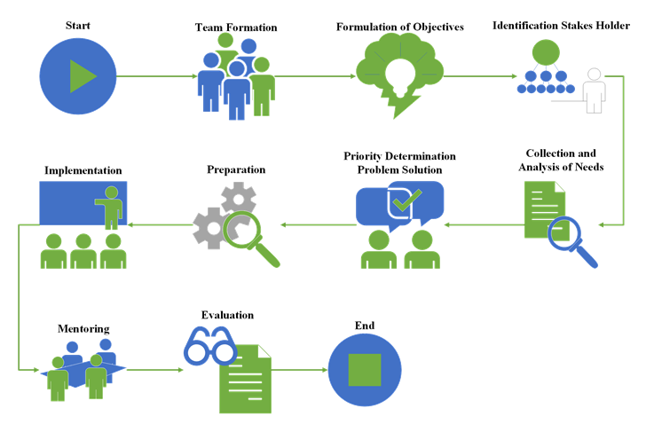
Figure 2.1 Workflow of activities
Formation of the Implementation Team
An implementation team was formed to ensure that each stage of program implementation runs well This team consists of:
- Dr. Djatmiko Noviantoro, SE., M.Si. As Program Coordinator: Responsible for designing the program framework, ensuring implementation goes according to plan, and coordinating all activities..
- Dr. Dewi Rawani, S.Pd., M.Pd. As Main Facilitator: Information technology and Mendeley software expert who is responsible for providing technical training to students.
- Imam Akbar, ST., MT. As Support Personnel: Responsible for preparing facilities and infrastructure, such as training rooms, computer equipment and internet connections..
- Tri Woro Setiati, ST. MT, Aida Rakhmawati, S.ST, MA dan Sasiska Rani, SE. M. Si. As the Evaluation and Monitoring Team: Designing evaluation questionnaires to measure the effectiveness of the training. Monitor participants' progress during training, including in the application of the skills taught. Collecting feedback from participants for future program improvements.
This team works together to design relevant training modules, select appropriate learning approaches, and ensure the availability of supporting resources to support program success.

Formulation of Objectives
At this stage, the objectives of the socialization program are formulated specifically so that the implementation of the program has a clear focus. The main objectives of this program include:
Increase students' understanding of the importance of managing scientific references in preparing academic work.
- Equip students with technical skills in using Mendeley software to compile automatic citations and organize libraries.
- Encourage students to produce scientific work that is more systematic, precise and in accordance with international standards.
- Support the creation of a technology-based academic culture within Tridinanti University.
Identification Stakeholders
This stage aims to identify parties involved or contributing to the implementation of the socialization program. Identified stakeholders include:
- Magister Management Students: As the main beneficiaries of this program, the focus is on developing their technical competence in reference management.
- Supervisor: Ensure that training is relevant to students' academic needs in the context of preparing final assignments or research.
- Study Program Manager: Supports program sustainability by integrating it into the master's program curriculum.
Collection and Analysis of Needs
To ensure that the training is in line with students' needs, an initial survey was conducted to identify the level of technological literacy and challenges faced in reference management. Data was collected through questionnaires, interviews and group discussions. The analysis results show several important points:
- Most students are not familiar with reference management software such as Mendeley.
- Students face difficulty in composing citations that are consistent with standard formats such as APA, Harvard, or Chicago.
- Manual reference management often takes a long time and increases the risk of errors.
Based on the results of this analysis, the training module was designed to focus on mastering basic Mendeley features, such as reference searching, library grouping, synchronization between devices, and automatic citation generation.
Priority Determination Problem Solution
After student needs have been mapped, the next stage is to determine solution priorities. In this case, training is focused on:
- Basic introduction to Mendeley software.
- Direct practice in compiling citations and bibliography.
- Library management simulation based on a research theme or chapter in a thesis.
- Case studies to strengthen students' understanding of Mendeley integration in preparing academic assignments
Preparation
The preparatory stage includes:
- Training Materials: Preparation of training modules that include steps for using Mendeley, case studies, and troubleshooting guides.
- Facilities and Infrastructure: Provision of training rooms equipped with computers, internet connections and multimedia devices.
- Technical Team: Support personnel who ensure the software is installed and functioning properly on all computers.
Implementation
The socialization was carried out through three main sessions:
- Theory Session: Explanation of the importance of reference management and the benefits of Mendeley.
- Practical Session: Live simulation of library management, including reference searching, document grouping, and automatic citation creation.
- Discussion Session: Questions and answers and problem solving to help students overcome technical difficulties during training.
Mentoring
After training, students are provided with assistance to ensure they can apply the skills they have learned. Mentoring is carried out offline, including, individual consultations regarding the use of Mendeley features and small group guidance sessions to help students integrate references into their scientific work.
Evaluation
Program evaluation is carried out through:
- Feedback Questionnaire: Measures the level of student understanding and satisfaction with the training which can be seen in Table 2.1
- Final Training Assignment: Students are asked to prepare an academic document using Mendeley which can be seen in Table 2.2.
- Direct Observation: Assess implementation of taught skills in real academic assignments.
Table 2.1 Questionnaires
Mendeley Software Usage Socialization Program

We ask that you be willing to fill out the following questionnaire as part of the training program evaluation. Your answers are very valuable for improving the quality of the program in the future. Thank you for your participation!

A. General Information
- Name: ____________________________________________
- Study Program: _____________________________________
- Gender:
  - Male
  - Female
- Have you ever used Mendeley software before??
  - Yes
  - No

B. Training Assessment
Use the following scale to answer the questions:
1: Strongly Disagree
2: Disagree
3: Neutral
4: Agree
5: Strongly Agree
- The training material presented is relevant to my academic needs.
  - 1 [ ] 2 [ ] 3 [ ] 4 [ ] 5 [ ]
- The facilitator is able to convey material clearly and easily understood.
  - 1 [ ] 2 [ ] 3 [ ] 4 [ ] 5 [ ]
- The time allocated for training is sufficient to understand the material.
  - 1 [ ] 2 [ ] 3 [ ] 4 [ ] 5 [ ]
- I feel more confident using Mendeley after attending the training.
  - 1 [ ] 2 [ ] 3 [ ] 4 [ ] 5 [ ]
- This training helped me understand the systematic management of scientific references.
  - 1 [ ] 2 [ ] 3 [ ] 4 [ ] 5 [ ]
- The facilities provided (room, computer, internet connection) support the implementation of training.
  - 1 [ ] 2 [ ] 3 [ ] 4 [ ] 5 [ ]
- I can understand Mendeley's main features, such as library grouping, automatic citation, and device synchronization.
  - 1 [ ] 2 [ ] 3 [ ] 4 [ ] 5 [ ]
- I feel this training is very useful for my academic assignments, such as preparing a thesis or scientific articles.
  - 1 [ ] 2 [ ] 3 [ ] 4 [ ] 5 [ ]

C. Open Questions
- Name the most useful thing you got from this training!

- Is there any part of the training that you think needs improvement? If yes, please specify.

- What are your suggestions for implementing the next Mendeley training?

D. Recommendations
- Would you recommend this training to other fellow students?
  - Ya
  - Tidak
- If you answered "Yes", state your main reason. If the answer is "No", what needs to be improved?

Thank you for taking the time to fill out this questionnaire! Your responses will help us improve the program in the future.

Table 2.2 Final Assignment Training on Using Mendeley
Mendeley Socialization Program for Tridinanti University, Magister Management Students

Instructions:
- Use Mendeley software to manage the references you will use in this assignment.
- Write a short academic document on the topic: "The Role of Digital Technology in Modern Business Management".
- Make sure you import references from international journals (at least 5 references), group libraries according to categories, and use the automatic citation feature from Mendeley.
- The document must consist of 500-700 words and use the APA citation format.
- Submit the results of your assignment in Microsoft Word or PDF format, complete with a bibliography produced by Mendeley.

Assignment Format:
- Title: The Role of Digital Technology in Modern Business Management
- Introduction: (100-150 words) Provide background on the development of digital technology in business management. Explain why this topic is relevant in academic and practical contexts.
- Discussion: (300-400 words)
  - Explain how digital technologies (such as software, big data, and AI) have changed the way businesses are managed.
  - Discuss the positive impacts, such as operational efficiency, data-driven decision making, and product innovation.
  - Use at least 3 scientific references from journals that you import into Mendeley. Include automatic citations in this section.
- Conclusion: (100-150 words)
Summarize the main points of your discussion and provide a future outlook on the role of digital technology in business management.
- Bibliography: Use Mendeley's "Generate Bibliography" feature to create an automatic bibliography. Make sure the format used is APA Style.

Assignment Assessment:
Your assignment will be assessed based on the following criteria:
- Reference Management:
  - Are the references imported correctly into the Mendeley library?
  - Are library categories used to organize documents?
- Citation Accuracy:
  - Are Mendeley's automatic citations used correctly in the document?
  - Does the citation format conform to APA style?
- Content Appropriateness:
  - Is the content of the document relevant to the given topic?
  - Is the argument supported by scientific references?
- Bibliography:
  - Is the bibliography compiled using Mendeley features?
  - Is the bibliography format consistent and in APA style?

Submission:
- Send your assignment via email to dewi_rawani@univ-tridinanti.ac.id.
- Deadline for submission: 4 Days After Socialization
- File name: Participant Name_Final AssignmentMendeley Training.docx

Finished
The program ends with the preparation of an implementation report which includes evaluation results, documentation and recommendations for the next program. This documentation is also used to publish the results of socialization in community service.

HASIL DAN PEMBAHASAN
The socialization program for using Mendeley software for Magister Management students at Tridinanti University, which has been documented in Figure 3.1, has provided significant results, both in terms of understanding, technical skills, and relevance to the participants' academic needs. The following is a combination of results and discussion based on the questionnaire data and final assignment that have been obtained. The training was attended by 30 students, consisting of 12 men and 18 women who can be seen in Figure 3.1. Before the training, only 20% of participants (6 people) had heard of or used Mendeley software, while 80% of participants (24 people) were not at all familiar with this application. Participants responded positively to the relevance of this training to their academic needs. As many as 88% of participants recommended this training to be continued and implemented on an ongoing basis. Positive comments such as, "This training really helped me understand reference management, especially for my thesis," indicate that participants realized the real benefits of using Mendeley in supporting their academic assignments.

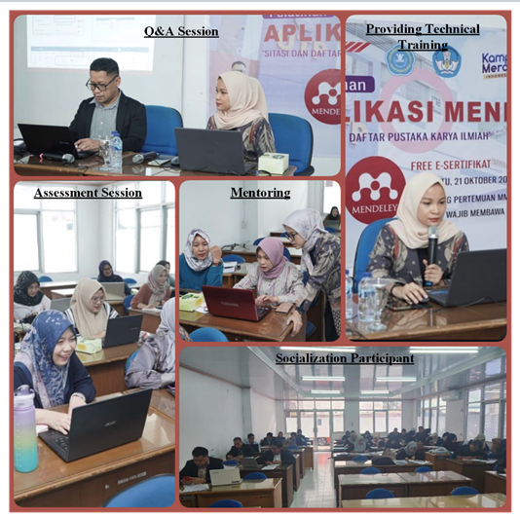
Figure 3.1 Activity Documentation
In Figure 3.2 Before the training, the average participant's understanding of digital reference management only reached an average score of 2.1 on a scale of 1-5, which indicates a low level of digital literacy. After training, this average score increased to 4.1 on a scale of 1-5, reflecting a significant increase in participants' understanding of the concept and the importance of systematically managing scientific references. Theory-based training methods and hands-on practice have proven effective in helping participants understand Mendeley's main functions, such as library grouping, reference synchronization, and automatic citation creation. This increased understanding is also supported by a simulation-based learning approach, where participants practice direct reference management using case studies. This method is consistent with research showing that practice-based learning significantly increases skill retention and application [10].

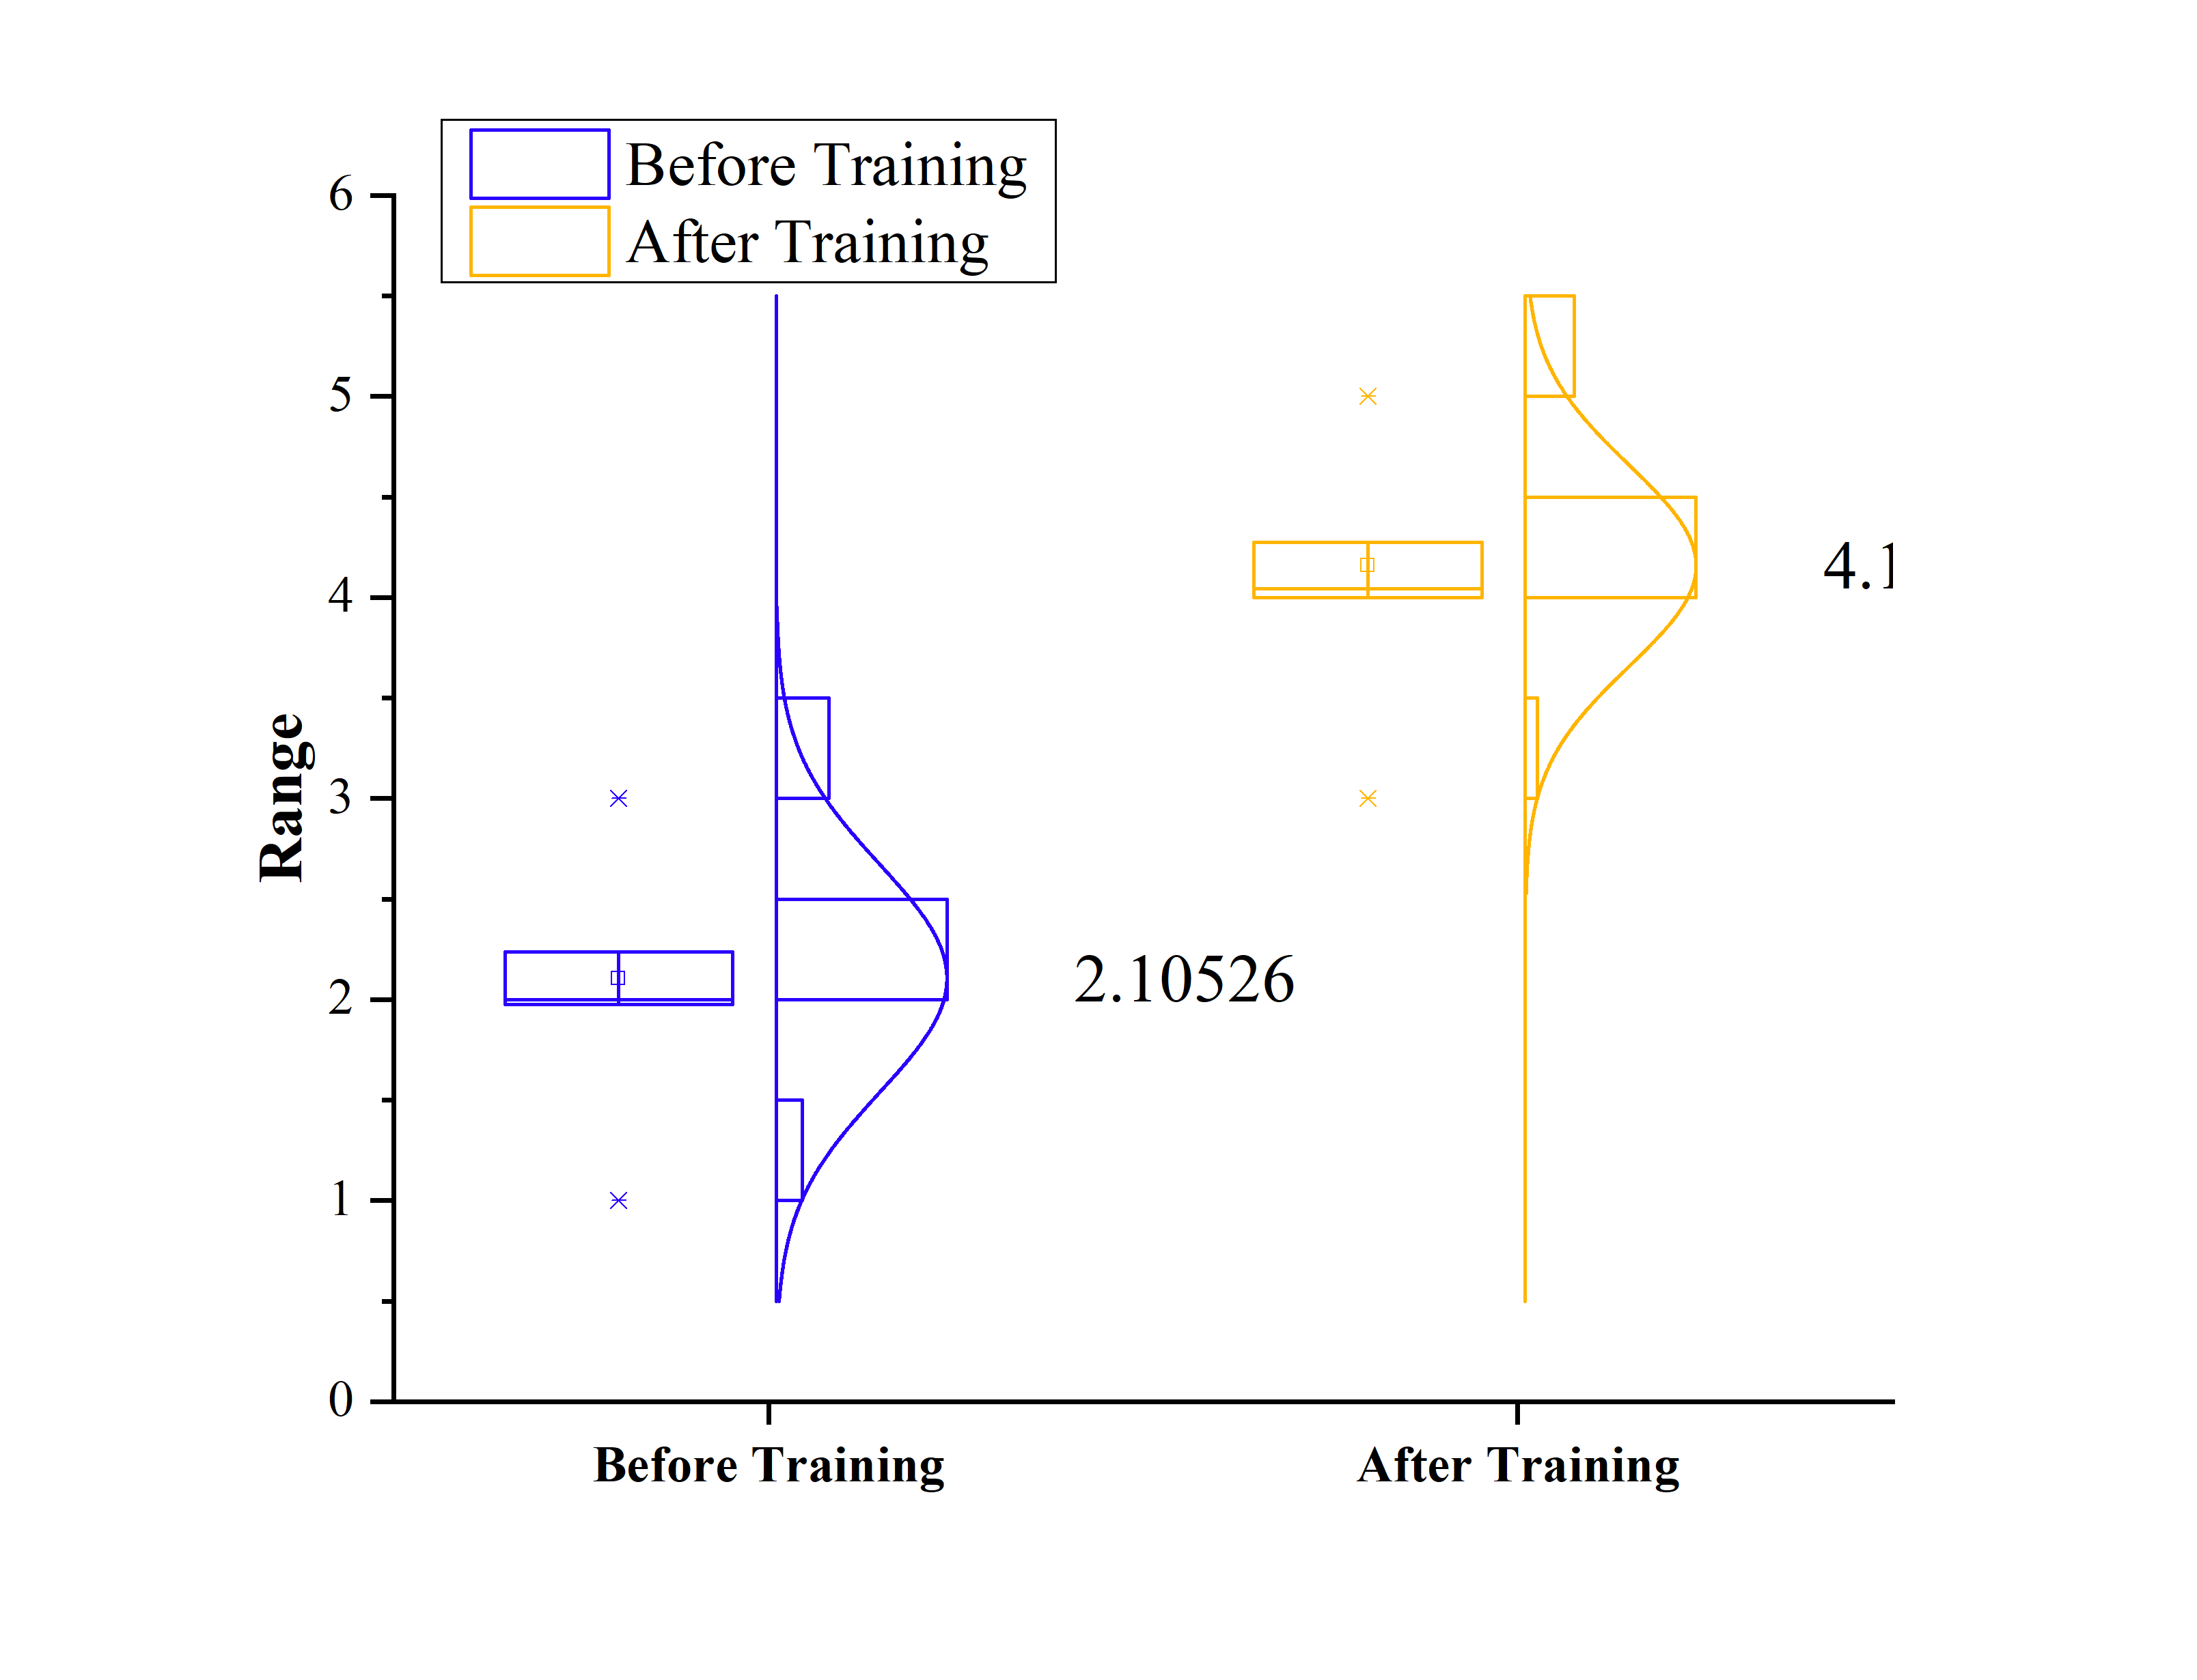
Figure 3.2 Participants Understanding In Managing Digital References

Hasil tugas akhir pada Gambar 3.2 show that 93% of participants (28 out of 30 students) succeeded in compiling academic documents with correct citations and bibliography using Mendeley. Specifically:
- 88% of participants were able to generate an automatic bibliography with consistent APA format.
- 70% of participants succeeded in grouping literature into thematic categories according to their research needs.
- 30% of participants needed additional guidance to understand library grouping features and editing incomplete reference metadata.
This increase in technical skills shows that participants not only understand Mendeley features but are also able to apply them effectively in an academic context. However, technical obstacles such as metadata errors and unstable internet connections are challenges that need to be considered for future training.

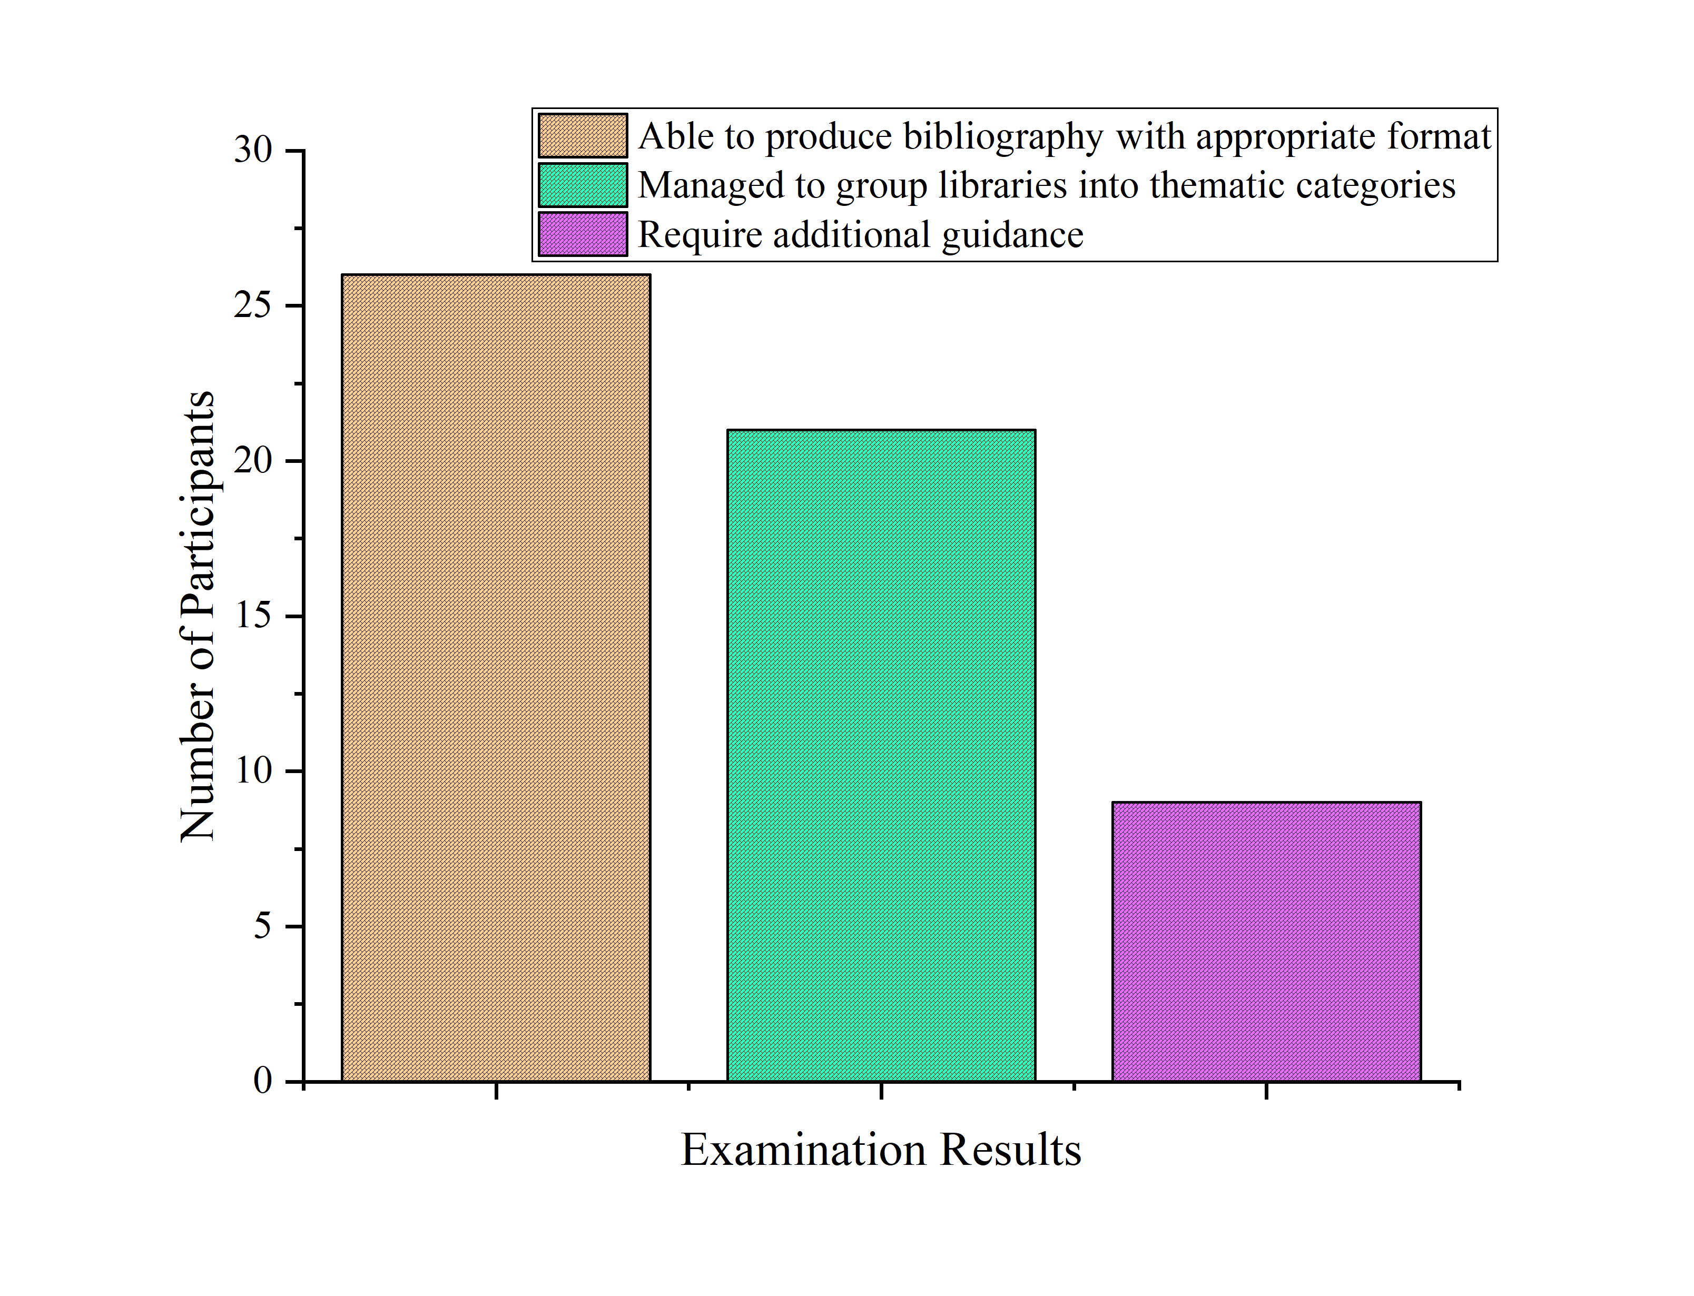
Figure 3.3 Evaluation of Final Assignment

Even though this training went well, several technical problems were encountered where some participants experienced difficulty in the library synchronization process due to unstable internet connections and some journals imported into the Mendeley library had incomplete metadata, so participants had to edit the data manually. This technical problem shows the need for more comprehensive troubleshooting guidance during training as well as providing more adequate technical facilities, such as a stable internet connection.
The survey results showed that 85% of participants felt that this training was very relevant to their academic needs, especially in preparing theses and scientific articles. By using Mendeley, participants can manage references more efficiently, save time, and minimize errors in compiling citations and bibliography. This also prepares students to publish their work in reputable journals, where citation consistency is a key requirement. Furthermore, this training helps build a technology-based academic culture at Tridinanti University, where students are trained to adopt digital devices to support their academic tasks. The high level of satisfaction and recommendations from participants shows that this training meets their needs directly and is relevant. Based on the results obtained, several recommendations for future program development are:
- Curriculum Integration: This training should be integrated into the regular curriculum of the master's program, especially in research methodology courses.
- Advanced Sessions: Provides additional training that focuses on advanced Mendeley features, such as library collaboration between researchers and integration with data analysis software.
- Independent Tutorial: Create video tutorials and digital guides that students can access to support independent learning.
- Technical Infrastructure Improvements: Provides a more stable internet connection and supports participants in editing incomplete reference metadata.
The success of this program shows that the use of software such as Mendeley can have a significant impact on increasing student competence in managing scientific references. In addition to supporting students' academic tasks, this training also prepares them to face the challenges of the world of work, where technology-based data management is a highly valued skill. It is hoped that this program can become part of Tridinanti University's ongoing strategy in improving student academic quality and institutional competitiveness at national and international levels.

KESIMPULAN
The socialization program on the use of Mendeley software for Magister Management students at Tridinanti University succeeded in significantly increasing their understanding and skills in managing scientific references. The increase in understanding scores from 2.1 to 4.1 (scale 1-5) and the success of 93% of participants in completing their final assignments demonstrate the effectiveness of the structured training approach. This program is relevant to students' academic needs, especially in preparing theses and scientific articles, and contributes to the efficiency of their academic work. Technical constraints such as unstable internet connections and incomplete reference metadata are challenges that need to be fixed. For sustainability, it is recommended that this training be integrated into the regular curriculum, equipped with follow-up sessions, and supported by independent guidance. This program not only helps students produce high-quality academic work, but also builds a technology-based academic culture at Tridinanti University.

DAFTAR PUSTAKA
[1] Zheng J. Research on software development and test environment automation based on association rules. Proc. 2021 IEEE Int. Conf. Emerg. Sci. Inf. Technol. ICESIT 2021, 2021. https://doi.org/10.1109/ICESIT53460.2021.9696910.
[2] Heaton D, Carver JC. Claims about the use of software engineering practices in science: A systematic literature review. Inf. Softw. Technol., 2015. https://doi.org/10.1016/j.infsof.2015.07.011.
[3] Cuschieri S, Grech V, Calleja N. WASP (Write a Scientific Paper): The use of bibliographic management software. Early Hum Dev 2019. https://doi.org/10.1016/j.earlhumdev.2018.09.012.
[4] Saxena R, Kaushik JS. Referencing Made Easy: Reference Management Softwares. Indian Pediatr 2022. https://doi.org/10.1007/s13312-022-2478-5.
[5] Sarrafzadeh M, Khaleghi N. Instruction of citation management tools by academic librarians: The need for training the trainers. Webology 2017.
[6] MacMillan D. Mendeley: Teaching scholarly communication and collaboration through social networking. Libr Manag 2012. https://doi.org/10.1108/01435121211279902.
[7] Zhang Y. Comparison of Select Reference Management Tools. Med Ref Serv Q 2012. https://doi.org/10.1080/02763869.2012.641841.
[8] Orhan Sungur M, Ozkan Seyhan T. Writing references and using citation management software. Türk Üroloji Dergisi/Turkish J Urol 2014. https://doi.org/10.5152/tud.2013.050.
[9] Aziz AMA, Al Faritzie H, Akbar I, Aziz I, Rawani D. Rancang Bangun Dan Sosialisasi Mesin Cetak 3D Tipe Fused Deposition Modeling (Fdm) Di Smk Satria Nusantara Betung. Minda Baharu 2023;7:287–301. https://doi.org/10.33373/jmb.v7i2.5804.
[10] Imam Akbar, Dewi Rawani, Akbar Teguh Prakoso, Tolu Tamalika, Ahmad Malik Abdul Aziz, Yules Pramona Zulkarnain. Digitalisasi Desain Teknik: Sosialisasi dan Pelatihan Autodesk Inventor di SMK Satria Nusantara (SN). Bersama J Pengabdi Masy 2024;2:07–20. https://doi.org/10.61994/bersama.v2i1.606.

