THE EFFECT OF USING MIND MAPPING ON THE WRITING ABILITY OF THE TENTH-GRADE STUDENTS AT SMA NEGERI 14 PALEMBANG

ABSTRACT: This study investigated the effect of using mind mapping on the writing ability of tenth grade students as SMA Negeri 14 Palembang. The study used a quantitative method comparing a group taught by using mind mapping (the experimental group, 34 students) and a group taught in the usual way (the control group, with 34 students) before and after the treatment. The students’ writing ability was measured with writing test before and after the treatment. Because the test results were not normally distributed, non-parametric statistical tests were used to analyze the data. The Wilcoxon Signed-Rank Test showed that the writing ability of the experimental group significantly improved after using mind mapping. Furthermore, the Mann-Whitney U Test showed a significant difference in the writing test scores after the treatment between the experimental and control groups, with the experimental group scoring better. The findings of this research indicated that using mind mapping greatly helped to improve the tenth grade students’ writing ability in recount text. This study suggests that the teachers could use mind mapping as a way to enhance students’ writing skills.
Keywords: Mind mapping, writing ability, Recount text, Experimental research

PENGARUH PENGGUNAAN MIND MAPPING TERHADAP KEMAMPUAN MENULIS SISWA KELAS X DI SMA NEGERI 14 PALEMBANG

ABSTRAK: Penelitian ini mengkaji pengaruh penggunaan mind mapping terhadap kemampuan menulis siswa kelas X di SMA Negeri 14 Palembang. Penelitian menggunakan metode kuantitatif dengan membandingkan satu kelompok yang diajarkan dengan menggunakan mind mapping (kelompok eksperimen, 34 siswa) dan satu kelompok yang diajarkan dengan cara konvensional (kelompok kontrol, 34 siswa) sebelum dan sesudah perlakuan. Kemampuan menulis siswa diukur melalui tes menulis sebelum dan sesudah perlakuan. Karena hasil tes tidak berdistribusi normal, analisis data dilakukan dengan uji statistik non-parametrik. Uji Wilcoxon Signed-Rank menunjukkan bahwa kemampuan menulis kelompok eksperimen meningkat secara signifikan setelah menggunakan mind mapping. Selanjutnya, uji Mann-Whitney U menunjukkan adanya perbedaan yang signifikan pada skor tes menulis antara kelompok eksperimen dan kelompok kontrol setelah perlakuan, dengan kelompok eksperimen memperoleh skor yang lebih baik. Temuan penelitian ini menunjukkan bahwa penggunaan mind mapping sangat membantu dalam meningkatkan kemampuan menulis teks recount pada siswa kelas X. Penelitian ini menyarankan agar guru dapat menggunakan mind mapping sebagai salah satu cara untuk meningkatkan keterampilan menulis siswa.

Kata Kunci: Peta Pikiran, Kemampuan Menulis, Teks Recount, Penelitian Eksperimen
INTRODUCTION
E

nglish is a crucial subject in Indonesia’s educational system as it serves as a gateway for students to access global knowledge, communicate across borders, and improve their academic and professional prospects. As a foreign language, English is introduced in the national curriculum from elementary to senior high school levels, where writing becomes an essential yet complex skill for students to master. Writing requires students to generate ideas, structure information coherently, and apply correct language conventions. It is not only a curricular objective but also a medium for cognitive and communicative development (Perumal & Ajit, 2020; Klimova, 2015).
Despite its importance, writing remains one of the most challenging aspects of English learning for Indonesian students. Many senior high school students struggle with initiating and organizing their ideas, applying grammar accurately, and maintaining cohesion in their writing. These difficulties often lead to anxiety and low motivation (Prayogo, 2009, as cited in Fujiono, 2016; Rista, 2021). Consequently, teachers must adopt innovative teaching strategies that can help students overcome these barriers and actively engage in the writing process.
………………….
One strategy that has shown promising results in writing instruction is the use of mind mapping. Mind mapping is a visual technique that enables students to brainstorm ideas, establish connections, and structure content in a non-linear format (Suyanto, 2015). It mirrors the brain’s natural way of processing information, making it easier for students to visualize their thoughts and develop logical flow in writing. According to Stokhof (2020), mind mapping facilitates question generation by visualizing prior knowledge, while Parikh (2016) asserts that it fosters both logical and imaginative thinking. Buran (2015) further highlights that mind mapping supports meaningful learning in language classrooms by reducing cognitive overload.
Although previous studies have explored the use of mind mapping in improving writing skills, most have focused on general writing activities or other genres such as analytical exposition (Yue, 2023; Listyowati & Hannah, 2021). Limited attention has been given to the application of mind mapping in teaching recount texts, a genre that requires students to describe events in a chronological and coherent manner. This gap suggests a need for further investigation, especially in the Indonesian senior high school context.
A preliminary study conducted at SMA Negeri 14 Palembang through classroom observations and interviews revealed that students' writing abilities were still relatively low. Many students found it difficult to start writing, organize their ideas, and produce cohesive recount texts. These findings underscore the urgency of introducing more effective and student-centered instructional strategies in the classroom.

In response to the issues identified, this study aims to examine the effect of using mind mapping on the writing ability of tenth-grade students at SMA Negeri 14 Palembang. Specifically, it seeks to determine (1) whether there is a significant improvement in students' writing ability before and after being taught using the mind mapping strategy, and (2) whether there is a significant difference in writing performance between students taught using mind mapping and those taught using conventional methods.

METHODOLOGY
- Research Design

This study utilized quantitative methods within an experimental research design. Quantitative research involves systematically analyzing phenomena by gathering measurable data and applying statistical, mathematical, or computational methods. This study adopted a quasi-experimental design. Miller et al. (2020) stated that pre-post designs with a non-equivalent control group interrupted time series (ITS) and stepped wedge designs were quasi-experimental.

- Research Participants

The population of this study included tenth-grade students from SMA Negeri 14 Palembang during the 2024/2025 academic year. The total number of participants was 68 people divided equally into the experimental group (34) and control group (34). The researcher selected a sample based on specific criteria (Sukmawati et al., 2023):

Students in the control and experimental groups had similar English proficiency levels.

Each class had a relatively equal number of students.

Both classes were taught by the same English teacher.

- Technique for Collecting Data

A pre-test was administered to both the control and experimental groups to assess their initial writing ability. Students were asked to write a recount text based on one of five given topics (e.g., a family vacation, a memorable birthday, the first day at school). The text followed the generic structure of orientation, chronological events, and re-orientation, with a minimum of three paragraphs (approximately 180–290 words in total). The test was completed individually within 90 minutes under the researcher’s supervision.

Following the pre-test, a treatment was conducted to compare the writing outcomes between the two groups. The experimental group received instruction using the mind mapping strategy, while the control group was taught using conventional methods. The intervention was carried out over ten meetings, each lasting 2 × 45 minutes, with an additional 90 minutes allocated for both pre- and post-tests. The instructional activities were aligned with the Merdeka Curriculum framework.

After the treatment, both groups took an identical post-test to evaluate their writing performance. Students were again required to write a recount essay on one of the provided topics within 90 minutes. The post-test aimed to determine whether the experimental group showed greater improvement compared to the control group. The test was administered under the direct supervision of the researcher to ensure consistency and reliability. The research instrument used in this study was a writing test designed to evaluate students’ performance in producing recount texts.

- Technique for Analyzing the Data
The data in this study were initially planned to be analyzed using parametric tests, namely the Paired Sample t-test and the Independent Sample t-test. These tests could be used if the data were normal and homogeneous. However, non-parametric tests were used instead because the data were not normal and not homogeneous. The tests used were the Wilcoxon Signed-Rank Test and the Mann-Whitney U Test. The analysis was conducted using the Statistical Package for Social Science (SPSS) version 26 for Windows.

FINDINGS AND DISCUSSION
Pre-test and post-test were used to collect the research data. 68 participants answered the writing test (essay), in which students wrote a recount essay on one of the provided topics. The normality of the data was tested using the Kolmogorov-Smirnov Z test. The results showed that all significance values (p > 0.05), indicating that the pre-test and post-test scores in both groups were normally distributed as shown in Table 1.

Table 1. The Results of Normality in Pre-test and Post-test of control and Experimental Groups.
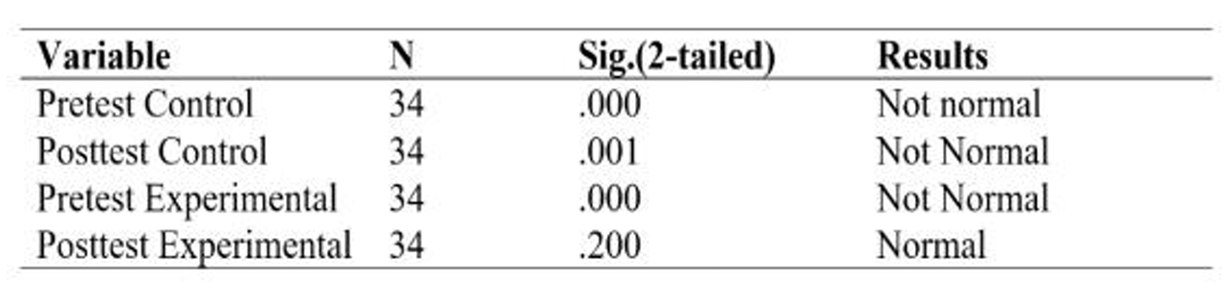
Based on the Kolmogorov-Smirnov test, the control group's pre-test and post-test scores had significance values of .000 and .001, respectively. Since both values were below 0.05, the data were not normally distributed.
In the experimental group, the normality test showed a significance value of .000 for the pre test and .200 for the post-test. While the post-test scores were normally distributed (p > 0.05), the pre-test scores were not. As both sets of data must meet the normality assumption, the overall data for the experimental group were classified as not normally distributed.
The results showed that the pre-test scores of the experimental group were not normally distributed, while the post-test scores met the criteria for normal distribution. However, the data was still considered not normally distributed because both the pre-test and post-test needed to be normally distributed. If one of them did not meet the normality assumption, the overall data was classified as not normally distributed.
To determine whether the two data sets exhibited a similar distribution, a homogeneity test was necessary. In this study, the writer employed Levene's test to assess the equality of the data sets' variances. The two data sets were considered to have a similar distribution (homogeneous) if the p value (Sig.) from Levene's greater than 0.05 as shown in Table 2.

Table 2. The Results of Homogeneity Test

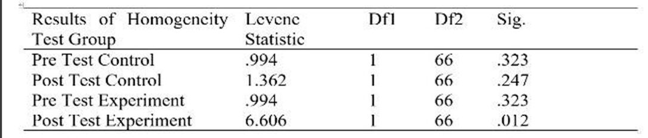

Levene’s Test results showed that both control and experimental groups had homogeneous variances in the pretest (p > 0.05). The post-test of the control group also remained homogeneous (p = 0.247). However, the experimental group's post-test showed a significance value of 0.012 (p < 0.05), indicating non-homogeneous variance. This suggests that the mind mapping strategy led to varied improvements among students, resulting in a wider score distribution. Given this variance inequality, the Mann–Whitney U Test was used to compare the post-test scores between the groups.
To evaluate the effectiveness of the mind mapping strategy, the Wilcoxon Signed-Rank Test was conducted on the pre-test and post-test scores of the experimental group. The null hypothesis (H₀) posited that there was no significant difference in the distribution of students’ writing ability scores before and after the implementation of mind mapping. Conversely, the alternative hypothesis (H₁) asserted that the distribution of post-test scores was significantly higher than that of the pre-test. This non parametric test was deemed appropriate due to the nature of the data and aimed to determine whether the observed changes in students’ writing performance were statistically significant following the intervention. The results of this test were presented in Table 3 below:

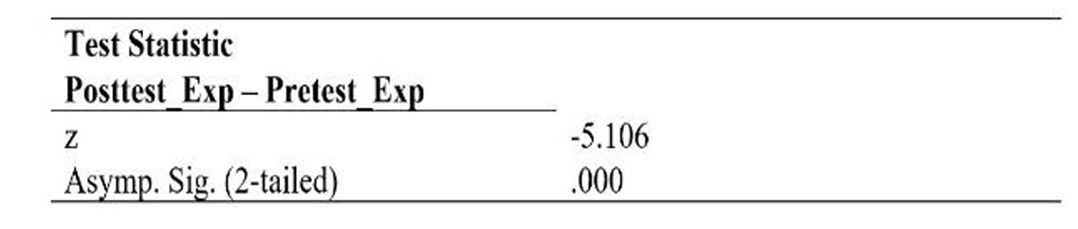
Table 3. The Results of the Wilcoxon Signed-Rank Test
The Wilcoxon Signed-Rank Test produced a Z-value of -5.106 with a significance value of .000. Since this p-value was below the 0.05 threshold, the null hypothesis was rejected. This finding suggests a significant difference in students’ writing scores between the experimental group and the control group on the post-test. In other words, the use of mind mapping had a meaningful impact in improving students’ writing ability compared to those who did not receive the same treatment.
The null hypothesis (H₀) stated that there was no significant difference in the distribution of students’ writing scores between the experimental group taught using mind mapping and the control group in the post-test. Meanwhile, the alternative hypothesis (H₁) suggested that the experimental group had significantly higher scores than the control group. To examine these hypotheses, the Mann–Whitney U Test was used to analyze the post test scores of both groups as showned in Table 4 below:

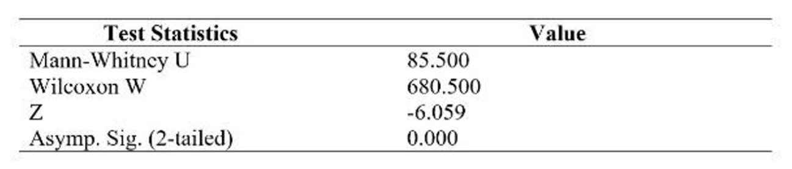
Table 4. Mann-Whitney Test Results
The Mann–Whitney U Test resulted in a U value of 85.500 with an asymptotic significance (2 tailed) of .000. Since the p-value was below the significance threshold of 0.05, the null hypothesis (H₀) was rejected. This indicates a significant difference in the distribution of writing scores between the group taught using mind mapping and the control group. As the alternative hypothesis (H₁) predicted higher scores for the experimental group, it can be concluded that the mind mapping strategy had a significant positive effect on students’ writing ability compared to conventional instruction.
To strengthen the value of this study, the interpretations were grounded in the data analysis results. The findings revealed a significant improvement in the writing performance of tenth grade students after receiving instruction through the mind mapping strategy. Furthermore, a clear distinction was observed between the writing outcomes of students taught using mind mapping and those who were not.
Effective writing instruction at the high school level requires strategies that maintain student motivation and support idea generation. Prayogo (2009, as cited in Fujiono, 2016) highlighted that many students perceive writing as a frustrating task due to limited knowledge and skills. Mind mapping serves as a practical approach to help students visually organize their ideas, enhancing both structure and creativity. Stokhof (2020) emphasized that mind mapping facilitates question generation and supports creative thinking through visualization.
This study focused on the implementation of mind mapping in writing instruction. Preliminary observations showed that students’ writing skills were relatively low. Two classes with similar writing proficiency, E5 and E7, were selected. The pretest results showed that class E5 scored slightly higher (M = 30.41) than E7 (M = 25.76), largely due to challenges in organizing content. This aligns with Al Khasawneh’s (2013) findings, which identified disorganized ideas, limited vocabulary, and frequent grammatical errors as common issues in student writing.
Mind mapping helped address these problems. Al-Jarf (2009) and Buzan (2002) explained that visual outlining helps connect main ideas to supporting details, improving organization. Vocabulary was enriched as students grouped related words, making retrieval during writing easier (D’Antoni et al., 2010; Goodnough & Woods, 2002). Moreover, working with key phrases reduced grammatical errors caused by direct translation (Al Shaer, 2014; Holland et al., 2003). Mind mapping also boosted motivation by turning writing into a creative, visual activity (Budd, 2004; Farrand et al., 2002).
The use of visual strategies such as mind mapping supports the view of Buzan (2018), who emphasized the importance of tools that stimulate creativity and organization. An effective mind map starts with a central image and expands through colored branches and symbols that reflect the brain’s natural thought patterns. It promotes engagement through personalization (Al-Jarf, 2021; Andrade, 2010), and research supports its role in enhancing motivation and cognitive involvement (Davies, 2011; Miller, 2018).
Statistical analysis using the Wilcoxon Signed-Rank Test and Mann–Whitney U Test confirmed that mind mapping significantly improved students' writing performance. These findings are consistent with previous studies, such as Kamelia et al. (2018) and Hasanah et al. (2016), though those studies had limitations such as the absence of a control group or a short treatment duration. The current study also faced constraints regarding data normality and variance homogeneity, which can be attributed to the small sample size (Statistics, 2018) and initial differences between groups (Trochim et al., 2016). Moreover, the ten-session intervention might not have been sufficient to maximize writing improvement (Graham, 2020; Zhang, 2023), suggesting that extended implementation could yield even stronger results.

CONCLUSION
This study examined the effectiveness of the mind mapping strategy in enhancing students’ writing skills. The results indicated a significant improvement in students' performance, as reflected in their test scores. The integration of mind mapping into the instructional process not only increased student engagement but also supported their ability to write recount texts more effectively. It enabled students to better organize their ideas, understand the text structure, and develop coherent content. Nonetheless, the presence of non-normal data distribution suggests limitations in the study, likely due to the small sample size and the relatively short duration of the intervention. These factors may have influenced the consistency and generalizability of the findings.

REFERENCE

Al-Jarf, R. (2009). Enhancing freshman students’ writing skills with a mind mapping software. Conference Proceedings of the 5th International scientific Conference eLearning and Software for Education, 4247.

https://www.semanticscholar.org/paper/

Al-Khasawneh, F. M. S. (2013). The reasons behind the weaknesses in writing in English among pre-year students at Taibah University. English for Specific Purposes World, 14(38), 1-9. http://www.espworld.info/Articles_38/D oc/Weaknesses_Writing.pdf

Al-Shaer, I. M. (2014). Employing mind mapping techniques in enhancing EFL students’ writing skills. International Journal of Linguistics, 6(3), 1–12. https://doi.org/10.5296/ijl.v6i3.5633

Andrade, J. (2010). Doodling for cognitive engagement in learning. Applied Cognitive Psychology, 24(1), 100–106. https://doi.org/10.1002/acp.1561

Budd, J. W. (2004). Mind maps as classroom exercises. Journal of Economic Education, 35(1), 35–46. https://doi.org/10.3200/JECE.35.1.35-46

Buran, A. (2015). Mind mapping as a mind tool in education. Procedia - Social and Behavioral Sciences, 191, 602608. https://doi.org/10.1016/j.sbspro.2015.04 .664 Enhancing-Freshman-Students’-Writing Skills-with-a-Al-Jarf/60ce14c2567337a5cb3a8bdfeff9619 4fd3a5e9f

Al-Jarf, R. (2021). Enhancing freshman students' writing skills with Mind Mapping. Journal of Educational Research, 114(3), 4560. https://doi.org/10.2139/ssrn.3901075

Buzan, T. (2002). How to mind map. Thorsons.

Buzan, T. (2018). Mind Map Mastery: The Complete Guide to Learning and Using the Most Powerful Thinking Tool in the Universe. Watkins Publishing.

D’Antoni, A. V., Zipp, G. P., Olson, V. G., & Cahill, T. F. (2010). Does the mind map learning strategy facilitate information retrieval and critical thinking in medical students? BMC Medical Education, 10, 61. https://doi.org/10.1186/1472-6920-10 61

Davies, M. (2011). Using visual cues to enhance learning from mind maps. Australasian Journal of Educational Technology, 27(1), 108–122. https://ajet.org.au/index.php/AJET/articl e/view/782

Farrand, P., Hussain, F., & Hennessy, E. (2002). The efficacy of the mind map study technique. Medical Education, 36(5), 426 431. https://doi.org/10.1046/j.1365 2923.2002.01205.x

Fujiono. (2016). The use of mind mapping technique to improve the students’ writing skill on descriptive text at the tenth grade of SMA PGRI 1 Pangkalan Kerinci [Undergraduate thesis, Universitas Islam Negeri Sultan Syarif Kasim Riau]. https://www.researchgate.net/publicatio n/340397424

Goodnough, K., & Long, R. (2002). Mind mapping: A graphic organizer for the pedagogical toolbox. Science Scope, 25(8), 2024. https://www.nsta.org/journals/science scope/science-scope-may-2002/mind mapping-graphic-organizer-pedagogical toolbox

Graham, S. (2020). Changing how writing is taught. Review of Research in Education, 44(1), 277–303. https://doi.org/10.3102/0091732X20923 770

Hasanah, U., Rizqiya, D. A., & Sari, R. F. (2016). The use of mind mapping technique in improving students’ writing skill. English Education Journal (EEJ), 7(3), 350–364. https://www.academia.edu/73821125

Holland, B., Holland, L., & Davies, J. (2003). Using mind maps to improve student writing. Journal for Language Teaching, 37(2), 53 67. https://doi.org/10.4314/jlt.v37i2.6015

Kamelia, K., Rifa’i, A., & Fadillah, R. (2018). The use of mind mapping on improving students’ writing ability at tenth grade of SMAN 7 Kota Tangerang in the academic year of 2018/2019. Journal of English Language and Literature (JELL), 3(01), 110. https://www.researchgate.net/publicatio n/331284278

Klimova, B. F. (2015). Teaching writing to learners of English as a foreign language. Procedia - Social and Behavioral Sciences, 191, 1344–1349. https://doi.org/10.1016/j.sbspro.2015.04 .525

Listyowati, R., & Hanna, I. D. (2021). The use of mind mapping technique to improve the students’ writing skill on analytical exposition text in senior high school. Loquen: English Studies Journal, 14(1), 112. https://ftk.uinbanten.ac.id/journals/inde x.php/loquen/article/view/2552

Miller, C. J., Smith, S. N., & Pugatch, M. (2020). Experimental and quasi-experimental designs in implementation research. Psychiatric Research and Clinical Practice, 2(1), 24–31. https://doi.org/10.1176/appi.prcp.20190 010

Parikh, S. (2016). Mind mapping and its applications in education. New Delhi: Vikas Publishing.

Perumal, K., & Ajit, I. (2020). Enhancing writing skills: A review. Psychology and Education Journal, 57(9), 22292236. https://psychologyandeducation.net/pae /index.php/pae/article/view/592

Prayogo, J. A. (2009). Developing writing skills through genre-based approach. In Y. Fujiono (Ed.), Exploring English teaching strategies (pp. 101–120). Surabaya: Unesa Press.

Rista, L. (2021). An analysis of students’ difficulties in writing skill. English Journal Literacy Utama, 6(1), 20–30.

Statistics, J. T. (2018). Statistical assumptions and the validity of parametric tests. Journal of Applied Measurement and Statistics, 22(1), 1–9.

Stokhof, H. (2020). Inquiry-based learning and the use of mind maps in higher education. Thinking Skills and Creativity, 35, 100627. https://doi.org/10.1016/j.tsc.2019.10062 7

Sukmawati, S., Weda, S., & Dollah, S. (2023). Sampling techniques in educational research: A comparative analysis. International Journal of Contemporary Educational Research, 10(1), 95106. https://doi.org/10.33200/ijcer.1139478.

Suyanto, K. K. E. (2015). A mind mapping: A strategy to enhance students' writing skill. Jurnal Pendidikan dan Pembelajaran, 22(2), 143 150. https://media.neliti.com/media/publicati ons/362607-a-mind-mapping-a-strategy to-enhance-stu-76496c11.pdf

Trochim, W. M. K. (2016). Research methods: The essential knowledge base (2nd ed.). Cengage.

Yue, J. (2023). Exploring the application of mind maps in high school English reading and writing class. Journal of Language Teaching and Research, 14(1), 86–92. https://www.researchgate.net/publicatio n/369561739

Zhang, Y. (2023). Duration and effectiveness of intervention programs in writing skill development. International Journal of Educational Research, 112, 101945. https://doi.org/10.1016/j.ijer.2022.10194 5

