AN IMPACT OF VOCABULARY MASTERY TO WRITING ABILITY THROUGH DESCRPTIVE TEXT
A CORRELATION RESEARCH

ABSTRACT: This research aimed to find out whether or not there was a correlation between students’ vocabulary mastery and their writing ability of descriptive textof the tenth grade students at SMA Negeri 10 Palembang and to find out whether or not there was a contribution of students’ vocabulary mastery to their writing ability of descriptive text . The research method used quantitative research and the population was the tenth-grade students with the total 450 students from 14 classes at SMA N 10 Palembang. To select the sample of this research, intake sampling technique was implemented. There were 72 students as a sample from class X.7 and X.8. Correlation and regression analysis were used to analyze the data, which were obtained fromwriting ability and vocabulary mastery tests. The results showed that the significant coefficient between writing ability and vocabulary mastery was 0.802 higher than the alpha value of 0.05. it means that vocabulary mastery and writing ability was not correlated. At that point, the correlation coefficient was 0.030, which placed it in the poor level. Subsequently, regression analysis revealed that the output data's correlation value (R) was 0.066 and its coefficient of determination (R Square) was 0.004. To conclude that the contribution of vocabulary mastery on writing skill was only 0.04%. In conclusion, the findings indicate that students who have high vocabulary mastery does mean that they would be also have good writing ability.
Keywords: Correlation, Vocabulary Mastery, Writing Ability

DAMPAK PENGUASAAN KOSAKATA TERHADAP KEMAMPUAN MENULIS MELALUI TEKS DESKRIPTIF
PENELITIAN KORELASI
ABSTRAK: Tujuan dari penelitian ini adalah untuk mengetahui apakah ada korelasi antara penguasaan kosakata siswa dan kemampuan menulis teks deskriptif mereka untuk siswa kelas sepuluh di SMA Negeri 10 Palembang dan untuk mengetahui apakah ada kontribusi dari penguasaan kosakata siswa dan kemampuan menulis teks deskriptif mereka untuk siswa kelas sepuluh di SMA Negeri 10 Palembang. Metode penelitian menggunakan penelitian kuantitatif dan populasinya adalah siswa kelas sepuluh dengan total 450 siswa dari 14 kelas di SMA N 10 Palembang. Untuk sampel penelitian ini, teknik pengambilan sampel diterapkan. Ada 72 siswa sebagai sampel dari kelas X.7 dan X.8. Uji korelasi, regresi, dan normalitas digunakan untuk menganalisis data, yang diambil dari tes kemampuan menulis dan penguasaan kosakata siswa. Hasil penelitian menunjukkan bahwa koefisien signifikan antara kemampuan menulis dan penguasaan kosakata adalah 0,802 lebih tinggi dari nilai alpha 0,05. Ini berarti bahwa penguasaan kosakata dan kemampuan menulis tidak berkorelasi. Pada saat itu, koefisien korelasi adalah 0,030, yang menempatkannya pada kelompok buruk. Selanjutnya, analisis regresi menunjukkan nilai korelasi (R2) data keluaran sebesar 0,066 dan koefisien determinasi (R2 Square) sebesar 0,004. Dapat disimpulkan bahwa kontribusi penguasaan bahasa terhadap keterampilan menulis hanya 0,04%. Kesimpulannya, temuan ini menunjukkan bahwa siswa yang memiliki penguasaan kosakata yang tinggi juga memiliki kemampuan menulis yang baik.
Kata Kunci: Korelasi, Penguasaan Kosakata, Kemampuan Menulis
INTRODUCTION
Education is a fundamental human need that must be fulfilled, serving a higher purpose beyond mere survival; it enables individuals to attain dignity and a more esteemed position compared to those without education. Education continually undergoes change, development, and improvement in line with advancements in all areas of life Adler., (2017). Education is inseparable from learning activities. According to Firman et al. (2020), learning involves observing, reading, imitating, experimenting, listening, and following specific instructions. Thus, learning can be understood as an active process of behavioural change, a process of responding to the surrounding environment, a goal-directed activity, and an engagement in diverse experiences. It encompasses observing, understanding, and internalizing the subject matter being learned.
Vocabulary mastery is the process of developing one's ability to comprehend and use words found in a language, both orally and in writing. Mastery of language is essential; the more words one knows, the more easily one can communicate and receive information. Intelligence can also be gauged by a person's vocabulary. Rahmati., (2018). Vocabulary mastery means having full knowledge and skills in words. The word mastery means knowing something completely or having good skill in a subject. So, vocabulary mastery is having a large number of words that can be put together to form sentences. These sentences can be used to share thoughts or ideas with others. Laili., (2022)
Writing can be defined as the activity of expressing ideas or concepts using written language as a medium of delivery Toba et al., (2019). According to Anggraini et al., (2020), wrote means expressing in writing thoughts, ideas, opinions or thoughts and feelings. According to Malik., (2019), Writing was an activity where you thought and felt about a topic, decided what to say, and figured out how to say it so that others could understand it clearly and easily.
Descriptive is a type of essay that students need to learn. According to Dalimunthe (2021), descriptive writing is a way to explain or show something so that it creates a clear picture in the reader's mind, giving them the impression that they can see, hear, and feel what is being explained. Ulfa et al. (2023) say that descriptive text is a paragraph that clearly explains the main idea by describing an object, place, or event in detail. This helps the reader imagine or experience what is being talked about, making it feel real and personal. Sahalluddin et al. (2023) also agree, saying that descriptive writing is a type of writing that gives a detailed description of an object., allowing readers to imagine, visualize, and even hear or feel what is being described through the words used
SMA Negeri 10 Palembang was selected as the research site after interviews with the English teacher and classroom observations the researcher found that students at SMA N 10 Palembang are afraid of learning English, and the lack of vocabulary makes it hard for them to express their ideas. confuse to do writing about grammar, therefore students have low understanding in vocabulary and writing
previous research "The Correlation Between Students Vocabulary Mastery and Writing Skill at SMK 2 Ponorogo" by Laili, (2022). The similarity between previous research and the research was used tenth grade as a sample of the research. Also, researcher and previous research used test to collect data. The difference between previous research and the research research is sample of the test, previous research used 109 students of vocational school and used correlation between two variables, the researcher used 72 students of high school and there is no correlation between two variables. Previous research used vocational school and the researcher used high school. The previous research has correlation between two variables, but this research there is no correlation between two variables. Also, previous research used random sampling and the researcher used purposive sampling.
The second is “The Correlation Between Grammatical Mastery and Descriptive Writing Mastery of The Tenth Grade Students of SMA Negeri 1 Indralaya” by Randika., (2018). The similarity between previous research and the research research is both researches used the same research method there was quantitative research with correlation approach, and both researches conducted at senior high school. Then, the sample of both researches was taken by using purposive sampling. The differences between previous research and the research research are previous research used grammar test and researcher used vocabulary mastery test. Also, sample of previous research consisted of 94 students from three classes and researcher research consisted of 72 students from two classes. Then, the result of previous research was a fair significant correlation and researcher research was no significant correlation.
Consequently, given considering the explanations provided, the writers conducted a study titled “an impact of vocabulary mastery to writing ability through descriptive text: a correlation research”.

METHODOLOGY
1. Research Design
This research used a correlation design. Correlational research, according to Mardianti et al. (2021), is a quantitative technique intended to demonstrate the connections between two or more variables. An additional viewpoint from Temizhan et al., (2022) correlation research is to investigate the extent to which variations in one factor correspond with variations in one or more other factor based on correlation coefficients. In correlation design, researchers use the statistical process of correlation analysis to quantify the degree of relationship between two or more variables. Whether the two variables are related or if one may predict the other is indicated by this degree of correlation, which is a numerical value. The researcher used correlation between two variables in this research. The most suitable research design was used to determine whether or not the tenth grade students vocabulary mastery had correlation to writing ability of descriptive text of tenth grade students at SMA Negeri 10. In this reasearch, the independent variable was vocabulary mastery and the dependent variable was writing ability. Vocabulary was represented by X and writing was represented by Y.

2. Population and Sample
The population in this research is all of the students from the tenth grade at SMA Negeri 10 Palembang. According to Levitt (2021), population is a region for generalization that includes an item or subject with unique qualities and traits that the researcher has chosen to study and draw conclusions from Obilor (2023) notice that sample is a little gathering of people who have similar encounters about a specific case. Afterwards, the samples in this research are from the students that belong to classes X.7, and X.8 with 72 total of students at SMA Negeri 10 Palembang chosen by using purposive sampling technique. These classes were involved as the sample because these classes are more active in class and they are taught by the same teacher

3. Techniques for Collecting Data
To collect the data, vocabulary mastery test and writing test were employed, The purpose of vocabulary mastery test is to measure the students' understanding in vocabulary mastery. the researcher distributeda vocabulary test consisting 35 items of multiple-choice questions to the sample . Then, the writing test was given to measure the students' writing ability of descriptive text about person. In this test, the students are free to be creative and develop their writing with a minimum 50 words. Validity test, Before going to data collection process, the researcher will validate the test as the instrument to find out the research question of this research because an instrument is qualified to using after showing the data variables research correctly. Reliability, Reliability, according to Fraenkel et al. (2012, p.154), is the degree to which the scores obtained are consistent for each individual across several instrument administrations and item sets.

4. Techniques for Analysis Data
Descriptive Statistic of the data limits generalization to a certain observational subject. The data used described from one group to the others. Descriptive analysis used distribute more valuable and accurate information about the nature of the certain group of subjects. Sari et, al., (2021) stated that descriptive statistics used to analyze data to elaborate the collected data. Normality test, Haryadi et, al., (2022) claims that the normality used to measure whether the data are normal or not. Then, the result of the test can be called as normal if the probability is higher than 0.05 as normal measurement in the form Kolmogorov-Smirnov. Normality test, Haryadi., (2022) stated that a researcher needs to used correlational statistical to elaborate and measure the degree of correlation. Therefore, SPSS 25 is using to see the coefficient of the correlation and the influence between two variables. The researcher analyzes data using person product methodology. The correlation's significance is established by comparing the coefficient data (r value) with the significance level in percentage accessible in the product moment table (r table), where the correlation is known if r table is less than r data. Regression analysis. According to Cote (2021) the statistical method for determining the structure of an interaction between two, three, or more variables is regression analysis. In this research, regression analysis was used to examine how much the listening comprehension contribute to reading comprehension. This analysis was analyzed by using SPPS 25.

FINDINGS AND DISCUSSION
1. Descriptive Statistic
Descriptive statistics revealed that the mean score for the vocabulary mastery test was 76.87, with a minimum score of 29, a maximum score of 97, and a standard deviation of 17.898; the mean score for the writing ability test was 77.15, with a minimum score of 70, a maximum score of 91, and a standard deviation of 4.904. The findings can be presented in the following table 1 below:

Table 1. Descriptive Statistic of Vocabulary Mastery and Writing Ability

 | N | Minimum | Maximum | Mean | Std. Deviation
Vocabulary | 72 | 29 | 97 | 76.87 | 17.898
Writing | 72 | 70 | 91 | 77.15 | 4.904

2. The Analysis of Frequency

The vocabulary mastery test's findings stated that 3 students were in very poor category with percentage 4%. 7 Students were in poor category with percentage 10%. 8 students were in average category with percentage 11%. 25 students were in good category with percentage 35% and 29 students were in very good category with percentage 41%. In addition, the score distribution of writing ability can be seen in the following table 2.

Table 2. Score Distribution of Vocabulary Mastery Test

Category | Score | Vocabulary Mastery
 |  | Frequency | Percentage
Very Good | 86-100 | 29 | 40%
Good | 71-85 | 25 | 35%
Average | 52-70 | 8 | 11%
Poor | 36-51 | 7 | 10%
Very Poor | 0-35 | 3 | 4%
Total |  | 72 | 100%

Additionally, figure 1 below shows the vocabulary mastery.

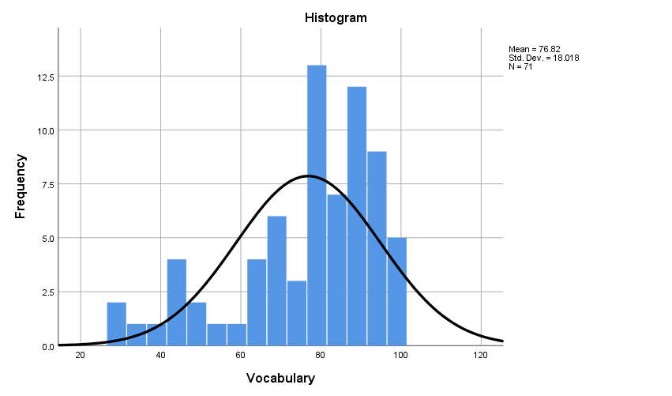
Figure 1. The Frequency Analysis of Vocabulary Mastery
The result of writing ability test showed that 0 student was in very poor category with percentage 0%. 0 student were in poor category with percentage 0 %. 8 students were in average category with percentage 11%. 57 students were in good category with percentage 79 % and 8 students were in very good category with percentage 11 %.

Table 3. The Score Distribution for Writing Ability
Category | Score | Writing Ability
 |  | Frequency | Percentage
Very Good | 86-100 | 7 | 10%
Good | 71-85 | 57 | 79%
Average | 52-70 | 8 | 11%
Poor | 36-51 | 0 | 0%
Very Poor | 0-35 | 0 | 0%
Total |  | 72 | 100%

Furthermore, Figure 2 below shows the writing ability.

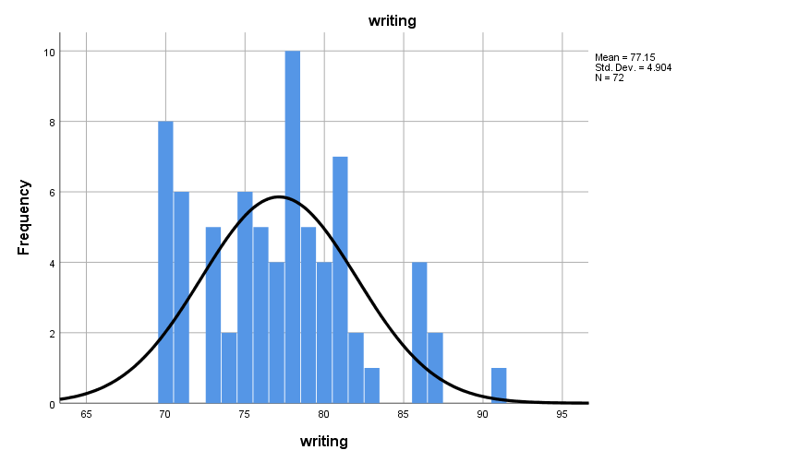

Figure 2. The Frequency Analysis of Writing Ability

3. Normality Test

In this research, to determine whether or not the data on writing ability and vocabulary mastery were distributed normally, the normality test was employed. It was calculated by using residual normality of Kolmogorov-smirnov that is presented table 4.

Table 4. The Normality Test

One-Sample Kolmogorov-Smirnov Test
 |  | Unstandardized Residual
N |  | 72
Normal Parameters^{a,b} | Mean | .0000000
 | Std. Deviation | 4.88068409
Most Extreme Differences | Absolute | .075
 | Positive | .075
 | Negative | -.062
Test Statistic |  | .075
Asymp. Sig. (2-tailed) |  | .200^{c,d}
a. Test distribution is Normal.
b. Calculated from data.
c. Lilliefors Significance Correction.
d. This is a lower bound of the true significance.

it was found that the data from the normality test of vocabulary mastery and writing ability showed .200 > 0.05, it means that the data was normally distributed

4. Correlation Analysis

Regression analysis was utilized in this research to look at how much vocabulary mastery contributed toward writing ability that is presented in Table 5.

Table 5. The Homogeneity Test
Model Summary
Model | R | R Square | Adjusted R Square | Std. Error of the Estimate
1 | .066ª | .004 | -.010 | 18.754
a. Predictors: (Constant), writing

Based on the table above, it was found that the correlation value (R) was .066 from the output data, the coefficient of determination (R Square) was .004 it means that the contribution of vocabulary mastery toward writing ability was .004. It could be concluded that vocabulary mastery only contributed as much as 0.04% toward writing ability.

5. Regression Analysis

Regression analysis was utilized in this research to look at how much vocabulary mastery contributed toward writing ability that is presented in Table 6.

Table 6. Regression Analysis
Model Summary
Model | R | R Square | Adjusted R Square | Std. Error of the Estimate
1 | .066ª | .004 | -.010 | 18.754
a. Predictors: (Constant), writing

Based on the table above, it was found that the correlation value (R) was .066 from the output data, the coefficient of determination (R Square) was .004 it means that the contribution of vocabulary mastery toward writing ability was .004. It could be concluded that vocabulary mastery only contributed as much as 0.04% toward writing ability.

After this part, please elaborate the discussion section

CONCLUSION
Two conclusions could be made in light of the study's findings and interpretation. First, correlation coefficient was .030 it indicated in low category of the correlation coefficient. It could be assumed that the score of vocabulary mastery could not be influenced by the score of writing ability. So, Ho 1 (null hypothesis) was accepted and Ha1 (alternative hypothesis) was rejected.
Second, regression analysis revealed that the output data had a correlation value (R) of .066 and a coefficient of determination (R Square) of.004. It indicates that mastery of language contributed.004 to writing skill. One could conclude that the contribution of language mastery on writing skill was only 0.04%. It indicates that the null hypothesis (Ha2) was rejected and the alternative hypothesis (Ho2) was accepted..

REFERENCES
Adler, A. (2017). Positive education: Educating for academic success and for a fulfilling life. Papeles del psicólogo, 38(1), 50-57.
Anggraini, R., Rozimela, Y., & Anwar, D. (2020). The effects of collaborative writing on EFL learners' writing skills and their perception of the strategy. Journal of language teaching and research, 11(2), 335-341.
Cote, C. (2021, December 14). What is Regression Analysis in Bussiness Analytics? Retrieved Januari 17, 2024
Dalimunthe, M. R. (2021). The Effect Of Using Sequence Picture On Students’writing Descriptive Text At The Xi Student Of Sma Sista Kampus Padangsidimpuan. Jurnal Liner (Language Intelligence and Educational Research), 4(2), 13-26.
Firman, F., Mirnawati, M., Sukirman, S., & Aswar, N. (2020). The Relationship Between Student Learning Types and Indonesian Language Learning Achievement in FTIK IAIN Palopo Students. Jurnal Konsepsi, 9(1), 1-12.
Fraenkel, J. R., Wallen, N. E., & Hyun, H. H. (2012). How to evaluate research in education (8th ed.). New York, NY: McGraw-Hill.
Haryadi, R. N., Endah, J., & Dalimunthe, L. (2021). The Effects Of Vocabulary And Grammar Mastery On Students’writing Skill In Descriptive Text (Surveys at Private Junior High Schools in Serang Banten). JLE: Journal of Literate of English Education Research Program, 2(02), 46-54.
Laili, E. N. (2022). The Correlation Between Students'vocabulary Mastery And Writing Skill At Skm Negeri 2 Ponorogo (Doctoral Dissertation, Iain Ponorogo).
Malik, M. (2019). Writing Skills Development among Students with Deafness at Elementary Level. Bulletin of Education and Research, 41(1), 1-16.
Obilor, E. I. (2023). Convenience and purposive sampling techniques: Are they the same. International Journal of Innovative Social & Science Education Research, 11(1), 1-7.
Rahmati, U. (2018). The Correlation Between Vocabulary Mastery And Students' Writing Skill (Doctoral dissertation, UIN Ar-Raniry Banda Aceh).
Randika, A. (2018). The Correlation Between Grammatical Mastery And Descriptive Writing Mastery Of The Tenth-Grade Students Of Sma Negeri 1 Indralaya.
Sahalluddin, M., & Akbariah, Y. (2023, July). 121. Improving Student’s Ability in Writing Descriptive Text through Picture Series. In Prosiding Seminar Nasional Pendidikan Profesi Guru (Vol. 1, No. 1, pp. 1105-1112).
Sari, S. N., & Aminatun, D. (2021). Students’perception on the use of English movies to improve vocabulary mastery. Journal of English language teaching and learning, 2(1), 16-22.
Toba, R., & Noor, W. N. (2019). The current issues of Indonesian EFL students’ writing skills: Ability, problem, and reason in writing comparison and contrast essay. Dinamika Ilmu, 19(1), 57-73.
Ulfa, F., Sudrajad, W., & Sulistyaningsih, S. (2023). Increasing Student’s Ability to Write Descriptive Text Using the Brainstorming Method. International Journal of English and Applied Linguistics (IJEAL), 3(2), 109-118.

