VOCABULARY MASTERY AND ITS INFLUENCE ON STUDENTS’ DESCRIPTIVE WRITING: A CORRELATION RESEARCH
ABSTRACT: This research aimed to find out whether or not there was correlation between students’ vocabulary mastery and their writing ability of descriptive text of the tenth grade students at SMA Negeri 10 Palembang and to find out whether or not there was a contribution of students’ vocabulary mastery to their writing ability in descriptive texts. The research method used quantitative research and the population was the tenth-grade students with the total 450 students from 14 classes at SMA N 10 Palembang. To select the sample of this research, intake purposive sampling was implemented. There were 72 students as a sample from class X.7 and X.8. It is better to use correlation analysis and regression analysis were used to analyze the data, which were obtain from writing ability and vocabulary mastery tests. The results showed that the significant coefficient between writing ability and vocabulary mastery was 0.802 higher than the alpha value of 0.05. it means that vocabulary mastery and writing ability was not correlated. At that point, the correlation coefficient was 0.030, which placed it in the low category of the correlation coefficient. Subsequently, regression analysis revealed that the output data's correlation value (R) was 0.066 and its coefficient of determination (R Square) was 0.004. It concluded that the contribution of vocabulary mastery on writing skill was only 0.04%. In conclusion, The r-value was less than the alpha-value (.802 >.05), indicating that there was no significant relationship between writing ability and vocabulary mastery and There was no contribution and interaction effect towards vocabulary mastery and writing ability, since the R-value .004> 0.04% the result was rejected.
Keywords: Correlation, Vocabulary Mastery, Writing Ability

DAMPAK PENGUASAAN KOSAKATA TERHADAP KEMAMPUAN MENULIS MELALUI TEKS DESKRIPTIF
PENELITIAN KORELASI
ABSTRAK: Penelitian ini bertujuan untuk mengetahui apakah ada korelasi antara penguasaan kosakata siswa dan kemampuan menulis teks deskriptif untuk siswa kelas sepuluh di SMA Negeri 10 Palembang dan untuk mengetahui apakah ada kontribusi dari penguasaan kosakata siswa terhadap kemampuan menulis mereka dalam teks deskriptif pada siswa kelas sepuluh SMA Negeri 10 Palembang. Metode penelitian menggunakan penelitian kuantitatif dan populasinya adalah siswa kelas sepuluh dengan total 450 siswa dari 14 kelas di SMA N 10 Palembang. Untuk sampel penelitian ini, teknik pengambilan sampel diterapkan. Ada 72 siswa sebagai sampel dari kelas X.7 dan X.8. Lebih baik menggunakan analisis korelasi dan analisis regresi digunakan untuk menganalisis data, yang diambil dari kemampuan menulis siswa dan tes penguasaan kosakata. Hasil penelitian menunjukkan bahwa koefisien signifikan antara kemampuan menulis dan penguasaan kosakata adalah 0.802 lebih tinggi dari nilai alpha 0,05. Ini berarti bahwa penguasaan kosakata dan kemampuan menulis tidak berkorelasi. Pada titik tersebut, koefisien korelasi adalah 0.030, yang menempatkannya dalam kategori rendah dari koefisien korelasi. Selanjutnya, analisis regresi mengungkapkan bahwa nilai korelasi data keluaran (R) adalah 0.066 dan koefisien determinasinya (R Square) adalah 0.004. Disimpulkan bahwa kontribusi penguasaan kosakata pada keterampilan menulis hanya 0.04%. Sebagai kesimpulan, nilai r lebih kecil dari nilai alpha (.802 >.05), yang menunjukkan bahwa tidak ada hubungan yang signifikan antara kemampuan menulis dan penguasaan kosakata dan Tidak ada kontribusi dan efek interaksi terhadap penguasaan kosakata dan kemampuan menulis, karena nilai R 0.004 > 0.04% hasilnya ditolak menulis hanya 0.04%. Kesimpulannya, temuan ini menunjukkan bahwa siswa yang memiliki penguasaan kosakata yang tinggi juga memiliki kemampuan menulis yang baik.
Kata Kunci: Korelasi, Penguasaan Kosakata, Kemampuan Menulis
INTRODUCTION
Vocabulary mastery is the process of developing one's ability to comprehend and use words found in a language, both orally and in writing. Mastery of language is essential; the more words one knows, the more easily one can communicate and receive information. Rahmati., (2018). Vocabulary mastery means having full knowledge and skills in words. The word mastery means knowing something completely or having good skill in a subject. Hence, vocabulary mastery is having a large number of words that can be put together to form sentences. Laili., (2022)
vocabulary is one of the important elements of the language. At the very basic understanding, vocabulary connects meaning the real world with language. Schmitt & Schmitt, 2020 in Soma., (2025).
According to Schmitt et al, (2020) Vocabulary plays a very important part in language skills. Having a good vocabulary helps a person learn more about language and makes their knowledge wider. Vocabulary refers to the words that a person knows and can use well. This includes individual words, words with added parts, and words made by putting together other words, each of which has its own meaning.
Writing as a part of language skills has different stages of the process. The different stages of the writing process will depend on how much attention we give to what the content and length, what kind of writing we are doing, what medium we are using. Harmer in Irawan., (2023). Thus, writing is the activity of expressing ideas, thoughts, information, knowledge and expressing one's feelings in written form, where the article is addressed to readers. Writing activities are commonly found in the teaching and learning process in schools, especially in English language learning. In learning English there are a lot of materials related to writing activities, one of them is writing descriptive text. Therefore, writing skills must also be trained intensively. Writing will make students more creative in expressing themselves so that students activities become more positive. Otherwise, wrote can also were a means of entertainment for students Pradana et al., (2020).
Writing can be defined as the activity of expressing ideas or concepts using written language as a medium of delivery Toba et al., (2019). According to Anggraini et al., (2020), wrote means expressing in writing thoughts, ideas, opinions or thoughts and feelings. According to Malik., (2019), Writing was an activity where you thought and felt about a topic, decided what to say, and figured out how to say it so that others could understand it clearly and easily. Writing as a part of language skills has different stages of the process. The different stages of the writing process will depend on how much attention we give to what the content and length, what kind of writing we are doing, what medium we are using (Harmer, 2004, p. 6).
Descriptive is a type of essay that students need to learn. According to Dalimunthe (2021), descriptive writing is a way to explain or show something so that it creates a clear picture in the reader's mind, giving them the impression that they can see, hear, and feel what is being explained. Ulfa et al. (2023) say that descriptive text is a paragraph that clearly explains the main idea by describing an object, place, or event in detail. This helps the reader imagine or experience what is being talked about, making it feel real and personal. Sahalluddin et al. (2023) also agree, said that descriptive writing is a type of writing that gives a detailed description of an object., allowing readers to imagine, visualize, and even hear or feel what is being described through the words used.
The researcher observed that students at SMA Negeri 10 Palembang are afraid of learning English, and the lack of vocabulary makes it difficult for them to express their ideas. They are also confused when writing due to problems with grammar. Therefore, the students have a low level of understanding in both vocabulary and writing.
Therefore, previous research "The Correlation Between Students Vocabulary Mastery and Writing Skill at SMK 2 Ponorogo" by Laili,. (2022). The research results was positive value of 0.661 is the correlation coefficient. This demonstrates that the two variables are directly related. Previous research used product moment table to interpret the correlation coefficient. Accordingly, throughout the 2021–2022 school year, there is a relationship between the writing abilities and vocabulary mastery of tenth grade students at SMKN 2 Ponorogo. Therefore, the research findings are accepted.

The second is “The Correlation Between Grammatical Mastery and Descriptive Writing Mastery of The Tenth Grade Students of SMA Negeri 1 Indralaya” by Randika., (2018). The result showed that there was a fair correlation between the students grammatical mastery and their descriptive writing mastery (r= 0.598 and p-value=0.000). In conclusion, there was a significant correlation between grammatical mastery and descriptive writing mastery of the tenth-grade students of SMA Negeri 1 Indralaya.
Consequently, given considering the explanations provided, the writer decided on a study titled “an impact of vocabulary mastery to writing ability through descriptive text: a correlation research”. Then, objectives of the research are: To find out whether or not there was correlation between students’ vocabulary mastery and their writing ability of descriptive text for tenth grade students at SMA Negeri 10 Palembang and to find out whether or not there was contribution from students` vocabulary mastery and their writing ability of descriptive text of tenth grade students at SMA Negeri 10 Palembang.

METHODOLOGY
1. Research Design
This research used a correlation design. Correlational research, according to Mardianti et al. (2021), is a quantitative technique intended to demonstrate the connections between two or more variables. In addition, emizhan et al., (2022) states that correlation research is to investigate the extent to which variations in one factor correspond with variations in one or more other factor based on correlation coefficients. In correlation design, researcher used the statistical process of correlation analysis to quantify the degree of relationship between two or more variables. Whether the two variables are related or if one may predict the other is indicated by this degree of correlation, which is a numerical value. The researcher used correlation between two variables in this research. The research design was used to determine whether or not the tenth grade students vocabulary mastery had correlation to writing ability of descriptive text of tenth grade students at SMA Negeri 10. Also, to find out whether or not there was a contribution of students’ vocabulary mastery to their writing ability in descriptive texts at the tenth-grade students of SMA Negeri 10 Palembang
In this reasearch, the independent variable was vocabulary mastery and the dependent variable was writing ability. Vocabulary was represented by X and writing was represented by Y.

2. Population and Sample
The population in this research is all of the students from the tenth grade at SMA Negeri 10 Palembang. According to Levitt (2021), population is a region for generalization that includes an item or subject with unique qualities and traits that the researcher has chosen to study and draw conclusions from. Obilor., (2023) notice that sample is a little gathering of people who have similar encounters about a specific case. Afterwards, the samples in this research are from the students that belong to classes X.7, and X.8 with 72 total of students at SMA Negeri 10 Palembang chosen by using purposive sampling technique.
These classes were involved as the sample because the English teacher in both classes told researcher that the students in those classes had insufficient vocabulary and weak writing ability. The teacher then chose those classes because it was the most suitable for researcher research material.

3. Techniques for Collecting Data
To assess vocabulary mastery to writing ability. Vocabulary mastery test, The purpose of vocabulary mastery test is to measure the students' understanding in vocabulary mastery. At the beginning of the research, the researcher distributed try out test consisting 35 items of multiple-choice questions at X.7 and X.8 at SMA Negeri 10 Palembang. Writing ability test, the written test was given to measure the students' writing ability of descriptive text about person. In this test, the students are free to be creative and develop their writing with a minimum 50 words in 40 minutes and the question consist of 2 questions about famous landmarks such as the Ampera Bridge and Borobudur Temple. Validity test, before going to data collection process, the researcher would validate the test as the instrument to find out the research question of this research because an instrument is qualified to using after showing the data variables research correctly. The result of validity test was the value of r-table lower than the r-value of items is not valid. The researcher found the r-table was 0.235 for 72 samples. Initially, the instrument to the test consisted of 35 items. Based on the result of the test it was found that 3 items of instruments were not valid. Those items were 27, 28 and 29. Reliability, according to Fraenkel et al. (2012, p.154), is the degree to which the scores obtained are consistent for each individual across several instrument administrations and item sets. The reliability test yielded a dependable coefficient of.928. Based on the interpretation of the reliability classification, it was possible to conclude that the writing test was highly reliable

4. Techniques for Analysis Data
Descriptive Statistic of the data limits generalization to a certain observational subject. The data used described from one group to the others.
4.1 Descriptive analysis
Descriptive analysis used distribute more valuable and accurate information about the nature of the certain group of subjects. Sari et, al., (2021) stated that descriptive statistics used to analyze data to elaborate the collected data.
4.2 Normality Test
Normality test, Haryadi et, al., (2022) claims that the normality used to measure whether the data are normal or not. Then, the result of the test can be called as normal if the probability is higher than 0.05 as normal measurement in the form Kolmogorov-Smirnov. Normality test, Haryadi., (2022) stated that a researcher needs to used correlational statistical to elaborate and measure the degree of correlation.
4.3 Correlation Analysis
SPSS 25 is using to see the coefficient of the correlation and the influence between two variables. The researcher analyzes data using person product method. The correlation's significance is established by comparing the coefficient data (r value) with the significance level in percentage accessible in the product moment table (r table), where the correlation is known if r table is less than r data.
4.4 Regression Analyis
According to Cote (2021) the statistical method for determining the structure of an interaction between two, three, or more variables is regression analysis. In this research, regression analysis was used to examine how much vocabulary mastery contribute to writing ability. This analysis was analyzed by using SPPS 25.

FINDINGS AND DISCUSSION
1. Descriptive Statistic
Descriptive statistics revealed that the mean score for the vocabulary mastery test was 76.87, with a minimum score of 29, a maximum score of 97, and a standard deviation of 17.898; the mean score for the writing ability test was 77.15, with a minimum score of 70, a maximum score of 91, and a standard deviation of 4.904. The findings can be presented in the following table 1 below:

Table 1. Descriptive Statistic of Vocabulary Mastery and Writing Ability

 | N | Minimum | Maximum | Mean | Std. Deviation
Vocabulary | 72 | 29 | 97 | 76.87 | 17.898
Writing | 72 | 70 | 91 | 77.15 | 4.904

2. The Analysis of Frequency

The vocabulary mastery test's findings stated that 3 students were in very poor category with percentage 4%. 7 Students were in poor category with percentage 10%. 8 students were in average category with percentage 11%. 25 students were in good category with percentage 35% and 29 students were in very good category with percentage 40%. In addition, the score distribution of writing ability can be seen in the following table 2.

Table 2. Score Distribution of Vocabulary Mastery Test

Category | Score | Vocabulary Mastery
 |  | Frequency | Percentage
Very Good | 86-100 | 29 | 40%
Good | 71-85 | 25 | 35%
Average | 52-70 | 8 | 11%
Poor | 36-51 | 7 | 10%
Very Poor | 0-35 | 3 | 4%
Total |  | 72 | 100%

Additionally, figure 1 below shows the vocabulary mastery.

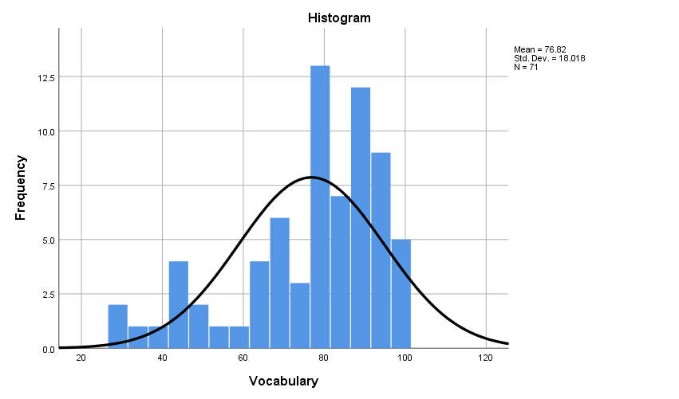
Figure 1. The Frequency Analysis of Vocabulary Mastery
The result of writing ability test showed that 0 student was in very poor category with percentage 0%. 0 student were in poor category with percentage 0 %. 8 students were in average category with percentage 11%. 57 students were in good category with percentage 79 % and 8 students were in very good category with percentage 11 %.
Table 3. The Score Distribution for Writing Ability
Category | Score | Writing Ability
 |  | Frequency | Percentage
Very Good | 86-100 | 7 | 10%
Good | 71-85 | 57 | 79%
Average | 52-70 | 8 | 11%
Poor | 36-51 | 0 | 0%
Very Poor | 0-35 | 0 | 0%
Total |  | 72 | 100%

Furthermore, Figure 2 below shows the writing ability.

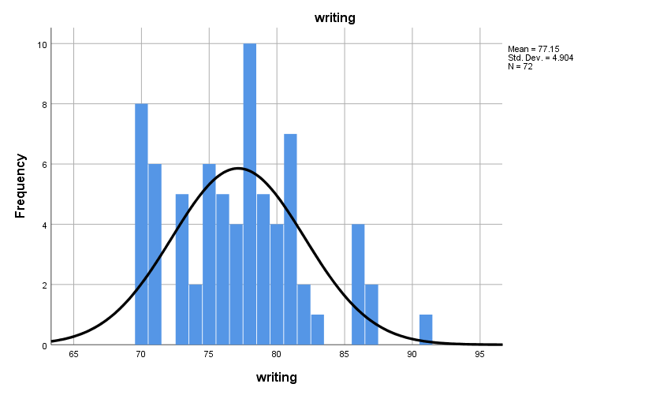

Figure 2. The Frequency Analysis of Writing Ability

3. Normality Test

In this research, to determine whether or not the data on writing ability and vocabulary mastery were distributed normally, the normality test was employed. It was calculated by using residual normality of Kolmogorov-smirnov that is presented table 4.

Table 4. The Normality Test

One-Sample Kolmogorov-Smirnov Test
 |  | Unstandardized Residual
N |  | 72
Normal Parameters^{a,b} | Mean | .0000000
 | Std. Deviation | 4.88068409
Most Extreme Differences | Absolute | .075
 | Positive | .075
 | Negative | -.062
Test Statistic |  | .075
Asymp. Sig. (2-tailed) |  | .200^{c,d}
a. Test distribution is Normal.
b. Calculated from data.
c. Lilliefors Significance Correction.
d. This is a lower bound of the true significance.

it was found that the data from the normality test of vocabulary mastery and writing ability showed 0.200 > 0.05, it means that the data was normally distributed

4. Correlation Analysis

Regression analysis was utilized in this research to look at how much vocabulary mastery contributed toward writing ability that is presented in Table 5.

Table 5. The Homogeneity Test
Model Summary
Model | R | R Square | Adjusted R Square | Std. Error of the Estimate
1 | .066ª | .004 | -.010 | 18.754
a. Predictors: (Constant), writing

Based on the table above, it was found that the correlation value (R) was .066 from the output data, the coefficient of determination (R Square) was .004 it means that the contribution of vocabulary mastery toward writing ability was .004. It could be concluded that vocabulary mastery only contributed as much as 0.04% toward writing ability.

5. Regression Analysis

Regression analysis was utilized in this research to look at how much vocabulary mastery contributed toward writing ability that is presented in Table 6.

Table 6. Regression Analysis
Model Summary
Model | R | R Square | Adjusted R Square | Std. Error of the Estimate
1 | .066ª | .004 | -.010 | 18.754
a. Predictors: (Constant), writing

Based on the table above, it was found that the correlation value (R) was .066 from the output data, the coefficient of determination (R Square) was 0.004 it means that the contribution of vocabulary mastery toward writing ability was 0.004. It could be concluded that vocabulary mastery only contributed as much as 0.04% toward writing ability.

CONCLUSION
Two conclusions could be made in light of the study's findings and interpretation. First, correlation coefficient was .030 it indicated in low category of the correlation coefficient. It could be assumed that the score of vocabulary mastery could not be influenced by the score of writing ability. So, Ho 1 (null hypothesis) was accepted and Ha1 (alternative hypothesis) was rejected.
Second, regression analysis revealed that the output data had a correlation value (R) of .066 and a coefficient of determination (R Square) of.004. It indicates that mastery of language contributed.004 to writing skill. It could conclude that the contribution of language mastery on writing skill was only 0.04%. It indicates that the null hypothesis (Ha2) was rejected and the alternative hypothesis (Ho2) was accepted.
Teachers must to take an active part in encouraging students to write better and expand their vocabulary. Then, students should work harder to improve their writing and vocabulary. To succeed, students must enhance their vocabulary mastery and writing abilities. Also, Institution needs more media and facilities should be provided by the school to assist the teaching and learning process; teachers and the institution should work together to achieve educational goals. Finally, the researcher wants to advise other researchers to be able to control the classroom situation in the learning process so that they can focus on learning and obtain satisfactory result

REFERENCES
Adler, A. (2017). Positive education: Educating for academic success and for a fulfilling life. Papeles del psicólogo, 38(1), 50-57.
Anggraini, R., Rozimela, Y., & Anwar, D. (2020). The effects of collaborative writing on EFL learners' writing skills and their perception of the strategy. Journal of language teaching and research, 11(2), 335-341.
Cote, C. (2021, December 14). What is Regression Analysis in Bussiness Analytics? Retrieved Januari 17, 2024
Dalimunthe, M. R. (2021). The Effect Of Using Sequence Picture On Students’writing Descriptive Text At The Xi Student Of Sma Sista Kampus Padangsidimpuan. Jurnal Liner (Language Intelligence and Educational Research), 4(2), 13-26.
Firman, F., Mirnawati, M., Sukirman, S., & Aswar, N. (2020). The Relationship Between Student Learning Types and Indonesian Language Learning Achievement in FTIK IAIN Palopo Students. Jurnal Konsepsi, 9(1), 1-12.
Fraenkel, J. R., Wallen, N. E., & Hyun, H. H. (2012). How to evaluate research in education (8th ed.). New York, NY: McGraw-Hill.
Haryadi, R. N., Endah, J., & Dalimunthe, L. (2021). The Effects Of Vocabulary And Grammar Mastery On Students’writing Skill In Descriptive Text (Surveys at Private Junior High Schools in Serang Banten). JLE: Journal of Literate of English Education Research Program, 2(02), 46-54.
Irawan, R. (2023). The Use of Short Animated Movie to Improve Students’ Skill in Writing Descriptive Text. Didascein: Journal of English Education, 4(1), 60-67.
Laili, E. N. (2022). The Correlation Between Students'vocabulary Mastery And Writing Skill At Skm Negeri 2 Ponorogo (Doctoral Dissertation, Iain Ponorogo).
Malik, M. (2019). Writing Skills Development among Students with Deafness at Elementary Level. Bulletin of Education and Research, 41(1), 1-16.
Obilor, E. I. (2023). Convenience and purposive sampling techniques: Are they the same. International Journal of Innovative Social & Science Education Research, 11(1), 1-7.
Rahmati, U. (2018). The Correlation Between Vocabulary Mastery And Students' Writing Skill (Doctoral dissertation, UIN Ar-Raniry Banda Aceh).
Randika, A. (2018). The Correlation Between Grammatical Mastery And Descriptive Writing Mastery Of The Tenth-Grade Students Of Sma Negeri 1 Indralaya.
Sahalluddin, M., & Akbariah, Y. (2023, July). 121. Improving Student’s Ability in Writing Descriptive Text through Picture Series. In Prosiding Seminar Nasional Pendidikan Profesi Guru (Vol. 1, No. 1, pp. 1105-1112).
Sari, S. N., & Aminatun, D. (2021). Students’perception on the use of English movies to improve vocabulary mastery. Journal of English language teaching and learning, 2(1), 16-22.
Soma, R. (2025). Using Youtube Videos to Enhance The EFL Students’ Vocabulary Mastery. Didascein: Journal of English Education, 6(1), 38-47.
Toba, R., & Noor, W. N. (2019). The current issues of Indonesian EFL students’ writing skills: Ability, problem, and reason in writing comparison and contrast essay. Dinamika Ilmu, 19(1), 57-73.
Ulfa, F., Sudrajad, W., & Sulistyaningsih, S. (2023). Increasing Student’s Ability to Write Descriptive Text Using the Brainstorming Method. International Journal of English and Applied Linguistics (IJEAL), 3(2), 109-118

