CULTIVATING STUDENTS’ SPEAKING SKILLS THROUGH THE THREE-STEP INTERVIEW TECHNIQUE AT THE ELEVENTH GRADERS OF SMK PGRI 2 PALEMBANG

ABSTRACT: This research was aimed to find out if there was a significant difference in speaking skill between the eleventh-grade students of SMK PGRI 2 Palembang who were taught by using the Three-step Interview technique and those who were not. Experimental research was used in this research. There were 42 students in the sample, 22 students for the experimental group and 20 students for the control group. The sample was taken by using purposive sampling. The method of this research used quantitative with a quasi-experimental design, the data was collected by using the speaking test. The data were analyzed using the Wilcoxon signed-rank test and Mann-Whitney U test to verify the hypotheses. Based on the data analysis, there was a significant improvement in speaking skill. It was proved by the result of the Wilcoxon Signed-rank test the value Asymp.Sig. (2-tailed) of 0.000 < 0.05. It indicated that students' speaking skill was improved. Also, it was proved by the result of Mann Whitney U test the significant U-value of 169.500 and W-value of 379.500. If converted to Z value, the amount was -1.304. it can be seen that the value Asymp.Sig. (2-tailed) of 0.000. So, it can be concluded that 0.000 < 0.05, and the Mann-Whitney U test showed that the coefficient was higher than the alpha value, therefore the hypothesis was not accepted or there was no significant difference on students' speaking skill after using Three-step Interview technique. In short, that the alternative hypothesis was rejected and null hypothesis was accepted.
.
Keywords: Three-Step Interview technique, speaking skill, experimental design

INTRODUCTION
The era of globalization is highly competitive. English has grown in importance as a communication language and as a tool that promotes globalization (Hamsia, 2018). Employers are increasingly requiring employees to satisfy a certain level of English proficiency, according to Nickerson at all (2011). In Asia, many multinational firms (MNCs) continue to operate in their native tongues. Because English is more in line with MNCs operating in other regions of the world, Harzing and Pudelko (2013) found that 41% of Asian companies polled used it, indicating a shift in favor of English as the corporate language.
Additionally, Richard and Renandya (2002) noted that English is used for communication in a variety of contexts, including international relations, commerce, sports, education, tourism, and transportation. As a result, English is now required of Indonesian students (Harmer, 2011). Following a 1967 decision by the Minister of Education and Culture, English is now formally taught as a foreign language in Indonesian schools. The study of English is thought to be crucial for the international adoption and advancement of science, technology, and the arts and culture (Yulizar, 2022). For this reason, English has become a required subject in Indonesia in order to establish contact, along with the evolution of the language among the country's successors and the changing periods (Yulizar, 2022). Speaking is a productive talent that includes meaning-conveying verbal utterances, according to Brown (2004). A person may ask questions or communicate thoughts or feelings. However, speaking English is far more challenging than speaking their native tongue, which makes it more challenging to help pupils improve their English-speaking abilities. Speaking is particularly important for people's interactions, as they speak every day and everywhere, according to Harmer (2011). Speaking is the oral exchange of concepts and messages. We should utilize the language in authentic conversations and advise students to follow suit if we wish to motivate them to speak in English.
Furthermore, speaking is an essential ability for interacting and communicating with others, according to Muhayyang and Amin (2017). Speaking, according to Cameron (2001), is the active use of language and meaning negotiation to convey meanings that are understandable to others. Furthermore, speaking is an interactive process of meaning construction that includes information production, reception, and processing, according to Luoma (2004). Speaking, then, is the oral exchange of ideas and messages, and it is a productive skill that involves meaning-conveying vocal utterances.
However, a lot of teachers discover that their pupils' speaking abilities are still lacking. The majority of students believe that speaking is a complicated endeavor. Many kids still struggle with their speaking abilities. The low achievement of the pupils' speaking skills is influenced by numerous internal and external factors (Mai, 2017). Affective variables, performance conditions, family issues, the environment, and society are examples of external factors. Schools, instructors, and staff are examples of social environment components that have a big impact on students' motivation and learning activities (Mai, 2017). She added that all aspects of language competency are improved by internal factors, including students' speaking talents, motivation, attitude, and study habits, as well as internal factors like vocabulary, grammar, pronunciation, and fluency. According to Januariza & Hendriani (2016), internal issues including anxiety, shyness, lack of confidence, and fear of making mistakes have a big impact on language acquisition and should be addressed by students to maximize success.
On July 16th 2024, the researcher interviewed who were English teacher of grade eleven TKJ 2 and 3 at SMK PGRI 2 Palembang. The English teacher said that there were some students lack of the courage to pronounce English words, lack of English vocabulary mastery, lack of motivation to speak and they did not know how to start a conversation will with their partner.
Many studies have investigated how to overcome speaking problems, one of which is learning techniques. According to Lam (2020), the need for classroom activities for teaching speaking is a basis for designing an interesting learning atmosphere. The teacher needs to create meaningful learning activities that support students in practicing speaking. One of the strategies that can help the students actively practice speaking is the Three Step Interview technique.
Three-step interview is one technique that can be used to encourage students to share their thoughts, ask questions, and take notes (Rolhelser, 2006). Many studies have been conducted to investigate the three-step interview technique related to speaking ability. The learning strategy using three-step interviews is considered effective because students can express their language skills freely and
courageously (Маса, 2020).
The Three Step Interview (TSI) technique is a valuable tool for teaching and learning a language. It has been shown to significantly improve students' speaking skills by providing oral communication tasks, promoting personal and social skills, and making students familiar with each other. However, there are some disadvantages to the TSI technique, such as students missing attention during interviews and difficulty keeping the current discussion going. Despite these challenges, the TSI technique can still be used in the learning process to help students overcome learning disabilities such as attention span issues and difficulty keeping conversations going. Interviews provide a conducive environment for conversation, creating simultaneous accountability and motivating students to share and apply different thinking and questioning tasks. The TSI technique also includes interactive activities that support teaching speaking. By applying the TSI technique, students spontaneously learn when and how to say and speak in English. The researchers conducted a study titled "Cultivating Students' Speaking Skills through Three Steps Interview Technique at the Eleventh Graders of SMK PGRI 2 Palembang" to investigate the effectiveness of using TSI in the speaking class.

METHODOLOGY
The researcher used quasi-experimental research with a non-equivalent control group design. According to Creswell (2012), a quasi-experimental design has both a pre-test and a post-test, but a nonrandom assignment of subjects. The design involves the experimental and control groups.
A research variable is a characteristic or attribute of an individual or organization that can be measured or observed and varies among the people being studied. There are two types of variables: independent variables, which influence an outcome or dependent variable, and dependent variables, which are influenced by the independent variable. In this research, the independent variable was the Three Step Interview technique, while the dependent variable was speaking skills.
A population is a group of individuals who have the same characteristics (Cresswell, 2012). The population of this study was all the eleventh-grade students of SMK PGRI 2 Palembang in the academic year 2024/2025. Table 2 presents the distribution of the population with a total number of 111 students.
A sample is a small proportion of the population selected for observation. In choosing the sample for the research, the researcher used purposive sampling which is a type of non-probability sampling technique. In non-probability sampling, the researcher selects individuals because they are available, convenient, and represent some characteristic the investigator seeks to research (Cresswell, 2012). In this research, the researcher took two classes which had similar characteristics. They were classes of XI TKJ 2 and XI TKJ 3. They had the same problems dealing with speaking skills such as: lack of confidence in pronunciation and lack of vocabulary mastery. Table 3 presents the distribution of the sample.
In conducting the research, there were obstacles faced by students when the research was conducted, because the school was holding activities and participating in competitions: for XI TKJ 2 class there were 5 students were completing the school's AKM (minimum competency assessment) and 1 student was participating in a national swimming competition in Jakarta. For XI TKJ 3 class, there were 6 students were completing the school's AKM (minimum competency assessment) and 2 students were missing without notice. During the pre-test and post-test, there were 6 students of XI TKJ 2 and 8 students of TKJ 3 who could not complete the pre-test and post-test session.
Therefore, the sample who could join the treatment session were 22 students for the experiment group and 20 students for the control group.
A test must be reliable and valid to measure the intended outcome. Validity refers to the correctness, meaningfulness, and usefulness of inferences researchers make based on collected data. Content validity is the degree to which a sample of items represents an adequate operational definition of the construct of interest. This study used content validity, which is expert judgment on the relevance and sampling of test
contents to a specific topic. Content validity ensures that the items of the instruments match the teacher's syllabus or curriculum. The researcher made the test specification based on learning outcomes and validated the speaking test to a validator before used.
A normality test was used to determine whether a data set is well modelled by a normal distribution or not. In analyzing the normality of the data from the pretest and post-test of the experimental and control groups, the researcher used the Kolmogorov Smirnov test with SPSS 24. If the value is lower than 0.05, it indicates that the data are not normal. If the value is higher than 0.05, it indicates that the data is normal.
Homogeneity of variance is the assumption that the spread of scores is roughly equal in different groups of cases, or more generally that the spread of scores is roughly equal at different points on the predictor variable. Field (2009) In measuring the homogeneity test, the researcher used Levene Statistics in SPSS program software. Homogeneity test is used to determine whether samples are drawn from populations that are significant to each other. The data can be classified as homogeneous when the Levene T-test coefficient is greater than 0.05.
The researcher employed the Wilcoxon Signed-rank test to determine the efficacy of the Threestep Interview technique because the data were not normally distributed. Field (2018) describes the Wilcoxon Signed-rank test as a nonparametric test that finds the difference between two related samples. Since it doesn't presuppose normalcy in the data, it is comparable to the dependent test.
According Field (2018) stated that the Mann Whitney U test is a non-parametric test that is used when the independent t-test cannot be conducted because the normality assumptions are not met. It searches for differences between two independent samples. Unlike the independent t-test, which looks for differences between the means of two groups, the Mann Whitney U test does not do this. Rather, it looks for variations between the medians of the two groups.

RESULT AND DISCUSSION
The Result of Pre-test and Post-test for Experimental and Control Group.
Pre-test and post-test were administered to the experimental and control group to examine their speaking achievement before and after the treatment session. Based on the pre-test results of the experimental group, the highest score was 34, the lowest score was 20, and the mean score was 24.09 with standard deviation was 3.927. Then, in the post-test of the experimental group, the highest score was 56, the lowest score was 40, and the mean score was 45.73 with standard deviation 4.506. Next, in the pre-test of the control group, the highest score was 28, the lowest score was 20, and the mean score was 22.90 with standard deviation was 2.936. Finally, in the post-test of the control group, the highest score was 52, the lowest score was 40, and the mean score was 40.00 with standard deviation was 3.893.
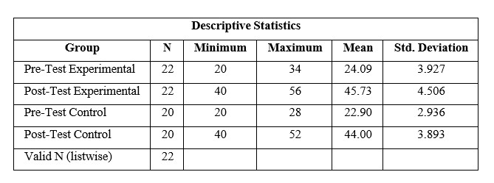
A normality test is used to determine whether a data set is well modelled by a normal distribution or not. The normality test was done using Kolmogorov Smirnov.

The Result of the Normality Test
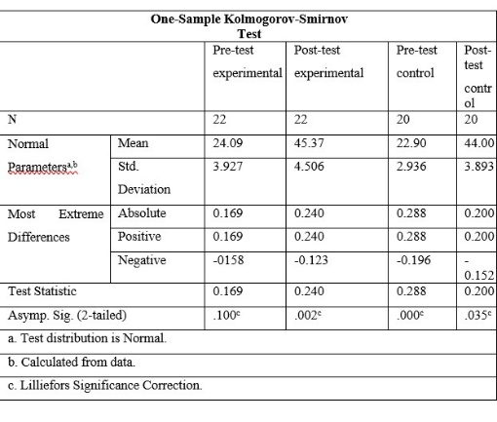

Based on the normality test of the pre-test experimental group, the significance coefficient (sig 2-tailed) of the Kolmogorov Smirnov test in the pre-test was 0.100, which was greater than 0.05. It means data of the experimental group pre-test was normally distributed. For post-test data of experimental group, the significant value of normality test was 0.002, which was less than 0.05. It indicates that the post-test data of experimental group was not normally distributed.
Based on the normality data of the control group post-test, the significance coefficient (sig 2-tailed) of the Kolmogorov Smirnov test was 0.000, which was less than 0.05. For the post-test data of control group, the significant value of normality test was 0.035. Which was less than 0.05. It indicates that data was not normally distributed for post-test data of control group.
Homogeneity of variance is the assumption that the spread of scores is roughly equal in different groups of cases, or more generally that the spread of scores is roughly equal at different points on the predictor variable.
Before administering inferential analysis, the researcher examined the homogeneity of the data for post-tests of both experimental and control groups using Levene T- Test statistics to see whether or not the data are homogeneous.

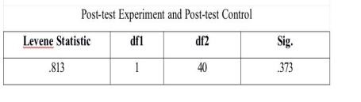

Based on the homogeneity test of the post-test results of both groups, for the post-test score of the result of homogeneity showed that the significance coefficient (sig 2-tailed) of the Levene Statistics test from the post-test of both groups was 0.373. Because the significance coefficient was greater than 0.05, it could be concluded that the data of both groups are homogeneous.
The Wilcoxon Signed-rank test is used to analyze the results of paired observations of two data whether there is a difference or not. This test is an alternative to the Paired Sample T-Test if the data is not normally distributed.
Based on Table 16, the Asymp.sig. (2-tailed) value is 0.000. Because the coefficient of 0.000 <0.05, it can be concluded that "the hypothesis is accepted". This means that there was a significant difference in students' speaking achievement in the pre-test and post-test. Thus, it can be concluded that "there was a significant improvement in the speaking skills of class XI students of SMK PGRI 2 Palembang after implementing the Three-step Interview technique.

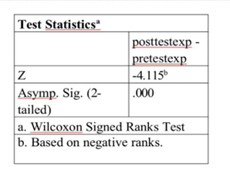

The Mann-Whitney test aims to determine whether there is a difference in the mean of two independent samples. The MannWhitney U test is used as an alternative to the independent t-test, if the research data is not normally distributed. The decision-making criteria for the Mann-Whitney U test are if the Asymp.sig value <0.05 then the alternative hypothesis is accepted and if the Asymp.sig value >0.05 then the alternative hypothesis is rejected. The U value is 169.500 and the W value is 379.500. If converted to the Z value, the value is -1.304. The Asymp.Sig. (2-tailed) value is 0.192. Thus, it can be concluded that 0.192>0.05, and the alternative hypothesis is not accepted. It means that there was no significant difference in the speaking skills between the students in the experimental group and the students in the control group.

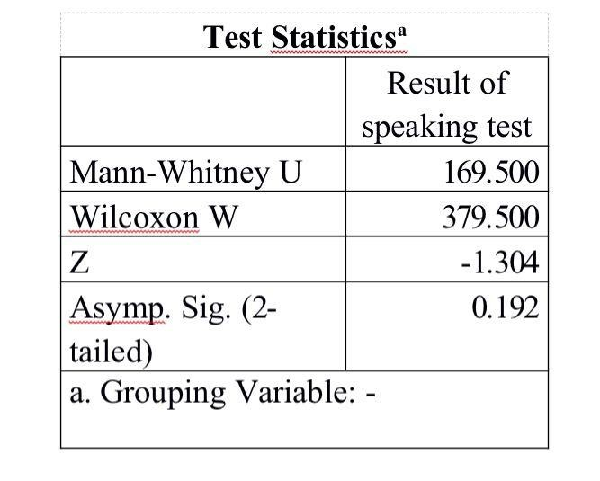

CONCLUSION
Based on the research significant difference on students' findings, two conclusions can be speaking skill after using Three-step drawn based in the finding and Interview technique. In short, that the interpretation of this research. First, alternative hypothesis was rejected from the calculation of the Wilcoxon and null hypothesis was accepted. Signed Ranks test, the results of the Wilcoxon Signed Ranks test by comparing the Sig value and the alpha value revealed that the coefficient of Wilcoxon Signed Ranks test was lower than alpha value. It means that the alternative hypothesis was.

REFERENCES
Brown, M. J. (2004). Guidelines for management of hypertension: report of the fourth working party of the British Hypertension Society, 2004—BHS IV. Journal of human hypertension.
Creswell, J. (2012). Best practices in mixed methods for quality of life research. Quality of life Research.
Field, M. (2009). Symmetry in chaos: a search for pattern in mathematics, art, and nature. Society for Industrial and Applied Mathematics.
Hamsia, W. (2018). Developing students’speaking ability through story completion. Jo-ELT (Journal of English Language Teaching) Fakultas Pendidikan Bahasa & Seni Prodi Pendidikan Bahasa Inggris IKIP, 5(1), 57-64.
Harmer, (2011). Rhythmic growth explained by coincidence between internal and external cues. Nature.
Harzing, A. W., & Pudelko, M. (2013). Language competencies, policies and practices in multinational corporations: A comprehensive review and comparison of Anglophone, Asian, Continental European and Nordic MNCs. Journal of World Business, 48(1), 87-97.
Januariza, Y., & Hendriani, S. (2016). Student’anxiety in learning speaking. Proceedings of ISELT FBS Universitas Negeri Padang, 4(2), 468474.
Lam, K. F. (2020). Validation of the English and Mandarin versions of the Fear of Cancer Recurrence Inventory in an Asian population. Journal of Health Psychology, 25(5), 617-628.
Luoma, S. (2004). Assessing speaking. Cambridge university press.
Maca, S. (2020). Teaching English speaking skill through pair and group interview techniques. Ethical Lingua: Journal of Language Teaching and Literature, 7(2), 329-337.
Mai, T. D. (2017). Reconfigurable emulator for photovoltaic modules under static partial shading conditions. Solar Energy, 141, 256-265.
Muhayyang, M., & Amin Rasyid, M. (2017). Integrating Language Skills Into Points Of Discussion: An Interpersonal Communication Approach.
Nickerson, C., Ebel, R., Borchers, A., & Carriazo, F. (2011). Major uses of land in the United States, 2007.
Richard, J. C., & Renandya, W. A. (2002). Approaches to teaching. Methodology in language teaching: An anthology of current practice, 1-5.
Rolheiser-Bennett, N. C. (2006). Four models of teaching: A meta-analysis of student outcomes (strategies, memory, cooperative learning, synectics). University of Oregon.
Yulizar, I (2022). Mengapa Bahasa Inggris Menjadi Mata Pelajaran Wajib Di Indonesia. Tarbiyah bil Qalam: Jurnal Pendidikan Agama dan Sains, 6(2), 25-38.

