CULTIVATING STUDENTS’ SPEAKING SKILLS THROUGH THE THREE-STEP INTERVIEW TECHNIQUE AT THE ELEVENTH GRADERS OF SMK PGRI 2 PALEMBANG

ABSTRACT: This research was aimed to find out: 1) if there was a significant improvement in speaking skills among the experimental group and 2)if there was a significant difference in speaking skill between the experimental group and the control group. Experimental research was used in this research. There were 42 students in the sample, 22 students for the experimental group and 20 students for the control group. The sample was taken by using purposive sampling. The method of this research used quantitative with a quasi-experimental design. the data was collected by using the speaking test. The data were analyzed using the Wilcoxon signed-rank test and Mann-Whitney U test since the data were not normally distributed. The Wilcoxon Signed-rank test results showed that there was a significant improvement in speaking skill among the experimental group. the result of Mann Whitney U test the significant showed that t there was no significant difference on students' speaking skill between the experimental group and the control group. . …
.
Keywords: Three-Step Interview technique, speaking skill, experimental design

INTRODUCTION
The era of globalization is highly competitive. English has grown in importance as a communication language and as a tool that promotes globalization (Hamsia, 2018). Employers are increasingly requiring employees to satisfy a certain level of English proficiency, according to Nickerson at all (2011). In Asia, many multinational firms (MNCs) continue to operate in their native tongues. Because English is more in line with MNCs operating in other regions of the world, Harzing and Pudelko (2013) found that 41% of Asian companies polled used it, indicating a shift in favor of English as the corporate language.
Additionally, Richard and Renandya (2002) noted that English is used for communication in a variety of contexts, including international relations, commerce, sports, education, tourism, and transportation. As a result, English is now required of Indonesian students (Harmer, 2011). Following a 1967 decision by the Minister of Education and Culture, English is now formally taught as a foreign language in Indonesian schools. The study of English is thought to be crucial for the international adoption and advancement of science, technology, and the arts and culture (Yulizar, 2022). For this reason, English has become a required subject in Indonesia in order to establish contact, along with the evolution of the language among the country's successors and the changing periods (Yulizar, 2022). Speaking is a productive talent that includes meaning-conveying verbal utterances, according to Brown (2004). A person may ask questions or communicate thoughts or feelings. However, speaking English is far more challenging than speaking their native tongue, which makes it more challenging to help pupils improve their English-speaking abilities. Speaking is particularly important for people's interactions, as they speak every day and everywhere, according to Harmer (2011). Speaking is the oral exchange of concepts and messages. We should utilize the language in authentic conversations and advise students to follow suit if we wish to motivate them to speak in English.
Furthermore, speaking is an essential ability for interacting and communicating with others, according to Muhayyang and Amin (2017). Speaking, according to Cameron (2001), is the active use of language and meaning negotiation to convey meanings that are understandable to others. Furthermore, speaking is an interactive process of meaning construction that includes information production, reception, and processing, according to Luoma (2004). Speaking, then, is the oral exchange of ideas and messages, and it is a productive skill that involves meaning-conveying vocal utterances.
However, a lot of teachers discover that their pupils' speaking abilities are still lacking. The majority of students believe that speaking is a complicated endeavor. Many kids still struggle with their speaking abilities. The low achievement of the pupils' speaking skills is influenced by numerous internal and external factors (Mai, 2017). Affective variables, performance conditions, family issues, the environment, and society are examples of external factors. Schools, instructors, and staff are examples of social environment components that have a big impact on students' motivation and learning activities (Mai, 2017). She added that all aspects of language competency are improved by internal factors, including students' speaking talents, motivation, attitude, and study habits, as well as internal factors like vocabulary, grammar, pronunciation, and fluency. According to Januariza & Hendriani (2016), internal issues including anxiety, shyness, lack of confidence, and fear of making mistakes have a big impact on language acquisition and should be addressed by students to maximize success.
On July 16th 2024, the researcher interviewed who were English teacher of grade eleven TKJ 2 and 3 at SMK PGRI 2 Palembang. The English teacher said that there were some students lack of the courage to pronounce English words, lack of English vocabulary mastery, lack of motivation to speak and they did not know how to start a conversation will with their partner.
Many studies have investigated how to overcome speaking problems, one of which is learning techniques. According to Lam (2020), the need for classroom activities for teaching speaking is a basis for designing an interesting learning atmosphere. The teacher needs to create meaningful learning activities that support students in practicing speaking. One of the strategies that can help the students actively practice speaking is the Three Step Interview technique.
Three-step interview is one technique that can be used to encourage students to share their thoughts, ask questions, and take notes (Rolhelser, 2006). Many studies have been conducted to investigate the three-step interview technique related to speaking ability. The learning strategy using three-step interviews is considered effective because students can express their language skills freely and
courageously (Маса, 2020).
The Three Step Interview (TSI) technique is a valuable tool for teaching and learning a language. It has been shown to significantly improve students' speaking skills by providing oral communication tasks, promoting personal and social skills, and making students familiar with each other. However, there are some disadvantages to the TSI technique, such as students missing attention during interviews and difficulty keeping the current discussion going. Despite these challenges, the TSI technique can still be used in the learning process to help students overcome learning disabilities such as attention span issues and difficulty keeping conversations going. Interviews provide a conducive environment for conversation, creating simultaneous accountability and motivating students to share and apply different thinking and questioning tasks. The TSI technique also includes interactive activities that support teaching speaking. By applying the TSI technique, students spontaneously learn when and how to say and speak in English. The researchers conducted a study titled "Cultivating Students' Speaking Skills through Three Steps Interview Technique at the Eleventh Graders of SMK PGRI 2 Palembang" to investigate the effectiveness of using TSI in the speaking class.

METHODOLOGY
Research Design
The researchers used quasi-experimental research with a non-equivalent control group design. According to Creswell (2012), a quasi-experimental design has both a pre-test and a post-test, but a nonrandom assignment of subjects. The design involves the experimental and control groups.
….

Population and Sample
A population is a group of individuals who have the same characteristics (Cresswell, 2012). The population of this study was all the eleventh-grade students of SMK PGRI 2 Palembang in the academic year 2024/2025 with a total number of 111 students.
In choosing the sample for the research, the researchers used purposive sampling which is a type of non-probability sampling technique. In non-probability sampling, the researcher selects individuals because they are available, convenient, and represent some characteristic the investigator seeks to research (Cresswell, 2012). In this research, the researcher took two classes which had similar characteristics. They were classes of XI TKJ 2 and XI TKJ 3. They had the same problems dealing with speaking skills such as: lack of confidence in pronunciation and lack of vocabulary mastery.

Data Collection Technique
In conducting the research, there were obstacles faced by students when the research was conducted, because the school was holding activities and participating in competitions: for XI TKJ 2 class there were 5 students were completing the school's AKM (minimum competency assessment) and 1 student was participating in a national swimming competition in Jakarta. For XI TKJ 3 class, there were 6 students were completing the school's AKM (minimum competency assessment) and 2 students were missing without notice. During the pre-test and post-test, there were 6 students of XI TKJ 2 and 8 students of TKJ 3 who could not complete the pre-test and post-test session.
Therefore, the sample who could join the treatment session were 22 students for the experiment group and 20 students for the control group.
The data were obtained by administering a spoken test. ….

Data Analysis Techniques
A normality test was used to determine whether a data set is well modelled by a normal distribution or not. In analyzing the normality of the data from the pretest and post-test of the experimental and control groups, the researcher used the Kolmogorov Smirnov test with SPSS 24. If the value is lower than 0.05, it indicates that the data are not normal. If the value is higher than 0.05, it indicates that the data is normal.
Homogeneity of variance is the assumption that the spread of scores is roughly equal in different groups of cases, or more generally that the spread of scores is roughly equal at different points on the predictor variable. Field (2009) In measuring the homogeneity test, the researcher used Levene Statistics in SPSS program software. Homogeneity test is used to determine whether samples are drawn from populations that are significant to each other. The data can be classified as homogeneous when the Levene T-test coefficient is greater than 0.05.
The researcher employed the Wilcoxon Signed-rank test to determine the efficacy of the Threestep Interview technique because the data were not normally distributed. Field (2018) describes the Wilcoxon Signed-rank test as a nonparametric test that finds the difference between two related samples. Since it doesn't presuppose normalcy in the data, it is comparable to the dependent test.
g Field (2018) stated that the Mann Whitney U test is a non-parametric test that is used when the independent t-test cannot be conducted because the normality assumptions are not met. It searches for differences between two independent samples. Unlike the independent t-test, which looks for differences between the means of two groups, the Mann Whitney U test does not do this. Rather, it looks for variations between the medians of the two groups.

RESULT AND DISCUSSION
Descriptive Statistical Data for Experimental and Control Group.
Pretest and post-test were administered to the experimental and control group to examine their speaking achievement before and after the treatment session. Based on the t results of the experimental group, the highest score was 34, the lowest score was 20, and the mean score was 24.09 with standard deviation was 3.927. Then, in the of the experimental group, the highest score was 56, the lowest score was 40, and the mean score was 45.73 with standard deviation 4.506.
Next, in the pretest of the control group, the highest score was 28, the lowest score was 20, and the mean score was 22.90 with standard deviation was 2.936. Finally, in the post-test of the control group, the highest score was 52, the lowest score was 40, and the mean score was 40.00 with standard deviation was 3.893. Table 1 presents the descriptive data of the experimental and the control group.
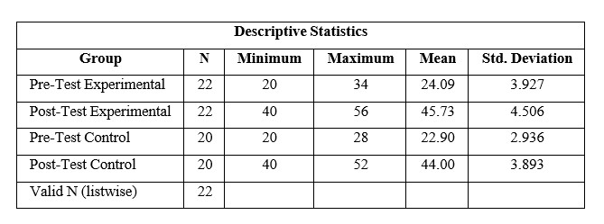

Normality Test Results
A normality test is used to determine whether a data set is well modeled by a normal distribution or not. The normality test was done using Kolmogorov Smirnov. Table 2 presents the normality test results.

Table 2. The Result of the Normality Test

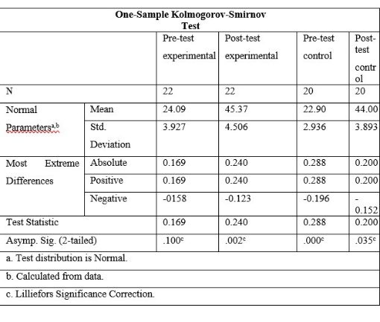

Based on the normality test of the experimental group pretest, the significance value (sig 2-tailed) of the Kolmogorov Smirnov test was 0.100, which was greater than 0.05. It means the data of the experimental group pre-test was normally distributed. For the post-test data of the experimental group, the significant value of normality test was 0.002, which was less than 0.05. It indicates that the post-test data of experimental group was not normally distributed.
following that, the normality test data of the control group pre-test, the significance coefficient (sig. 2-tailed) of the Kolmogorov Smirnov test was 0.000, which was less than 0.05. For the post-test data of control group, the significant value of normality test was 0.035Which was less than 0.05. It indicates that data werenot normally distributed for the pretest and the post-test data in the control group. …

Homogeneity Test Results
Homogeneity of variance is the assumption that the spread of scores is roughly equal in different groups of cases, or more generally that the spread of scores is roughly equal at different points on the predictor variable.
Before administering inferential analysis, the researcher examined the homogeneity of the data for post-tests of both experimental and control groups using the Levene T- Test statistics to see whether or not the data are homogeneous. Table 4 summarizes the homogeneity test results.
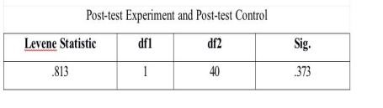

Based on the homogeneity test of the post-test results of both groups, it revealed that they were homogeneous. The homogeneity test results showed that the significance coefficient (sig 2-tailed) of the Levene Statistics test for the both of groups’ post test was 0.373. Because the significance coefficient was greater than 0.05, it could be concluded that the data of both groups are homogeneous.

The Results of the Wilcoxon Signed-rak test
The Wilcoxon Signed-rank test is used to analyze the results of paired observations of two data whether there is a difference or not. This test is an alternative to the Paired Sample T-Test if the data is not normally distributed.
The Wilcoxon Signed-rank test confirmed that the Asymp.sig. (2-tailed) value is 0.000, which was lower than0.05, itrevealed that there was a significant improvement in the experimental group’s speaking achievement . Thus, it can be concluded that "Three Step interview technique could enhance the eleventh grade students’ speaking skills of SMK PGRI 2 Palembang Table 5 presents the results of the Wilcoxon-Signed rank test.

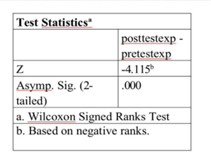

The Mann-Whitney Test
The Mann-Whitney test aims to determine whether there is a difference in the mean of two independent samples. The MannWhitney U test is used as an alternative to the independent t-test, if the research data is not normally distributed. The decision-making criteria for the Mann-Whitney U test are if the Asymp.sig value <0.05 then the alternative hypothesis is accepted and if the Asymp.sig value >0.05 then the alternative hypothesis is rejected. The U value was 169.500 and the W value was 379.500. If converted to the Z value, the value was -1.304. The Asymp.Sig. (2-tailed) value was 0.192. Thus, it can be concluded that 0.192>0.05,meaning that there was no significant difference in the speaking skills between the students in the experimental group and the students in the control group. Table 6 presents the results of the mann-Whitney test.

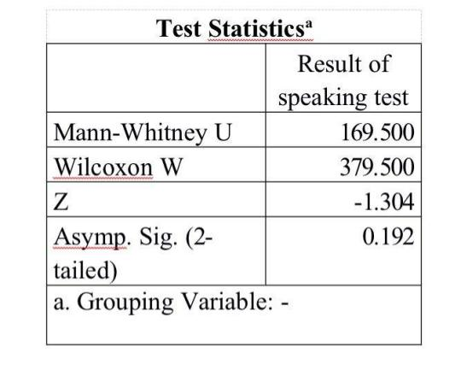

….… (Add Discussion section here)

CONCLUSION
Based on the research findings, two conclusions can be made. First, the students’ speaking skill was improved after using Three-step interview technique. Second, there was no difference in the speaking skill between the experimental and the control group. …

REFERENCES
Brown, M. J. (2004). Guidelines for management of hypertension: report of the fourth working party of the British Hypertension Society, 2004—BHS IV. Journal of human hypertension.
Creswell, J. (2012). Best practices in mixed methods for quality of life research. Quality of life Research.
Field, M. (2009). Symmetry in chaos: a search for pattern in mathematics, art, and nature. Society for Industrial and Applied Mathematics.
Hamsia, W. (2018). Developing students’speaking ability through story completion. Jo-ELT (Journal of English Language Teaching) Fakultas Pendidikan Bahasa & Seni Prodi Pendidikan Bahasa Inggris IKIP, 5(1), 57-64.
Harmer, (2011). Rhythmic growth explained by coincidence between internal and external cues. Nature.
Harzing, A. W., & Pudelko, M. (2013). Language competencies, policies and practices in multinational corporations: A comprehensive review and comparison of Anglophone, Asian, Continental European and Nordic MNCs. Journal of World Business, 48(1), 87-97.
Januariza, Y., & Hendriani, S. (2016). Student’anxiety in learning speaking. Proceedings of ISELT FBS Universitas Negeri Padang, 4(2), 468474.
Lam, K. F. (2020). Validation of the English and Mandarin versions of the Fear of Cancer Recurrence Inventory in an Asian population. Journal of Health Psychology, 25(5), 617-628.
Luoma, S. (2004). Assessing speaking. Cambridge university press.
Maca, S. (2020). Teaching English speaking skill through pair and group interview techniques. Ethical Lingua: Journal of Language Teaching and Literature, 7(2), 329-337.
Mai, T. D. (2017). Reconfigurable emulator for photovoltaic modules under static partial shading conditions. Solar Energy, 141, 256-265.
Muhayyang, M., & Amin Rasyid, M. (2017). Integrating Language Skills Into Points Of Discussion: An Interpersonal Communication Approach.
Nickerson, C., Ebel, R., Borchers, A., & Carriazo, F. (2011). Major uses of land in the United States, 2007.
Richard, J. C., & Renandya, W. A. (2002). Approaches to teaching. Methodology in language teaching: An anthology of current practice, 1-5.
Rolheiser-Bennett, N. C. (2006). Four models of teaching: A meta-analysis of student outcomes (strategies, memory, cooperative learning, synectics). University of Oregon.
Yulizar, I (2022). Mengapa Bahasa Inggris Menjadi Mata Pelajaran Wajib Di Indonesia. Tarbiyah bil Qalam: Jurnal Pendidikan Agama dan Sains, 6(2), 25-38.

