CULTIVATING STUDENTS’ SPEAKING SKILLS THROUGH THE THREE-STEP INTERVIEW TECHNIQUE AT THE ELEVENTH GRADERS OF SMK PGRI 2 PALEMBANG

Aldi¹, Yuyun Hendrety²
Universitas Tridinanti
Aldia7793@gmail.com

ABSTRACT: This research was aimed to find out if there was a significant difference in speaking skill between the eleventh-grade students of SMK PGRI 2 Palembang who were taught by using the Three-step Interview technique and those who were not. Experimental research was used in this research. There were 42 students in the sample, 22 students for the experimental group and 20 students for the control group. The sample was taken by using purposive sampling. The method of this research used quantitative with a quasi-experimental design, the data was collected by using the speaking test. The data were analyzed using the Wilcoxon signed-rank test and Mann-Whitney U test to verify the hypotheses. Based on the data analysis, there was a significant improvement in speaking skill. It was proved by the result of the Wilcoxon Signed-rank test the value Asymp.Sig. (2-tailed) of 0.000 < 0.05. It indicated that students' speaking skill was improved. Also, it was proved by the result of Mann Whitney U test the significant U-value of 169.500 and W-value of 379.500. If converted to Z value, the amount was -1.304. it can be seen that the value Asymp.Sig. (2-tailed) of 0.000. So, it can be concluded that 0.000 < 0.05, and the Mann-Whitney U test showed that the coefficient was higher than the alpha value, therefore the hypothesis was not accepted or there was no significant difference on students' speaking skill after using Three-step Interview technique. In short, that the alternative hypothesis was rejected and null hypothesis was accepted.
.
Keywords: Three-Step Interview technique, speaking skill, experimental design

INTRODUCTION
The time of global integration is extremely fierce. The significance of English has risen as a medium of communication and as an aid to globalization (Hamsia, 2018). Employers are progressively insisting that their workers meet specific standards of English skills, as noted by Nickerson et al. (2011). In Asia, numerous multinational corporations (MNCs) still conduct their business in their local languages. However, Harzing and Pudelko (2013) discovered that 41% of Asian firms surveyed have adopted English, reflecting a trend towards its use as the primary corporate language in alignment with MNCs in other parts of the globe. Furthermore, Richard and Renandya (2002) observed that English serves as a means of communication in many areas, such as global relations, business, athletics, education, travel, and transport. Consequently, Indonesian students are now required to learn English (Harmer, 2011). As per a decision made in 1967 by the Minister of Education and Culture, English is officially taught as a foreign language in schools across Indonesia. Learning English is regarded as vital for the global uptake and growth of fields like science, technology, and the arts and culture (Yulizar, 2022). Therefore, English has been made a compulsory subject in Indonesia to facilitate connections, alongside the development of the language among the younger generations and in response to changing times (Yulizar, 2022). According to Brown (2004), speaking is a productive skill that encompasses verbal expressions conveying meaning. A person can pose queries or share their thoughts and emotions. Nevertheless, communicating in English presents a greater challenge than in one’s mother tongue, which complicates efforts to enhance students' English-speaking skills. Harmer (2011) argues that speaking is crucial for personal interactions, as it occurs daily and in various settings. Speaking involves the verbal exchange of ideas and information. To encourage students to engage in English conversations, it is beneficial for us to use the language in real discussions and for us to prompt them to do the same.Furthermore, speaking is an essential ability for interacting and communicating with others, according to Muhayyang and Amin (2017). Speaking, according to Cameron (2001), is the active use of language and meaning negotiation to convey meanings that are understandable to others. Furthermore, speaking is an interactive process of meaning construction that includes information production, reception, and processing, according to Luoma (2004). Speaking, then, is the oral exchange of ideas and messages, and it is a productive skill that involves meaning-conveying vocal utterances.
However, many educators find that their students' oral communication skills are still underdeveloped. Most learners perceive speaking as a challenging task. Numerous students face difficulties in their speaking abilities. The limited success in students’ speaking skills is affected by various internal and external factors (Mai, 2017). External influences include emotional factors, circumstances of performance, family dynamics, the surrounding environment, and societal aspects. Components of the social environment, such as schools, teachers, and staff, significantly affect students' motivation and engagement in learning activities (Mai, 2017). She indicated that internal factors, such as students' verbal skills, enthusiasm, attitudes, and study practices, as well as elements like vocabulary, grammar, pronunciation, and fluency, enhance all facets of language proficiency. As per Januariza and Hendriani (2016), internal challenges like anxiety, shyness, low self-esteem, and fear of errors greatly influence language learning and should be addressed by students to achieve better outcomes.
On July 16, 2024, the researcher conducted interviews with the English teachers of the eleventh-grade TKJ 2 and 3 classes at SMK PGRI 2 Palembang. The teachers mentioned that some students lacked the confidence to pronounce English words, did not have a strong command of English vocabulary, showed little motivation to speak, and were unsure of how to begin conversations with their peers.
Numerous research studies have explored solutions to speaking difficulties, including learning techniques. Lam (2020) states that the necessity for classroom activities aimed at teaching speaking forms the foundation for creating an engaging learning environment. It is essential for teachers to design meaningful learning experiences that facilitate student practice in speaking. One effective approach that encourages students to actively engage in speaking is the Three Step Interview method.
The Three Step Interview is a technique that can be utilized to motivate students to articulate their opinions, pose questions, and make notes (Rolhelser, 2006). Several studies have examined the Three Step Interview method concerning oral proficiency. This learning strategy is viewed as effective since it allows students to demonstrate their language abilities openly and confidently (Маса, 2020).
The Three Step Interview (TSI) method is an effective resource for language education. It has been demonstrated to greatly enhance students' oral communication abilities by offering speaking tasks, fostering social interaction, and helping students get to know one another better. Nonetheless, there are some drawbacks associated with the TSI method, including students losing focus during interviews and challenges in maintaining the dialogue. Even with these obstacles, the TSI strategy can still be beneficial in education, assisting students in addressing learning challenges like attention issues and struggles with conversation flow. Interviews create a supportive setting for dialogue, establishing mutual responsibility and encouraging students to engage in various thinking and questioning exercises. The TSI approach also features engaging activities that aid in the instruction of speaking skills. By utilizing the TSI method, students learn to express themselves in English more naturally and appropriately. Researchers carried out a study called "Cultivating Students' Speaking Skills through Three Steps Interview Technique at the Eleventh Graders of SMK PGRI 2 Palembang" to explore the effectiveness of the TSI method within speaking classes.

METHODOLOGY
The researcher employed a quasi-experimental methodology featuring a non-equivalent control group setup. As stated by Creswell in 2012, this type of design includes both an initial and a final examination, alongside a non-random selection of participants. The framework includes both experimental and control groups.
A research variable pertains to a specific quality or feature of a person or organization that is measurable or can be observed, and that exhibits variation among the subjects in the study. There are two categories of variables: independent variables that affect the outcome or dependent variables, and dependent variables that are affected by independent variables. In the context of this study, the Three Step Interview method served as the independent variable, whereas the dependent variable was represented by speaking abilities.
A population is comprised of individuals who share common traits according to Creswell (2012). The subjects for this research included all eleventh-grade students attending SMK PGRI 2 Palembang during the 2024/2025 academic year. The population distribution is displayed in Table 2, which indicates a total of 111 students.
A sample refers to a smaller segment of the population chosen for analysis. For sample selection in this research, the researcher applied purposive sampling, which is a non-probability approach. In non-probability sampling, the researcher picks individuals based on their availability, convenience, or some characteristic relevant to the research focus, as noted by Creswell in 2012. In this study, two classes were selected that shared similar attributes: XI TKJ 2 and XI TKJ 3, both of which faced issues with speaking skills, including a lack of confidence in pronunciation and limited vocabulary mastery. The distribution of the selected sample can be found in Table 3.
While conducting the research, students experienced some challenges due to concurrent school events and competitions. In XI TKJ 2, five students were involved in the school’s AKM (minimum competency assessment), and one student was competing in a national swimming event in Jakarta. For XI TKJ 3, six students were also participating in the AKM, and two were absent without prior notice. During both the pre-test and post-test phases, six students from XI TKJ 2 and eight students from TKJ 3 were unable to finish the testing sessions.
Consequently, the number of students who participated in the treatment session included 22 from the experimental group and 20 from the control group. To accurately assess the desired outcomes, a test must possess both reliability and validity. Validity pertains to the accuracy, significance, and utility of the conclusions drawn by researchers from the gathered information. Content validity is the extent to which a selection of items adequately reflects the operational definition of the concept being studied. This research employed content validity, which is based on expert evaluation regarding the relevance and representation of the test items in relation to a specific subject. Content validity ensures that the assessment materials align with the teacher’s syllabus or curriculum. The test specifications were developed based on intended learning outcomes, and the speaking assessment was validated by an expert prior to its implementation.
A normality assessment was conducted to evaluate if a dataset accurately represents a normal distribution. To analyze the normal behavior of the data from the pretest and post-test results of both the experimental and control groups, the researcher utilized the Kolmogorov Smirnov test via SPSS 24. A value below 0. 05 suggests that the data is not normally distributed, while a value above 0. 05 implies that the data conforms to a normal distribution.
Homogeneity of variance refers to the expectation that the score distribution is approximately the same across various groups or, more broadly, that it is similar at different points along the predictor variable (Field, 2009). To assess homogeneity, the researcher applied Levene Statistics within the SPSS software. This test is employed to verify if the samples are from populations that are comparable to one another. The data is considered homogeneous when the Levene T-test coefficient exceeds 0. 05.
Due to the data not following a normal distribution, the researcher used the Wilcoxon Signed-rank test to evaluate the effectiveness of the Threestep Interview technique. According to Field (2018), the Wilcoxon Signed-rank test is a nonparametric method that assesses differences between two related samples. Since it does not assume normality in the data, it functions similarly to dependent tests.
Field (2018) explains that the Mann Whitney U test is a nonparametric test applied when normality requirements for an independent t-test are not satisfied. It identifies differences between two independent samples. Unlike the independent t-test, which focuses on the means of two groups, the Mann Whitney U test examines differences between the medians of those groups.

RESULT AND DISCUSSION
The Result of Pre-test and Post-test for Experimental and Control Group.
Pre-test and post-test were administered to the experimental and control group to examine their speaking achievement before and after the treatment session. Based on the pre-test results of the experimental group, the highest score was 34, the lowest score was 20, and the mean score was 24.09 with standard deviation was 3.927. Then, in the post-test of the experimental group, the highest score was 56, the lowest score was 40, and the mean score was 45.73 with standard deviation 4.506. Next, in the pre-test of the control group, the highest score was 28, the lowest score was 20, and the mean score was 22.90 with standard deviation was 2.936. Finally, in the post-test of the control group, the highest score was 52, the lowest score was 40, and the mean score was 40.00 with standard deviation was 3.893.
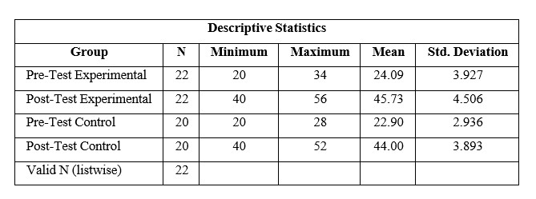
A normality test is used to determine whether a data set is well modelled by a normal distribution or not. The normality test was done using Kolmogorov Smirnov.

The Result of the Normality Test
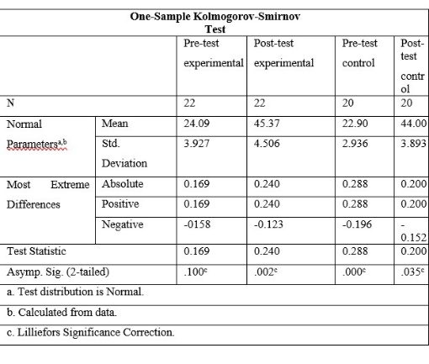

Based on the normality test of the pre-test experimental group, the significance coefficient (sig 2-tailed) of the Kolmogorov Smirnov test in the pre-test was 0.100, which was greater than 0.05. It means data of the experimental group pre-test was normally distributed. For post-test data of experimental group, the significant value of normality test was 0.002, which was less than 0.05. It indicates that the post-test data of experimental group was not normally distributed.
Based on the normality data of the control group post-test, the significance coefficient (sig 2-tailed) of the Kolmogorov Smirnov test was 0.000, which was less than 0.05. For the post-test data of control group, the significant value of normality test was 0.035. Which was less than 0.05. It indicates that data was not normally distributed for post-test data of control group.
Homogeneity of variance is the assumption that the spread of scores is roughly equal in different groups of cases, or more generally that the spread of scores is roughly equal at different points on the predictor variable.
Before administering inferential analysis, the researcher examined the homogeneity of the data for post-tests of both experimental and control groups using Levene T- Test statistics to see whether or not the data are homogeneous.

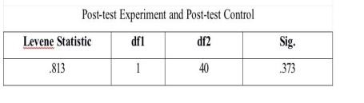

Based on the homogeneity test of the post-test results of both groups, for the post-test score of the result of homogeneity showed that the significance coefficient (sig 2-tailed) of the Levene Statistics test from the post-test of both groups was 0.373. Because the significance coefficient was greater than 0.05, it could be concluded that the data of both groups are homogeneous.
The Wilcoxon Signed-rank test is used to analyze the results of paired observations of two data whether there is a difference or not. This test is an alternative to the Paired Sample T-Test if the data is not normally distributed.
Based on Table 16, the Asymp.sig. (2-tailed) value is 0.000. Because the coefficient of 0.000 <0.05, it can be concluded that "the hypothesis is accepted". This means that there was a significant difference in students' speaking achievement in the pre-test and post-test. Thus, it can be concluded that "there was a significant improvement in the speaking skills of class XI students of SMK PGRI 2 Palembang after implementing the Three-step Interview technique.

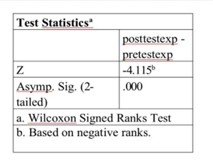

The Mann-Whitney test aims to determine whether there is a difference in the mean of two independent samples. The MannWhitney U test is used as an alternative to the independent t-test, if the research data is not normally distributed. The decision-making criteria for the Mann-Whitney U test are if the Asymp.sig value <0.05 then the alternative hypothesis is accepted and if the Asymp.sig value >0.05 then the alternative hypothesis is rejected. The U value is 169.500 and the W value is 379.500. If converted to the Z value, the value is -1.304. The Asymp.Sig. (2-tailed) value is 0.192. Thus, it can be concluded that 0.192>0.05, and the alternative hypothesis is not accepted. It means that there was no significant difference in the speaking skills between the students in the experimental group and the students in the control group.

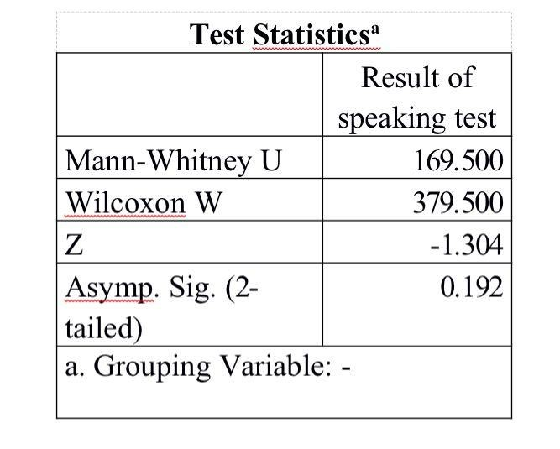

CONCLUSION
Based on the research significant difference on students' findings, two conclusions can be speaking skill after using Three-step drawn based in the finding and Interview technique. In short, that the interpretation of this research. First, alternative hypothesis was rejected from the calculation of the Wilcoxon and null hypothesis was accepted. Signed Ranks test, the results of the Wilcoxon Signed Ranks test by comparing the Sig value and the alpha value revealed that the coefficient of Wilcoxon Signed Ranks test was lower than alpha value. It means that the alternative hypothesis was.

REFERENCES
Brown, M. J. (2004). Guidelines for management of hypertension: report of the fourth working party of the British Hypertension Society, 2004—BHS IV. Journal of human hypertension.
Creswell, J. (2012). Best practices in mixed methods for quality of life research. Quality of life Research.
Field, M. (2009). Symmetry in chaos: a search for pattern in mathematics, art, and nature. Society for Industrial and Applied Mathematics.
Hamsia, W. (2018). Developing students’speaking ability through story completion. Jo-ELT (Journal of English Language Teaching) Fakultas Pendidikan Bahasa & Seni Prodi Pendidikan Bahasa Inggris IKIP, 5(1), 57-64.
Harmer, (2011). Rhythmic growth explained by coincidence between internal and external cues. Nature.
Harzing, A. W., & Pudelko, M. (2013). Language competencies, policies and practices in multinational corporations: A comprehensive review and comparison of Anglophone, Asian, Continental European and Nordic MNCs. Journal of World Business, 48(1), 87-97.
Januariza, Y., & Hendriani, S. (2016). Student’anxiety in learning speaking. Proceedings of ISELT FBS Universitas Negeri Padang, 4(2), 468474.
Lam, K. F. (2020). Validation of the English and Mandarin versions of the Fear of Cancer Recurrence Inventory in an Asian population. Journal of Health Psychology, 25(5), 617-628.
Luoma, S. (2004). Assessing speaking. Cambridge university press.
Maca, S. (2020). Teaching English speaking skill through pair and group interview techniques. Ethical Lingua: Journal of Language Teaching and Literature, 7(2), 329-337.
Mai, T. D. (2017). Reconfigurable emulator for photovoltaic modules under static partial shading conditions. Solar Energy, 141, 256-265.
Muhayyang, M., & Amin Rasyid, M. (2017). Integrating Language Skills Into Points Of Discussion: An Interpersonal Communication Approach.
Nickerson, C., Ebel, R., Borchers, A., & Carriazo, F. (2011). Major uses of land in the United States, 2007.
Richard, J. C., & Renandya, W. A. (2002). Approaches to teaching. Methodology in language teaching: An anthology of current practice, 1-5.
Rolheiser-Bennett, N. C. (2006). Four models of teaching: A meta-analysis of student outcomes (strategies, memory, cooperative learning, synectics). University of Oregon.
Yulizar, I (2022). Mengapa Bahasa Inggris Menjadi Mata Pelajaran Wajib Di Indonesia. Tarbiyah bil Qalam: Jurnal Pendidikan Agama dan Sains, 6(2), 25-38.

