Using Development of Scramble Sentences in Students’ Writing the procedural Text

ABSTRACT: The objective of this research was to find out The untences in students’ writing the procedural text.. The sample of this research was taken by using totaling sampling technique with 26 nursing students of the fourth semester. The data was obtained based on survey result of students’ writing in every meeting during that was from the June 5th to July 3rd, 2023 that consists of 5 days for obtaining the data. Then from the data analysis, it obtained that there was the good progress on students/ writing where the response by writing English related to the material since the frist day to the fifith The students’s wtiting showed the improvement of the score in every aspect such as rearrange the sentence showed from the lowest score in the first day was 60 and in the end of meeting the lowest score was 80, The good significant average of writing can be seen in fourth and fifth meeting where for example in the fourth meeting had average in explanation was 87,3 and in the fifth was 90. The students were helped by using this method or way to rearrange and develop the teks By using the scramble sentences lead them easily to explore and develop their writing, by having this method the students have framework or steps to added some information and more in writing
Keywords: writing, scramble sentence

Penggunaan Pengembangan Scramble Sentence dalam Menulis Teks Procedur Mahasiswa
ABSTRAK: Tujuan dari penelitian ini adalah untuk mengetahui Untences dalam siswa menulis teks prosedur. Sampel penelitian ini diambil dengan menggunakan teknik totaling sampling dengan 26 mahasiswa keperawatan semester empat. Data diperoleh berdasarkan hasil survey tulisan siswa pada setiap pertemuan selama 5 Juni sampai dengan 3 Juli 2023 yang terdiri dari 5 hari pengambilan data. Kemudian dari analisis data, diperoleh bahwa terdapat kemajuan yang baik pada siswa/penulisan dimana respon dengan menulis bahasa Inggris terkait dengan materi sejak hari pertama hingga kelima Tulisan siswa menunjukkan peningkatan skor di setiap aspek seperti menyusun ulang kalimat tersebut terlihat dari skor terendah pada hari pertama adalah 60 dan pada akhir pertemuan skor terendah adalah 80, Rata-rata penulisan yang signifikan baik dapat dilihat pada pertemuan keempat dan kelima dimana misalnya pada pertemuan keempat memiliki rata-rata dalam penjelasan. adalah 87,3 dan yang kelima adalah 90. Siswa terbantu dengan menggunakan metode atau cara menyusun ulang dan mengembangkan teks ini dengan menggunakan pengacakan kalimat lead. mereka dengan mudah untuk mengeksplorasi dan mengembangkan tulisan mereka, dengan memiliki metode ini siswa memiliki kerangka atau langkah-langkah untuk menambahkan beberapa informasi dan lebih banyak lagi dalam tulisan
KataKunci: menulis, kalimat acak

INTRODUCTION
E
nglish is one of the languages ​​that is used as an international language and is used as one of the subjects/courses in schools and colleges. English is also a talent or skill that is considered important by people, so that not only students but people compete to master it by participating in training at language institutions. English is like any other language that has 4 abilities or skills in it, namely listening, reading, writing and speaking. These 4 abilities are very closely related where each ability will affect other abilities. In learning English, some people will focus on developing language skills, such as writing skills.
Writing is a way of communication through writing that is poured into media such as paper, pamphlets, social media from writers to readers. Chappell (2011) claims that the main factors that make writing so significant are: Writing is portable and permanent. It expresses what you think.
- Writing makes it easy for you to switch between facts, conclusions, and views without getting confused—or confusing your audience.
- Writing encourages the development of thoughtful questions.
- Explaining complex ideas to readers and yourself through writing improves your communication skills.
- Writing facilitates input from others.
- When you solicit input from others, writing helps you hone your ideas.
- When writing, you must consider the demands of your audience. Your ability to do so shows how adaptable and mature your mind is.
- Preserving your thoughts by writing them down allows you to think about them later.
- By outlining your thoughts in writing, you can judge their adequacy.
In addition, writing is a technique of placing ideas, interactions between writers and readers, growing and deepening the author's world view” (Brown, 2007). there is interaction between the reader and the writer in each piece of writing, the author's strategy when writing messages directs the reader to understand and get to the point where the use of tenses, vocabulary in the text. As Hedge (2000) says writing is the result of using message strategies to control the writing process, which is one of progressively evolving text. There is some action involved. Setting goals, generating ideas, organizing materials, choosing acceptable language, drafting, reading and evaluating them, and finally rewriting and editing is a sequence of actions, according to Hedge (2000). There are various stages in the writing process. According to Langan (2008), there are four fundamental stages of writing. Planning, drafts, revisions, and edits are under way. The first component is planning, which requires considering what ideas the writer has and what they will say or write. Drafting is the next step. At this point, the author is more concerned with the flow of writing than grammatical correctness. This is what authors usually refer to as their initial draft, which may go through multiple revisions. Purifying or contemplating comes next. What do you read that has been written by the author is the process of revising. In other words, authors evaluate their writing based on the comments provided and reach a final decision.
In simple writing, the writer can write down everything based on his thoughts or ideas, sometimes the writer only writes about daily life, experiences or even planning using the simple tense, but in good writing the writer must know about everything. aspects of writing such as content, organization and so on.
In line with Hughes (2003), there are five factors that must be considered in producing written work: (1) Content; “content” refers to how well students express their thesis statements and support them with supporting evidence; (2) Organization; "organization" refers to how skillfully the author uses the introduction, body, and conclusion. Also, the ideas are arranged logically; (3) Discourse is the use of subject sentences, paragraph coherence, transitions, discourse markers, cohesion, rhetorical norms, references, fluency, economy, and variations in writing; (4) vocabulary is a phrase that shows all the words that someone knows or uses. Writing must be meaningful and successful for writers to be able to make the right choices. (5) Correct spelling, punctuation, reference citations, neatness, and presentation are all aspects of the mechanics of writing. There are many options, including the use of personal experience, illustrations, facts, and opinions as well as descriptions, causes and effects, and comparisons and contrasts.
In an article, it is intended that the information from the author is conveyed and clear. However, in the use of skills in writing, most students have no self-confidence and lack of knowledge in good writing procedures.
According to Fahmi and Cynantia (2021) A few understudies can talk English familiarity and certainly, in spite of the fact that they have diffulties in passing on their composing aptitudes.But in the event that you'll aced in composing you may be simple aced the other abilities. In line, to Pamuji (2022), The students have difficulties when they want to write the paragraphs especially in English written. Sometimes they have many ideas and they don’t know how to produce them into English written.
The many types or forms of writing, texts, paragraphs make many students, especially nursing students, think that the forms of writing in English are the same, some forms of writing such as procedure text, narrative, descriptive, and others. Procedure text is text that is often encountered by health workers such as public health or nurses in providing information in carrying out something such as how to maintain cleanliness. Although this type of text is often found, in its use, students as writers have difficulty writing procedural texts in English. So in this case, the use of methods or strategies can be used by students in developing and increasing students' knowledge in writing procedural texts such as scrable sentences. Scrable sentences are sentences that are not arranged, and students can compose and develop them into paragraphs with aspects of procedural text techniques. And it is hoped that the use of the scramble sentence technique can help students improve their ability to write procedural texts for nursing students at Stik Bina Husada

METHODOLOGY
The researcher used survey study in conducting the present research. In this study, the researcher would like to find Using Development of Scramble Sentences in Students’ Writing the procedural Text. The researcher used the total sampling technique in this study. The study sample was from the 4th semesters of nursing students of STIK Bina Husada were 26 students. Since the researcher taught EFL in nursing of STIK Bina Husada, the researcher took the sample total was 26 from the total of the population. The sample as a target research as a result of survey in the class during the teaching and learning process and the sample interested in writing and they had the difficulties on writing. In the class the researcher conduct the research from June 5th to July 3rd, 2023
To collect the data, the researcher obtained the scoring of students’ writing achievement in five meetings, the written tests were given to the students by giving in each meetings by using development of scramble sentences, where the sentences were distributed with different topics in each meetings to the students. The scheme were as follows:

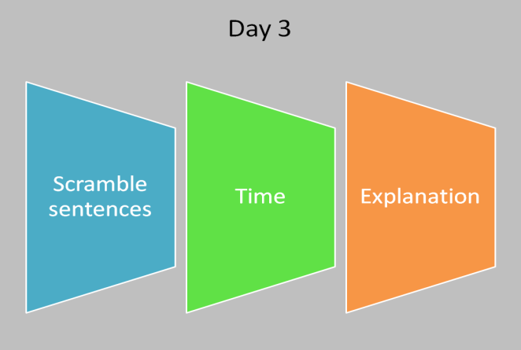
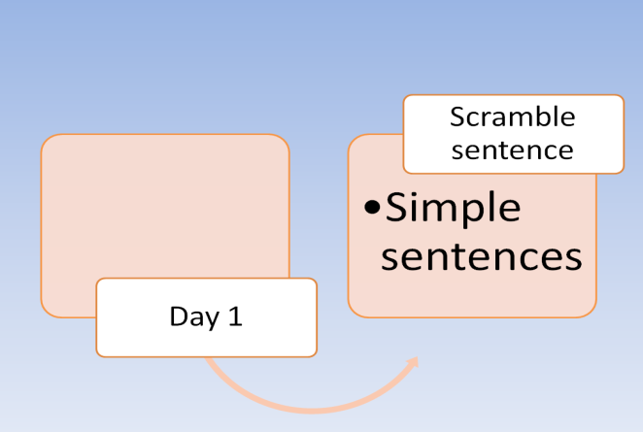

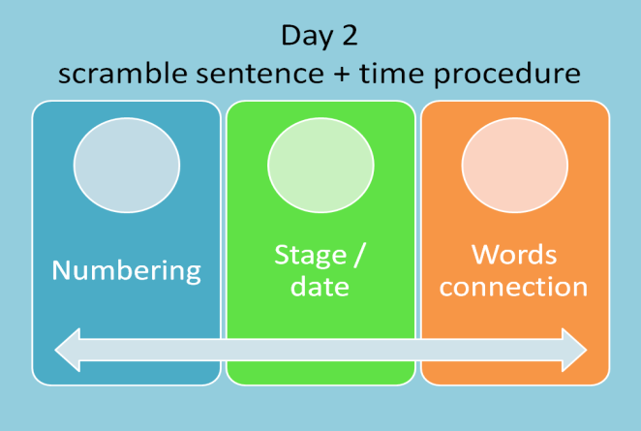
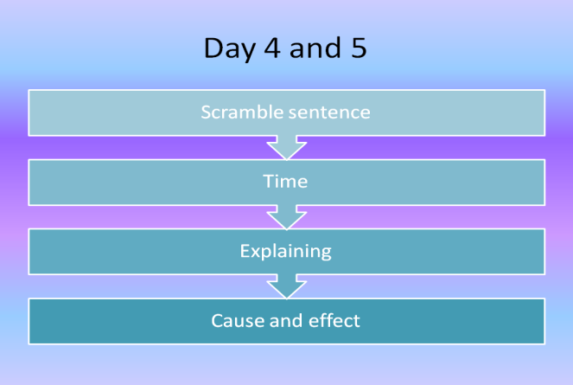

From the schemes, In the first day, the students were asked to rearrange the sentences into the good text of procedure. Continued to the second day, the students were given the information about time procedure, mainly numbering, stage and word connection that they can add into the sentences which they would arranged. In the third day the students had the knowledge about time (one, two, three, first, second, then, next) in adding the sentences and give a little explanation in after sentences which were they arranged. For the fourth and fifth meeting, the complex task are given to the students, from the previous meetings, the students added the reasons (cause and effect) as addition in after the explanation in every distribution of sentences.
For scoring the writing score the researcher used using a modified banded marking scheme as described by Brown (2007). In analyzing the data, the writing rubric was used to analyze students’ writing. There were several aspects that were used to analyze mainly vocabulary, structure, organization, content and mechanism where from the all aspects the possible maximum total score were 30.

Table 1. Writing rubric
No | Elements | Poor | Fair | Good | Very good
1 | Vocabulary | 1 – 2 | 3 – 4 | 5 – 6 | 7 – 8
2 | Structure | 1 | 2 – 3 | 4 | 5
3 | Organization | 1 – 2 | 3 – 4 | 5 – 6 | 7 – 8
4 | Content | 1 | 2 – 3 | 4 | 5
5 | Mechanics | 1 | 2 | 3 | 4

FINDINGS AND DISCUSSION
From the analyzing the data, the study found the important things. There were some important findings of this study.
First, From English writing score in the first day, there was obtained the highest score was 100, while the lowest score was 60 and the average score from 26 students were 90,7. From the first day, it found that most of the students were easily to rearrange the sentences into good aprropriate procedural teks where the students were distiributed the pieces of unarrange sentences of the teks but some students had difficulties, they made mistake to rearrange the sentences. It can be seen on the chart 1.
Chart 1
The Result of Writing Score

Second, From the second day there were 2 findings mainly, one, from the rearrange the sentences obtained the highest score was 100, while the lowest score was 65 and the average score from 26 students were 91,3. There was good improvement in lowest scrore from first day to second day. And two, in adding the time procedure in every sentences that they rearranged and rewrote, it found that most of students understood in using time procedure and had the average score was 94,2. . It can be seen on the chart 2
Chart 2
Result of Writing Score
Based On 2nd meetings

Third, From the third meetings, it obtained 3 findings mainly rearrange the sentences, time procedure usage and explanation addition, one, from rearrange the sentences obtained the highest score was 100, while the lowest score was 70 and the average score was 85. Two, the time procedure usage obtained the highest score was 100, while the lowest score was 70 and the average score was 96,1. Three, the explanation addition obtained the highest score was 100, while the lowest score was 60 and the average score was 83,8. In writing explanation in each sentences of procedural text, the students still had difficulties in grammar, and vocabullaries. It can be seen on the chart 3.
Chart 3
Result of Writing Score
Based On Third Meetings

Fourth, From the Fourth meetings, it obtained 4 findings mainly rearrange the sentences, time procedure usage, explanation addition and reason (cause and effect), one, from rearrange the sentences obtained the highest score was 100, while the lowest score was 75 and the average score was 93,3. Two, the time procedure usage obtained the highest score was 100, while the lowest score was 75 and the average score was 97,8. Three, the explanation addition obtained the highest score was 100, while the lowest score was 70 and the average score was 87,3. Four, the reason part obtained the highest score was 90, while the lowest score was 60 and the average score was 80,3. In writing explanation and reasons in each sentences of procedural text, the students still had difficulties in grammar, and vocabullaries.. It can be seen on the chart 4.
Chart 4
Result of Speaking Score
Based On Fourth Meetings

Fifth, From the Fifth meetings, it obtained 4 findings mainly rearrange the sentences, time procedure usage, explanation addition and reason (cause and effect), one, from rearrange the sentences obtained the highest score was 100, while the lowest score was 80 and the average score was 98. Two, the time procedure usage obtained the highest score was 100, while the lowest score was 80 and the average score was 98,4. Three, the explanation addition obtained the highest score was 100, while the lowest score was 70 and the average score was 90,1. Four, the reason part obtained the highest score was 90, while the lowest score was 75 and the average score was 86,7. In writing explanation and reasons in each sentences of procedural text, the students still had difficulties in grammar, and vocabullaries.. It can be seen on the chart 5.
Chart 5
Result of Writing Score
From Fifth Meetings

Discussion
To strengthen the value of this study, here are some interpretations based on the results of data analysis. Based on the results of the study, it was found that in writing test the students used Scramble sentences to help them easily in writing the procedural teks. In each meetings the students had several knowledge and in each emeetings the students showed the improvement of the score in every aspect such as rearrange the sentence showed from the lowest score in the first day was 60 and in the end of meeting the lowest score was 80, it meant that most of students understood to arrange the sentences even some of them still confused. And the main foccuss of this research was in the end of meetings, that the students were expected tobe able to explore their written by adding some explanation and reasons in each sentences that they arranged. The good significant average of writing can be seen in fourth and fifth meeting where for example in the fourth meeting had average in explanation was 87,3 and in the fifth was 90.
Based on the the scoring of writing the procedural teks, the result showed that most of the students were helped by using this method or way to rearrange and develop the teks \.
CONCLUSION
In this study, researcher aimed to determine the use of Development of Scramble Sentences in Students’ Writing the procedural Text
In this study the researcher collected the data of writing by distributed the tests in five meetings. From the data that obtained, the scoring of students showed the students got good score in their writing. By using the scramble sentences lead them easily to explore and develop their writing, by having this method the students have framework or steps to added some information and more in writing. And this method was useful to be used by teacher in teaching English Foreign Language in offline and online classes.

REFERENCE

Brown, H. D. (2000). Principles of language learning and teaching. New York: Pearson Education

Brown, H, D. (2001). Teaching by principles: an interactive approach to language pedagogy. (2nd Ed). New York: Pearson Education.

Brown, D. (2007). Teaching by principles: An interactive approach to language pedagogy. (3rd Ed.). New York: Longman University Press

Chappell, V (2011). What Makes Writing So Important?. Marquetee University.
http://www.marquette.edu/wac/WhatMakesWritingSoImportant.shtml
Accessed on February 27th, 2023

Fahmi, Sri & Cynantia Rachmijati. 2021. Improving Students’ Writing Skill Using Grammaly Application For Second Grade In Senior High School. Professional Journal of English Education, 4 (1). 69-74

Hedge, T (2000), Teaching and learning in the language classroom. Oxford: Oxford University

Hughes, Arthur. 2003. Testing for Language Teachers. Cambridge University Press

Langan, J. (2011). College Writing Skills with Readings-International Edition 8th Edition. New York: McGraw-Hill, Inc

Lume, M H (2022). The Effectiveness of Task-Based Language Teaching to Teach Speaking Skills. Journal of Languages and Language Teaching (1), 85 – 93.

Pamuji, A. (2022). Opinion Essays In Promoting Nursing Students' writing Achievement. Didascein: Journal of English Education, 3 (1), 7-13

Sholehah,M. (2022). Improving students’ writing ability in simple past and present perfect tense through teaching strategy of error recognition. INFERENCE: Journal of English Language Teaching, 5 (1), 49-55.

Tan, J, P (2012). The importance of writing well: a justification and how to guide.
Retrieved from http://people.uncw.edu/tanp/writingwell.html
Accessed on February 27th, 2023.

