IMPROVING THE REPORT TEXT LEARNING OUTCOMES OF TENTH GRADERS THROUGH THE DIFFERENTIATED LEARNING APPROACH

Yossi Stefani¹, Rudi Anton Simanjuntak², Ismail Petrus³
^{1,3}Universitas Sriwijaya, Indonesia
²SMA Negeri 4 Palembang, Indonesia
yossi.stefani@gmail.com
ABSTRACT: The using of the differentiated learning approach has become a popular trend in MERDEKA Curriculum. This study aimed to improve English learning outcomes in the subject of report text through the differentiated learning approach based on students' readiness. This study was collaborative classroom action research conducted in class XB at SMAN 4 Palembang with 34 students. Data for this research were obtained from tests conducted in each cycle, observations, tasks, and documentation. The data were analyzed qualitatively and quantitatively. Qualitative analysis involved data processing, reading, classifying, and interpreting, while quantitative data were analyzed using percentage analysis. The PTKK consisted of two cycles, starting with the pre-cycle. Initially, 12 students (35.3%) passed, while 22 students (64.7%) did not reach the Minimum Learning Mastery Standard (KKM) with an average score of 63.82. After Cycle I, the number of students who successfully completed the tasks increased to 15 (44.1%), with 19 students (55.9%) not reaching the target, and the average score improved to 71.17. In Cycle II, a significant improvement was observed, with 33 students (97%) reaching the KKM, and only 1 student (3%) did not pass, resulting in an average score of 89.11. This research indicates that the differentiated learning approach effectively enhances English learning outcomes in the subject of report text for students in class XB at SMAN 4 Palembang in the second semester, Academic Year 2022-2023.
Keywords: learning outcomes, report text, differentiated

MENINGKATKAN HASIL BELAJAR TEKS LAPORAN PADA SISWA KELAS X MELALUI PENDEKATAN PEMBELAJARAN BERDIFERENSIASI
ABSTRAK: Penggunaan pendekatan pembelajaran berdiferensiasi telah menjadi tren populer pada kurikulum MERDEKA. Penelitian ini bertujuan untuk meningkatkan hasil belajar Bahasa Inggris pada materi teks laporan melalui pendekatan pembelajaran berdiferensiasi berdasarkan kesiapan belajar. Penelitian ini merupakan penelitian tindakan kelas kolaboratif (PTKK) yang dilakukan di kelas XB SMAN 4 Palembang dengan 34 peserta didik. Data penelitian ini diperoleh dari hasil tes pada setiap siklus, observasi, tugas, dan dokumentasi. Data dianalisis secara kualitatif dan kuantitatif. Kualitatif dianalisis dengan mengolah data, membaca, mengklasifikasikan, dan menginterpretasikan. Data kuantitatif dianalisis melalui analisis persentase. PTKK terdiri dari dua siklus, dimulai dengan Pra-siklus. Pada awalnya, 12 peserta didik (35,3%) tuntas, namun 22 peserta didik (64,7%) belum tuntas mencapai target KKM dengan nilai rata-rata 63,82. Setelah Siklus I, jumlah peserta didik yang tuntas meningkat menjadi 15 (44,1%), dengan 19 peserta didik (55,9%) yang belum tuntas, dan nilai rata-rata 71,17. Pada Siklus II, terjadi peningkatan yang signifikan, dengan 33 peserta didik (97%) tuntas mencapai KKM dan hanya 1 peserta didik (3%) yang belum tuntas mencapainya, dengan nilai rata-rata 89,11. Penelitian ini membuktikan bahwa pendekatan pembelajaran berdiferensiasi efektif meningkatkan hasil belajar Bahasa Inggris pada materi teks laporan untuk peserta didik kelas XB SMAN 4 Palembang semester genap Tahun Pelajaran 2022-2023.
Kata Kunci: hasil belajar, teks laporan, berdiferensiasi
INTRODUCTION
L
earning activities are crucial aspects of educational development, meanwhile, educators are the key to the success of these activities. Ki Hadjar Dewantara, as the father of Indonesian education stated that the task of educators is to guide children to grow and develop according to their nature in achieving happiness and safety (Fitra, 2022, p. 251). According to the author, educators should have the ability and skills to guide students based on their interests, talents, and readiness so that the provided learning is targeted accurately, thus creating meaningful and enjoyable learning experiences.
An educator must be aware that each student has their uniqueness. Therefore, an educator must have good pedagogical skills because the quality of education and learning outcomes in schools is determined by the quality of educators. This will enable students to achieve their fullest potential. According to Surbakti and Panjaitan (2020, p. 66), the learning process essentially involves a change in an individual's behavior in a repeated manner based on their circumstances. Students undergo behavioral changes as a result of the learning process. In the process of learning, students are expected to achieve the desired outcomes.
Students who are the center of learning should be more actively engaged compared to educators. Educators merely serve as facilitators, and students are taught to actively participate in learning, which involves both physical and mental activities, especially in learning English. Handayani (2016, p. 103) states that English plays a crucial role in mastering communication technology and direct interaction. It can be concluded that learning English, which serves as a global means of communication, is essential to be actively learned and mastered, both in oral and written forms. As a prospective teacher currently undergoing the Teacher Professional Education Program (PPG), the writer feels challenged to realize an education that prioritizes the students. This is because ideally, education should be student-oriented. Therefore, the learning process must consider the needs of the students, allowing them to develop their full potential based on their readiness, learning styles, and interests.
Previously, the writer has attempted to implement enjoyable learning by using engaging media, such as PowerPoint slides and videos displayed through an LCD projector. However, the learning outcomes of the students remain low. Learning outcomes refer to the overall abilities possessed by students based on their experiences after going through the learning activities (Laia, et al., 2021, p. 315). In other words, learning outcomes are abilities learned by students during their classroom learning. In this context, learning outcomes are categorized based on two criteria: achieved or not achieved. It is considered achieved if the students' results meet the Minimum Learning Mastery Standard (KKM), which is ≥ 75 in SMA Negeri 4 Palembang. The learning outcomes of students in the English subject are greatly influenced by the methods used. This is influenced by various factors that affect students' learning outcomes and the criteria for learning outcomes. Therefore, teachers can utilize approaches preferred by the students when implementing learning based on the school program standards. In addressing the issue of students obtaining grades below the Minimum Learning Mastery Standard (KKM), teachers provide remedial measures until the students meet the required grades according to the established Minimum Learning Mastery Standard (KKM).
Based on the description above, it can be concluded that the English subject holds significant strategic value in preparing skilled, intelligent, and environmentally-conscious human resources. Effective and meaningful learning activities are necessary for students. It turns out that there are varying differences among students in the learning process. Certain students quickly absorb the material and complete it faster than expected, while others take longer to absorb the material, causing them to fall behind in lessons and require more time than anticipated for regular students.
The writer suggests the use of the differentiated learning approach to address the problem above. Purba, et al. (2021, p. 26) state that differentiated learning is a teaching and learning process in which students can learn the subject matter according to their abilities, preferences, and individual needs so that they do not feel frustrated or unsuccessful in their learning experiences. Differentiated learning is an effective teaching process that allows students from various ability backgrounds to learn effectively by providing various ways to access content, process, construct, or reason ideas, and create products and learning outcomes. Students differentiate their lessons to meet their learning needs, styles, or interests.
Furthermore, while the differentiated learning approach has the potential to meet individual students' needs and enhance their participation in learning, there is insufficient information on how teachers or educators effectively implement this approach in English language learning, especially concerning report text content. This creates a gap in understanding the most effective strategies or methods for implementing differentiated learning that aligns with students' needs in English language learning, particularly for report text materials.
The research aims to address the gap in knowledge regarding the implementation of the differentiated learning approach in English language learning, specifically focusing on report text materials, to improve students' learning outcomes. The study will explore effective strategies to accommodate individual student needs and enhance their participation in the learning process. By investigating the impact of differentiated learning on students' outcomes, the research intends to provide valuable insights for educators to optimize learning experiences and achieve better results in English language education.
From the background provided, the research problem in this study is formulated as follows: "How is the implementation of the differentiated learning approach to improve students learning outcomes in the subject of English regarding Report Text in tenth graders of SMAN 4 Palembang, Academic Year 2022-2023?"

METHODOLOGY
1. Research Design
This study was classroom action research (CAR). According to Rusman (2020, p. 5), classroom action research is an activity conducted to observe events within a classroom setting over a while or cycles, using contextual methods, which means that the variables to be understood are always related to the classroom conditions themselves. Classroom action research aims not only to uncover the causes of various learning problems faced, such as students' difficulties in learning specific topics but more importantly, to provide problem-solving in the form of specific actions to improve the quality of the learning process and outcomes. Furthermore, Mu’alimin (2014, p. 6) states classroom action research is a research activity that focuses on a learning process implemented with deliberate actions, intentionally introduced in a classroom setting, aimed at solving problems or improving the quality of learning in that specific class. The deliberate actions are provided by the teacher or based on the teacher's guidance and then carried out by the students. Thus, it can be concluded that classroom action research is an examination of the learning process in the form of deliberate actions intentionally introduced and taking place collectively in a classroom.
This classroom action research (CAR) used four steps as stated in Arikunto et al. (2010, p. 42), namely: (1) planning, (2) implementing, (3) observing, and (4) evaluating or reflecting. This CAR was conducted in two cycles. Each cycle was performed in one meeting. Moreover, this study tries to describe the implementation of the differentiated learning approach to provide an improved way for teachers to teach reading comprehension. This study is also a collaborative research design which is conducted by the researcher as a practitioner, and English teacher at SMA Negeri 4 Palembang as collaborator. The illustration of this study is presented in Figure 1.
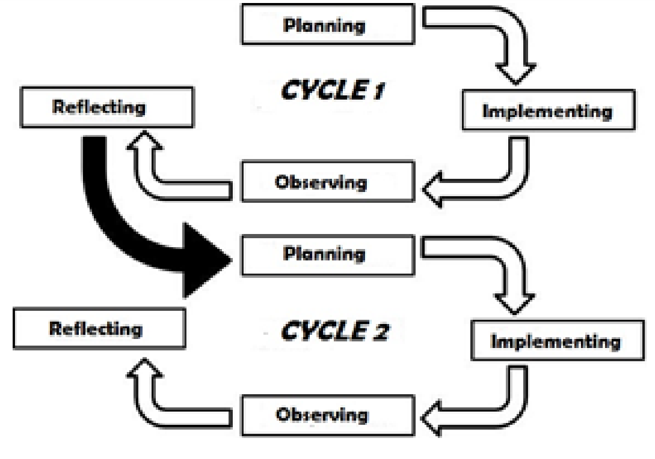

Figure 1. Model of Classroom Action Research by Arikunto et al. (2010, p. 42)

2. Respondents
The subject of this study was the tenth-grade students in the second semester of the 2022-2023 academic year at SMA Negeri 4 Palembang. The population was taken in XB class with 34 students, consisting of 23 female students and 11 male students.

3. Procedures
The study is conducted from March 2023 to April 2023. Based on the figure above, it can be seen that the pre-test is given before cycle I is given while the post-test is given after cycle I is completed, and so on. The research procedures of this study in each cycle were as follows: plan, action, observation, and reflection. The activities were:
  - Planning: In this stage, researchers plan the objectives, research questions, research design, data sources, data collection instruments, and the steps to be taken during the study.
  - Acting (Implementation): This stage involves the implementation of the planned activities. Researchers carry out the teaching and learning activities according to the predetermined steps.
  - Observing: This stage involves the collection of data through direct observation of the teaching and learning process and the interaction between teachers and students. The collected data can include observation notes, video recordings, or other relevant documents.
  - Reflecting: In this stage, researchers analyse the collected data, identify successes and challenges encountered during the research implementation, and formulate improvement steps for the next cycle.
These four stages provide a systematic framework for conducting Classroom Action Research, enabling researchers to plan, implement, observe, and reflect on the research process. Arikunto (2010) states that this stage is most appropriate when the implementing teacher has completed the action and expects to discuss the implementation of the action plan with the researcher. During this stage, the researcher records the observation and implementation results, evaluates the observation outcomes, analyzes the learning outcomes, and improves the weaknesses identified in Cycle I for Cycle II.
The reflection results consist of reflections on the implemented planning, which will be used to improve the teacher's performance in Cycle II and subsequent cycles.

4. The Data Collection Techniques
This study used observation, learning outcome tests, and documentation for collecting the data. According to Margono (2010), observation is a data collection technique that has specific characteristics compared to interview techniques. Observation is a data collection technique used when the research relates to human behavior, work processes, and natural phenomena when the observed respondents are not too numerous (Sugiyono, 2019. p. 145). Observation is the systematic observation and recording of visible phenomena in the research object. The observation used in this study is used to observe the activities of students in the learning process directly, to complement quantitative data through observation sheets. Then, this study used a learning outcome test. Slameto (2010) states learning outcomes are a process carried out by an individual to achieve a comprehensive new behavioral change as a result of their own experiences, resulting in changes in their interaction with the environment. A learning outcome test is a test that measures an individual's achievement in a field as a result of a typical learning process, intentionally conducted in the form of knowledge, understanding, skills, attitudes, and values. The researcher used this learning outcome test to measure the learning outcomes of tenth graders students in English with the material of Report Text with a Minimum Learning Mastery Standard (KKM) in the subject of English, which is ≥ 75 from the total students. The test administered is a post-test. Meanwhile, documentation is also used for collecting the data. Sugiyono (2019, p. 240) says documents are records of past events. Documentation is a method used to obtain information from written sources or documents, including books, magazines, regulations, meeting minutes, diary notes, and so on. Based on this opinion, it is clear that documentation refers to a data collection method used in a study by recording various issues documented by the teacher.

5. Data Analysis
The data analysis method used in this research involves both qualitative and quantitative data. Quantitative data is obtained through the learning outcome test, while qualitative data is obtained from observation. Once the data is collected, analysis is performed through the process of data reduction, data presentation, and finally conclusion.

5.1. Quantitative Analysis
Quantitative data analysis is calculated using simple statistical formulas to determine students' learning outcomes, as follows:
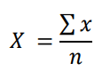

Explanation:
X = Mean value
∑ x = Sum of all values
n = Number of data

The results and discussion should be presented in the same section, clearly and concisely. The discussion section should focus on the significance of the research findings, rather than repeating the results. Combining the results and discussion in the same section can help avoid redundant language and unnecessary repetition.

5.2. Qualitative Analysis
Qualitative analysis is conducted to conclude observation sheets. The observation results are recorded in the observation sheet instrument. The collected data from the observation sheets are analyzed qualitatively using an inductive approach. The learning activities of the students can be presented in percentages using the following formula:
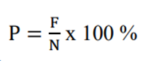

Explanation:
P = Percentage value
F = Frequency for which the percentage is being calculated
N = Total frequency or number of individuals

FINDINGS AND DISCUSSION
Findings
Based on the data analysis, the writer divides three important findings of this classroom action research, it can be explained as follow:
Pre-Cycle Learning Outcomes
Based on the formative test results during the pre-cycle learning phase, it is found that the outcomes of 34 students are far below expectations, as many students have results below the Minimum Learning Mastery Standard (KKM). The proficiency level that students need to achieve is ≥ 75 within the range of 1-100. The highest score obtained by the students is 80, while the lowest score is 20. The average score achieved is 63,82. The data on students' learning outcomes during the pre-cycle phase can be depicted in the following diagram:

Figure 2. Diagram of Students' Learning Outcomes in Pre-Cycle

From the above diagram, it can be seen that 12 students have achieved proficiency, accounting for 35,3%, while 22 students have not achieved proficiency, accounting for 64,7%. The students' lack of proficiency in learning outcomes is attributed to their lack of attention to the lessons provided by the teacher. To cultivate motivation and facilitate students' understanding of the X topic in the Report Text, it is necessary to improve the learning process through the implementation of differentiated instruction. This improvement in learning will be carried out through classroom action research consisting of two cycles: Cycle I and Cycle II.

Cycle I Learning Outcomes
After conducting the learning process in Cycle I, the following are the learning outcomes of English for students with the implementation of differentiated instruction in Cycle I.
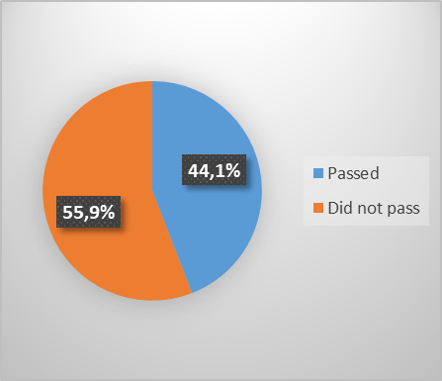
Figure 3. Diagram of Students' Learning Outcomes in Cycle I

From the diagram above, it can be seen that out of 34 students, 15 students passed and have achieved the learning target, with a percentage of 44,1%, while 19 students did not pass and have not achieved the learning target yet, with a percentage of 55,9%.
Cycle II Learning Outcomes
After implementing the differentiated learning approach in cycle II, the following are the results of students' learning achievement in English.
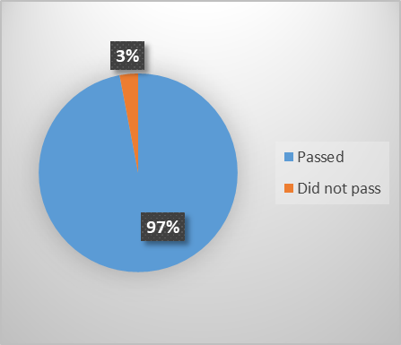

Figure 4. Diagram of Students' Learning Outcomes in Cycle II

From the above diagram, it can be seen that 33 students passed and have achieved the learning target, with a percentage of 97%, and 1 student did not pass and has not achieved the learning target yet, with a percentage of 3%.

Discussion of Research Results
The discussion of research results reveals a significant improvement in the implementation of the differentiated learning approach for report text learning outcomes among tenth-grade students at SMA Negeri 4 Palembang. The research findings align with various theories proposed by experts in the field of education. According to Huang's socio-cultural theory, the interaction between teachers and students, as well as students' collaboration, play a pivotal role in enhancing learning outcomes. For Huang, it provided a link between social learning and individual development (Huang et al, 2014, p. 167). This theory supports the positive impact of differentiated learning in Cycle II, where students actively engaged in the learning process through group demonstrations and produced tangible products.
Furthermore, the presence of the students’ diverse intelligences became evident as they selected projects, the students chose projects that matched their own strengths and interests (Chen et al., 2009 p. 277). In other words, he multiple intelligences theory emphasizes the importance of addressing students' diverse abilities and interests. The implementation of differentiated learning allowed tailoring the instruction to meet individual students' needs, catering to different intelligences. This approach likely contributed to the significant increase in the number of students who passed the learning outcomes in Cycle II.
Additionally, Nesmith (2023, p. 119) explains the role of observational learning and self-efficacy in shaping students' behavior. The use of engaging media, such as slides and videos, during the learning process, likely boosted students' self-confidence and motivation to actively participate, leading to improved learning outcomes. Moreover, Grix and Phillpots (2014, p. 86) highlights the significance of providing students with autonomy, competence, and relatedness in the learning environment. The differentiated learning approach empowered students to make choices in their learning, leading to increased engagement and better learning outcomes.
Overall, the findings suggest that implementing differentiated learning in English language learning, particularly for report text materials, is effective in improving students' learning outcomes. By catering to individual needs, interests, and abilities, this approach enhances students' active participation and motivation. The research results align with various educational theories, validating the effectiveness of differentiated learning in optimizing learning experiences for students at SMA Negeri 4 Palembang. However, it is essential to acknowledge that the success of this approach is contingent on both internal and external factors, including students' motivation, intelligence, and the school environment.
In conclusion, the research results support the efficacy of the differentiated learning approach in the context of English language learning, particularly for report text materials. The positive outcomes are in line with various educational theories, highlighting the importance of addressing students' individual needs and interests in the learning process. The study's findings offer valuable insights into effective instructional strategies that can be adopted by educators to enhance students' learning outcomes and achieve optimal learning goals in the English subject. However, further research may be needed to explore other variables and contextual factors that could impact the effectiveness of differentiated learning in different educational settings.
The number of the students who passed from pre-cycle, cycle I, and cycle II are 12 students (35,3%) in pre-cycle, 15 students (44,1%) in cycle I, and 33 students (97%) in cycle II. Meanwhile, the number of the students who did not pass from pre-cycle, cycle I, and cycle II are 22 students (64,7%) in pre-cycle, 19 students (55,9%) in cycle I, and 1 student (3%) in cycle II. On the other hand, there is an improvement in the implementation of the differentiated learning approach to the report text learning outcomes for the tenth-grade students at SMA Negeri 4 Palembang.
Furthermore, referring to the stages of pre-cycle activities by Arikunto et al. (2010, p. 42), the above research results can be described as follows.

1. Planning
The implementation of differentiated learning specifically focused on the topic of Report Text was chosen as a problem-solving strategy that the author tried to present by providing various ways for all students in the diverse classroom community to understand new information. This includes ways to acquire content, process, develop, or reason ideas, and develop learning products and assessment measures so that all students in a classroom with diverse abilities can learn effectively. The process of differentiating instruction is carried out to meet the needs, learning styles, or interests of each student. Based on these considerations, the author believes that by implementing differentiated learning specifically focused on the topic of Report Text for students who have difficulty understanding the subject, they can be more motivated to actively engage in the learning process according to their readiness level, interests, and their learning profile.

2. Implementation
Following the implementation process outlined in the Lesson Plan, during the pre-cycle, students' activities were limited to observing slides only. In Cycle I, students' activities were still limited to observing slides and videos displayed through an LCD Projector (content differentiation), and for the presentation of the report text (process differentiation), the results showed that students were still passive in carrying out the activity. Only a few students were willing to participate in the demonstration activity, while most of them remained silent. As for differentiation in terms of products, it was not yet evident. In Cycle II, after observing slides and videos about the report text, during the presentation of the report text, almost all students participated in this activity, and the class environment seemed lively and noisy. Differentiation in terms of content, process, and products was fulfilled for all students.

3. Observation
Based on the analysis of the data collected, conclusions were drawn regarding students' learning outcomes. The recapitulation of students' learning outcomes per cycle through the implementation of differentiated learning can be seen in the following graphic:
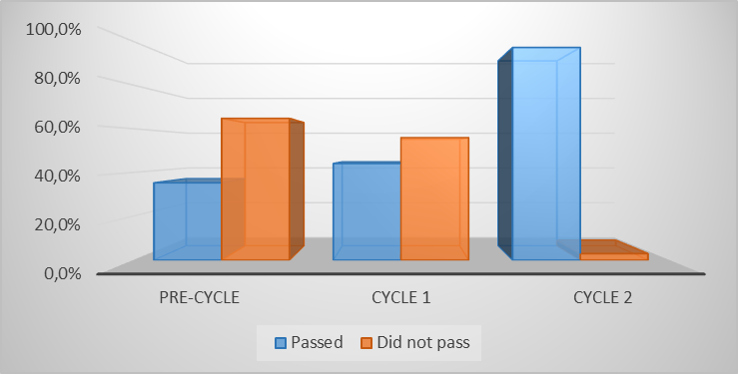

Figure 5. The Recapitulation of Students' Learning Outcomes

From the above comparison, it can be seen that in the pre-cycle, the number of students who have completed the task is 12 students with a percentage of 35,3%, and the number of students who have not completed the task is 22 students with a percentage of 64,7%. In Cycle I, the number of students who have completed the task is 15 students with a percentage of 44,1%, and the number of students who have not completed the task is 19 students with a percentage of 55,9%. In Cycle II, the number of students who have completed the task is 33 students with a percentage of 97%, and the number of students who have not completed the task is 1 student with a percentage of 3%.
Based on the research and discussion, it is explained that the implementation of differentiated learning can improve students' English language learning outcomes, especially in the subject of Report Text and their overall academic performance. The results of the learning evaluation show an improvement in learning achievement. In the pre-cycle, the percentage of students who achieved mastery was 35,3%. In Cycle I, it increased to 44,1%, and in Cycle II, it further improved to 97%.
The success in improving the learning outcomes of English language students in Report Text and their overall academic performance through the implementation of differentiated learning in Class X of SMA Negeri 4 Palembang is determined by several factors. These factors can be categorized as internal and external factors. Internal factors originate from within the individual and include intelligence, interest, and self-built motivation. One student's difficulty in achieving satisfactory grades is attributed to their low intelligence, as the student has special needs (intellectual disability). Additionally, the student lacks focus in participating in the learning process. On the other hand, external factors stem from the external environment, with the dominant factor in this study being the school environment. It is evident that there is an improvement in students' learning outcomes after one component of the school environment is improved, namely the presentation of material through the implementation of differentiated learning. The presentation of material through differentiated learning contributes to the improvement in students' learning outcomes, as evidenced by the increase in average scores in each cycle. In the pre-cycle, the average score was 63,82, which increased to 71,17 in Cycle I, and further increased to 89,11 in Cycle II. Therefore, based on the research findings and observations from Cycle I to Cycle II, there was a significant improvement from the initial stages of implementing differentiated learning in the English subject, specifically in the Report Text topic. The results of Cycle II outperformed Cycle I, indicating students' understanding of learning and meeting the average achievement indicator of student success.

4. Reflection
In the pre-cycle, student engagement was not apparent. In Cycle I, student activities were limited to observing slides and videos presented by the teacher through an LCD projector, and some students began participating in report text presentations, although no tangible products were produced in this cycle. On the other hand, in Cycle II, in addition to observing slides and videos, students were actively involved in report text presentations, and there were tangible products generated during this cycle. These products included small summaries made by students during the learning activities and some even created observation tables.
The advantages of each cycle are as follows: the author began the teaching and learning process by presenting engaging slides and videos. The limitation of Cycle I was caused by suboptimal time efficiency, with too much time spent on presenting slides and videos, and during the teacher's demonstration, students were only directed to perform the activities individually. On the other hand, in Cycle II, the teacher guided students to conduct demonstrations based on their learning style groups.

CONCLUSION
Based on the research findings and discussions, it can be concluded that the implementation of differentiated learning can improve the learning outcomes of English, specifically in the report text material, for the tenth graders in the second semester of SMA Negeri 4 Palembang in the academic year 2022-2023. The improvement in learning outcomes is evident from the results in the pre-cycle, Cycle I, and Cycle II, involving a total of 34 students in the tenth graders at SMA Negeri 4 Palembang, with a school-determined Minimum Learning Mastery Standard (KKM) of ≥ 75 from the total students.
During the pre-cycle, 12 students (35,3%) achieved a passing grade, while 22 students (64,7%) did not, with an average score of 63,82. In Cycle I, there was an increase in the number of students who met the passing criteria, with 15 students (44,1%) successfully achieving it, while 19 students (55,9%) did not, resulting in an average score of 71,17. In Cycle II, there was a significant improvement compared to the previous cycle, with 33 students (97%) reaching the passing grade, and only 1 student (3%) remaining below the passing grade, with an average score of 89,11.
Through the implementation of differentiated learning, the learning outcomes of students have significantly improved, surpassing the school's set target of achieving the minimum passing grade in the English subject, specifically in the Report Text topic, for the tenth graders in the second semester of SMA Negeri 4 Palembang in the academic year 2022-2023.
Based on the research findings, the following recommendations can be drawn. Students who have achieved satisfactory learning outcomes and actively participated in the learning process should strive to maintain or further improve their learning achievements. For students who have not yet reached satisfactory learning outcomes, they should continue to study and make efforts to improve.
For teachers, the implementation of differentiated learning should be utilized in English language instruction, as it has been proven to enhance learning outcomes, provide motivation, and foster students' enthusiasm for learning, ultimately leading to improved academic performance. It is also advisable to emphasize the reinforcement of key conclusions at the end of each lesson to ensure a better understanding of the taught material. Creating an engaging classroom environment is crucial, and teachers can achieve this by incorporating creative and innovative teaching media, thus fostering an enjoyable learning atmosphere.
Furthermore, schools should provide the necessary facilities and resources to support the teaching and learning process effectively.

REFERENCE

Arikunto, S., Suhardjono, & Supardi. (2010). Penelitian tindakan kelas. Jakarta: Bumi Aksara.

Chen, J., Moran, S., & Gardner, H. (2009). Multiple Intelligences around the World. United Kingdom, Wiley, https://www.google.co.id/books/edition/Multiple_Intelligences_Around_the_World/C-5bI3Kk46QC?hl=en&gbpv=1, diunduh 28 Juli 2023.

Fitra, D. K., (2022). Pembelajaran berdiferensiasi dalam perspektif progresivisme pada mata pelajaran bahasa inggris. Jurnal Filsafat Indonesia, 5(3).

Grix, J. & Phillpots, L. (2014). Understanding UK sport policy in context. United States of America, Taylor and Francis Books, https://www.google.co.id/books/edition/Understanding_UK_Sport_Policy_in_Context/bTMrDwAAQBAJ?hl=en&gbpv=1&dq=Self-Determination+Theory+by+Deci+and+Ryan+highlights&pg=PA86&printsec=frontcover, diunduh 28 Juli 2023.

Handayani, S. (2016). Pentingnya kemampuan berbahasa inggris sebagai dalam menyongsong ASEAN. Jurnal Profesi Pendidik, 3(1), 102-106.

Huang, R., Kinshuk, & Chen, N. S. (2014). The new development of technology enhanced learning. New York, Springer https://www.google.co.id/books/edition/The_New_Development_of_Technology_Enhanc/ZWAlBAAAQBAJ?hl=en&gbpv=1&kptab=getbook, diunduh 28 Juli 2023.

Laia, I. S. A., Sitorus, P., Surbakti, M., Simanullang, E. K., Tumanggor, R. M., & Silaban, B. (2022). Pengaruh strategi pembelajaran berdiferensiasi terhadap hasil belajar peserta didik SMA Negeri 1 Lahusa. Jurnal Ilmiah Wahana Pendidikan, 8(20), 314-321. DOI: https://doi.org/10.5281/zenodo.7242959.

Margono, S. (2010). Metodologi penelitian pendidikan. Jakarta, Rineka Cipta, http://www.digilib.unipdu.ac.id/beranda/index.php?p=show_detail&id=5092, diunduh 9 Juni 2023.

Mu’alimin. (2014). Penelitian tindakan kelas: Teori dan praktik. Jember: Ganding Pustaka.

Nesmith, R. (2023). An educational primer for new teachers. United States, U.S., https://www.google.co.id/books/edition/An_Educational_Primer_for_New_Teachers_L/Aba1EAAAQBAJ?hl=en&gbpv=1&dq=Bandura%27s+social+learning+theory+emphasizes+the+role+of+observational+learning+and+self-efficacy+in+shaping+students%27+behavior&pg=PA119&printsec=frontcover, diunduh 28 Juli 2023

Purba, M., Purnamasari, N., Soetantyo, S., Suwarna, I. R., & Susanti, E. I. (2021). Naskah akademik prinsip pengembangan pembelajaran berdiferensiasi (differentiated instruction) pada kurikulum fleksibel sebagai wujud merdeka belajar. Jakarta: Pusat Kurikulum dan Pembelajaran, Badan Standar, Kurikulum, dan Asesmen Pendidikan, Kementerian Pendidikan, Kebudayaan, Riset, dan Teknologi, Republik Indonesia.

Rusman, A. (2020). Classroom action research: Pengembangan kompetensi guru. Jawa Tengah: CV. Pena Persada.

Slameto. (2010). Belajar dan faktor-faktor yang mempengaruhinya. Jakarta: PT. Rineka Cipta.

Sugiyono (2019). Metode penelitian kuantitatif, kualitatif, dan R&D. Bandung, Alphabet, https://www.scribd.com/document/391327717/Buku-Metode-Penelitian-Sugiyono, diunduh 9 Juni 2023.

Surbakti, M. & Panjaitan, P. (2020). peningkatan kualitas pembelajaran biologi dengan metode kooperatif di prodi pend. fisika FKIP UHN Medan. Jurnal Visi Eksakta, 1(1), 63–78.

