PRE-SERVICE TEACHER STUDENTS LANGUAGE LEARNING STRATEGIES IN LEARNING ENGLISH

Laila Amalia¹⁾, Jenny Elvina Manurung ²⁾, Rahma Dianti ³⁾
Universitas Tridinanti
amalialaila1920@gmail.com¹⁾, Jenny.EM@univ-tridinanti.ac.id²⁾, rahma_dianti@univ-tridinanti.ac.id³⁾
ABSTRACT: The research intended to investigate which language learning strategies are mostly adopted by the undergraduate students of FKIP at Tridinanti University in learning English. The sample was 147 out of 169 students of the Faculty of Teacher Training and Education at Tridinanti University who participated in this research and were selected using total sampling. Google Forms was used to distribute online surveys in order to gather data. Adopted from Oxford (1990) version 7.0. of the SILL questionnaire has 50 items that are divided into 6 strategies: memory, cognitive, compensation, metacognitive, affective, and social strategies. Each item of the questionnaire has 5 scales that students can select based on their actual situation. This research had a quantitative design as the method of the data collected from the questionnaire results. It employed Microsoft Excel as a tool to analyze the descriptive analysis and find the main strategy used by the students to acquire English. The research findings revealed that the majority of the undergraduate students of FKIP at Tridinanti University mostly adopted a metacognitive strategy with a mean score of 3.625 at a level of high indicating that students usually use metacognitive strategy.
Keywords: language learning strategies, learning strategies, learning English

STRATEGI PEMBELAJARAN BAHASA SISWA PRA-SERVIS GURU DALAM PEMBELAJARAN BAHASA INGGRIS

ABSTRAK: Penelitian ini bertujuan untuk mengetahui strategi pembelajaran bahasa manakah yang paling banyak diterapkan oleh mahasiswa S1 FKIP Universitas Tridinanti dalam mempelajari bahasa Inggris. Samplenya adalah 147 dari 169 mahasiswa Fakultas Keguruan dan Ilmu Pendidikan Universitas Tridinanti yang mengikuti penelitian ini dan dipilih dengan menggunakan total sampling. Google Formulir digunakan untuk menditribusikan survey online untuk mengumpulkan data. Diadopsi dari Oxford (1990) versi 7.0. kuesioner SILL memiliki 50 item yang dibagi menjadi 6 strategi: strategi memori, kognitif, kompensasi, metakognitif, affectif, dan social. Setiap item angket mempunyai 5 skala yang dapat dipilih siswa berdasarkan kondisi sebenarnya. Penelitian ini mempunyai desain kuantitatif dengan metode pengumpulan data dari hasil kuesioner. Penelitian ini menggunakan Microsoft Excel sebagai alat untuk menganalisis analisis deskriptif dan menemukan strategi utama yang digunakan siswa untuk memperoleh bahasa Inggris. Hasil penelitian menunjukkan bahwa sebagian besar mahasiswa S1 FKIP Universitas Tridinanti sebagian besar menerapkan strategi metakognitif dengan skor rata-rata 3.625 pada level tinggi yang menunjukkan bahwa mahasiswa biasanya menggunakan strategi metakognitif.
Kata kunci: strategi pembelajaran bahasa, strategi pembelajaran, pembelajaran bahasa Inggris

INTRODUCTION
English is now widely recognized as an internal lingua franca. It serves as a common language or communication medium amongst people of different mother tongues (Marlina & Xu, 2018, p.2). Rao (2019) also added that as the first universal language, English is the language that is spoken globally the most for printing books, and other publications, as well as for international trade, diplomacy, mass entertainment, and international telecommunications. In addition, it is critical to learn English in this day of globalization, mastery of English is very important for students and it is crucial for the students to be capable of competing with other nations.
In learning a foreign language, especially English we need methods for learning languages as the supporting factors in learning a language. LLS is one of the supporting or determining factors for student success in learning a language. According to Teng (2023), learners’ development in a second language can be influenced by variables like age, learning styles, and motivation. Ghani (2003) defined language learning strategies as particular behaviors, procedures, acts, or techniques that students regularly apply to gain skills. Rose (2015, p. 421) stated that the procedures and methods used by language learners to acquire a language more successfully are referred to as language learning strategies. In addition, Hardan (2013), to successfully learn English the learners must use learning strategies. To sum up, language learning strategies are essential for students to succeed in language acquisition because they make the process of learning a language easier for them.
Some research has found that language learning strategies have some benefits for students in learning a language. Habok and Magyar (2018) found that the students who employ strategies in learning a foreign language have a better chance of being more proficient language learners. They also believe that the students who use strategies for learning languages offer a positive outlook on language acquisition. Pebriani (2013), described that the use of language learning strategies helps the learners in terms of storage, understanding, and the use of information related to the target language. She also suggested it can help the students store information related to the target language. In addition, Teng (2023) stated that less successful language learners could benefit from language learning strategies by using them to deal with and resolves their inner states in individualized ways.
Moreover, from the description language previous elaboration about language learning strategies, it gives impacts in the students’ learning achievement. According to Irmawan (2018), the use of note-taking as a learning strategy could improve the students’ reading comprehension. Next, Zakaria (2019) defined a relationship exists between the students’ performance in reading-focused English classes and the language learning strategies they use. In addition, Anthonysamy (2021) defined the use metacognitive strategies has an impact on university students’ online learning performance.
However, the absence of LLS (Language Learning Strategies) among the students negatively affects the students’ process and results of language learning. Students who do not use strategies are not aware of using the strategies and cannot effectively manage the learning process well (Peacock & Ho, 2003). According to Teng (2023), learners may perform poorly, feel less confident, and experience significant anxiety. Students who do not use strategies in language learning can negatively affect language achievement. In addition, Graham (2004) found that the less students did not aware of the learning techniques in enhancing their language ability. The results from those opinions are that language learning strategies can affect the students negatively for both sociology and learning results.
In addition, the research gap between this research and the previous studies before it was in this study the researcher discusses direct and indirect strategies which the most adopted by undergraduate students of FKIP at Tridinanti University in learning English. Meanwhile, in the previous studies, the findings only discuss which was language learning strategies that were adopted by the students.
Therefore, in the previous paragraph, the researcher assumes that actually language learning strategy is the learning factor that helps the students to be successful in the process of learning and learning achievement. Based on the previous explanation, the writer intends to conduct research entitled “Language Learning Strategies Employed by Undergraduate Students of FKIP at Tridinanti University in Learning English”.

Language Learning Strategies
With language learning strategies becoming a significant factor the importance of language learning is growing in the present year. According to Rose (2015, p. 421), the procedures and methods used by language learners to acquire or utilize a language more successfully are referred to as language learning strategies. According to Andrew (2006), learners are encouraged to acquire and apply a wide range of language-learning strategies employed at different stages of the learning process. Next, language learning behaviors, such as acquiring and controlling the meaning of a second or foreign language, are among the language learning strategies (Weden as cited in Lee, 2010, p.136). According to Chamot (2005) also believed that “learning strategies are procedures that facilitate a learning task. Particularly when starting on a new language assignment, strategies are typically goal-driven and planned. In addition, Chamot (2004) states that language strategies are the concepts and techniques that students use to achieve a learning objectives (p. 14).

Classification of Language Learning Strategies
There are two kind of language learning strategies for learning a language: direct strategies and indirect strategies. These two sorts of tactics are further developed by Oxford (1990) into six groupings, each of which comprises of a particular thought process and conduct. According to Oxford (1990), direct strategy consists of memory, cognitive, and compensation strategies. Language learners benefit from memory strategies that aid in storing new information, cognitive strategies that facilitate comprehension and multimodal usage of the target language, and compensation strategies that maintain language learners' usage of the target language even in the face of limited proficiency (Oxford, 1990). Metacognitive, affective, and social strategies are the components of indirect strategy (Oxford, 1990). Language learners can independently regulate their cognitive processes thanks to metacognitive strategies, and self-regulation of emotion and motivation is aided by affective strategies and for social strategy make social interaction by the students during learn a language. Each of the mentioned strategies is described in the next paragraph.
To begin with, memory strategies are methods for improving memory as well as retrieving and transferring knowledge necessary for language use in the future. Through memorization, pupils can commit key knowledge they have learned to memory. The second set of cognitive strategies methods involves utilizing all of the processes to assist pupils in correctly manipulating the target language or activity. Third, the compensation strategy that students use compensatory tactics to make up for the lexical gaps in their target language expertise. Even if their vocabulary is restricted, the tactics enable the pupils to write and communicate in the target language. Fourth, students use metacognitive strategies—centering, organizing, planning, and evaluating—to assist them in coordinating the learning process. Fifth, affective strategies assist the students in managing their motivations, emotions, and values. In addition, the social strategy involves the students having a social behavior.

Furhermore, the diagram of the dividing of LLS appears in Figure 1 below.

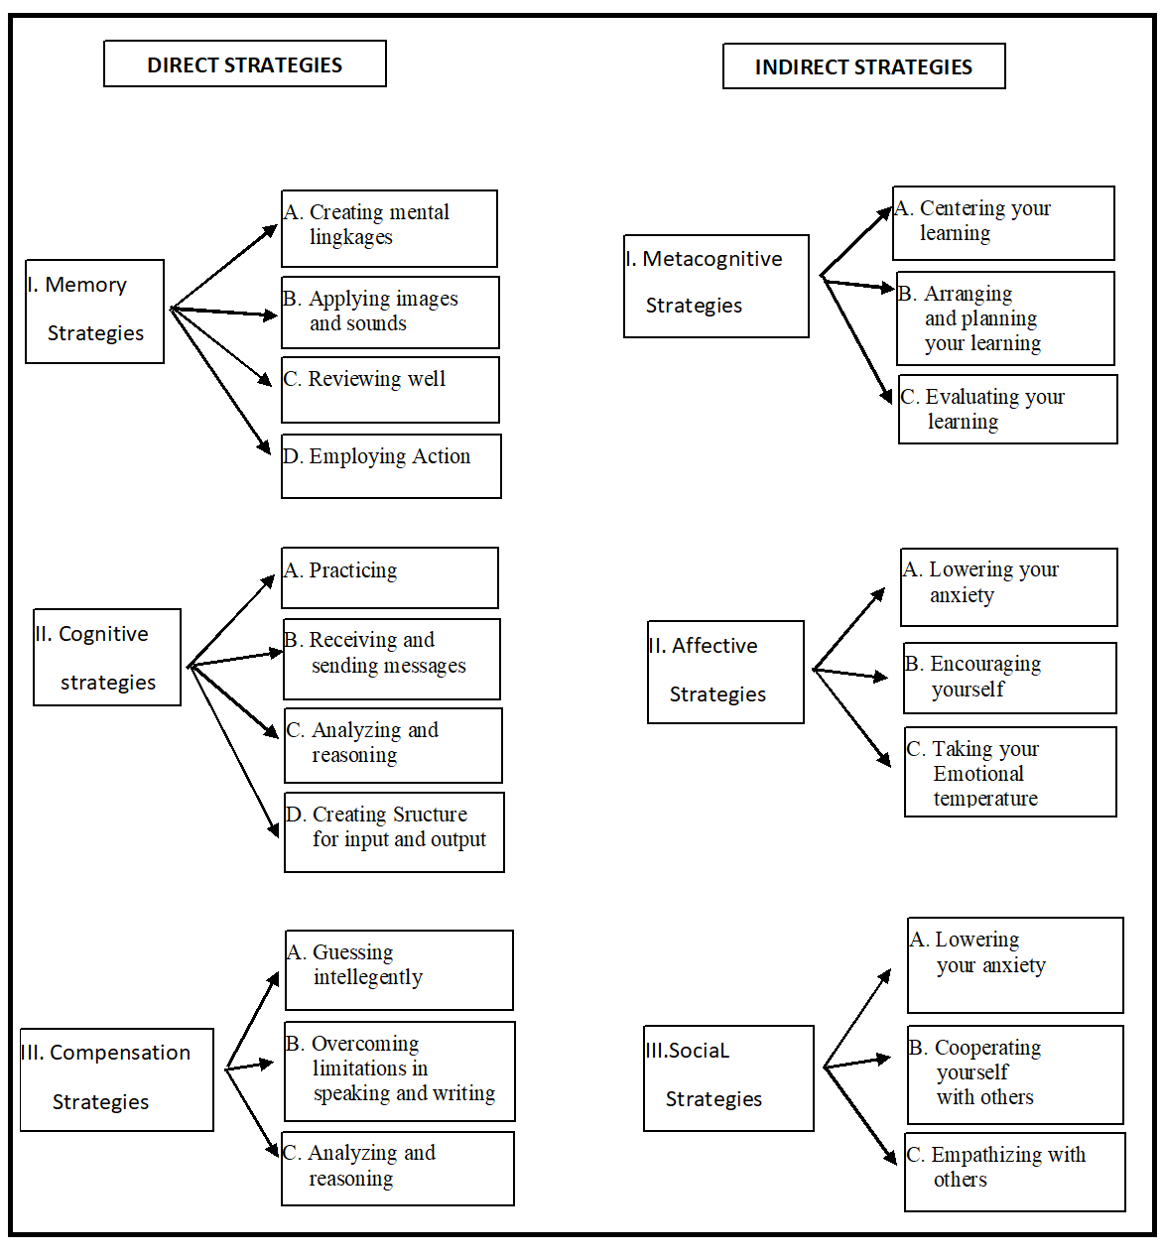
Figure 1. The dividing of Language Learning Strategies
(Direct and Indirect Strategies) Source: Oxford (1990)

The Impact Of Language Learning Strategies
Numerous research have examined language learning strategies in order to determine how these strategies affect students’ English language acquisition process. Pebriani (2013) pointed out that the use of language learning strategies helps the learners in terms of storage related to students’ prior knowledge which is said to be able to help students in storing related with the target language. In addition, Teng (2023) stated that language learning strategies could help L2 in individualized ways to address and deal with their own inner states and could help less successful language learners and language learning strategies also have an impact on student learning results. According to Nurharjanto (2020), the use of language learning strategies could improve the student’s writing abilities. Planning and time management, involvement and focus during instruction, information organization, recording, practice, study environment design, and efficient use of social resources are all examples of academic self-regulated processes (Zimmerman, 1990). Cesur (2011), discovered that LLS such cognitive, memory, and compensation had a direct impact on may predict accomplishment in reading comprehension in a foreign language based on correlation and regression analysis results. In addition, Irmawan (2018) found that the use of note-taking as a learning strategy could improve the student's reading comprehension. Next, the relationship between cognitive strategy and self-efficacy does not correlate among eleventh-grade students at SMK Kesehatan Kader Bangsa Palembang (Anggraini, 2024). In addition, according to the findings of the relationship between vocabulary-learning strategies and reading comprehension, there is a low correlation among the students (Julistri, 2024).

METHODOLOGY

Research Method and Design

This research used a quantitative method. Quantitative research is an inquiry approach useful for describing trends and explaining the relationship among variables found in the literature (Creswell, 2012. The research design for this research was a survey. Survey design is a quantitative research procedure in which the researcher administers a survey or questionnaire to a small group of people or sample in order to identify trends in attitudes, opinions, behaviors, or characteristics of a larger group of people or population (Creswell, 2012)

Participants
The population of this research consisted of all undergraduate students from FKIP at Tridinanti University in the academic year 2023/2024 with a total number of 169 students. This faculty has two study programs namely the English department and Indonesian language and literature department. For the sample using total sampling for this research, the researcher used a sample of 147 respondents.

Instrument and Data Collection
The data was obtained using a questionnaire from SILL version 7.0., adopted by Oxford (1990) that consisted of 50 items. This questionnaire measured 6 categories of language learning strategies: (a) memory which include 9 items that represent effectively remembering information, (b) cognitive which include 14 items that represent using mental processes, (c) compensation which include 6 items that represent making up for knowledge gaps, (d) metacognitive which include 9 items that represent organizing and evaluating the learning, (e) affective which include 6 items that represent managing emotion, and (f) social which include 6 items that represent gaining knowledge in collaboration with others.
The researcher prepares before distributing the questionnaire. To facilitate students’ understanding of the statements, the researcher employed translation services in Bahasa Indonesia. When the questionnaire was prepared for distribution, the researcher approached the students to gather information. The participants graded the questionnaire based on the scale items from a scale 1 to 5, namely, scale 1 indicate never true of me, scale 2 indicates rarely true of me, scale 3 indicates sometimes true of me, scale 4 indicates usually true of me, scale 5 indicate always true of me.

Data Analysis
In this research, the researcher employed the data by using descriptive analysis which measures the mean, standard deviation, and range of scores (Creswell, 2014).
After the data was collected, the researcher classified the rate scores according to the following criteria to ascertain which strategy the students most frequently used. The mean score used by the students of the language learning strategies was determined using the following score. The classification of the mean score is shown in Table 2.

Table 1. The Classification of Rate Scale
Classification | Frequency of Use | Mean Score
Low | Never used | 1.0 to 1.4
 | Generally not used | 1.5 to 2.4
Medium | Sometimes used | 2.5 to 3.4
High | Usually used | 3.5 to 4.4
 | Always used | 4.5 to 5.0

Source: Adopted from Oxford (1990)

FINDINGS AND DISCUSSION
This section presents the analysis result of the data collection process. The data were obtained by distributing the questionnaire of SILL version 7.0. that was adopted by Oxford (1990). The questionnaire consisted of 50 items that measured 6 language learning strategies, namely memory, cognitive, compensation, metacognitive, affective, and social strategies. This research surveyed of 147 samples from 169 population to investigate which language learning strategy was mostly adopted by the undergraduate students of FKIP at Tridinanti University.

The researcher investigated the language learning strategies mostly employed by undergraduate students of FKIP at Tridinanti University with 147 students as the sample. The summary of language learning strategies employed by undergraduate students of FKIP at Tridinanti University as shown in Table 2.

Table 2. Language Learning Strategies Adopted by Undergraduate Students of FKIP
Strategy |  | Max | Min | Std.Dev | Mean Score | Category
DIRECT | Memory Strategy | 4.7 | 1.0 | 0.7 | 3.327 | Medium
 | Cognitive Strategy | 4.9 | 1.0 | 0.8 | 3.339 | Medium
 | Compensation Strategy | 5.0 | 1.0 | 0.8 | 3.356 | Medium
 | Mean Score of Direct Strategy |  |  |  | 3.341 | Medium
INDIRECT | Metacognitive Strategy | 5.0 | 1,0 | 0.9 | 3.625 | High
 | Affective Strategy | 5.0 | 1.0 | 0.8 | 3.516 | High
 | Social Strategy | 5.0 | 1.0 | 0.9 | 3.329 | Medium
 | Mean Score of Indirect Strategy |  |  |  | 3.490 | High

The table above shows that for memory strategies, the maximum score was 4.7, the minimum score was 1.0, the standard deviation was 0,7, and the mean score was 3.327. The mean score of the memory strategy showed that it was in the medium level indicating that students sometimes employed memory strategy in learning English.
For cognitive strategies, the maximum score was 4.9, the minimum score was 1.0, the standard deviation was 0.8, and the mean score was 3.339. The mean score of the cognitive strategy showed that it was in the medium level indicating that students sometimes employed cognitive strategy in learning English.
For compensation strategies, the maximum score was 5.0, the minimum score was 1.0, the standard deviation was 0.8, and the mean score was 3.356. The mean score of the compensation strategy showed that it was in the medium level indicating that students sometimes employed compensation strategy in learning English.
For metacognitive strategies, the maximum score was 5.0, the minimum score was 1.0, the standard deviation was 0.9, and the mean score was 3.63. The mean score of the metacognitive strategy showed that it was in the high level meaning that the students frequently employed metacognitive strategy in learning English.
For affective strategies, the maximum score was 5.0, the minimum score was 1.0, the standard deviation was 0.8, and the mean score was 3.52. The mean score of the affective strategy showed that it was at a high level indicating that students frequently employed affective strategy in learning English.
For social strategies, the maximum score was 5.0 , the minimum score was 1.0, the standard deviation was 0.9, and the mean score was 3.33. The mean score of the social strategy showed that it was in the medium level means that students sometimes employed social strategy in learning English.
Based on the mean score of each language learning strategy, it was revealed that metacognitive was the most employed strategy among the undergraduate students of FKIP at Tridinanti University. Following that, affective strategy was also dominant strategy used compared to the four other strategies. The rank of language learning strategies adopted by the undergraduate students of FKIP at Tridinanti university can be seen in Figure 3.

Figure 2. Language Learning Strategies Adopted by Undergraduate Students of FKIP at Tridinanti University

CONCLUSION
From the results and interpretations in the previous chapter, it can be concluded that the undergraduate students of FKIP at Tridinanti University adopted a metacognitive strategy as their language learning strategy with a mean score of 3.625 for high level indicating that students usually used metacognitive strategy in learning English.

REFERENCES
Andrews, S. (2006). The evolution of teachers’ language awareness. Language Awareness, 15(1), 1-19.
Anggraini, A. (2024). The Correlation among Self-Efficacy, Cognitive Strategy, and Students’ Speaking Achievement of Eleventh Graders at SMK Kesehatan Kader Bangsa Palembang. Didascein: Journal of English Education, 5(1), 70-77.
Anthonysamy, L., Ah Choo, K., & Soon Hin, H. (2021). Investigating Self-Regulated Learning Strategies for Digital Learning Relevancy. Malaysian Journal of Learning and Instruction, 18(1), 29-64.
Chamot, A. U. (2004). Issues in language learning strategy research and teaching. Electronic journal of foreign language teaching, 1(1), 14-26.
Chamot, A. U. (2005). Language learning strategy instruction: Current issues and research. Annual review of applied linguistics, 25, 112-130.
Creswell, J. W. (2012). Educational research: Planning, conducting, and evaluating quantitative and qualitative research (4th ed). Boston, MA: Pearson.
Creswell, J. W. (2014). A concise introduction to mixed methods research. SAGE publications.
Ghani, M. (2003). Language learning strategies employed by L2 learners. Journal of Research (Faculty of Languages & Islamic Studies), 4(1), 31-36.
Habók, A., & Magyar, A. (2018). The effect of language learning strategies on proficiency, attitudes and school achievement. Frontiers in psychology, 8, 293044.
Hardan, A. A. (2013). Language learning strategies: A general overview. Procedia-Social and Behavioral Sciences, 106, 1712-1726.
Julistri, A., Tridinanti, G., & Manurung, J. E. (2024). The The Correlation between Vocabulary Learning Strategies and Reading Comprehension. Didascein: Journal of English Education, 5(1), 30-43.
Lee, C. K. (2010). An overview of language learning strategies. Annual Review of Education, Communication & Language Sciences, 7.
Marlina, R., & Xu, Z. (2018). English as a lingua franca. The TESOL encyclopedia of English language teaching, 1-13.
Nurharjanto, A. A., & Widyantoro, A. (2020). The effect of language learning strategy and technology toward students’ writing skills. Jurnal Kependidikan Penelitian Inovasi Pembelajaran, 4(2), 213-225.
Oxford, R. L. (1990). Language learning strategies: What every teacher should know. (No Title).
Oxford, R. L. (1990). Styles, strategies, and aptitude: Connections for language learning. Document Resume, 73.
Peacock, M., & Ho, B. (2003). Student language learning strategies across eight disciplines. International Journal of Applied Linguistics, 13(2), 179-200.
Pebriani, L. K. (2013). Language Learning Strategies Used by Learners in SMA N 1 Ungaran (Doctoral dissertation, Program Studi Pendidikan Bahasa Inggris FBS-UKSW).
Rao, P. S. (2019). The role of English as a global language. Research journal of English, 4(1), 65-79.
Rose, H. (2015). Researching language learner strategies. Research methods in applied linguistics: A practical resource, 421, 437.
Teng, M. F. (2023). 8 Language Learning Strategies. Cognitive Individual Differences in Second Language Acquisition, 147.
Teng, M. F., & Yue, M. (2023). Metacognitive writing strategies, critical thinking skills, and academic writing performance: A structural equation modeling approach. Metacognition and Learning, 18(1), 237-260.
Zakaria, N. Y. K., Azmi, N. E., & Hadi, N. A. A. (2019). Improving reading skills using language learning strategies (LLS). J. Couns. Educ. Technol, 2, 1-5.
Zimmerman, B. J. (1990). Self-regulated learning and academic achievement: An overview. Educational psychologist, 25(1), 3-17.

