PROSPECTIVE TEACHERS’ LEARNING STRATEGIES IN LEARNING ENGLISH

Laila Amalia¹⁾, Jenny Elvina Manurung ²⁾, Rahma Dianti ³⁾
Tridinanti University
amalialaila1920@gmail.com¹⁾, Jenny.EM@univ-tridinanti.ac.id²⁾,
rahma_dianti@univ-tridinanti.ac.id³⁾

ABSTRACT: Language learning strategies are specific actions, processes, acts, or methods that students frequently use to improve their language proficiency. Learning strategies are crucial for language learners since they facilitate the learners in processing language learning and acquisition. This current research highlights the investigation of prospective teachers’ preferences on learning strategies they mostly adopt when learning English. This research used a cross-sectional survey design. The sample was 147 prospective teachers, selected by using total sampling. The data was obtained using a Strategy Inventory of Language Learning (SILL) questionnaire, version 7.0., adopted from Oxford (1990) which consisted of 50 items measuring 6 learning strategies: memory, cognitive, compensation, metacognitive, affective, and social. The students used a Likert scale of 5 ratings to respond to each item of the questionnaire describing their preferences and experience in learning English. The obtained data were analyzed descriptively by measuring and comparing the mean score range to identify which learning strategy was mostly employed by the students in English language learning. The research findings showed that the mean score of metacognitive strategy was 3.625. It was higher than other learning strategies. It indicated that the prospective teachers mostly adopted metacognitive as their strategy in learning English.

Keywords: language learning, strategies, prospective teachers

STRATEGI PEMBELAJARAN MAHASIWA KEGURUAN DALAM BELAJAR BAHASA INGGRIS

ABSTRAK: Strategi pembelajaran bahasa adalah tindakan, proses, tindakan, atau metode khusus yang sering digunakan siswa untuk meningkatkan kemahiran bahasa mereka. Strategi pembelajaran sangat penting karena memfasilitasi peserta didik dalam proses pembelajaran dan pemerolehan bahasa. Penelitian ini menyoroti penyelidikan preferensi mahasiswa keguruan tentang strategi pembelajaran yang paling banyak mereka adopsi saat belajar bahasa Inggris. Penelitian ini menggunakan desain survei cross-sectional. Sampel adalah 147 mahasiswa jeguruan, dipilih dengan menggunakan total sampling. Data diperoleh dengan menggunakan kuesioner Strategy Inventory of Language Learning (SILL), versi 7.0., yang diadopsi dari Oxford (1990) yang terdiri dari 50 item yang mengukur 6 strategi pembelajaran: memori, kognitif, kompensasi, metakognitif, afektif, dan sosial. Para mahasiswa menggunakan skala Likert dari 5 peringkat untuk menanggapi setiap item kuesioner yang menggambarkan preferensi dan pengalaman mereka dalam belajar bahasa Inggris. Data dianalisis secara deskriptif dengan mengukur skor rata-rata untuk mengidentifikasi strategi pembelajaran mana yang paling banyak digunakan oleh mahasiswa dalam pembelajaran bahasa Inggris. Temuan penelitian menunjukkan bahwa skor rata-rata strategi metakognitif adalah 3,625. Itu lebih tinggi dari strategi pembelajaran lainnya. Hal ini menunjukkan bahwa mahasiswa keguruan sebagian besar mengadopsi metakognitif sebagai strategi dalam belajar bahasa Inggris.

Kata Kunci: pembelajaran bahasa, strategi, mahasiswa keguruan

INTRODUCTION
English is now widely recognized as an internal lingua franca. It serves as a common language or communication medium amongst people of different mother tongues (Marlina & Xu, 2018, p.2). Rao (2019) also added that as the first universal language, English is the language that is spoken globally the most for printing books, and other publications, as well as for international trade, diplomacy, mass entertainment, and international telecommunications. In addition, it is critical to learn English in this day of globalization, mastery of English is very important for students and the students must be capable of competing with other nations.
In learning a foreign language, especially English we need methods for learning languages as the supporting factors in learning a language. Language Learning Strategies is one of the supporting or determining factors for student success in learning a language. According to Teng (2023), learners’ development in a second language can be influenced by variables like age, learning styles, and motivation. Ghani (2003) defined language learning strategies as particular behaviors, procedures, acts, or techniques that students regularly apply to gain skills. Rose (2015, p. 421) stated that the procedures and methods used by language learners to acquire a language more successfully are referred to as language learning strategies. In addition, Hardan (2013), to successfully learn English learners must use learning strategies. To sum up, language learning strategies are essential for students to succeed in language acquisition because they make the process of learning a language easier for them.
Some research has found that language learning strategies have some benefits for students in learning a language. Habok and Magyar (2018) found that students who employ strategies in learning a foreign language have a better chance of being more proficient language learners. They also believe that the students who use strategies for learning languages offer a positive outlook on language acquisition. Pebriani (2013) described that the use of language learning strategies helps learners in terms of storage, understanding, and the use of information related to the target language. She also suggested it can help the students store information related to the target language. In addition, Teng (2023) stated that less successful language learners could benefit from language learning strategies by using them to deal with and resolve their inner states in individualized ways.
Moreover, from the previous elaboration, language learning strategies have an impact on the student’s learning achievement. According to Irmawan (2018), the use of note-taking as a learning strategy could improve the students’ reading comprehension. Next, Zakaria (2019) defined a relationship that exists between the student’s performance in reading-focused English classes and the language learning strategies they use. In addition, Anthonysamy (2021) defined that the use of metacognitive strategies has an impact on university students’ online learning performance.
However, the absence of LLS (Language Learning Strategies) among the students negatively affects the students’ process and results of language learning. Students who do not use strategies are not aware of using the strategies and cannot effectively manage the learning process well (Peacock & Ho, 2003). According to Teng (2023), learners may perform poorly, feel less confident, and experience significant anxiety. Students who do not use strategies in language learning can negatively affect language achievement. In addition, Graham (2004) found that the less students did not seem to be aware of the potential role of learning strategies in improving their language performance. In conclusion, language learning strategies can affect the students negatively for both sociology and learning results.
Therefore, in the previous paragraph, the researcher assumes that language learning strategy is the learning factor that helps the students to be successful in the process of learning and learning achievement. Based on the previous explanation, the researcher investigated research entitled “Language Learning Strategies Employed by Undergraduate Students of FKIP at Tridinanti University in Learning English”.

Language Learning Strategies
According to Rose (2015, p. 421), the procedures and methods used by language learners to acquire or utilize a language more successfully are referred to as language learning strategies. According to Andrew (2006), learners are encouraged to acquire and apply a wide range of language-learning strategies employed at different stages of the learning process. Next, language learning behaviours, such as acquiring and controlling the meaning of a second or foreign language, are among the language learning strategies (Weden as cited in Lee, 2010, p.136). According to Chamot (2005) also believed that “learning strategies are procedures that facilitate a learning task. Particularly when starting on a new language assignment, strategies are typically goal-driven and planned. In addition, Chamot (2004) states that language strategies are the concepts and techniques that students use to achieve learning objectives (p. 14).

Classification of Language Learning Strategies
There are two kinds of language learning strategies, they are direct strategy and indirect strategy. Oxford (1990) elaborates these two classes of strategies in six subtypes; each group consists of a specific behaviour and thinking process. Direct strategy includes memory strategy, cognitive strategy, and compensation strategy (Oxford, 1990). Indirect strategy includes metacognitive strategy, affective strategy, and social strategy (Oxford, 1990).
- Memorization Strategies
Memorization strategies are techniques used to remember more effectively, to retrieve and transfer information needed for future language use Memorization helps students to store in memory important information gathered from their learning When the information is needed for use in the future, these strategies help the student to get the information back. For example, the semantic map of a group of noun or verb that shows the relationship between the words.
- Cognitive Strategies
Cognitive strategies used to help the students to manipulate the target language or task correctly by using all then processes They include reasoning, analysis, and drawing conclusions. For example, the use of drills to practice the language and the use of dictionary to find difficult words.
- Compensation Strategies
Compensations strategies are employed by the students to compensate the missing knowledge in the target language due to lack of vocabulary. The strategies help to allow the students to use the language to speak and write in the target language even when their vocabulary is limited. For example, the use of linguistic clues to guess the meaning or by inventing words to the use of linguistic clues to guess compensates vocabulary.

- Metacognitive Strategies
Metacognitive strategies are employed by the students to help them coordinate the learning process by centering, arranging, planning, and evaluating their learning, this help learner to control their own learning. Students will also be able to plan what their learning strategies should be and change them if they are not suitable. For example, overviewing with already known material and deciding in advance on what to pay attention to.
- Affective Strategies
Affective strategies are techniques to help the students control their emotions attitudes, motivations and values. These strategies have a powerful influence on language learning because they allow the students to manage their feelings. For example, students may use laughter to relax and praise to reward themselves for their achievements.
- Social Strategies
Social strategies are activities that students engage in to seek opportunities to be exposed to an environment where practice is possible. These strategies are important because language learning always involves other people, it is a form of social behaviour. For example, questioning for understanding or facts and work together with peers or speakers of the target language including native and native like speakers to upgrade their language skills. Figure 1 diagram displays the classifications of learning strategies.

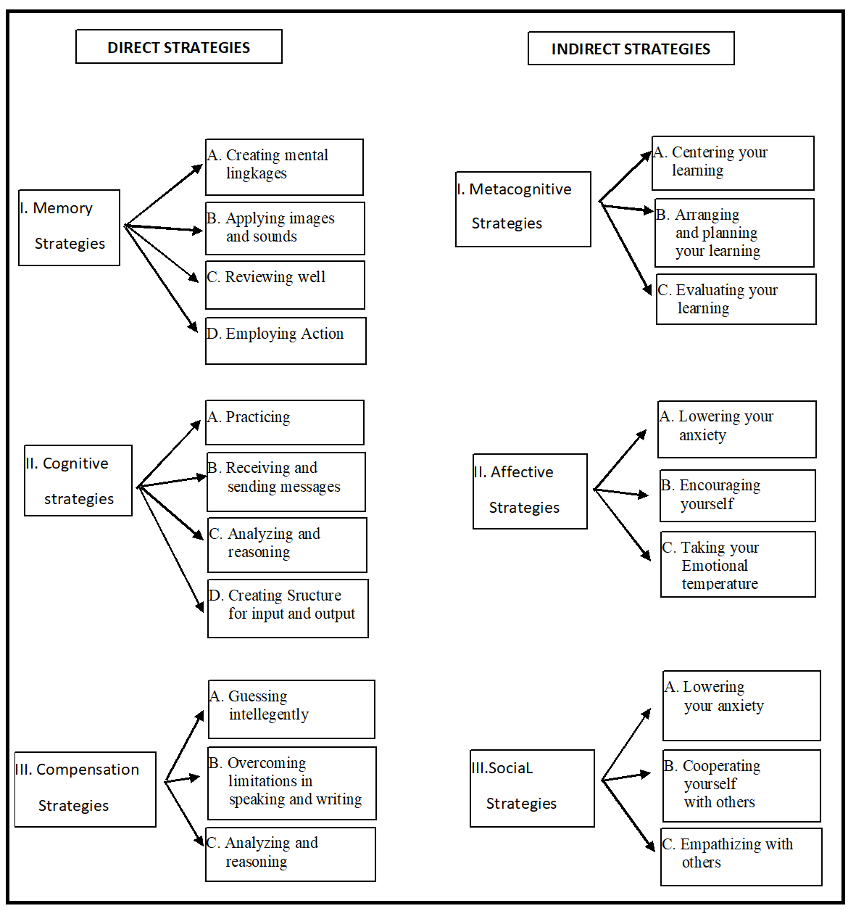
Figure 1. The Classification of Language Learning Strategies adopted from Oxford (1990)

The Impact of Language Learning Strategies
Numerous research has examined language learning strategies to determine how these strategies affect students’ English language acquisition process. Pebriani (2013) pointed out that the use of language learning strategies helps the learners in terms of storage related to students’ prior knowledge which is said to be able to help students in storing related with the target language. In addition, Teng (2023) stated that language learning strategies could help L2 in individualized ways to address and deal with their inner states and could help less successful language learners and language learning strategies also have an impact on student learning results. According to Nurharjanto (2020), the use of language learning strategies could improve the student’s writing abilities. Planning and time management, involvement and focus during instruction, information organization, recording, practice, study environment design, and efficient use of social resources are all examples of academic self-regulated processes (Zimmerman, 1990). Cesur (2011), discovered that LLS such as cognitive, memory, and compensation had a direct impact on predicting accomplishment in reading comprehension in a foreign language based on correlation and regression analysis results. In addition, Irmawan (2018) found that the use of note-taking as a learning strategy could improve the student's reading comprehension. Next, the relationship between cognitive strategy and self-efficacy does not correlate among eleventh-grade students at SMK Kesehatan Kader Bangsa Palembang (Anggraini, 2024). In addition, according to the findings of the relationship between vocabulary-learning strategies and reading comprehension, there is a low correlation among the students (Julistri, 2024).

METHODOLOGY

Research Method and Design

This research used a quantitative method. Quantitative research is an inquiry approach useful for describing trends and explaining the relationship among variables found in the literature (Creswell, 2012. The research design for this research was a survey. Survey design is a quantitative research procedure in which the researcher administers a survey or questionnaire to a small group of people or sample to identify trends in attitudes, opinions, behaviours, or characteristics of a larger group of people or population (Creswell, 2012). In conducting the survey, the researchers adopted the procedures for surveying proposed by Creswell (2012). The first step was to design the survey design. The second step was to identify the research questions. The third step was to identify the population, the sampling frame, and the sample. The fourth step was to determine the survey design and data collection procedures. The fifth step was to develop an instrument. The sixth step was to establish the instrument. The seventh step was to analyze the data to address the research ptoblems. The last step was to prepare to write the report. The procedures of conducting survey can be seen in Figure 2.
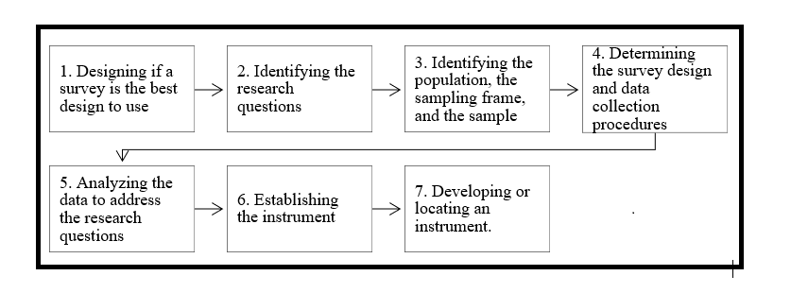
Figure 2. The Procedures of Conducting a Survey

- Research Participants
The population of this research consisted of all undergraduate students of FKIP at Tridinanti University in the academic year 2023/2024 with a total number of 169 students divided into two language education departments. The sample was selected using total sampling technique due to survey research needs 100 or more subject to be surveyed. It meant that 169 were involved as the sample. However, only 147 students responded the questionnaire.

- Data Collection
The data was obtained using a questionnaire from SILL version 7.0., adopted by Oxford (1990) consisting of 50 items. This questionnaire measured 6 categories of language learning strategies: (a) memory strategy which includes 9 items that represent effectively remembering information, (b) cognitive strategy which includes 14 items that represent using mental processes, (c) compensation strategy which includes 6 items that represent making up for knowledge gaps, (d) metacognitive strategy which include 9 items that represent organizing and evaluating the learning, (e) affective strategy which include 6 items that represent managing emotion, and (f) social strategy which include 6 items that represent gaining knowledge in collaboration with others. The participants rated the questionnaire using a Likert scale ranging from scale 1 to 5. Scale 1 indicates never true of me, scale 2 indicates rarely true of me, scale 3 indicates sometimes true of me, scale 4 indicates usually true of me, and scale 5 indicates always true of me.

- Data Analysis
The researchers employed descriptive analysis to analyze the students’ responses by measuring the mean, standard deviation, and range of scores (Creswell, 2014). After that, the researchers calculated the mean score proposed by Oxford (1990) for each strategy to determine which strategies were mostly adopted by the students. Table 1 presents the classification of the mean score range.

Table 1. The Classification of Mean Score Adopted from Oxford (1990)
Classification | Frequency of Use | Mean Score
Low | Never used | 1.0 to 1.4
 | Generally not used | 1.5 to 2.4
Medium | Sometimes used | 2.5 to 3.4
High | Usually used | 3.5 to 4.4
 | Always used | 4.5 to 5.0

FINDINGS AND DISCUSSION
- Prospective teachers’ Language Learning Strategies
The results investigated which language learning strategy was mostly employed by the undergraduate students of FKIP at Tridinanti University. The summary of language learning strategies employed by undergraduate students of FKIP at Tridinanti University as shown in Table 2.

Table 2. Language Learning Strategies Adopted by Undergraduate Students of FKIP
Strategy | Max | Min | Std.Dev | Mean Score | Category
Memory Strategy | 4.7 | 1.0 | 0.7 | 3.327 | Medium
Cognitive Strategy | 4.9 | 1.0 | 0.8 | 3.339 | Medium
Compensation Strategy | 5.0 | 1.0 | 0.8 | 3.356 | Medium
Metacognitive Strategy | 5.0 | 1,0 | 0.9 | 3.625 | High
Affective Strategy | 5.0 | 1.0 | 0.8 | 3.516 | High
Social Strategy | 5.0 | 1.0 | 0.9 | 3.329 | Medium

The table above shows that for memory strategies, the maximum score was 4.7, the minimum score was 1.0, the standard deviation was 0,7, and the mean score was 3.327. The mean score of the memory strategy showed that it was in the medium level indicating that students sometimes employed memory strategy in learning English.
For cognitive strategies, the maximum score was 4.9, the minimum score was 1.0, the standard deviation was 0.8, and the mean score was 3.339. The mean score of the cognitive strategy showed that it was in the medium level indicating that students sometimes employed cognitive strategy in learning English.
For compensation strategies, the maximum score was 5.0, the minimum score was 1.0, the standard deviation was 0.8, and the mean score was 3.356. The mean score of the compensation strategy showed that it was in the medium level indicating that students sometimes employed compensation strategy in learning English.
For metacognitive strategies, the maximum score was 5.0, the minimum score was 1.0, the standard deviation was 0.9, and the mean score was 3.63. The mean score of the metacognitive strategy showed that it was in the high level meaning that the students frequently employed metacognitive strategy in learning English.
For affective strategies, the maximum score was 5.0, the minimum score was 1.0, the standard deviation was 0.8, and the mean score was 3.52. The mean score of the affective strategy showed that it was at a high level indicating that students frequently employed affective strategy in learning English.
For social strategies, the maximum score was 5.0, the minimum score was 1.0, the standard deviation was 0.9, and the mean score was 3.33. The mean score of the social strategy showed that it was at the medium level means that students sometimes employed social strategy in learning English.
Based on the mean score of each language learning strategy, it revealed that metacognitive was the most employed strategy among the prospective teachers at Tridinanti university. Following that, the affective strategy was also the dominant strategy used compared to the four other strategies. Figure 3 displays the language learning strategy employed by the students.

Figure 3. Language Learning Strategies Adopted by Prospective teachers

- Discussion
Referring to the findings elaborated above, it could be interpreted that metacognitive strategy becomes the most dominant strategy employed by the prospective teachers at Tridinanti university when they are learning English. It is in line with Sofyan’s study (2019) who found that the students mostly preferred using metacognitive strategy. Based on the students’ responses, most of the students set their study plan, arrange or manage their schedule to study English, monitor their learning progress, and evaluate their mistakes and make use of the information to help them perform better in the future learning. Those conditions were in line with what have been claimed by Oxford (1990) who suggests that metacognitive strategy includes some aspects of planning, monitoring, and evaluating in language learning strategies. In addition, Lestari (2015) found that the participants of her study preferred using metacognitive strategy in learning English. She highlighted that most of the students choose metacognitive as their learning strategy because it allows the learner to overview the lesson, to pay attention in the classroom, and to self-evaluate the language learning. In this study based on the student's responses. To summarize, metacognitive strategy can help the language learners to keep managing and monitoring their learning process to ensure that their learning goals are accomplished when learning a language.

CONCLUSION
From the results in the previous section, it can be concluded that the metacognitive strategy is the most dominant strategy employed by prospective teachers at Tridinanti university when they learn English. This strategy helps the language learners to regulate their learning process by adapting some strategies including arranging study plan, monitoring, and evaluating the learning process.

REFERENCES
Andrews, S. (2006). The evolution of teachers’ language awareness. Language Awareness, 15(1), 1-19.
Anggraini, A. (2024). The Correlation among Self-Efficacy, Cognitive Strategy, and Students’ Speaking Achievement of Eleventh Graders at SMK Kesehatan Kader Bangsa Palembang. Didascein: Journal of English Education, 5(1), 70-77.
Anthonysamy, L., Ah Choo, K., & Soon Hin, H. (2021). Investigating Self-Regulated Learning Strategies for Digital Learning Relevancy. Malaysian Journal of Learning and Instruction, 18(1), 29-64.
Chamot, A. U. (2004). Issues in language learning strategy research and teaching. Electronic journal of foreign language teaching, 1(1), 14-26.
Chamot, A. U. (2005). Language learning strategy instruction: Current issues and research. Annual review of applied linguistics, 25, 112-130.
Creswell, J. W. (2012). Educational research: Planning, conducting, and evaluating quantitative and qualitative research (4th ed). Boston, MA: Pearson.
Creswell, J. W. (2014). A concise introduction to mixed methods research. SAGE publications.
Ghani, M. (2003). Language learning strategies employed by L2 learners. Journal of Research (Faculty of Languages & Islamic Studies), 4(1), 31-36.
Habók, A., & Magyar, A. (2018). The effect of language learning strategies on proficiency, attitudes and school achievement. Frontiers in psychology, 8, 293044.
Hardan, A. A. (2013). Language learning strategies: A general overview. Procedia-Social and Behavioral Sciences, 106, 1712-1726.
Julistri, A., Tridinanti, G., & Manurung, J. E. (2024). The The Correlation between Vocabulary Learning Strategies and Reading Comprehension. Didascein: Journal of English Education, 5(1), 30-43.
Lee, C. K. (2010). An overview of language learning strategies. Annual Review of Education, Communication & Language Sciences, 7.
Marlina, R., & Xu, Z. (2018). English as a lingua franca. The TESOL encyclopedia of English language teaching, 1-13.
Nurharjanto, A. A., & Widyantoro, A. (2020). The effect of language learning strategy and technology toward students’ writing skills. Jurnal Kependidikan Penelitian Inovasi Pembelajaran, 4(2), 213-225.
Oxford, R. L. (1990). Language learning strategies: What every teacher should know. (No Title).
Oxford, R. L. (1990). Styles, strategies, and aptitude: Connections for language learning. Document Resume, 73.
Peacock, M., & Ho, B. (2003). Student language learning strategies across eight disciplines. International Journal of Applied Linguistics, 13(2), 179-200.
Pebriani, L. K. (2013). Language Learning Strategies Used by Learners in SMA N 1 Ungaran (Doctoral dissertation, Program Studi Pendidikan Bahasa Inggris FBS-UKSW).
Rao, P. S. (2019). The role of English as a global language. Research journal of English, 4(1), 65-79.
Rose, H. (2015). Researching language learner strategies. Research methods in applied linguistics: A practical resource, 421, 437.
Teng, M. F. (2023). 8 Language Learning Strategies. Cognitive Individual Differences in Second Language Acquisition, 147.
Teng, M. F., & Yue, M. (2023). Metacognitive writing strategies, critical thinking skills, and academic writing performance: A structural equation modeling approach. Metacognition and Learning, 18(1), 237-260.
Zakaria, N. Y. K., Azmi, N. E., & Hadi, N. A. A. (2019). Improving reading skills using language learning strategies (LLS). J. Couns. Educ. Technol, 2, 1-5.
Zimmerman, B. J. (1990). Self-regulated learning and academic achievement: An overview. Educational psychologist, 25(1), 3-17.

