Documentation

Installation

* Open Blender.exe
* Edit – Preferences – Add-ons
* Click Install
* Select “AIO.zip” you have downloaded and Install
* Search “AIO” and Enable

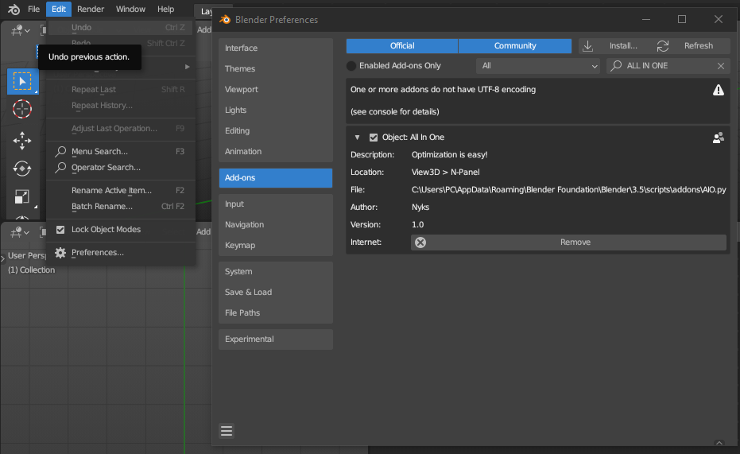

* In the 3d Viewport you can press “N” on your keyboard or you can click the arrow on right top

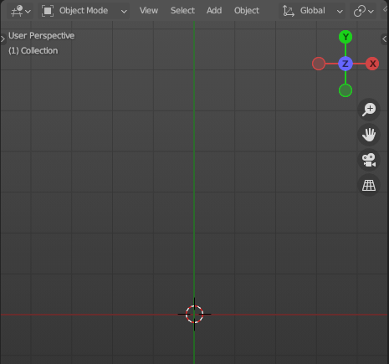 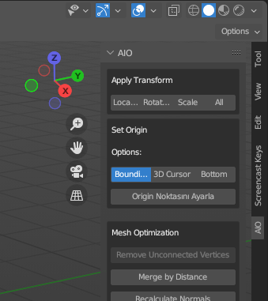

How to Use

* There are multiple functions:

1. Apply Transform
2. Set Origin
3. Mesh Optimization
4. Object and Mesh Naming
5. Uv Naming
6. Texture Optimization
7. Texture Naming

Apply Transform

You can apply single or multiple selected objects by pressing Location, Rotation, Scale and All transforms.

Set Origin

You can set origins of single or multiple selected objects. Select origin options first:

1. Bounding Box:

Calculates the bounding box of the mesh, and finds the center.

1. 3D cursor:

Finds the 3D Cursor Location

1. Bottom:

Calculates the lowest Z vertices’ location (Apply transform for accurate result)

Mesh Optimization

1. Remove Unconnected Verices:

It removes the vertices that doesnt effects the geometry, good for maximum optimization models. Can be used multiple times.

1. Merge By Distance:

Merges the vertices that closer to each other more than 0.0001m

1. Recalculate Normals:

This button recalculates the face normals of mesh and reset.

1. Triangulate Faces:

This button triangulates faces. Good for game engines and gltf/glb exports to see the result before exporting

1. Smart Uv Projection:

This is Blenders Uv-Unwrap algorithm option with:

* Angle Limit : 1.151917 Radians
* Margin Method: Scaled
* Island Margin: 0
* Area Weight: 0
* Correct Aspect: True
* Scale to Bounds: False

Naming Object & Mesh

This are has 2 Options for selected objects and their meshes

1. Prefix:

You can enter the prefix for selected objects and their meshes. For example object named “cube” with “SM_” prefix will be “SM_Cube”

1. Suffix:

Same with the Prefix but adds to the end of the object name

Naming Uv

For selected object, you can find the uv map list on a dropdown list. You can rename the selected UV-Map

Texutre Optimization

You can find all textures imported to the project in a dropdown list.

For selected texture you can see the informations at the bottom:

To Optimize texture:

1. You can set With and Height for extracted new Image
2. Quality of the image
3. Output Name
4. Extension format (JPEG, PNG, TIFF)

Set Prefix and Suffix for Linked Textures

Select the material from the project

You can change the prefix and suffix of the textures names that linked to Principled BSDF for selected Socket

Example: Base color: “Wall4K.jpg”

Prefix: “T_”

Suffix: “_D”

New texture is “T_Wall4K_D.jpg”

You can find the new image at the same directory of the original image.