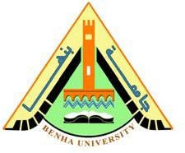

**Faculty of engineering - Shoubra Benha University**

# Research Article / Research Project / Literature Review

in fulfillment of the requirements of

|  |  |
| --- | --- |
| **Department** | Engineering Mathematics and physics |
| **Division** | ---------- |
| **Academic Year** | 2019-2020 |
| **Course name** | Computer |
| **Course code** | ECE001 |

**Title: -**

**Operating Systems**

|  |  |  |  |
| --- | --- | --- | --- |
|  | Name | Edu mail | B.N |
| 1 | حسين محمود محمد حسن الملط | Hussain195334@feng.bu.edu.eg | 304 |

## Approved by:

|  |  |
| --- | --- |
| Examiners committee | Signature |
| Dr.Ahmed Bayoumi | 1 |
| Dr.Shady Elmasha | 2 |
| Dr. Abdelhamid Attaby | 3 |

# Table of contents

|  |  |
| --- | --- |
| **Subject / section** | **Page** |
| **Introduction** | 1 |
| **Literature Review** | 3 |
| **References** | 9 |

# List of Figures

|  |  |  |
| --- | --- | --- |
| **Figure I.D** | **Description** | **Page** |
| 1 | Code | 7 |
| 2 | Code | 7 |
| 3 | code | 7 |
| 4 | page | 8 |
| 5 | page | 8 |
| 6 | page | 9 |

**Introduction**

The operating system is one of the most important basic software that a computer needs in order to operate what is known as the Operating System and is sometimes called (System Software). The operating system is a set of basic software that manages the computer and controls all the tasks and tasks that it performs. This software runs on the user to take advantage of the devices that make up the computer and its accessories such as the printer, mouse, etc. It also enables the user to take advantage of the various application software for the computer, such as printing software For messages, computations, etc. The operating system is the most important software, but rather the lifeblood of the computer. Usually, the major manufacturers of computers make operating systems compatible with their devices, depending on the type of processor. The user in it or delegates specialized companies to make operating systems for them, while small companies manufacture their devices to be compatible with the products of one of the major companies. Large companies to manufacture computers, and the tasks of operating systems vary according to different computer sizes. Large computers need highly efficient operating systems that enable them to deal with many computer units and the units attached to it, such as printers, storage media, and terminals as well. From providing the ability to operate for many users of the computer at the same time, but in personal computers, the operating systems are less complicated since they usually deal with one computer for one user.

# Literature Review

In the beginning we will know how the computer operating system works: when the computer is running, the operating system goes through several steps until it is ready to receive user orders and these steps can be summarized as follows:

1- Reading and executing instructions and commands from the ROM reading memory

2- Checking the computer units to ensure their safety

3- Loading the operating system from soft or optical disks or from the hard disk

4- Receiving device user orders

5- Download the application software and execute its instructions

6- Return to the operating system, wait for user orders and repeat the previous steps.

After we got to know how to operate the computer system, we will get to know the main function of the operating system, which is: operating the computer, managing it and allocating its resources.

The timing of the memory move: - When the computer is turned on

- How long does it last for memory after download: - It continues until the computer is closed

- The consequences of the program failure: - The computer stops working and the computer when it is running implements a set of instructions stored on the computer's memory that:

 Checking the physical components and ensuring their integrity is called a

Power On Self Test, and it detects errors resulting from the processor, memory,

basic input and output systems and stores them in a special memory.

- Activating the disk player and searching for the first part of the operating system that

is called the Bootstrap loader, which is a small program that has one task, which is to load the operating system into memory and allow it to start controlling the computer.

- The employment functions are generally summarized in the following six categories: -Management of the processor

Memory Management

Management of physical components

 - Storage management

Network Administration

User Interface Management

Application Software: -

The main function: - To meet the user's needs by solving his problems

The timing of the memory transition: - When the program is run

- How long will the memory last after downloading: - The program will continue to be terminated

- The consequences of the program crashing: - The program only stops working

After you know the functions of the operating system for a computer, we will learn about the types of operating systems and the types of operating systems used in computers, digital devices, and smart devices as follows:

1- DOS is called in the English language (DOS), and it is considered one of the first electronic operating systems that computer users have known, especially

manufactured in cooperation with Microsoft, which worked in 1982 to develop

it, to be called MS-DOS and contribute to providing the basic environment for operating the computer, and addresses The data is through commands written by the

user in the system’s board, which consists of black, but did not continue to work on it

individually, due to the lack of ease of dealing with it for new users, so Microsoft was keen to find an alternative, relied mainly on an environment Dos in his work, and this was Windows OS Alternative.

2- Windows is called the English language (Windows), which is an operating system designed by Microsoft in 1983, and it has the ability to deal with it, compared to the previous operating system (DOS); Because it contained a more interactive user interface, including the presence of windows, and icons associated with a group of applications, and provided a complete practical environment, such as the ability to write, draw, and perform calculations, and other means provided by the Windows operating system, and Microsoft is keen to develop it in a way Continuous and design updated versions of it.

3- Linux is called in the English language (Linux), which is an operating system designed in 1991, and it is one of the operating systems used via computers, and it provides many applications that are similar to the applications of the Windows operating system, and many computer companies have been keen to attract it and work to develop it. , In order to suit his working environment

4- Android is called the English language (Android), which is an operating system of Google, which was announced in 2007, and it is one of the most used operating systems in modern smart devices, because of its ease of design and dealing with it, and it also provided the ability to download free applications, And paid to give the user the ability to control the contents that he uses in his smart device.

**Source code**

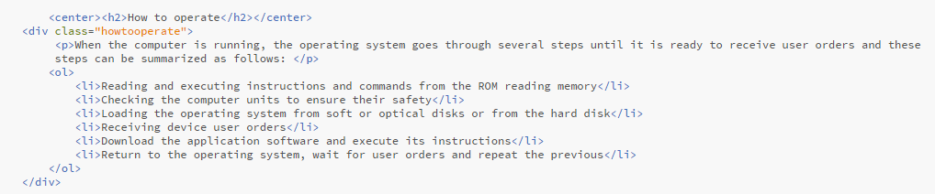

Fig.1

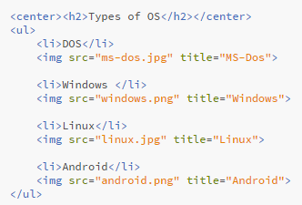

Fig.2

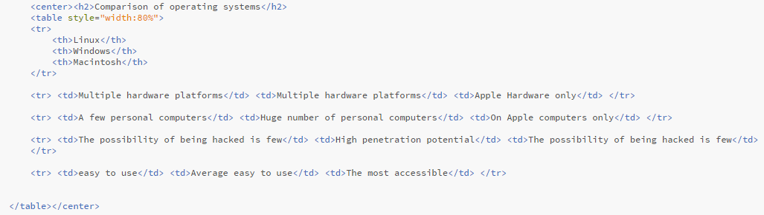

Fig.3

**Screenshot**

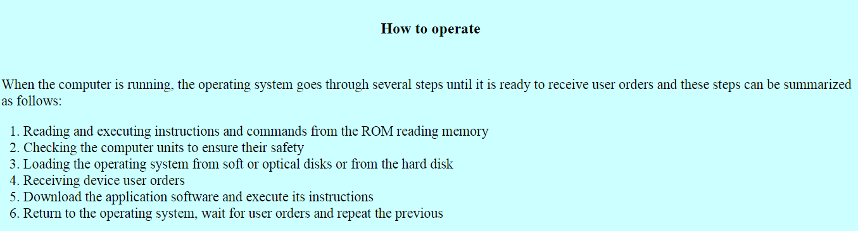

Fig.4

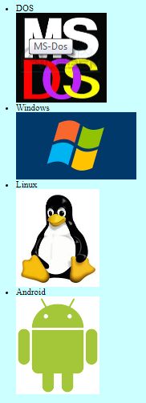

Fig.5

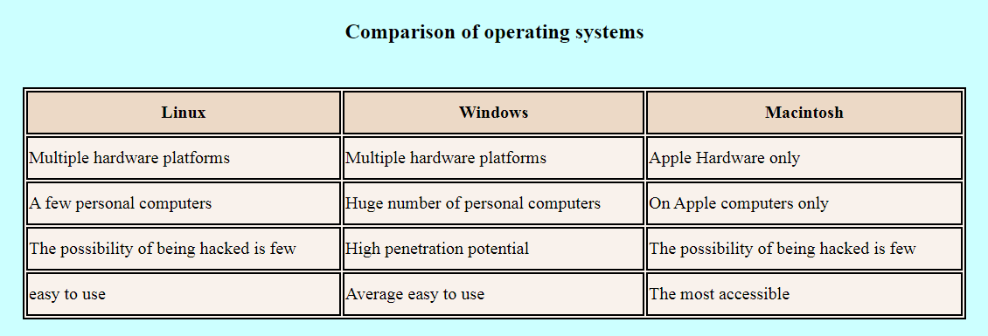

Fig.6

# References

<https://computer.howstuffworks.com/operating-system.htm?fbclid=IwAR0yXFkF9cfgl3EczqbqZ2fr6NhIkghHXLeg7espLM1_tXuvppOxpkSD64M>

<https://edu.gcfglobal.org/en/computerbasics/understanding-operating-systems/1/?fbclid=IwAR2zsvgBSvEY-ZgtRhEg6kcGFDjEQtTXb92yJVOt-p8KpMEFaJ5rryxC90A>

**<https://www.educba.com/types-of-computer-operating-system/>**

<https://www.guru99.com/operating-system-tutorial.html>

<https://whatis.techtarget.com/definition/operating-system-OS>