Task-3
Find the Maximally Specific Hypothesis for the following Data sets using FIND-S Algorithm
- Enjoy Sport Data set

Day Sky AirTemp Humidity Wind Water Forecast WaterSport
1 Sunny Warm Normal Strong Warm Same Yes
2 Sunny Warm High Strong Warm Same Yes
3 Rainy Cold High Strong Warm Change No
4 Sunny Warm High Strong Cool Change Yes

- Digital Papers Data set

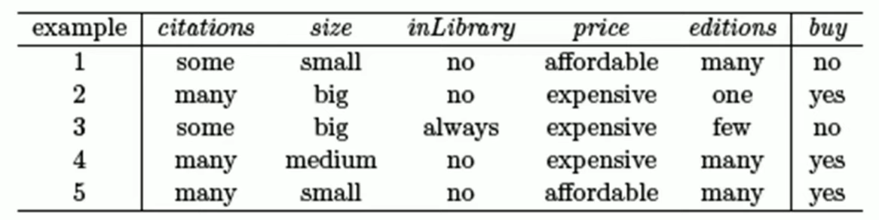

- Face Features Data Set

