Assignment Cover Sheet
Please fill out and insert as the first page of any essay-style Assignment.
Student Name(s) and Number(s) as per student card (s):
Hussian Amin Manj 20065768
Ahmad Raza 20074749
Noman Nazir 20075781

Program: Masters of Science in Cyber Security
Lecturer Name: Pete Cassidy
Module/Subject Title: B9CY109 CRYPTOGRAPHY & DIGITAL FORENSICS
Assignment Title: CA-2
No of Words:
By submitting this assignment, I am/ we are confirming that:
1. This assignment is all my/our own work;
2. Any sources used have been referenced;
3. I/we have followed the Generative AI instructions/ scale set out in the Assignment Brief;
4. I/we have read the College rules regarding academic integrity in the QAH Part B Section 3, and the Generative
AI Guidelines, and understand that penalties will be applied accordingly if work is found not to be my/our own.
5. I/we understand that all work uploaded is submitted via Ouriginal, whereby a text-matching report will show any similarities with other texts.

Table of Contents
Abstract 3
1. Getting Started: An Introduction 3
2. Our Setup: Tools and Environment 4
3. The Main Event: A Step-by-Step Walkthrough 5
4. What We Found: Results 15
5. What We Learned: Discussion 15
6. Final Thoughts: Conclusion 16
7. References 16

Abstract
In our Digital Forensics and Cryptography module, we were given a Capture The Flag (CTF) challenge called "Digital Forensics Training 0.5." This report is a detailed walkthrough of everything we did, from setting up the virtual machine to finding the very last flag. Our main goal was to use what we've learned in class in a hands-on, practical way. We had to find and use different vulnerabilities to uncover five hidden flags. This document explains our step-by-step process, the tools we used, the problems we ran into, and how we solved them. This experience was a great way to learn about penetration testing and to understand the importance of teamwork and persistence in cybersecurity. As some researchers have pointed out, these kinds of games are great for learning because they let you practice your skills in a realistic setting [1].

1. Getting Started: An Introduction

1.1. What Was the Challenge?
Our assignment was to complete a CTF challenge called "Digital Forensics Training v3." We were given a virtual machine file (.ova) that we had to set up and then break into to find five flags. The whole point was to make it feel like a real penetration test where we didn't know much about the target. The instructions were simple: find the first four flags, which were all two-digit numbers. Then, combine those numbers to create the password for the root user, where our final flag was.

1.2. What This Report Covers
In this report, we will walk you through our entire journey. We want to show you:
- Exactly what we did, step-by-step, from start to finish.
- The specific tools and commands we used to find each flag.
- The evidence we gathered during our challenge, such as screenshots of our command line, webpages and files present on the server.
- The tricky parts we ran into and how we figured them out.
- What we learned from doing this and the skills we got to practice.

1.3. Why CTFs Are Great for Learning
CTF challenges are a really popular way to learn cybersecurity. Instead of just reading books, they let you jump into a hands-on environment and try things out for yourself. These challenges are often designed upon real-world situations, and make the users think practically. As one study puts it, a CTF is a "cybersecurity game played by multiple teams… with the objective of honing their cybersecurity skills by solving various challenges" [1]. This approach makes learning easier and helps us to understand concepts better because we are actually using skills in a practical environment. Doing this CTF really showed us how valuable this kind of learning is. It made us think hard, work together, and not give up, which are essential skills for anyone who wants to work in cybersecurity.

2. Our Setup: Tools and Environment
Before we could start hacking, we had to set up our virtual lab correctly. This was important to make sure everything we did was in a safe, isolated space.

2.1. Getting the Virtual Lab Ready
We started by downloading the given "DF Training v3.ova" file from the Moodle page. We used Oracle VM VirtualBox [2] to load the given file. When we started it up, it showed its IP address as 192.168.56.101. This was our target for the whole challenge.
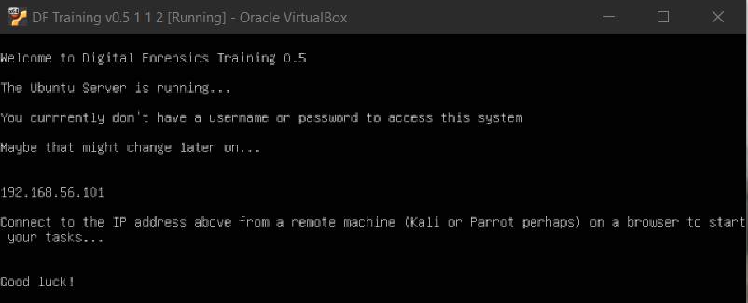
Figure 1: The first thing we saw when we booted up the target server.
As hinted above, we started another Kali Linux virtual machine [3] to handle all the work required for this challenge. Kali is great because it comes with tons of penetration testing tools already installed, so we had everything we needed. Both machines were running in VirtualBox on the same machine to ensure there was no connectivity issue between them.

2.2. The Tools We Used
We used a handful of really useful open-source tools during this challenge:
- Nmap: This was our go-to tool for checking out the network. We used it to see what ports were open on the server [4].
- Hydra: A tool for cracking passwords. We used it to brute-force our way into the FTP server [5].
- Dirb: A web scanner that helps find hidden files and folders on a website [6] by trying out a lot of common file paths present in the file system.
- Python: We wrote a small Python script to solve the first flag, which was a hash cracking puzzle [7].
- SecLists: This is a huge collection of wordlists. We used "500-worst-passwords.txt "with Hydra to make our brute-force attack more effective [8].
- Basic Linux Tools: We also used a lot of standard command-line tools like ftp, ssh, cat, and ls to interact with the server.

3. The Main Event: A Step-by-Step Walkthrough
We tried to be organised and followed the basic steps of a real penetration test. We took screenshots along the way to keep track of what we were doing.

3.1. First Look: Reconnaissance
First things first, we needed to see what we were up against. We ran a basic Nmap scan to see what services were running on the target IP.
- nmap 192.168.56.101
The scan showed three open ports: FTP (port 21), SSH (port 22), and HTTP (port 80).
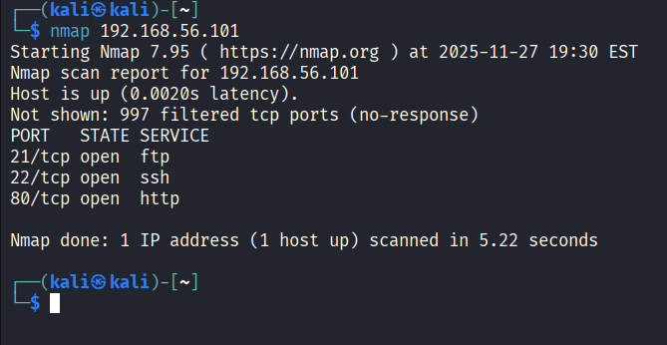
Figure 2: Nmap scan results showing the three open ports.
We decided to check out the website on port 80 first. The homepage gave us a huge clue: it explained the whole challenge, telling us to find five flags and how the first four would help us get the last one. This was a great starting point.
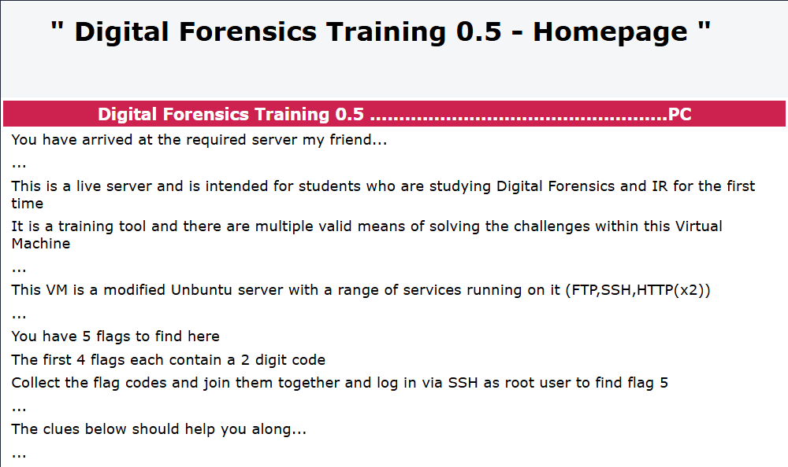
Figure 3: The webpage on port 80

3.2. Finding Flag 1: Cracking the Hashes
The website led us straight to our first puzzle. We were given two hashes, an MD5 and a SHA1, and told they belonged to a two-digit number. This meant we had to find a number between 00 and 99 that, when hashed, produced both of those values.
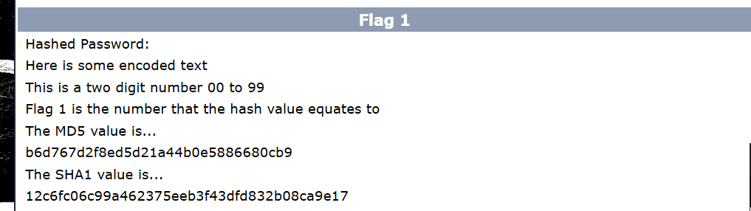
Figure 4: Flag 1 Question
We figured the easiest way to do this was to write a simple Python script. It iterated over every number from 0 to 99, calculated MD5 and SHA-1 hashes for each, and checked whether they matched the ones we were given.
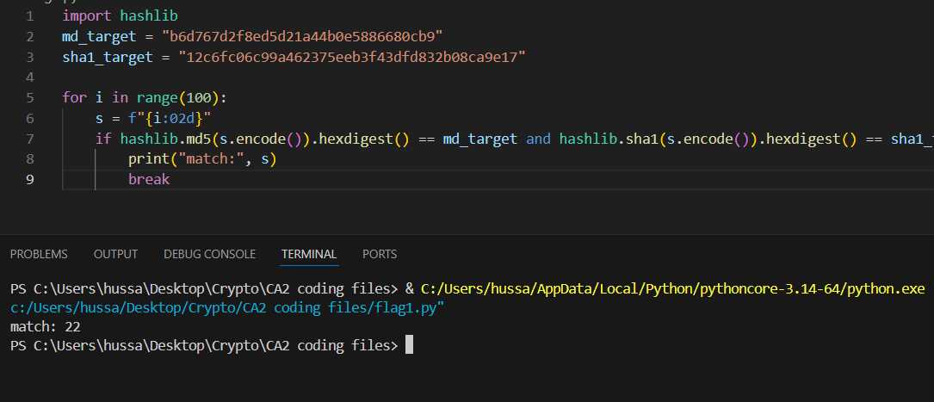
Figure 5: Python Script and its output
It did not take long for the script to find the answer: 22, which was our first flag.

3.3. Finding Flag 2
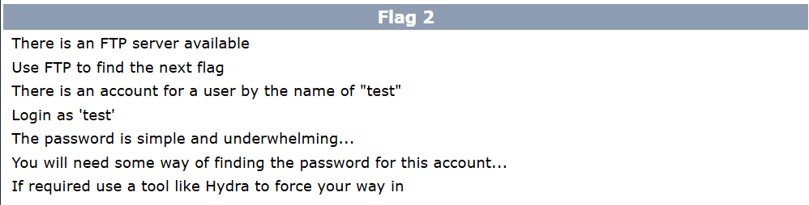
Figure 6: Flag 2 Question
The next clue pointed us toward the FTP server, which we found in our previous Nmap scan. It gave us the username "test" and hinted that the password was "simple and underwhelming." This was a huge hint. It meant that we only needed to check very simple passwords. To make our attack effective, we needed a password list that met that criterion. We used the "500-worst-passwords.txt" file from the popular "SecLists" repository on GitHub. Now we needed a tool to brute-force our password list on the FTP server. We chose Hydra because it is built into Kali and is fast and easy to use for this kind of task. The command we put together was:
- hydra -l test -P 500-worst-passwords.txt ftp://192.168.56.101
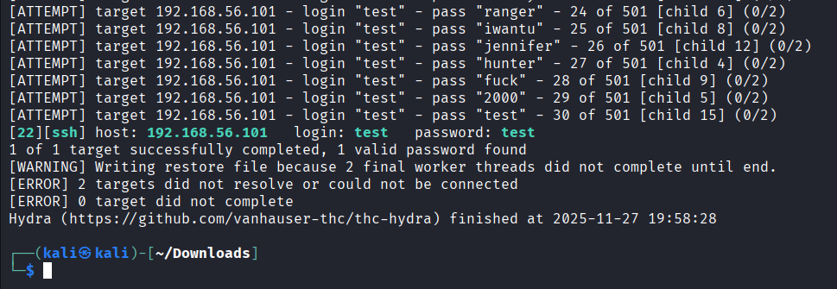
Figure 7: Hydra tool output
Hydra found the password almost instantly, i.e. "test". It was a bit funny that the password was the same as the username, and it is a surprisingly common mistake in the real world. With these credentials, we logged into the FTP server. Inside, we found two folders, "files" and "directory", and a "hint.txt" file. Our first instinct was to check the "directory" folder. We found a file named "flag.txt". For a second, we were really excited and thought we had already found the flag. But when we opened it, it said "TOTAL FALSE FLAG." It was a classic misdirection, a trick to see if we were paying attention.
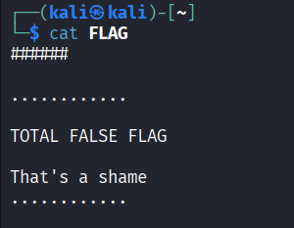
Figure 8: Contents of FLAG.txt
That was a bit of a letdown, but it was also a great learning moment. It taught us to be skeptical and thorough. We went back and looked at the other folder, "files". This one was full of random-looking files, which seemed designed to be confusing. But as we scrolled through the list, we found the file, "FLAG2.txt". It seemed too obvious to be another trick, so we downloaded it using the get command and opened it up.
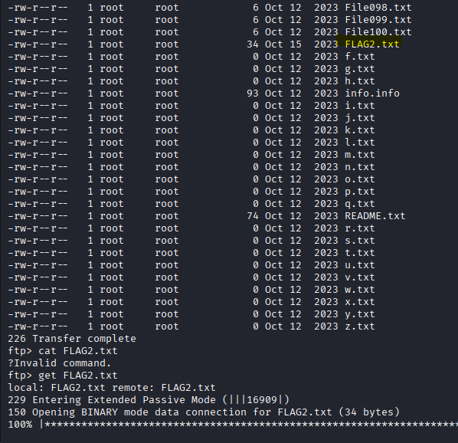
Figure 9: "Files" folder's content where FLAG2.txt was found
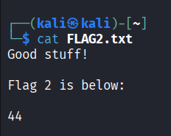
Figure 10: Flag 2

3.4. Finding Flag 3: Digging Through the Website
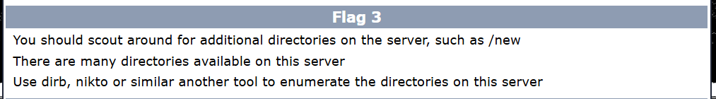
Figure 11: Flag 3 Question
The clue for Flag 3 told us to look for more directories on the web server. This is a common step in web penetration testing, so we used the tool "dirb" to help us.
- dirb http://192.168.56.101
dirb started scanning the website for common file and folder names and found a bunch of hidden directories, like /admin, /php, and /secret.
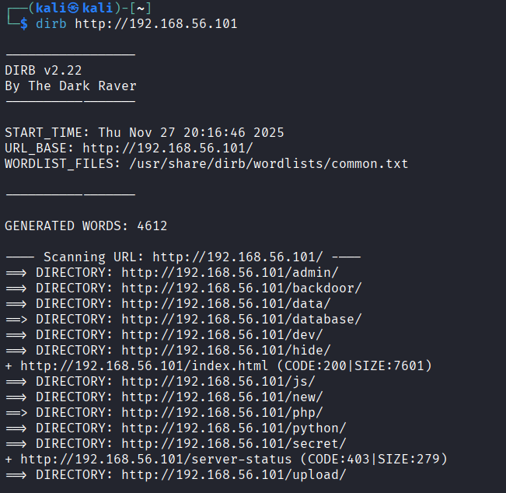
Figure 12: Dirb tool output
We started poking around in these new directories. A file in /admin gave us a hint to look for scripts, which made us think the /php or /python folders were a good bet.
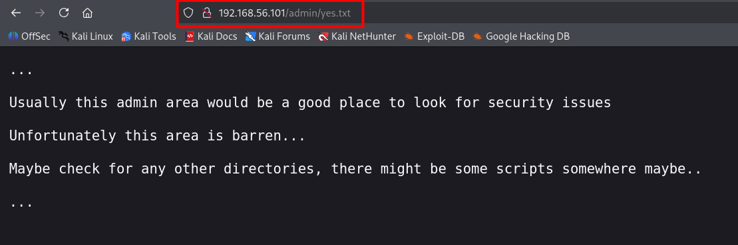
Figure 13: 192.168.56.101/admin/yes.txt
After a bit of clicking around, we found our flag deep in directories at the path: /php/readme/FLAG/FLAG3.txt. When we went to that URL, we found our third flag.
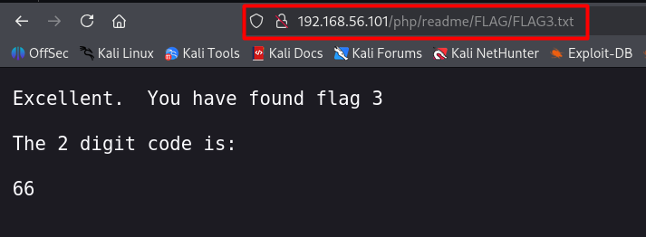
Figure 14: Flag 3

3.5. Finding Flag 4: A Hidden Port and Source Code Secrets
For the fourth flag, the clue told us to run another, more detailed nmap scan, suggesting that another HTTP server was hiding somewhere. This was a great hint that our initial, basic scan was not enough. Attackers often hide services on non-standard ports to avoid easy detection, a technique known as security through obscurity. To find it, we needed to scan every single possible port. We ran Nmap again, but this time with the -p- flag to scan all 65,535 TCP ports.
- nmap -p- --open -sC 192.168.56.101
This scan took a few minutes to run, which is much longer than the first one, but our patience paid off. It found a new open port that was not there before: 14545.
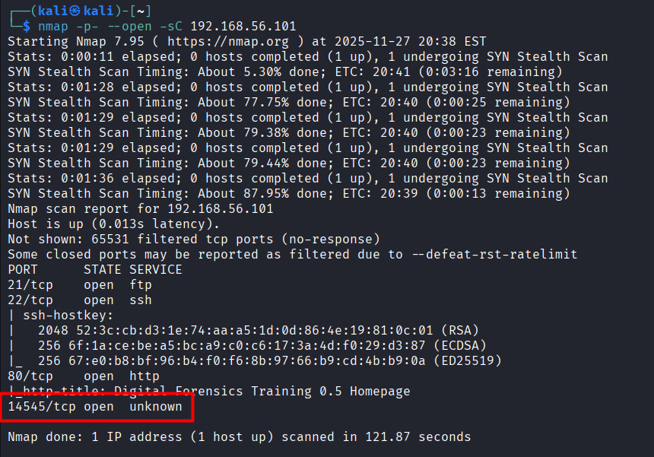
Figure 15: Nmap scan showing port 14545 as open
Finding an unexpected open port is always exciting during a penetration test. We immediately opened it in our browser by navigating to "http://192.168.56.101:14545".
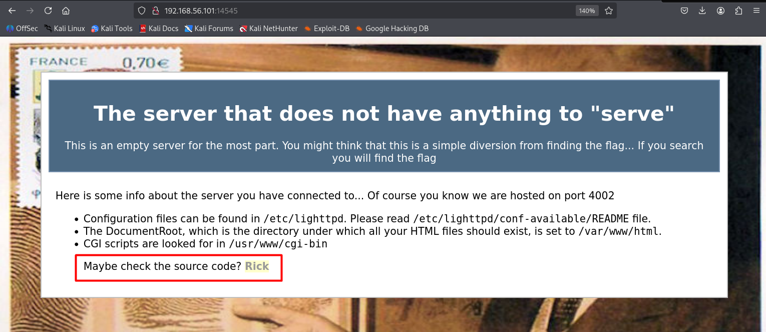
Figure 16: http://192.168.56.101:14545
The page that loaded was very plain and seemed to contain no meaningful data, except for two items in the last line. Firstly, it had a link to a popular old song, "Never Gonna Give You Up" by Rick Astley (1987). Incorporating the iconic "Rickroll" into the challenge added a humorous touch. This unexpected interaction refreshed our mindset and demonstrated how even simple pop-culture references can positively influence concentration and creativity during technical investigations. The second prominent thing in the last line was actually the hint. Upon inspecting the webpage's source code, we found a hidden comment, which was our flag 4.
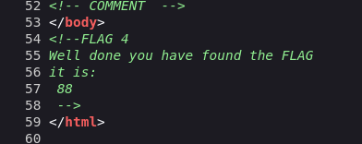
Figure 17: Flag 4

3.6. The Final Flag: Getting Root Access
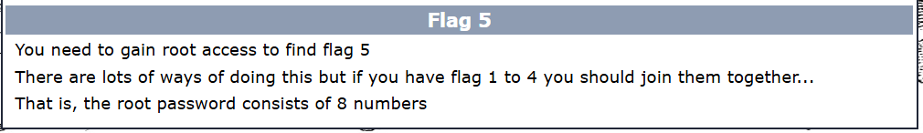
Figure 18: Flag 5 Question
We had the first four flags: 22, 44, 66, and 88. The instructions said to put them together to make the root password, so we tried 22446688. We used this password to try to log in as the root user with SSH.
- ssh root@192.168.56.101
- entered password: 22446688
It worked! We were in. We had full root access to the server.
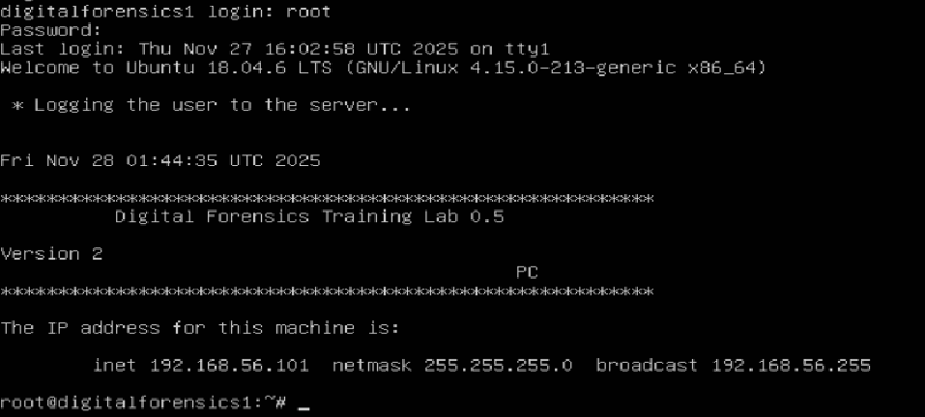
Figure 19: Accessing our root server
Now we have to find the last flag. We looked through the root user's home directory and found a subfolder containing a file named "FLAG". We opened it up, and it turned out to be our last flag.
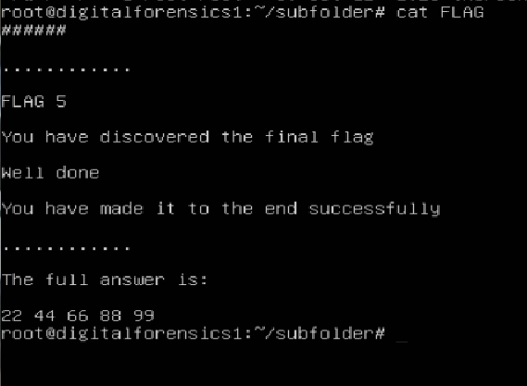
Figure 20: Flag 5
The file congratulated us on making it to the end and gave us the final number, 99.

4. What We Found: Results
We completed the challenge by finding all five flags listed in the table below.
Table 1: Quick Summary of the Flags
Flag | Value | How We Found It
1 | 22 | We cracked the MD5 and SHA1 hashes with a Python script.
2 | 44 | We used Hydra to crack the FTP password and then found the flag file.
3 | 66 | We used Dirb to find hidden web directories and found the flag on a hidden page.
4 | 88 | We did a full port scan with Nmap and found the flag in the HTML source code.
5 | 99 | We used the other flags to create the root password and logged in via SSH.

4.1. The Vulnerabilities We Exploited
This challenge was a great showcase of common security problems:
- Weak Hashes: The first flag used hashes on a tiny set of possible inputs, making it easy to brute-force.
- Weak Passwords: The FTP server had a user with a very weak password, "test", which is a huge security risk.
- Exposed Information: The web server had hidden folders that should not have been public, which led us to a flag.
- Hidden Code: The fourth flag was sitting in an HTML comment, which is a classic mistake developers make while coding.
- Hiding in Plain Sight: The server was running a service on a weird, high-numbered port, hoping no one would find it. This is a common but often ineffective way to hide things.

5. What We Learned: Discussion
This project was about more than just finding flags; it was a huge learning experience for our whole team.

5.1. The Technical Skills We Practised
We got to put a lot of our classroom knowledge to the test. We practised:
- Network Scanning: Using Nmap to find open ports and services.
- Cracking Passwords: Using Hydra for a dictionary attack and writing our own script for a hash challenge.
- Python Scripting: Writing a Python script for the hash calculation.
- Analyzing Websites: Using Dirb to find hidden pages and looking through source code for clues.
- Using the Command Line: Getting comfortable with using tools like FTP and SSH to interact with a remote server.
- Privilege Escalation: It involves finding leads as you go and using them to escalate privileges in the system

5.2. Teamwork and Solving Problems
This project really helped us understand the importance of teamwork in cybersecurity. Alongside technical skills, it was about how we worked together to solve problems. When we got stuck, we did not just stare at our screens. We would get together, talk about what we had tried, and brainstorm new ideas. Instead of getting stuck, we talked it through. One of us suggested that it might be a deliberate trick, and that we should re-examine the other folders. This collaborative approach helped us get back on track quickly.
We also learned to play to our strengths and divide the work. For example, Ahmad is good with Python, so he took the lead on writing the hash-checking script. While he was doing that, Noman started setting up the Hydra attack using his laptop. Meanwhile, I went through the clues again to make sure we had not missed anything. This teamwork made us much more efficient throughout the challenge. We used a shared document to keep notes of every command we ran and every piece of information we found. It felt like we were a real security team, communicating and coordinating to achieve our goal. This experience was just as valuable as the technical skills we learned.

6. Conclusion
Overall, the "Digital Forensics Training 0.5" CTF was an excellent learning experience. We used practical penetration testing tools and techniques on a live target. This makes things way more interesting than just reading about them in theory. The challenge was well-designed, with each flag teaching us something new. This project really helped solidify our technical skills, but it also taught us a lot about problem-solving and the importance of working together. It was a great reminder of why hands-on learning is so crucial in a field like cybersecurity.

7. References
[1] D. G. Kartasasmita, F. G. C. Timur, and A. H. Reksobrodjo, "Enhancing Competency of Cybersecurity Through Implementation of the 'CAPTURE THE FLAG' On College in Indonesia," International Journal of Humanities Education and Social Sciences (IJHESS), vol. 3, no. 2, pp. 875–890, Oct. 2023.
[2] Oracle Corporation, "Oracle VM VirtualBox," 2023. [Online]. Available: https://www.virtualbox.org
[3] Offensive Security, "Kali Linux," 2023. [Online]. Available: https://www.kali.org
[4] Nmap.org, "Nmap: The Network Mapper," 2023. [Online]. Available: https://nmap.org
[5] van Hauser, T., "THC-Hydra," 2023. [Online]. Available: https://github.com/vanhauser-thc/thc-hydra
[6] The Dark Raver, "Dirb," 2023. [Online]. Available: http://dirb.sourceforge.net
[7] Python Software Foundation, "Python Language Reference," 2023. [Online]. Available: https://www.python.org
[8] D. Miessler, "SecLists," 2023. [Online]. Available: https://github.com/danielmiessler/SecLists/blob/master/Passwords/Common-Credentials/500-worst-passwords.txt

