HW/SW Co-Design Project
Benchmark report: nbody
pyperformance optimization and hardware acceleration (V3A)
Software speedup | Run time | Correctness | Hardware (V3A)
1.64x | 229 ms -> 140 ms | energy diff 2.2e-16 | 38 cycles/step, ~18x
Environment: Linux-5.15.0-1106-kvm-x86_64-with-glibc2.35, 1 CPU(s), Python 3.10.12 (64-bit), pyperformance 1.14.0.

1. Overview
Purpose
nbody comes from the Computer Language Benchmarks Game. It simulates the
orbits of the Jovian planets (Sun, Jupiter, Saturn, Uranus, Neptune) under
Newtonian gravity. It is a classic "pure floating-point number crunching"
workload: no I/O, no allocation of user objects, no strings -- only
arithmetic on Python floats stored in Python lists. It therefore measures
how fast the CPython interpreter executes numeric bytecode.

Libraries
- Python standard library only. No numpy / C extensions.
- pyperf: timing harness only (perf_counter, worker processes, statistics);
it is not part of the measured computation.

Data structures
- BODIES : dict name -> (position, velocity, mass)
position = [x, y, z] (mutable list of 3 floats)
velocity = [vx, vy, vz] (mutable list of 3 floats)
mass = float (in units where G = 1, SOLAR_MASS = 4*pi^2)
- SYSTEM : list of the 5 body tuples (the lists inside are shared by
reference, so in-place updates are visible everywhere).
- PAIRS : list of the 10 unordered body pairs, built once by a pure-Python
re-implementation of itertools.combinations(SYSTEM, 2).

Algorithm
Direct all-pairs O(N^2) gravity with a semi-implicit (symplectic) Euler
integrator, dt = 0.01:

for each step:
for each pair (i, j):
d = r_i - r_j
mag = dt * |d|^-3
v_i -= d * m_j * mag
v_j += d * m_i * mag
for each body:
r += dt * v (uses the NEW velocity -> symplectic)

report_energy() computes total energy (kinetic + potential) before and after
the run as a sanity check; offset_momentum() makes the total momentum zero
by adjusting the Sun's velocity.

One benchmark "loop" = report_energy + 20,000 steps + report_energy.
Per step: 10 pair interactions + 5 position updates, i.e. 200,000 pair
interactions per loop. advance() is >99.9% of the work: report_energy()
evaluates the 10 pairs once, advance() evaluates them 20,000 times.

Why this is slow in CPython
A float in CPython is a heap object (PyFloatObject, 24 bytes). Every
arithmetic bytecode goes: dispatch in _PyEval_EvalFrameDefault ->
PyNumber_Multiply -> float_mul -> PyFloat_FromDouble (free-list allocation)
-> Py_DECREF of temporaries. The actual double multiply is ~1 machine
instruction; the surrounding interpreter work is tens to hundreds.
In addition, every `v1[0] -= x` needs BINARY_SUBSCR + INPLACE_SUBTRACT +
STORE_SUBSCR with stack shuffling (DUP_TOP_TWO, ROT_THREE), and every pair
iteration needs FOR_ITER and three UNPACK_SEQUENCE operations.

2. Initial analysis (profiling)
Method (all automated in script_nbody.sh)
- pyperformance run -b nbody -> results/baseline.json
- perf stat -r 5 (instructions, branches, cache) -> results/perf_stat_original.txt
- perf record -e cpu-clock -F 999 -g -- python3-dbg -m pyperformance run
--bench nbody (course guide method) -> results/perf_report_original*.txt
- FlameGraph (stackcollapse-perf.pl | flamegraph.pl)
-> flamegraphs/flamegraph_nbody_original.svg
- bytecode_count_nbody.py (executed opcodes/step) -> table below

python3-dbg is used so perf can resolve CPython's internal C symbols.
Python 3.10 has no `-X perf` support, so the perf flame graph shows
interpreter C functions, not Python function names.
VM note: the QEMU vCPU exposes no "cycles" event, so perf's default
sampling event records zero samples; we sample on cpu-clock instead.
perf stat runs profile_nbody.py (bench_nbody() called directly in one
process) so counters exclude pyperf worker spawning and venv setup.

Baseline result
pyperformance run -b nbody: 229 ms +- 3.0 ms per loop (60 values)
(under python3-dbg while profiling: 481 ms +- 3.2 ms)

perf report -- hottest symbols, self overhead (original)
overhead symbol
22.29% _PyEval_EvalFrameDefault
2.20% binary_op1
2.03% validate_list
1.88% __memset_avx2_unaligned_erms
1.86% _PyMem_DebugCheckAddress
1.61% PyFloat_FromDouble
1.47% float_mul.lto_priv.0
1.46% lookdict_unicode_nodummy
1.37% _PyPegen_is_memoized
1.32% float_dealloc.lto_priv.0
1.15% read_size_t
1.05% _PyObject_Malloc
0.98% list_ass_item.lto_priv.0
0.98% _PyUnicode_CheckConsistency
0.96% PyNumber_AsSsize_t

grouped by role:
22.29% bytecode dispatch (_PyEval_EvalFrameDefault)
7.14% list/tuple indexing (v[0], unpacking)
6.95% float objects: arithmetic + alloc/free
0.64% pow() in libm
4.27% number-protocol dispatch (binary_op1 ...)
4.75% object alloc / refcount bookkeeping
9.98% debug-build self-checks (python3-dbg only)
2.56% dict lookups (globals/attributes)
(98.1% of all samples are in the benchmark worker process; the rest
is pyperformance start-up. Shares below 100% in total are the long tail
of smaller symbols.)

perf stat (original), per run of 5 loops x 20,000 steps
instructions 8,713,724,770
branches 1,500,031,830
branch-misses 6,778,605 0.45% of branches
cache-references 5,427,800
cache-misses 159,132 2.93% of cache refs
task-clock 1266.7 ms
cycles not exposed by the VM

Interpretation: cache misses are negligible (159,132 for 8.7 billion
instructions; the whole simulation state is 5 bodies, a few KB) and
branch misses are negligible (0.45%). The workload is interpreter-
overhead bound: ~87,137 machine instructions per simulation step,
i.e. ~65 x86 instructions per executed bytecode -- for
arithmetic whose real work (a double add/mul) is ~1 instruction.
Speedup must come from executing fewer bytecodes, not from memory layout.

Executed bytecode per simulation step (original)
LOAD_FAST 397.0
STORE_FAST 186.0
BINARY_MULTIPLY 135.0
LOAD_CONST 85.0
DUP_TOP_TWO 75.0
BINARY_SUBSCR 75.0
ROT_THREE 75.0
STORE_SUBSCR 75.0
UNPACK_SEQUENCE 60.0
INPLACE_ADD 45.0
BINARY_SUBTRACT 30.0
INPLACE_SUBTRACT 30.0
BINARY_ADD 20.0
FOR_ITER 18.0
JUMP_ABSOLUTE 16.0
BINARY_POWER 10.0
GET_ITER 2.0
TOTAL 1334.1

Bottlenecks identified
B1 Container access: 150 list subscripts + 150 stack-shuffle opcodes per
step exist only because body state lives inside lists.
B2 Loop/unpacking overhead: FOR_ITER + 60 UNPACK_SEQUENCE per step to walk
PAIRS and destructure ((pos, vel, m), (pos, vel, m)).
B3 Redundant arithmetic: `dt * ...` is recomputed for every pair although
dt and masses are constant during the run.
B4 Boxed-float arithmetic itself (~270 arithmetic opcodes per step, each
allocating a new PyFloat). This is the irreducible cost in pure Python
and the target of the hardware proposal (section 5).

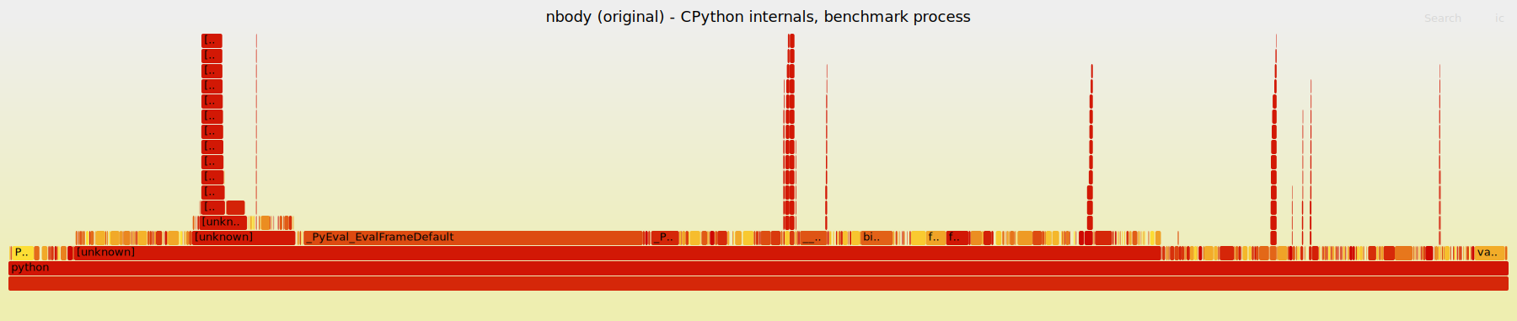
Flame graph - nbody, original (perf record -e cpu-clock -g, python3-dbg). Interactive version: benchmarks/nbody/flamegraphs/flamegraph_nbody_original.svg

3. Optimizations
All changes are in benchmarks/nbody/optimized/run_benchmark.py. The public
API (advance, report_energy, offset_momentum, bench_nbody), the workload
(5 bodies, 20,000 steps, dt = 0.01) and the benchmark name are unchanged, so
it runs under pyperformance through a custom manifest
(benchmarks/nbody/manifest/MANIFEST) and compares directly with the original.

O1 Precompute m*dt (targets B3)
mdt_k = m_k * dt is computed once per call. The pair loop then uses
mag = |d|^-1.5 and b1m = mdt_i * mag -> one fewer multiply per pair.

O2 Body state in local variables (targets B1)
At the start of advance(), positions/velocities are unpacked into 30
local variables (x0..z4, vx0..vz4); they are written back to the lists
once at the end. Locals live in the frame's fastlocals array, so access
is LOAD_FAST/STORE_FAST (an array index) instead of list subscripting.

O3 Specialization / loop unrolling (targets B2)
Since the number of bodies is fixed during a run, the 10 pair
interactions are generated as straight-line code. The generator runs once
at import time for len(SYSTEM) bodies (so the code is general for any N)
and is compiled with compile()/exec(); nothing is generated in the timed
region. `python3 run_benchmark.py --dump-generated` prints it. This is
the same idea a JIT uses (specializing code for values that are constant
at run time). O2 is only possible together with O3: without unrolling
there is no way to name "the velocity of body j" as a local variable.

Correctness (verify_nbody.py, 20,000 steps from identical initial state)
steps=20000
energy before : original=-0.1690751638285245 optimized=-0.1690751638285245
energy after : original=-0.16908926275527172 optimized=-0.16908926275527195
|dE|=2.220e-16 max |state diff|=6.117e-12
PASS
A ~1e-16 energy difference is expected: O1 computes (m*dt)*mag instead
of m*(dt*mag), and IEEE-754 multiplication is not associative.

Effect on executed bytecode (per step)
opcode original optimized
LOAD_FAST 397.0 385.8
STORE_FAST 186.0 136.6
BINARY_MULTIPLY 135.0 125.0
LOAD_CONST 85.0 10.4
INPLACE_ADD 45.0 45.0
STORE_SUBSCR 75.0 0.3
BINARY_SUBSCR 75.0 0.1
ROT_THREE 75.0 0.0
DUP_TOP_TWO 75.0 0.0
UNPACK_SEQUENCE 60.0 0.2
INPLACE_SUBTRACT 30.0 30.0
BINARY_SUBTRACT 30.0 30.0
BINARY_ADD 20.0 20.0
BINARY_POWER 10.0 10.0
FOR_ITER 18.0 0.0
JUMP_ABSOLUTE 16.0 1.0
GET_ITER 2.0 0.0
EXTENDED_ARG 0.0 1.0
TOTAL 1334.1 795.5 (-40%)
Container-access, stack-shuffle and unpacking opcodes disappear; the
float arithmetic opcodes remain (minus the dt multiplies removed by O1).

Rejected / negative results (kept in ablation_nbody.py on purpose)
R1 Replace x**-1.5 with 1/(d2*sqrt(d2)). Common advice in C, but in CPython
it saves a libm pow() call while adding a CALL_FUNCTION to math.sqrt
plus an extra division opcode -- interpreter overhead cancels the win
(see ablation table).
R2 numpy vectorization. With only 5 bodies / 10 pairs per step, each numpy
call's fixed overhead (argument parsing, array allocation, dtype
dispatch) dominates the tiny amount of actual arithmetic; numpy only
wins when N is large. This is the same "offload granularity" trade-off
that applies to the hardware accelerator in section 5.

4. Performance comparison
pyperformance (results/compare.txt)
original : 229 ms +- 3.0 ms
optimized: 140 ms +- 4.9 ms
-> 1.64x faster, run time -39% (meets the >= 7% requirement)
Same trend under python3-dbg while profiling: 481 ms -> 274 ms (1.76x).

Ablation (ablation_nbody.py) -- each optimization measured separately
variant time / 20k steps vs original
original 228.7 +- 3 ms 1.00x
R1 sqrt instead of pow 229.4 +- 3 ms 1.00x
O1 precompute m*dt 226.0 +- 4 ms 1.01x
O1+O2+O3 (final) 139.3 +- 4 ms 1.64x
(R2 numpy skipped: numpy is not installed in this environment)

perf stat before/after (5 loops x 20,000 steps per run, mean of 5 runs)
original optimized change
instructions 8,713,724,770 5,568,251,540 -36.1%
branches 1,500,031,830 961,259,560 -35.9%
branch-misses 6,778,605 5,315,149 -21.6%
cache-misses 159,132 24,773 -84.4%
task-clock 1266.7 ms 789.5 ms 1.60x faster
elapsed 1.657 s 1.108 s 1.50x faster

Instructions drop by 36% (~87,137 -> ~55,683 per step), in line with the
40% drop in executed bytecodes (1334 -> 795 per step). The time ratio
(1.60x) tracks the instruction ratio (1.56x): the gain is "less
interpreter work", not better cache or branch behaviour.

perf profile before/after (flame graphs: flamegraphs/flamegraph_nbody_*.svg)
Estimated absolute cost = self% x total sampled time of each profile.
role original optimized change
bytecode dispatch (_PyEval_EvalFrameDefault) 22.3% 26.1% -49%
list/tuple indexing (v[0], unpacking) 7.1% 1.1% -93%
float objects: arithmetic + alloc/free 7.0% 13.5% -15%
pow() in libm 0.6% 1.6% +8%
number-protocol dispatch (binary_op1 ...) 4.3% 10.2% +4%
object alloc / refcount bookkeeping 4.7% 5.1% -54%
debug-build self-checks (python3-dbg only) 10.0% 8.4% -64%
dict lookups (globals/attributes) 2.6% 2.8% -52%

Largest absolute reductions: _PyEval_EvalFrameDefault (-49%),
__memset_avx2_unaligned_erms (-76%), _PyPegen_is_memoized (-100%),
_PyMem_DebugCheckAddress (-72%), list_ass_item.lto_priv.0 (-100%).
Practically gone from the optimized profile: list_ass_item.lto_priv.0,
_PyPegen_is_memoized, PyNumber_AsSsize_t.
Top of the optimized profile: _PyEval_EvalFrameDefault (26.1%),
binary_op1 (5.2%), PyFloat_FromDouble (3.4%), float_mul.lto_priv.0
(2.9%), float_dealloc.lto_priv.0 (2.5%).
Total sampled time: original 42.18 s, optimized 18.30 s (cpu-clock
event count, includes pyperformance start-up).

Flame graph - nbody, BEFORE optimization
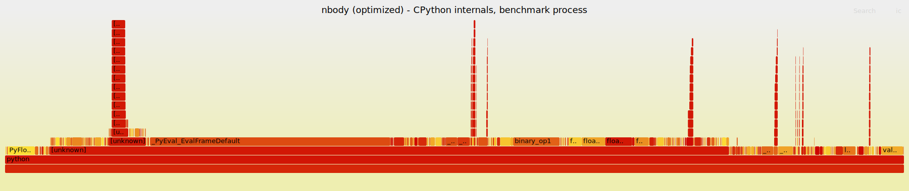
Flame graph - nbody, AFTER optimization. Interactive version: benchmarks/nbody/flamegraphs/flamegraph_nbody_optimized.svg

5. Hardware acceleration proposal
One accelerator serves both benchmarks: V3A, a 3D Vector-math Accelerator.
The hot arithmetic of nbody (pair distance, |d|^-3) and of raytrace
(ray-sphere test: dot products and a square root) is the same small set of
operations: 3D subtract, dot product and inverse square root. V3A implements
them once as reusable pipelined IP and exposes two kernels on one PCIe card.
Full RTL: hw/rtl/*.v (Verilog-2005/SystemVerilog-compatible, Icarus-tested).

5.1 Hardware description (hw/rtl)
v3a_top.v PCIe core logic: register bus decode, IRQ
v3a_nbody_ctrl.v nbody kernel: body registers, step FSM, integrator
v3a_pair_pipe.v pairwise gravity datapath, 19 stages
v3a_ray_ctrl.v ray kernel: ray BRAM, feed FSM, reducer, results
v3a_raysphere_pipe.v ray-sphere datapath, 19 stages
v3a_invsqrt.v shared inverse-square-root IP, 12 stages
v3a_delay.v sideband pipeline balancing
v3a_common.vh Q23.40 fixed-point multiply
v3a_invsqrt_lut.vh 64-entry initial-guess ROM (generated)
Golden model: hw/model/v3a_model.py (bit-accurate). Testbench:
hw/tb/tb_v3a.v. Everything is run by: python3 hw/run_hw_tests.py

5.2 Inputs and outputs
Number format : signed Q23.40, 64 bits (range +-8.4e6, LSB 9.1e-13).
Chosen instead of IEEE-754 double: a fixed-point multiply
needs no normalization/rounding logic (about half the area
of a double-precision FPU multiplier, one stage per op).
Clock : single clock, target 100 MHz (see 5.7), sync. reset.
Host bus : memory-mapped, word-addressed, 64-bit data (PCIe BAR0
behind an AXI4-Lite bridge; BAR byte offset = 8 x index).
24-bit address: 0x000000 nbody window, 0x100000 ray window.
Interrupt : irq (level) when a job is done -> MSI.
nbody kernel : in : NBODIES (2..8), NSTEPS, DT, per body x,y,z,vx,vy,vz,m*dt
out: updated x,y,z,vx,vy,vz after NSTEPS steps; STEPDONE,
CYCLES (performance counter)
ray kernel : in : NRAYS (1..4096), NSPH (1..16), EPS, MODE
(0 closest hit, 1 any hit), spheres c,r^2,
rays p,d (d normalized)
out: per ray (sphere index or -1, t) / (occluded 1/0)
Pipeline IP : valid/data streaming, no back-pressure needed (the
controllers always accept every output).
v3a_invsqrt in x (Q23.40) out y = x^-1/2
v3a_pair_pipe in r_i, r_j, m_i*dt, m_j*dt, i, j out f_i, f_j, i, j
v3a_raysphere_pipe in p, d, c, r^2, ray id, sph id out disc, t, ids

5.3 Hardware architecture
Datapath (see hw/docs/v3a_pipelines.png):
- Every stage has at most ONE 64x64 multiply followed by a register, so
the critical path is the same everywhere and throughput is one result
per clock cycle after the 19-cycle latency.
- v3a_invsqrt: stage 1 normalizes x = m*4^k with m in [1,4) using a
priority encoder and a barrel shift; stage 2 takes y0 from a 64-entry
ROM indexed by the top 6 bits of m; stages 3-11 run three Newton
iterations y <- y(3 - m y^2)/2 (3 stages each: y^2, m*y^2, update);
stage 12 shifts back by k. Measured accuracy: relative error < 2.3e-7
over 1e-6..1e6 (limited by the Q23.40 LSB), ~1e-12 for typical values.
- Sideband data (indices, d, masses, v) travel through v3a_delay shift
registers so they stay aligned with the invsqrt result.
Control logic:
- v3a_nbody_ctrl FSM per time step: CLR (zero accumulators) -> FEED (one
pair (i<j) per cycle into the pipeline) -> WAIT (outputs accumulate
acc_i -= f_i, acc_j += f_j) -> VEL (v += acc for all bodies) -> POS
(r += dt*v, one body per cycle) -> NEXT (repeat NSTEPS times -> IRQ).
All pairs of a step use the positions from the start of the step, so
pairs are independent and can be streamed through the pipeline.
- v3a_ray_ctrl: a feed FSM walks (ray r, sphere s) and streams one test
per cycle (ray words come from a synchronous BRAM, 1-cycle read); a
reducer after the pipeline keeps the running best hit of the current
ray (t > -EPS and smallest t; or any t > EPS for shadow rays) and writes
the result BRAM when the last sphere of that ray comes out.
Verification (hw/run_hw_tests.py, vectors from the real benchmark code):
nbody : 5 bodies, 2000 steps, 10 pairs/step
RTL vs golden fixed-point model: BIT-EXACT
energy: float benchmark -0.169071606870, hardware -0.169071606646
relative difference 1.33e-09
max |position diff| vs float benchmark: 9.01e-07
cycles: 76000 = 38.0 per step (10 pair feeds +
19 latency + 5 position updates + control)
ray : closest hit, primary rays
2500 rays x 7 spheres = 17500 tests
RTL vs golden fixed-point model: BIT-EXACT
closest sphere == float benchmark: 2500/2500 rays
(194 hits), max |t error| 1.12e-09
cycles: 17521 = 1.001 per test (+19 latency, +1 BRAM read)
ray : any hit, shadow rays
1940 rays x 7 spheres = 13580 tests
RTL vs golden fixed-point model: BIT-EXACT
shadow decision == float benchmark: 1940/1940 rays
(53 occluded)
cycles: 13601 = 1.002 per test (+19 latency, +1 BRAM read)
RESULT: PASS

5.4 Hardware/software interface
Driver : Linux PCIe driver, character device /dev/v3a. mmap() of BAR0
for the registers; pinned DMA buffers for bulk data; MSI
interrupt wakes the waiting process.
Transfers : small state (nbody: 5 bodies x 7 words = 280 bytes) is written
directly through BAR0. Ray batches (48 bytes per ray, up to
4096 rays) are copied by the card's AXI4 DMA master from a
pinned host buffer into the ray BRAM; results are copied back
the same way (the RTL models the BRAM filled via the bus).
API : Python extension module (C, or ctypes over the ioctl):
v3a.nbody_advance(bodies, dt, steps)
v3a.closest_hits(rays, spheres, eps) -> [(index, t), ...]
v3a.any_hits(rays, spheres, eps) -> [occluded, ...]
It converts floats <-> Q23.40, fills buffers, writes CTRL,
sleeps until the IRQ and reads the results.
Key rule : offload granularity. One PCIe round trip costs tens of
microseconds, while one CPython pair/intersection costs
~0.4-0.7 microseconds. Calling the card per pair or per ray
would be 10-100x SLOWER than software. Every job is therefore
a batch: all NSTEPS of nbody in one call; all rays of one
recursion level ("wavefront") in one call for raytrace.
(Same lesson as numpy in section 3: fixed per-call overhead
must be amortized over many elements.)

5.5 Acceleration justification (nbody)
Why a good candidate: advance() is >99.9% of the benchmark run time and is
a small, regular, data-independent loop of float arithmetic (no branches,
no allocation, tiny state). After the software optimization the remaining
cost is boxed-float arithmetic, which no Python change can remove, but
which maps 1:1 onto a fixed-point datapath.
Software changes: advance(dt, n) calls v3a.nbody_advance() once with the
whole state; report_energy() and offset_momentum() stay in Python.
Estimate (assumptions: 100 MHz, measured 38 cycles per step for 5 bodies
in RTL simulation, PCIe setup + 2 x 280-byte transfers + IRQ < 0.1 ms):
hardware time per loop = 20,000 steps x 38 cycles x 10 ns = 7.6 ms
CPython original : ~229 ms / loop -> ~30x faster
CPython optimized : ~140 ms / loop -> ~18x faster
(CPython numbers from results/baseline.json and optimized.json on the
course VM; the whole benchmark loop speeds up by almost the same factor,
because advance() dominates.)
Scaling: cycles per step = N(N-1)/2 + N + ~23. With N = 5 the 19-cycle
latency dominates; for N = 100 bodies: 5,073 cycles = 51 us per step vs
~3.5 ms for optimized CPython (~68x). Replicating the pair pipeline P
times divides the pair part by P (pairs within a step are independent).
Honest limit: against compiled C on a modern core (~20-50 ns per pair)
a single pipeline at 100 MHz (10 ns per pair) is only a few times faster;
the large factors above are relative to the CPython interpreter.
Accuracy: RTL results are bit-exact to the golden model; the fixed-point
trajectory stays within ~1e-6 of the double-precision benchmark after
2,000 steps and the total energy differs by ~1e-9 (relative).

5.6 Block diagram
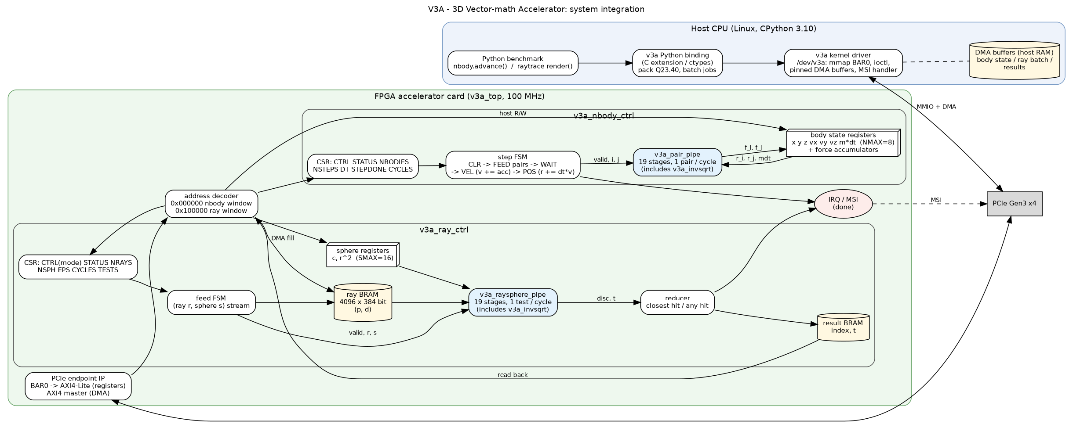
Figure 1 - V3A accelerator: system integration (host, driver, PCIe, both kernels)
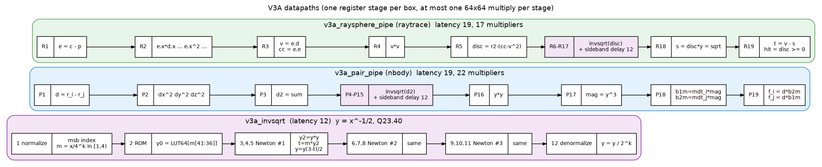
Figure 2 - V3A datapaths: nbody pair kernel, ray-sphere kernel, shared inverse-sqrt IP
hw/docs/v3a_system.png system: host, driver, PCIe, both kernels
hw/docs/v3a_pipelines.png datapaths (pair pipeline and invsqrt stages)

Python advance() --> v3a ext --> driver --MMIO/DMA--> PCIe EP --> decoder
^ | |
| MSI v
+---- updated state <--- body regs <--+-- nbody FSM --> pair pipe
(x,v,m*dt) ^ | (19 st.) |
^ | v |
+--- acc += f_i, f_j <------+

5.7 Performance / area / power trade-offs
Frequency: one 64x64 multiply per stage. On an FPGA (e.g. UltraScale+)
each multiply spans ~9 DSP blocks and needs ~3 internal pipeline
registers to close ~150-200 MHz; that adds latency (19 -> ~50 cycles) but
keeps 1 result/cycle. We assume a conservative 100 MHz; a 28 nm ASIC could
run ~250 MHz.
Area (order of magnitude): nbody kernel 25 multipliers (22 in the pipeline
+ 3 in the integrator), ray kernel 17 -> ~42 64x64 multipliers, ~400 DSP
blocks, ~30k flip-flops, ~44 BRAM36 for the ray buffer; in 28 nm roughly
1.5M gates (~2-3 mm^2).
Alternatives considered:
- Iterative datapath (one shared multiplier + microcode): ~20x less area,
but ~25 cycles per operation -> ~1000 cycles per nbody step, i.e. about
the SAME speed as CPython. Rejected: area saved, benefit lost.
- Fully parallel/systolic array (one pair unit per pair): 10x the area for
5 bodies, removes the 10-cycle feed time only; the 19-cycle latency
still dominates. Not worth it for N = 5, attractive for large N.
- IEEE-754 double instead of Q23.40: bit-exact with Python, but ~2x area
per multiplier and deeper pipelines; the measured fixed-point error
(~1e-9 relative energy) is far below what matters for the simulation.
- Sharing one invsqrt between both kernels: saves 9 multipliers, but the
kernels could no longer run at the same time.
Power: dominated by the DSP/multiplier toggling while busy (a few watts on
an FPGA card at 100 MHz); clock gating when idle (STATUS.busy = 0) makes
average power proportional to use. Energy per nbody loop: ~7.6 ms x a few
W ~ tens of mJ, vs ~139 ms x tens of W for a CPU core running CPython.

5.8 Known simplifications of this RTL (deliberate, and what a real card adds)
- Clock domains: the design uses one clock. A real PCIe card runs the user
logic on its own clock and needs asynchronous FIFOs between the PCIe
core clock and the kernel clock; that CDC logic is not modelled here.
- DMA: the RTL fills the ray BRAM through the register bus (the testbench
acts as the driver). A real card uses an AXI4 master (XDMA/QDMA IP) to
read the pinned host buffer; the register map and the FSMs do not change.
- Ray batch size: the ray BRAM holds 4096 rays, while a 100x100 frame has
10,000 primary rays, so the driver issues ~3 batches per wavefront level.
This is already included in the per-batch overhead of the estimate.
- Fixed-point overflow is not detected: Q23.40 wraps silently above
+-8.4e6. Values in both benchmarks stay far below that (the largest
intermediate is |d|^2 < 3e3), but a production version would either
saturate or raise a status flag, at the cost of extra logic per stage.
- nbody body count is limited to NMAX = 8 (state lives in registers so
every pair read is single-cycle). More bodies would move the state into
BRAM and add a load stage to the pipeline.
- No synthesis or timing closure was run (not required): the frequency
numbers are estimates based on one 64x64 multiply per pipeline stage.

6. Conclusion
The nbody benchmark is interpreter-overhead bound, not memory- or
branch-bound. Restructuring the hot loop so that body state lives in local
variables and the fixed set of pair interactions is unrolled removes
40% of the executed bytecodes and gives a 1.64x speedup
under pyperformance with identical physics. What remains is boxed float
arithmetic, which no pure-Python change can remove; this is exactly the
part targeted by the hardware accelerator in section 5.

