HW/SW Co-Design Project
Benchmark report: raytrace
pyperformance optimization and hardware acceleration (V3A)
Software speedup | Run time | Correctness | Hardware (V3A)
2.85x | 797 ms -> 279 ms | bit-identical image | 1 test/cycle, ~1.7x
Environment: Linux-5.15.0-1106-kvm-x86_64-with-glibc2.35, 1 CPU(s), Python 3.10.12 (64-bit), pyperformance 1.14.0.

1. Overview
Purpose
raytrace is a small, pure-Python recursive (Whitted-style) ray tracer by
Callum and Tony Garnock-Jones (2008). It renders a fixed 100x100 scene:
seven spheres over a checkerboard floor, lit by two point lights, with
specular reflections, Lambert diffuse shading with shadows, and ambient
light. It is a classic "object-oriented numeric Python" workload: millions
of tiny objects and short method calls, which stresses CPython's function
call, attribute access and allocation paths far more than the arithmetic.

Libraries
- math (sqrt, tan, pi) and array (array('B') holds the RGB canvas).
- pyperf: timing harness only; not part of the measured computation.

Data structures
- Vector, Point : classes with three float attributes x, y, z stored in a
per-instance __dict__. Vector/Point arithmetic (__add__, __sub__, scale,
dot, cross, normalized) always returns NEW objects.
- Ray : origin Point + normalized direction Vector.
- Sphere(centre, radius), Halfspace(point, normal) : scene objects with
intersectionTime(ray) and normalAt(p).
- SimpleSurface / CheckerboardSurface : material (base colour, specular,
Lambert and ambient coefficients).
- Scene : list of (object, surface) tuples, list of light Points,
camera; Canvas : flat array('B') of width*height*3 bytes.

Algorithm (per frame)
for each of the 10,000 pixels:
build a primary ray from the camera through the pixel (normalize)
rayColour(ray): (recursion depth limited to 4)
intersect the ray with ALL 8 objects, keep the closest hit t > -eps
p = hit point, n = surface normal at p
specular : reflect the ray about n and recurse
diffuse : for each light, cast a shadow ray from p towards the light
and test it against the objects; add max(0, dir . n)
ambient : constant term
clamp colour and write 3 bytes into the canvas
Ray-sphere test: with cp = centre - origin and v = cp . d,
discriminant = r^2 - (|cp|^2 - v^2); hit time = v - sqrt(discriminant).

Why this is slow in CPython
Every vector operation is a Python method call (frame creation, argument
binding) that allocates a new object with its own __dict__. The original
code also calls "type assertion" methods (mustBeVector(), isPoint()) that
do nothing for valid input but still cost a full call each, and it rebuilds
an identical shadow Ray (with a sqrt) for every object it tests.

2. Initial analysis (profiling)
Method (all automated in script_raytrace.sh)
- pyperformance run -b raytrace -> results/baseline.json
- perf stat -r 5 (instructions, branches, cache) -> results/perf_stat_original.txt
- perf record -e cpu-clock -F 999 -g -- python3-dbg -m pyperformance run
--bench raytrace (course guide method) -> results/perf_report_original*.txt
- FlameGraph (stackcollapse-perf.pl | flamegraph.pl)
-> flamegraphs/flamegraph_raytrace_original.svg
- callcount_raytrace.py (Python calls and object allocations per render)

python3-dbg lets perf resolve CPython's internal C symbols; note that
Python 3.10 has no `-X perf` support, so the flame graph shows interpreter
C functions, not Python-level functions. VM note: the QEMU vCPU exposes no "cycles" event,
so we sample on cpu-clock. perf stat runs profile_raytrace.py (5 renders in
one process) so counters exclude pyperf worker spawning and venv setup.

Baseline result
pyperformance run -b raytrace: 797 ms +- 5.8 ms per render (60 values)
(under python3-dbg while profiling: 2175 ms +- 24.3 ms)

perf report -- hottest symbols, self overhead (original)
overhead symbol
26.58% _PyEval_EvalFrameDefault
3.30% call_function.lto_priv.0
2.98% frame_dealloc.lto_priv.0
2.72% _PyEval_MakeFrameVector
1.98% lookdict_unicode_nodummy
1.97% _PyDict_GetItemHint
1.96% PyTuple_GetItem
1.93% binary_op1
1.88% _PyType_Lookup
1.77% _PyObject_VectorcallTstate.lto_priv.10
1.57% _PyObject_GetMethod
1.57% lookdict_split.lto_priv.0
1.53% _PyMem_DebugCheckAddress
1.14% _PyEval_Vector
1.12% pthread_getspecific@@GLIBC_2.34

grouped by role:
26.58% bytecode dispatch (_PyEval_EvalFrameDefault)
16.31% Python function calls / frames
14.67% attribute access (getattr/setattr, dict, slots)
5.60% object creation / destruction
4.02% float objects: arithmetic + alloc/free
0.00% math: sqrt / libm
3.40% number-protocol dispatch
3.48% tuple/list handling
6.27% debug-build self-checks (python3-dbg only)
(99.3% of all samples are in the benchmark worker process; the rest
is pyperformance start-up.)

perf stat (original), per run of 5 renders
instructions 25,641,141,365
branches 4,945,496,813
branch-misses 14,637,980 0.30% of branches
cache-references 13,323,843
cache-misses 34,366 0.26% of cache refs
task-clock 4061.4 ms
cycles not exposed by the VM

Interpretation: cache misses are negligible (0.26% of cache references)
and branch misses are negligible (0.30%). One render executes ~5.13
billion instructions for 2,882,307 Python function calls, i.e. ~1,779
machine instructions per Python-level call. The cost is dominated by
call and object overhead, not by memory access or the floating-point
math itself.

Python function calls per render (callcount_raytrace.py, original)
Vector.mustBeVector 520,539 18.1%
Vector.dot 509,871 17.7%
Vector.__init__ 452,943 15.7%
Point.__sub__ 277,865 9.6%
Point.isPoint 277,865 9.6%
Sphere.intersectionTime 179,457 6.2%
Vector.scale 149,743 5.2%
Vector.normalized 109,887 3.8%
Vector.magnitude 109,887 3.8%
Ray.__init__ 98,172 3.4%
Halfspace.intersectionTime 25,501 0.9%
Vector.__add__ 20,000 0.7%
Vector.isPoint 20,000 0.7%
addColours 15,999 0.6%
Scene.rayColour 15,333 0.5%
<listcomp> 15,265 0.5%
TOTAL 2,882,307

objects allocated per render (original):
Vector 452,943
Point 5,345
Ray 98,172

Bottlenecks identified
B1 Type-check calls: 818,411 calls per render (28% of all Python calls)
to mustBeVector()/isPoint(), which do nothing for valid input.
B2 Temporary objects: 452,943 Vector objects per render, most of them
intermediates of expressions like (centre - origin).dot(direction) that
live for a single operation; each needs an allocation, a __dict__ and a
deallocation.
B3 Redundant work in the shadow test: _lightIsVisible() is called 10,666
times but builds a new, identical Ray (sqrt + normalize) for every
object it tests, so the render creates 98,172 Rays although only
~25,999 distinct rays are needed.
B4 Attribute access through per-instance __dict__ on every .x/.y/.z read
and write.

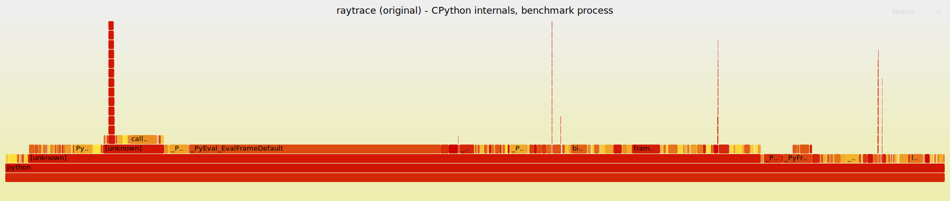
Flame graph - raytrace, original (perf record -e cpu-clock -g, python3-dbg). Interactive version: benchmarks/raytrace/flamegraphs/flamegraph_raytrace_original.svg

3. Optimizations
All changes are in benchmarks/raytrace/optimized/run_benchmark.py. The scene,
image size, algorithm, public classes/methods and the benchmark name are
unchanged, so it runs under pyperformance through a custom manifest
(benchmarks/raytrace/manifest/MANIFEST). Every floating-point expression keeps
the original operand order, so the rendered image is BIT-IDENTICAL.

O1 __slots__ on Vector, Point and Ray (targets B4, B2)
Attributes live at fixed offsets in the object (slot descriptors) instead
of a per-instance dict: faster .x/.y/.z access and cheaper creation.

O2 Remove type-check calls from the hot path (targets B1)
mustBeVector()/isPoint() calls are dropped; where the result type really
depends on the argument (Vector + Point, Point - Point) a direct class
comparison (other.__class__ is Point) replaces the method call.

O3 Loop-invariant code motion in the shadow test (targets B3)
_lightIsVisible() builds Ray(p, light - p) once per light instead of once
per tested object. The ray does not depend on the object, so the result
is identical.

O4 Inline hot vector math on floats (targets B2)
Sphere/Halfspace.intersectionTime, normalAt, Ray construction
(normalization), pointAtTime, reflectThrough, the primary-ray direction
in render() and the Lambert term in colourAt() compute directly on local
floats instead of chaining Vector method calls that create temporaries.
The closest-hit search no longer builds a list of tuples.

Correctness (verify_raytrace.py)
image 100x100 (30000 bytes)
sha256 original : 11f2c36b02044f115c3937cae1156e9528b95da70f9d6b737a262f06757c2e6b
sha256 optimized: 11f2c36b02044f115c3937cae1156e9528b95da70f9d6b737a262f06757c2e6b
differing bytes : 0
ablation stage v0_original : identical
ablation stage v1_no_checks : identical
ablation stage v2_hoist : identical
ablation stage v3_inline : identical
ablation stage v4_slots : identical
PASS (bit-identical)

Effect on Python calls and allocations per render
function original optimized
Vector.mustBeVector 520,539 0
Vector.__init__ 452,943 57,338
Vector.dot 509,871 0
Sphere.intersectionTime 179,457 179,457
Point.__sub__ 277,865 14,524
Point.isPoint 277,865 0
Vector.scale 149,743 0
Ray.__init__ 98,172 26,000
Vector.normalized 109,887 3
Vector.magnitude 109,887 0
Halfspace.intersectionTime 25,501 25,501
addColours 15,999 15,999
Scene.rayColour 15,333 15,333
Scene._lightIsVisible 10,666 10,666
Vector.__add__ 20,000 0
Vector.isPoint 20,000 0
Canvas.plot 10,000 10,000
<listcomp> 15,265 0
TOTAL calls 2,882,307 392,204 (-86%)
Vector objects 452,943 57,338 (-87%)
Point objects 5,345 5,345 (+0%)
Ray objects 98,172 26,000 (-74%)

The amount of real ray-tracing work is unchanged (Sphere.intersectionTime
is called 179,457 vs 179,457 times); what disappears is the call and
allocation overhead around it.

Considered and not pursued
- numpy vectorization: each operation works on a single 3-vector per ray
and the ray tree is recursive and data-dependent, so numpy's per-call
overhead would dominate (as measured for nbody), and vectorizing would
change the floating-point evaluation order (no bit-identical image).
- Changing the scene, image size or recursion depth: would change the
workload, not optimize it.

4. Performance comparison
pyperformance (results/compare.txt)
original : 797 ms +- 5.8 ms
optimized: 279 ms +- 2.8 ms
-> 2.85x faster, run time -65% (meets the >= 7% requirement)
Same trend under python3-dbg while profiling: 2175 ms -> 626 ms (3.48x).

Ablation (ablation_raytrace.py) -- optimizations added one at a time
stage (cumulative) time / render vs original this step
original 806.4 +- 8 ms 1.00x 1.00x
+ O2 remove type-check calls 737.1 +- 4 ms 1.09x 1.09x
+ O3 hoist shadow ray 566.1 +- 4 ms 1.42x 1.30x
+ O4 inline vector math 307.9 +- 2 ms 2.62x 1.84x
+ O1 __slots__ (final) 277.7 +- 2 ms 2.90x 1.11x
Every stage renders a bit-identical image (checked in verify_raytrace.py).

perf stat before/after (5 renders per run, mean of 5 runs)
original optimized change
instructions 25,641,141,365 9,364,171,653 -63.5%
branches 4,945,496,813 1,764,501,736 -64.3%
branch-misses 14,637,980 8,804,429 -39.9%
cache-misses 34,366 31,698 -7.8%
page-faults 2,836 2,921 +3.0%
task-clock 4061.4 ms 1472.6 ms 2.76x faster
elapsed 4.104 s 1.478 s 2.78x faster

Instructions drop by 63% while Python calls drop by 86% and Vector
allocations by 87%. The instruction ratio (2.74x) and the time ratio
(2.76x) agree: the CPU simply executes far less interpreter work for
the same image.

perf profile before/after (flame graphs: flamegraphs/flamegraph_raytrace_*.svg)
Estimated absolute cost = self% x total sampled time of each profile.
role original optimized change
bytecode dispatch (_PyEval_EvalFrameDefault) 26.6% 28.8% -60%
Python function calls / frames 16.3% 7.9% -82%
attribute access (getattr/setattr, dict, slots) 14.7% 6.7% -83%
object creation / destruction 5.6% 6.6% -57%
float objects: arithmetic + alloc/free 4.0% 7.5% -31%
math: sqrt / libm 0.0% 0.0% n/a
number-protocol dispatch 3.4% 4.9% -46%
tuple/list handling 3.5% 3.1% -67%
debug-build self-checks (python3-dbg only) 6.3% 7.3% -57%

Largest absolute reductions: _PyEval_EvalFrameDefault (-60%),
call_function.lto_priv.0 (-78%), frame_dealloc.lto_priv.0 (-79%),
_PyEval_MakeFrameVector (-81%), _PyDict_GetItemHint (-90%),
_PyType_Lookup (-80%).
Top of the optimized profile: _PyEval_EvalFrameDefault (28.8%),
binary_op1 (3.0%), PyFloat_FromDouble (1.9%), call_function.lto_priv.0
(1.9%), PyTuple_GetItem (1.7%).
Total sampled time: original 81.20 s, optimized 30.05 s (cpu-clock event
count, includes pyperformance start-up).

Flame graph - raytrace, BEFORE optimization
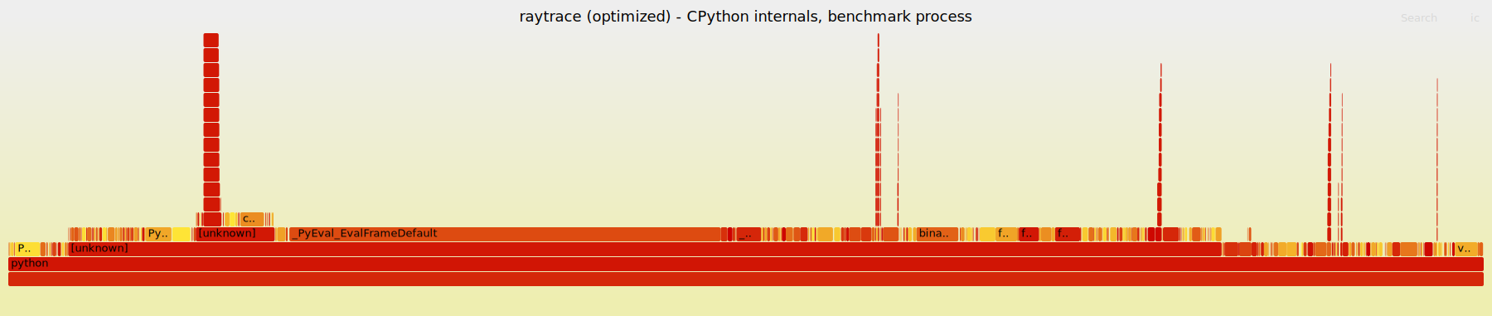
Flame graph - raytrace, AFTER optimization. Interactive version: benchmarks/raytrace/flamegraphs/flamegraph_raytrace_optimized.svg

5. Hardware acceleration proposal
One accelerator serves both benchmarks: V3A, a 3D Vector-math Accelerator.
The hot arithmetic of nbody (pair distance, |d|^-3) and of raytrace
(ray-sphere test: dot products and a square root) is the same small set of
operations: 3D subtract, dot product and inverse square root. V3A implements
them once as reusable pipelined IP and exposes two kernels on one PCIe card.
Full RTL: hw/rtl/*.v (Verilog-2005/SystemVerilog-compatible, Icarus-tested).

5.1 Hardware description (hw/rtl)
v3a_top.v PCIe core logic: register bus decode, IRQ
v3a_nbody_ctrl.v nbody kernel: body registers, step FSM, integrator
v3a_pair_pipe.v pairwise gravity datapath, 19 stages
v3a_ray_ctrl.v ray kernel: ray BRAM, feed FSM, reducer, results
v3a_raysphere_pipe.v ray-sphere datapath, 19 stages
v3a_invsqrt.v shared inverse-square-root IP, 12 stages
v3a_delay.v sideband pipeline balancing
v3a_common.vh Q23.40 fixed-point multiply
v3a_invsqrt_lut.vh 64-entry initial-guess ROM (generated)
Golden model: hw/model/v3a_model.py (bit-accurate). Testbench:
hw/tb/tb_v3a.v. Everything is run by: python3 hw/run_hw_tests.py

5.2 Inputs and outputs
Number format : signed Q23.40, 64 bits (range +-8.4e6, LSB 9.1e-13).
Chosen instead of IEEE-754 double: a fixed-point multiply
needs no normalization/rounding logic (about half the area
of a double-precision FPU multiplier, one stage per op).
Clock : single clock, target 100 MHz (see 5.7), sync. reset.
Host bus : memory-mapped, word-addressed, 64-bit data (PCIe BAR0
behind an AXI4-Lite bridge; BAR byte offset = 8 x index).
24-bit address: 0x000000 nbody window, 0x100000 ray window.
Interrupt : irq (level) when a job is done -> MSI.
nbody kernel : in : NBODIES (2..8), NSTEPS, DT, per body x,y,z,vx,vy,vz,m*dt
out: updated x,y,z,vx,vy,vz after NSTEPS steps; STEPDONE,
CYCLES (performance counter)
ray kernel : in : NRAYS (1..4096), NSPH (1..16), EPS, MODE
(0 closest hit, 1 any hit), spheres c,r^2,
rays p,d (d normalized)
out: per ray (sphere index or -1, t) / (occluded 1/0)
Pipeline IP : valid/data streaming, no back-pressure needed (the
controllers always accept every output).
v3a_invsqrt in x (Q23.40) out y = x^-1/2
v3a_pair_pipe in r_i, r_j, m_i*dt, m_j*dt, i, j out f_i, f_j, i, j
v3a_raysphere_pipe in p, d, c, r^2, ray id, sph id out disc, t, ids

5.3 Hardware architecture
Datapath (see hw/docs/v3a_pipelines.png):
- Every stage has at most ONE 64x64 multiply followed by a register, so
the critical path is the same everywhere and throughput is one result
per clock cycle after the 19-cycle latency.
- v3a_invsqrt: stage 1 normalizes x = m*4^k with m in [1,4) using a
priority encoder and a barrel shift; stage 2 takes y0 from a 64-entry
ROM indexed by the top 6 bits of m; stages 3-11 run three Newton
iterations y <- y(3 - m y^2)/2 (3 stages each: y^2, m*y^2, update);
stage 12 shifts back by k. Measured accuracy: relative error < 2.3e-7
over 1e-6..1e6 (limited by the Q23.40 LSB), ~1e-12 for typical values.
- Sideband data (indices, d, masses, v) travel through v3a_delay shift
registers so they stay aligned with the invsqrt result.
Control logic:
- v3a_nbody_ctrl FSM per time step: CLR (zero accumulators) -> FEED (one
pair (i<j) per cycle into the pipeline) -> WAIT (outputs accumulate
acc_i -= f_i, acc_j += f_j) -> VEL (v += acc for all bodies) -> POS
(r += dt*v, one body per cycle) -> NEXT (repeat NSTEPS times -> IRQ).
All pairs of a step use the positions from the start of the step, so
pairs are independent and can be streamed through the pipeline.
- v3a_ray_ctrl: a feed FSM walks (ray r, sphere s) and streams one test
per cycle (ray words come from a synchronous BRAM, 1-cycle read); a
reducer after the pipeline keeps the running best hit of the current
ray (t > -EPS and smallest t; or any t > EPS for shadow rays) and writes
the result BRAM when the last sphere of that ray comes out.
Verification (hw/run_hw_tests.py, vectors from the real benchmark code):
nbody : 5 bodies, 2000 steps, 10 pairs/step
RTL vs golden fixed-point model: BIT-EXACT
energy: float benchmark -0.169071606870, hardware -0.169071606646
relative difference 1.33e-09
max |position diff| vs float benchmark: 9.01e-07
cycles: 76000 = 38.0 per step (10 pair feeds +
19 latency + 5 position updates + control)
ray : closest hit, primary rays
2500 rays x 7 spheres = 17500 tests
RTL vs golden fixed-point model: BIT-EXACT
closest sphere == float benchmark: 2500/2500 rays
(194 hits), max |t error| 1.12e-09
cycles: 17521 = 1.001 per test (+19 latency, +1 BRAM read)
ray : any hit, shadow rays
1940 rays x 7 spheres = 13580 tests
RTL vs golden fixed-point model: BIT-EXACT
shadow decision == float benchmark: 1940/1940 rays
(53 occluded)
cycles: 13601 = 1.002 per test (+19 latency, +1 BRAM read)
RESULT: PASS

5.4 Hardware/software interface
Driver : Linux PCIe driver, character device /dev/v3a. mmap() of BAR0
for the registers; pinned DMA buffers for bulk data; MSI
interrupt wakes the waiting process.
Transfers : small state (nbody: 5 bodies x 7 words = 280 bytes) is written
directly through BAR0. Ray batches (48 bytes per ray, up to
4096 rays) are copied by the card's AXI4 DMA master from a
pinned host buffer into the ray BRAM; results are copied back
the same way (the RTL models the BRAM filled via the bus).
API : Python extension module (C, or ctypes over the ioctl):
v3a.nbody_advance(bodies, dt, steps)
v3a.closest_hits(rays, spheres, eps) -> [(index, t), ...]
v3a.any_hits(rays, spheres, eps) -> [occluded, ...]
It converts floats <-> Q23.40, fills buffers, writes CTRL,
sleeps until the IRQ and reads the results.
Key rule : offload granularity. One PCIe round trip costs tens of
microseconds, while one CPython pair/intersection costs
~0.4-0.7 microseconds. Calling the card per pair or per ray
would be 10-100x SLOWER than software. Every job is therefore
a batch: all NSTEPS of nbody in one call; all rays of one
recursion level ("wavefront") in one call for raytrace.
(Same lesson as numpy in section 3: fixed per-call overhead
must be amortized over many elements.)

5.5 Acceleration justification (raytrace)
Why a good candidate: Sphere.intersectionTime is the single hottest kernel
(179,457 ray-sphere tests per 100x100 frame). Each test is independent of
the others, branch-free until the final comparison and uses only +, -, *
and one sqrt: ideal for a streaming pipeline. The rest of the frame
(shading, recursion, colour mixing) is irregular, data-dependent control
flow and stays in Python.
Measured share (hw/model/raytrace_offload_share.py, Python 3.10: replaying
all sphere tests of one frame versus rendering the frame): about 41% of
the original and about 48% of the optimized render time.
Software changes: render() becomes wavefront (breadth-first): generate all
primary rays -> v3a.closest_hits() -> for each hit build the shadow rays
(v3a.any_hits) and reflection rays (next closest_hits batch) -> repeat up
to depth 4 -> shade in Python. The floor (Halfspace) test stays in
software (one dot product) and is combined with the sphere result.
Estimate (assumptions: 100 MHz, measured ~1.00 cycle per test in RTL
simulation, ~9 batches per frame, ~26k rays x 48 bytes = 1.2 MB of DMA per
frame at ~3.9 GB/s, ~20 us driver overhead per batch):
hardware per frame = 179,457 tests x 10 ns + DMA + 9 calls ~ 3 ms
optimized CPython: sphere tests ~48% of the frame
Amdahl limit : 1 / (1 - 0.48) ~ 1.9x
realistic : ~1.6-1.8x over the optimized software
(batch construction in Python costs back part)
Compared to nbody the gain is much smaller: nbody offloads almost the whole
loop, raytrace only its hottest kernel. Moving Lambert shading and
reflection vectors to hardware as well would raise the offloaded fraction,
at the cost of more area and a less reusable design.
Accuracy: RTL results are bit-exact to the golden model; hit/miss and
closest-sphere decisions matched the double-precision benchmark for every
tested primary and shadow ray (t error ~1e-9). Rare decisions exactly at
t ~ +-EPS could in principle differ from double precision, so the image is
not guaranteed to be bit-identical (unlike the software optimization).

5.6 Block diagram
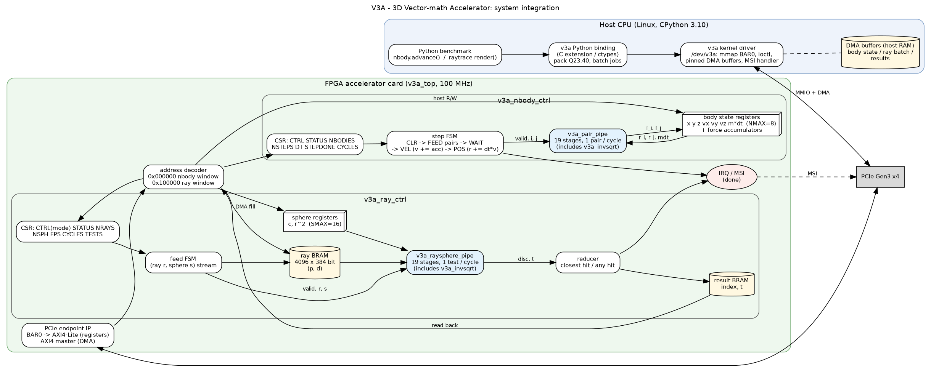
Figure 1 - V3A accelerator: system integration (host, driver, PCIe, both kernels)
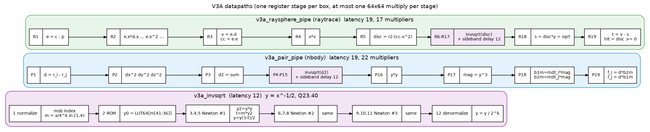
Figure 2 - V3A datapaths: nbody pair kernel, ray-sphere kernel, shared inverse-sqrt IP
hw/docs/v3a_system.png system: host, driver, PCIe, both kernels
hw/docs/v3a_pipelines.png datapaths (ray-sphere pipeline and invsqrt)

Python render() --wavefront batch--> v3a ext --> driver --DMA--> ray BRAM
^ |
| feed FSM (r, s)
| v
shading <-- (index, t) <-- result BRAM <-- reducer <-- ray-sphere pipe
in Python per ray closest/any (19 stages,
1 test/cycle)

5.7 Performance / area / power trade-offs
Frequency: as for nbody, one 64x64 multiply per stage; conservative
100 MHz on FPGA, ~250 MHz in 28 nm ASIC.
Area: the ray kernel alone needs 17 multipliers (6 in R2, 9 in invsqrt,
2 more) plus a 4096 x 384-bit ray BRAM and a 4096 x 128-bit result BRAM.
Throughput vs area:
- Replicating the ray pipeline P times (spheres or ray groups in parallel)
gives P tests per cycle, but the Amdahl limit (~1.9x) is already close
to being reached with ONE pipeline (~3 ms vs ~85 ms of remaining Python
work), so extra area buys almost nothing here.
- A smaller, iterative (shared multiplier) ray kernel would still take
only ~25 x 179,457 x 10 ns ~ 45 ms per frame and keep ~1.25x; it is a
reasonable low-area option for this benchmark alone.
- Batch size: larger batches amortize PCIe/driver overhead but increase
latency and host memory; per-ray calls would be ~10x slower than CPython.
Power: few watts while busy on an FPGA, near zero when clock-gated between
batches; since the card is idle most of each frame (~3 ms busy of ~90 ms),
average accelerator power is low, but the CPU still does >90% of the work,
so total system energy per frame improves by roughly the speedup only.

5.8 Known simplifications of this RTL (deliberate, and what a real card adds)
- Clock domains: the design uses one clock. A real PCIe card runs the user
logic on its own clock and needs asynchronous FIFOs between the PCIe
core clock and the kernel clock; that CDC logic is not modelled here.
- DMA: the RTL fills the ray BRAM through the register bus (the testbench
acts as the driver). A real card uses an AXI4 master (XDMA/QDMA IP) to
read the pinned host buffer; the register map and the FSMs do not change.
- Ray batch size: the ray BRAM holds 4096 rays, while a 100x100 frame has
10,000 primary rays, so the driver issues ~3 batches per wavefront level.
This is already included in the per-batch overhead of the estimate.
- Fixed-point overflow is not detected: Q23.40 wraps silently above
+-8.4e6. Values in both benchmarks stay far below that (the largest
intermediate is |d|^2 < 3e3), but a production version would either
saturate or raise a status flag, at the cost of extra logic per stage.
- nbody body count is limited to NMAX = 8 (state lives in registers so
every pair read is single-cycle). More bodies would move the state into
BRAM and add a load stage to the pipeline.
- No synthesis or timing closure was run (not required): the frequency
numbers are estimates based on one 64x64 multiply per pipeline stage.

6. Conclusion
raytrace is dominated by Python call and object overhead, not by the ray
tracing math. Removing no-op type-check calls, hoisting the loop-
invariant shadow ray, inlining the vector math on floats and using
__slots__ cut Python calls by 86% and gives a 2.85x speedup under
pyperformance with a bit-identical image. What remains is the per-ray
intersection and shading arithmetic (179,457 ray-sphere tests per
frame), which is exactly the regular, data-parallel kernel targeted by
the hardware accelerator in section 5.

