MIVA OPEN UNIVERSITY
FACULTY OF COMPUTING
DEPARTMENT OF SOFTWARE ENGINEERING
DESIGN AND IMPLEMENTATION OF AN AI-ENHANCED MULTI-TENANT FAMILY FUND MANAGEMENT SYSTEM WITH PREDICTIVE ANALYTICS AND INTELLIGENT REPORTING
BY
AMINU DANLADI HUSSAIN
2024/A/SENG/0156
A PROJECT SUBMITTED TO THE DEPARTMENT OF SOFTWARE ENGINEERING, FACULTY OF COMPUTING, MIVA OPEN UNIVERSITY, IN PARTIAL FULFILMENT OF THE REQUIREMENTS FOR THE AWARD OF THE DEGREE OF BACHELOR OF SCIENCE (B.Sc.) IN SOFTWARE ENGINEERING
SUPERVISOR: DR SAMUEL MAKINDE
MAY, 2026

CHAPTER ONE

INTRODUCTION

1.1 Background to the Study
Digital finance has changed how people save, transfer money, and keep records, yet many collective financial practices still depend on informal administration. Across Sub-Saharan Africa, households and small groups continue to rely on cooperative saving, rotating contributions, mutual aid, and family-level support systems because these arrangements are close to the people who use them and are flexible enough to respond to emergencies. Recent studies on financial inclusion still show that informal savings and group-based financial arrangements remain relevant in Nigeria, especially where formal products are too expensive, too distant, or not trusted enough for everyday use (Demirgüç-Kunt et al., 2022; EFInA, 2023; Kouandou & Zeh, 2024).
Nigeria has a long history of collective finance. The Yoruba ajo and esusu systems, the Hausa adashi, and similar community-based arrangements are usually built on periodic contributions, social pressure, and shared expectations of fairness (Akanji, 2006; Iganiga & Asemota, 2008; Oloyede, 2008). Some of these systems are rotating, where members take turns receiving the pooled amount. Others are non-rotating and exist mainly as a common purse for emergencies, ceremonies, school fees, medical bills, property maintenance, or family welfare. This second arrangement is the focus of this project. It is referred to in this study as a family fund or family purse.
Although family funds are socially important, their administration is still mostly manual. A family may keep a notebook, a spreadsheet, a WhatsApp thread, or a mixture of all three. These tools are convenient at first, but they are weak as financial records. They do not enforce roles, they do not allocate partial payments consistently, they do not produce reliable audit trails, and they are difficult to review when disputes arise. A payment screenshot posted in a messaging group may prove that money was sent, but it does not show which month the payment covers, whether it clears an old balance, or whether the family treasurer has updated the record correctly.
At the same time, Nigeria's digital financial services market has grown rapidly. Payment gateways and savings platforms have made online transactions familiar to many users, while the policy discussion around financial inclusion increasingly recognises digital channels as a route to wider access (Wezel & Ree, 2023). However, most popular platforms are designed either for individual savers or for formal lending and cooperative structures. PiggyVest and Cowrywise support personal saving and investment; CreditClan and Lendsqr focus more on formal lending infrastructure. None of these tools is designed primarily for informal family contribution funds with tiered member contributions, family-level roles, partial payments, expenses, reminders, and transparent reporting.
Modern software architecture makes it possible to address this gap. A multi-tenant web application can allow many families to use one platform while keeping each family's data logically separate. Role-based access control can distinguish the work of a family administrator, a financial secretary, and an ordinary member. Payment gateways such as Paystack can support online contributions, while PostgreSQL can provide structured relational storage for members, contributions, payments, expenses, and reports. In addition, recent advances in artificial intelligence make it possible to add controlled assistant features and plain-language report summaries, provided the system protects financial data and avoids unsupported claims in AI output (Brown et al., 2020; Kang & Liu, 2023).
This study therefore proposes FamilyFunds, an AI-enhanced multi-tenant family fund management system. The project is not merely a record book moved online. It is a structured system for managing contribution categories, generating monthly obligations, recording online and offline payments, allocating partial payments to the oldest outstanding balances first, tracking expenses and adjustments, producing reports, and giving authorised users secure access to the information they need. The work is timely because family funds remain socially useful, manual administration remains fragile, and the available digital tools still do not reflect the way many Nigerian families organise shared financial responsibility.

1.2 Statement of the Problem
Family contribution funds are often trusted because they are managed within a family, but that same informality creates administrative weaknesses. The person keeping the records may be honest and committed, yet mistakes can still occur when payments are late, partial, or made through different channels. A notebook can be misplaced. A spreadsheet can be overwritten. A WhatsApp message can be buried under hundreds of unrelated messages. Once the record is unclear, family members may disagree about who has paid, how much is outstanding, and whether expenses were properly authorised.
The problem is not simply that family funds lack software. The deeper problem is that existing software does not fit the structure of the practice. Individual savings applications do not support shared governance. Lending platforms are built for formal credit operations rather than informal family welfare. Generic spreadsheets allow calculations but do not enforce tenant isolation, member roles, invitations, payment verification, or audit-friendly records. As a result, families continue to manage money through tools that were never designed for the trust and accountability demands of a family purse.
Table 1.1 compares common digital finance tools with the requirements of the proposed system.
Table 1.1: Comparison of Existing Financial Management Platforms
Feature | PiggyVest | Cowrywise | CreditClan | Lendsqr | FamilyFunds
Main user focus | Individuals | Individuals | Cooperatives and lenders | Digital lenders | Family groups
Family workspace isolation | No | No | Limited | Limited | Yes
Tiered contribution categories | No | No | No | No | Yes
Admin, secretary, and member roles | No | No | Limited | Limited | Yes
Partial payment allocation | No | No | No | No | Yes
Expense and adjustment tracking | No | No | Limited | Limited | Yes
Online payment support | Yes | Yes | Yes | Yes | Yes
Family-readable reports | Limited | Limited | Limited | Limited | Yes
AI assistant or narrative summaries | No | No | No | No | Yes
Predictive analytics | No | No | No | Yes | Planned

The specific problem addressed in this study is the absence of a purpose-built, secure, and intelligent digital system for managing informal family contribution funds. Existing tools do not combine multi-tenant family separation, role-based governance, tiered contribution tracking, deterministic payment allocation, expense management, online payment support, and understandable reporting in one system. This gap exposes families to inaccurate records, weak accountability, delayed follow-up, and avoidable disputes.

1.3 Aim of the Study
The aim of this study is to design and implement FamilyFunds, an AI-enhanced multi-tenant web application for managing family contribution funds with secure member access, structured contribution tracking, payment allocation, expense recording, reminders, and financial reporting.

1.4 Objectives of the Study
The objectives of the study are to:
1. Review the management practices, digital tools, and literature related to informal savings groups, family contribution funds, multi-tenant systems, access control, payments, and AI-supported reporting.
2. Design a multi-tenant family fund management system with logical data isolation, role-based access control, contribution categories, payment allocation rules, reporting, and secure user access.
3. Implement the proposed system using Laravel, Vue.js, Inertia.js, PostgreSQL, Paystack, Laravel Fortify, Laravel AI SDK, and related development tools.
4. Integrate AI assistant and report-summary features in a controlled way that respects role permissions and uses available family fund data.
5. Define and evaluate the planned predictive analytics component according to data availability, payment-history quality, and suitable metrics such as accuracy, precision, recall, and usefulness.
6. Test the system against key requirements, including tenant isolation, role enforcement, payment allocation correctness, report accuracy, authentication security, and usability.

1.5 Research Questions
The study is guided by the following research questions:
1. What design features are required for a web-based system to manage informal family contribution funds securely and transparently?
2. How can multi-tenant architecture and role-based access control be applied to protect the records of separate family groups on one platform?
3. How can partial and lump-sum payments be allocated consistently across outstanding contribution balances?
4. To what extent can AI assistant and report-summary features improve access to understandable family fund information without exposing unauthorised data?
5. Under what conditions can historical contribution data support predictive analytics for member payment behaviour?
6. How can the system be tested to confirm that it meets functional, security, reliability, and usability requirements?

1.7 Significance of the Study
This study is significant to Nigerian families that maintain contribution funds because it addresses a problem that is often treated as a private inconvenience rather than a software design challenge. A family fund may be informal, but the money involved is real and the social consequences of inaccurate records can be serious. FamilyFunds provides a clearer structure: administrators manage settings and members, financial secretaries record operational transactions, and members can view their own obligations and payment history. This can reduce disputes and improve confidence in the fund.
The project is also useful to software engineering practice. It demonstrates how a modern Laravel and Vue application can be designed as a multi-tenant financial record system with tenant scoping, policy-based permissions, Paystack payment handling, PostgreSQL relational storage, scheduled contribution generation, reminders, passkeys, two-factor authentication, and AI features. The implementation therefore provides a concrete case study for applying established software engineering principles to an under-served local problem.
Academically, the study contributes by connecting separate areas of literature: informal finance, SaaS multi-tenancy, access control, payment processing, financial reporting, and AI-assisted interfaces. The novelty of the work is not that any single technology is new, but that these technologies are brought together for the family fund context. That context matters because a family fund is neither an individual wallet nor a formal cooperative loan system. It has its own governance structure, payment patterns, trust boundaries, and reporting needs.
The project may also benefit small community groups, religious associations, class sets, and workplace welfare groups that manage shared contributions without formal accounting systems. Although the design is centred on families, the underlying model can support any small group that needs transparent contributions, role-aware access, and simple financial reports.

1.8 Scope of the Study
The study covers the design and implementation of a web-based family fund management system. Each family is treated as a tenant, meaning that its records are separated from other families' records. The functional scope includes family workspace setup, member invitation, contribution category management, monthly contribution generation, manual payment recording, Paystack payment initiation and verification, oldest-balance-first payment allocation, expense tracking, fund adjustments, reminders, subscription plans, dashboards, reports, AI assistant support, and AI-assisted report summaries.
The technical scope covers a Laravel 13 backend, Vue.js 3 frontend, Inertia.js 3 server-client bridge, PostgreSQL database, Tailwind CSS 4 styling, Laravel Fortify authentication, WebAuthn/passkeys, Paystack integration, Laravel AI SDK, Laravel Pennant feature flags, Vite, Git, and Pest testing. The application is designed for web and mobile-browser access rather than native mobile deployment.
The study does not cover cryptocurrency payments, direct bank API integration, tax computation, full double-entry accounting, regulatory management for formal cooperative societies, or multilingual interfaces. Predictive analytics is included as a planned and evaluation-dependent capability because useful prediction requires sufficient payment-history data. The AI assistant and report-summary functions are treated as system features only where the application can ground the output in available family data and role permissions.

1.9 Limitations of the Study
The first limitation is internet dependency. FamilyFunds is a web application, so members need a working device and internet access. This may affect users in areas with unstable connectivity.
The second limitation is payment-channel scope. Paystack is used as the online payment gateway because the project is designed around Nigerian use. Families outside Paystack-supported contexts would need other gateways.
The third limitation is data availability for prediction. A new family may not have enough historical contribution records for reliable predictive analytics. In such cases, the system can still track payments and produce reports, but prediction should be delayed or treated as experimental.
The fourth limitation concerns AI output. Large Language Models can produce fluent but inaccurate responses if they are not constrained (Kang & Liu, 2023). For this reason, AI features in FamilyFunds must be grounded in system data, limited by user permissions, and validated before they are trusted for financial decisions.
The fifth limitation is project scale. The system is designed for multiple families, but very large-scale performance testing across thousands of tenants is beyond the scope of this study.

1.10 Definition of Terms
Table 1.2: Definition of Key Terms
Term | Definition
Family fund | A non-rotating pool of money contributed by family members for shared needs such as welfare, emergencies, ceremonies, and family projects.
Tenant | A separate family workspace within the same application, with its own members, contribution records, payments, expenses, and reports.
Multi-tenancy | A software architecture where one application serves many tenants while keeping their data and operations logically separated.
Role-Based Access Control (RBAC) | An access-control model where permissions are assigned according to user roles such as Administrator, Financial Secretary, and Member.
Contribution category | A family-defined tier that determines how much a member is expected to contribute each month.
Partial payment | A payment that is less than the full amount owed for one or more contribution periods.
Oldest-balance-first allocation | The rule that applies a payment to the earliest outstanding contribution balance before newer balances.
Payment gateway | A service that processes online payments between users, banks, cards, and the application. Paystack is used in this project.
Large Language Model (LLM) | An AI model capable of generating and interpreting human language. In this project, it supports assistant responses and report summaries.
Predictive analytics | The use of historical data to estimate future outcomes, such as whether a member is likely to miss a contribution deadline.
WebAuthn/passkey | A browser-based authentication standard that uses public-key credentials, often linked to device biometrics or security keys.

1.11 Organisation of the Report
This report is organised into five chapters. Chapter One introduces the study, states the problem, presents the aim, objectives, research questions, significance, scope, limitations, and key terms. Chapter Two reviews the literature on informal finance, multi-tenant systems, access control, payment systems, AI-assisted reporting, predictive analytics, and related systems. Chapter Three explains the methodology and system design, including the development approach, existing-system analysis, proposed system, requirements, data collection, architecture, UML diagrams, database design, algorithm design, tools, and ethical considerations. Chapter Four presents the implementation, testing, results, and validation of the system. Chapter Five summarises the study, draws conclusions, states the contribution of the project, and recommends areas for future work.

CHAPTER TWO

LITERATURE REVIEW

2.1 Introduction to the Chapter
This chapter reviews the literature and existing systems that inform the design of FamilyFunds. It is organised around five connected themes: informal family and group finance, multi-tenant software architecture, role-based access control, digital payments, and AI-supported reporting and prediction. The purpose is not only to summarise prior work, but to show where existing research and tools are insufficient for informal family fund management. The chapter therefore moves from concepts and theory to empirical studies, existing platforms, comparative analysis, and the specific research gap addressed by this project.

2.2 Conceptual Review

2.2.1 Informal Collective Finance and Family Contribution Funds
Informal collective finance refers to financial arrangements maintained outside formal banking structures, usually through social trust, repeated interaction, and community accountability. In Nigeria, these arrangements include ajo, esusu, adashi, cooperative savings, welfare funds, and family purses. Earlier studies established the importance of rotating savings and credit associations in African economies, but recent financial inclusion reports still show that informal saving and group finance remain relevant in Nigeria (Demirgüç-Kunt et al., 2022; EFInA, 2023; Kouandou & Zeh, 2024).
The family contribution fund differs from the better-known rotating model. In a rotating savings association, members contribute at fixed intervals and the pooled amount goes to one member per cycle. In a family fund, contributions are normally retained in a central pool and later used for family obligations. The purpose is not only saving; it is shared welfare. This difference affects the software design. A family fund needs a permanent balance, expense records, contribution categories, partial-payment handling, reports, and governance rules. A rotating savings application may not need all of these.
Trust is central to both arrangements. However, trust in a family fund should not mean the absence of verification. When payment records are scattered across notebooks, private spreadsheets, and messaging platforms, the group relies heavily on the memory and integrity of the financial secretary. That arrangement may work for a small group over a short period, but it becomes weaker as membership grows, members migrate, contribution categories change, and payments arrive through different channels. The concept of a family fund therefore includes both social trust and the need for reliable records.

2.2.2 Multi-Tenant Software Architecture
Multi-tenancy is a software architecture in which one application instance serves multiple independent tenants. In a business SaaS application, a tenant might be a company. In FamilyFunds, the tenant is a family. The architectural value is that one platform can support many families without deploying a separate application for each one. The main risk is tenant isolation: one tenant's data must never be exposed to another tenant (Amazon Web Services, 2020; Bezemer & Zaidman, 2010; Sharma & Kaur, 2021).
There are different data-isolation strategies. A system may provide a separate database for each tenant, a separate schema for each tenant, or a shared schema with a tenant identifier on tenant-owned records. Separate databases offer stronger physical isolation but increase cost and maintenance. A shared-schema design is cheaper and easier to operate for many small tenants, but it requires strict application-level controls. For FamilyFunds, shared-schema multi-tenancy is appropriate because the expected tenants are small family groups, not large institutions. The design therefore depends on `family_id` scoping, middleware, policies, and careful query boundaries.
Recent SaaS literature continues to treat isolation and tenant-specific quality requirements as central design concerns. Jia et al. (2021) reviewed multi-tenancy in cloud platforms and emphasised the need to balance shared resources with tenant-specific requirements. Sharma and Kaur (2021) also treated tenant-aware storage and isolation as a key concern in multi-tenant applications. For a family fund platform, this concern becomes personal: a tenant-isolation failure would not merely be a technical bug; it would expose one family's private financial records to another family.

2.2.3 Role-Based Access Control and Accountability
Role-Based Access Control (RBAC) assigns permissions to roles rather than assigning them directly to individual users. The classical RBAC model remains important because it is simple, understandable, and suitable for organisations where duties are clearly separated (Sandhu et al., 1996). In FamilyFunds, the main roles are Family Administrator, Financial Secretary, Member, and Platform Super Administrator.
The family fund setting makes RBAC more than a security feature. It is a governance structure. A Family Administrator should be able to manage members, settings, categories, and subscriptions. A Financial Secretary should be able to record payments, expenses, reminders, and reports. A Member should be able to view personal contribution history and pay online, but not alter financial records for others. The Platform Super Administrator should manage platform-level plans and oversight without becoming the treasurer for any one family.
Accountability also depends on audit-friendly records. If a financial secretary records a payment, the system should store who recorded it, when it was recorded, which member it relates to, and how it affected the contribution balance. RBAC therefore works together with data design. Permissions prevent unauthorised actions, while records make authorised actions reviewable.

2.2.4 Digital Payments and Payment Allocation
Digital payment systems reduce the friction of sending and receiving money. In African contexts, mobile money and payment gateways have expanded access to financial transactions and have influenced how households send, receive, and manage funds (Jack & Suri, 2014; Mbiti & Weil, 2016; Wezel & Ree, 2023). For Nigerian web applications, Paystack provides a practical payment gateway because it supports online payment flows, transaction references, webhooks, and developer-facing APIs.
However, accepting a payment is only part of the problem. A family fund also needs to decide how the payment should be applied to outstanding balances. If a member owes for January, February, and March but pays only enough for one and a half months, the system needs a clear rule. FamilyFunds uses an oldest-balance-first allocation rule. This is similar to a first-in, first-out treatment of obligations: older unpaid contributions are settled before newer ones. The benefit is consistency. The same payment history will always produce the same allocation result, which reduces disagreement and makes member statements easier to understand.

2.2.5 AI Assistance, Reporting, and Predictive Analytics
AI features in a financial system must be handled carefully. Large Language Models can help users ask questions in ordinary language and can turn structured report data into readable summaries. This is useful in a family fund because not every member is comfortable reading financial tables. Classical Natural Language Generation relied on templates and rule-based pipelines; modern LLMs are more flexible, but they also introduce the risk of fluent errors (Dale, 2020; de Wynter et al., 2023; Kang & Liu, 2023).
For this reason, the AI assistant in FamilyFunds is treated as a controlled interface, not as an independent financial authority. It should answer only within the user's family context, respect role permissions, use available system data, and avoid unsupported financial claims. Where actions are involved, the assistant should not silently change records without confirmation.
Predictive analytics is a separate but related concept. It uses historical contribution and payment data to estimate future behaviour, such as whether a member is likely to miss a contribution deadline. Credit-scoring literature provides useful evaluation ideas, including accuracy, precision, recall, F1-score, and attention to class imbalance (Hussin Adam Khatir & Bee, 2022; Robisco & Carbó Martínez, 2022). Still, the family fund context is smaller and more personal than bank credit scoring. A model that works with millions of loan records may not be appropriate for a family with twelve months of contribution history. Predictive analytics is therefore treated in this project as data-dependent and evaluation-dependent.

2.2.6 Authentication, Usability, and Member Access
A family fund system must be secure, but it must also be usable by people with different levels of technical confidence. Strong authentication is necessary because the system stores personal and money-related records. At the same time, a login process that is too difficult may discourage older or less technical members from using the platform. WebAuthn and passkeys are relevant because they reduce dependence on passwords and use public-key authentication through browsers and devices (FIDO Alliance, 2022; W3C, 2021). Lyastani et al. (2020), however, showed that passwordless authentication still needs careful user support because people may not immediately understand the relationship between passkeys, biometrics, and account security.
The usability concept behind FamilyFunds is therefore role-sensitive simplicity. A member should not face the same interface as a financial secretary. A member mainly needs personal balance, payment history, payment action, and reminders. A financial secretary needs payment entry, expenses, reports, and follow-up tools. A family administrator needs members, categories, settings, and subscription controls. Good responsive interface design also matters because many users are likely to interact with the system on phones rather than desktop computers (Li et al., 2022). Security and usability are treated together because a system that users avoid cannot improve family accountability, no matter how strong its technical design is.

2.3 Theoretical Framework
This study is guided by an applied system-development and design-oriented framework. The project starts with a real problem, studies the context, designs an artefact, implements it, and evaluates whether it addresses the problem. This aligns with the practical logic of software engineering: the contribution is demonstrated through a working system, not only through abstract explanation.
The development approach is Agile and iterative. Agile is suitable because the project requirements are likely to evolve as the family fund workflow becomes clearer. A payment feature may reveal the need for allocation rules; allocation rules may affect reports; reports may affect the AI summary design. Research on Agile development shows that iterative work helps teams respond to changing requirements and manage quality concerns throughout development rather than treating them as late additions (Karhapää et al., 2021; Masood et al., 2020; Schwaber & Sutherland, 2020).
The architectural theory is a modular monolith supported by multi-tenancy. A modular monolith allows related modules to remain inside one deployable Laravel application while still separating responsibilities such as authentication, families, contributions, payments, reports, subscriptions, notifications, and AI. This is appropriate for a final-year system because the project is broad enough to need modularity but not large enough to justify separate microservices.
The access-control theory is RBAC. The RBAC model is used because the family fund domain already has role-like responsibilities. Instead of inventing complex permission rules, the system formalises familiar duties: administrators manage the family workspace, financial secretaries manage money-related records, and members view and pay their own obligations. This theoretical choice supports both security and usability.

2.4 Empirical Review of Related Works
Empirical and technical studies related to this project can be grouped into informal finance, digital financial inclusion, multi-tenant systems, Agile development, AI reporting, and credit-risk prediction. Table 2.1 summarises selected works and their relevance to FamilyFunds.
Table 2.1: Empirical Review of Related Works
Author(s) and Year | Focus | Method/Approach | Key Finding | Relevance to FamilyFunds
Adegbite and Machethe (2020) | Financial inclusion in Nigeria | Quantitative analysis | Gender and access gaps affect financial inclusion. | Shows that access to suitable financial tools remains uneven.
Demirgüç-Kunt et al. (2022) | Global financial inclusion | Global survey/database | Informal saving remains important in many economies. | Supports the need to consider informal finance in system design.
EFInA (2023) | Nigerian financial access | National survey | Formal inclusion improved, but informal services remain part of financial behaviour. | Provides recent Nigerian context for the problem.
Wezel and Ree (2023) | Digital financial services in Nigeria | IMF policy analysis | Digital services can support inclusion but need stronger uptake and trust. | Supports the use of digital channels while recognising adoption barriers.
Kouandou and Zeh (2024) | Informal savings in Nigeria | Household panel analysis | Informal savings help households manage shocks. | Reinforces the social value of informal savings structures.
Jia et al. (2021) | Multi-tenancy in cloud platforms | Systematic review | Tenant-specific quality and resource-sharing concerns are central. | Supports the system's focus on tenant isolation.
Sharma and Kaur (2021) | Tenant-centric SaaS storage | System design and evaluation | Tenant-aware storage improves isolation and efficiency. | Supports tenant-aware data design.
Karhapää et al. (2021) | Quality requirements in Agile | Multiple case study | Quality requirements must be managed throughout Agile work. | Justifies handling security, reliability, and usability from design stage.
Masood et al. (2020) | Agile team practices | Grounded theory study | Agile work benefits from self-organisation and iterative delivery. | Supports the iterative development approach.
Lyastani et al. (2020) | FIDO2 authentication | Comparative usability study | Passwordless authentication can improve usability but needs user understanding. | Supports passkeys with fallback authentication.
Dale (2020) | Natural language generation | State-of-the-art review | NLG moved from rule-based systems toward neural methods. | Supports AI-generated narrative reports.
de Wynter et al. (2023) | LLM output evaluation | Empirical evaluation | LLM output requires careful evaluation. | Supports validation of AI summaries.
Kang and Liu (2023) | LLM hallucination in finance | Empirical examination | Off-the-shelf LLMs can hallucinate in financial tasks. | Supports controlled, data-grounded AI assistant design.
Hussin Adam Khatir and Bee (2022) | Credit scoring | Comparative ML study | Model performance depends on algorithm and data-balancing choices. | Informs evaluation of planned prediction.
Robisco and Carbó Martínez (2022) | Credit default prediction | Model-risk evaluation | Predictive models should be evaluated beyond raw accuracy. | Supports using precision and recall for prediction.

The reviewed studies justify the main design decisions of the project. Informal savings research shows that informal finance is still relevant rather than obsolete. Digital financial inclusion studies show why online payments and accessible interfaces matter. Multi-tenancy studies show why tenant isolation must be explicit. Agile studies support iterative development. LLM studies warn that AI reports must be verified. Credit-scoring research provides metrics for prediction but also shows why prediction cannot be claimed without enough data.
One important pattern across these works is that technology alone does not solve a trust problem. Informal savings groups work partly because members know each other and can apply social pressure. A digital system should not remove that social layer; it should make the shared facts easier to verify. This is why FamilyFunds focuses on transparent balances, role-aware actions, payment receipts, and reports. It supports the family structure rather than replacing it with a bank-like process.

2.5 Review of Existing Systems/Tools
Several existing systems are related to FamilyFunds, but none fully addresses the project problem.
PiggyVest is a Nigerian digital savings and investment platform for individuals. It supports personal savings goals and automated saving, which makes it useful for disciplined individual finance. Its limitation in this study is that it is not designed for family-level governance. It does not provide family tenants, financial-secretary roles, contribution categories, partial-payment allocation, or family expense reporting.
Cowrywise is also focused on individual saving and investment. It offers a polished digital experience and contributes to the broader adoption of financial technology in Nigeria. However, the platform is centred on personal financial goals, not informal family funds. It does not model a family purse with shared obligations, group reports, or role-separated record keeping.
CreditClan provides credit and lending infrastructure. It is closer to formal cooperative and lending workflows than to informal family welfare funds. Its strengths are credit-oriented features and payment support, but its assumptions differ from this project. A family fund does not require loan origination, credit underwriting, or formal lending operations as its core workflow.
Lendsqr provides lending infrastructure for digital lenders and financial institutions. It supports more advanced lending operations than a family fund needs. Its existence shows that Nigerian fintech has strong tools for credit businesses, but it also highlights the gap: the informal family contribution domain remains outside the main focus of such systems.
WhatsApp and spreadsheets are not financial platforms, but they are widely used in practice. They are accessible and familiar, which explains their popularity. Their weakness is that they are not structured record systems. They do not enforce roles, calculate balances reliably across partial payments, prevent accidental edits, verify online payments, or produce consistent family reports.
Table 2.2: Review of Existing Systems and Tools
System/Tool | Main Strength | Main Limitation for Family Funds
PiggyVest | Strong individual savings experience | No family workspace, RBAC, or contribution allocation
Cowrywise | Personal saving and investment support | Not designed for shared family welfare funds
CreditClan | Credit and cooperative finance infrastructure | More suited to formal lending than informal family funds
Lendsqr | Lending infrastructure and credit workflows | Focuses on lenders, not family contribution governance
WhatsApp | Familiar communication channel | No structured financial records, permissions, or reports
Spreadsheets | Flexible calculation and tabulation | Weak audit trail, weak access control, and error-prone collaboration

2.6 Comparative Analysis of Related Works
The comparison in Table 2.3 shows that related work and existing systems address parts of the problem but not the complete FamilyFunds requirement set.
Table 2.3: Comparative Analysis of Related Works
Area Compared | Prior Work or Tool | What It Covers | Gap Remaining
Informal finance | ROSCA and financial inclusion studies | Social value of informal savings and group finance | Limited attention to non-rotating family purses and software requirements
Digital financial inclusion | World Bank, EFInA, IMF studies | Importance of digital access and financial inclusion | Does not provide a system for family fund management
Individual savings platforms | PiggyVest, Cowrywise | Personal saving, investment, payment convenience | No family governance, tenant model, or shared fund reporting
Formal lending platforms | CreditClan, Lendsqr | Credit operations and lending infrastructure | Not designed for informal family contribution funds
Multi-tenant architecture | SaaS literature and cloud studies | Tenant isolation, resource sharing, scalability | Usually assumes business tenants, not family groups
RBAC | Access-control literature | Role-permission separation | Needs adaptation to family admin, secretary, and member roles
Digital payments | Paystack and mobile money literature | Online transactions and payment verification | Does not solve allocation across family contribution balances
AI reporting | NLG and LLM studies | Automated text generation and reporting support | Financial hallucination risk requires controlled, data-grounded summaries
Predictive analytics | Credit-scoring studies | Prediction metrics and model-risk lessons | Family funds have small datasets and social defaults, not bank-scale credit data

The key observation is that FamilyFunds is not trying to replace all existing tools. Instead, it combines the relevant strengths of several areas: the accessibility of digital finance, the separation of SaaS multi-tenancy, the accountability of RBAC, the convenience of online payment gateways, the consistency of payment-allocation algorithms, and the readability of AI-supported reporting. The gap lies in applying these ideas together to the informal family fund context.

2.7 Identified Research Gap
The literature and system review reveal four main gaps.
First, family contribution funds are under-represented in software-focused research. Informal finance literature often discusses rotating savings groups and financial inclusion, but the non-rotating family purse has different requirements. It needs contribution balances, shared expenses, adjustments, audit trails, and long-term reporting.
Second, existing digital finance platforms do not match family fund governance. Individual savings tools are useful for personal goals, and lending platforms are useful for formal credit operations, but neither category provides a role-governed family treasury with contribution categories and partial-payment allocation.
Third, multi-tenancy and RBAC have not been sufficiently discussed in the context of informal family finance. The technical pattern is established, but its application to family trust boundaries is specific. The system must prevent cross-family data exposure while also enforcing role differences within each family.
Fourth, AI-supported reporting and predictive analytics require careful adaptation. LLMs can improve readability, but financial hallucination is a serious risk. Predictive analytics can be useful, but only when enough reliable historical data exists. FamilyFunds addresses this gap by treating AI as a controlled assistant layer and treating prediction as data-dependent rather than automatically reliable.
The identified gap can therefore be stated as follows: there is limited research and no evident purpose-built system that integrates multi-tenant architecture, family-level RBAC, contribution tracking, deterministic payment allocation, expense management, online payments, AI-assisted reporting, and planned predictive analytics for informal family contribution funds.

2.8 Summary of the Chapter
This chapter reviewed the concepts, theories, empirical studies, and existing tools relevant to FamilyFunds. It showed that informal finance remains important in Nigeria, but family contribution funds are still managed with weak manual tools. It also showed that multi-tenant architecture, RBAC, payment gateways, AI-assisted reporting, and predictive analytics each offer useful ideas, but none of them alone solves the family fund problem.
The review established the academic and practical justification for the proposed system. FamilyFunds is positioned as an engineering response to a specific gap: informal family funds need a secure, role-governed, multi-tenant, payment-aware, report-friendly system. Chapter Three builds on this literature by explaining the methodology, design decisions, requirements, diagrams, database structure, tools, and ethical considerations used to develop the proposed system.

CHAPTER THREE

METHODOLOGY

3.1 Introduction to the Chapter
This chapter explains the methodology used to design and develop FamilyFunds. The aim stated in Chapter One is to build an AI-enhanced multi-tenant web application for managing family contribution funds with secure access, contribution tracking, payment allocation, expense recording, reminders, and reporting. The objectives require both academic investigation and practical system development: review related work, design the system, implement the major modules, integrate controlled AI assistance, define the predictive analytics pathway, and test the system against functional and quality requirements.
The chapter therefore covers the project approach, existing-system analysis, proposed-system overview, requirements, data collection, population and sampling considerations, architecture, UML and system diagrams, database design, algorithm and model design, tools and technologies, and ethical considerations. Each methodological choice is linked to the problem: family funds need reliable records, clear responsibilities, private family workspaces, accurate payment handling, and reports that members can understand.

3.2 Research Design / Project Approach
The study uses an applied system-development design. The output of the research is a working software artefact rather than only a survey or theoretical model. This approach is suitable because the central problem is practical: families need a better way to manage contribution funds than notebooks, spreadsheets, and scattered messages. The system is therefore designed, implemented, and validated as a response to identified requirements.
The software development approach is Agile and iterative. A strict Waterfall model was not selected because family fund requirements are likely to become clearer during design and implementation. A simple feature such as payment recording affects member balances, reports, reminders, AI summaries, and audit trails. If the system were designed once and frozen too early, important realities of the domain would be missed. Agile development supports incremental delivery, review, and correction while still keeping the work tied to the objectives of the study (Karhapää et al., 2021; Schwaber & Sutherland, 2020).
The work followed five broad stages:
1. Problem and literature analysis, covering informal finance, existing platforms, multi-tenancy, RBAC, digital payments, AI reporting, and predictive analytics.
2. Requirements identification, based on the problems observed in manual family fund administration and the gaps established in Chapter Two.
3. System design, including architecture, data design, user roles, process flows, interface structure, payment allocation, and security controls.
4. Incremental implementation, where authentication, family management, contributions, payments, expenses, reports, reminders, subscriptions, and AI features were developed in modules.
5. Validation planning, where the critical behaviours were mapped to tests and acceptance checks, especially tenant isolation, role enforcement, payment allocation, report accuracy, and AI response control.
This approach allows the project to remain honest about its scope. AI assistant and report-summary features are treated as implemented system features where supported by the application. Predictive analytics is treated as planned and evaluation-dependent because meaningful prediction requires sufficient historical contribution data.

3.3 Analysis of Existing System
The existing system is the manual or semi-digital method commonly used by families to manage contribution funds. In this arrangement, a family appoints a treasurer or financial secretary. Members send contributions through cash, bank transfer, or informal handover. The financial secretary records payments in a notebook, a spreadsheet, a phone note, or a WhatsApp message thread. Reports are given verbally, posted as text summaries, or shared as screenshots.
This existing process has several weaknesses. First, records are fragmented. A payment may exist in a bank alert, a WhatsApp screenshot, and a handwritten note, but those pieces may not agree. Second, roles are informal. A family may know who the financial secretary is, but the tools being used do not technically prevent other people from editing a spreadsheet or forwarding wrong information. Third, partial and lump-sum payments are difficult to allocate consistently. Fourth, expense records are often separate from contribution records, making it hard to calculate the true fund balance. Fifth, reporting depends on manual effort, so reports may be delayed, incomplete, or written in a way that ordinary members cannot interpret.
Figure 3.1 summarises the existing manual family fund process.
Figure 3.1: Existing Manual Family Fund Process
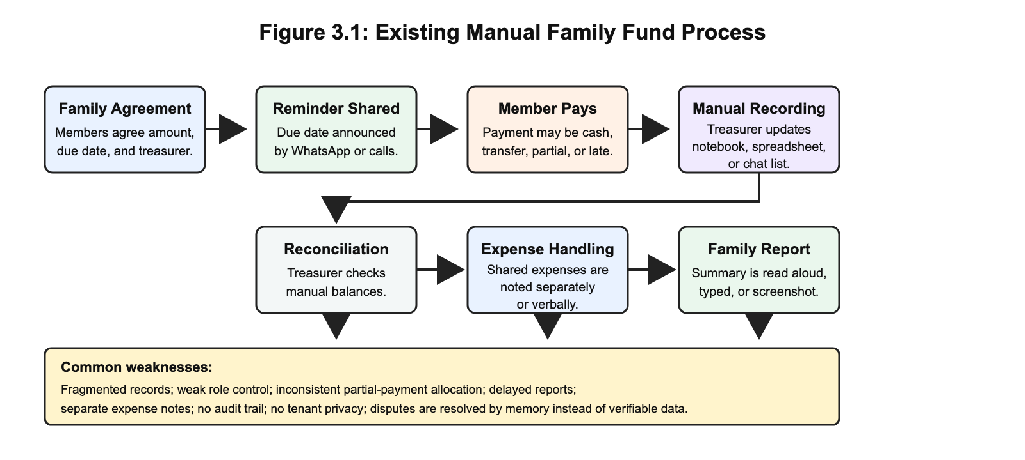

The major bottleneck in the existing system is that the family record depends too much on one person's manual discipline. Even when the person is honest, the process does not provide enough structure for verification, audit, payment allocation, or tenant-level privacy. These weaknesses justify the need for a purpose-built system.

3.4 Proposed System Overview
The proposed system is FamilyFunds, a multi-tenant web application for family contribution fund management. Each family operates in its own workspace, while the platform uses shared infrastructure. Users are assigned roles that determine what they can see and do. The system records members, contribution categories, monthly obligations, payments, expenses, adjustments, reminders, reports, subscription plans, and AI assistant interactions.
FamilyFunds resolves the problems in the existing system by moving the authoritative record into a structured PostgreSQL database. It also introduces role-based access control, Paystack payment support, deterministic oldest-balance-first payment allocation, automated contribution generation, reminders, and clear reports. AI assistance is added as a controlled interface for answering permitted questions and summarising reports in plain language.
Table 3.1: Summary of Proposed System Features
Feature Area | Description
Multi-tenant family workspaces | Each family has a logically isolated workspace within the same application.
Role-based access control | Family Administrator, Financial Secretary, Member, and Platform Super Administrator have separate permissions.
Contribution categories | Families define monthly contribution amounts for groups such as employed members, students, or other categories.
Monthly contribution generation | The system creates contribution obligations for paying members based on category and due date.
Payment recording | Authorised users record offline payments, while members can initiate online payments through Paystack.
Payment allocation | Payments are applied to the oldest outstanding balances first.
Expenses and adjustments | Family spending, donations, corrections, and other balance movements are recorded.
Reminders | Email, browser push, and WhatsApp-related reminder flows support follow-up.
Reports | Monthly and annual reports show collections, balances, expenses, and member status.
AI assistant and summaries | The assistant answers role-permitted questions and supports plain-language report summaries.
Predictive analytics pathway | Historical payment data can later support default-risk indicators when enough data exists.
Security controls | Email verification, password hashing, two-factor authentication, passkeys, signed invitations, policies, and tenant scoping protect the system.

3.5 System Requirements
System requirements define what the system must do and the qualities it must maintain while doing so. The requirements below are written to be testable because vague requirements such as "the system should be fast" do not help implementation or validation.

3.5.1 Functional Requirements
Table 3.2: Functional Requirements
ID | Requirement | Description | Main Actor
FR1 | User authentication | Users shall register, log in, verify email, reset passwords, and manage account security. | All users
FR2 | Family workspace creation | A family administrator shall create and configure a family workspace. | Family Admin
FR3 | Member invitation | The system shall allow administrators to invite members using secure invitation links. | Family Admin
FR4 | Role assignment | The system shall support Family Admin, Financial Secretary, Member, and Platform Super Admin roles. | Family Admin
FR5 | Contribution category setup | Administrators shall define contribution categories and monthly amounts. | Family Admin
FR6 | Monthly contribution generation | The system shall generate monthly obligations for paying members. | Family Admin, System
FR7 | Contribution status tracking | The system shall show unpaid, partially paid, paid, and overdue statuses. | All authorised users
FR8 | Manual payment recording | Authorised officers shall record cash, transfer, or offline payments. | Family Admin, Financial Secretary
FR9 | Online payment processing | Members shall initiate online payments through Paystack where enabled. | Member
FR10 | Payment verification | The system shall verify Paystack transactions before marking them successful. | System
FR11 | Payment allocation | The system shall allocate payments to the oldest outstanding contribution balances first. | System
FR12 | Expense recording | Authorised users shall record family expenses with amount, date, description, and recorder. | Family Admin, Financial Secretary
FR13 | Fund adjustment recording | Authorised users shall record donations, corrections, and other non-contribution balance movements. | Family Admin, Financial Secretary
FR14 | Reports | The system shall generate monthly and annual reports for contributions, payments, expenses, adjustments, and balances. | Family Admin, Financial Secretary
FR15 | Member dashboard | Members shall view personal balances, payment history, and contribution status. | Member
FR16 | Reminders | Authorised users shall send or trigger contribution reminders through supported channels. | Family Admin, Financial Secretary
FR17 | Subscription management | Families shall access platform plans with member limits and feature availability. | Family Admin
FR18 | AI assistant | The assistant shall answer questions using permitted family data and role-aware tools. | Authorised users
FR19 | AI report summary | The system shall support plain-language summaries of financial reports. | Family Admin, Financial Secretary
FR20 | Predictive analytics pathway | The system design shall support later prediction of payment behaviour where sufficient history exists. | Family Admin, Financial Secretary

3.5.2 Non-Functional Requirements
Table 3.3: Non-Functional Requirements
ID | Category | Requirement | Expected Measure
NFR1 | Security | A user shall access only records belonging to the user's family tenant. | Cross-family access attempts are denied.
NFR2 | Security | Sensitive actions shall be restricted by role. | Members cannot record payments or alter family settings.
NFR3 | Security | User accounts shall support strong authentication controls. | Email verification, 2FA, passkeys, and password hashing are available.
NFR4 | Reliability | Payment allocation shall be deterministic. | The same payment history produces the same balances.
NFR5 | Reliability | Paystack callbacks shall not create duplicate successful payments. | Repeated callback events do not double-record payments.
NFR6 | Usability | Common workflows shall be usable on mobile and desktop browsers. | Key pages remain responsive and readable.
NFR7 | Usability | Reports shall be understandable to non-accounting users. | Summary text and tables use clear labels and plain language.
NFR8 | Performance | Dashboard and report pages shall remain responsive for ordinary family sizes. | Common pages load within an acceptable time during testing.
NFR9 | Maintainability | Modules shall remain separated by responsibility. | Authentication, payments, reports, and AI logic are not mixed into one layer.
NFR10 | Auditability | Financial records shall store relevant dates, amounts, users, and relationships. | Transactions can be reviewed and reconciled.
NFR11 | Privacy | AI features shall use only the data needed for the user's request. | Prompts and tool calls avoid unnecessary personal exposure.
NFR12 | Availability | The deployed system shall support HTTPS, queues, scheduler, and backups. | Required services are configured in deployment.

3.5.3 Deployment Requirements
Table 3.4: Deployment Requirements
Requirement Type | Requirement
Runtime | PHP 8.4 or later with required Laravel extensions
Dependency tools | Composer, Node.js, npm, and Vite build process
Database | PostgreSQL database with secure credentials and backups
Web server | HTTPS-enabled Nginx, Apache, Laravel Cloud, or equivalent platform
Background processing | Queue worker and Laravel scheduler for jobs and reminders
Environment configuration | `.env` variables for database, mail, Paystack, AI provider, WhatsApp-related settings, and app keys
Security | HTTPS, password hashing, signed URLs, webhook validation, and restricted credentials

3.6 Data Collection Methods
This project does not rely on a formal questionnaire or invented survey data. The data used for the methodology came from four honest sources. The first source was literature and document analysis, including studies on informal finance, digital financial inclusion, SaaS multi-tenancy, RBAC, digital payments, AI reporting, and predictive analytics. The second source was observation of typical family fund administration: how members are added, how contribution amounts are agreed, how payments are announced, and how balances are reconciled. The third source was analysis of existing tools such as PiggyVest, Cowrywise, CreditClan, Lendsqr, WhatsApp, and spreadsheets. The fourth source was the system's own development artefacts: routes, controllers, models, migrations, diagrams, requirements, and test scenarios.
For AI and predictive features, the relevant data is system-generated family fund data such as contribution months, due dates, payment dates, payment amounts, outstanding balances, reminder history, and report summaries. No personal data is invented for the study. Where sample data is used for testing or demonstration, it is treated as test data rather than real participant data.

3.7 Population and Sampling
The study is mainly a system-development project, so it does not use a statistical population or probability sampling method. The relevant user population for design purposes consists of the people who normally participate in a family contribution fund: family administrators, financial secretaries, ordinary members, and the platform administrator.
Validation scenarios are selected purposively because the aim is to test whether the artefact behaves correctly in the most important use cases. The selected scenarios include creating a family, inviting members, assigning roles, generating contributions, recording partial payments, initiating Paystack payments, viewing dashboards, sending reminders, generating reports, using AI assistance, and preventing cross-family access. This sampling approach is appropriate because correctness is judged by system behaviour under realistic workflows, not by generalising survey responses.

3.8 System Architecture / Design
FamilyFunds is designed as a layered, modular monolith. The frontend layer uses Vue.js and Inertia.js to present dashboards, forms, reports, settings, and AI chat screens. The application layer uses Laravel controllers, requests, services, policies, jobs, commands, and AI tools. The data layer uses PostgreSQL to store families, users, contributions, payments, expenses, adjustments, plans, notifications, passkeys, WhatsApp-related messages, and AI conversations. External services include Paystack for payments and subscriptions, mail and messaging channels for communication, and AI providers for assistant functions.
Figure 3.2 shows the high-level architecture.
Figure 3.2: System Architecture Diagram
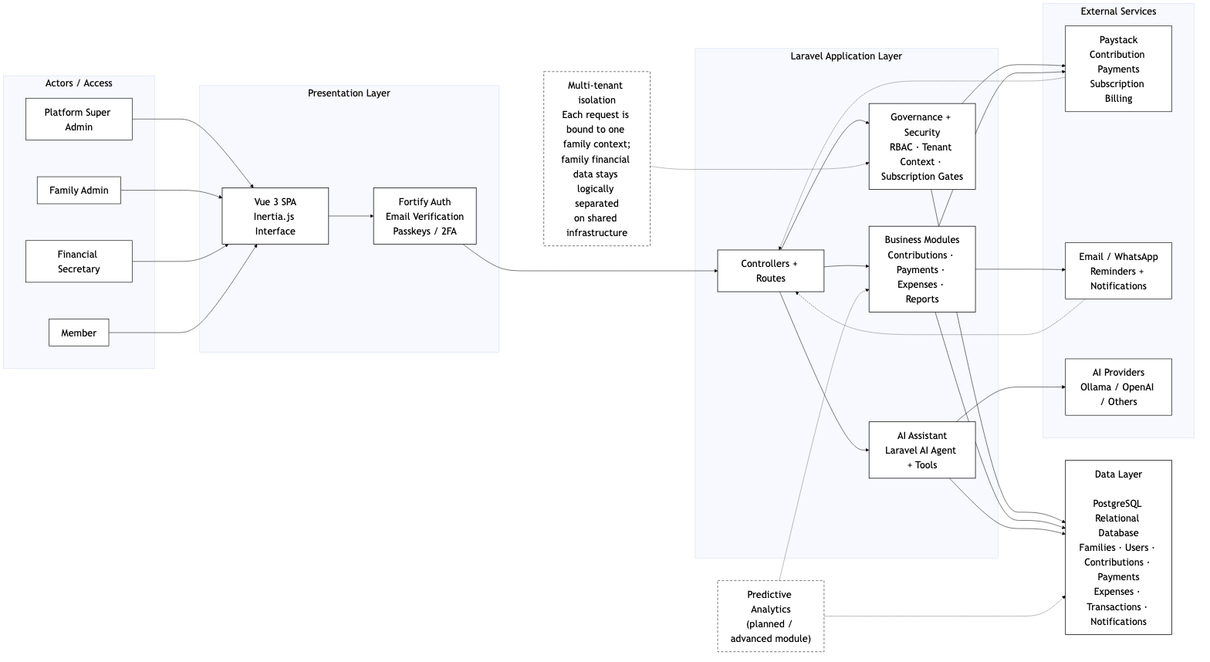

The architecture uses shared-schema multi-tenancy. Each family-specific record carries a `family_id` where appropriate. Middleware, policies, validation, and query scoping enforce the boundary. This strategy keeps the system practical for many small family groups while still maintaining logical separation. The design also keeps external services outside the authority of the application. Paystack verifies transactions, but Laravel decides how verified payments affect contribution records. The AI provider generates language, but Laravel controls permissions, tools, and data access.

3.9 Use Case / UML Diagrams
The system uses UML-style and process diagrams to explain the main actors, workflows, and data relationships. The diagrams are used because the system contains several roles, many related entities, and financial processes that are easier to verify visually than through prose alone.
Figure 3.3 presents the use case diagram.
Figure 3.3: Use Case Diagram
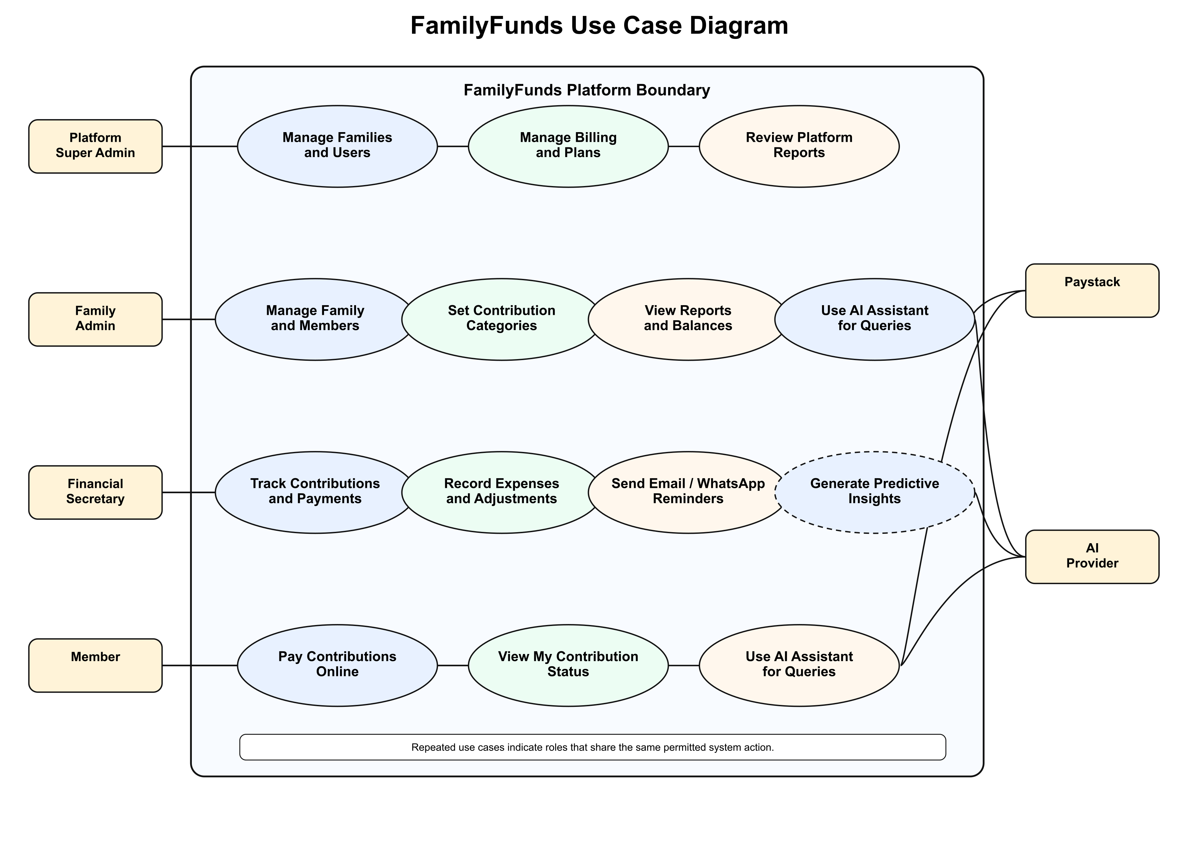

The main human actors are Platform Super Administrator, Family Administrator, Financial Secretary, and Member. The Platform Super Administrator manages platform-wide oversight. The Family Administrator manages the family workspace, members, settings, contribution categories, subscriptions, and reports. The Financial Secretary records payments, expenses, adjustments, reminders, and reports. Members view their own status and pay contributions. External actors include Paystack and AI providers, but they support rather than control the system.
The payment allocation process is one of the most important workflows because it affects member balances and family trust. Figure 3.4 presents the activity/flowchart view in readable panels.
Figure 3.4a: Payment Allocation Flowchart, Panel 1
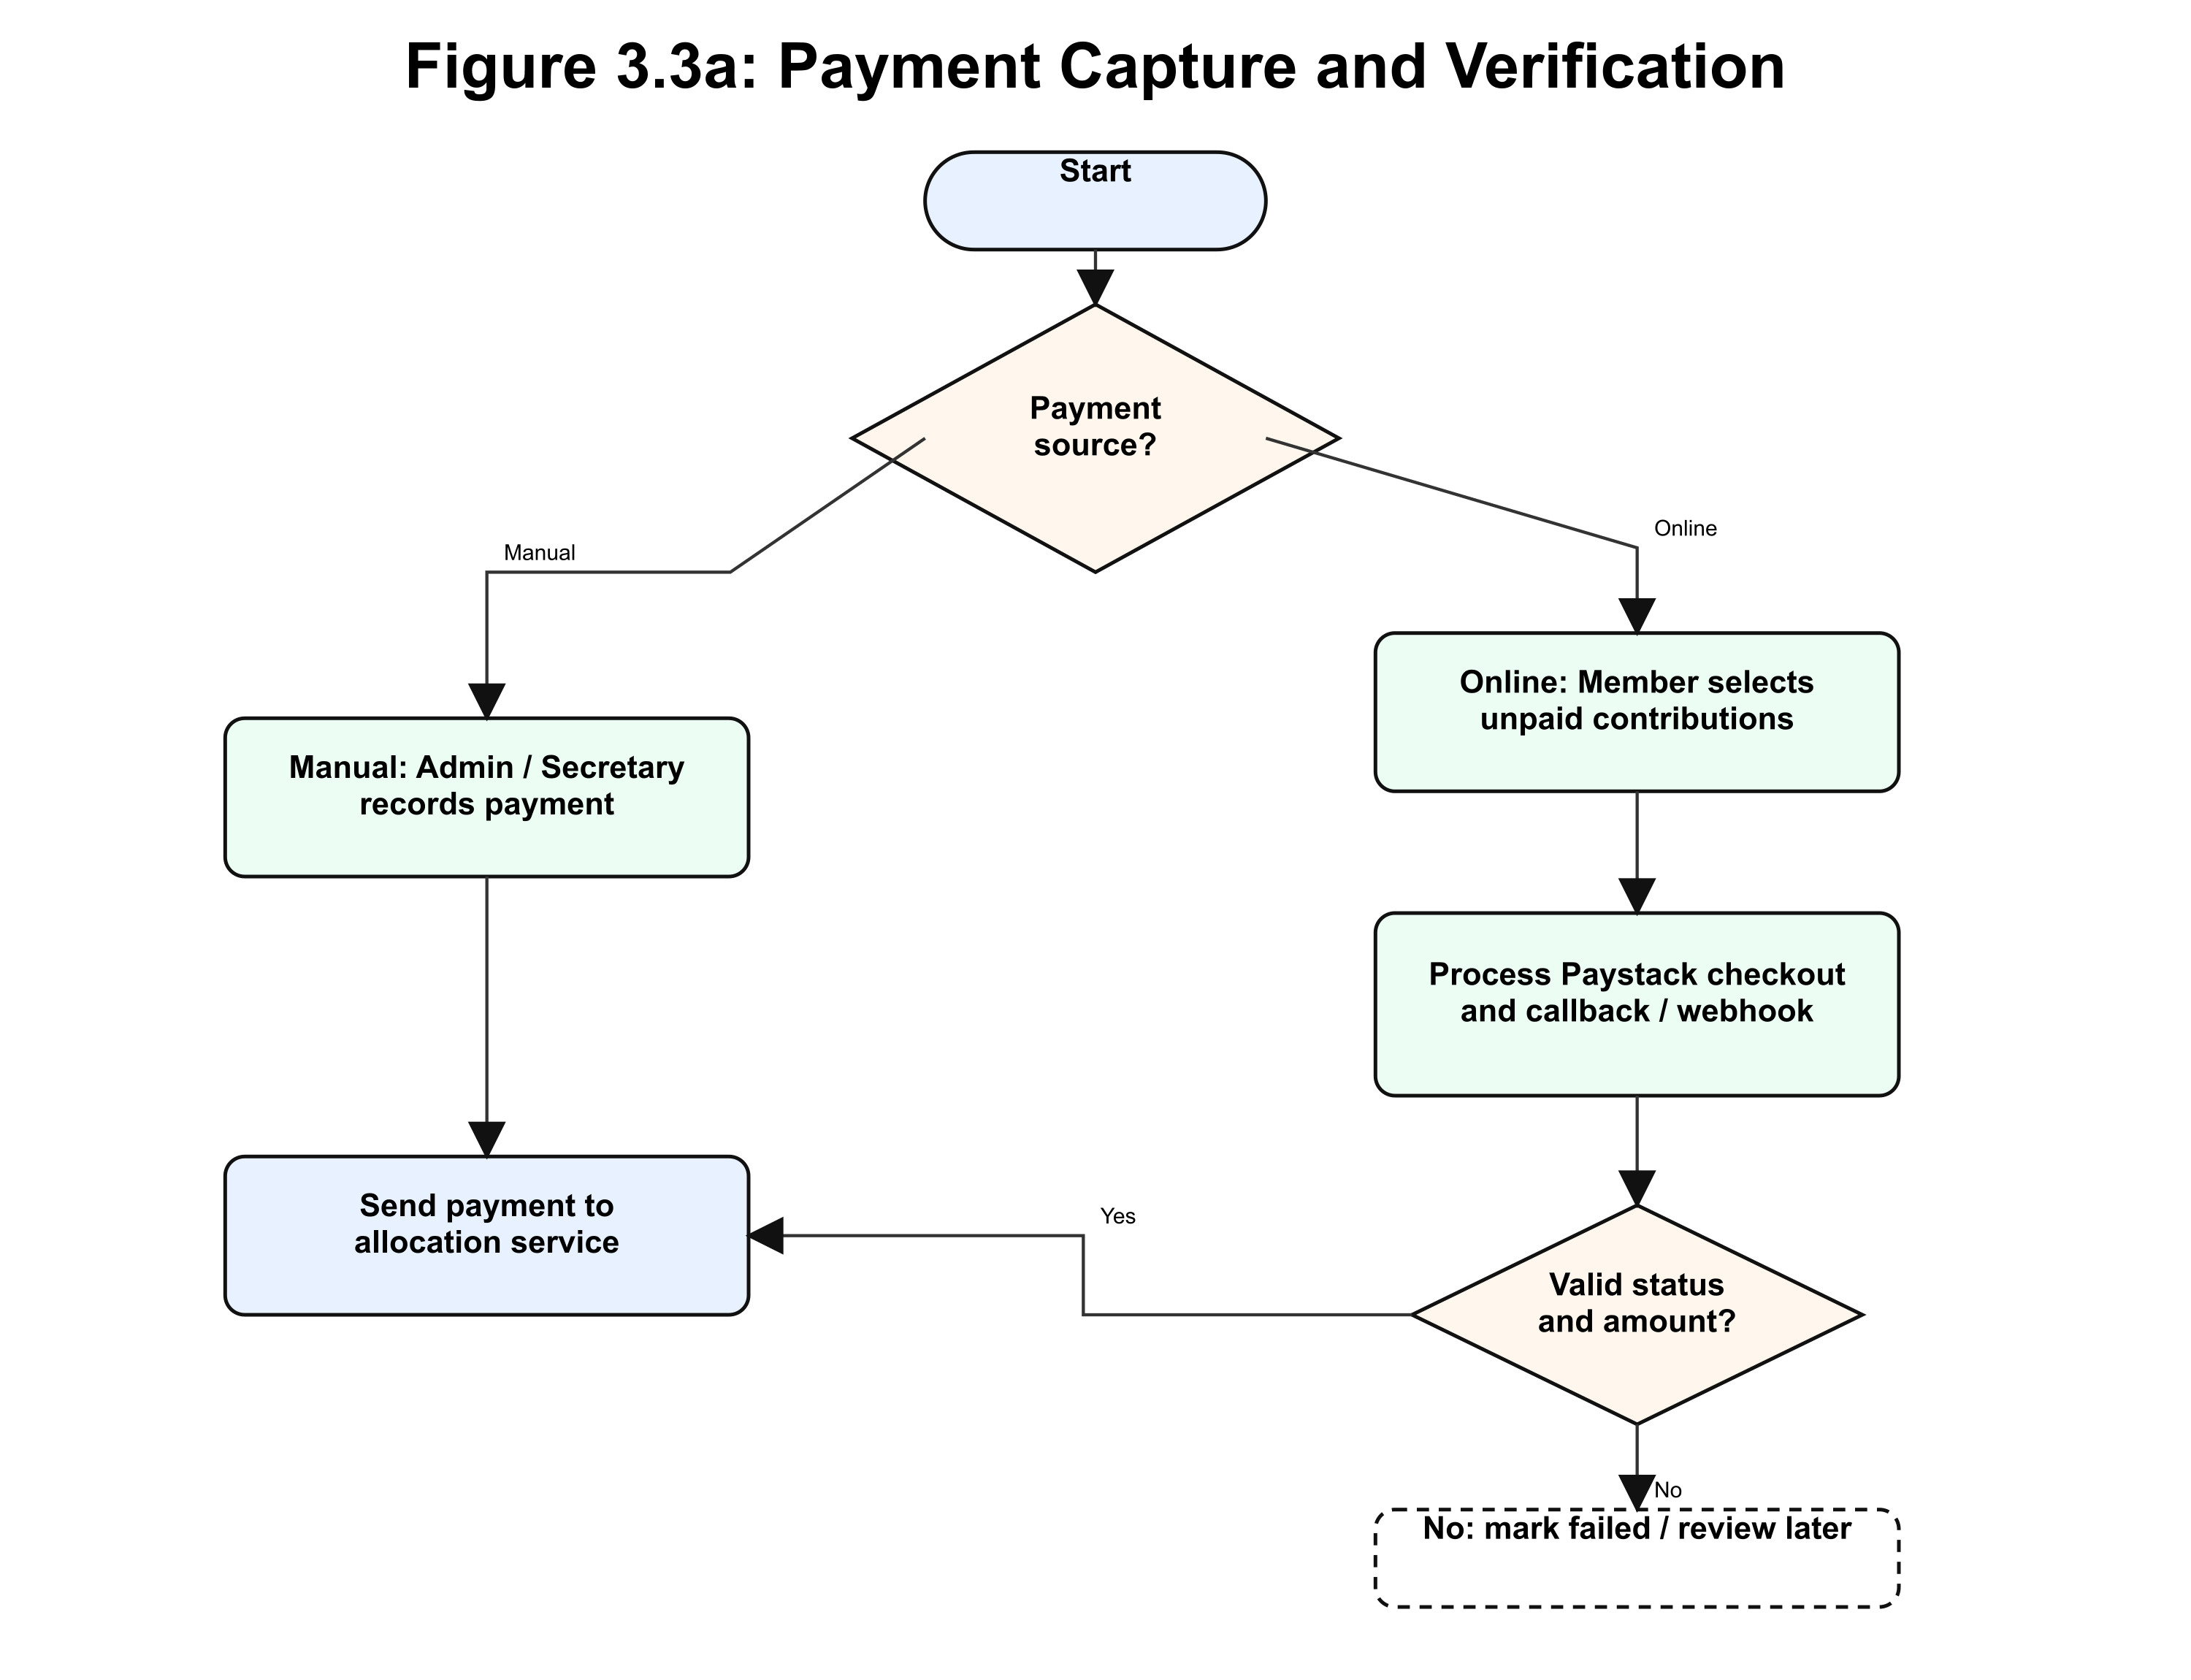

Figure 3.4b: Payment Allocation Flowchart, Panel 2
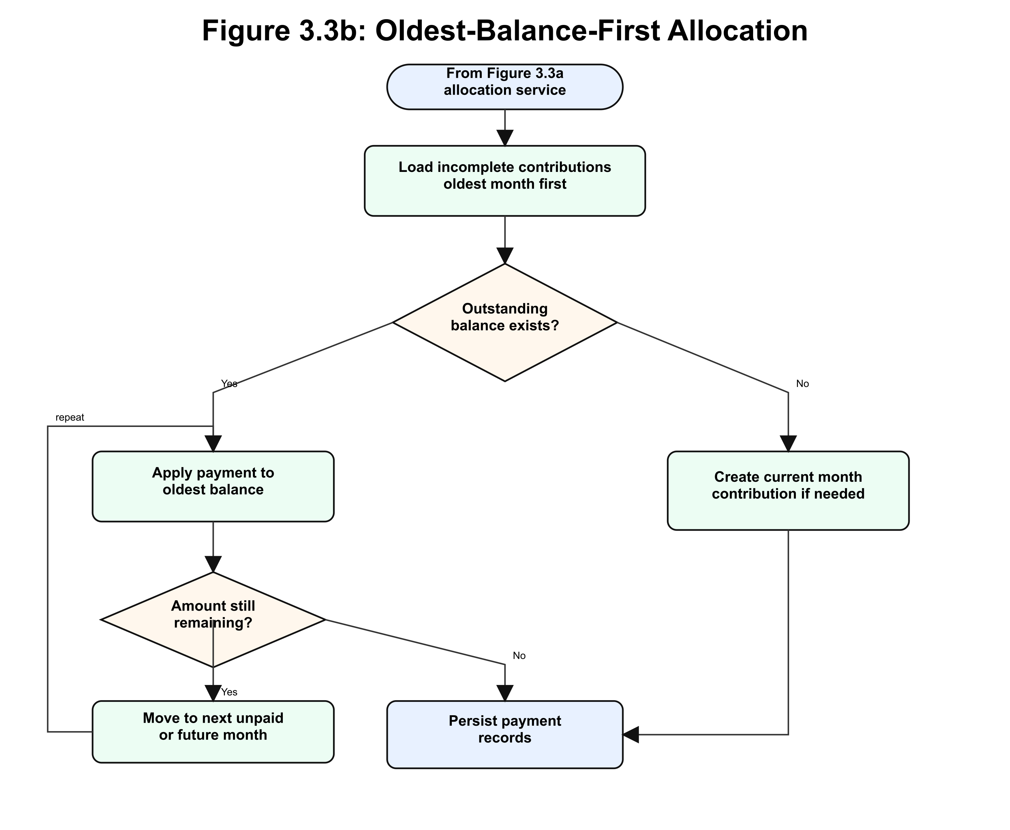

Figure 3.4c: Payment Allocation Flowchart, Panel 3
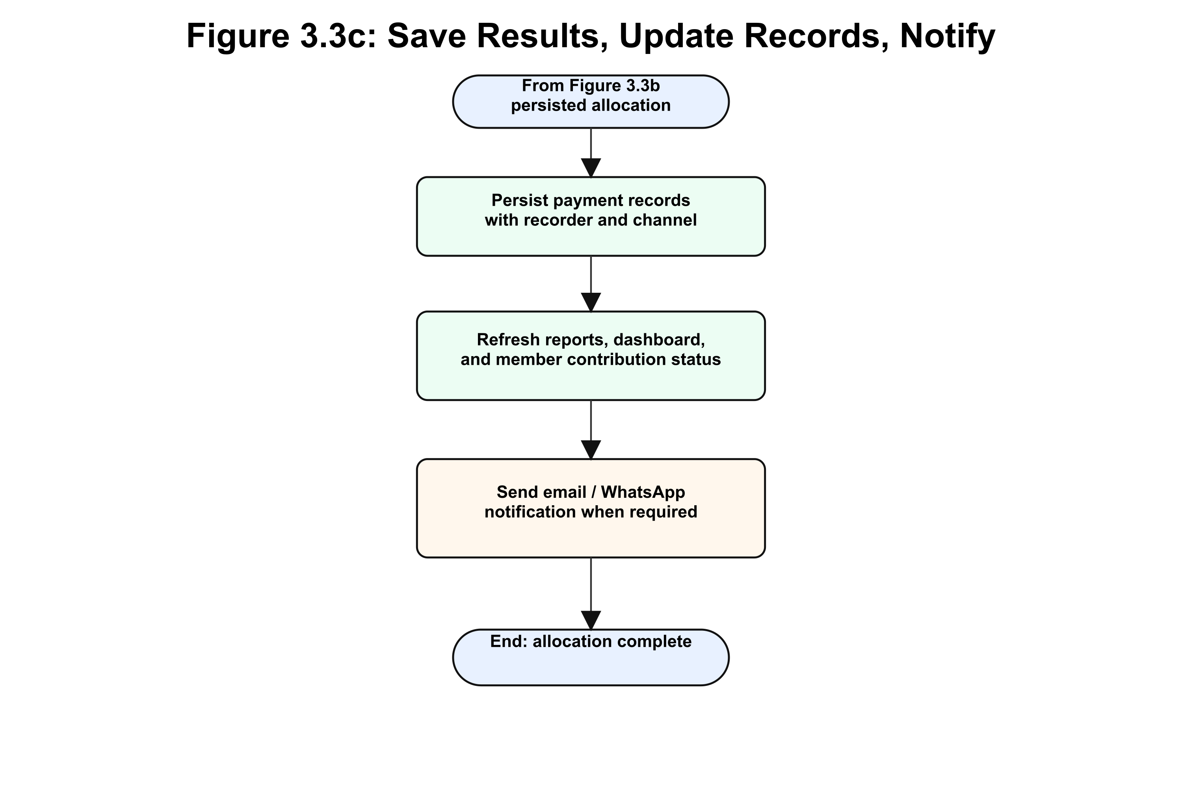

The class-style model is represented by the main domain entities: Family, User, FamilyCategory, Contribution, Payment, Expense, FundAdjustment, PlatformPlan, PaystackTransaction, Passkey, Notification, WhatsAppMessage, AgentConversation, and AgentConversationMessage. The sequence-style processes include invitation acceptance, contribution generation, manual payment recording, Paystack payment verification, reminder sending, report generation, and AI assistant response generation.

3.10 Database Design
The database design uses PostgreSQL as the relational database. The design is centred on the family tenant. Tables that contain family-specific data include a `family_id` field or are connected through another family-owned entity. This supports shared-schema multi-tenancy while keeping relationships clear.
Figure 3.5 shows the entity-relationship diagram.
Figure 3.5: Entity-Relationship Diagram
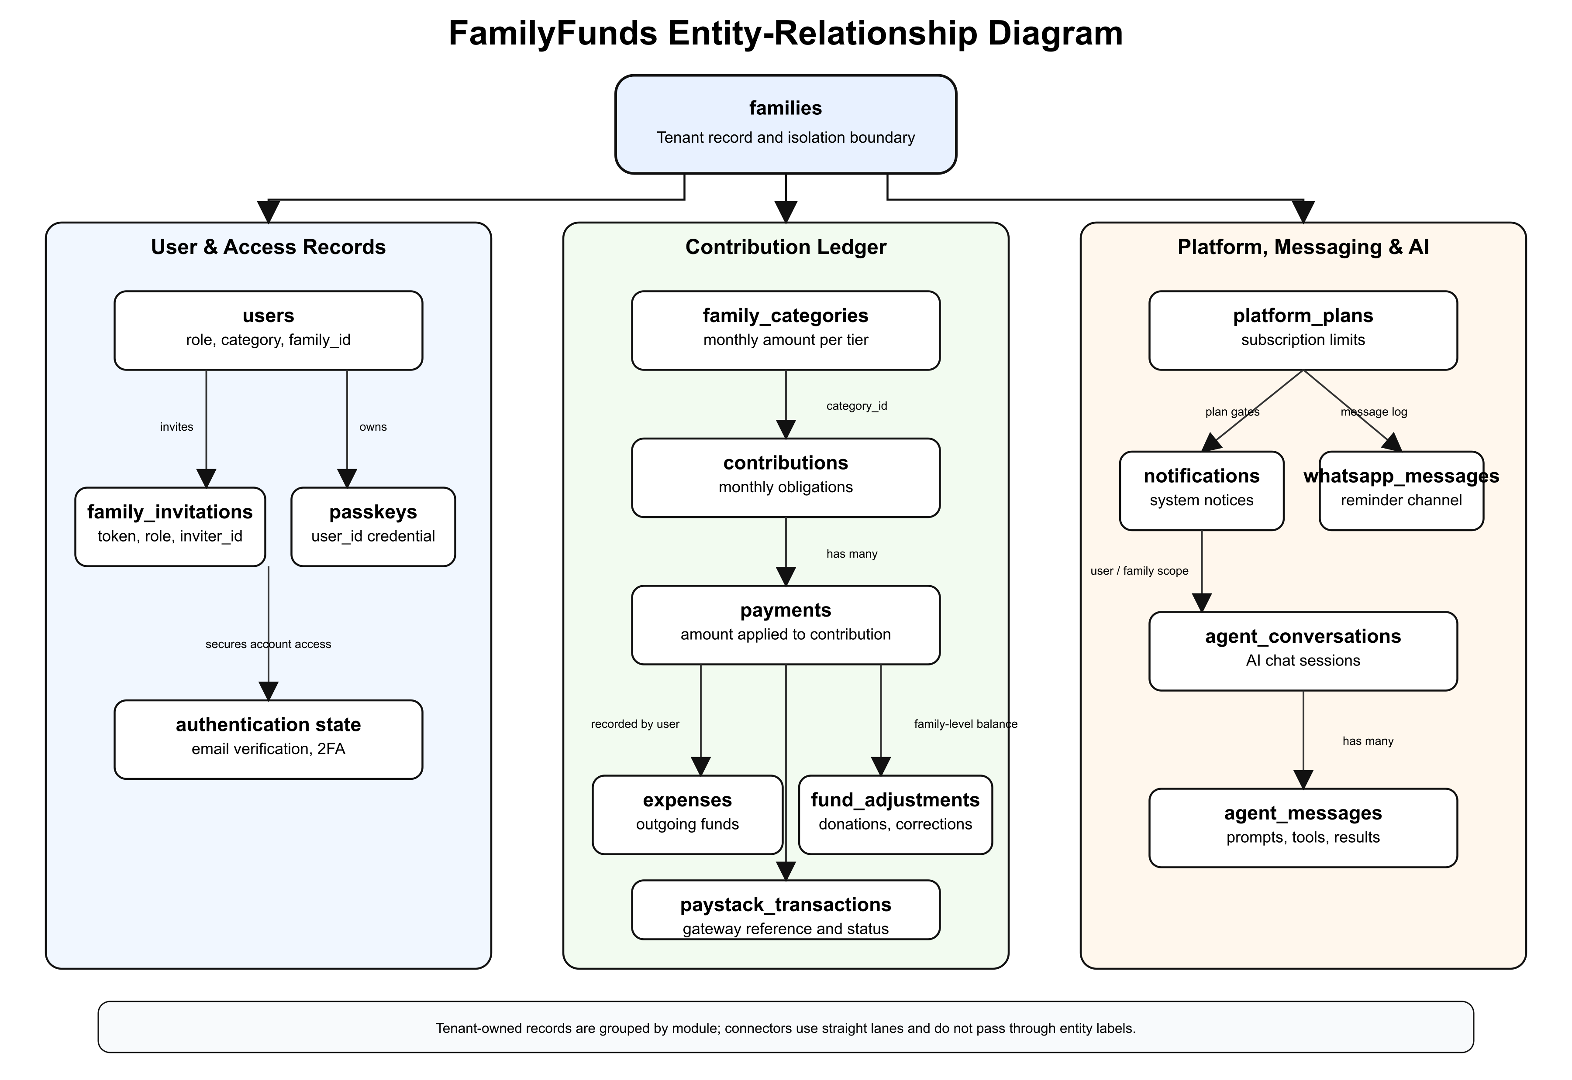

Table 3.5: Major Database Entities
Entity | Purpose | Key Relationship
`families` | Stores family workspace settings, currency, due day, status, billing, and bank details. | Has many users, categories, contributions, expenses, adjustments, invitations, and transactions.
`users` | Stores account, role, family membership, category, authentication, and profile data. | Belongs to a family and may belong to a family category.
`family_categories` | Stores contribution tiers and monthly amounts. | Belongs to a family and may be assigned to users.
`family_invitations` | Stores invitation email, role, token, expiry, and acceptance status. | Belongs to a family and inviter.
`contributions` | Stores monthly contribution obligations and statuses. | Belongs to a family and user; receives payments.
`payments` | Stores payment amounts applied to contribution obligations. | Belongs to a contribution and recorded-by user.
`expenses` | Stores family spending records. | Belongs to a family and recorded-by user.
`fund_adjustments` | Stores donations, corrections, and non-contribution balance changes. | Belongs to a family and recorded-by user.
`paystack_transactions` | Stores online payment and subscription transaction references. | Belongs to a family and user.
`platform_plans` | Stores subscription plan names, prices, limits, and features. | Used by families for subscription management.
`passkeys` | Stores WebAuthn credential information. | Belongs to a user.
`notifications` | Stores application notifications. | Linked to notifiable users.
`whatsapp_messages` | Stores inbound and outbound WhatsApp-related communication. | Linked to family and user where applicable.
`agent_conversations` | Stores AI assistant conversation sessions. | Belongs to a user.
`agent_conversation_messages` | Stores AI messages, tool calls, tool results, and metadata. | Belongs to an AI conversation.

The database design supports financial traceability by separating obligations from payments. A contribution records what a member owes for a period. A payment records money applied to that obligation. This separation is important because one incoming amount can be split across more than one contribution.

3.11 Algorithm / Model Design
The main algorithm in the system is the oldest-balance-first payment allocation algorithm. It handles manual and verified online payments in a consistent way.
Table 3.6: Oldest-Balance-First Payment Allocation Algorithm
Step | Operation
1 | Receive the member, payment amount, payment channel, and transaction details.
2 | Retrieve the member's unpaid and partially paid contributions, ordered from oldest to newest.
3 | For each contribution, calculate the outstanding balance.
4 | Apply the available payment amount to the oldest outstanding balance.
5 | Mark the contribution as paid if the balance reaches zero, or partially paid if a balance remains.
6 | Continue until the payment amount is exhausted or all outstanding balances are cleared.
7 | If an overpayment remains, apply it according to the system's advance-payment rules or record it for review.
8 | Store payment records and update contribution statuses for reporting.

The AI assistant model is designed as a tool-aware assistant. The user's role and family context are checked before tools are used. Read-only questions, such as contribution summaries or fund balances, return information from permitted records. Write-related actions, such as recording expenses or payments through an assistant tool, require explicit confirmation and role permission.
The predictive analytics model is planned as a supervised classification pathway, not as an unconditional feature claim. Possible input features include payment delay, number of unpaid months, contribution category, previous partial payments, reminder count, and historical consistency. Possible output labels include "likely on time" and "likely overdue." The evaluation should use accuracy together with precision, recall, and F1-score because raw accuracy can be misleading when most members usually pay on time (Hussin Adam Khatir & Bee, 2022; Robisco & Carbó Martínez, 2022).

3.12 Tools and Technologies
The project uses tools selected for practicality, maintainability, and compatibility with the application requirements.
Table 3.7: Tools and Technologies
Category | Tool/Technology | Purpose
Backend language | PHP 8.4 | Main server-side language.
Backend framework | Laravel 13 | Routing, controllers, validation, queues, scheduler, policies, models, and services.
Frontend framework | Vue.js 3 | User interface pages, dashboards, forms, and interactive components.
Server-client bridge | Inertia.js 3 | Connects Laravel routes to Vue pages without a separate REST API.
Database | PostgreSQL | Relational storage for family, user, contribution, payment, expense, and AI records.
Styling | Tailwind CSS 4 | Responsive interface styling.
Authentication | Laravel Fortify | Login, registration, password reset, email verification, and two-factor support.
Passwordless access | WebAuthn/passkeys | Strong browser-based authentication.
Payment gateway | Paystack | Online contribution payments and subscription billing.
AI integration | Laravel AI SDK | Assistant responses, tool calling, and provider integration.
Feature flags | Laravel Pennant | Controlled release of features such as AI assistance.
Testing | Pest PHP | Automated tests for models, features, policies, payments, reports, and AI tools.
Build tool | Vite | Frontend asset compilation and development server.
Version control | Git | Source tracking and collaboration.
Code quality | Laravel Pint, ESLint, Prettier | Formatting and static code quality.
Development tools | Composer, Node.js, npm | Dependency management and project tooling.

Laravel was selected because it provides mature support for routing, validation, queues, scheduled commands, notifications, policies, and Eloquent models. Vue and Inertia were selected because they allow a modern single-page experience without forcing the project to maintain a separate API layer. PostgreSQL was selected as the stated database technology because the project requires reliable relational storage, constraints, and query support. Paystack fits the Nigerian payment context. The Laravel AI SDK keeps assistant features inside the application's own permission and tool structure.

3.13 Ethical Considerations
The project handles financial and personal information, so ethical considerations are central to the design. The first concern is privacy. A family member's contribution history, payment status, phone number, email address, and role should not be exposed to another family or to unauthorised members of the same family. Tenant isolation and RBAC are therefore ethical safeguards as well as technical features.
The second concern is consent and transparency. Members should understand that their records are being stored in a digital system for family fund management. If AI summaries or assistant features are used, users should understand that the AI is a support tool and not an independent auditor or financial adviser.
The third concern is data minimisation. The system should collect only data needed for contribution management, payment processing, reminders, reporting, authentication, and authorised AI assistance. AI prompts should avoid sending unnecessary personal data to external providers.
The fourth concern is security. Password hashing, email verification, two-factor authentication, passkeys, signed invitation links, webhook validation, HTTPS deployment, and secure environment variables are required to protect users. The design should also comply with applicable Nigerian data protection expectations, including responsible processing and protection of personal data under the Nigeria Data Protection Act 2023.
The fifth concern is intellectual property. The project uses open-source frameworks and libraries such as Laravel, Vue, Inertia, Tailwind CSS, and Pest according to their licences. External services such as Paystack and AI providers are used through their documented APIs and configuration requirements.

3.14 Summary of the Chapter
This chapter described the methodology used for FamilyFunds. It adopted an applied system-development design and an Agile iterative approach because the project solves a practical problem whose requirements become clearer through design and implementation. The chapter analysed the existing manual system, introduced the proposed system, specified functional and non-functional requirements, explained the data collection method, clarified the non-survey sampling approach, and described the architecture, diagrams, database design, algorithms, tools, and ethical considerations.
The methodology shows how the project moves from the literature gap in Chapter Two to a concrete system design. Chapter Four will present how the designed modules were implemented, tested, and validated against the requirements stated in this chapter.

REFERENCES
Adegbite, O. O., & Machethe, C. L. (2020). The gender gap in financial inclusion: Evidence from Nigeria. World Development, 127, 104755. https://doi.org/10.1016/j.worlddev.2019.104755
Adeyemo, R., & Bamire, A. S. (2005). Savings and investment patterns of cooperative farmers in Southwestern Nigeria. Journal of Social Sciences, 11(3), 183–192. https://doi.org/10.1080/09718923.2005.11892512
Akanji, O. O. (2006). Microfinance as a strategy for poverty reduction. Central Bank of Nigeria Economic and Financial Review, 39(4), 111–134.
Aker, J. C., & Mbiti, I. M. (2010). Mobile phones and economic development in Africa. Journal of Economic Perspectives, 24(3), 207–232. https://doi.org/10.1257/jep.24.3.207
Anderson, S., & Baland, J.-M. (2002). The economics of ROSCAs and intrahousehold resource allocation. Quarterly Journal of Economics, 117(3), 963–995. https://doi.org/10.1162/003355302760193931
Apt, N. A. (2002). Ageing and the changing role of the family and the community: An African perspective. International Social Security Review, 55(1), 39–47. https://doi.org/10.1111/1468-246X.00113
Ardener, S. (1964). The comparative study of rotating credit associations. Journal of the Royal Anthropological Institute of Great Britain and Ireland, 94(2), 201–229. https://doi.org/10.2307/2844382
Ardener, S., & Burman, S. (Eds.). (1995). Money-go-rounds: The importance of rotating savings and credit associations for women. Berg Publishers.
Aryeetey, E. (2008). From informal finance to formal finance in Sub-Saharan Africa: Lessons from linkage efforts. In African Finance for the 21st Century (pp. 1–24). International Monetary Fund.
Amazon Web Services. (2020). SaaS tenant isolation strategies: Isolating resources in a multi-tenant environment. https://docs.aws.amazon.com/whitepapers/latest/saas-tenant-isolation-strategies/saas-tenant-isolation-strategies.html
Bascom, W. R. (1952). The Esusu: A credit institution of the Yoruba. Journal of the Royal Anthropological Institute of Great Britain and Ireland, 82(1), 63–69. https://doi.org/10.2307/2844040
Beck, K., Beedle, M., van Bennekum, A., Cockburn, A., Cunningham, W., Fowler, M., Grenning, J., Highsmith, J., Hunt, A., Jeffries, R., Kern, J., Marick, B., Martin, R. C., Mellor, S., Schwaber, K., Sutherland, J., & Thomas, D. (2001). Manifesto for Agile Software Development. https://agilemanifesto.org
Bellotti, T., & Crook, J. (2009). Support vector machines for credit scoring and discovery of significant features. Expert Systems with Applications, 36(2), 3302–3308. https://doi.org/10.1016/j.eswa.2008.01.005
Bezemer, C. P., & Zaidman, A. (2010). Multi-tenant SaaS applications: Maintenance dream or nightmare? In Proceedings of the Joint ERCIM Workshop on Software Evolution (EVOL) and International Workshop on Principles of Software Evolution (IWPSE) (pp. 88–92). ACM. https://doi.org/10.1145/1862372.1862393
Bonneau, J., Herley, C., van Oorschot, P. C., & Stajano, F. (2012). The quest to replace passwords: A framework for comparative evaluation of web authentication schemes. In Proceedings of the 2012 IEEE Symposium on Security and Privacy (pp. 553–567). IEEE. https://doi.org/10.1109/SP.2012.44
Bouman, F. J. A. (1995). Rotating and accumulating savings and credit associations: A development perspective. World Development, 23(3), 371–384. https://doi.org/10.1016/0305-750X(94)00141-K
Breiman, L. (2001). Random forests. Machine Learning, 45(1), 5–32. https://doi.org/10.1023/A:1010933404324
Brown, T. B., Mann, B., Ryder, N., Subbiah, M., Kaplan, J., Dhariwal, P., ... & Amodei, D. (2020). Language models are few-shot learners. In Advances in Neural Information Processing Systems, 33, 1877–1901.
Chen, T., & Guestrin, C. (2016). XGBoost: A scalable tree boosting system. In Proceedings of the 22nd ACM SIGKDD International Conference on Knowledge Discovery and Data Mining (pp. 785–794). ACM. https://doi.org/10.1145/2939672.2939785
Chong, F., Carraro, G., & Wolter, R. (2006). Multi-tenant data architecture. Microsoft Developer Network (MSDN). https://learn.microsoft.com/en-us/previous-versions/aa479086(v=msdn.10)
Cormen, T. H., Leiserson, C. E., Rivest, R. L., & Stein, C. (2009). Introduction to Algorithms (3rd ed.). MIT Press.
Cowrywise. (2024). Cowrywise — Save and invest in dollars and naira. https://cowrywise.com
CreditClan. (2024). CreditClan — Lending infrastructure for Africa. https://creditclan.com
Dale, R. (2020). Natural language generation: The commercial state of the art in 2020. Natural Language Engineering, 26(4), 481–487. https://doi.org/10.1017/S1351324920000340
de Wynter, A., Wang, X., Sokolov, A., Gu, Q., & Chen, S.-Q. (2023). An evaluation on large language model outputs: Discourse and memorization. Natural Language Processing Journal, 4, 100024. https://doi.org/10.1016/j.nlp.2023.100024
Demirgüç-Kunt, A., Klapper, L., Singer, D., & Ansar, S. (2022). The Global Findex Database 2021: Financial inclusion, digital payments, and resilience in the age of COVID-19. World Bank. https://doi.org/10.1596/978-1-4648-1897-4
Devlin, J., Chang, M.-W., Lee, K., & Toutanova, K. (2019). BERT: Pre-training of deep bidirectional transformers for language understanding. In Proceedings of the 2019 Conference of the North American Chapter of the Association for Computational Linguistics: Human Language Technologies (pp. 4171–4186). ACL.
EFInA. (2023). Access to Financial Services in Nigeria 2023 Survey. Enhancing Financial Innovation & Access. https://efina.org.ng
Ferraiolo, D. F., Sandhu, R., Gavrila, S., Kuhn, D. R., & Chandramouli, R. (2001). Proposed NIST standard for role-based access control. ACM Transactions on Information and Systems Security, 4(3), 224–274. https://doi.org/10.1145/501978.501980
Federal Republic of Nigeria. (2023). Nigeria Data Protection Act, 2023. https://ndpc.gov.ng
FIDO Alliance. (2022). FIDO2: Web Authentication (WebAuthn). https://fidoalliance.org/fido2/fido2-web-authentication-webauthn/
Fielding, R. T. (2000). Architectural styles and the design of network-based software architectures (Doctoral dissertation, University of California, Irvine).
Fowler, M. (2002). Patterns of Enterprise Application Architecture. Addison-Wesley.
Gugerty, M. K. (2007). You can't save alone: Commitment in rotating savings and credit associations in Kenya. Economic Development and Cultural Change, 55(2), 251–282. https://doi.org/10.1086/508716
Gamma, E., Helm, R., Johnson, R., & Vlissides, J. (1994). Design Patterns: Elements of Reusable Object-Oriented Software. Addison-Wesley.
Gomber, P., Koch, J. A., & Siering, M. (2017). Digital finance and FinTech: Current research and future research directions. Journal of Business Economics, 87(5), 537–580. https://doi.org/10.1007/s11573-017-0852-x
Hand, D. J. (2009). Measuring classifier performance: A coherent alternative to the area under the ROC curve. Machine Learning, 77(1), 103–123. https://doi.org/10.1007/s10994-009-5119-5
Hastie, T., Tibshirani, R., & Friedman, J. (2009). The Elements of Statistical Learning: Data Mining, Inference, and Prediction (2nd ed.). Springer.
Hu, V. C., Ferraiolo, D., Kuhn, R., Schnitzer, A., Sandlin, K., Miller, R., & Scarfone, K. (2014). Guide to Attribute Based Access Control (ABAC) Definition and Considerations. NIST Special Publication 800-162.
Hussin Adam Khatir, A. A., & Bee, M. (2022). Machine learning models and data-balancing techniques for credit scoring: What is the best combination? Risks, 10(9), 169. https://doi.org/10.3390/risks10090169
Iganiga, B. O., & Asemota, A. (2008). The Nigerian unorganised rural financial institutions and operations: A framework for improved rural credit schemes in a fragile environment. Journal of Social Sciences, 17(1), 63–71.
Jack, W., & Suri, T. (2014). Risk sharing and transactions costs: Evidence from Kenya's mobile money revolution. American Economic Review, 104(1), 183–223. https://doi.org/10.1257/aer.104.1.183
Jia, R., Yang, Y., Grundy, J., Keung, J., & Hao, L. (2021). A systematic review of scheduling approaches on multi-tenancy cloud platforms. Information and Software Technology, 132, 106478. https://doi.org/10.1016/j.infsof.2020.106478
Kang, H., & Liu, X.-Y. (2023). Deficiency of large language models in finance: An empirical examination of hallucination (arXiv:2311.15548). arXiv. https://arxiv.org/abs/2311.15548
Khandani, A. E., Kim, A. J., & Lo, A. W. (2010). Consumer credit-risk models via machine-learning algorithms. Journal of Banking & Finance, 34(11), 2767–2787. https://doi.org/10.1016/j.jbankfin.2010.06.001
Karhapää, P., Behutiye, W., Rodríguez, P., Oivo, M., Costal, D., Franch, X., Aaramaa, S., Choraś, M., Partanen, J., & Abherve, A. (2021). Strategies to manage quality requirements in agile software development: A multiple case study. Empirical Software Engineering, 26, Article 28. https://doi.org/10.1007/s10664-020-09903-x
Krasner, G. E., & Pope, S. T. (1988). A description of the model-view-controller user interface paradigm in the Smalltalk-80 system. Journal of Object-Oriented Programming, 1(3), 26–49.
Kouandou, A., & Zeh, I. P. (2024). Insuring consumption against shocks: The role of informal savings in Nigeria. Food Policy, 129, Article 102737. https://doi.org/10.1016/j.foodpol.2024.102737
Lessmann, S., Baesens, B., Seow, H. V., & Thomas, L. C. (2015). Benchmarking state-of-the-art classification algorithms for credit scoring: An update of research. European Journal of Operational Research, 247(1), 124–136. https://doi.org/10.1016/j.ejor.2015.05.030
Li, W., Zhou, Y., Luo, S., & Dong, Y. (2022). Design factors to improve the consistency and sustainable user experience of responsive interface design. Sustainability, 14(15), 9131. https://doi.org/10.3390/su14159131
Lyastani, S. G., Schilling, M., Neuber, M., Backes, M., & Bugiel, S. (2020). Is FIDO2 the kingslayer of user authentication? A comparative usability study of FIDO2 passwordless authentication. In Proceedings of the 2020 IEEE Symposium on Security and Privacy (pp. 268–285). IEEE.
Masood, Z., Hoda, R., & Blincoe, K. (2020). How agile teams make self-assignment work: A grounded theory study. Empirical Software Engineering, 25, 4962–5005. https://doi.org/10.1007/s10664-020-09876-x
Mikowski, M. S., & Powell, J. C. (2013). Single page web applications: JavaScript end-to-end. Manning Publications.
Mbiti, I., & Weil, D. N. (2016). Mobile banking: The impact of M-Pesa in Kenya. In S. Edwards, S. Johnson, & D. N. Weil (Eds.), African Successes, Volume III: Modernization and Development (pp. 247–293). University of Chicago Press. https://doi.org/10.7208/chicago/9780226315867.003.0009
Oloyede, J. A. (2008). Informal financial sector, savings mobilisation and rural development in Nigeria: Further evidence from Ekiti State of Nigeria. African Economic and Business Review, 6(1), 35–63.
Ometov, A., Bezzateev, S., Mäkitalo, N., Andreev, S., Mikkonen, T., & Koucheryavy, Y. (2018). Multi-factor authentication: A survey. Cryptography, 2(1), 1. https://doi.org/10.3390/cryptography2010001
OpenAI. (2023). GPT-4 technical report. arXiv preprint arXiv:2303.08774.
Osili, U. O. (2007). Remittances and savings from international migration: Theory and evidence using a matched sample. Journal of Development Economics, 83(2), 446–465. https://doi.org/10.1016/j.jdeveco.2006.06.003
Otwell, T. (2024). Laravel — The PHP framework for web artisans. https://laravel.com
Paystack. (2024). Paystack — Payments infrastructure for Africa. https://paystack.com
PiggyVest. (2024). PiggyVest — Save and invest with confidence. https://piggyvest.com
Reinink, J. (2024). Inertia.js — The modern monolith. https://inertiajs.com
Reiter, E., & Dale, R. (2000). Building Natural Language Generation Systems. Cambridge University Press.
Robisco, A. A., & Carbó Martínez, J. M. (2022). Measuring the model risk-adjusted performance of machine learning algorithms in credit default prediction. Financial Innovation, 8, Article 70. https://doi.org/10.1186/s40854-022-00366-1
Sandhu, R. S., Coyne, E. J., Feinstein, H. L., & Youman, C. E. (1996). Role-based access control models. IEEE Computer, 29(2), 38–47. https://doi.org/10.1109/2.485845
Schein, A. I., Popescul, A., Ungar, L. H., & Pennock, D. M. (2002). Methods and metrics for cold-start recommendations. In Proceedings of the 25th Annual International ACM SIGIR Conference on Research and Development in Information Retrieval (pp. 253–260). ACM.
Schwaber, K., & Sutherland, J. (2020). The Scrum Guide: The Definitive Guide to Scrum: The Rules of the Game. https://scrumguides.org
Sharma, A., & Kaur, P. (2021). TOSDS: Tenant-centric object-based software defined storage for multitenant SaaS applications. Arabian Journal for Science and Engineering, 46(9), 9221–9235. https://doi.org/10.1007/s13369-021-05743-z
Sommerville, I. (2016). Software Engineering (10th ed.). Pearson.
Thomas, L. C. (2000). A survey of credit and behavioural scoring: Forecasting financial risk of lending to consumers. International Journal of Forecasting, 16(2), 149–172. https://doi.org/10.1016/S0169-2070(00)00034-0
Vaswani, A., Shazeer, N., Parmar, N., Uszkoreit, J., Jones, L., Gomez, A. N., Kaiser, Ł., & Polosukhin, I. (2017). Attention is all you need. In Advances in Neural Information Processing Systems, 30, 5998–6008.
W3C. (2021). Web Authentication: An API for accessing Public Key Credentials Level 2. World Wide Web Consortium. https://www.w3.org/TR/webauthn-2/
Wezel, T., & Ree, J. J. (2023). Nigeria: Fostering financial inclusion through digital financial services (Selected Issues Paper No. 2023/020). International Monetary Fund. https://doi.org/10.5089/9798400237195.018
You, E. (2024). Vue.js — The progressive JavaScript framework. https://vuejs.org

