MIVA OPEN UNIVERSITY
FACULTY OF COMPUTING
DEPARTMENT OF SOFTWARE ENGINEERING
DESIGN AND IMPLEMENTATION OF AN AI-ENHANCED MULTI-TENANT FAMILY FUND MANAGEMENT SYSTEM WITH PREDICTIVE ANALYTICS AND INTELLIGENT REPORTING
BY
AMINU DANLADI HUSSAIN
2024/A/SENG/0156
A PROJECT SUBMITTED TO THE DEPARTMENT OF SOFTWARE ENGINEERING, FACULTY OF COMPUTING, MIVA OPEN UNIVERSITY, IN PARTIAL FULFILMENT OF THE REQUIREMENTS FOR THE AWARD OF THE DEGREE OF BACHELOR OF SCIENCE (B.Sc.) IN SOFTWARE ENGINEERING
SUPERVISOR: DR. AYODEJI SAMUEL MAKINDE
MAY, 2026

DECLARATION
I, Aminu Danladi Hussain (Matriculation Number: 2024/A/SENG/0156), declare that this report accurately presents the design, implementation, testing, and limitations of the project titled “Design and Implementation of an AI-Enhanced Multi-Tenant Family Fund Management System with Predictive Analytics and Intelligent Reporting.” All sources consulted have been acknowledged in the reference list, and no data, test result, model metric, or system evidence has been knowingly fabricated. Forms of technical and editorial assistance, including the limited use of generative artificial intelligence, are disclosed in Section 5.9. This report has not been submitted elsewhere for the award of another degree.
Aminu Danladi Hussain ____________________ ____________________
Student Signature Date

CERTIFICATION
This is to certify that this project titled "Design and Implementation of an AI-Enhanced Multi-Tenant Family Fund Management System with Predictive Analytics and Intelligent Reporting" was carried out by Aminu Danladi Hussain (Matriculation Number: 2024/A/SENG/0156) of the Department of Software Engineering, Faculty of Computing, Miva Open University.
Dr. Ayodeji Samuel Makinde | ______________ | ______________
Supervisor | Signature | Date
______________ | ______________ | ______________
Head of Department | Signature | Date
______________ | ______________ | ______________
External Examiner | Signature | Date

DEDICATION
This project is dedicated to my family, whose collective spirit of contribution, mutual support, and togetherness inspired the problem addressed in this study.

ACKNOWLEDGMENTS
I express my sincere gratitude to my supervisor, Dr. Ayodeji Samuel Makinde, for his guidance, constructive feedback, and encouragement throughout this project. I also appreciate the Department of Software Engineering, Miva Open University, for providing the academic environment in which the study was undertaken.
I am grateful to my family, whose practical experience of managing shared contributions inspired the problem addressed by this project. My appreciation also goes to my classmates and friends for their moral support and useful technical discussions, and to the open-source community, particularly the maintainers of Laravel, Vue.js, and the supporting libraries used in developing the system.
Above all, I am grateful to Almighty God for the wisdom, strength, and perseverance to complete this work.

ABSTRACT
The management of shared financial contributions within families and cooperative groups in Nigeria remains largely informal, relying on manual record-keeping methods such as spreadsheets, notebooks, and messaging platforms. These approaches are prone to errors, lack transparency, and offer no mechanism for accountability, payment reminders, or financial forecasting. While digital financial platforms exist for individual savings and formal cooperatives, no purpose-built solution addresses the unique needs of family-level fund management with role-based governance. This project presents the design and implementation of an AI-enhanced multi-tenant web-based family fund management system. The system employs a multi-tenant software architecture to provide isolated operational environments for each family group on a single platform. It implements a role-based access control model with three tiers—Administrator, Financial Secretary, and Member—to enforce appropriate permissions across fund management operations. Core modules include contribution tracking with partial payment support and an oldest-balance-first allocation algorithm, expense recording, fund balance management, and online payment processing via the Paystack payment gateway; reconciliation was added later as an audit-focused extension. The system further integrates controlled AI assistant and report-summary features through Large Language Model (LLM) technology, allowing authorised users to ask permitted questions and receive human-readable narrative summaries of financial reports. The predictive component implements an offline, leakage-aware logistic-regression training pipeline, two transparent baselines (training prevalence and previous-period lateness), a versioned portable model artefact, activation gates, and role-restricted advisory inference. The component remains activation-gated: no authorised private training CSV is present in this report package, so production-model training, held-out evaluation, populated predictive screenshots, and live predictive performance claims are recorded as not executed rather than inferred. Security is reinforced through WebAuthn passkey authentication and two-factor authentication mechanisms. The application is developed using Laravel (PHP) for the backend, Vue.js with Inertia.js for the frontend single-page application, PostgreSQL for the database, Tailwind CSS for responsive styling, and Python/scikit-learn for the offline predictive pipeline. The final local gate passed 1,421 Pest tests with 6,904 assertions and 100.0% PHP coverage, while the locked predictive package passed 66 tests with 100% statement coverage. Twenty redacted synthetic-tenant images document the principal interface journeys. Hosted, live-provider, performance, recovery, and private-data model evidence remains explicitly pending in Chapter Four.
Keywords: Multi-Tenancy, Family Fund Management, Role-Based Access Control, Payment Allocation, Large Language Model, Logistic Regression, Payment Gateway, WebAuthn, Laravel, Vue.js, PostgreSQL

TABLE OF CONTENTS
Preliminary Pages i
Title Page i
Declaration ii
Certification iii
Dedication iv
Acknowledgments v
Abstract vi
Table of Contents viii
List of Tables x
List of Figures xi
List of Listings xiii
List of Abbreviations xiv
Chapter One: Introduction 1
1.1 Background to the Study 1
1.2 Statement of the Problem 2
1.3 Aim of the Study 4
1.4 Objectives of the Study 4
1.5 Research Questions 5
1.7 Significance of the Study 5
1.8 Scope of the Study 6
1.9 Limitations of the Study 7
1.10 Definition of Terms 7
1.11 Organisation of the Report 8
Chapter Two: Literature Review 9
2.1 Introduction to the Chapter 9
2.2 Conceptual Review 9
2.3 Theoretical Framework 13
2.4 Empirical Review of Related Works 14
2.5 Review of Existing Systems/Tools 16
2.6 Comparative Analysis of Related Works 17
2.7 Identified Research Gap 18
2.8 Summary of the Chapter 19
Chapter Three: Methodology 20
3.1 Introduction to the Chapter 20
3.2 Research Design / Project Approach 20
3.3 Analysis of Existing System 21
3.4 Proposed System Overview 22
3.5 System Requirements 24
3.6 Data Collection Methods 28
3.7 Population and Sampling 28
3.8 System Architecture / Design 29
3.9 Use Case / UML Diagrams 30
3.10 Database Design 33
3.11 Algorithm / Model Design 36
3.12 Tools and Technologies 37
3.13 Ethical Considerations 39
3.14 Summary of the Chapter 40
Chapter Four: System Implementation and Testing 41
4.1 Implementation of the System Design 41
4.2 Module Integration and Coding 46
4.3 Testing Strategy and Procedures 73
4.4 Test Results and Discussion 83
Chapter Five: Summary, Conclusion and Recommendations 90
5.1 Introduction 90
5.2 Summary of Findings 90
5.3 Achievement of Objectives 92
5.4 Contributions of the Study 94
5.5 Conclusion 95
5.6 Limitations 95
5.7 Recommendations 96
5.8 Future Work 97
5.9 AI-Assistance Disclosure 98
References 99

LIST OF TABLES
Table No. | Title | Page
1.1 | Comparison of Existing Financial Management Platforms | 3
1.2 | Definition of Key Terms | 7
2.1 | Empirical Review of Related Works | 14
2.2 | Review of Existing Systems and Tools | 17
2.3 | Comparative Analysis of Related Works | 17
3.1 | Summary of Proposed System Features | 23
3.2 | Functional Requirements | 24
3.3 | Non-Functional Requirements | 26
3.4 | Deployment Requirements | 27
3.5 | Major Database Entities | 34
3.6 | Oldest-Balance-First Payment Allocation Algorithm | 36
3.7 | Tools and Technologies | 37
4.1 | Implementation and Evidence Environment | 42
4.2 | Design-to-Implementation Traceability | 44
4.3 | Chapter Four Interface Evidence Register | 55
4.4 | Testing Strategy and Evidence Sources | 74
4.5 | Structured System Test Cases and Current Results | 76
4.6 | Predictive Analytics Test and Evidence Matrix | 80
4.7 | Non-Functional Requirement Evaluation | 83
4.8 | Predictive Training and Evaluation Evidence Status | 85
4.9 | Objectives and Research Questions Verdict Matrix | 88
5.1 | Achievement of Study Objectives | 92

LIST OF FIGURES
Figure No. | Title | Page
3.1 | Existing Manual Family Fund Process | 22
3.2 | System Architecture Diagram | 29
3.3 | Use Case Diagram | 30
3.4 | Payment Allocation Flowchart | 31
3.5 | Entity-Relationship Diagram (ERD) | 34
4.1a | Login Entry for the Synthetic Demonstration Tenant | 56
4.1b | Password Confirmation Before a Sensitive Setting | 56
4.1c | Account Security, Two-Factor and Passkey Settings | 57
4.2 | Family Administrator Dashboard | 58
4.3 | Member, Role and Contribution-Category Management | 58
4.4 | Contribution Register and Payment States | 59
4.5 | Oldest-First Payment Allocation Review | 60
4.6a | Member Contribution Statement | 61
4.6b | Receipt Showing Split Allocation Across Periods | 62
4.6c | Paystack Self-Pay Review State Before Submission | 63
4.7a | Expense Register | 64
4.7b | Fund-Adjustment Register | 64
4.8a | Reports, Exports and Schedule Controls | 65
4.8b | Generated Financial Report Output | 66
4.9 | Seeded Contribution-Reminder Notification | 67
4.10 | Current Growth Plan and Feature Entitlements | 68
4.11 | Existing Controlled-AI Conversation in the Synthetic Tenant | 69
4.12 | Predictive Analytics Model-Unavailable State | 70
4.13 | Reconciliation Workspace and Seeded Settlement Candidate | 71
4.14 | Responsive Member Dashboard at 390 Pixels | 72
4.15 | Predictive Class Distribution | Not executed
4.16 | Logistic Regression Evaluation Curves | Not executed
4.17 | Predictive Confusion Matrix | Not executed
4.18 | Predictive Calibration and Standardised Coefficients | Not executed

LIST OF LISTINGS
Listing No. | Title | Page
4.1 | Family Context Binding | 47
4.2 | Oldest-Balance-First Payment Allocation | 47
4.3 | Paystack Webhook Reference Verification | 48
4.4 | Confirm-First AI Write Governance | 49
4.5 | Logistic Regression Training | 52
4.6 | Baseline Comparison and Activation Gates | 53

Listings 4.5 and 4.6 show the implemented training and evaluation path. They do not represent an executed production training run or substitute for the missing authorised dataset and model evidence.

LIST OF ABBREVIATIONS
Abbreviation | Full Meaning
2FA | Two-Factor Authentication
AI | Artificial Intelligence
API | Application Programming Interface
CRUD | Create, Read, Update, Delete
CSS | Cascading Style Sheets
ERD | Entity-Relationship Diagram
HMAC | Hash-based Message Authentication Code
HTML | HyperText Markup Language
HTTP | HyperText Transfer Protocol
JSON | JavaScript Object Notation
LLM | Large Language Model
ML | Machine Learning
MVC | Model-View-Controller
NGN | Nigerian Naira
ORM | Object-Relational Mapping
PHP | PHP: Hypertext Preprocessor
RBAC | Role-Based Access Control
REST | Representational State Transfer
SaaS | Software as a Service
SHA | Secure Hash Algorithm
SPA | Single Page Application
SQL | Structured Query Language
SSR | Server-Side Rendering
UI | User Interface
UX | User Experience
WebAuthn | Web Authentication

CHAPTER ONE

INTRODUCTION

1.1 Background to the Study
Digital finance has changed how people save, transfer money, and keep records, yet many collective financial practices still depend on informal administration. Across Sub-Saharan Africa, households and small groups continue to rely on cooperative saving, rotating contributions, mutual aid, and family-level support systems because these arrangements are close to the people who use them and are flexible enough to respond to emergencies. Recent studies on financial inclusion still show that informal savings and group-based financial arrangements remain relevant in Nigeria, especially where formal products are too expensive, too distant, or not trusted enough for everyday use (Demirgüç-Kunt et al., 2022; EFInA, 2023; Kouandou & Zeh, 2024).
Nigeria has a long history of collective finance. The Yoruba ajo and esusu systems, the Hausa adashi, and similar community-based arrangements are usually built on periodic contributions, social pressure, and shared expectations of fairness (Akanji, 2006; Iganiga & Asemota, 2008; Oloyede, 2008). Some of these systems are rotating, where members take turns receiving the pooled amount. Others are non-rotating and exist mainly as a common purse for emergencies, ceremonies, school fees, medical bills, property maintenance, or family welfare. This second arrangement is the focus of this project. It is referred to in this study as a family fund or family purse.
Although family funds are socially important, their administration is still mostly manual. A family may keep a notebook, a spreadsheet, a WhatsApp thread, or a mixture of all three. These tools are convenient at first, but they are weak as financial records. They do not enforce roles, they do not allocate partial payments consistently, they do not produce reliable audit trails, and they are difficult to review when disputes arise. A payment screenshot posted in a messaging group may prove that money was sent, but it does not show which month the payment covers, whether it clears an old balance, or whether the family treasurer has updated the record correctly.
At the same time, Nigeria's digital financial services market has grown rapidly. Payment gateways and savings platforms have made online transactions familiar to many users, while the policy discussion around financial inclusion increasingly recognises digital channels as a route to wider access (Wezel & Ree, 2023). However, most popular platforms are designed either for individual savers or for formal lending and cooperative structures. PiggyVest and Cowrywise support personal saving and investment; CreditClan and Lendsqr focus more on formal lending infrastructure. None of these tools is designed primarily for informal family contribution funds with tiered member contributions, family-level roles, partial payments, expenses, reminders, and transparent reporting.
Modern software architecture makes it possible to address this gap. A multi-tenant web application can allow many families to use one platform while keeping each family's data logically separate. Role-based access control can distinguish the work of a family administrator, a financial secretary, and an ordinary member. Payment gateways such as Paystack can support online contributions, while PostgreSQL can provide structured relational storage for members, contributions, payments, expenses, and reports. In addition, recent advances in artificial intelligence make it possible to add controlled assistant features and plain-language report summaries, provided the system protects financial data and avoids unsupported claims in AI output (Brown et al., 2020; Kang & Liu, 2023).
This study therefore proposes FamilyFunds, an AI-enhanced multi-tenant family fund management system. The project is not merely a record book moved online. It is a structured system for managing contribution categories, generating monthly obligations, recording online and offline payments, allocating partial payments to the oldest outstanding balances first, tracking expenses and adjustments, producing reports, and giving authorised users secure access to the information they need. The work is timely because family funds remain socially useful, manual administration remains fragile, and the available digital tools still do not reflect the way many Nigerian families organise shared financial responsibility.

1.2 Statement of the Problem
Family contribution funds are often trusted because they are managed within a family, but that same informality creates administrative weaknesses. The person keeping the records may be honest and committed, yet mistakes can still occur when payments are late, partial, or made through different channels. A notebook can be misplaced. A spreadsheet can be overwritten. A WhatsApp message can be buried under hundreds of unrelated messages. Once the record is unclear, family members may disagree about who has paid, how much is outstanding, and whether expenses were properly authorised.
The problem is not simply that family funds lack software. The deeper problem is that existing software does not fit the structure of the practice. Individual savings applications do not support shared governance. Lending platforms are built for formal credit operations rather than informal family welfare. Generic spreadsheets allow calculations but do not enforce tenant isolation, member roles, invitations, payment verification, or audit-friendly records. As a result, families continue to manage money through tools that were never designed for the trust and accountability demands of a family purse.
Table 1.1 compares common digital finance tools with the requirements of the proposed system.
Table 1.1: Comparison of Existing Financial Management Platforms
Feature | PiggyVest | Cowrywise | CreditClan | Lendsqr | FamilyFunds
Main user focus | Individuals | Individuals | Cooperatives and lenders | Digital lenders | Family groups
Family workspace isolation | No | No | Limited | Limited | Yes
Tiered contribution categories | No | No | No | No | Yes
Admin, secretary, and member roles | No | No | Limited | Limited | Yes
Partial payment allocation | No | No | No | No | Yes
Expense and adjustment tracking | No | No | Limited | Limited | Yes
Online payment support | Yes | Yes | Yes | Yes | Yes
Family-readable reports | Limited | Limited | Limited | Limited | Yes
AI assistant or narrative summaries | No | No | No | No | Yes
Predictive analytics | No | No | No | Yes | Activation-gated logistic regression

The specific problem addressed in this study is the absence of a purpose-built, secure, and intelligent digital system for managing informal family contribution funds. Existing tools do not combine multi-tenant family separation, role-based governance, tiered contribution tracking, deterministic payment allocation, expense management, online payment support, and understandable reporting in one system. This gap exposes families to inaccurate records, weak accountability, delayed follow-up, and avoidable disputes.

1.3 Aim of the Study
The aim of this study is to design and implement FamilyFunds, an AI-enhanced multi-tenant web application for managing family contribution funds with secure member access, structured contribution tracking, payment allocation, expense recording, reminders, and financial reporting.

1.4 Objectives of the Study
The objectives of the study are to:
1. Review the management practices, digital tools, and literature related to informal savings groups, family contribution funds, multi-tenant systems, access control, payments, and AI-supported reporting.
2. Design a multi-tenant family fund management system with logical data isolation, role-based access control, contribution categories, payment allocation rules, reporting, and secure user access.
3. Implement the proposed system using Laravel, Vue.js, Inertia.js, PostgreSQL, Paystack, Laravel Fortify, Laravel AI SDK, and related development tools.
4. Integrate AI assistant and report-summary features in a controlled way that respects role permissions and uses available family fund data.
5. Implement an activation-gated logistic regression component that estimates whether a monthly contribution will still have a system-recorded outstanding balance at the end of its due date and evaluate it, when an authorised historical dataset is available, against training-prevalence and previous-period-late baselines using accuracy, precision, recall, F1-score, calibration, and discrimination metrics.
6. Test the system against key requirements, including tenant isolation, role enforcement, payment allocation correctness, report accuracy, authentication security, and usability.

1.5 Research Questions
The study is guided by the following research questions:
1. What design features are required for a web-based system to manage informal family contribution funds securely and transparently?
2. How can multi-tenant architecture and role-based access control be applied to protect the records of separate family groups on one platform?
3. How can partial and lump-sum payments be allocated consistently across outstanding contribution balances?
4. To what extent can AI assistant and report-summary features improve access to understandable family fund information without exposing unauthorised data?
5. How does logistic regression perform against training-prevalence and previous-period-late baselines when predicting whether a monthly contribution will still have a system-recorded outstanding balance at the end of its due date from authorised historical records?
6. How can the system be tested to confirm that it meets functional, security, reliability, and usability requirements?

1.7 Significance of the Study
This study is significant to Nigerian families that maintain contribution funds because it addresses a problem that is often treated as a private inconvenience rather than a software design challenge. A family fund may be informal, but the money involved is real and the social consequences of inaccurate records can be serious. FamilyFunds provides a clearer structure: administrators manage settings and members, financial secretaries record operational transactions, and members can view their own obligations and payment history. This can reduce disputes and improve confidence in the fund.
The project is also useful to software engineering practice. It demonstrates how a modern Laravel and Vue application can be designed as a multi-tenant financial record system with tenant scoping, policy-based permissions, Paystack payment handling, PostgreSQL relational storage, scheduled contribution generation, reminders, passkeys, two-factor authentication, and AI features. The implementation therefore provides a concrete case study for applying established software engineering principles to an under-served local problem.
Academically, the study contributes by connecting separate areas of literature: informal finance, SaaS multi-tenancy, access control, payment processing, financial reporting, and AI-assisted interfaces. The novelty of the work is not that any single technology is new, but that these technologies are brought together for the family fund context. That context matters because a family fund is neither an individual wallet nor a formal cooperative loan system. It has its own governance structure, payment patterns, trust boundaries, and reporting needs.
The project may also benefit small community groups, religious associations, class sets, and workplace welfare groups that manage shared contributions without formal accounting systems. Although the design is centred on families, the underlying model can support any small group that needs transparent contributions, role-aware access, and simple financial reports.

1.8 Scope of the Study
The study covers the design and implementation of a web-based family fund management system. Each family is treated as a tenant, meaning that its records are separated from other families' records. The functional scope includes family workspace setup, member invitation, contribution category management, monthly contribution generation, manual payment recording, Paystack payment initiation and verification, oldest-balance-first payment allocation, expense tracking, fund adjustments, reminders, subscription plans, dashboards, reports, AI assistant support, and AI-assisted report summaries.
The technical scope covers a Laravel 13 backend, Vue.js 3 frontend, Inertia.js 3 server-client bridge, PostgreSQL database, Tailwind CSS 4 styling, Laravel Fortify authentication, WebAuthn/passkeys, Paystack integration, Laravel AI SDK, Laravel Pennant feature flags, a Python 3.12/scikit-learn offline predictive package, Vite, Git, and Pest testing. The application is designed for web and mobile-browser access rather than native mobile deployment.
The study does not cover cryptocurrency payments, direct bank API integration, tax computation, full double-entry accounting, regulatory management for formal cooperative societies, or multilingual interfaces. Predictive analytics is limited to an activation-gated logistic regression classifier and two transparent baselines: training prevalence and the member's previous-period-late state. The classifier may be trained and activated only when an authorised dataset passes minimum schema, history, class, and evaluation checks. The AI assistant and report-summary functions are treated as system features only where the application can ground the output in available family data and role permissions.

1.9 Limitations of the Study
The first limitation is internet dependency. FamilyFunds is a web application, so members need a working device and internet access. This may affect users in areas with unstable connectivity.
The second limitation is payment-channel scope. Paystack is used as the online payment gateway because the project is designed around Nigerian use. Families outside Paystack-supported contexts would need other gateways.
The third limitation is data availability for prediction. No private training CSV is stored in the report package, and a new family may not have enough historical contribution records or both outcome classes for defensible evaluation. The system can still track payments and produce reports, but the predictive component must remain unavailable until its data and quality gates are satisfied. This report therefore distinguishes implementation readiness from executed training and does not invent model metrics.
The fourth limitation concerns AI output. Large Language Models can produce fluent but inaccurate responses if they are not constrained (Kang & Liu, 2023). For this reason, AI features in FamilyFunds must be grounded in system data, limited by user permissions, and validated before they are trusted for financial decisions.
The fifth limitation is project scale. The system is designed for multiple families, but very large-scale performance testing across thousands of tenants is beyond the scope of this study.

1.10 Definition of Terms
Table 1.2: Definition of Key Terms
Term | Definition
Family fund | A non-rotating pool of money contributed by family members for shared needs such as welfare, emergencies, ceremonies, and family projects.
Tenant | A separate family workspace within the same application, with its own members, contribution records, payments, expenses, and reports.
Multi-tenancy | A software architecture where one application serves many tenants while keeping their data and operations logically separated.
Role-Based Access Control (RBAC) | An access-control model where permissions are assigned according to user roles such as Administrator, Financial Secretary, and Member.
Contribution category | A family-defined tier that determines how much a member is expected to contribute each month.
Partial payment | A payment that is less than the full amount owed for one or more contribution periods.
Oldest-balance-first allocation | The rule that applies a payment to the earliest outstanding contribution balance before newer balances.
Payment gateway | A service that processes online payments between users, banks, cards, and the application. Paystack is used in this project.
Large Language Model (LLM) | An AI model capable of generating and interpreting human language. In this project, it supports assistant responses and report summaries.
Predictive analytics | The use of historical data to estimate future outcomes, such as whether a member is likely to miss a contribution deadline.
WebAuthn/passkey | A browser-based authentication standard that uses public-key credentials, often linked to device biometrics or security keys.

1.11 Organisation of the Report
This report is organised into five chapters. Chapter One introduces the problem, aim, objectives, research questions, significance, scope, limitations, and key terms. Chapter Two reviews informal finance, multi-tenancy, access control, payments, AI-assisted reporting, predictive analytics, and related systems. Chapter Three explains the methodology and design: development approach, requirements, data collection, architecture, UML diagrams, database, algorithms, tools, and ethics. Chapter Four presents system implementation, testing, results, and validation. Chapter Five summarises the study, conclusions, contributions, and recommendations.

CHAPTER TWO

LITERATURE REVIEW

2.1 Introduction to the Chapter
This chapter reviews the literature and existing systems that inform the design of FamilyFunds. It is organised around five connected themes: informal family and group finance, multi-tenant software architecture, role-based access control, digital payments, and AI-supported reporting and prediction. The purpose is not only to summarise prior work, but to show where existing research and tools are insufficient for informal family fund management. The chapter therefore moves from concepts and theory to empirical studies, existing platforms, comparative analysis, and the specific research gap addressed by this project.

2.2 Conceptual Review

2.2.1 Informal Collective Finance and Family Contribution Funds
Informal collective finance refers to financial arrangements maintained outside formal banking structures, usually through social trust, repeated interaction, and community accountability. In Nigeria, these arrangements include ajo, esusu, adashi, cooperative savings, welfare funds, and family purses. Earlier studies established the importance of rotating savings and credit associations in African economies, but recent financial inclusion reports still show that informal saving and group finance remain relevant in Nigeria (Demirgüç-Kunt et al., 2022; EFInA, 2023; Kouandou & Zeh, 2024).
The family contribution fund differs from the better-known rotating model. In a rotating savings association, members contribute at fixed intervals and the pooled amount goes to one member per cycle. In a family fund, contributions are normally retained in a central pool and later used for family obligations. The purpose is not only saving; it is shared welfare. This difference affects the software design. A family fund needs a permanent balance, expense records, contribution categories, partial-payment handling, reports, and governance rules. A rotating savings application may not need all of these.
Trust is central to both arrangements. However, trust in a family fund should not mean the absence of verification. When payment records are scattered across notebooks, private spreadsheets, and messaging platforms, the group relies heavily on the memory and integrity of the financial secretary. That arrangement may work for a small group over a short period, but it becomes weaker as membership grows, members migrate, contribution categories change, and payments arrive through different channels. The concept of a family fund therefore includes both social trust and the need for reliable records.

2.2.2 Multi-Tenant Software Architecture
Multi-tenancy is a software architecture in which one application instance serves multiple independent tenants. In a business SaaS application, a tenant might be a company. In FamilyFunds, the tenant is a family. The architectural value is that one platform can support many families without deploying a separate application for each one. The main risk is tenant isolation: one tenant's data must never be exposed to another tenant (Amazon Web Services, 2020; Bezemer & Zaidman, 2010; Sharma & Kaur, 2021).
There are different data-isolation strategies. A system may provide a separate database for each tenant, a separate schema for each tenant, or a shared schema with a tenant identifier on tenant-owned records. Separate databases offer stronger physical isolation but increase cost and maintenance. A shared-schema design is cheaper and easier to operate for many small tenants, but it requires strict application-level controls. For FamilyFunds, shared-schema multi-tenancy is appropriate because the expected tenants are small family groups, not large institutions. The design therefore depends on family_id scoping, middleware, policies, and careful query boundaries.
Recent SaaS literature continues to treat isolation and tenant-specific quality requirements as central design concerns. Jia et al. (2021) reviewed multi-tenancy in cloud platforms and emphasised the need to balance shared resources with tenant-specific requirements. Sharma and Kaur (2021) also treated tenant-aware storage and isolation as a key concern in multi-tenant applications. For a family fund platform, this concern becomes personal: a tenant-isolation failure would not merely be a technical bug; it would expose one family's private financial records to another family.

2.2.3 Role-Based Access Control and Accountability
Role-Based Access Control (RBAC) assigns permissions to roles rather than assigning them directly to individual users. The classical RBAC model remains important because it is simple, understandable, and suitable for organisations where duties are clearly separated (Sandhu et al., 1996). In FamilyFunds, the main roles are Family Administrator, Financial Secretary, Member, and Platform Super Administrator.
The family fund setting makes RBAC more than a security feature. It is a governance structure. A Family Administrator should be able to manage members, settings, categories, and subscriptions. A Financial Secretary should be able to record payments, expenses, reminders, and reports. A Member should be able to view personal contribution history and pay online, but not alter financial records for others. The Platform Super Administrator should manage platform-level plans and oversight without becoming the treasurer for any one family.
Accountability also depends on audit-friendly records. If a financial secretary records a payment, the system should store who recorded it, when it was recorded, which member it relates to, and how it affected the contribution balance. RBAC therefore works together with data design. Permissions prevent unauthorised actions, while records make authorised actions reviewable.

2.2.4 Digital Payments and Payment Allocation
Digital payment systems reduce the friction of sending and receiving money. In African contexts, mobile money and payment gateways have expanded access to financial transactions and have influenced how households send, receive, and manage funds (Jack & Suri, 2014; Mbiti & Weil, 2016; Wezel & Ree, 2023). For Nigerian web applications, Paystack provides a practical payment gateway because it supports online payment flows, transaction references, webhooks, and developer-facing APIs.
However, accepting a payment is only part of the problem. A family fund also needs to decide how the payment should be applied to outstanding balances. If a member owes for January, February, and March but pays only enough for one and a half months, the system needs a clear rule. FamilyFunds uses an oldest-balance-first allocation rule. This is similar to a first-in, first-out treatment of obligations: older unpaid contributions are settled before newer ones. The benefit is consistency. The same payment history will always produce the same allocation result, which reduces disagreement and makes member statements easier to understand.

2.2.5 AI Assistance, Reporting, and Predictive Analytics
AI features in a financial system must be handled carefully. Large Language Models can help users ask questions in ordinary language and can turn structured report data into readable summaries. This is useful in a family fund because not every member is comfortable reading financial tables. Classical Natural Language Generation relied on templates and rule-based pipelines; modern LLMs are more flexible, but they also introduce the risk of fluent errors (Dale, 2020; de Wynter et al., 2023; Kang & Liu, 2023).
For this reason, the AI assistant in FamilyFunds is treated as a controlled interface, not as an independent financial authority. It should answer only within the user's family context, respect role permissions, use available system data, and avoid unsupported financial claims. Where actions are involved, the assistant should not silently change records without confirmation.
Predictive analytics is a separate but related concept. It uses historical contribution and payment data to estimate future behaviour, such as whether a member is likely to miss a contribution deadline. Credit-scoring literature provides useful evaluation ideas, including accuracy, precision, recall, F1-score, and attention to class imbalance (Hussin Adam Khatir & Bee, 2022; Robisco & Carbó Martínez, 2022). FamilyFunds uses logistic regression because its coefficients and predicted probabilities are easier to inspect than those of a more complex ensemble, which is important when predictions concern named family members. Its evaluation uses two deliberately simple reference points: a training-prevalence baseline and a previous-period-late baseline. Still, the family fund context is smaller and more personal than bank credit scoring. A model that works with millions of loan records may not be appropriate for a family with twelve months of contribution history. Prediction is therefore activation-gated and remains unavailable when history, class variation, or held-out evidence is insufficient.

2.2.6 Authentication, Usability, and Member Access
A family fund system must be secure, but it must also be usable by people with different levels of technical confidence. Strong authentication is necessary because the system stores personal and money-related records. At the same time, a login process that is too difficult may discourage older or less technical members from using the platform. WebAuthn and passkeys are relevant because they reduce dependence on passwords and use public-key authentication through browsers and devices (FIDO Alliance, 2022; W3C, 2021). Lyastani et al. (2020), however, showed that passwordless authentication still needs careful user support because people may not immediately understand the relationship between passkeys, biometrics, and account security.
The usability concept behind FamilyFunds is therefore role-sensitive simplicity. A member should not face the same interface as a financial secretary. A member mainly needs personal balance, payment history, payment action, and reminders. A financial secretary needs payment entry, expenses, reports, and follow-up tools. A family administrator needs members, categories, settings, and subscription controls. Good responsive interface design also matters because many users are likely to interact with the system on phones rather than desktop computers (Li et al., 2022). Security and usability are treated together because a system that users avoid cannot improve family accountability, no matter how strong its technical design is.

2.3 Theoretical Framework
This study is guided by an applied system-development and design-oriented framework. The project starts with a real problem, studies the context, designs an artefact, implements it, and evaluates whether it addresses the problem. This aligns with the practical logic of software engineering: the contribution is demonstrated through a working system, not only through abstract explanation.
The development approach is Agile and iterative. Agile is suitable because the project requirements are likely to evolve as the family fund workflow becomes clearer. A payment feature may reveal the need for allocation rules; allocation rules may affect reports; reports may affect the AI summary design. Research on Agile development shows that iterative work helps teams respond to changing requirements and manage quality concerns throughout development rather than treating them as late additions (Karhapää et al., 2021; Masood et al., 2020; Schwaber & Sutherland, 2020).
The architectural theory is a modular monolith supported by multi-tenancy. A modular monolith allows related modules to remain inside one deployable Laravel application while still separating responsibilities such as authentication, families, contributions, payments, reports, subscriptions, notifications, and AI. This is appropriate for a final-year system because the project is broad enough to need modularity but not large enough to justify separate microservices.
The access-control theory is RBAC. The RBAC model is used because the family fund domain already has role-like responsibilities. Instead of inventing complex permission rules, the system formalises familiar duties: administrators manage the family workspace, financial secretaries manage money-related records, and members view and pay their own obligations. This theoretical choice supports both security and usability.

2.4 Empirical Review of Related Works
Empirical and technical studies related to this project can be grouped into informal finance, digital financial inclusion, multi-tenant systems, Agile development, AI reporting, and credit-risk prediction. Table 2.1 summarises selected works and their relevance to FamilyFunds.
Table 2.1: Empirical Review of Related Works
Author(s) and Year | Focus | Method/Approach | Key Finding | Relevance to FamilyFunds
Adegbite and Machethe (2020) | Financial inclusion in Nigeria | Quantitative analysis | Gender and access gaps affect financial inclusion. | Shows that access to suitable financial tools remains uneven.
Demirgüç-Kunt et al. (2022) | Global financial inclusion | Global survey/database | Informal saving remains important in many economies. | Supports the need to consider informal finance in system design.
EFInA (2023) | Nigerian financial access | National survey | Formal inclusion improved, but informal services remain part of financial behaviour. | Provides recent Nigerian context for the problem.
Wezel and Ree (2023) | Digital financial services in Nigeria | IMF policy analysis | Digital services can support inclusion but need stronger uptake and trust. | Supports the use of digital channels while recognising adoption barriers.
Kouandou and Zeh (2024) | Informal savings in Nigeria | Household panel analysis | Informal savings help households manage shocks. | Reinforces the social value of informal savings structures.
Jia et al. (2021) | Multi-tenancy in cloud platforms | Systematic review | Tenant-specific quality and resource-sharing concerns are central. | Supports the system's focus on tenant isolation.
Sharma and Kaur (2021) | Tenant-centric SaaS storage | System design and evaluation | Tenant-aware storage improves isolation and efficiency. | Supports tenant-aware data design.
Karhapää et al. (2021) | Quality requirements in Agile | Multiple case study | Quality requirements must be managed throughout Agile work. | Justifies handling security, reliability, and usability from design stage.
Masood et al. (2020) | Agile team practices | Grounded theory study | Agile work benefits from self-organisation and iterative delivery. | Supports the iterative development approach.
Lyastani et al. (2020) | FIDO2 authentication | Comparative usability study | Passwordless authentication can improve usability but needs user understanding. | Supports passkeys with fallback authentication.
Dale (2020) | Natural language generation | State-of-the-art review | NLG moved from rule-based systems toward neural methods. | Supports AI-generated narrative reports.
de Wynter et al. (2023) | LLM output evaluation | Empirical evaluation | LLM output requires careful evaluation. | Supports validation of AI summaries.
Kang and Liu (2023) | LLM hallucination in finance | Empirical examination | Off-the-shelf LLMs can hallucinate in financial tasks. | Supports controlled, data-grounded AI assistant design.
Hussin Adam Khatir and Bee (2022) | Credit scoring | Comparative ML study | Model performance depends on algorithm and data-balancing choices. | Informs the evaluation and class-balance checks for logistic regression.
Robisco and Carbó Martínez (2022) | Credit default prediction | Model-risk evaluation | Predictive models should be evaluated beyond raw accuracy. | Supports using precision and recall for prediction.

The reviewed studies justify the main design decisions of the project. Informal savings research shows that informal finance is still relevant rather than obsolete. Digital financial inclusion studies show why online payments and accessible interfaces matter. Multi-tenancy studies show why tenant isolation must be explicit. Agile studies support iterative development. LLM studies warn that AI reports must be verified. Credit-scoring research provides metrics for logistic regression but also shows why a trained model must be compared with transparent baselines and must not be claimed without enough data.
One important pattern across these works is that technology alone does not solve a trust problem. Informal savings groups work partly because members know each other and can apply social pressure. A digital system should not remove that social layer; it should make the shared facts easier to verify. This is why FamilyFunds focuses on transparent balances, role-aware actions, payment receipts, and reports. It supports the family structure rather than replacing it with a bank-like process.

2.5 Review of Existing Systems/Tools
Several existing systems are related to FamilyFunds, but none fully addresses the project problem.
PiggyVest is a Nigerian digital savings and investment platform for individuals. It supports personal savings goals and automated saving, which makes it useful for disciplined individual finance. Its limitation in this study is that it is not designed for family-level governance. It does not provide family tenants, financial-secretary roles, contribution categories, partial-payment allocation, or family expense reporting.
Cowrywise is also focused on individual saving and investment. It offers a polished digital experience and contributes to the broader adoption of financial technology in Nigeria. However, the platform is centred on personal financial goals, not informal family funds. It does not model a family purse with shared obligations, group reports, or role-separated record keeping.
CreditClan provides credit and lending infrastructure. It is closer to formal cooperative and lending workflows than to informal family welfare funds. Its strengths are credit-oriented features and payment support, but its assumptions differ from this project. A family fund does not require loan origination, credit underwriting, or formal lending operations as its core workflow.
Lendsqr provides lending infrastructure for digital lenders and financial institutions. It supports more advanced lending operations than a family fund needs. Its existence shows that Nigerian fintech has strong tools for credit businesses, but it also highlights the gap: the informal family contribution domain remains outside the main focus of such systems.
WhatsApp and spreadsheets are not financial platforms, but they are widely used in practice. They are accessible and familiar, which explains their popularity. Their weakness is that they are not structured record systems. They do not enforce roles, calculate balances reliably across partial payments, prevent accidental edits, verify online payments, or produce consistent family reports.
Table 2.2: Review of Existing Systems and Tools
System/Tool | Main Strength | Main Limitation for Family Funds
PiggyVest | Strong individual savings experience | No family workspace, RBAC, or contribution allocation
Cowrywise | Personal saving and investment support | Not designed for shared family welfare funds
CreditClan | Credit and cooperative finance infrastructure | More suited to formal lending than informal family funds
Lendsqr | Lending infrastructure and credit workflows | Focuses on lenders, not family contribution governance
WhatsApp | Familiar communication channel | No structured financial records, permissions, or reports
Spreadsheets | Flexible calculation and tabulation | Weak audit trail, weak access control, and error-prone collaboration

2.6 Comparative Analysis of Related Works
The comparison in Table 2.3 shows that related work and existing systems address parts of the problem but not the complete FamilyFunds requirement set.
Table 2.3: Comparative Analysis of Related Works
Area Compared | Prior Work or Tool | What It Covers | Gap Remaining
Informal finance | ROSCA and financial inclusion studies | Social value of informal savings and group finance | Limited attention to non-rotating family purses and software requirements
Digital financial inclusion | World Bank, EFInA, IMF studies | Importance of digital access and financial inclusion | Does not provide a system for family fund management
Individual savings platforms | PiggyVest, Cowrywise | Personal saving, investment, payment convenience | No family governance, tenant model, or shared fund reporting
Formal lending platforms | CreditClan, Lendsqr | Credit operations and lending infrastructure | Not designed for informal family contribution funds
Multi-tenant architecture | SaaS literature and cloud studies | Tenant isolation, resource sharing, scalability | Usually assumes business tenants, not family groups
RBAC | Access-control literature | Role-permission separation | Needs adaptation to family admin, secretary, and member roles
Digital payments | Paystack and mobile money literature | Online transactions and payment verification | Does not solve allocation across family contribution balances
AI reporting | NLG and LLM studies | Automated text generation and reporting support | Financial hallucination risk requires controlled, data-grounded summaries
Predictive analytics | Credit-scoring studies | Logistic regression, prediction metrics, and model-risk lessons | Family funds have small datasets and social defaults, so activation requires evidence beyond simple baselines

The key observation is that FamilyFunds is not trying to replace all existing tools. Instead, it combines the relevant strengths of several areas: the accessibility of digital finance, the separation of SaaS multi-tenancy, the accountability of RBAC, the convenience of online payment gateways, the consistency of payment-allocation algorithms, and the readability of AI-supported reporting. The gap lies in applying these ideas together to the informal family fund context.

2.7 Identified Research Gap
The literature and system review reveal four main gaps.
First, family contribution funds are under-represented in software-focused research. Informal finance literature often discusses rotating savings groups and financial inclusion, but the non-rotating family purse has different requirements. It needs contribution balances, shared expenses, adjustments, audit trails, and long-term reporting.
Second, existing digital finance platforms do not match family fund governance. Individual savings tools are useful for personal goals, and lending platforms are useful for formal credit operations, but neither category provides a role-governed family treasury with contribution categories and partial-payment allocation.
Third, multi-tenancy and RBAC have not been sufficiently discussed in the context of informal family finance. The technical pattern is established, but its application to family trust boundaries is specific. The system must prevent cross-family data exposure while also enforcing role differences within each family.
Fourth, AI-supported reporting and predictive analytics require careful adaptation. LLMs can improve readability, but financial hallucination is a serious risk. Predictive analytics can be useful, but only when enough reliable historical data exists. FamilyFunds addresses this gap by treating AI as a controlled assistant layer and logistic regression as an advisory, activation-gated component that must outperform training-prevalence and previous-period-late baselines before use.
The identified gap can therefore be stated as follows: there is limited research and no evident purpose-built system that integrates multi-tenant architecture, family-level RBAC, contribution tracking, deterministic payment allocation, expense management, online payments, AI-assisted reporting, and governed late-payment prediction for informal family contribution funds.

2.8 Summary of the Chapter
This chapter reviewed the concepts, theories, empirical studies, and existing tools relevant to FamilyFunds. It showed that informal finance remains important in Nigeria, but family contribution funds are still managed with weak manual tools. It also showed that multi-tenant architecture, RBAC, payment gateways, AI-assisted reporting, and predictive analytics each offer useful ideas, but none of them alone solves the family fund problem.
The review established the academic and practical justification for the proposed system. FamilyFunds is positioned as an engineering response to a specific gap: informal family funds need a secure, role-governed, multi-tenant, payment-aware, report-friendly system. Chapter Three builds on this literature by explaining the methodology, design decisions, requirements, diagrams, database structure, tools, and ethical considerations used to develop the proposed system.

CHAPTER THREE

METHODOLOGY

3.1 Introduction to the Chapter
This chapter explains the methodology used to design and develop FamilyFunds. The aim stated in Chapter One is to build an AI-enhanced multi-tenant web application for managing family contribution funds with secure access, contribution tracking, payment allocation, expense recording, reminders, and reporting. The objectives require both academic investigation and practical system development: review related work, design the system, implement the major modules, integrate controlled AI assistance, implement an activation-gated logistic regression component for late-payment risk, and test the system against functional and quality requirements.
The chapter therefore covers the project approach, existing-system analysis, proposed-system overview, requirements, data collection, population and sampling considerations, architecture, UML and system diagrams, database design, algorithm and model design, tools and technologies, and ethical considerations. Each methodological choice is linked to the problem: family funds need reliable records, clear responsibilities, private family workspaces, accurate payment handling, and reports that members can understand.

3.2 Research Design / Project Approach
The study uses an applied system-development design. The output of the research is a working software artefact rather than only a survey or theoretical model. This approach is suitable because the central problem is practical: families need a better way to manage contribution funds than notebooks, spreadsheets, and scattered messages. The system is therefore designed, implemented, and validated as a response to identified requirements.
The software development approach is Agile and iterative. A strict Waterfall model was not selected because family fund requirements are likely to become clearer during design and implementation. A simple feature such as payment recording affects member balances, reports, reminders, AI summaries, and audit trails. If the system were designed once and frozen too early, important realities of the domain would be missed. Agile development supports incremental delivery, review, and correction while still keeping the work tied to the objectives of the study (Karhapää et al., 2021; Schwaber & Sutherland, 2020).
The work followed five broad stages:
1. Problem and literature analysis, covering informal finance, existing platforms, multi-tenancy, RBAC, digital payments, AI reporting, and predictive analytics.
2. Requirements identification, based on the problems observed in manual family fund administration and the gaps established in Chapter Two.
3. System design, including architecture, data design, user roles, process flows, interface structure, payment allocation, and security controls.
4. Incremental implementation, where authentication, family management, contributions, payments, expenses, reports, reminders, subscriptions, AI features, and the predictive pipeline were developed in modules.
5. Validation planning, where the critical behaviours were mapped to tests and acceptance checks, especially tenant isolation, role enforcement, payment allocation, report accuracy, AI response control, and predictive data/evaluation gates.
This approach allows the project to remain honest about its scope. AI assistant and report-summary features are treated as implemented system features where supported by the application. Predictive analytics uses logistic regression with training-prevalence and previous-period-late baselines, but training and activation remain evidence-dependent because meaningful prediction requires an authorised dataset with adequate history and class variation.

3.3 Analysis of Existing System
The existing system is the manual or semi-digital method commonly used by families to manage contribution funds. In this arrangement, a family appoints a treasurer or financial secretary. Members send contributions through cash, bank transfer, or informal handover. The financial secretary records payments in a notebook, a spreadsheet, a phone note, or a WhatsApp message thread. Reports are given verbally, posted as text summaries, or shared as screenshots.
This existing process has several weaknesses. First, records are fragmented. A payment may exist in a bank alert, a WhatsApp screenshot, and a handwritten note, but those pieces may not agree. Second, roles are informal. A family may know who the financial secretary is, but the tools being used do not technically prevent other people from editing a spreadsheet or forwarding wrong information. Third, partial and lump-sum payments are difficult to allocate consistently. Fourth, expense records are often separate from contribution records, making it hard to calculate the true fund balance. Fifth, reporting depends on manual effort, so reports may be delayed, incomplete, or written in a way that ordinary members cannot interpret.
Figure 3.1 summarises the existing manual family fund process.
Figure 3.1: Existing Manual Family Fund Process
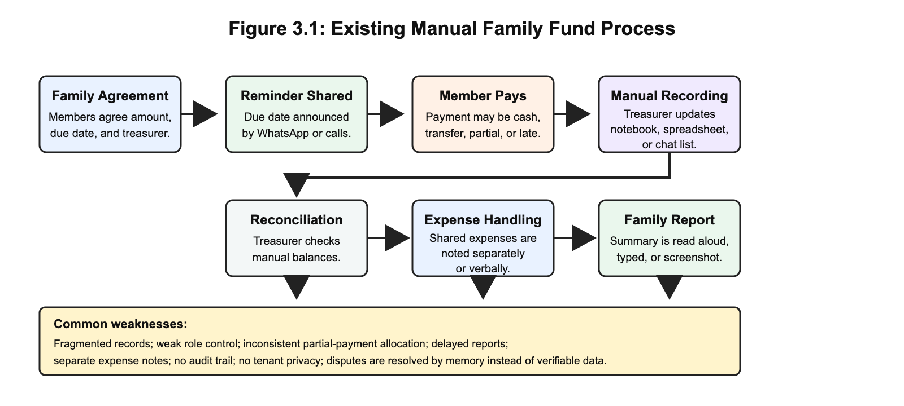

The major bottleneck in the existing system is that the family record depends too much on one person's manual discipline. Even when the person is honest, the process does not provide enough structure for verification, audit, payment allocation, or tenant-level privacy. These weaknesses justify the need for a purpose-built system.

3.4 Proposed System Overview
The proposed system is FamilyFunds, a multi-tenant web application for family contribution fund management. Each family operates in its own workspace, while the platform uses shared infrastructure. Users are assigned roles that determine what they can see and do. The system records members, contribution categories, monthly obligations, payments, expenses, adjustments, reminders, reports, subscription plans, and AI assistant interactions.
FamilyFunds resolves the problems in the existing system by moving the authoritative record into a structured PostgreSQL database. It also introduces role-based access control, Paystack payment support, deterministic oldest-balance-first payment allocation, automated contribution generation, reminders, and clear reports. AI assistance is added as a controlled interface for answering permitted questions and summarising reports in plain language.
Table 3.1: Summary of Proposed System Features
Feature Area | Description
Multi-tenant family workspaces | Each family has a logically isolated workspace within the same application.
Role-based access control | Family Administrator, Financial Secretary, Member, and Platform Super Administrator have separate permissions.
Contribution categories | Families define monthly contribution amounts for groups such as employed members, students, or other categories.
Monthly contribution generation | The system creates contribution obligations for paying members based on category and due date.
Payment recording | Authorised users record offline payments, while members can initiate online payments through Paystack.
Payment allocation | Payments are applied to the oldest outstanding balances first.
Expenses and adjustments | Family spending, donations, corrections, and other balance movements are recorded.
Reminders | Email, browser push, and WhatsApp-related reminder flows support follow-up.
Reports | Monthly and annual reports show collections, balances, expenses, and member status.
AI assistant and summaries | The assistant answers role-permitted questions and supports plain-language report summaries.
Predictive analytics | An activation-gated logistic regression component estimates late-payment risk only after data and evaluation requirements are satisfied.
Security controls | Email verification, password hashing, two-factor authentication, passkeys, signed invitations, policies, and tenant scoping protect the system.

Bank reconciliation was not part of the original requirement set above. It emerged during later Agile iterations when immutable receipts, expenses, adjustments, provider settlements, and imported bank transactions needed a governed way to be compared. Chapter Four therefore reports reconciliation as a post-design extension rather than presenting it retrospectively as an original requirement.

3.5 System Requirements
System requirements define what the system must do and the qualities it must maintain while doing so. The requirements below are written to be testable because vague requirements such as "the system should be fast" do not help implementation or validation.

3.5.1 Functional Requirements
Table 3.2: Functional Requirements
ID | Requirement | Description | Main Actor
FR1 | User authentication | Users shall register, log in, verify email, reset passwords, and manage account security. | All users
FR2 | Family workspace creation | A family administrator shall create and configure a family workspace. | Family Admin
FR3 | Member invitation | The system shall allow administrators to invite members using secure invitation links. | Family Admin
FR4 | Role assignment | The system shall support Family Admin, Financial Secretary, Member, and Platform Super Admin roles. | Family Admin
FR5 | Contribution category setup | Administrators shall define contribution categories and monthly amounts. | Family Admin
FR6 | Monthly contribution generation | The system shall generate monthly obligations for paying members. | Family Admin, System
FR7 | Contribution status tracking | The system shall show unpaid, partially paid, paid, and overdue statuses. | All authorised users
FR8 | Manual payment recording | Authorised officers shall record cash, transfer, or offline payments. | Family Admin, Financial Secretary
FR9 | Online payment processing | Members shall initiate online payments through Paystack where enabled. | Member
FR10 | Payment verification | The system shall verify Paystack transactions before marking them successful. | System
FR11 | Payment allocation | The system shall allocate payments to the oldest outstanding contribution balances first. | System
FR12 | Expense recording | Authorised users shall record family expenses with amount, date, description, and recorder. | Family Admin, Financial Secretary
FR13 | Fund adjustment recording | Authorised users shall record donations, corrections, and other non-contribution balance movements. | Family Admin, Financial Secretary
FR14 | Reports | The system shall generate monthly and annual reports for contributions, payments, expenses, adjustments, and balances. | Family Admin, Financial Secretary
FR15 | Member dashboard | Members shall view personal balances, payment history, and contribution status. | Member
FR16 | Reminders | Authorised users shall send or trigger contribution reminders through supported channels. | Family Admin, Financial Secretary
FR17 | Subscription management | Families shall access platform plans with member limits and feature availability. | Family Admin
FR18 | AI assistant | The assistant shall answer questions using permitted family data and role-aware tools. | Authorised users
FR19 | AI report summary | The system shall support plain-language summaries of financial reports. | Family Admin, Financial Secretary
FR20 | Predictive analytics | Authorised officers shall receive an advisory due-date-outstanding result only from a versioned model that passed the defined gates: unavailable for zero to two mature periods, pooled non-individualised baseline for three to five, experimental logistic score for six to eleven, and standard logistic score for twelve or more; a missing, stale, corrupt, incompatible, or ineligible model shall remain unavailable. | Family Admin, Financial Secretary

3.5.2 Non-Functional Requirements
Table 3.3: Non-Functional Requirements
ID | Category | Requirement | Expected Measure
NFR1 | Security | A user shall access only records belonging to the user's family tenant. | Cross-family access attempts are denied.
NFR2 | Security | Sensitive actions shall be restricted by role. | Members cannot record payments or alter family settings.
NFR3 | Security | User accounts shall support strong authentication controls. | Email verification, 2FA, passkeys, and password hashing are available.
NFR4 | Reliability | Payment allocation shall be deterministic. | The same payment history produces the same balances.
NFR5 | Reliability | Paystack callbacks shall not create duplicate successful payments. | Repeated callback events do not double-record payments.
NFR6 | Usability | Common workflows shall be usable on mobile and desktop browsers. | Key pages remain responsive and readable.
NFR7 | Usability | Reports shall be understandable to non-accounting users. | Summary text and tables use clear labels and plain language.
NFR8 | Performance | Dashboard and report pages shall remain responsive for ordinary family sizes. | Common pages load within an acceptable time during testing.
NFR9 | Maintainability | Modules shall remain separated by responsibility. | Authentication, payments, reports, and AI logic are not mixed into one layer.
NFR10 | Auditability | Financial records shall store relevant dates, amounts, users, and relationships. | Transactions can be reviewed and reconciled.
NFR11 | Privacy | AI features shall use only the data needed for the user's request. | Prompts and tool calls avoid unnecessary personal exposure.
NFR12 | Availability | The deployed system shall support HTTPS, queues, scheduler, and backups. | Required services are configured in deployment.
NFR13 | Model governance | Predictive output shall be reproducible and activation-gated. | Dataset schema, feature version, split, coefficients, baselines, and evaluation artefacts are recorded before activation.
NFR14 | Model safety | Predictive output shall be advisory, role-restricted, and honest about insufficient history. | Predictions do not trigger automatic penalties and unavailable cases show a clear reason.

3.5.3 Deployment Requirements
Table 3.4: Deployment Requirements
Requirement Type | Requirement
Runtime | PHP 8.4 or later with required Laravel extensions
Dependency tools | Composer, Node.js, npm, and Vite build process
Database | PostgreSQL database with secure credentials and backups
Web server | HTTPS-enabled Nginx, Apache, Laravel Cloud, or equivalent platform
Background processing | Queue worker and Laravel scheduler for jobs and reminders
Environment configuration | .env variables for database, mail, Paystack, AI provider, WhatsApp-related settings, and app keys
Security | HTTPS, password hashing, signed URLs, webhook validation, and restricted credentials
Predictive runtime | Versioned logistic-regression training and inference components, with activation disabled until model evidence is complete

3.6 Data Collection Methods
This project does not rely on a formal questionnaire or invented survey data. The data used for the methodology came from four honest sources. The first source was literature and document analysis, including studies on informal finance, digital financial inclusion, SaaS multi-tenancy, RBAC, digital payments, AI reporting, and predictive analytics. The second source was observation of typical family fund administration: how members are added, how contribution amounts are agreed, how payments are announced, and how balances are reconciled. The third source was analysis of existing tools such as PiggyVest, Cowrywise, CreditClan, Lendsqr, WhatsApp, and spreadsheets. The fourth source was the system's own development artefacts: routes, controllers, models, migrations, diagrams, requirements, and test scenarios.
For AI and predictive features, the relevant data is system-generated family fund data such as contribution periods, obligation-creation timestamps, due dates, expected amounts, amounts paid by the due date, payment counts, and first/full-settlement timestamps. No personal data is invented for the study. Predictive training requires a separately authorised, de-identified export whose provenance, digest, time window, schema, consent basis, and point-in-time correctness can be recorded. Because the locked twelve-column export cannot encode the time-varying effect of a later financial reversal, its provenance policy also requires histories containing reversed allocations to be excluded upstream; the minimum-data gate is then applied to the remaining histories. No such private CSV is present in this repository. Where sample data is used for software testing or demonstration, it is treated as test data and is not used to support real-world model-performance claims.

3.7 Population and Sampling
The study is mainly a system-development project, so it does not use a statistical population or probability sampling method. The relevant user population for design purposes consists of the people who normally participate in a family contribution fund: family administrators, financial secretaries, ordinary members, and the platform administrator.
Validation scenarios are selected purposively because the aim is to test whether the artefact behaves correctly in the most important use cases. The selected scenarios include creating a family, inviting members, assigning roles, generating contributions, recording partial payments, initiating Paystack payments, viewing dashboards, sending reminders, generating reports, using AI assistance, preventing cross-family access, rejecting invalid predictive inputs, and showing unavailable or pooled predictive states when history is insufficient. This sampling approach is appropriate because correctness is judged by system behaviour under realistic workflows, not by generalising survey responses.

3.8 System Architecture / Design
FamilyFunds is designed as a layered, modular monolith. The frontend layer uses Vue.js and Inertia.js to present dashboards, forms, reports, settings, AI chat screens, and predictive advisory states. The application layer uses Laravel controllers, requests, services, policies, jobs, commands, and AI tools. The data layer uses PostgreSQL to store families, users, contributions, payments, expenses, adjustments, plans, notifications, passkeys, WhatsApp-related messages, AI conversations, payment-risk model metadata, and immutable predictions. A separate offline Python package validates authorised exports, trains and evaluates logistic regression, and produces a portable artefact for Laravel. External services include Paystack for payments and subscriptions, mail and messaging channels for communication, and AI providers for assistant functions.
Figure 3.2 shows the high-level architecture.
Figure 3.2: System Architecture Diagram
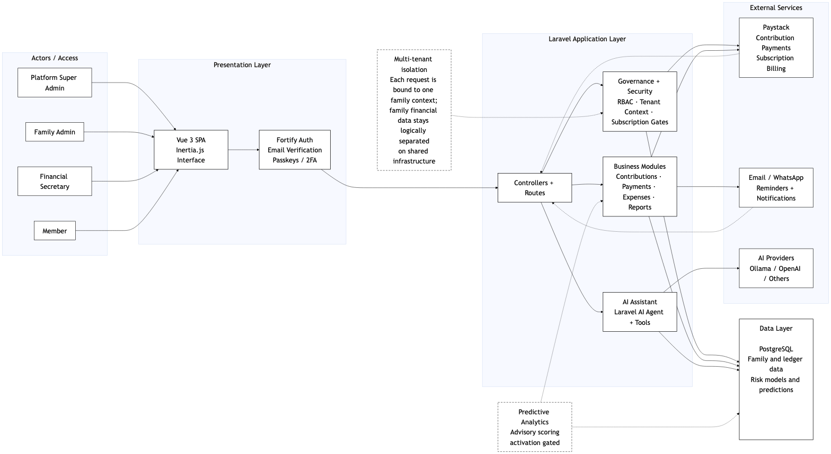

The architecture uses shared-schema multi-tenancy. Each family-specific record carries a family_id where appropriate. Middleware, policies, validation, and query scoping enforce the boundary. This strategy keeps the system practical for many small family groups while still maintaining logical separation. The design also keeps external services outside the authority of the application. Paystack verifies transactions, but Laravel decides how verified payments affect contribution records. The AI provider generates language, but Laravel controls permissions, tools, and data access.

3.9 Use Case / UML Diagrams
The system uses UML-style and process diagrams to explain the main actors, workflows, and data relationships. The diagrams are used because the system contains several roles, many related entities, and financial processes that are easier to verify visually than through prose alone.
Figure 3.3 presents the use case diagram.
Figure 3.3: Use Case Diagram
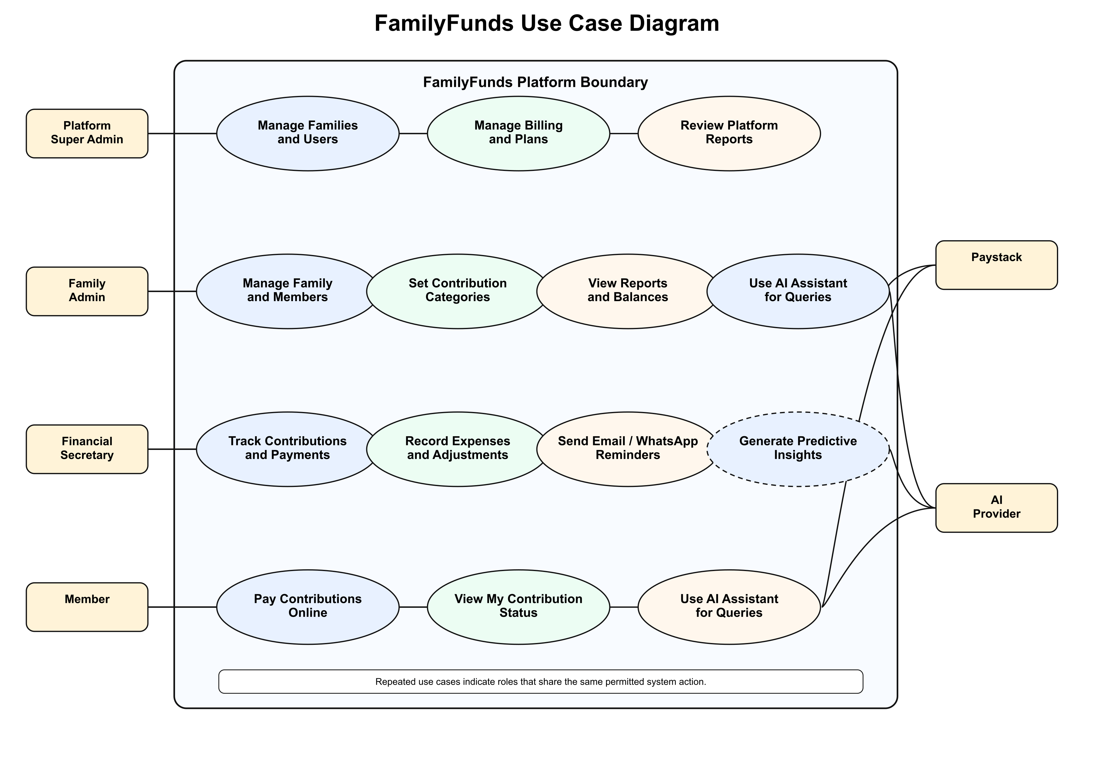

The main human actors are Platform Super Administrator, Family Administrator, Financial Secretary, and Member. The Platform Super Administrator manages platform-wide oversight. The Family Administrator manages the family workspace, members, settings, contribution categories, subscriptions, and reports. The Financial Secretary records payments, expenses, adjustments, reminders, and reports. Members view their own status and pay contributions. External actors include Paystack and AI providers, but they support rather than control the system.
The payment allocation process is one of the most important workflows because it affects member balances and family trust. Figure 3.4 presents the activity/flowchart view in readable panels.
Figure 3.4a: Payment Allocation Flowchart, Panel 1
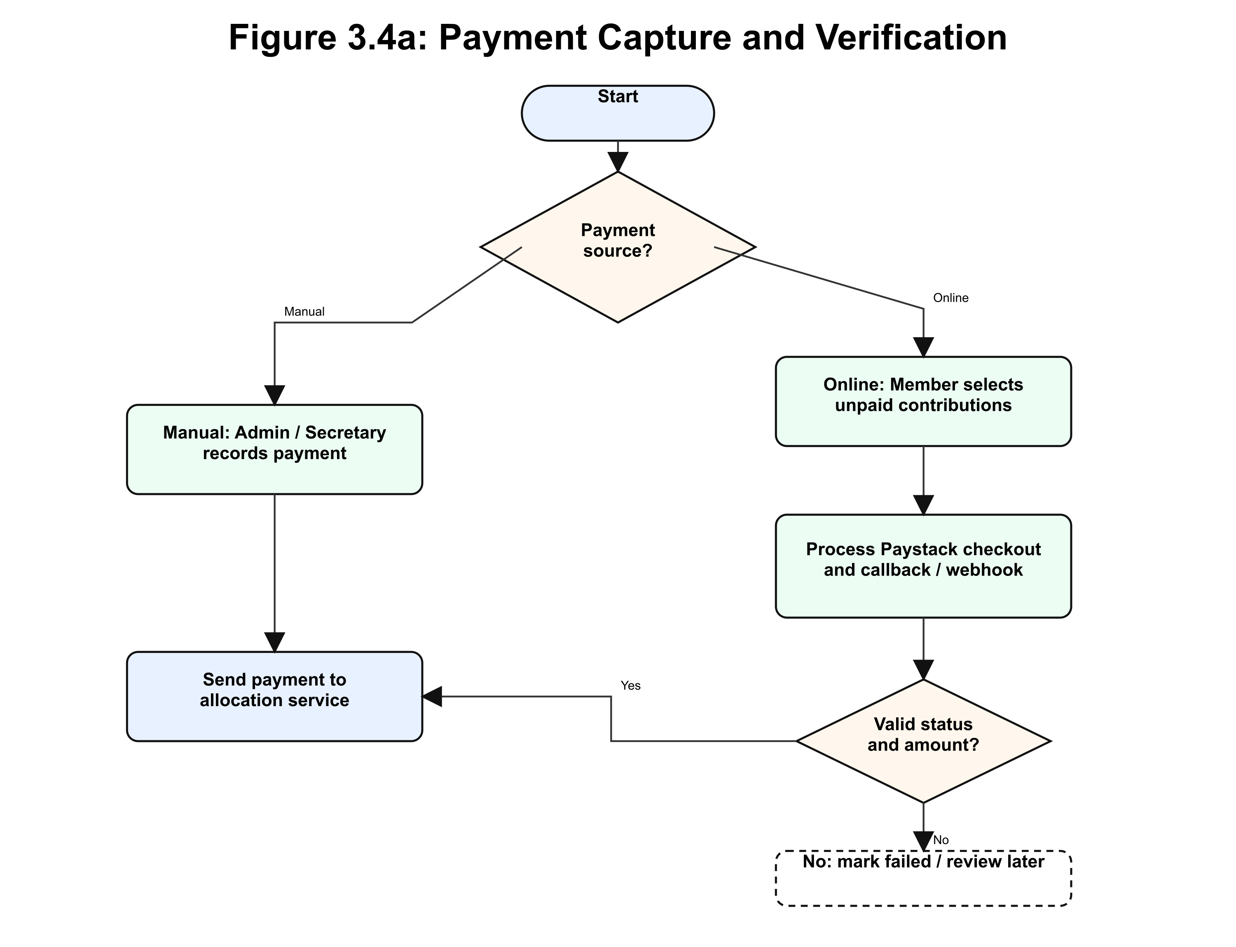

Figure 3.4b: Payment Allocation Flowchart, Panel 2
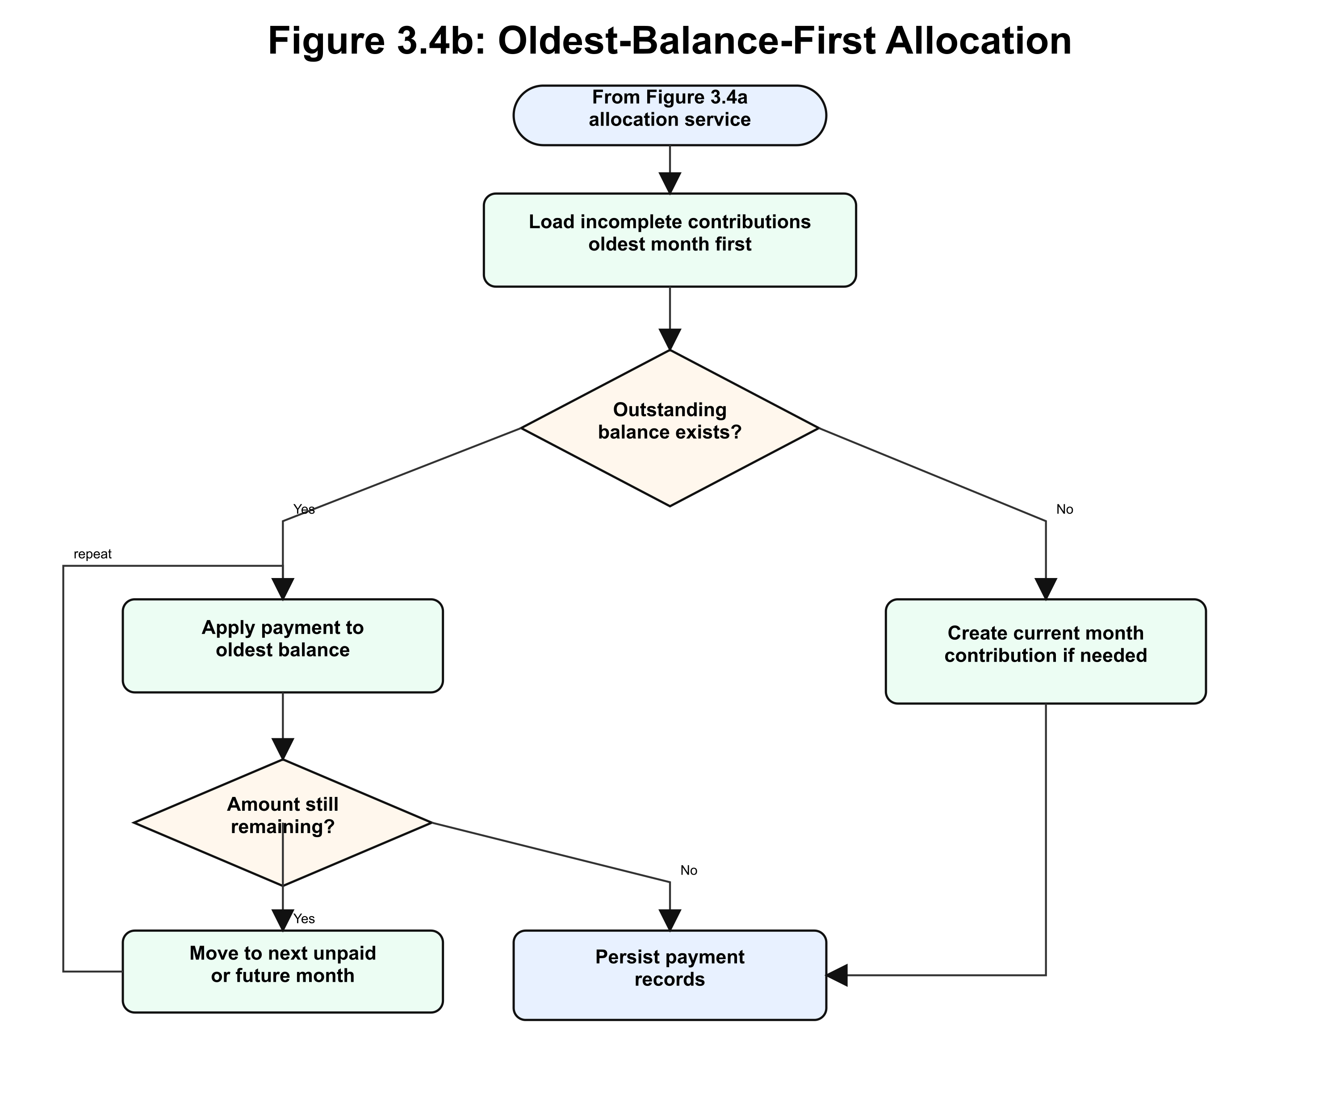

Figure 3.4c: Payment Allocation Flowchart, Panel 3
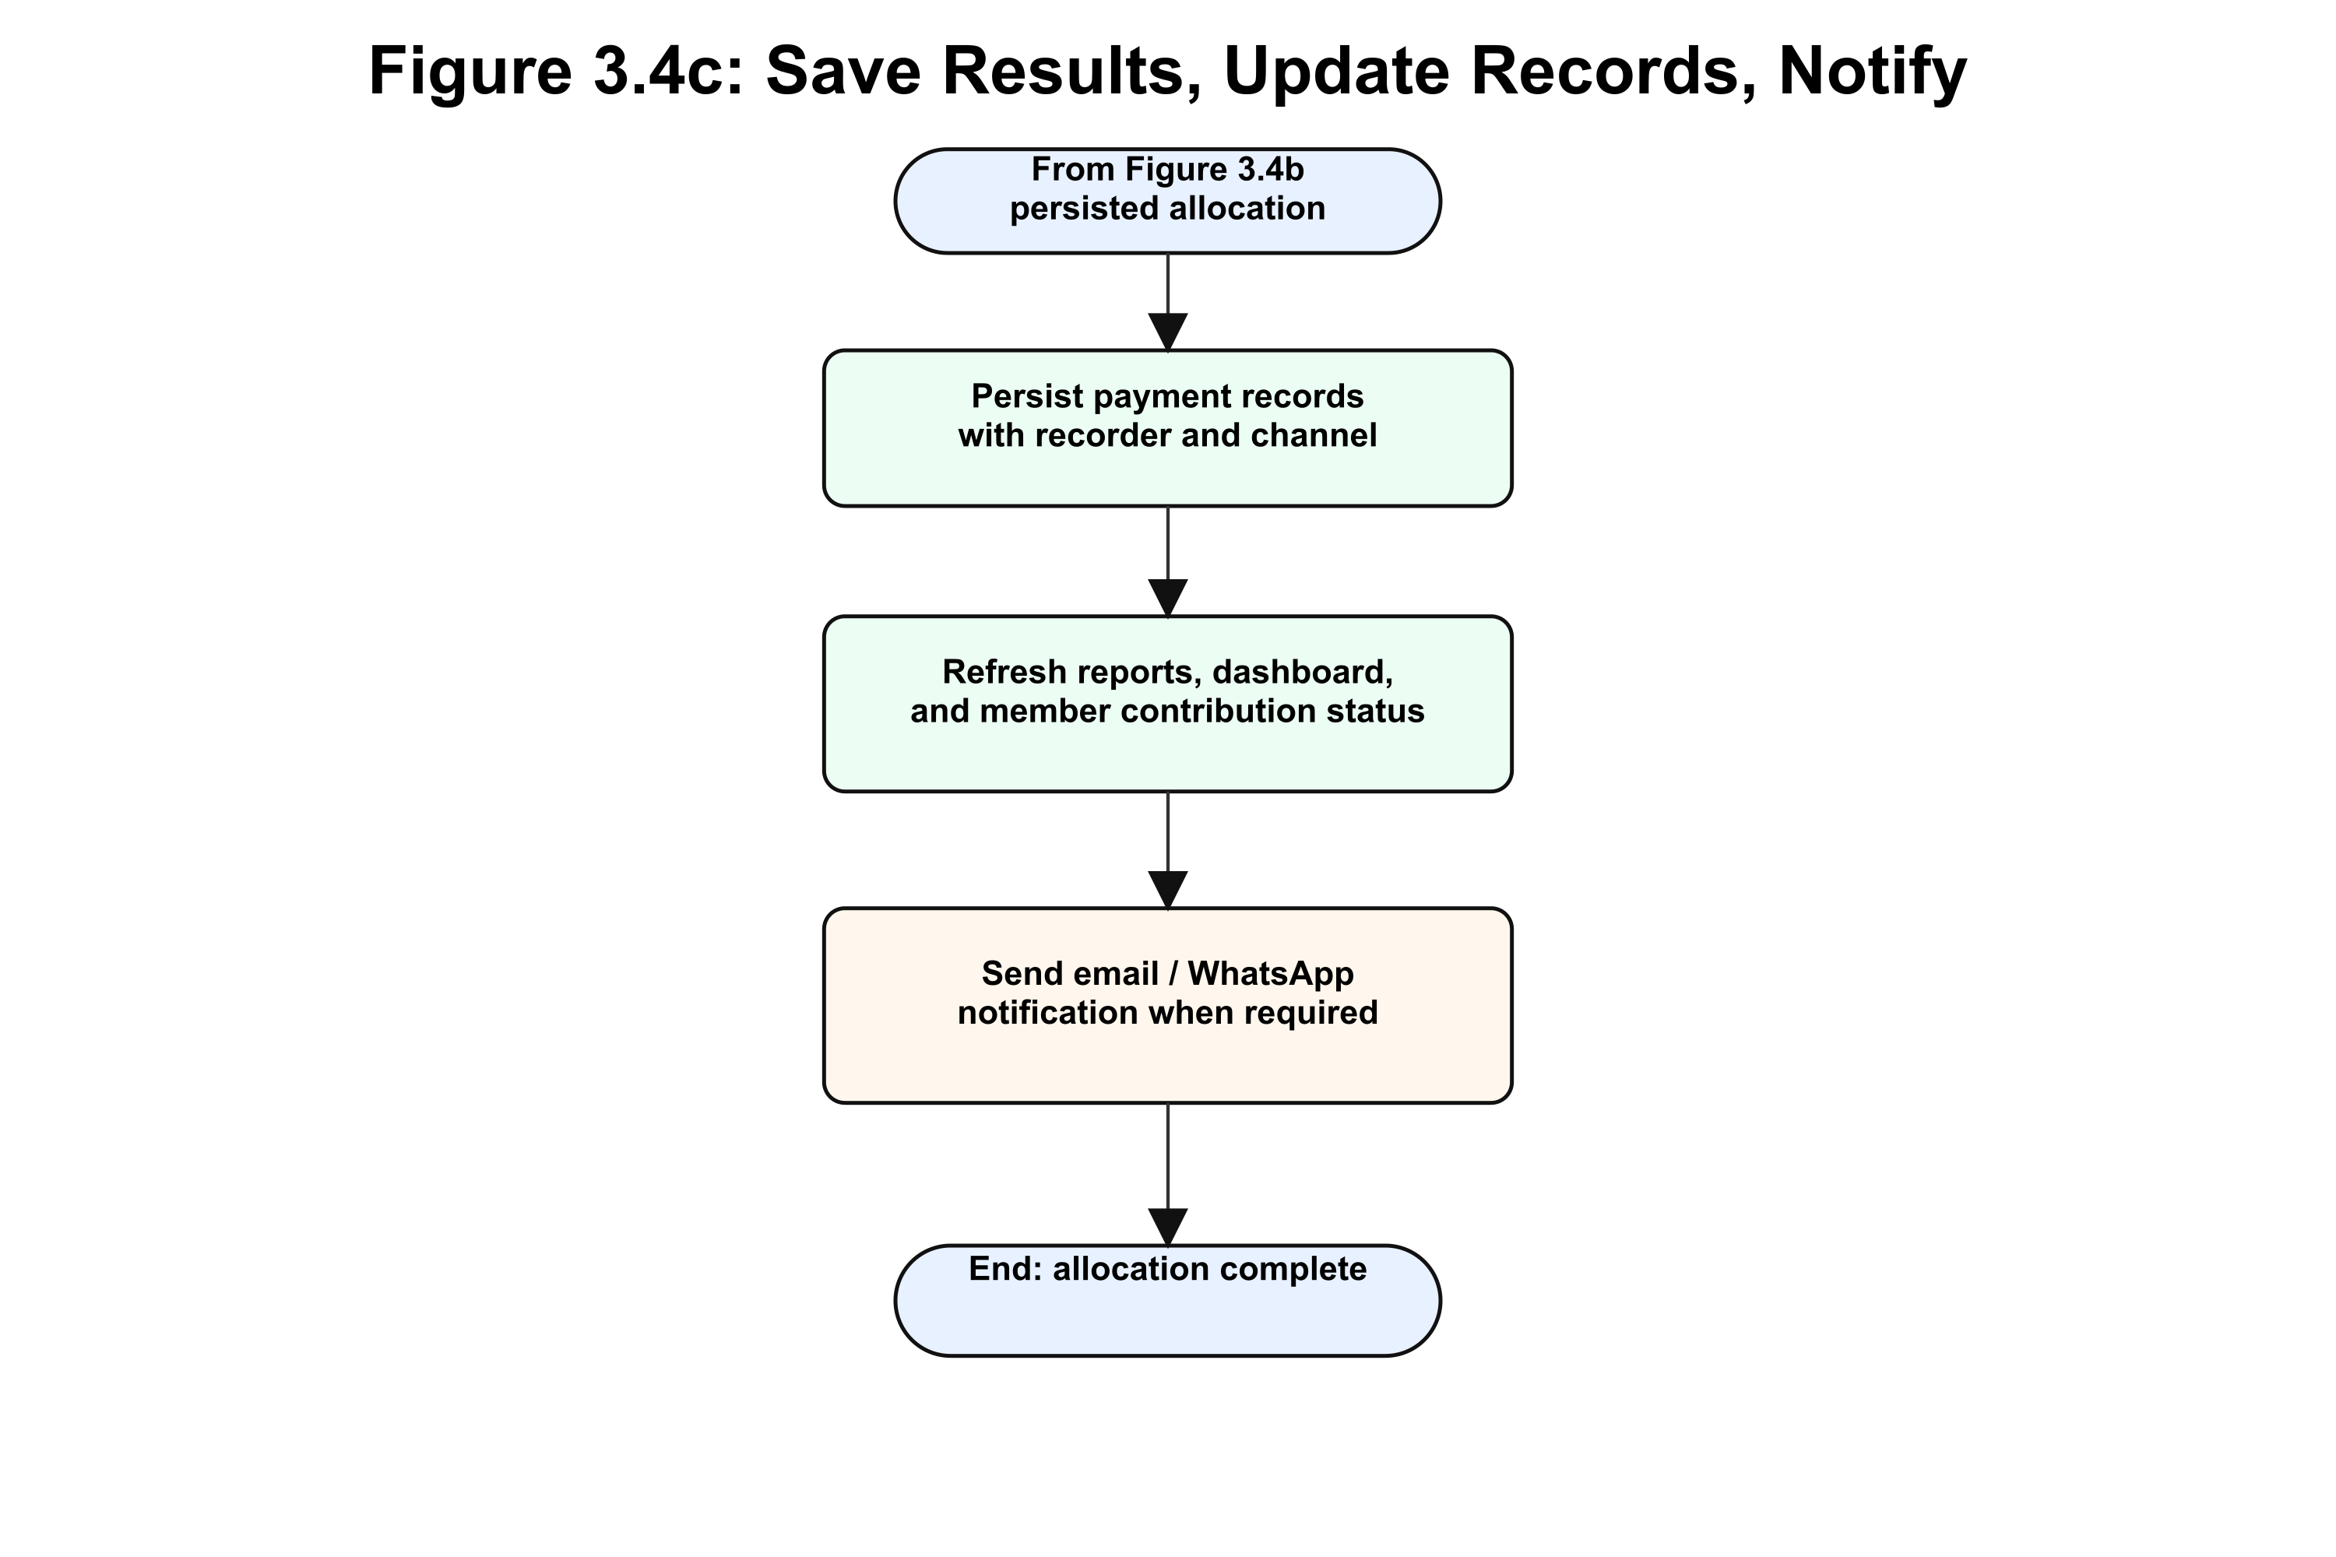

The class-style model is represented by the main domain entities: Family, User, FamilyCategory, Contribution, Payment, Expense, FundAdjustment, PlatformPlan, PaystackTransaction, Passkey, Notification, WhatsAppMessage, AgentConversation, AgentConversationMessage, PaymentRiskModelVersion, and PaymentRiskPrediction. The sequence-style processes include invitation acceptance, contribution generation, manual payment recording, Paystack payment verification, reminder sending, report generation, AI assistant response generation, model installation, and advisory scoring.

3.10 Database Design
The database design uses PostgreSQL as the relational database. The design is centred on the family tenant. Tables that contain family-specific data include a family_id field or are connected through another family-owned entity. This supports shared-schema multi-tenancy while keeping relationships clear.
Figure 3.5 shows the entity-relationship diagram.
Figure 3.5: Entity-Relationship Diagram
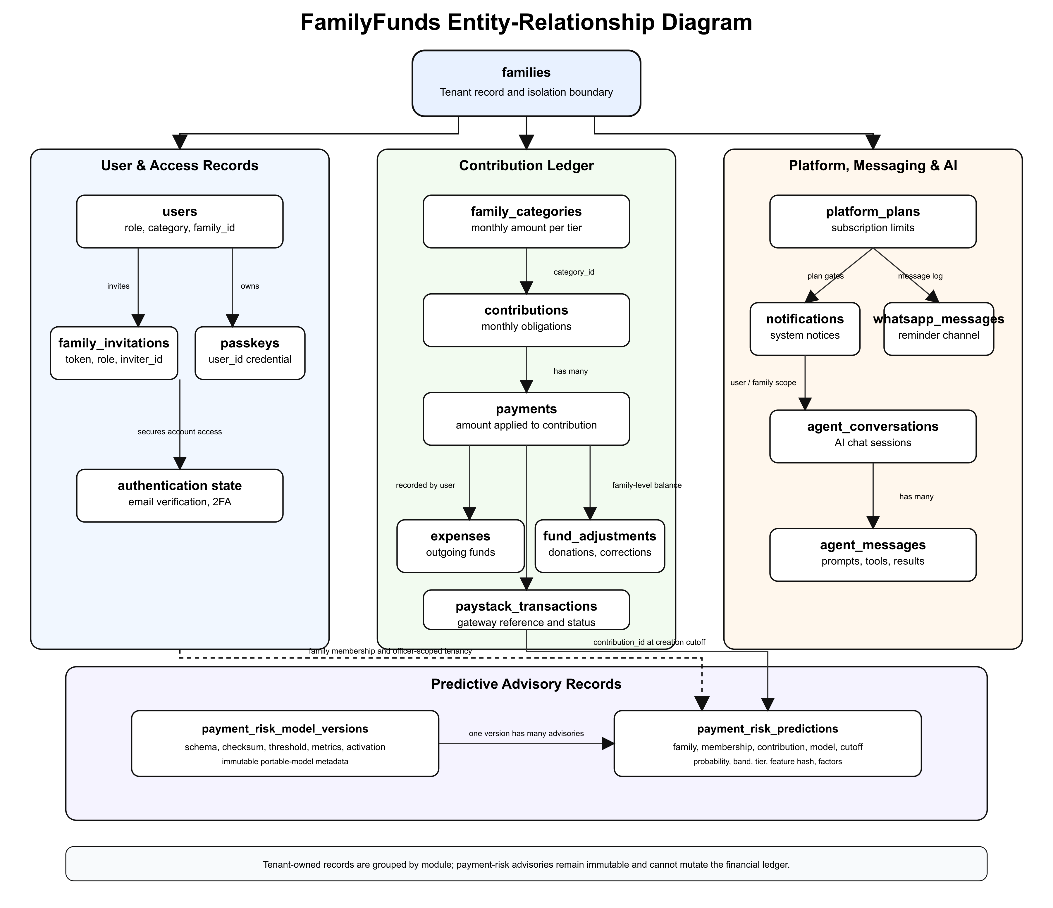

Table 3.5: Major Database Entities
Entity | Purpose | Key Relationship
families | Stores family workspace settings, currency, due day, status, billing, and bank details. | Has many users, categories, contributions, expenses, adjustments, invitations, and transactions.
users | Stores account, role, family membership, category, authentication, and profile data. | Belongs to a family and may belong to a family category.
family_categories | Stores contribution tiers and monthly amounts. | Belongs to a family and may be assigned to users.
family_invitations | Stores invitation email, role, token, expiry, and acceptance status. | Belongs to a family and inviter.
contributions | Stores monthly contribution obligations and statuses. | Belongs to a family and user; receives payments.
payments | Stores payment amounts applied to contribution obligations. | Belongs to a contribution and recorded-by user.
expenses | Stores family spending records. | Belongs to a family and recorded-by user.
fund_adjustments | Stores donations, corrections, and non-contribution balance changes. | Belongs to a family and recorded-by user.
paystack_transactions | Stores online payment and subscription transaction references. | Belongs to a family and user.
platform_plans | Stores subscription plan names, prices, limits, and features. | Used by families for subscription management.
passkeys | Stores WebAuthn credential information. | Belongs to a user.
notifications | Stores application notifications. | Linked to notifiable users.
whatsapp_messages | Stores inbound and outbound WhatsApp-related communication. | Linked to family and user where applicable.
agent_conversations | Stores AI assistant conversation sessions. | Belongs to a user.
agent_conversation_messages | Stores AI messages, tool calls, tool results, and metadata. | Belongs to an AI conversation.
payment_risk_model_versions | Stores immutable model schema, checksum, training window, threshold, dataset summary, metrics, and activation state. | Has many payment-risk predictions.
payment_risk_predictions | Stores immutable contribution-cutoff advisories, history tier, feature hash, model version, and factors. | Belongs to a family, membership, contribution, and model version.

The database design supports financial traceability by separating obligations from payments. A contribution records what a member owes for a period. A payment records money applied to that obligation. This separation is important because one incoming amount can be split across more than one contribution.

3.11 Algorithm / Model Design
The main algorithm in the system is the oldest-balance-first payment allocation algorithm. It handles manual and verified online payments in a consistent way.
Table 3.6: Oldest-Balance-First Payment Allocation Algorithm
Step | Operation
1 | Receive the member, payment amount, payment channel, and transaction details.
2 | Retrieve the member's unpaid and partially paid contributions, ordered from oldest to newest.
3 | For each contribution, calculate the outstanding balance.
4 | Apply the available payment amount to the oldest outstanding balance.
5 | Mark the contribution as paid if the balance reaches zero, or partially paid if a balance remains.
6 | Continue until the payment amount is exhausted or all outstanding balances are cleared.
7 | If an overpayment remains, apply it according to the system's advance-payment rules or record it for review.
8 | Store payment records and update contribution statuses for reporting.

The AI assistant model is designed as a tool-aware assistant. The user's role and family context are checked before tools are used. Read-only questions, such as contribution summaries or fund balances, return information from permitted records. Write-related actions, such as recording expenses or payments through an assistant tool, require explicit confirmation and role permission.
The predictive component is a binary logistic regression classifier for the outcome "overdue" versus "on time," where overdue means that the system still recorded an outstanding balance at the end of the obligation's due date. The implementation uses fourteen point-in-time features: expected amount, days available before the due date, calendar month and quarter, previous mature-period count, three-period, six-period and lifetime on-time rates, prior partial-payment rate, mean and median recorded settlement delay, prior outstanding count and amount, and overdue streak. Within the locked export, “prior outstanding amount” has the reproducible meaning of the due-date residual summed only for prior obligations that were still unsettled strictly before the target cutoff; later partial amounts cannot be reconstructed from the approved columns. Every feature must be computable strictly before the target obligation's creation-time cutoff; direct identity fields and future target-period payment information are excluded.
The approved evaluation is chronological: complete contribution periods are assigned 60% to training, 20% to validation, and 20% to a held-out future-like partition. Standardisation and an L2, class-balanced logistic regression are fitted on training data only. The threshold is selected on validation data by maximising overdue-class F1 subject to at least 0.70 recall, and the untouched partition is then used once for final evaluation. Logistic regression is compared with a training-prevalence baseline and a previous-period-late baseline. Accuracy is reported with balanced accuracy, overdue precision, recall and F1, ROC-AUC, PR-AUC, Brier score, bootstrap intervals, class distribution, and a confusion matrix because raw accuracy can be misleading when most members pay on time (Hussin Adam Khatir & Bee, 2022; Robisco & Carbó Martínez, 2022). Dataset schema, feature version, coefficients, intercept, decision threshold, and evaluation artefacts are versioned with the model. If the dataset lacks adequate history, both outcome classes, a valid held-out period, or improvement over the two baselines, training or activation fails closed and the interface reports that prediction is unavailable.

3.12 Tools and Technologies
The project uses tools selected for practicality, maintainability, and compatibility with the application requirements.
Table 3.7: Tools and Technologies
Category | Tool/Technology | Purpose
Backend language | PHP 8.4 | Main server-side language.
Backend framework | Laravel 13 | Routing, controllers, validation, queues, scheduler, policies, models, and services.
Frontend framework | Vue.js 3 | User interface pages, dashboards, forms, and interactive components.
Server-client bridge | Inertia.js 3 | Connects Laravel routes to Vue pages without a separate REST API.
Database | PostgreSQL | Relational storage for family, user, contribution, payment, expense, and AI records.
Styling | Tailwind CSS 4 | Responsive interface styling.
Authentication | Laravel Fortify | Login, registration, password reset, email verification, and two-factor support.
Passwordless access | WebAuthn/passkeys | Strong browser-based authentication.
Payment gateway | Paystack | Online contribution payments and subscription billing.
AI integration | Laravel AI SDK | Assistant responses, tool calling, and provider integration.
Predictive method | Logistic regression | Interpretable late-payment probability with activation and evidence gates.
Predictive training | Python 3.12, scikit-learn, NumPy, Matplotlib | Offline validation, feature engineering, chronological training, evaluation, and evidence charts.
Feature flags | Laravel Pennant | Controlled release of features such as AI assistance.
Testing | Pest PHP | Automated tests for models, features, policies, payments, reports, and AI tools.
Build tool | Vite | Frontend asset compilation and development server.
Version control | Git | Source tracking and collaboration.
Code quality | Laravel Pint, ESLint, Prettier | Formatting and static code quality.
Development tools | Composer, Node.js, npm | Dependency management and project tooling.

Laravel was selected because it provides mature support for routing, validation, queues, scheduled commands, notifications, policies, and Eloquent models. Vue and Inertia were selected because they allow a modern single-page experience without forcing the project to maintain a separate API layer. PostgreSQL was selected as the stated database technology because the project requires reliable relational storage, constraints, and query support. Paystack fits the Nigerian payment context. The Laravel AI SDK keeps assistant features inside the application's own permission and tool structure.

3.13 Ethical Considerations
The project handles financial and personal information, so ethical considerations are central to the design. The first concern is privacy. A family member's contribution history, payment status, phone number, email address, and role should not be exposed to another family or to unauthorised members of the same family. Tenant isolation and RBAC are therefore ethical safeguards as well as technical features.
The second concern is consent and transparency. Members should understand that their records are being stored in a digital system for family fund management. If AI summaries or assistant features are used, users should understand that the AI is a support tool and not an independent auditor or financial adviser.
The third concern is data minimisation. The system should collect only data needed for contribution management, payment processing, reminders, reporting, authentication, and authorised AI assistance. AI prompts should avoid sending unnecessary personal data to external providers.
The fourth concern is security. Password hashing, email verification, two-factor authentication, passkeys, signed invitation links, webhook validation, HTTPS deployment, and secure environment variables are required to protect users. The design should also comply with applicable Nigerian data protection expectations, including responsible processing and protection of personal data under the Nigeria Data Protection Act 2023.
The predictive component introduces a separate fairness and dignity concern. A late-payment estimate is an advisory signal for authorised officers, not a factual label about a member's character and not a basis for automatic sanctions. The interface must explain data sufficiency and model version, restrict access by role, avoid exposing another family's history, and provide an unavailable state rather than manufacturing confidence from sparse data.
The fifth concern is intellectual property. The project uses open-source frameworks and libraries such as Laravel, Vue, Inertia, Tailwind CSS, and Pest according to their licences. External services such as Paystack and AI providers are used through their documented APIs and configuration requirements.

3.14 Summary of the Chapter
This chapter described the methodology used for FamilyFunds. It adopted an applied system-development design and an Agile iterative approach because the project solves a practical problem whose requirements become clearer through design and implementation. The chapter analysed the existing manual system, introduced the proposed system, specified functional and non-functional requirements, explained the data collection method, clarified the non-survey sampling approach, and described the architecture, diagrams, database design, algorithms, activation-gated logistic regression design, tools, and ethical considerations.
The methodology shows how the project moves from the literature gap in Chapter Two to a concrete system design. Chapter Four will present how the designed modules were implemented, tested, and validated against the requirements stated in this chapter.

CHAPTER FOUR

SYSTEM IMPLEMENTATION AND TESTING

4.1 Implementation of the System Design

4.1.1 Introduction to the Chapter
This chapter reports how the FamilyFunds design described in Chapter Three is represented in the application and how that representation will be validated. It separates three kinds of evidence that must not be confused. The first is static implementation evidence, such as a named service, policy, migration, page, or automated test in the repository. The second is executed evidence, such as the output of a fresh test, build, browser, performance, or security run against the final revision. The third is external evidence, such as a live AI-provider response, hosted deployment check, populated screenshot, or predictive-model evaluation that depends on data or services outside the source tree.
The repository provides substantial static evidence for the conventional system modules and the predictive implementation pipeline. Fresh post-change evidence was executed on 15 August 2026. The canonical local quality gate passed 1,421 Pest tests with 6,904 assertions and 100.0% PHP coverage in 22.209 seconds; the same gate passed PHPStan, Pint, Prettier, ESLint, and the client and server-side-rendering builds. Its locked Python stage passed 66 machine-learning tests with 100% statement coverage. Focused checks additionally passed 138 Laravel payment-risk tests with 440 assertions and 100% coverage across the 16 payment-risk PHP files; the same 138 tests and 440 assertions passed against a disposable PostgreSQL database; five focused Chromium browser tests passed with 82 assertions; and a combined local payment-risk, subscription, and package-script check passed 171 tests with 517 assertions. These focused results overlap the canonical suite and are therefore not added into one artificial total. Twenty redacted running-system images were also captured from the synthetic development tenant and are presented as Figures 4.1a–4.14. Hosted checks, live-provider verification, performance measurements, recovery evidence, and authorised-data predictive training remain Partially Met or Not Executed. Commit a699a821 is a pre-change hosted baseline and is not accepted as final Chapter Four evidence.

4.1.2 Implementation and Evidence Environment
The development environment was inspected directly for this report track. FamilyFunds remains a modular Laravel application with a Vue/Inertia interface, PostgreSQL data design, background jobs, scheduled commands, external payment and messaging integrations, and a controlled AI layer. The local computer, installed command-line versions, and disposable PostgreSQL integration environment can be reported now. The final hosted revision, deployment-service state, browser version, live provider behaviour, and authorised predictive-training environment still require external evidence.
Table 4.1: Implementation and Evidence Environment
Area | Current evidence | Purpose | Evidence status
Development computer | Apple MacBook Pro, Apple M5 Pro, 15 CPU cores, 24 GB RAM, arm64 | Local development and document preparation | Observed
Operating system | macOS 26.6 | Local host environment | Observed
PHP runtime | PHP 8.5.8 | Laravel application runtime | Observed
Composer | Composer 2.10.1 | PHP dependency management | Observed
Backend framework | Laravel 13.24.0 | Routing, policies, models, jobs, services, and commands | Observed from installed dependencies
Frontend runtime and tools | Node.js 24.15.0, npm 11.14.1, Vite 8.2.1 | Vue build and browser assets | Observed
Frontend frameworks | Vue 3.5.41, Inertia Vue 3.6.1, Tailwind CSS 4.3.3 | Responsive application interface | Observed from installed dependencies
Testing | Pest 5.0.4 with Laravel and browser plugins; canonical local run passed 1,421 tests/6,904 assertions at 100.0% PHP coverage; focused runs passed 138 payment-risk tests/440 assertions, 5 browser tests/82 assertions, and 171 combined tests/517 assertions | Unit, feature, integration, and browser specifications | Post-change local gate passed; hosted gate pending
Database | PostgreSQL 18.4 on arm64, including a disposable migrated integration database | Persistent family and financial records | Migration smoke and focused payment-risk integration passed: 138 tests/440 assertions
Hosted environment | HTTPS application with queues, scheduler, backups, and monitoring required | Deployment and operations | Not Executed for final revision
AI provider | Provider- and model-configurable Laravel AI integration | Controlled assistant and summary generation | Live evidence Not Executed
Predictive runtime | Python 3.12.3 package plus Laravel artefact installation and scoring services | Logistic regression with training-prevalence and previous-period-late baselines | 66 Python tests passed at 100% coverage; authorised-data training Not Executed

No authorised private predictive-training CSV matching the twelve-column contract is present in docs/project-report or the supplied project evidence. Consequently, no dataset row count, class distribution, coefficient, threshold, accuracy value, confusion matrix, or prediction screenshot is reported. The model must remain inactive until an authorised dataset is supplied and the PRED evidence gates in Section 4.3 are completed.

4.1.3 Design-to-Implementation Traceability
The design in Chapter Three is realised through request middleware, policies, Eloquent models, domain services, controllers, queued jobs, scheduled commands, Vue pages, and automated tests. Shared-schema multi-tenancy is not enforced by a single mechanism. The active family is resolved from the authenticated membership and route context; family-owned queries include family identifiers; policies test membership and role; validation constrains identifiers to the current family; and feature tests exercise cross-family rejection. This layered approach is important because financial isolation would be fragile if it depended only on a hidden form value or one global query scope.
Financial correctness is similarly distributed. Monthly contribution obligations remain separate from payment receipts and allocation rows. PaymentAllocationService creates an immutable receipt batch, locks the family and membership records, orders incomplete contributions from oldest to newest, allocates the available amount, and limits advance allocation. Paystack processing verifies signatures and references before settlement, while reporting uses shared query logic so displayed, CSV, PDF, receipt, and scheduled outputs can be compared against the same totals.
The implementation also distinguishes authoritative application decisions from external-service observations. Paystack may attest to a transaction, a mail provider may accept a message, and an AI provider may return generated text, but none of those services owns the family ledger or its permissions. Laravel validates the external response, maps it to a known family-owned record, and applies a domain service or rejects the request. This boundary makes external failures recoverable: a provider timeout should leave a pending job or failed delivery record, not a half-written receipt. The same principle applies to the predictive component. A calculated probability is advisory evidence; it cannot create an expense, alter an obligation, block a member, or override an officer's governed decision.
The database design has grown beyond the entities shown in the original ER diagram. Membership history, payment batches, reversals, report artifacts, report deliveries, bank transactions, reconciliation periods and links, provider settlements, and retention state support requirements that became clearer during implementation. Chapter Three has been amended only where necessary to acknowledge these outcomes. Chapter Four retains the distinction between the original design and later extensions so an examiner can follow the real development path rather than a retrospective idealisation.
Table 4.2: Design-to-Implementation Traceability
Design area | Principal implementation evidence | Verification evidence located | Current conclusion
Tenant isolation | Family context middleware, membership routing, family-aware policies and queries | FamilyMembershipRoutingTest, policy tests, AI tool isolation tests | Met in the canonical local suite
Roles and permissions | Role helpers, policies, middleware, request authorisation | RoleAccessTest, member and policy tests | Met in the canonical local suite
Contributions | Contribution model, generation command/controller, category history | Generation, status, due-date, and Phase One tests | Met in the canonical local suite
Payment allocation | PaymentAllocationService, immutable batches and allocations | Allocation, balance-first, partial and advance-payment tests | Met in the canonical local suite
Paystack | Service, webhook job/processor, settlement service | Service, webhook, ledger, fee, and idempotency tests | Partially Met; live gateway not executed
Expenses and adjustments | Controllers, policies, reversal actions, observers | CRUD, policy, model, reversal, and AI tool tests | Met in the canonical local suite
Reporting | Shared review query, private artifacts, receipts, schedules | Monthly, annual, Phase Three reporting and scheduled-report tests | Partially Met; rendered final artifacts pending
Notifications | Email, Web Push, WhatsApp channels and reminder commands | Manual reminder, channel, webhook, and notification tests | Partially Met; delivery not executed
Authentication | Fortify flows, 2FA, passkeys, password and verification settings | Authentication, passkey, 2FA, reset, and verification tests | Met in the canonical local suite; report capture pending
Controlled AI | Family assistant, sub-agents, role-aware tools, confirm-first writes | AI agent, tool, middleware, and chat feature tests | Partially Met; live provider evidence not executed
Predictive analytics | Offline Python validation/training/evaluation package; portable artefact; Laravel validation, storage and scoring services | 66 Python tests at 100% coverage; 138 Laravel tests/440 assertions at 100% payment-risk-file coverage; PostgreSQL and browser reruns | Partially Met; software checks passed, but private-data training and activation Not Executed
Reconciliation extension | Imports, bank transactions, periods, matching, links, settlements | Phase Four and reconciliation unit/browser tests | Post-design extension; local automated checks passed
Retention and recovery | Archive, restore, purge, legal hold, backup configuration | Phase Three retention and backup tests | Partially Met; hosted recovery drill not executed

Reconciliation deserves explicit treatment because it was added after the original Chapter Three requirement set. Iterative development exposed a gap between application records and external bank statements: a verified receipt, expense, adjustment, or provider settlement could be internally valid yet still require comparison with an imported transaction. The later reconciliation workspace introduced import batches, bank transactions, controlled matching, immutable links, closeable periods, and provider-settlement grouping. This is an Agile post-design extension that improves auditability; it is not presented as an original FR that existed before implementation.

4.2 Module Integration and Coding

4.2.1 Tenancy, Membership, and Role Governance
FamilyFunds supports users who may belong to more than one family while operating within one current family context at a time. Membership records carry the family-specific role, contribution category, lifecycle state, and display information. Route middleware resolves the selected family, and policies make the final decision for protected records. An ordinary member can inspect personal contributions and payment history, while family administrators and financial secretaries receive wider operational views according to their duties. Platform administration is kept separate from family operations.
The membership model avoids storing all authority as one global property of the user. A person can therefore be a financial secretary in one family and an ordinary member in another without one role leaking across the boundary. Category assignments are dated so that a future contribution-rate change does not rewrite the amount that applied to an older obligation. Invitation acceptance attaches the user to the intended family only after token, expiry, identity, role, and category rules have been checked. Archive state is also membership-aware, allowing a person's relationship with one family to change without deleting the global account or unrelated memberships.
This design introduces more joins than a single family_id column on the user record, but it better represents the domain and supports auditability. Compatibility mirrors remain for earlier records, while backfill and routing tests protect the transition. The final evidence run must exercise both a single-family member and a person with multiple memberships because cross-context behaviour is where role leakage would be most likely.
Listing 4.1 shows the small but important context-binding step. It does not, by itself, authorise access; downstream membership checks, policies, validation, and scoped queries remain necessary.
Listing 4.1: Family Context Binding
if ($user) {
$family = $user->currentFamily ?? $user->family;
if ($family instanceof Family) {
app()->instance('current-family', $family);
app()->instance(Family::class, $family);
}
}

4.2.2 Contributions and Oldest-Balance-First Allocation
Contribution categories define monthly expectations for memberships. Generation creates dated obligations, while status logic distinguishes unpaid, partially paid, paid, and overdue records. A receipt is modelled separately from its allocation lines, allowing one incoming amount to satisfy several months while preserving the amount, recorder, source, reference, and receipt number. The allocation service uses a transaction and row locks to prevent concurrent writes from producing inconsistent balances. Existing incomplete contributions are ordered chronologically; any permitted remainder can create future obligations only within the defined advance-payment limit.
Listing 4.2: Oldest-Balance-First Payment Allocation
$contributions = Contribution::query()
->forUser($member)
->where('family_id', $family->id)
->where(fn ($query) => $query->incomplete())
->oldestFirst()
->lockForUpdate()
->get();
foreach ($contributions as $contribution) {
$remainingAmount = $this->allocateLine(
$batch,
$contribution,
$remainingAmount,
$paidAt,
$recordedBy,
$notes,
$replaces,
);
if ($remainingAmount === 0) {
return 0;
}
}
The listing omits receipt creation and future-period handling so that the core ordering decision remains visible. The full implementation also validates family membership, uses idempotency keys, assigns sequential receipt numbers, supports corrections through replacement batches, and rejects money that would exceed the six-month advance limit.

4.2.3 Paystack, Expenses, Adjustments, Reports, and Notifications
Paystack is integrated as an external processor rather than the authority for family balances. A transaction is initialised within the application, and a signed callback or queued webhook is matched to a known reference before the settlement service is invoked. Duplicate success events must not create duplicate receipts. Amount mismatches, unknown references, missing data, and invalid signatures follow explicit rejection or ignore paths.
Listing 4.3: Paystack Webhook Reference Verification
$reference = $data['reference'] ?? null;
if (! is_string($reference) || $reference === '') {
return;
}
if (! PaystackTransaction::query()
->where('reference', $reference)
->exists()) {
Log::info('Paystack webhook ignored an unknown transaction reference.', [
'reference' => $reference,
]);
return;
}
$this->settlementService->settle($reference, $data);
Expenses and fund adjustments use immutable financial records plus explicit reversal or correction actions. Reports draw from contribution, receipt, allocation, expense, adjustment, and reversal data. Private artifacts store their family, requester, type, format, normalised filter hash, path, size, and expiry. CSV cells are sanitised to reduce spreadsheet-formula risk; PDFs and receipts use A4 output; signed recipient links expire. Scheduled jobs can create and deliver the same report definitions without introducing a separate calculation path.
Separating receipt batches from allocation lines also clarifies reports. A family's cash receipt should appear once at its full value, while a member statement may need the individual month-by-month allocation lines. Reversals must remove the effective financial impact without deleting the historical record. The shared review service is intended to keep these interpretations consistent across screen, CSV, PDF, receipt, and scheduled delivery. The Phase Three reporting specifications are valuable static evidence because they compare these surfaces, but the final report must still render and inspect representative PDF and CSV outputs after all current changes.
Report artifacts are private by default. An authenticated, authorised requester may download an artifact through policy checks, while a recipient link uses a time-limited signature. The path is stored on the local private disk rather than a public asset directory. This matters academically because “a report was generated” is incomplete evidence if the report leaks another family or can be guessed indefinitely. The final screenshot set should show the report interface and access controls without exposing real family names, phone numbers, email addresses, bank references, or personal contribution histories.
Reminder workflows select unpaid or partially paid obligations and support the configured email, browser-push, and WhatsApp-related channels. Delivery state is operational evidence and cannot be established from source alone. The current report therefore records channel and command coverage as partial while leaving actual message delivery for the final evidence run.

4.2.4 Controlled AI Assistant and Report Summaries
The assistant coordinates specialist agents for contribution, expense, balance, member-status, invitation, generation, and write workflows. Tools query current family data rather than relying on model memory. Their availability is filtered by role. Write operations follow a preview-and-confirm pattern: the initial tool call returns a human-readable description and the same details needed for execution; only a later confirmed call can mutate records. This reduces accidental changes and keeps Laravel policies, validation, and domain services in authority over the language model.
Listing 4.4: Confirm-First AI Write Governance
if (! $confirmed) {
return json_encode([
'status' => 'confirmation_required',
'message' => "I'll record a payment of {$formattedAmount} for {$member->name}. Please confirm to proceed.",
'details' => [
'member' => $member->name,
'amount' => $amount,
'paid_at' => $paidAt,
],
], JSON_THROW_ON_ERROR);
}
Static feature tests cover role-aware tools, family isolation, validation, preview responses, and confirmed execution. They do not prove the quality of a live model response. No provider-backed conversation or final report-summary example was executed for this document revision, so live AI relevance, latency, and wording remain Not Executed.

4.2.5 Reconciliation as a Post-Design Extension
The reconciliation workspace accepts bank-transaction imports, preserves import and period state, proposes candidate internal records, supports explicit links, and locks closed periods. Exact automatic matching is deliberately narrow. A credit is automatically linked only where reference and amount produce one unique unmatched candidate; ambiguity produces suggestions for officer review. Date-and-amount proximity is useful for suggestions but is not sufficient for an automatic authoritative link.
Provider settlements are distinguished from member receipts so that a net bank deposit is not incorrectly matched to a gross contribution. Closed-period guards prevent late mutation unless an authorised reopening process is completed. These behaviours extend the original fund-management design while maintaining its role, tenant, audit, and immutability principles.

4.2.6 Predictive Analytics Implementation Contract
The predictive component is implemented as two connected parts. An offline Python 3.12 package accepts a separately authorised CSV and provenance file, validates them, creates point-in-time features, performs a chronological split, fits and evaluates the approved model, and emits a portable JSON artefact and checksumed evidence files. Laravel validates that artefact again, stores it on a private disk, records immutable model-version metadata, permits activation only when all gates pass, and scores family-owned contribution targets. This separation keeps private training material and Python dependencies out of web requests while allowing deterministic PHP inference.
The approved predictive method is logistic regression only. The target is a binary overdue/on-time outcome for a contribution period: an obligation is overdue when the system still recorded an outstanding balance at the end of its due date. The fourteen implemented features are expected amount, days until due, calendar month and quarter, number of previous mature periods, three-period, six-period and lifetime on-time rates, previous partial-payment rate, mean and median recorded settlement delay, previous outstanding count and amount, and overdue streak. The outstanding-amount feature is operationally the due-date residual summed only for prior obligations still unsettled strictly before the scoring cutoff; this keeps offline and Laravel reconstruction identical under the locked twelve-column export. All features are constructed from data recorded strictly before the target obligation's creation-time cutoff. Direct identity attributes and target-period outcome data are excluded.
The input contract is deliberately strict. The uncommitted source must be storage/app/private/payment-risk/source/member-periods.csv and contain exactly: family_key, member_key, obligation_key, period_start, obligation_created_at, due_date, expected_amount_minor, amount_paid_by_due_minor, first_payment_recorded_at, fully_paid_recorded_at, payment_count_by_due, and is_backfilled. The three opaque pseudonymous keys support grouping and split integrity only; they are never predictors. The CSV digest must match its provenance JSON. Provenance records whether consent, de-identification and point-in-time correctness were confirmed. Because this fixed export cannot express the time-varying effect of later reversals, it also requires the explicit system_known_by_cutoff_no_reversed_allocations policy: histories containing reversed allocations must be excluded upstream before the minimum-data gate is applied. Backfilled obligations, incomplete periods, PII or extra columns, contradictory payment timestamps, duplicate obligations/member-periods, negative amounts, impossible chronology, non-mature outcomes, and obligations created fewer than seven days before their due date are rejected. The default quality gates require at least 500 valid rows, 50 distinct member histories, 12 complete periods, and 100 rows in each outcome class. Synthetic provenance may exercise the software path but is always activation-ineligible and cannot support real-world performance claims. These are implemented rules, not claims about the unavailable private dataset.
The label and prediction cutoff are fixed before data is examined. A feature such as “days late for the target period” would leak the answer because it becomes known only after the outcome window. By contrast, the previous mature periods' outcomes, settlement delays and outstanding amounts are available at the obligation-creation cutoff. The implemented artefact stores the ordered feature schema, standardisation means and scales, coefficients, intercept, threshold, training window, data-quality report, evaluation summary and human-readable factor labels so that training and inference cannot silently disagree.
Chronological evaluation is required because a random row split could place later records for the same member in training while earlier records appear in testing. The implementation keeps whole contribution periods together and assigns the earliest 60% to training, the next 20% to validation, and the latest 20% to held-out evaluation. Standardisation and the class-balanced L2 logistic regression are fitted only on training data. The decision threshold is selected only on validation data by maximising overdue-class F1 subject to at least 0.70 overdue recall, with precision and threshold as deterministic tie-breakers. The latest partition is not consulted during fitting or selection.
Listing 4.5: Logistic Regression Training
scaler = StandardScaler()
training_features = scaler.fit_transform(split.training.features)
classifier = LogisticRegression(
C=1.0,
class_weight="balanced",
max_iter=2_000,
penalty="l2",
random_state=RANDOM_SEED,
solver="liblinear",
)
classifier.fit(training_features, split.training.targets)
validation_probabilities = classifier.predict_proba(
scaler.transform(split.validation.features)
)[:, 1]
threshold = select_validation_threshold(
split.validation.targets,
validation_probabilities,
)
held_out_probabilities = classifier.predict_proba(
scaler.transform(split.held_out.features)
)[:, 1]
Two baselines are computed on the same held-out partition. The training-prevalence baseline assigns every held-out record the late-class prevalence learned from the training partition. The previous-period-late baseline predicts late when the feature snapshot contains a positive overdue streak. Evaluation records accuracy, balanced accuracy, overdue precision, recall and F1, ROC-AUC, PR-AUC, Brier score, confusion matrix, and 95% bootstrap intervals. The training package also writes confusion-matrix, ROC, precision-recall, calibration and coefficient charts. No populated chart is included in this report because the authorised dataset has not been supplied.
Listing 4.6: Baseline Comparison and Activation Gates
training_prevalence = float(np.mean(split.training.targets))
prevalence_probabilities = np.full_like(
split.held_out.targets,
training_prevalence,
dtype=np.float64,
)
prevalence_baseline = _binary_metrics(
split.held_out.targets,
prevalence_probabilities,
0.5,
)
overdue_streak_index = FEATURE_NAMES.index("overdue_streak")
previous_period_probabilities = (
split.held_out.features[:, overdue_streak_index] > 0
).astype(np.float64)
previous_period_baseline = _binary_metrics(
split.held_out.targets,
previous_period_probabilities,
0.5,
)
activation_checks = {
"consented_anonymized_provenance": provenance.source_type == "consented_anonymized"
and provenance.consent_confirmed,
"data_quality_gate_passed": data_quality["gate_passed"],
"validation_recall_at_least_0_70": validation["recall_overdue"]
>= MINIMUM_VALIDATION_RECALL,
"held_out_f1_beats_both_baselines": held_out["overdue_f1"] > baseline_f1,
"held_out_balanced_accuracy_above_0_5": held_out["balanced_accuracy"] > 0.5,
"held_out_brier_beats_training_prevalence": held_out["brier_score"]
< prevalence_baseline["brier_score"],
}
Activation is intentionally stricter than successful fitting. The training command can produce a candidate artefact, but the Laravel installer continues to reject activation unless the Python decision and independent PHP checks agree. The private artefact is identified by schema and model versions, ordered features, SHA-256 digest, training window, trained timestamp, threshold, dataset summary and metrics. The repository refuses an overwritten version with a different digest, prevents mutation or deletion of installed metadata and predictions, accepts only one active version, revalidates the artefact before scoring, and rejects a stale training window.
Runtime scoring also handles sparse history explicitly. Fewer than three mature periods produces an unavailable result; three to five periods use the training-prevalence pooled baseline instead of an individual probability; six to eleven periods are labelled experimental; and twelve or more periods receive a standard logistic advisory. The application records the immutable cutoff, history tier, feature-snapshot hash, model version, advisory band and top coefficient contributions. These results are designed for routine or priority review only and cannot directly penalise a member or mutate the ledger.
The implemented interface is officer-only through the report permission, subscription entitlement and predictive feature flag. Its readiness state reports why no active model can be used, while a ready state exposes the version, training window, threshold, period/band filters, summary counts, member history tier, advisory band and explanatory factors. The page states that the output is not a credit score and cannot send reminders, restrict access, change contribution terms or automate an action. A focused Chromium run passed five tests with 82 assertions, covering administrator and financial-secretary access, member denial, tenant switching, refresh-safe filters, synthetic populated and unavailable states, keyboard use, dark mode and a 390-pixel layout without JavaScript, accessibility or smoke errors. The running-system unavailable state is shown in Figure 4.12. This verifies the interface contract and fail-closed presentation, but it does not substitute for an authorised active-model result.
No authorised private predictive-training CSV, executed training output, fitted coefficient set, candidate artefact, active model, or real-model populated predictive screenshot was available to this report task. The populated state used by the browser test was synthetic test state and is not model-performance evidence. It would be misleading to include representative coefficients or fabricated results. Listings 4.5 and 4.6 are repository implementation excerpts, not evidence that training or activation occurred. PRED-01–PRED-10 define the exact evidence that must be added after an authorised dataset is available.

4.2.7 Interface and Screenshot Evidence Register
The captured interface sequence follows the user journey and the financial control flow rather than presenting disconnected pages. All twenty assets came from the operating local application and its synthetic development tenant. They contain no production records or credentials, and no payment, reminder, schedule, reconciliation link or external-provider request was submitted during capture. Where a view depends on evidence that was unavailable, the figure shows the genuine fail-closed or read-only state instead of a mock result.
Table 4.3: Chapter Four Interface Evidence Register
Figure | Required running-system view | Primary requirements | Current status
4.1 | Login, password confirmation, and account-security settings | FR1, NFR3 | Executed; three panels
4.2 | Family administrator dashboard | FR2, FR15 | Executed
4.3 | Member, role, and category management | FR3–FR5 | Executed
4.4 | Contribution register with paid, partial, unpaid, and overdue states | FR6–FR7 | Executed
4.5 | Oldest-first allocation, member statement, and receipt | FR8, FR11 | Executed; three panels
4.6 | Paystack self-pay review state | FR9–FR10 | Interface executed; live provider transaction Not Executed
4.7 | Expense and fund-adjustment records | FR12–FR13 | Executed; two panels
4.8 | Reports, exports, schedules, and generated financial output | FR14 | Executed; two panels
4.9 | Seeded contribution-reminder notification | FR16 | Interface executed; no delivery request sent
4.10 | Subscription entitlements and family limits | FR17 | Executed
4.11 | Existing controlled-AI conversation | FR18–FR19 | Interface executed; no live provider call made
4.12 | Predictive model-unavailable state | FR20, NFR13–NFR14 | Executed; populated model result Not Executed
4.13 | Reconciliation workspace and settlement candidate | Post-design extension | Executed; no statement import or link submitted
4.14 | Responsive member dashboard at 390 pixels | NFR6 | Executed

Figures 4.1a–4.1c record the authentication boundary from the initial sign-in screen through password confirmation to the security controls. The sequence matters because sensitive settings are not presented as an extension of a public login form; the authenticated user must re-establish intent before changing password, two-factor or passkey settings.
Figure 4.1a: Login Entry for the Synthetic Demonstration Tenant
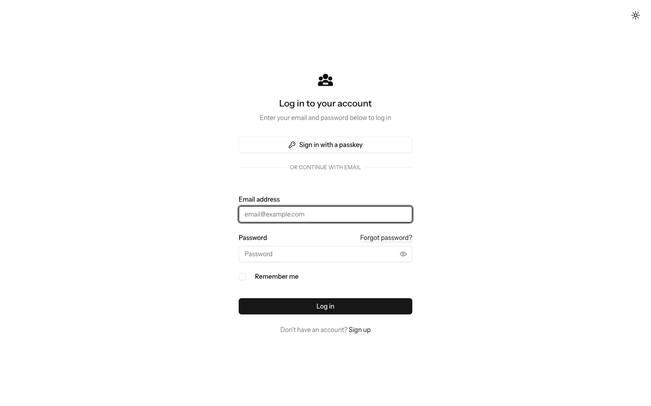

Figure 4.1b: Password Confirmation Before a Sensitive Setting


Figure 4.1c: Account Security, Two-Factor and Passkey Settings
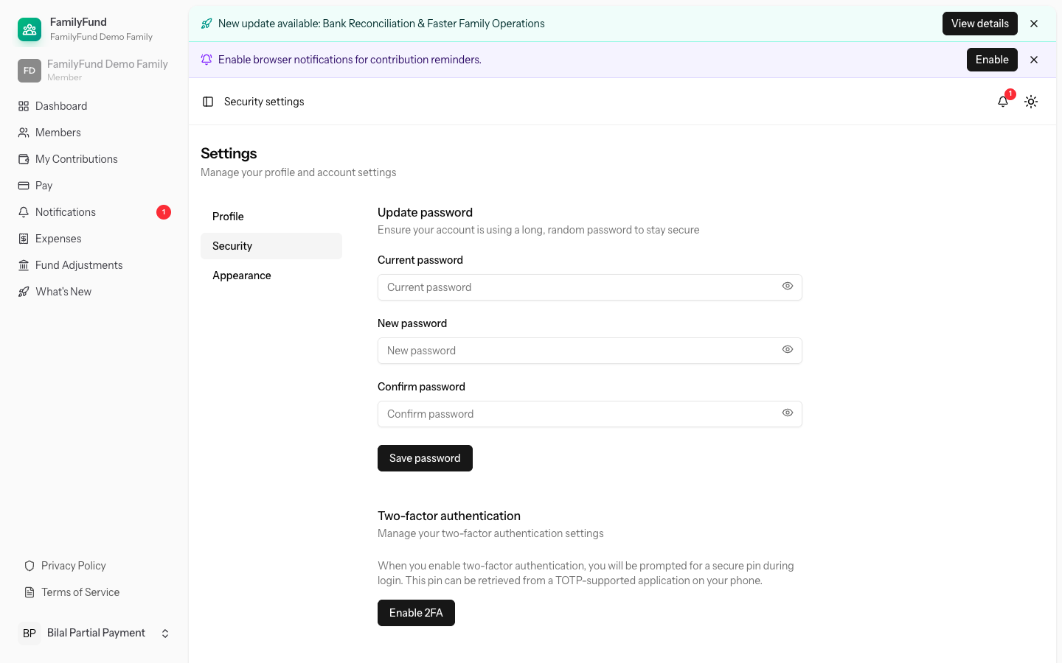

Figure 4.2 shows the administrator's current-family dashboard, where contribution and balance information is summarised without exposing another tenant. Figure 4.3 then shows the management context in which roles and contribution categories are assigned. Together they connect the tenancy and RBAC design to the officer's normal operating view.
Figure 4.2: Family Administrator Dashboard
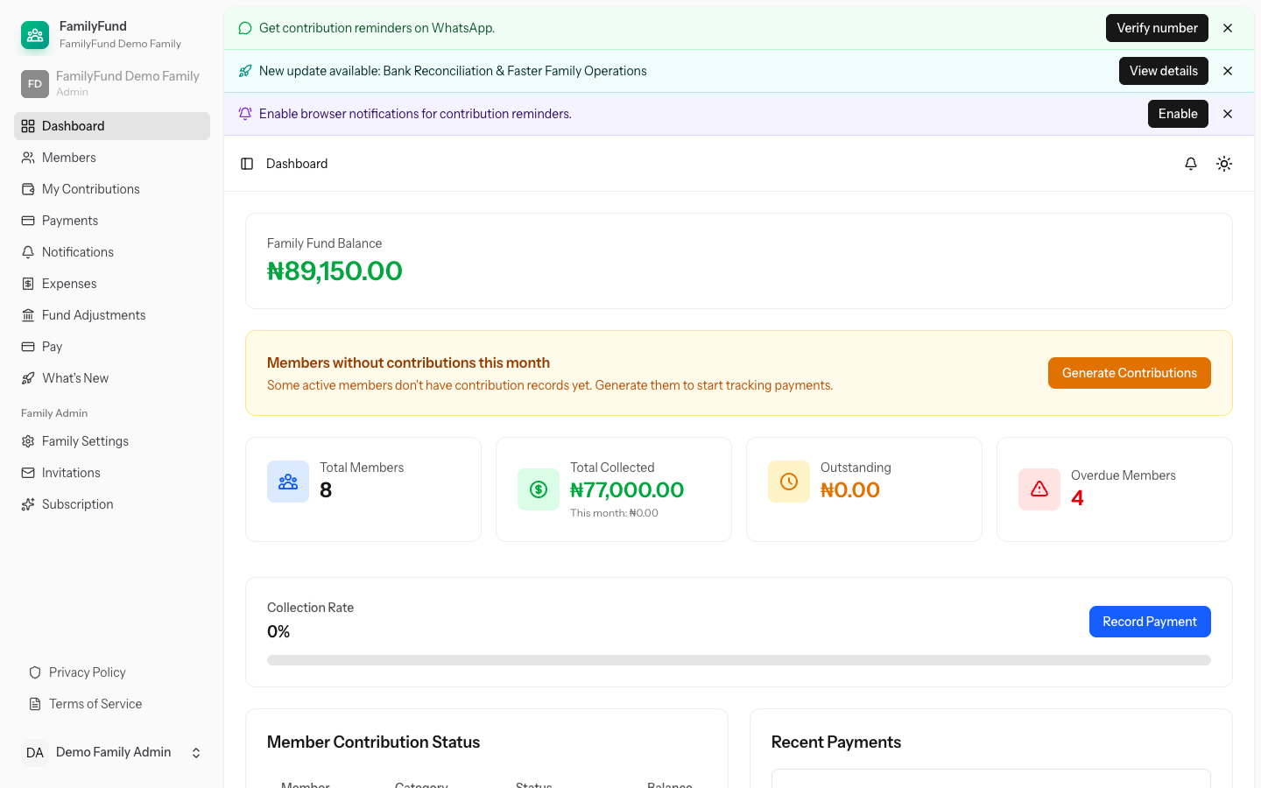

Figure 4.3: Member, Role and Contribution-Category Management
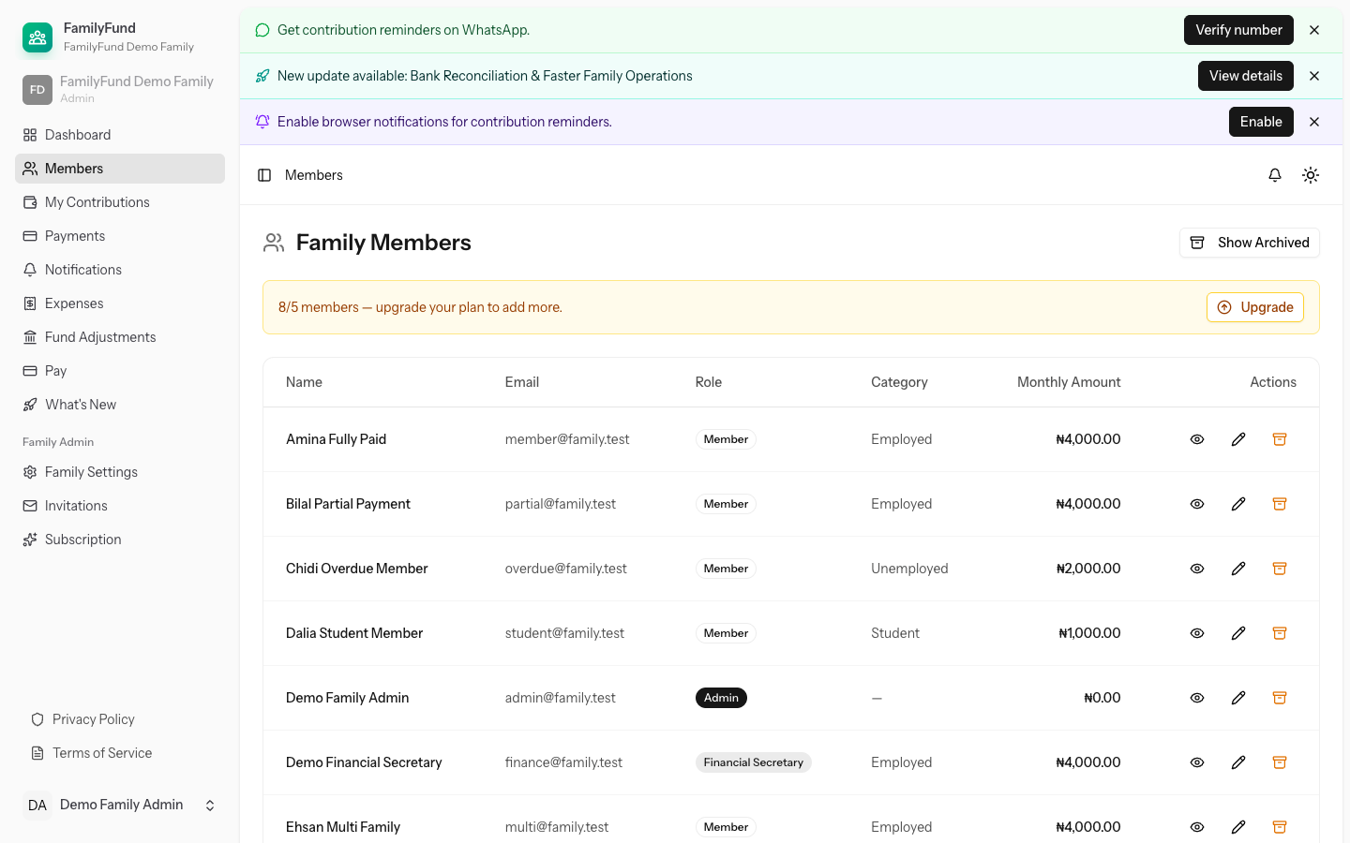

Figures 4.4 and 4.5 show the ledger rule from both sides. The register exposes paid, partial, unpaid and overdue obligations, while the payment screen explains how an amount is applied to the oldest open periods. This visible ordering supports the same deterministic rule exercised by the automated tests.
Figure 4.4: Contribution Register and Payment States
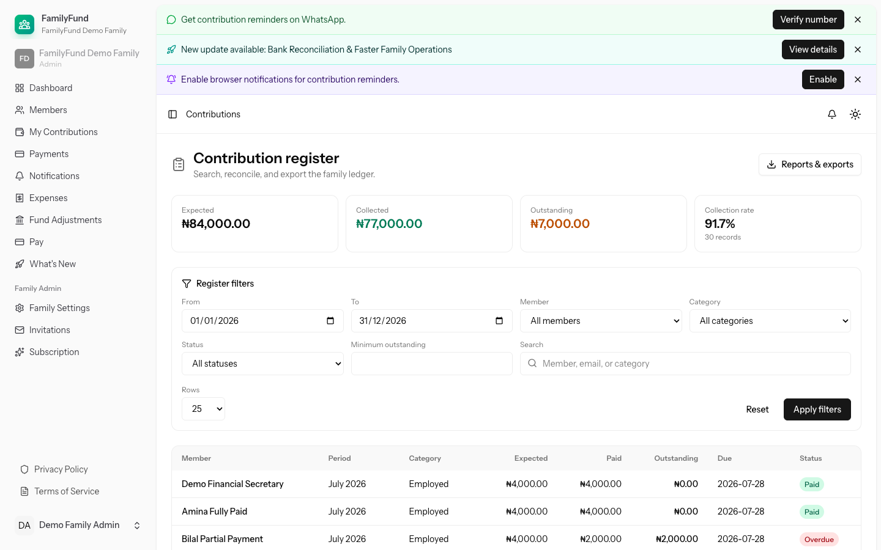

Figure 4.5: Oldest-First Payment Allocation Review
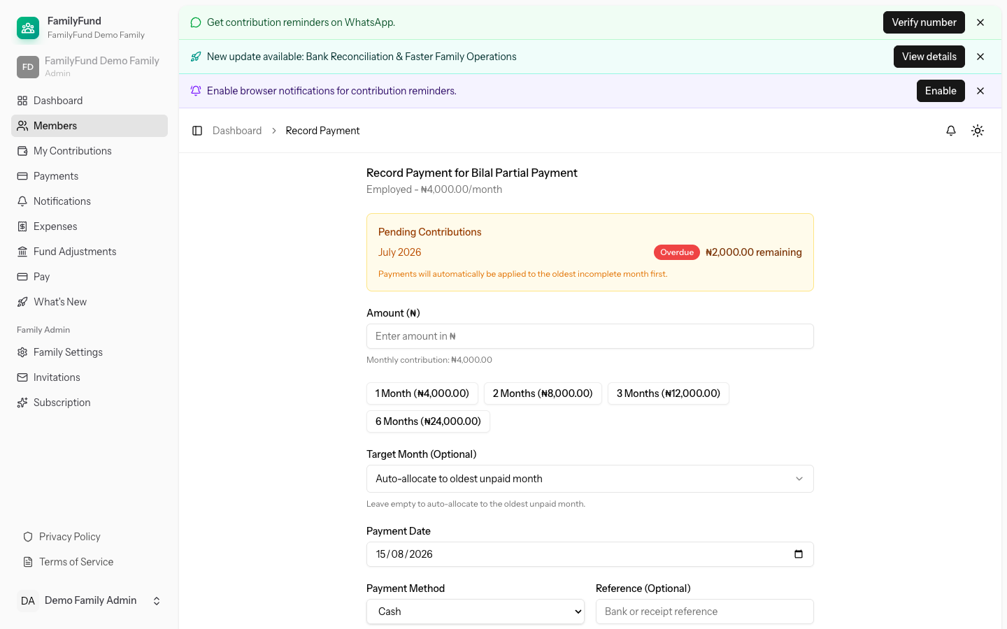

Figures 4.6a–4.6c follow the resulting member evidence. The statement presents the obligation history, the receipt records how one batch was split across periods, and the Paystack page shows the self-pay review state before any external request. The last panel is interface evidence only; no live transaction was initiated during capture.
Figure 4.6a: Member Contribution Statement


Figure 4.6b: Receipt Showing Split Allocation Across Periods


Figure 4.6c: Paystack Self-Pay Review State Before Submission
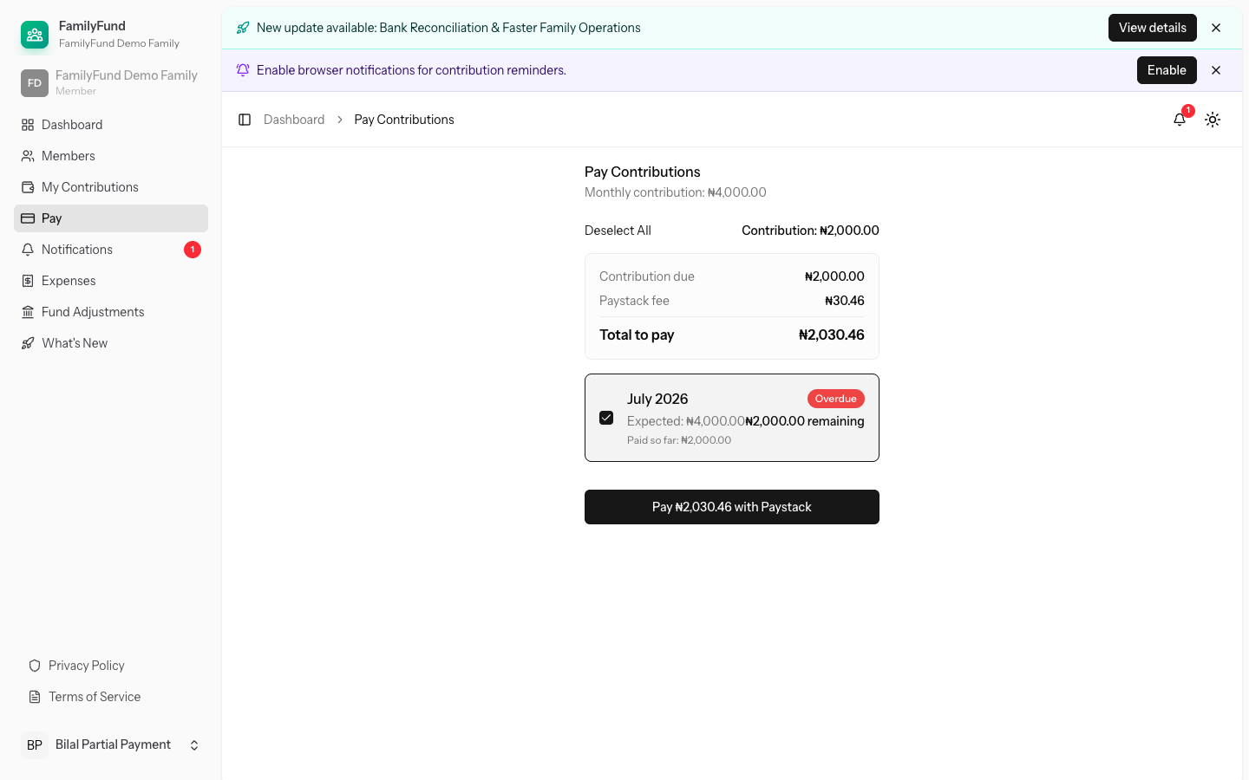

Figures 4.7a and 4.7b show that spending and balance corrections are recorded as separate operations rather than being hidden inside a contribution entry. This separation supports clearer authorisation, reversal and audit treatment.
Figure 4.7a: Expense Register
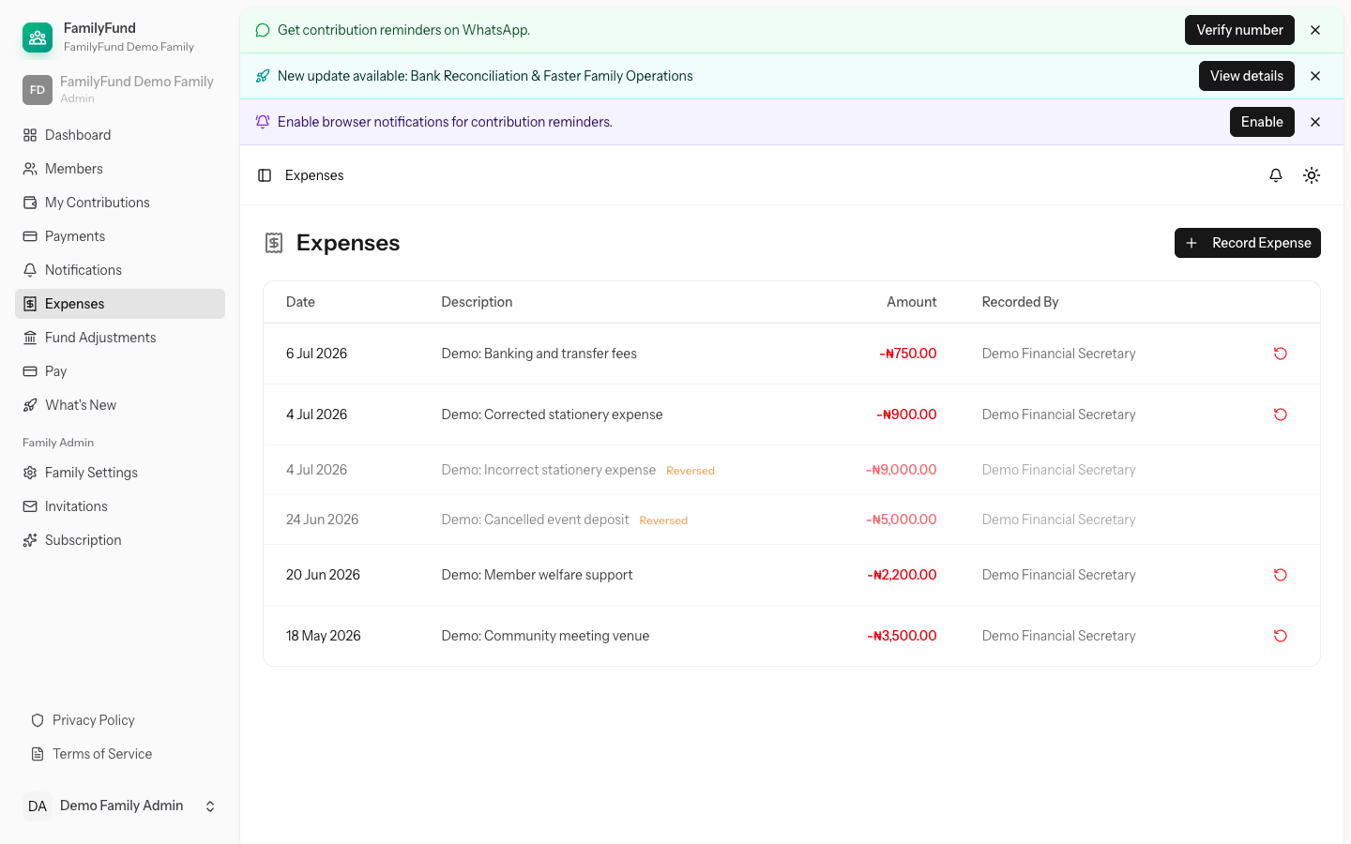

Figure 4.7b: Fund-Adjustment Register
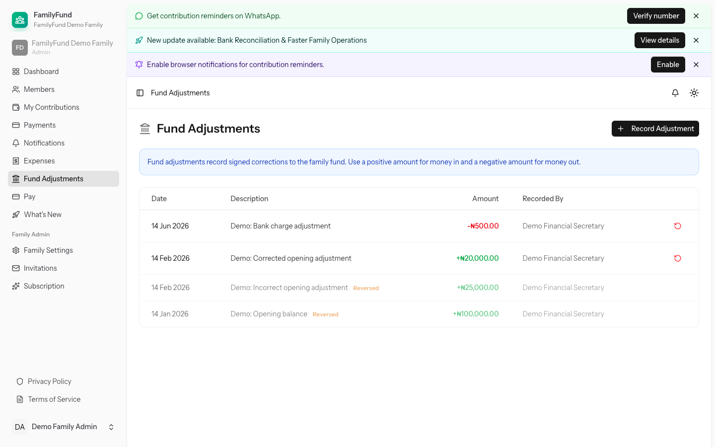

Figures 4.8a and 4.8b connect report controls to a rendered financial output. The first panel shows filters, export choices and schedule management; the second shows the generated report based on the same underlying family records. This is stronger evidence than an isolated download button because the displayed result can be compared with the application totals.
Figure 4.8a: Reports, Exports and Schedule Controls
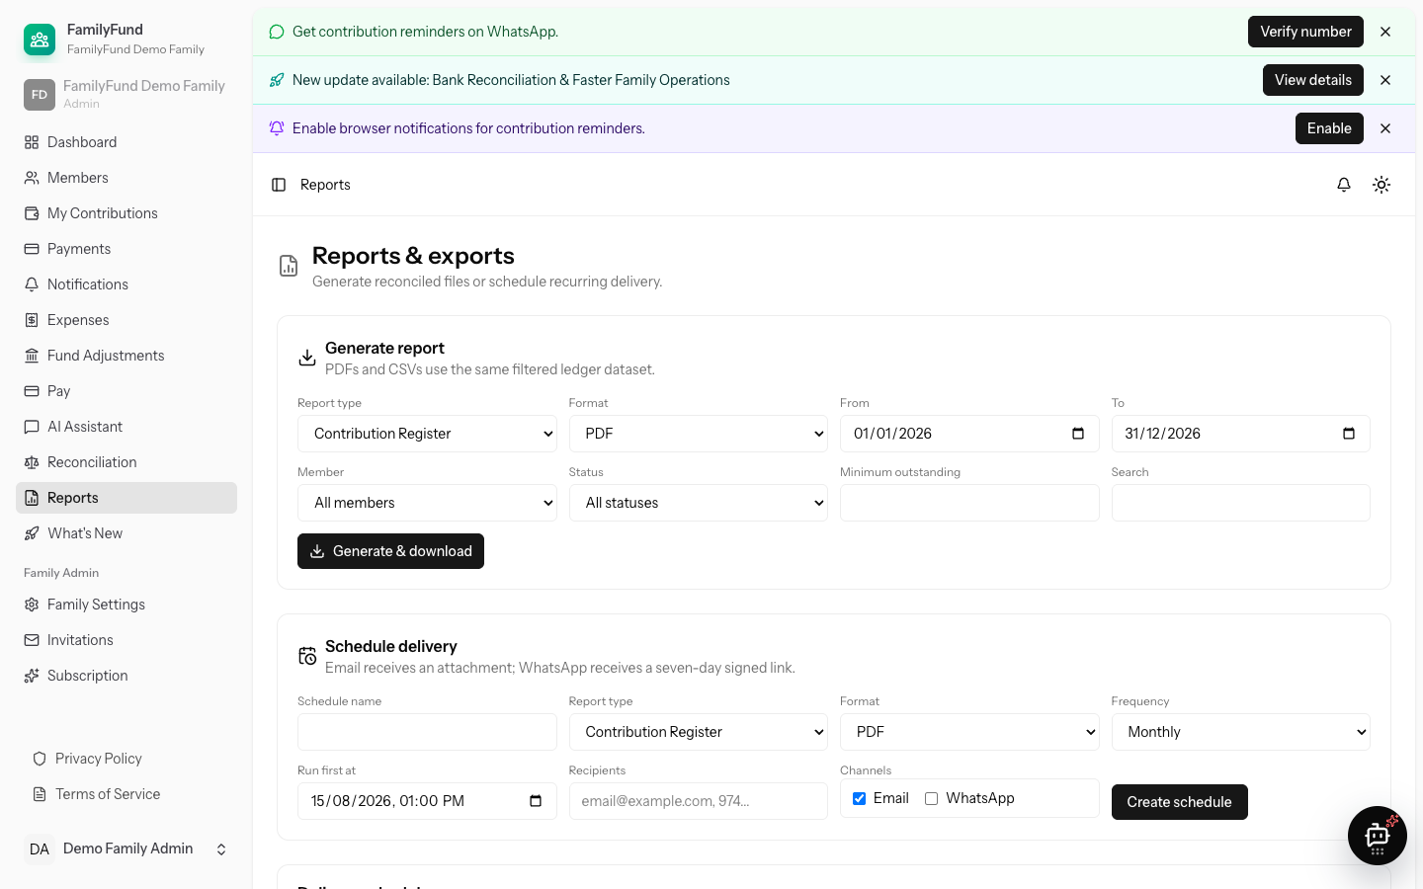

Figure 4.8b: Generated Financial Report Output


Figure 4.9 contains an existing seeded reminder notification and does not claim a newly delivered message. Figure 4.10 shows the plan-entitlement comparison with Growth identified as the current assigned plan, demonstrating how paid features are communicated after the shared-plan defect discovered during capture was corrected and regressed.
Figure 4.9: Seeded Contribution-Reminder Notification
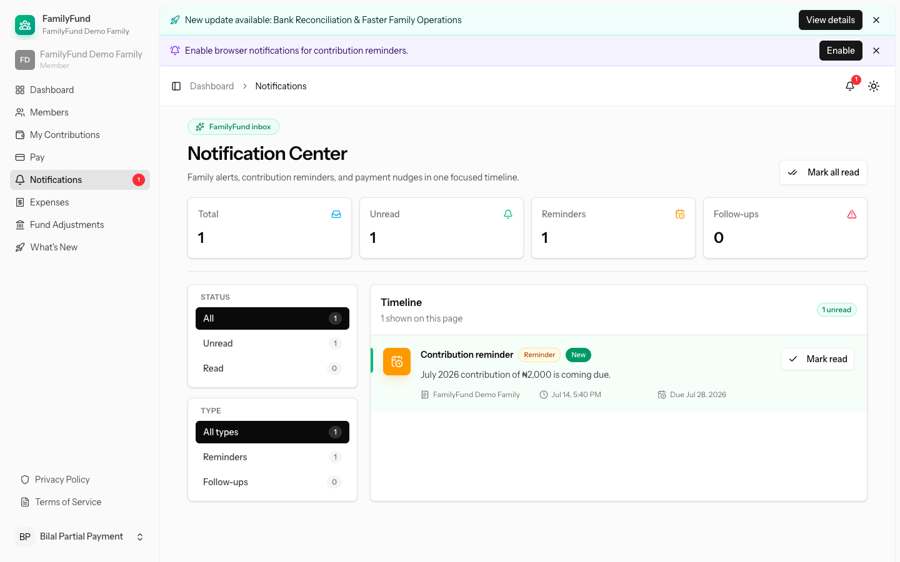

Figure 4.10: Current Growth Plan and Feature Entitlements
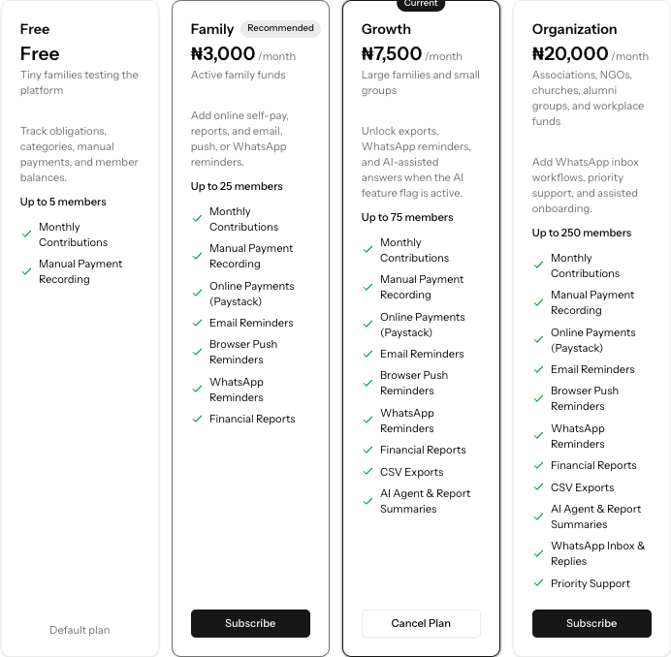

Figure 4.11 shows an existing seeded assistant conversation in the controlled interface. It demonstrates the conversation layout and family context, but it is not counted as a live-provider acceptance result because no provider request was made during this evidence pass.
Figure 4.11: Existing Controlled-AI Conversation in the Synthetic Tenant
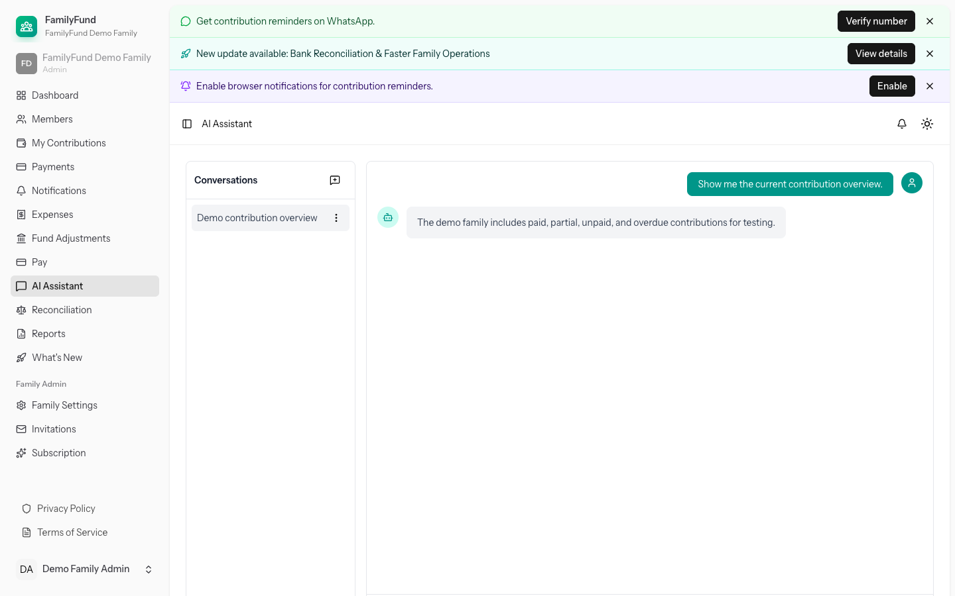

Figure 4.12 records the predictor's actual fail-closed response: without an installed, validated and active private-data model, the page reports that payment-risk insights are unavailable. Figure 4.13 shows the reconciliation workspace and an existing settlement candidate without importing a statement or creating a link. These are useful boundary results because they show what the system refuses to infer or mutate when prerequisite evidence is missing.
Figure 4.12: Predictive Analytics Model-Unavailable State
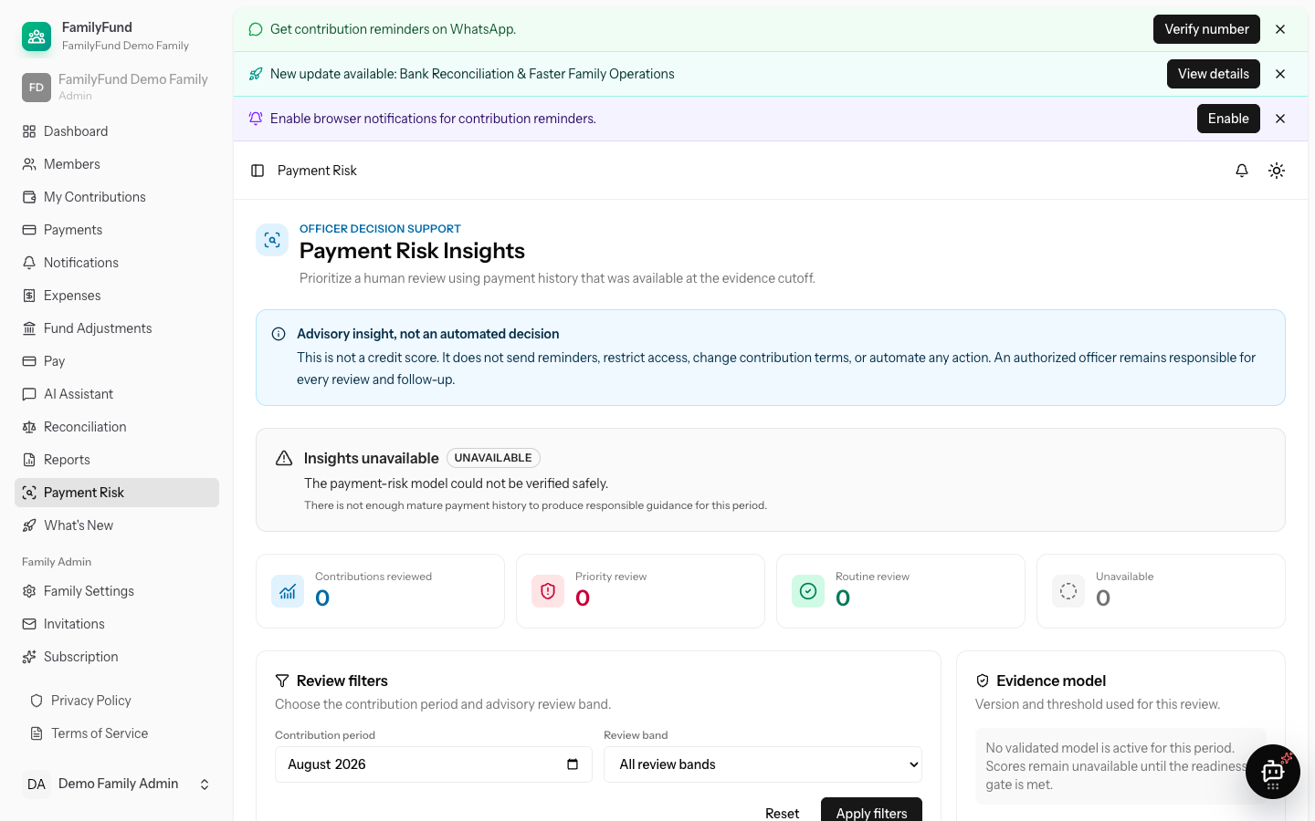

Figure 4.13: Reconciliation Workspace and Seeded Settlement Candidate
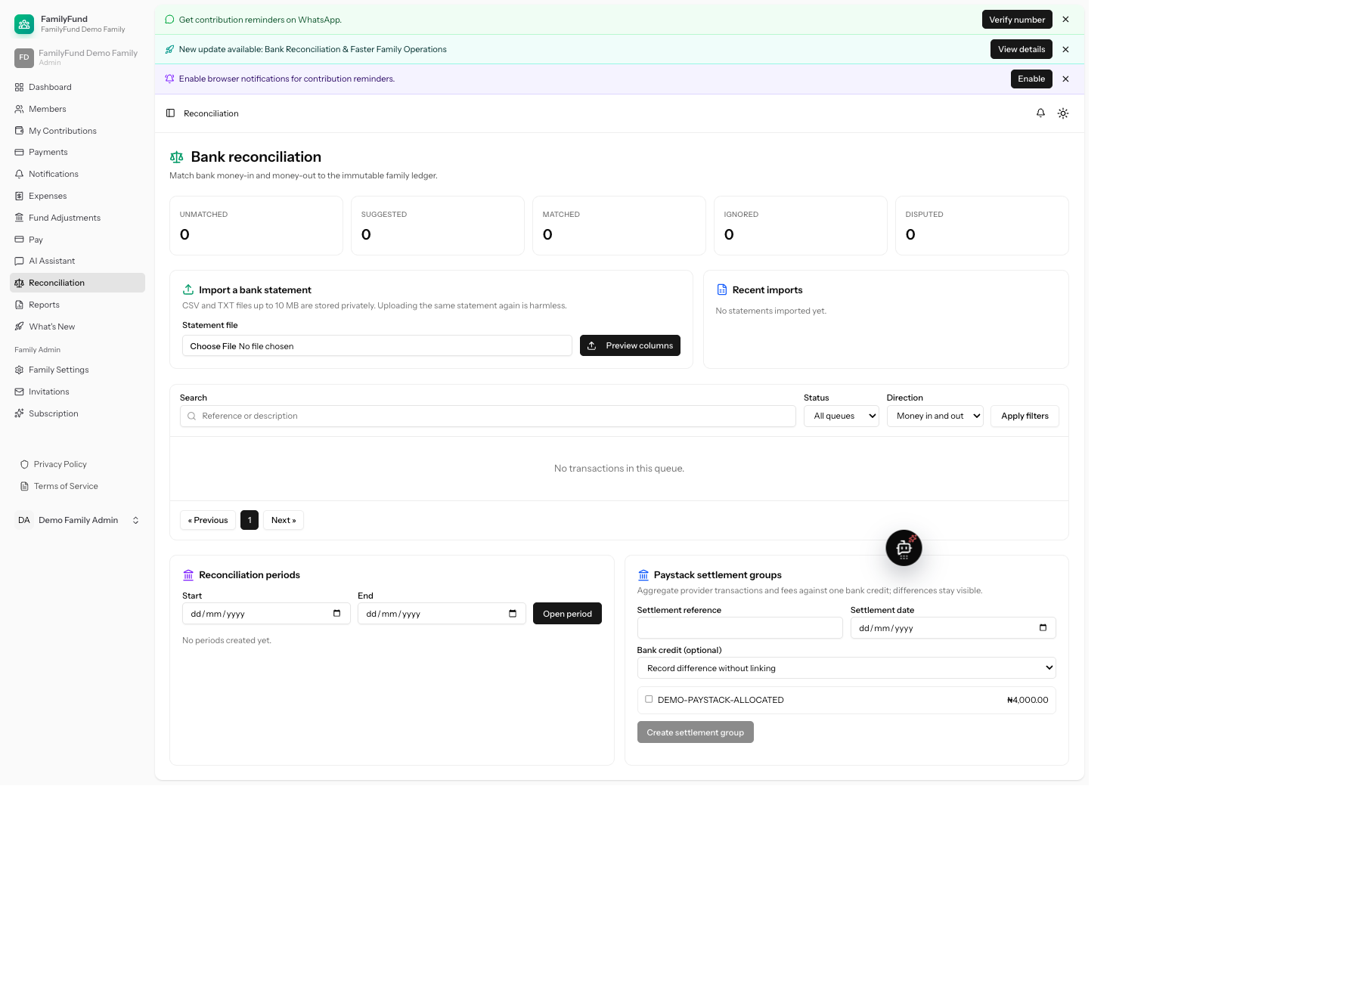

Finally, Figure 4.14 shows the member dashboard at a 390-pixel viewport. Navigation, summary cards and contribution information remain contained within the mobile width, supporting the focused Chromium result without treating one viewport as a complete usability study.
Figure 4.14: Responsive Member Dashboard at 390 Pixels
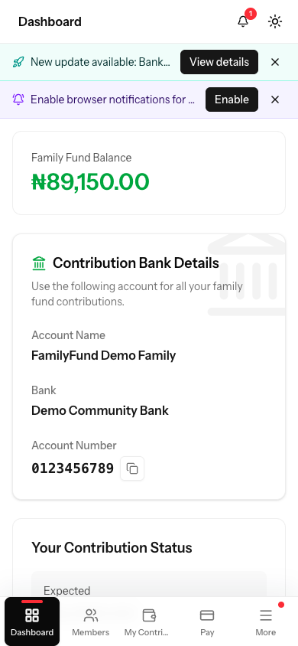

4.3 Testing Strategy and Procedures

4.3.1 Test Plan
Testing is organised by risk. Unit tests isolate calculations and matching rules. Feature tests exercise routes, policies, validation, database changes, jobs, and service integration. Browser tests cover rendered user journeys and responsive behaviour. External integration tests fake or stub providers where deterministic automated proof is required; final live checks are reported separately because they depend on credentials, network access, and provider state. Security evidence includes cross-family denial, role denial, signature validation, signed-link expiry, immutable financial records, and confirmation-before-write behaviour. Performance evidence must measure a declared dataset and environment rather than relying on subjective impressions.
Developer-authored automated tests are the only tester evidence currently identified. No peer-testing session, end-user acceptance session, usability survey, or controlled comparative user study is claimed. If those activities occur later, the participants, task script, consent treatment, sample size, and results must be recorded before they are discussed.
The final verification sequence should minimise evidence drift. Focused machine-learning, Laravel, PostgreSQL and browser checks, the canonical local quality gate, and the redacted screenshot journeys have been completed against the post-change worktree. The next evidence stage is to commit the reviewed revision and obtain a fresh hosted gate. Performance probes, recovery exercises and live integrations must identify that same revision. If a later fix changes application behaviour, affected evidence must be repeated; an earlier successful screenshot or hosted run cannot certify a newer commit.
For each TC row, the final “Actual” field should describe the observed state rather than repeat the expected result. A suitable entry might name a returned status, created record, denied response, unchanged count, or rendered total, together with its test or capture reference. A failed case should remain in the table with the failure, corrective action, and rerun result. This structure makes the test reproducible and avoids the weak statement that a page “works.”
Table 4.4: Testing Strategy and Evidence Sources
Test level | Objective | Primary evidence source | Final evidence required | Current status
Unit | Verify isolated allocation, fee, enum, matching, and configuration behaviour | Pest and pytest unit specifications | Canonical local gate passed within 1,421 Pest tests/6,904 assertions at 100.0% PHP coverage; 66 Python tests passed at 100% coverage | Met locally
Feature | Verify authorised application workflows and persistence | Pest feature specifications | Canonical local gate passed; focused payment-risk suite also passed 138 tests/440 assertions at 100% payment-risk-file coverage | Met locally
Integration | Verify payments, reports, jobs, channels, AI tools, and reconciliation boundaries | Service/feature specifications with fakes and PostgreSQL smoke | Canonical integrations passed; disposable PostgreSQL migration and focused rerun passed 138 tests/440 assertions | Met locally; live providers remain separate
Browser/system | Verify complete responsive user journeys | Pest browser specifications and redacted running-system captures | Focused predictive browser run passed 5 tests/82 assertions; 20 synthetic-tenant images captured and inspected | Met for the recorded local journeys
Security | Verify tenant, role, signature, immutable-record, and signed-link controls | Policies and negative-path specifications | Canonical local negative paths passed; focused predictive authorisation, tenant, immutability, and advisory-only paths also passed | Met for automated scope
External/live | Verify Paystack, message delivery, hosted services, and AI provider | Authorised test accounts and hosted environment | Time-stamped final observations | Not Executed
Predictive | Verify data contract, baselines, logistic regression, metrics, artefact, and activation | PRED-01–PRED-10 | Software verification passed in Python, Laravel, PostgreSQL and Chromium; authorised CSV and evaluation artefacts absent | Partially Met
Performance | Quantify response time and resource use against NFRs | Declared benchmark dataset/environment | Raw results, summary table, and chart | Not Executed

4.3.2 Structured System Test Cases
The following cases cover the functional requirements and the major post-design controls. “Met” means the relevant deterministic checks passed in the fresh canonical local run. “Partially Met” means the automated portion passed but the case also requires external-provider, hosted, rendered, recovery, or performance evidence that was not executed. It does not convert an absent live observation into a pass.

Table 4.5: Structured System Test Cases and Current Results
ID | Test objective | Preconditions | Test input(s) | Expected output | Actual output/evidence | Status
TC-01 | Authenticate and route a verified user | Registered verified account | Valid and invalid credentials | Valid login reaches current family; invalid login is rejected | Authentication, registration, reset, and email-verification cases passed in the canonical 1,421-test run; Figures 4.1a–4.1c record the interface boundary | Met
TC-02 | Enforce 2FA and passkey ownership | Authenticated account with security setup | Valid challenge, invalid challenge, another user's passkey | Valid challenge succeeds; invalid/foreign credential fails | Passkey, 2FA, challenge, and allowed-origin cases passed in the canonical run | Met
TC-03 | Create and switch isolated family workspaces | User with two memberships | Family slug/current-family switch | Context changes only to a joined family | Membership-routing, family-switching, and predictive tenant-switch browser cases passed | Met
TC-04 | Invite a member and assign permitted role/category | Family administrator; active category | Valid, expired, duplicate, and invalid-role invitations | Only valid invitation creates membership with permitted role/category | Invitation and role/category cases passed; external message delivery was not exercised | Partially Met
TC-05 | Prevent cross-family and ordinary-member administration | Two families and roles | Foreign record URL and restricted form submission | Request is denied without data exposure or mutation | Role, policy, membership, report, AI-isolation, and predictive member-denial cases passed | Met
TC-06 | Generate monthly obligations without duplicates | Active paying memberships | Month generation repeated for same period | One obligation per eligible membership/period | Generation, category-history, and idempotency cases passed in the canonical run | Met
TC-07 | Calculate contribution status at boundaries | Paid, partial, unpaid, due, and overdue records | Amounts around balance and dates around due date | Correct status and balance are shown | Due-date, status, partial-payment, and dashboard cases passed in the canonical run | Met
TC-08 | Allocate partial and lump-sum payments oldest first | Member with several incomplete months | Partial amount and multi-month amount | Oldest balances receive money first; totals equal receipt | Allocation, balance-first, and partial-payment cases passed in the canonical run | Met
TC-09 | Enforce advance-payment and invalid-amount limits | Member with current obligations | Zero, excessive, and within-limit future amounts | Invalid amounts fail; permitted amount allocates within limit | Advance-limit and payment-allocation boundary cases passed in the canonical run | Met
TC-10 | Restrict manual payment recording by role | Admin, secretary, and member accounts | Same valid payment request from each role | Admin/secretary permitted; member denied | Payment policy, request validation, and recording cases passed in the canonical run | Met
TC-11 | Verify Paystack before applying contribution | Known initiated reference | Valid, invalid-signature, unknown, duplicate, and mismatched events | Only valid known matching event settles once | Deterministic service, webhook, ledger, fee, mismatch, and duplicate-processing cases passed; live gateway not executed | Partially Met
TC-12 | Record and reverse expenses/adjustments immutably | Authorised officer and existing record | Valid create, direct update, correction/reversal | Create succeeds; direct mutation denied; reversal remains auditable | CRUD, policy, observer, reversal, and governed AI-tool cases passed in the canonical run | Met
TC-13 | Generate consistent monthly/annual reports | Family with financial records | Same filters for screen, CSV, PDF, scheduled output | Formats use identical shared totals and private access rules | Monthly, annual, Phase Three, export, private-artifact, and schedule cases passed; Figures 4.8a–4.8b record the controls and generated output | Met for local evidence
TC-14 | Limit member dashboard/history to authorised records | Member and officer accounts | Own and another member's history | Member sees own records; officer access follows role | Dashboard, member-history, contribution, and payment-policy cases passed in the canonical run | Met
TC-15 | Send reminders only through eligible channels | Overdue contribution and configured/unconfigured channels | Email, push, WhatsApp, invalid selection | Valid eligible selection sends; unavailable choice is reported | Reminder command, channel, notification, webhook, and MCP cases passed with fakes; external delivery not executed | Partially Met
TC-16 | Enforce subscription features and member limits | Families on different plans | Feature request and add-member at/under limit | Plan rules allow or reject consistently | Subscription, strict Payment Risk entitlement, and plan-limit cases passed in the canonical run | Met
TC-17 | Keep AI reads tenant- and role-scoped | Configured test user and family data | Balance, contribution, expense, and member queries | Tools use only permitted family data | AI tool, privacy, family-context, and role cases passed with deterministic fakes; live provider not executed | Partially Met
TC-18 | Require confirmation and permission for AI writes | Officer/member accounts | Preview, confirmed repeat, unauthorised write | Preview does not mutate; exact confirmed authorised request may execute | AI preview, confirmation, idempotency, role, payment, expense, adjustment, generation, and invitation cases passed; live provider not executed | Partially Met
TC-19 | Reconcile only unique exact matches automatically | Imported credit with unique, ambiguous, and absent references | Match request for each case | Unique exact candidate links; ambiguity remains suggested/unlinked | Matching-service, Phase Four, and reconciliation-browser cases passed in the canonical run | Met
TC-20 | Guard closed reconciliation periods and provider settlements | Open/closed periods and settlement records | Mutation, close, reopen, settlement match | Closed period blocks mutation; authorised reopen is auditable | Period, mutation, reopening, provider-settlement, and browser cases passed in the canonical run | Met
TC-21 | Archive, retain, restore, and purge under policy | Active and archived family/member records | Archive, restore, legal hold, expired retention | Lifecycle follows retention and legal-hold rules | Archive, restore, retention, purge, legal-hold, and backup-configuration cases passed; hosted recovery drill not executed | Partially Met
TC-22 | Demonstrate responsive hosted operation | Final deployed revision with populated test family | Mobile/desktop journeys, queues, scheduler, backup, /up and performance probes | Pages are readable, services healthy, and declared thresholds met | Focused predictive Chromium run passed 5 tests/82 assertions, including 390-pixel and dark-mode checks; hosted SHA, report screenshots, service checks, and measurements are unavailable | Partially Met

4.3.3 Predictive Test and Evidence Gates
The predictive cases are separated because application tests cannot substitute for a real training dataset and held-out evaluation. Each case must retain its raw configuration or machine-readable output in the final evidence package.
Table 4.6: Predictive Analytics Test and Evidence Matrix
ID | Test objective | Preconditions | Input(s) | Expected output | Actual output/evidence | Status
PRED-01 | Validate authorised dataset presence and provenance | Approved private export | CSV path and provenance record | Readable dataset with documented owner, period, and privacy treatment | No authorised predictive-training CSV is present | Not Executed
PRED-02 | Validate schema, types, history, and both classes | PRED-01 complete | Contribution/payment fields and provenance | Invalid or insufficient data fails closed with reasons | Python quality-gate tests passed within the 66-test, 100%-coverage run; no private-data output | Partially Met
PRED-03 | Build leakage-safe chronological partitions | PRED-02 complete | Dated labelled records | Training, validation, and untouched test periods with no future features | Point-in-time and complete-period 60/20/20 split tests passed; no private split manifest | Partially Met
PRED-04 | Evaluate training-prevalence baseline | PRED-03 complete | Training prevalence and held-out labels | Accuracy, balanced accuracy, overdue precision/recall/F1, PR-AUC, ROC-AUC when defined, Brier score, support, prevalence, and confusion matrix | Baseline metric and serialization tests passed; no private held-out result | Partially Met
PRED-05 | Evaluate previous-period-late baseline | PRED-03 complete | Prior outcome and held-out labels | The same complete metric set and confusion matrix on the identical held-out partition | Previous-period baseline tests passed on controlled fixtures; no private result | Partially Met
PRED-06 | Fit approved logistic regression only | PRED-03 complete | Training features/labels and fixed configuration | Versioned coefficients, intercept, scaler and threshold | Deterministic L2 training, artefact serialization and Python/PHP golden-score parity passed; no fitted private artefact | Partially Met
PRED-07 | Select and evaluate without test leakage | PRED-04–06 complete | Validation selection then one held-out evaluation | Full metric table, curves, class distribution, intervals, and confusion matrix | Threshold, held-out protocol, bootstrap and chart tests passed within the 66-test run; no private evaluation artefacts | Partially Met
PRED-08 | Record error and coefficient analysis | PRED-07 complete | False positives/negatives and fitted coefficients | Interpretable limitations without causal overclaiming | Aggregate chart and coefficient-factor tests passed; no private error analysis | Partially Met
PRED-09 | Activate only a passing versioned artefact | PRED-07 complete and gates satisfied | Model metadata and inference request | Authorised result or explicit unavailable reason; no automatic sanction | Laravel validation, checksum, immutability, activation, idempotency and advisory-only tests passed within 138 tests/440 assertions; no active artefact | Partially Met
PRED-10 | Capture populated UI and performance evidence | PRED-09 complete | Sufficient-history and cold-start members | Captioned result/unavailable screenshots and timed inference | Focused Chromium run passed 5 tests/82 assertions for synthetic populated and unavailable states; real-model screenshot and performance results absent | Partially Met

4.3.4 Performance, Security, and Usability Procedure
Final performance measurement must declare the hardware, hosted revision, database, record counts, warm-up method, number of repetitions, and percentile reported. The prescribed benchmark uses synthetic families of 25, 75 and 250 members over 12 and 24 months. After a documented warm-up, each case is repeated three times. Evidence records batch duration, per-score median and p95, page and refresh p50/p95, database-query count, peak memory, private artefact size, and 30-second concurrency probes. The operational acceptance thresholds are a page and refresh p95 below two seconds for the 75-member case, a 250-member scoring batch below 30 seconds, bounded query growth without an N+1 pattern, and zero request errors. These are declared operational thresholds, not retrospectively attributed to the original Chapter Three NFRs.
The benchmark dataset must reflect ordinary family sizes without containing private production records. Its construction, member count, contribution periods, receipt allocations, expenses, adjustments, bank transactions, and report rows should be recorded. Cold and warm measurements should not be mixed. Query-cache, application-cache, and browser-cache conditions need to be stated, and enough repetitions should be retained to show a distribution rather than one unusually fast response. Predictive inference timing is meaningful only after an activated artifact exists; a controller returning “model unavailable” measures the guard path, not model performance.
Security validation should combine automated negative paths with configuration review. Tenant and role denials, signed URLs, Paystack signatures, AI confirmation, predictive authorisation, immutable records, secret handling, HTTPS, backup configuration, queue/scheduler operation, and basic dependency/security checks are in scope. Usability evidence is limited to responsive browser workflows unless real participants are recruited. No satisfaction percentage or Likert result may be added without an actual instrument and sample.
Basic vulnerability checking should be reported with its scope and date rather than as a claim that the system is “secure.” Dependency advisories, insecure transport, exposed secrets, missing authorisation, mass assignment, cross-family identifiers, forged webhooks, expired links, and direct mutation routes are relevant checks. Backup configuration alone is not recovery evidence: a final operational claim requires a controlled restore or equivalent provider proof using non-production material. Where a live check cannot be performed safely, the limitation should remain visible.

4.4 Test Results and Discussion

4.4.1 Current Results and Non-Functional Evaluation
The current evidence supports a cautious but stronger conclusion. The repository contains implementation and tests for the core family-fund functions, including later reporting, retention, reconciliation, and browser workflows. On 15 August 2026, the canonical local gate passed 1,421 Pest tests with 6,904 assertions and 100.0% PHP coverage in 22.209 seconds. PHPStan, Pint, Prettier, ESLint, and both client and server-side-rendering builds also passed. The locked predictive package passed 66 Python tests with 100% statement coverage. Focused evidence further recorded 138 Laravel payment-risk tests with 440 assertions and 100% coverage across the 16 payment-risk PHP files, the same 138 tests and 440 assertions on PostgreSQL, five Chromium tests with 82 assertions, and 171 combined Laravel tests with 517 assertions. Those focused runs overlap the canonical gate and are reported separately. The twenty inspected running-system images provide additional local interface evidence. No post-change hosted SHA is claimed; the older hosted baseline a699a821 predates this work and must not be substituted.
Table 4.7: Non-Functional Requirement Evaluation
Requirement | Evidence currently available | Required final result | Status
NFR1 Tenant isolation | Canonical family-routing, policy, report, AI-isolation, and predictive tenant-switch checks passed | Fresh negative-path suite with no cross-family exposure | Met for automated scope
NFR2 Role restriction | Canonical role, policy, request, and predictive officer/member checks passed | Fresh suite and browser proof for each role | Met for automated scope
NFR3 Strong authentication | Canonical Fortify, verification, 2FA, passkey, and browser checks passed | Fresh feature and browser proof | Met for automated scope
NFR4 Deterministic allocation | Canonical oldest-first, partial, lump-sum, balance, and boundary checks passed | Fresh allocation suite including boundary cases | Met
NFR5 Paystack idempotency | Reference/signature/settlement logic and webhook tests | Fresh suite plus authorised live test transaction | Partially Met
NFR6 Responsive usability | Focused Chromium run passed mobile, dark-mode, keyboard, refresh and error checks for predictive states | Complete report screenshot set and wider journey review | Partially Met
NFR7 Understandable reports | Shared report service, labels, CSV/PDF/receipt generation | Rendered final report inspection and, if conducted, user feedback | Partially Met
NFR8 Performance | No final measurements | Declared benchmark dataset, response percentiles, and thresholds | Not Executed
NFR9 Maintainability | Separate services, actions, policies, jobs, and components; canonical static analysis, formatting, lint, builds, and 100% PHP/Python coverage passed | Clean canonical full gate | Met locally
NFR10 Auditability | Canonical immutable-batch, reversal, artifact, reconciliation-link, and period checks passed | Fresh audit/reconciliation tests and rendered trail | Met for automated scope; report capture pending
NFR11 AI privacy | Family-scoped tools and role-aware source/tests | Fresh tests plus authorised live conversation review | Partially Met
NFR12 Availability | Deployment, backup, queue, scheduler configuration/tests | Final hosted health, worker, scheduler, and recovery evidence | Not Executed
NFR13 Model governance | Python 66-test/100%-coverage run and Laravel 138-test/440-assertion run verified provenance/schema validation, chronological training, baselines, checksumed artefact and activation gates | Versioned private dataset, executed split, model and evaluation evidence | Partially Met
NFR14 Model safety | Laravel, PostgreSQL and Chromium runs verified history tiers, immutable advisory records, unavailable/pooled paths, role denial and no action side effects | Authorised active-model inference and real populated screenshot | Partially Met

4.4.2 Predictive Training and Experimental Results
Predictive training and experimental results are Not Executed. This status is itself an important finding. Without the approved private predictive-training CSV, the system cannot establish record count, history length, outcome distribution, temporal partitions, baseline performance, fitted logistic-regression coefficients, or held-out quality. Generating synthetic rows solely to obtain favourable accuracy would answer a different question: whether the pipeline can recover patterns planted by the developer. It would not demonstrate prediction of real family payment behaviour.
Table 4.8: Predictive Training and Evaluation Evidence Status
Evidence item | Required evidence | Actual result | Status
Dataset and provenance | Dataset identifier, owner/consent basis, SHA-256 digest, time window, row/member/period counts and class distribution | No authorised private CSV or provenance file supplied | Not Executed
Chronological split | Training, validation and held-out periods, rows and class counts | No private split manifest produced | Not Executed
Logistic regression | Configuration, threshold, coefficients, intercept and held-out metrics with intervals | No fitted private artefact or metrics produced | Not Executed
Training-prevalence baseline | Same held-out metrics and confusion matrix | No private baseline result produced | Not Executed
Previous-period-late baseline | Same held-out metrics and confusion matrix | No private baseline result produced | Not Executed
Calibration, discrimination and error analysis | Figures 4.15–4.18, false-positive/negative review and limitations | No populated figures or error analysis produced | Not Executed
Artefact and activation | Model/schema versions, checksum, evidence package and activation decision | No candidate or active artefact installed | Not Executed
Inference and interface | Authorised populated result, insufficient-history state and timing | No populated screenshot or performance measurement | Not Executed

If an authorised dataset becomes available in a later revision, this subsection should add the observed class-distribution figure (Figure 4.15), evaluation curves (Figure 4.16), confusion matrix (Figure 4.17), calibration and standardised-coefficient evidence (Figure 4.18), baseline table, and error analysis. The training-prevalence baseline and previous-period-late baseline must be evaluated on the same held-out period as logistic regression. Results must not be compared across different samples or after tuning on the test partition. If logistic regression does not improve meaningfully upon the transparent baselines, FR20 should remain Partially Met or be classified Not Met, and the feature should remain inactive.

4.4.3 Discussion of Results
The implementation and executed test evidence indicate that FamilyFunds addresses the central engineering gap identified in Chapter Two more directly than notebooks, spreadsheets, or messaging threads. The application formalises family workspaces and roles, separates obligations from receipts, applies one deterministic allocation rule, records spending and corrections, and produces reviewable outputs. The canonical gate and predictive-focused tenant, role, persistence, PostgreSQL, and browser checks provide fresh local evidence. Production-readiness conclusions still depend on the hosted, live-provider, screenshot, recovery, performance, and authorised-data evidence identified in this chapter.
The tenant and role design is consistent with RBAC and multi-tenant literature: permissions are adapted to family administrator, financial secretary, member, and platform roles rather than copied from a commercial bank. Payment handling also responds to a domain-specific gap left by payment gateways. Paystack can report that a transaction succeeded, but it does not decide which family obligation the money satisfies. The oldest-balance-first service keeps that decision inside the governed application and makes partial and lump-sum payments reproducible.
The reporting and reconciliation work demonstrates the value of iterative development. Chapter Three originally focused on reports, expenses, adjustments, and payment verification. Implementation later showed that an audit-friendly system also needs a controlled comparison between internal records and external bank transactions. Reconciliation is therefore a defensible extension of the auditability objective. Its narrow exact-match rule avoids treating an approximate suggestion as an authoritative financial link, which is particularly important where several receipts may share an amount or nearby date.
The controlled AI design addresses the fourth research question only partially. Static tests and source structure show role-aware tools, family-scoped queries, and confirmation before writes. They do not establish that a configured live provider will always produce accurate, understandable language or acceptable latency. This limitation is consistent with literature warning that fluent financial text may still contain unsupported claims. Final evaluation requires authorised provider-backed examples grounded in known report data, followed by comparison of the response with the source totals. Until that occurs, live AI relevance and usefulness remain Not Executed.
The fifth research question cannot yet be answered empirically. Logistic regression was selected for interpretability, and the two baselines provide meaningful reference points, but method selection is not model evidence. The absence of a private CSV prevents training and evaluation. This avoids an overclaim: a family-level prediction model may face sparse histories, class imbalance, recurring member patterns, and changes in contribution expectations. A high accuracy score could merely reproduce the majority on-time class. The final judgment must therefore consider late-class recall, precision, F1, PR-AUC, errors, and improvement over both baselines. Prediction must remain advisory even if those gates are met.
The sixth research question is partially addressed by the clean canonical gate and the predictive-focused Python, Laravel, PostgreSQL and Chromium checks covering normal, boundary, invalid, authorisation, idempotency, immutability, and browser scenarios. Populated report screenshots, the performance run, hosted services, live integrations, and recovery evidence still prevent a complete operational claim. Honest status reporting remains preferable to importing historical counts from an earlier revision because the evidential question is whether the integrated system passes at each claimed boundary.

4.4.4 Objectives and Research Questions Verdicts
Table 4.9: Objectives and Research Questions Verdict Matrix
Item | Current evidence | Verdict
Objective 1: Review related practice and literature | Chapter Two concepts, empirical works, existing systems, and gap | Met for report scope
Objective 2: Design the multi-tenant system | Chapter Three requirements, architecture, database, algorithms, and diagrams | Met for design scope
Objective 3: Implement the proposed system | Broad current source, clean canonical local gate, and predictive-focused Laravel, PostgreSQL and browser evidence | Partially Met overall; local implementation gate passed, hosted evidence pending
Objective 4: Integrate controlled AI | Role-aware agents/tools and static tests | Partially Met; live provider evidence pending
Objective 5: Implement and evaluate logistic regression | Training, evaluation, artefact and inference implementation exists; private-data training and PRED evidence absent | Partially Met; evaluation Not Executed
Objective 6: Test key requirements | TC evidence mapping plus clean canonical, Python, PostgreSQL and Chromium checks and twenty inspected interface images | Partially Met; external, recovery, and performance evidence pending
RQ1: Required design features | Chapters Two and Three plus implementation traceability | Answered at design level
RQ2: Tenant and role protection | Layered implementation plus canonical and predictive route, tenant-switching and member-denial checks | Validated in the local automated scope; hosted review pending
RQ3: Consistent payment allocation | Transactional oldest-first implementation and canonical normal/boundary checks | Validated in the local automated scope
RQ4: Controlled AI usefulness | Governance design and static tests, no live output | Partially answered
RQ5: Logistic regression versus baselines | No authorised training/evaluation evidence | Not answered empirically
RQ6: Functional, security, reliability, and usability testing | Broad specification set plus fresh focused local and PostgreSQL/browser results; external and performance evidence absent | Partially answered

4.4.5 Summary of the Chapter
This chapter connected the Chapter Three design to identifiable FamilyFunds modules, code listings, and test specifications. The application contains substantial static evidence for tenant-aware membership, role control, contribution generation, deterministic payment allocation, Paystack handling, expenses, adjustments, reports, reminders, controlled AI tools, retention, and the later reconciliation extension. It also defined twenty-two system cases and ten predictive evidence gates.
The chapter did not convert pending work into claimed success. The canonical local application gate passed 1,421 tests, 6,904 assertions and 100.0% PHP coverage, while 66 Python tests reached 100% statement coverage. Focused Laravel, PostgreSQL and Chromium checks also passed, and twenty redacted synthetic-tenant images provide running-system evidence for the recorded journeys. Hosted checks, performance measurements, recovery proof, live-provider acceptance, and authorised-data predictive training remain pending or Not Executed. No private predictive CSV was available, so logistic-regression and baseline metrics were not invented and the feature cannot be treated as activated. The conventional application is locally verified, but operational readiness and the predictive objective remain partially met at the current evidence boundary; predictive evaluation itself is Not Executed. Chapter Five must preserve these verdicts unless newer, reproducible evidence replaces them.

CHAPTER FIVE

SUMMARY, CONCLUSION AND RECOMMENDATIONS

5.1 Introduction
This chapter brings together the main findings of the study and considers what they mean for the original aim of designing and implementing FamilyFunds. It draws its conclusions from the requirements, design, implementation evidence and test results presented in the preceding chapters. It does not introduce a new experiment or convert an unexecuted activity into a successful result. In particular, the conclusions about predictive analytics remain bounded by the absence of an authorised historical training dataset, while the conclusions about hosted operation and live external services remain bounded by the evidence gaps reported in Chapter Four.
The discussion is organised around the research findings, the extent to which each objective was achieved, the study's contributions and its practical limitations. It then presents recommendations for completing the outstanding validation work and for operating the implemented system responsibly. The final sections identify suitable directions for later research and disclose the role of artificial intelligence tools in supporting the project work.

5.2 Summary of Findings
The study began with a practical problem: informal family contribution funds are often managed through notebooks, spreadsheets and messaging threads that do not provide one consistent account of obligations, payments, expenses and balances. The literature and system review showed that existing tools tend to address only part of this problem. General payment applications move money but do not apply family contribution rules; spreadsheets are flexible but weak in access control and audit history; and cooperative platforms are usually designed for a more formal organisational setting. This supported the need for a purpose-built system that combines family-level tenancy, defined roles, deterministic payment allocation, reporting and controlled automation.
The design findings established that logical data separation cannot depend on a single interface choice or hidden identifier. FamilyFunds therefore combines the active family context, membership records, family-scoped queries, validation and policies. Roles are attached to a person's membership in a particular family rather than treated only as a global user property. This allows the same person to hold different responsibilities in different family groups without automatically carrying privileges from one context into another. The local automated evidence reported in Chapter Four supports this design at the tested boundary, although final hosted review is still required before making a wider operational claim.
The financial implementation also confirmed the value of separating an obligation from the receipt used to settle it. Monthly contributions record what a member is expected to pay, while payment batches and allocation lines record what was received and how it was applied. The oldest-balance-first rule gives partial and lump-sum payments a repeatable outcome: earlier outstanding periods are settled before later ones, subject to the defined advance-payment limit. Transaction boundaries, row locking, idempotency controls and explicit reversal records protect the ledger from duplicate or conflicting operations. This directly answers the third research question within the local automated scope.
The broader application integrates contribution generation, manual and Paystack-related payment handling, expenses, fund adjustments, reminders, reports, receipts, scheduled outputs, account security and subscription controls. Reconciliation emerged during implementation as a useful post-design extension. It provides a controlled means of comparing internal records with imported bank transactions without pretending that this feature belonged to the original functional baseline. This distinction is important because it presents the development history as it occurred and shows how iterative software work can reveal an audit requirement that was not fully visible at the design stage.
The controlled AI work produced a governed implementation rather than an unrestricted financial chatbot. Tools obtain current family data through the application, their availability depends on the user's role, and write actions require a preview followed by explicit confirmation. These controls reduce the risk that generated language will bypass established permissions or silently alter financial records. However, the study did not execute the planned live provider acceptance matrix. The evidence therefore supports the architecture and automated safeguards, but it does not establish the factual quality, clarity or latency of live model responses. The fourth research question is consequently only partially answered.
The predictive component reached a similar but more sharply defined boundary. The project includes an offline logistic-regression training and evaluation package, chronological splitting, leakage controls, transparent baselines, a portable model format, validation, activation gates and native Laravel scoring. It also enforces cold-start states and keeps predictions advisory and officer-only. The software path was tested, but no authorised private CSV was available for actual training and held-out evaluation. There is therefore no defensible threshold, coefficient set, confusion matrix or comparison with the training-prevalence and previous-period-late baselines. The fifth research question remains unanswered empirically, and the model must remain inactive.
Testing provided strong local evidence while also revealing the difference between implementation quality and complete operational validation. The canonical local gate passed 1,421 Pest tests with 6,904 assertions and 100.0% PHP coverage, alongside the static-analysis, formatting, lint and client and server-side-rendering build checks reported in Chapter Four. The locked predictive package passed 66 Python tests with 100% statement coverage, and focused Laravel, PostgreSQL and Chromium runs exercised the payment-risk boundary. Twenty redacted images from the synthetic development tenant also document the principal running-system journeys. These results support the conventional application and predictive software implementation locally. They do not replace the pending hosted run, live Paystack and messaging evidence, live AI review, recovery exercise, performance measurements or private-data model evaluation. The sixth research question is therefore partially answered rather than fully closed.

5.3 Achievement of Objectives
Table 5.1: Achievement of Study Objectives
Objective | Evidence-based outcome | Verdict
1. Review relevant practice, tools and literature | Chapters One and Two established the problem context, related concepts, existing systems and research gap. | Met for report scope
2. Design the multi-tenant family fund system | Chapter Three specified requirements, architecture, data design, algorithms, interfaces, security and ethical safeguards. | Met for design scope
3. Implement the proposed system | Core and extended modules are present, and the canonical local implementation gate passed; final hosted evidence is pending. | Partially Met overall
4. Integrate controlled AI features | Role-aware, family-scoped tools and confirmation controls are implemented and tested statically; live provider evidence was not executed. | Partially Met
5. Implement and evaluate logistic regression | The governed training and scoring path is implemented, but authorised-data training and held-out baseline comparison were not executed. | Partially Met; evaluation Not Executed
6. Test the system against key requirements | Broad local, Python, PostgreSQL and Chromium checks passed and the principal interface journeys were captured; external, performance and recovery evidence remains outstanding. | Partially Met

The first two objectives were achieved within their stated academic boundaries. The review identified a coherent gap rather than assuming that every digital payment tool is a family fund system. The design then translated that gap into requirements and a layered architecture covering tenancy, roles, obligations, receipts, allocations, expenses, adjustments, reporting, security and controlled intelligent features. Together, these chapters supplied the foundation against which implementation could be traced.
The remaining objectives require more qualified verdicts. The third objective progressed beyond a prototype because the application modules and local quality gate provide substantial implementation evidence. Nevertheless, a locally passing system is not the same as a fully evidenced hosted service. The fourth objective established credible governance for AI-assisted functions, but usefulness cannot be concluded from source code and mocked responses alone. The fifth objective delivered the predictive engineering framework but not the empirical model result named in the research question. The sixth objective produced broad automated evidence but stopped short of all external and non-functional checks. These partial verdicts are not failures hidden by wording; they identify exactly what has been completed and what a later acceptance exercise must still demonstrate.

5.4 Contributions of the Study
The first contribution is a domain-specific interpretation of multi-tenant financial administration for informal family groups. FamilyFunds treats each family as an independent workspace while recognising that one user may participate in several families. This model is more suitable than assigning one permanent global family role to a person, and it shows how membership context can be combined with policies and scoped queries to represent social responsibilities without weakening data isolation.
The second contribution is the explicit modelling of obligations, receipts and allocations as related but different records. This supports partial payments, lump-sum payments, oldest-balance-first settlement, correction and traceable reporting without rewriting historical obligations. In a family setting, that clarity is valuable because disagreements often concern not only whether money was paid, but also which period it settled and how the current balance was derived.
The third contribution is the integration of operational modules within one governed workflow. Contribution generation, payment processing, expenses, adjustments, reminders, reports, account security, reconciliation and retention are not isolated demonstrations. They share family context, authorisation and financial records. The later reconciliation extension also illustrates a defensible Agile response to an implementation finding: external bank evidence can be compared with internal records while authoritative links remain controlled and auditable.
The fourth contribution is a restrained approach to AI and prediction in a financial-administration context. The assistant does not receive independent authority to write records, and the predictor does not become a credit score, sanction mechanism or automatic reminder trigger. Predictions are versioned, history-aware, officer-only and subject to activation gates. By keeping missing evidence visible, the study demonstrates that implementing a model pipeline and proving a useful model are separate achievements.
Finally, the report contributes an evidence-oriented method for evaluating a student software project. Static implementation evidence, fresh executed evidence and external evidence are reported separately. This makes the findings reproducible and reduces the temptation to treat the existence of code, an earlier continuous-integration run or a synthetic demonstration as proof of current real-world behaviour.

5.5 Conclusion
The study concludes that a multi-tenant web application can provide a clearer and more accountable way to administer informal family contribution funds than fragmented notebooks, spreadsheets and messaging conversations. FamilyFunds brings member roles, contribution expectations, payment allocation, expenditure, adjustments and reporting into a shared but family-isolated system. Its deterministic allocation rule and immutable financial history address common sources of uncertainty, while authentication, policies and tenant-aware validation strengthen access control.
The local evidence supports the design and conventional implementation to a meaningful degree. The application passed the fresh canonical checks reported in Chapter Four, focused predictive tests demonstrated that the scoring framework can enforce its software contract, and the principal interface journeys were captured from a synthetic tenant. Even so, the overall conclusion must remain measured. Hosted operation, live integrations, recovery and performance were not fully demonstrated for the final revision. Controlled AI was not evaluated with a live provider, and predictive usefulness was not evaluated with authorised historical data. FamilyFunds is therefore best described as a substantially implemented and locally verified system whose operational and predictive claims remain partly open. The predictive feature, in particular, should not be activated until the declared data and held-out evaluation gates are satisfied.

5.6 Limitations
The most significant limitation is the absence of an authorised private predictive dataset. The project could verify schema validation, feature reconstruction, training logic and Laravel scoring with tests, but it could not establish how logistic regression performs on genuine historical member-period records. No empirical answer can therefore be given for the baseline comparison in Research Question Five.
A second limitation is the boundary of the final execution evidence. Although the redacted screenshot register was completed locally, the hosted continuous-integration revision, performance workload, concurrency test, backup recovery exercise and final live-provider checks were not executed. Local automated and interface success offers confidence in the implementation but cannot prove infrastructure health, production configuration or end-to-end delivery through third-party services.
The live usefulness of the AI assistant and report summaries is also unresolved. Role restrictions and confirm-before-write behaviour were tested, but generated responses were not assessed against a live provider for factual correctness, ambiguity, prompt injection, privacy and latency. In addition, the study did not conduct a formal user study with several family groups, so conclusions about ease of use and long-term adoption are based on design and browser checks rather than longitudinal field evidence.
Finally, the system depends on internet access and external services such as Paystack and configured communication providers. Its current payment design is centred on the supported Nigerian context, and the project does not attempt full double-entry accounting, direct bank integration, cryptocurrency support or operation at the scale of large regulated cooperatives. These boundaries should be considered when generalising the findings.

5.7 Recommendations
First, the project team should complete the declared release-evidence gate before presenting the system as production-ready. This should include a fresh hosted commit with green test and lint workflows, a healthy deployed application, worker and scheduler checks, a controlled backup-and-restore exercise, and a repeat of the redacted browser evidence set against that same hosted revision. The planned 25-, 75- and 250-member performance workloads should also be run with recorded percentiles, query counts, memory use and error totals.
Second, predictive activation should remain disabled until a formally authorised, pseudonymised dataset passes the provenance, maturity, history and class-balance checks. Training and validation should follow the chronological protocol defined in Chapter Three, and the untouched held-out period should be compared with both transparent baselines. Activation should occur only if the declared F1, balanced-accuracy and Brier-score gates are satisfied. The evaluation package, checksum and model version should be retained for audit, while the private source data and deployable artefact remain outside the public report.
Third, the controlled AI functions should undergo a supervised live acceptance exercise before wider use. Test prompts should cover factual report questions, tenant and role boundaries, missing data, ambiguous requests, prompt injection, member write denial and officer preview-and-confirm flows. Each generated answer should be checked against authoritative application records. Officers should continue to review proposed actions, and AI output should never replace Laravel authorisation, validation or the financial ledger.
Fourth, operating procedures should accompany the software. Family administrators and financial secretaries need concise guidance on contribution generation, corrections, reversals, reconciliation, report handling and privacy. Access should be reviewed when a member's responsibility changes, expired report links should remain short-lived, and retention and legal-hold rules should be applied consistently. Regular restore drills and reconciliation reviews would turn the implemented audit features into dependable organisational practice.
Fifth, any extension to new countries or larger associations should begin with a requirements and compliance review rather than a simple interface change. Payment gateways, currencies, identity practices, record-retention duties and cooperative regulations vary by jurisdiction. The tenant and policy model can provide a foundation, but financial and operational rules must be validated for the intended setting.

5.8 Future Work
Future research should first complete a longitudinal predictive study using authorised historical records from consenting family groups. Beyond the initial held-out comparison, later work could examine probability calibration across time, subgroup error patterns, concept drift and retraining criteria. Alternative models may be explored only against the same chronological splits and transparent baselines. Any improvement should preserve interpretability and advisory use rather than introducing automatic sanctions or opaque member scoring.
A second direction is a structured field study of usability and adoption. Administrators, financial secretaries and members could complete realistic tasks on mobile and desktop devices, followed by interviews or standard usability measures. This would provide evidence about whether report labels, reminder flows, receipts and AI explanations are understandable to the intended users. It could also guide multilingual support, accessibility improvements and a low-connectivity or progressive-web-application mode.
A third direction is deeper financial interoperability. Additional verified payment gateways, bank-statement formats and carefully governed bank-data integrations could reduce manual reconciliation work. More formal groups may also benefit from an optional double-entry accounting layer and export links to established accounting systems. These additions should retain the present separation between external provider events and authoritative family-owned records.
Further work could also study platform-scale tenancy under sustained load. Larger benchmark populations, multiple concurrent families, queue back-pressure and disaster-recovery scenarios would show where caching, indexing, archival or infrastructure changes become necessary. Such testing would provide a sounder basis for moving from a family-focused deployment to broader community or welfare-group use.

5.9 AI-Assistance Disclosure
Artificial intelligence tools supported parts of this project by assisting with code development, test planning, document structure and language editing. Their output was treated as a draft or technical aid rather than independent evidence. The student remains responsible for reviewing the implementation, confirming that descriptions match the repository and executed results, checking every citation against its source, and ensuring that the submitted report reflects the work that was actually completed.
No citation, dataset, model metric, test outcome or operational result should be included merely because an AI tool proposed it. Where required evidence was unavailable, the report records the item as pending, partially met or not executed. This disclosure does not transfer authorship or accountability to the tool; it makes the assistance transparent and preserves the student's responsibility for the final academic submission.

REFERENCES
Adegbite, O. O., & Machethe, C. L. (2020). The gender gap in financial inclusion: Evidence from Nigeria. World Development, 127, 104755. https://doi.org/10.1016/j.worlddev.2019.104755
Adeyemo, R., & Bamire, A. S. (2005). Savings and investment patterns of cooperative farmers in Southwestern Nigeria. Journal of Social Sciences, 11(3), 183–192. https://doi.org/10.1080/09718923.2005.11892512
Akanji, O. O. (2006). Microfinance as a strategy for poverty reduction. Central Bank of Nigeria Economic and Financial Review, 39(4), 111–134.
Aker, J. C., & Mbiti, I. M. (2010). Mobile phones and economic development in Africa. Journal of Economic Perspectives, 24(3), 207–232. https://doi.org/10.1257/jep.24.3.207
Amazon Web Services. (2020). SaaS tenant isolation strategies: Isolating resources in a multi-tenant environment. https://docs.aws.amazon.com/whitepapers/latest/saas-tenant-isolation-strategies/saas-tenant-isolation-strategies.html
Anderson, S., & Baland, J.-M. (2002). The economics of ROSCAs and intrahousehold resource allocation. Quarterly Journal of Economics, 117(3), 963–995. https://doi.org/10.1162/003355302760193931
Apt, N. A. (2002). Ageing and the changing role of the family and the community: An African perspective. International Social Security Review, 55(1), 39–47. https://doi.org/10.1111/1468-246X.00113
Ardener, S. (1964). The comparative study of rotating credit associations. Journal of the Royal Anthropological Institute of Great Britain and Ireland, 94(2), 201–229. https://doi.org/10.2307/2844382
Ardener, S., & Burman, S. (Eds.). (1995). Money-go-rounds: The importance of rotating savings and credit associations for women. Berg Publishers.
Aryeetey, E. (2008). From informal finance to formal finance in Sub-Saharan Africa: Lessons from linkage efforts. In African Finance for the 21st Century (pp. 1–24). International Monetary Fund.
Bascom, W. R. (1952). The Esusu: A credit institution of the Yoruba. Journal of the Royal Anthropological Institute of Great Britain and Ireland, 82(1), 63–69. https://doi.org/10.2307/2844040
Beck, K., Beedle, M., van Bennekum, A., Cockburn, A., Cunningham, W., Fowler, M., Grenning, J., Highsmith, J., Hunt, A., Jeffries, R., Kern, J., Marick, B., Martin, R. C., Mellor, S., Schwaber, K., Sutherland, J., & Thomas, D. (2001). Manifesto for Agile Software Development. https://agilemanifesto.org
Bellotti, T., & Crook, J. (2009). Support vector machines for credit scoring and discovery of significant features. Expert Systems with Applications, 36(2), 3302–3308. https://doi.org/10.1016/j.eswa.2008.01.005
Bezemer, C. P., & Zaidman, A. (2010). Multi-tenant SaaS applications: Maintenance dream or nightmare? In Proceedings of the Joint ERCIM Workshop on Software Evolution (EVOL) and International Workshop on Principles of Software Evolution (IWPSE) (pp. 88–92). ACM. https://doi.org/10.1145/1862372.1862393
Bonneau, J., Herley, C., van Oorschot, P. C., & Stajano, F. (2012). The quest to replace passwords: A framework for comparative evaluation of web authentication schemes. In Proceedings of the 2012 IEEE Symposium on Security and Privacy (pp. 553–567). IEEE. https://doi.org/10.1109/SP.2012.44
Bouman, F. J. A. (1995). Rotating and accumulating savings and credit associations: A development perspective. World Development, 23(3), 371–384. https://doi.org/10.1016/0305-750X(94)00141-K
Breiman, L. (2001). Random forests. Machine Learning, 45(1), 5–32. https://doi.org/10.1023/A:1010933404324
Brown, T. B., Mann, B., Ryder, N., Subbiah, M., Kaplan, J., Dhariwal, P., ... & Amodei, D. (2020). Language models are few-shot learners. In Advances in Neural Information Processing Systems, 33, 1877–1901.
Chen, T., & Guestrin, C. (2016). XGBoost: A scalable tree boosting system. In Proceedings of the 22nd ACM SIGKDD International Conference on Knowledge Discovery and Data Mining (pp. 785–794). ACM. https://doi.org/10.1145/2939672.2939785
Chong, F., Carraro, G., & Wolter, R. (2006). Multi-tenant data architecture. Microsoft Developer Network (MSDN). https://learn.microsoft.com/en-us/previous-versions/aa479086(v=msdn.10)
Cormen, T. H., Leiserson, C. E., Rivest, R. L., & Stein, C. (2009). Introduction to Algorithms (3rd ed.). MIT Press.
Cowrywise. (2024). Cowrywise — Save and invest in dollars and naira. https://cowrywise.com
CreditClan. (2024). CreditClan — Lending infrastructure for Africa. https://creditclan.com
Dale, R. (2020). Natural language generation: The commercial state of the art in 2020. Natural Language Engineering, 26(4), 481–487. https://doi.org/10.1017/S1351324920000340
de Wynter, A., Wang, X., Sokolov, A., Gu, Q., & Chen, S.-Q. (2023). An evaluation on large language model outputs: Discourse and memorization. Natural Language Processing Journal, 4, 100024. https://doi.org/10.1016/j.nlp.2023.100024
Demirgüç-Kunt, A., Klapper, L., Singer, D., & Ansar, S. (2022). The Global Findex Database 2021: Financial inclusion, digital payments, and resilience in the age of COVID-19. World Bank. https://doi.org/10.1596/978-1-4648-1897-4
Devlin, J., Chang, M.-W., Lee, K., & Toutanova, K. (2019). BERT: Pre-training of deep bidirectional transformers for language understanding. In Proceedings of the 2019 Conference of the North American Chapter of the Association for Computational Linguistics: Human Language Technologies (pp. 4171–4186). ACL.
EFInA. (2023). Access to Financial Services in Nigeria 2023 Survey. Enhancing Financial Innovation & Access. https://efina.org.ng
Federal Republic of Nigeria. (2023). Nigeria Data Protection Act, 2023. https://ndpc.gov.ng
Ferraiolo, D. F., Sandhu, R., Gavrila, S., Kuhn, D. R., & Chandramouli, R. (2001). Proposed NIST standard for role-based access control. ACM Transactions on Information and Systems Security, 4(3), 224–274. https://doi.org/10.1145/501978.501980
FIDO Alliance. (2022). FIDO2: Web Authentication (WebAuthn). https://fidoalliance.org/fido2/fido2-web-authentication-webauthn/
Fielding, R. T. (2000). Architectural styles and the design of network-based software architectures (Doctoral dissertation, University of California, Irvine).
Fowler, M. (2002). Patterns of Enterprise Application Architecture. Addison-Wesley.
Gamma, E., Helm, R., Johnson, R., & Vlissides, J. (1994). Design Patterns: Elements of Reusable Object-Oriented Software. Addison-Wesley.
Gomber, P., Koch, J. A., & Siering, M. (2017). Digital finance and FinTech: Current research and future research directions. Journal of Business Economics, 87(5), 537–580. https://doi.org/10.1007/s11573-017-0852-x
Gugerty, M. K. (2007). You can't save alone: Commitment in rotating savings and credit associations in Kenya. Economic Development and Cultural Change, 55(2), 251–282. https://doi.org/10.1086/508716
Hand, D. J. (2009). Measuring classifier performance: A coherent alternative to the area under the ROC curve. Machine Learning, 77(1), 103–123. https://doi.org/10.1007/s10994-009-5119-5
Hastie, T., Tibshirani, R., & Friedman, J. (2009). The Elements of Statistical Learning: Data Mining, Inference, and Prediction (2nd ed.). Springer.
Hu, V. C., Ferraiolo, D., Kuhn, R., Schnitzer, A., Sandlin, K., Miller, R., & Scarfone, K. (2014). Guide to Attribute Based Access Control (ABAC) Definition and Considerations. NIST Special Publication 800-162.
Hussin Adam Khatir, A. A., & Bee, M. (2022). Machine learning models and data-balancing techniques for credit scoring: What is the best combination? Risks, 10(9), 169. https://doi.org/10.3390/risks10090169
Iganiga, B. O., & Asemota, A. (2008). The Nigerian unorganised rural financial institutions and operations: A framework for improved rural credit schemes in a fragile environment. Journal of Social Sciences, 17(1), 63–71.
Jack, W., & Suri, T. (2014). Risk sharing and transactions costs: Evidence from Kenya's mobile money revolution. American Economic Review, 104(1), 183–223. https://doi.org/10.1257/aer.104.1.183
Jia, R., Yang, Y., Grundy, J., Keung, J., & Hao, L. (2021). A systematic review of scheduling approaches on multi-tenancy cloud platforms. Information and Software Technology, 132, 106478. https://doi.org/10.1016/j.infsof.2020.106478
Kang, H., & Liu, X.-Y. (2023). Deficiency of large language models in finance: An empirical examination of hallucination (arXiv:2311.15548). arXiv. https://arxiv.org/abs/2311.15548
Karhapää, P., Behutiye, W., Rodríguez, P., Oivo, M., Costal, D., Franch, X., Aaramaa, S., Choraś, M., Partanen, J., & Abherve, A. (2021). Strategies to manage quality requirements in agile software development: A multiple case study. Empirical Software Engineering, 26, Article 28. https://doi.org/10.1007/s10664-020-09903-x
Khandani, A. E., Kim, A. J., & Lo, A. W. (2010). Consumer credit-risk models via machine-learning algorithms. Journal of Banking & Finance, 34(11), 2767–2787. https://doi.org/10.1016/j.jbankfin.2010.06.001
Kouandou, A., & Zeh, I. P. (2024). Insuring consumption against shocks: The role of informal savings in Nigeria. Food Policy, 129, Article 102737. https://doi.org/10.1016/j.foodpol.2024.102737
Krasner, G. E., & Pope, S. T. (1988). A description of the model-view-controller user interface paradigm in the Smalltalk-80 system. Journal of Object-Oriented Programming, 1(3), 26–49.
Lessmann, S., Baesens, B., Seow, H. V., & Thomas, L. C. (2015). Benchmarking state-of-the-art classification algorithms for credit scoring: An update of research. European Journal of Operational Research, 247(1), 124–136. https://doi.org/10.1016/j.ejor.2015.05.030
Li, W., Zhou, Y., Luo, S., & Dong, Y. (2022). Design factors to improve the consistency and sustainable user experience of responsive interface design. Sustainability, 14(15), 9131. https://doi.org/10.3390/su14159131
Lyastani, S. G., Schilling, M., Neuber, M., Backes, M., & Bugiel, S. (2020). Is FIDO2 the kingslayer of user authentication? A comparative usability study of FIDO2 passwordless authentication. In Proceedings of the 2020 IEEE Symposium on Security and Privacy (pp. 268–285). IEEE.
Masood, Z., Hoda, R., & Blincoe, K. (2020). How agile teams make self-assignment work: A grounded theory study. Empirical Software Engineering, 25, 4962–5005. https://doi.org/10.1007/s10664-020-09876-x
Mbiti, I., & Weil, D. N. (2016). Mobile banking: The impact of M-Pesa in Kenya. In S. Edwards, S. Johnson, & D. N. Weil (Eds.), African Successes, Volume III: Modernization and Development (pp. 247–293). University of Chicago Press. https://doi.org/10.7208/chicago/9780226315867.003.0009
Mikowski, M. S., & Powell, J. C. (2013). Single page web applications: JavaScript end-to-end. Manning Publications.
Oloyede, J. A. (2008). Informal financial sector, savings mobilisation and rural development in Nigeria: Further evidence from Ekiti State of Nigeria. African Economic and Business Review, 6(1), 35–63.
Ometov, A., Bezzateev, S., Mäkitalo, N., Andreev, S., Mikkonen, T., & Koucheryavy, Y. (2018). Multi-factor authentication: A survey. Cryptography, 2(1), 1. https://doi.org/10.3390/cryptography2010001
OpenAI. (2023). GPT-4 technical report. arXiv preprint arXiv:2303.08774.
Osili, U. O. (2007). Remittances and savings from international migration: Theory and evidence using a matched sample. Journal of Development Economics, 83(2), 446–465. https://doi.org/10.1016/j.jdeveco.2006.06.003
Otwell, T. (2024). Laravel — The PHP framework for web artisans. https://laravel.com
Paystack. (2024). Paystack — Payments infrastructure for Africa. https://paystack.com
PiggyVest. (2024). PiggyVest — Save and invest with confidence. https://piggyvest.com
Reinink, J. (2024). Inertia.js — The modern monolith. https://inertiajs.com
Reiter, E., & Dale, R. (2000). Building Natural Language Generation Systems. Cambridge University Press.
Robisco, A. A., & Carbó Martínez, J. M. (2022). Measuring the model risk-adjusted performance of machine learning algorithms in credit default prediction. Financial Innovation, 8, Article 70. https://doi.org/10.1186/s40854-022-00366-1
Sandhu, R. S., Coyne, E. J., Feinstein, H. L., & Youman, C. E. (1996). Role-based access control models. IEEE Computer, 29(2), 38–47. https://doi.org/10.1109/2.485845
Schein, A. I., Popescul, A., Ungar, L. H., & Pennock, D. M. (2002). Methods and metrics for cold-start recommendations. In Proceedings of the 25th Annual International ACM SIGIR Conference on Research and Development in Information Retrieval (pp. 253–260). ACM.
Schwaber, K., & Sutherland, J. (2020). The Scrum Guide: The Definitive Guide to Scrum: The Rules of the Game. https://scrumguides.org
Sharma, A., & Kaur, P. (2021). TOSDS: Tenant-centric object-based software defined storage for multitenant SaaS applications. Arabian Journal for Science and Engineering, 46(9), 9221–9235. https://doi.org/10.1007/s13369-021-05743-z
Sommerville, I. (2016). Software Engineering (10th ed.). Pearson.
Thomas, L. C. (2000). A survey of credit and behavioural scoring: Forecasting financial risk of lending to consumers. International Journal of Forecasting, 16(2), 149–172. https://doi.org/10.1016/S0169-2070(00)00034-0
Vaswani, A., Shazeer, N., Parmar, N., Uszkoreit, J., Jones, L., Gomez, A. N., Kaiser, Ł., & Polosukhin, I. (2017). Attention is all you need. In Advances in Neural Information Processing Systems, 30, 5998–6008.
W3C. (2021). Web Authentication: An API for accessing Public Key Credentials Level 2. World Wide Web Consortium. https://www.w3.org/TR/webauthn-2/
Wezel, T., & Ree, J. J. (2023). Nigeria: Fostering financial inclusion through digital financial services (Selected Issues Paper No. 2023/020). International Monetary Fund. https://doi.org/10.5089/9798400237195.018
You, E. (2024). Vue.js — The progressive JavaScript framework. https://vuejs.org

