AIR UNIVERITY
Department of Mechatronics
College of Engineering

ARTIFICIAL INTELLIGENCE LAB
LAB 07
LAB08

Lab Objective: Nearest Neighbor (NN) and k-Nearest Neighbor Classification (k-NN)

Class ID: _____________________ LabDate:October 30, 2020

Student’s ID: __________________
Lab 07
Lab  08 | Nearest Neighbor (NN) and k-Nearest Neighbor Classification (k-NN)
PLO’s | PLO3 – Design and Development |  | Bloom’s  Taxonomy | C3 – Apply

LAB TASK PERFORMANCE
CLO’s | Aspects of Assessments | Excellent  (75-100%) | Average  (50-75%) | Poor  (<50%) | M
CLO2  100% | Design & Development Design solution for problem that meets specified needs by using the concept of artificial intelligence. | A complete solution / Explain necessary requirements according to task description with great use of time and resource material. | Solution was complete but need minor modifications /student could have followed specification more closely. | Solution was complete but did not work, needed several modifications / did not make correct use of resource material or instructions.

Total Marks: 10

Graded by Engineer: _____________________________ Date: ____________________

Remarks: ___________________________________________________________________________

Objective:

- Make attendee familiar with the concept of classification
- Make attendee understand the nearest neighbor (NN) and k-nearest neighbor (k-NN) classifiers
- Hands-on activity

K Nearest Neighbor (KNN) Algorithm

K Nearest Neighbor(KNN) is a very simple, easy to understand, versatile and one of the topmost machine learning algorithms. KNN used in the variety of applications such as finance, healthcare, political science, handwriting detection, image recognition and video recognition. In Credit ratings, financial institutes will predict the credit rating of customers. In loan disbursement, banking institutes will predict whether the loan is safe or risky. In political science, classifying potential voters in two classes will vote or won’t vote.
KNN is a non-parametric and lazy learning algorithm. Non-parametric means there is no assumption for underlying data distribution. In other words, the model structure determined from the dataset. This will be very helpful in practice where most of the real world datasets do not follow mathematical theoretical assumptions. Lazy algorithm means it does not need any training data points for model generation. All training data used in the testing phase. This makes training faster and testing phase slower and costlier. Costly testing phase means time and memory. In the worst case, KNN needs more time to scan all data points and scanning all data points will require more memory for storing training data
In KNN, K is the number of nearest neighbors. The number of neighbors is the core deciding factor. K is generally an odd number if the number of classes is 2. When K=1, then the algorithm is known as the nearest neighbor algorithm. This is the simplest case. Suppose P1 is the point, for which label needs to predict. First, you find the one closest point to P1 and then the label of the nearest point assigned to P1.
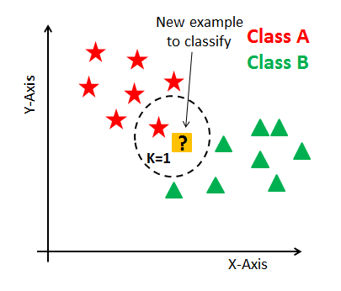

Suppose P1 is the point, for which label needs to predict. First, you find the k closest point to P1 and then classify points by majority vote of its k neighbors. Each object votes for their class and the class with the most votes is taken as the prediction. For finding closest similar points, you find the distance between points using distance measures such as Euclidean distance, Hamming distance, Manhattan distance and Minkowski distance. KNN has the following basic steps:
- Calculate distance
- Find closest neighbors
- Vote for labels
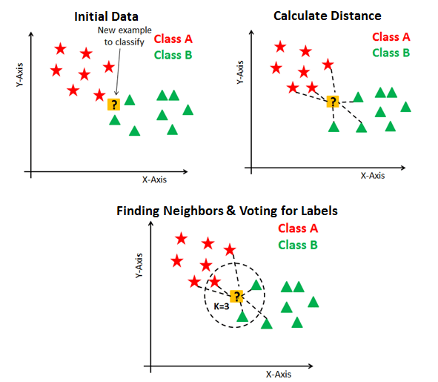

Hands-on Activity

We shall perform experiments on the Sklearn built-in tool for KNN algorithm

# First Feature
weather=['Sunny','Sunny','Overcast','Rainy','Rainy','Rainy','Overcast','Sunny','Sunny',
'Rainy','Sunny','Overcast','Overcast','Rainy']
# Second Feature
temp=['Hot','Hot','Hot','Mild','Cool','Cool','Cool','Mild','Cool','Mild','Mild','Mild','Hot','Mild']

# Label or target variable
play=['No','No','Yes','Yes','Yes','No','Yes','No','Yes','Yes','Yes','Yes','Yes','No']

from sklearn import preprocessing
#creating labelEncoder
le = preprocessing.LabelEncoder()
# Converting string labels into numbers.
weather_encoded=le.fit_transform(weather)
print(weather_encoded)

temp_encoded=le.fit_transform(temp)
label=le.fit_transform(play)
print(label)

features=list(zip(weather_encoded,temp_encoded))
print(features)

from sklearn.neighbors import KNeighborsClassifier

model=KNeighborsClassifier(n_neighbors=3)
model.fit(features,label)

#prediction on [0,2]
predicted=model.predict([[0,2]])
print(predicted)

Lab Task:
(CLO4, Marks 4) Complete hands-on activities as prescribed above.
Look critically at the predictor decisions so generated. Are there any discrepancies in the output of the predictor (Classifier). Locate and identify its position(s) and Explain how the classifier is generating an anomaly(ies) in this instance?
Note that the above classifier can also accept decimal values for the data of weather and temperature (instead of only integers). Your next task is to make a square grid of size 2 by 2. Divide this grid at intervals of 0.2. Now pick the center point of each microsquare within the grid, and calculate the output of the classifier (predictor) Shade the squares where the classifier decides ‘play’ and leave unshaded where the classifier decides ‘not play’. Repeat this task for number of neighbors
- 3
- 4
- 5
Comment which values gives more sharp decision regions?
(CLO 6, Marks 1) Perform properly handling of lab.

Further Tasks:
- (CLO4, Marks 2) Consider the performance curve for KNN algorithm is shown below. Which value of “K” will you choose for your classifier based on this performance curve?

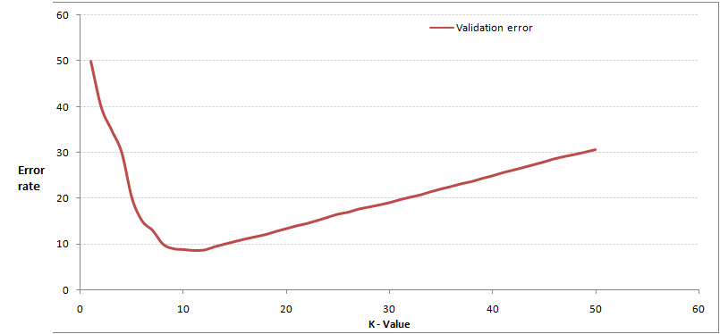

- (CLO4, Marks 3) Compute the Euclidean Distance between the two data point A(1,3) and B(2,3)? Explain why KNN algorithm works on this metric and not any other suitable metric

