AIR UNIVERITY

Department of Mechatronics
College of Engineering

ARTIFICIAL INTELLIGENCE

LAB01

Lab Objective: Introduction to Python and Cloud Computing

Class ID: _____________________ LabDate: Sep 1, 2020

Student’s ID: __________________
Lab  01 | Introduction to Python and Cloud Computing
PLO’s | PLO5 – Modern Tool Usage |  | BLOOM’S TAXONOMY | P2 – Set

LAB TASK PERFORMANCE
CLO’s | Aspects of Assessments | Excellent  (75-100%) | Average  (50-75%) | Poor  (<50%) | M
CLO1  100% | Tools Utilization Apply and discover different basic level functions of python. | Properly and accurately implement the functions and modules of python as per given task. | Implement the functions and modules of python with minor errors that give output with slightly differ from the given task. | Does not know how to implement the functions and modules and achieved the required output as describe in a task.

Total Marks: 10

Graded by Engineer: _____________________________ Date: ____________________

Remarks: ___________________________________________________________________________

Objective:

To make students familiar with the concept of cloud computing. Hands-on activity on Python in the Google Colab/ Spyder IDE environment.
Google Colab:
Google Colab is a free cloud service and now it supports free GPU! You can; improve your Python programming language coding skills. develop deep learning applications using popular libraries such as Keras, TensorFlow, PyTorch, and OpenCV.

Spyder IDE:
Sypder is a IDE for python programming, where it offers help to programmers to identify list of functions available under an object (python is an object oriented language) or number and data type of parameters accepted by a function. Like Google Colab you can make use of popular libraries such as Keras, TensorFlow, PyTorch, and OpenCV.

Python
Python is a general-purpose and open source coding language—which means that, unlike HTML, CSS, and JavaScript, it can be used for other types of programming and software development besides web development. That includes back end development, software development, data science and writing system scripts among other things. It is one of the most popular language in AI programming and model development.
A number of packages are available in Python for efficient implementation of AI algorithms. One of the most extensively used package is called as “numpy”. Numpy is primarily used for mathematical operations.

Numpy Primer:
Let’s do some hands-on experiments:
>>import numpy as np
>>A=np.array([[2 ,3],[ 2,2]]) #define a matrix#
>>AI=np.linalg.inv(A) #calculate inverse
To check your variables: To see the value of a particular variable, move your mouse to the variable, a pull down menu will appear you can click ‘view’ to see the value of that variable.
To remove any variable say A in python console use command
>>del A
for multiple variables use >>del A,AI
To access elements of an array we use square brackets >> A[0,0]
Indexing starts from 0 in python
To know dimensions of a variable b>> np.shape(b) # will return rows and cols
To know type of variable b >> type(b)
In above example variable b is a tuple. Tuple is a data type in python which means a sequence i.e a collection of numbers, names etc separated by a comma. Note that a tuple is not an array
b=np.ones((2,3))

bshape=np.shape(b)

type(bshape)
Now the variable ‘bshape’ is a tuple, length of bshape can be found using>> len(bshape), which will be ‘2’ as there are total 2 elements in the sequence . consequently the rows and columns returned by np.shape commands are not integers and therefore cannot be used as numbers. To find the dimensions in integer form:
>>len(b) ## will give number of rows
>>len(b[0]) ## will give number of columns
Note that lists and tuples both are sequence of items. However lists are mutable i.e. there particular item can be changed whereas tuples are immutable.
Lists can be formed by using square brackets >> c=[‘apples’,’oranges’,’berries’]
To change a particular item >>c[0]=(‘mangoes’)
Tuples can be formed using paranthesis >> d=(‘apples’,’oranges’,’berries’)
For accessing all rows of a particular column (or vise versa) of an array:
A[:,[1]] # will return all rows of column 1
A[:,[1,2]] # will return all entries of column 1 and 2

Creating all zeros and all ones
>>np.zeros((2,3)) # will create a 2x3 array of all zeros
>>np.ones((2,3)) # will create a 2x3 array of all ones
We can fix the data type as well
>>np.ones((2,3),dtype=np.int16) # will create a 2x3 array of all ones
Multiplication of arrays:
>>C=np.ones((3,3))
>>C*C ## this will not be matrix multiplication, rather an element-wise multiplication. For matrix multiplication you may use >> np.matmul()
For transposition
>>a.T
Lab Task:
(CLO1, Marks 4) Complete hands-on activities as prescribed above.
(CLO 6, Marks 1) Perform properly handling of lab.

Home Task:
For all tasks given below, submit the relevant commands and the corresponding output values in a word file/hardcopy with your name and ID.
- (CLO1, Marks 2) Generate a 2x2 numpy array [[2,3],[2,2]] and call it A. Now using the concept of broadcasting add 2 to each entry of A. Call the new matrix B. (Hint: Search ‘Broadcasting in Python’)
- (CLO1, Marks 1) Perform matrix multiplication of A and B, call the output E.
- (CLO1, Marks 1) Add the rows of E so that the output is a 1x2 vector ‘F’.
- (CLO1, Marks 1) Add the columns of E so that the output is a 2x1 vector ‘G’

AIR UNIVERITY
Department of Mechatronics
College of Engineering

ARTIFICIAL INTELLIGENCE LAB

LAB02
Lab Objective: Data Preliminaries: Fetching data using Pandas library (Python), checking for anomalies in data and data imputation using scikit-learn library (Python)

Class ID: _____________________ Lab Date: September 8, 2020

Student’s ID: __________________

Lab  02 | Data Preliminaries: Fetching data using Pandas library (Python), checking for anomalies in data and data imputation using scikit-learn library (Python)
PLO’s | PLO3 – Design and Development |  | Bloom’s  Taxonomy | C3 – Apply

LAB TASK PERFORMANCE
CLO’s | Aspects of Assessments | Excellent  (75-100%) | Average  (50-75%) | Poor  (<50%) | M
CLO2  100% | Design & Development Design solution for problem that meets specified needs by using the concept of artificial intelligence. | A complete solution / Explain necessary requirements according to task description with great use of time and resource material. | Solution was complete but need minor modifications /student could have followed specification more closely. | Solution was complete but did not work, needed several modifications / did not make correct use of resource material or instructions.

Total Marks: 10

Graded by Engineer: _____________________________ Date: ____________________

Remarks: ___________________________________________________________________________

Objective:

- Make attendee familiar with the concept of fetching data files using Pandas specifically in a cloud-computing environment (Google Co-laboratory for example)
- Make attendee understand how to check the anomalies in data
- Make attendee familiar with the concept of data imputation using Scikit-learn (Python)

Importing Data in a Cloud-computing Environment

pandas is a fast, powerful, flexible and easy to use open source data analysis and manipulation tool, built on top of the Python programming language. It can be used to fetch and manipulate most types of standard datasets and therefore is a very important tool for AI-experts and data scientists.

A dataset called ‘train_new.csv’ is provided to students and students will fetch this data through their Google co-lab environment as follows:

For Google Colab

>>import pandas as pd
>>import numpy as np
>>from google.colab import files
>>uploaded=files.upload()
>>import io
>>df1=pd.read_csv(io.BytesIO(uploaded['train_new.csv']))

For Spyder (the above commands a modified a little bit to reduce the extra steps of uploading data to cloud enivonment as data will be run on your computer instead of cloud)
import pandas as pd
import numpy as np
df1=pd.read_csv('E:/Courses/ArtificialIntelligence/Fall2021/Lab/AI Lab Manuals/train_new.csv')
(note:you will use the path where you have put the dataset)
print (df1.shape)

Once the data is acquired, it is always instructive to note the dimensions of the data. Students are encouraged to note that there are missing values in the data. In the following code we will define the missing values present in the data and ask the python to treat them as missing rather than assuming a garbage value. Also it is to be noted that the data fetched gives n rows while the actual dimension is of n+1 rows (value of n is depending on the dataset given to you by your teacher). This is because by default pandas take the first row as a header and doesn’t fetch it. So if there is no header, as in this case, we will have to give an explicit command within the pd.read_csv command:

>>df1.shape
>>missing_values=["n/a","NAN","na"," "]
>>df1=pd.read_csv(io.BytesIO(uploaded['train_new.csv']),na_values=missing_values,header=None)
>>#df1.shape
>>a=df1.isnull()
>>#print(a)
>>df1.shape

(you can easily modify above code for spyder as guided above)

Data Imputation:

For various reasons, many real world datasets contain missing values, often encoded as blanks, NaNs or other placeholders. Such datasets however are incompatible with AI mode-development which assumes that all values in an array are numerical, and that all have and hold meaning. A basic strategy to use incomplete datasets is to discard entire rows and/or columns containing missing values. However, this comes at the price of losing data which may be valuable (even though incomplete). A better strategy is to impute the missing values, i.e., to infer them from the known part of the data.

The following snippet demonstrates how to replace missing values, encoded as np.nan, using the mean value of the columns (axis 0) that contain the missing values:
>>>
>>>importnumpyasnp
>>>fromsklearn.imputeimport SimpleImputer
>>>imp = SimpleImputer(missing_values=np.nan, strategy='mean')
>>>imp.fit([[1, 2], [np.nan, 3], [7, 6]])
SimpleImputer()
>>>X = [[np.nan, 2], [6, np.nan], [7, 6]]
>>>print(imp.transform(X))
[[4. 2. ]
[6. 3.666...]
[7. 6. ]]

Lab Task:
(CLO2, Marks 4) Complete hands-on activities as prescribed above.
(CLO 6, Marks 1) Perform properly handling of lab.

Home Task:
- (CLO2, Marks 2) The dataset is provided in the file train_new. Write a code to automatically find the location of the missing values and replace it by zero.

- (CLO2, Marks 3) Write a program to perform basic data imputation using the ‘mean’ strategy. You may use sklearn.impute with SimpleImputer

AIR UNIVERITY

Department of Mechatronics
College of Engineering

ARTIFICIAL INTELLIGENCE LAB
LAB 3B 3
LAB04

Lab Objective: Local Search Algorithms - Gradient Descent Optimization
Class ID: _____________________ Lab Date: September 22, 2020

Student’s ID: __________________

Lab  LAB  3  04 | Local Search Algorithms - Gradient Descent Optimization
PLO’s | PLO3 – Design and Development |  | Bloom’s  Taxonomy | C3 – Apply

LAB TASK PERFORMANCE
CLO’s | Aspects of Assessments | Excellent  (75-100%) | Average  (50-75%) | Poor  (<50%) | M
CLO2  100% | Design & Development Design solution for problem that meets specified needs by using the concept of artificial intelligence. | A complete solution / Explain necessary requirements according to task description with great use of time and resource material. | Solution was complete but need minor modifications /student could have followed specification more closely. | Solution was complete but did not work, needed several modifications / did not make correct use of resource material or instructions.

Total Marks: 10

Graded by Engineer: _____________________________ Date: ____________________

Remarks: ___________________________________________________________________________

Objective:

- Make attendee familiar with the concept of local search algorithms
- Elaborate the fundamental principle of gradient descent optimization (also called as steepest descent)
- Hands-on implementation on Python using the gradient descent optimization

Gradient Descent Optimization

Gradient descent is a first-order iterative optimization algorithm for finding a local minimum of a differentiable function. To find a local minimum of a function using gradient descent, we take steps proportional to the negative of the gradient (or approximate gradient) of the function at the current point. But if we instead take steps proportional to the positive of the gradient, we approach a local maximum of that function; the procedure is then known as gradient ascent.

We need to find minima of a simple bowl-shaped function, L(w), as shown below.

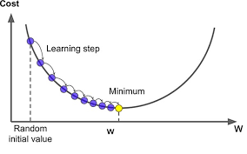
- We start randomly at any point and keep changing the values of ‘w’ to move down-hill in small steps until we reach the minimum
- Note that the parameter ‘w’ could have any notation like x, \theta etc
- The size of steps we take is called as “learning rate” or “step-size”. It is typically denoted by Latin alphabets \alpha or \eta
- Gradient at any point of the curve gives you positive slope
- Since we need to go down-hill we have to move in the negative direction of the gradient
- Update rule of GD:
- (New position):= (old position) – (step-size) * (gradient of the function)
- This is called as the first iteration of the GD algorithm
- We will continue to do this until hopefully we reach the minima of our function
- Mathematically we can write:
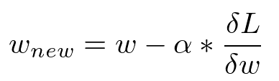
- This is called as the update rule of gradient descent
Hands-on Activity

In this exercise you will learn how to implement a gradient descent (GD) algorithm. It is really imperative to understand the working of the GD algorithm as many data science/ML algorithms are based on this concept. You will try to find the minimum of a concave function y=(x+5)^2 starting with an initial value x=2 for example. The function looks like this:
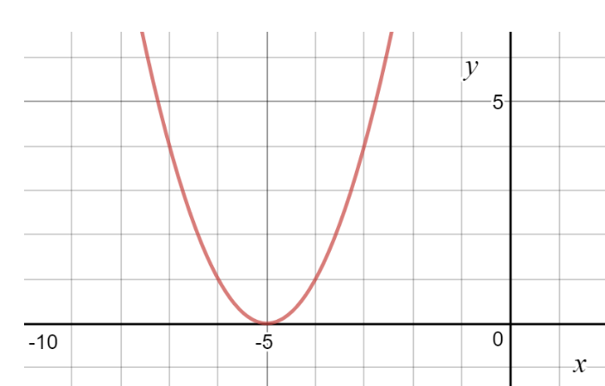

#initialize parameters ie x and eta (two lines of code)
x=2
eta=0.01 ## We have assumed a typical value for the learning rate
for i in range(1):
x=x-eta*(2*(x+5))
print(x)

1.8599999999999999
Now let's increase the iterations to say 500 and see how things go..

[ ]
#initialize parameters ie x and eta (two lines of code)
x=2
eta=0.01 ## We have assume a typical value for the learning rate
for i in range(500):
x=x-eta*(2*(x+5))
print(x)

Expected value: -4.999712832103982

Lab Task:
(CLO2, Marks 4) Complete hands-on activities as prescribed above. What effect has learning rate (Step size) on the convergence of algorithm. Justify your answer with mathematical reasoning
Now, for the following higher order polynomial functions repeat above experiments varying learning rate (0.0001,0.001, 0.01, 0.1) and number of iterations (1,2,5,50,100,500). (Note keep one parameter fixed and vary the other and then repeat).
- y= y=3(x-5)⁴+8(x-5)³-18(x-5)²
- y= 6x³-12x²+1
- y= 4x/(1+x²)
- y=4x^{0.5}-x²
Comment on the behavior of the algorithm convergence as you vary the learning rate and iterations. Plot a table for each polynomial function as per above variation in learning rate and number of iterations. How does the algorithm behave at points of inflection? Is the algorithm always successful in finding the global minima or sometimes find the local minima only. (Note only positive values of x are to be used with x_{max} fixed to 300). Comment on the answers obtained with proper justification.
(CLO 6, Marks 1) Perform properly handling of lab.

Post Lab Task:
In this task you will get a chance to perform feature gradient descent minimization of a two dimensional cost function:
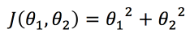
- (CLO2, Marks 2) Find the update rule for \theta_1 and \theta_2.
- (CLO2, Marks 3) Now minimize the above cost function using the concept of gradient descent minimization. You may initialize your code with \theta_1=\theta_2= 0.75, take learning rate=0.2. Your code should converge in 10 iterations as such. Report the final values of the parameters \theta_1 and \theta_2
- Comment on the answer
- You vary the initialization values, learning rate and number of iterations. What difference do you see in the rate of convergence of algorithm.

AIR UNIVERITY
Department of Mechatronics
College of Engineering

ARTIFICIAL INTELLIGENCE LAB

LAB05
LAB 04

Lab Objective: Least Square Regression using Gradient Descent

Class ID: _____________________ LabDate:September 29, 2020

Student’s ID: __________________
Lab 04
Lab  05 | Least Square Regression using Gradient Descent
PLO’s | PLO3 – Design and Development |  | Bloom’s  Taxonomy | C3 – Apply

LAB TASK PERFORMANCE
CLO’s | Aspects of Assessments | Excellent  (75-100%) | Average  (50-75%) | Poor  (<50%) | M
CLO2  100% | Design & Development Design solution for problem that meets specified needs by using the concept of artificial intelligence. | A complete solution / Explain necessary requirements according to task description with great use of time and resource material. | Solution was complete but need minor modifications /student could have followed specification more closely. | Solution was complete but did not work, needed several modifications / did not make correct use of resource material or instructions.

Total Marks: 10

Graded by Engineer: _____________________________ Date: ____________________

Remarks: ___________________________________________________________________________

Objective:

- Make attendee familiar with the concept of linear regression
- Elaborate the application of gradient descent for linear regression also called as LMS
- Hands-on implementation on Python

Linear Regression

Linear regression is a linear approach to modelling the relationship between a scalar response (or dependent variable) and one or more explanatory variables (or independent variables). The case of one explanatory variable is called simple linear regression or univariate linear regression.

It is a supervised learning concept, for example in the figure below we have size of houses on the x-axis (input variable) and price of houses on the y-axis (output variable). The data points show the given data set and we are required to learn a model which can predict the unknown output variable (y) on a given test input ‘x’.

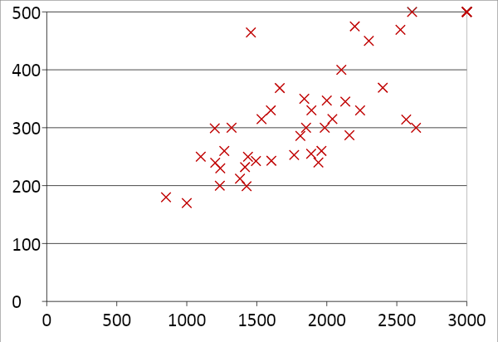

We define our model:
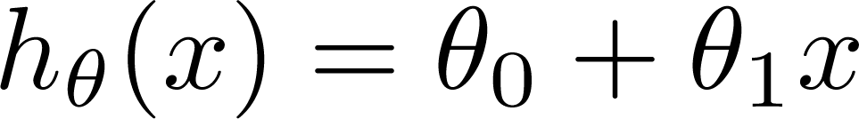
Where \thetas are called as the parameters of the model and are need to be computed carefully. Essentially we use the concept of gradient descent minimization on a squared error cost function:

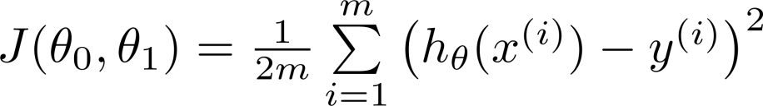
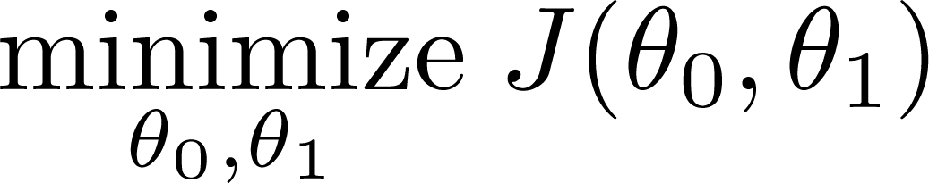

Application of gradient descent will result in the following update rules (derivation needs to be covered during lab):

Hands-on Activity

In this activity we will use the concept of least square regression to iteratively learn and perform predictive analysis on stock-exchange data:

import pandas as pd
import numpy as np
import matplotlib.pyplot as plt

Stock_Market = {'Year': [2017,2017,2017,2017,2017,2017,2017,2017,2017,2017,2017,2017,2016,2016,2016,2016,2016,2016,2016,2016,2016,2016,2016,2016],
'Month': [12, 11,10,9,8,7,6,5,4,3,2,1,12,11,10,9,8,7,6,5,4,3,2,1],
'Interest_Rate': [2.75,2.5,2.5,2.5,2.5,2.5,2.5,2.25,2.25,2.25,2,2,2,1.75,1.75,1.75,1.75,1.75,1.75,1.75,1.75,1.75,1.75,1.75],
'Unemployment_Rate': [5.3,5.3,5.3,5.3,5.4,5.6,5.5,5.5,5.5,5.6,5.7,5.9,6,5.9,5.8,6.1,6.2,6.1,6.1,6.1,5.9,6.2,6.2,6.1],
'Stock_Index_Price': [1464,1394,1357,1293,1256,1254,1234,1195,1159,1167,1130,1075,1047,965,943,958,971,949,884,866,876,822,704,719]
}

df = pd.DataFrame(Stock_Market,columns=['Year','Month','Interest_Rate','Unemployment_Rate','Stock_Index_Price'])

print (df)

x=df.Interest_Rate #We take only one input variable 'x' i.e interest rate
y=df.Stock_Index_Price ##Output variable 'y' i.e. stock index price

theta_0=10
theta_1=10
iters=1000
alpha=0.1
m=x.size
J=np.zeros([1,iters])

for i in range(iters):

h_x = theta_0 + theta_1*x
theta_0 = theta_0 - _____________ #update rule to be inserted by student
theta_1 = theta_1 - ____________ #update rule to be inserted by student

J[0,i]=(1/2*m)*sum(((theta_0+theta_1*x)-y)**2)

#print(J)
print("iteration", i, "loss", J[0,i], "theta_0=",theta_0,"theta_1=",theta_1)
# plt.plot(J.T)
plt.plot(10*np.log10(J.T))
plt.show()

plt.scatter(x,y)
plt.plot(x,theta_0+theta_1*x)
plt.show()

Lab Task:
(CLO 4, Marks 9) Write the code in proper python syntax for the update statements for theta0 and theta1 in the above python code based on the derived equations. You will obtain two graphs for the output.
Sketch screen shots here and analyze the behavior exhibited by the two graphs.
Analyze the change in behavior of the graphs if the number of iterations are progressively varied from 100 to 1000 in steps of 100 keeping alpha constant. Comment on the final values of theta0 and theta1, explaining if any change is seen or expected.
Analyze the change in the behavior of the graphs if the learning rate is varied from 0.0001 to 0.1 keeping iterations constant. Comment on it explaining the change.

Now repeat the above activity but choosing the parameters Unemployment Rate and Stock Index Price. How do the new calculated parameters theta0 and theta1 compare to the previously calculated ones.

(CLO 6, Marks 1) Perform properly handling of lab.

AIR UNIVERITY
Department of Mechatronics
College of Engineering

ARTIFICIAL INTELLIGENCE LAB
LAB 05
LAB06

Lab Objective: Dimensionality Reduction – Principal Component Analysis (PCA)
Class ID: _____________________ LabDate:October 6, 2020

Student’s ID: __________________
LAB 05
Lab  06 | Dimensionality Reduction – Principal Component Analysis (PCA)
PLO’s | PLO3 – Design and Development |  | Bloom’s  Taxonomy | C3 – Apply

LAB TASK PERFORMANCE
CLO’s | Aspects of Assessments | Excellent  (75-100%) | Average  (50-75%) | Poor  (<50%) | M
CLO2  100% | Design & Development Design solution for problem that meets specified needs by using the concept of artificial intelligence. | A complete solution / Explain necessary requirements according to task description with great use of time and resource material. | Solution was complete but need minor modifications /student could have followed specification more closely. | Solution was complete but did not work, needed several modifications / did not make correct use of resource material or instructions.

Total Marks: 10

Graded by Engineer: _____________________________ Date: ____________________

Remarks: ___________________________________________________________________________

Objective:

- Make attendee familiar with the concept of dimensionality reduction
- Elaborate the concept of Principal Component Analysis (PCA)
- Hands-on implementation on Python

Dimensionality Reduction

Dimensionality reduction, or dimension reduction, is the transformation of data from a high-dimensional space into a low-dimensional space so that the low-dimensional representation retains some meaningful properties of the original data, ideally close to its intrinsic dimension. Working in high-dimensional spaces can be undesirable for many reasons; raw data are often sparse as a consequence of the curse of dimensionality, and analyzing the data is usually computationally intractable. Dimensionality reduction is common in fields that deal with large numbers of observations and/or large numbers of variables, such as signal processing, speech recognition, neuroinformatics, and bioinformatics

Principal Component Analysis

Principal Component Analysis (PCA) is a linear dimensionality reduction technique that can be utilized for extracting information from a high-dimensional space by projecting it into a lower-dimensional sub-space. It tries to preserve the essential parts that have more variation of the data and remove the non-essential parts with fewer variation.
Dimensions are nothing but features that represent the data. For example, A 28 X 28 image has 784 picture elements (pixels) that are the dimensions or features which together represent that image.
One important thing to note about PCA is that it is an Unsupervised dimensionality reduction technique, you can cluster the similar data points based on the feature correlation between them without any supervision (or labels)

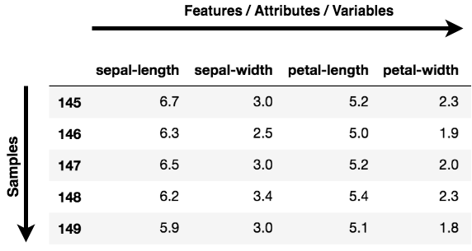

But where all you can apply PCA?
- Data Visualization: When working on any data related problem, the challenge in today's world is the sheer volume of data, and the variables/features that define that data. To solve a problem where data is the key, you need extensive data exploration like finding out how the variables are correlated or understanding the distribution of a few variables. Considering that there are a large number of variables or dimensions along which the data is distributed, visualization can be a challenge and almost impossible.
Hence, PCA can do that for you since it projects the data into a lower dimension, thereby allowing you to visualize the data in a 2D or 3D space with a naked eye.
- Speeding Machine Learning (ML) Algorithm: Since PCA's main idea is dimensionality reduction, you can leverage that to speed up your machine learning algorithm's training and testing time considering your data has a lot of features, and the ML algorithm's learning is too slow.
At an abstract level, you take a dataset having many features, and you simplify that dataset by selecting a few Principal Components from original features.

What is a Principal Component?
Principal components are the key to PCA; they represent what's underneath the hood of your data. In a layman term, when the data is projected into a lower dimension (assume three dimensions) from a higher space, the three dimensions are nothing but the three Principal Components that captures (or holds) most of the variance (information) of your data.
Principal components have both direction and magnitude. The direction represents across which principal axes the data is mostly spread out or has most variance and the magnitude signifies the amount of variance that Principal Component captures of the data when projected onto that axis. The principal components are a straight line, and the first principal component holds the most variance in the data. Each subsequent principal component is orthogonal to the last and has a lesser variance. In this way, given a set of x correlated variables over y samples you achieve a set of u uncorrelated principal components over the same y samples.
The reason you achieve uncorrelated principal components from the original features is that the correlated features contribute to the same principal component, thereby reducing the original data features into uncorrelated principal components; each representing a different set of correlated features with different amounts of variation.
Each principal component represents a percentage of total variation captured from the data.

Hands-on Activity

In the hands-on activity we will work on the IRIS data set and will use PCA to transform the data to lower dimensional space

import numpy as np
import pandas as pd #package to fetch the data

#from google.colab import files # Commented out as not needed in current execution environment
#uploaded=files.upload() # Uncomment this line to enable file upload
#import io
#df=pd.read_csv(io.BytesIO(uploaded['Iris.csv']),header=None)
# If you are running outside of Google Colab you will need to directly load your dataframe
# using pd.read_csv() or another method to load data.

# Replace 'Iris.csv' with your actual CSV file path if needed
df = pd.read_csv('Iris.csv', header=0)

# Convert the dataframe to a NumPy array
df1 = df.to_numpy()

# Select columns 1 to 4 (SepalLengthCm, SepalWidthCm, PetalLengthCm, PetalWidthCm) as features
# Skip the 'Id' column (index 0) and the header row.
X = df1[1:, 1:5] # Start from the second row (index 1) to exclude the header

# The rest of your code remains the same
from sklearn.preprocessing import StandardScaler
# Standard Scaler normalizes all data to have zero mean and variance 1
X = StandardScaler().fit_transform(X)

from sklearn.decomposition import PCA
pca = PCA(n_components=2)
transformed_data = pca.fit_transform(X)
transformed_data

(Note: You may convert the code for Spyder environment yourself as explained in earlier labs)

Lab Tasks:
(CLO2, Marks 9)
Complete hands-on activities as prescribed above.

Plot scatter plot of original data with different colors for the 3 classes
What is the size of the transformed data? Which two parameters are selected by the algorithm, Give answer with reasoning and justification? If your increase the parameters to 3, then which additional feature is selected? Plot new scatter plots to see if data visualization is improved?
Another alternative way to understand Principle Component Analysis through Eigen Values and Eigen Vectors. Find the Eigen values and Eigen Vectors of the following matrices
A=np.array([[2 ,3, 3],[ 2,2, -3], [4,-3.1,2]])
A=np.array([[2 ,3, 3],[ 2,2, 3], [4,3.1,7]])
Comment on the difference in values and relate this to the principle components?
(Hint: You can make use of the command np.linalg.eig(A) for this task)

Is PCA a supervised method or an un supervised method? Give reason for your answer
You are now asked to perform PCA on the IRIS dataset as done in the hands-on activity, but by using the number of principal components which preserve 95% variance in the data. Design an algorithm for this and analyze your observations, how they are different from previous part.

(CLO 6, Marks 1) Perform properly handling of lab.

AIR UNIVERITY
Department of Mechatronics
College of Engineering

ARTIFICIAL INTELLIGENCE LAB
LAB 06
LAB07

Lab Objective: Ordinary Least Square Regression (OLS) hands-on real data
Class ID: _____________________ LabDate:

Student’s ID: __________________

Lab  LAB 06  07 | Ordinary Least Square Regression (OLS) hands-on real data
PLO’s | PLO3 – Design and Development |  | Bloom’s  Taxonomy | C3 – Apply

LAB TASK PERFORMANCE
CLO’s | Aspects of Assessments | Excellent  (75-100%) | Average  (50-75%) | Poor  (<50%) | M
CLO2  100% | Design & Development Design solution for problem that meets specified needs by using the concept of artificial intelligence. | A complete solution / Explain necessary requirements according to task description with great use of time and resource material. | Solution was complete but need minor modifications /student could have followed specification more closely. | Solution was complete but did not work, needed several modifications / did not make correct use of resource material or instructions.

Total Marks: 10

Graded by Engineer: _____________________________ Date: ____________________

Remarks: ___________________________________________________________________________

Objective:

- Make attendee familiar with the concept of univariate ordinary least square regression (OLS)
- Make attendee understand multivariate OLS
- Hands-on activity on real data set using the vectorized implementation of multivariate OLS

Ordinary Least Square Regression (OLS)

Linear regression, also called Ordinary Least-Squares (OLS) Regression, is probably the most commonly used technique in Statistical Learning. It is also the oldest, dating back to the eighteenth century and the work of Carl Friedrich Gauss and Adrien-Marie Legendre. It is also one of the easier and more intuitive techniques to understand, and it provides a good basis for learning more advanced concepts and techniques.

Let us take a simple linear regression to begin with. We want to find the best fit line through a set of data points: (x1, y1), (x2, y2), … (x_m, y_m).
If we can find a slope and an intercept for a single line that passes through all the possible data points, then that is the best fit line. But in most of the cases, such a line does not exist! So we resolve to finding a line such that when a connecting line is drawn parallel to the y-axis from the data points to the regression line, which measures the error of each data point, the sum of all such errors should be minimum. We take an example and define some notations:

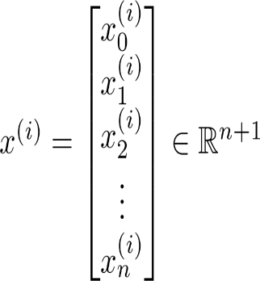

Let’s consider a hypothetical data:

 | Size (feet²) | Number of bedrooms | Number of floors | Age of home (years) | Price ($1000)
1 | 2104 | 5 | 1 | 45 | 460
1 | 1416 | 3 | 2 | 40 | 232
1 | 1534 | 3 | 2 | 30 | 315
1 | 852 | 2 | 1 | 36 | 178
1 | 3000 | 4 | 1 | 38 | 540

The formulation will be:

$$y=Xθ$$

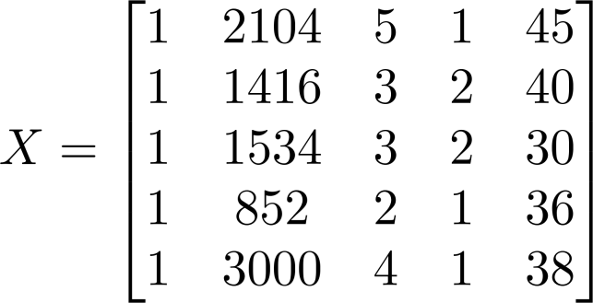
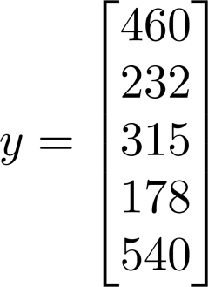

Our problem is to find the unknown vector of parameters:

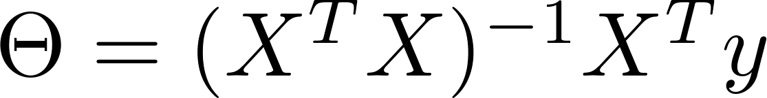

Once the vector of parameters is known, we can easily perform prediction on the unknown data

Hands-on Activity

We shall perform experiments on the Sklearn built-in data set “Boston Housing Data”.

import matplotlib.pyplot as plt
import numpy as np
from sklearn import datasets, linear_model, metrics

# load the boston dataset
boston = datasets.load_boston(return_X_y=False)

##note that if we put return_X_y=True, the output will be in form of tuples and will not be easy to read
##sklearn therefore recommends to put this false for easy access to the data

## now we can explore this data using different commands

print(boston.feature_names) #gives you names of the features#
print(boston.data.shape)## gives you the size of the data
print(boston.target.shape) ## gives you dimensions of the target variable etc

# defining feature matrix(X) and response vector(y)
X = boston.data
y = boston.target
X.shape
y.shape
#now as you can see dimensions of y are showing empty space in col. This is an issue in python and should be fixed

y=y.reshape(-1,1)##this will put y in one column and infer the number of rows automatically

X=np.insert(X,0,np.ones(X.shape[0]),axis=1)#adding the col of ones#

# splitting X and y into training and testing sets, we are going for a 60-40 split
from sklearn.model_selection import train_test_split
X_train, X_test, y_train, y_test = train_test_split(X, y, test_size=0.4,
random_state=1)

##Let's do OLS manually first

tmp1=(np.linalg.inv(np.matmul(X_train.T,X_train)))
tmp2=np.matmul(tmp1,X_train.T)
theta = np.matmul(tmp2,y_train)

Note to read the dataset you can alternately use

df1=pd.read_csv(‘E:/Courses/ArtificialIntelligence/Fall2021/Lab/AI Lab Manuals/diabetes.csv’)

(if the dataset file is provided to you as a csv file)

Or you may read it off the URL directly using

import pandas as pd
import numpy as np

data_url = "http://lib.stat.cmu.edu/datasets/boston"
raw_df = pd.read_csv(data_url, sep="\s+", skiprows=22, header=None)
data = np.hstack([raw_df.values[::2, :], raw_df.values[1::2, :2]])
target = raw_df.values[1::2, 2]

print (raw_df.shape)
print (data.shape)
print (target.shape)

Convert the above code for Spyder environment as explained in class.

Lab Task:
(CLO4, Marks 4) Complete hands-on activities as prescribed above.
(CLO 6, Marks 1) Perform properly handling of lab.

Post Lab Task:
- (CLO4, Marks 2) Perform predictions on the test data X_test and store your predicted values in ‘y_pred’.

- (CLO4, Marks 2) Also plot your predicted values against the true values to see how accurate your predictions are, you may use the following code:

fig, ax = plt.subplots()
ax.plot(y_test,"r-")
ax.plot(y_pred.T)

Give detailed comments on the accuracy obtained?

- Explain why the theoretical value of unknown vector is obtained through using pseudo inverse

And not just simply

$$θ=X^{-1}y$$

AIR UNIVERITY
Department of Mechatronics
College of Engineering

ARTIFICIAL INTELLIGENCE LAB
LAB 07
LAB08

Lab Objective: Nearest Neighbor (NN) and k-Nearest Neighbor Classification (k-NN)

Class ID: _____________________ LabDate:October 30, 2020

Student’s ID: __________________
Lab 07
Lab  08 | Nearest Neighbor (NN) and k-Nearest Neighbor Classification (k-NN)
PLO’s | PLO3 – Design and Development |  | Bloom’s  Taxonomy | C3 – Apply

LAB TASK PERFORMANCE
CLO’s | Aspects of Assessments | Excellent  (75-100%) | Average  (50-75%) | Poor  (<50%) | M
CLO2  100% | Design & Development Design solution for problem that meets specified needs by using the concept of artificial intelligence. | A complete solution / Explain necessary requirements according to task description with great use of time and resource material. | Solution was complete but need minor modifications /student could have followed specification more closely. | Solution was complete but did not work, needed several modifications / did not make correct use of resource material or instructions.

Total Marks: 10

Graded by Engineer: _____________________________ Date: ____________________

Remarks: ___________________________________________________________________________

Objective:

- Make attendee familiar with the concept of classification
- Make attendee understand the nearest neighbor (NN) and k-nearest neighbor (k-NN) classifiers
- Hands-on activity

K Nearest Neighbor (KNN) Algorithm

K Nearest Neighbor(KNN) is a very simple, easy to understand, versatile and one of the topmost machine learning algorithms. KNN used in the variety of applications such as finance, healthcare, political science, handwriting detection, image recognition and video recognition. In Credit ratings, financial institutes will predict the credit rating of customers. In loan disbursement, banking institutes will predict whether the loan is safe or risky. In political science, classifying potential voters in two classes will vote or won’t vote.
KNN is a non-parametric and lazy learning algorithm. Non-parametric means there is no assumption for underlying data distribution. In other words, the model structure determined from the dataset. This will be very helpful in practice where most of the real world datasets do not follow mathematical theoretical assumptions. Lazy algorithm means it does not need any training data points for model generation. All training data used in the testing phase. This makes training faster and testing phase slower and costlier. Costly testing phase means time and memory. In the worst case, KNN needs more time to scan all data points and scanning all data points will require more memory for storing training data
In KNN, K is the number of nearest neighbors. The number of neighbors is the core deciding factor. K is generally an odd number if the number of classes is 2. When K=1, then the algorithm is known as the nearest neighbor algorithm. This is the simplest case. Suppose P1 is the point, for which label needs to predict. First, you find the one closest point to P1 and then the label of the nearest point assigned to P1.
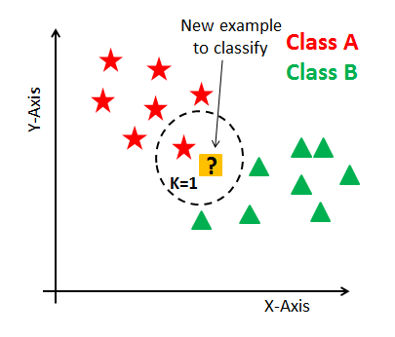

Suppose P1 is the point, for which label needs to predict. First, you find the k closest point to P1 and then classify points by majority vote of its k neighbors. Each object votes for their class and the class with the most votes is taken as the prediction. For finding closest similar points, you find the distance between points using distance measures such as Euclidean distance, Hamming distance, Manhattan distance and Minkowski distance. KNN has the following basic steps:
- Calculate distance
- Find closest neighbors
- Vote for labels
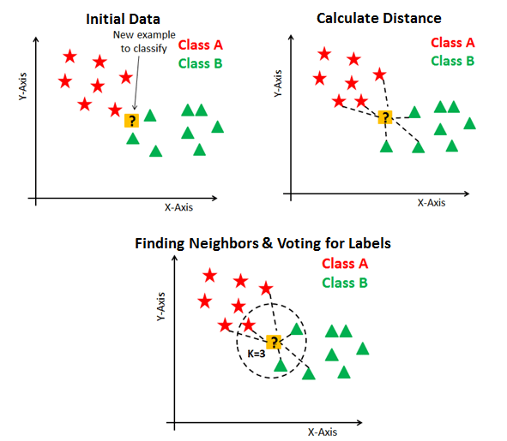

Hands-on Activity

We shall perform experiments on the Sklearn built-in tool for KNN algorithm

# First Feature
weather=['Sunny','Sunny','Overcast','Rainy','Rainy','Rainy','Overcast','Sunny','Sunny',
'Rainy','Sunny','Overcast','Overcast','Rainy']
# Second Feature
temp=['Hot','Hot','Hot','Mild','Cool','Cool','Cool','Mild','Cool','Mild','Mild','Mild','Hot','Mild']

# Label or target variable
play=['No','No','Yes','Yes','Yes','No','Yes','No','Yes','Yes','Yes','Yes','Yes','No']

from sklearn import preprocessing
#creating labelEncoder
le = preprocessing.LabelEncoder()
# Converting string labels into numbers.
weather_encoded=le.fit_transform(weather)
print(weather_encoded)

temp_encoded=le.fit_transform(temp)
label=le.fit_transform(play)
print(label)

features=list(zip(weather_encoded,temp_encoded))
print(features)

from sklearn.neighbors import KNeighborsClassifier

model=KNeighborsClassifier(n_neighbors=3)
model.fit(features,label)

#prediction on [0,2]
predicted=model.predict([[0,2]])
print(predicted)

Lab Task:
(CLO4, Marks 4) Complete hands-on activities as prescribed above.
Look critically at the predictor decisions so generated. Are there any discrepancies in the output of the predictor (Classifier). Locate and identify its position(s) and Explain how the classifier is generating an anomaly(ies) in this instance?
Note that the above classifier can also accept decimal values for the data of weather and temperature (instead of only integers). Your next task is to make a square grid of size 2 by 2. Divide this grid at intervals of 0.2. Now pick the center point of each microsquare within the grid, and calculate the output of the classifier (predictor) Shade the squares where the classifier decides ‘play’ and leave unshaded where the classifier decides ‘not play’. Repeat this task for number of neighbors
- 3
- 4
- 5
Comment which values gives more sharp decision regions?
(CLO 6, Marks 1) Perform properly handling of lab.

Further Tasks:
- (CLO4, Marks 2) Consider the performance curve for KNN algorithm is shown below. Which value of “K” will you choose for your classifier based on this performance curve?

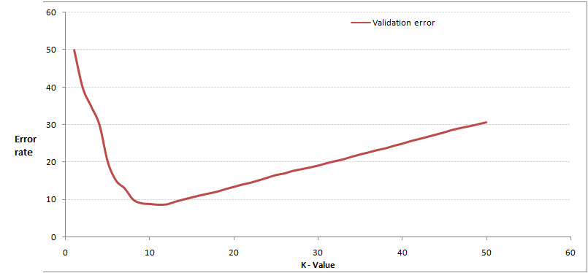

- (CLO4, Marks 3) Compute the Euclidean Distance between the two data point A(1,3) and B(2,3)? Explain why KNN algorithm works on this metric and not any other suitable metric

AIR UNIVERITY
Department of Mechatronics
College of Engineering

ARTIFICIAL INTELLIGENCE LAB
LAB 08
LAB09

Lab Objective: Perceptron Learning Algorithm
Class ID: _____________________ LabDate:November 6, 2020

Student’s ID: __________________
LAB 08
Lab  09 | Perceptron Learning Algorithm
PLO’s | PLO3 – Design and Development |  | Bloom’s  Taxonomy | C3 – Apply

LAB TASK PERFORMANCE
CLO’s | Aspects of Assessments | Excellent  (75-100%) | Average  (50-75%) | Poor  (<50%) | M
CLO2  100% | Design & Development Design solution for problem that meets specified needs by using the concept of artificial intelligence. | A complete solution / Explain necessary requirements according to task description with great use of time and resource material. | Solution was complete but need minor modifications /student could have followed specification more closely. | Solution was complete but did not work, needed several modifications / did not make correct use of resource material or instructions.

Total Marks: 10

Graded by Engineer: _____________________________ Date: ____________________

Remarks: ___________________________________________________________________________

Objective:

- Make attendee familiar with the concept of perceptron
- Make attendee understand perceptron learning algorithm and the relevant weight update rules
- Hands-on activity

Perceptron

The idea of a Perceptron is analogous to the operating principle of the basic processing unit of the brain — Neuron. A Neuron is comprised of many input signals carried by Dendrites, the cell body and one output signal carried along Axon. The Neuron fires an action signal when the cell meets a particular threshold. This action either happen or they don’t; there is no such thing as a “partial” firing of a neuron.

Similarly, the perceptron has many inputs(often called features) that are fed into a Linear unit that produces one binary output. Therefore, perceptrons can be applied in solving Binary Classification problems where the sample is to be identified as belonging to one of the predefined two classes.

The Perceptron Learning Algorithm
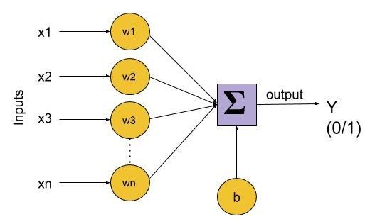

Since Perceptrons are Binary Classifiers (0/1), we can define their computation as follows:

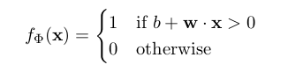
Let’s recall that the dot product of two vectors of length n (1≤i≤n) is w . x = ∑ᵢ wᵢ . xᵢThe function f(x)=b+w.x is a linear combination of weight and feature vectors. Perceptron is, therefore, a linear classifier — an algorithm that predicts using a linear predictor function.
The weights signify the effectiveness of each feature xᵢ in x on the model’s behavior. Higher the weight wᵢ of a feature xᵢ, higher is it’s influence on the output. On the other hand, the bias ‘b’ is like the intercept in the linear equation. It’s a constant that helps the model adjust in a way that best fits the data. The bias term assumes an imaginary input feature coefficient x₀=1.
The model can be trained using the following algorithm:
1. set b = w = 0
2. for N iterations, or until weights do not change
(a) for each training example xᵏ with label yᵏ
i. if yᵏ — f(xᵏ) = 0, continue
ii. else, update wᵢ, △wᵢ = (yᵏ — f(xᵏ)) xᵢ

Implementation
The dataset that we consider for implementing Perceptron is the Iris flower dataset. This dataset contains 4 features that describe the flower and classify them as belonging to one of the 3 classes. We strip the last 50 rows of the dataset that belongs to the class ‘Iris-virginica’ and use only 2 classes ‘Iris-setosa’ and ‘Iris-versicolor’ because these classes are linearly separable and the algorithm converges to a local minimum by eventually finding the optimal weights.
import numpy as np
import pandas as pd
import matplotlib.pyplot as plt
def load_data():
URL_='https://archive.ics.uci.edu/ml/machine-learning-databases/iris/iris.data'
data = pd.read_csv(URL_, header = None)
print(data)

# make the dataset linearly separable by selecting samples from two classes only
data = data[:100]
data[4] = np.where(data.iloc[:, -1]=='Iris-setosa', 0, 1)
data = np.asmatrix(data, dtype = 'float64')
return data
data = load_data()

Visualizing the dataset with 2 of the features, we can see that that dataset can be clearly separated by drawing a straight line between them.
Our goal is to write an algorithm that finds that line and classifies all of these data points correctly.
plt.scatter(np.array(data[:50,0]), np.array(data[:50,2]), marker='o', label='setosa')
plt.scatter(np.array(data[50:,0]), np.array(data[50:,2]), marker='x', label='versicolor')
plt.xlabel('petal length')
plt.ylabel('sepal length')
plt.legend()
plt.show()
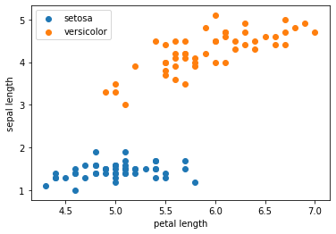
Now we implement the algorithm mentioned above as it is and see how it works. We have 4 features and hence 4 weights associated with each feature. Remember that we defined a bias term w₀ that assumes x₀=1 making it a total of 5 weights.
We have defined the number of iterations to be 10. This is one of the hyperparameters, as opposed to system parameters like w that are learned by the algorithm. At each iteration, the algorithm computes the class (0 or 1) for all the data points and updates the weights with each misclassification.
If the sample is misclassified, then the weights are updated by delta that shifts in the opposite direction. So if the sample is to be classified again, the result is “less wrong”. We classify any label≤0 as ‘0’ (Iris-setosa) anything else to be a ‘1’ (Iris-versicolor)

def perceptron(data,num_iter):
features = data[:, :-1]##take all data except the last column
labels = data[:, -1]##take only the last column

# set weights to zero
w = np.zeros(shape=(1, features.shape[1]+1))

misclassified_ = [] ##Used by convention to avoid naming conflicts with Python keywords.

for epoch in range(num_iter):
misclassified = 0
for x, label in zip(features, labels): ##The zip() function returns a zip object, which is an iterator of tuples
#where the first item in each passed iterator is paired together, and then the second item in each passed iterator are paired together etc
x = np.insert(x,0,1) ## insert 1 to make DC term work by fixing an artificially generated feature value as 1
y = np.dot(w, x.transpose())
target = 1.0 if (y > 0) else 0.0 ##hardlimiter

delta = (label.item(0,0) - target) ## actual class – predicted class

if(delta): # misclassified
misclassified += 1
w += (delta * x)

misclassified_.append(misclassified)
return (w, misclassified_)

num_iter = 10
w, misclassified_ = perceptron(data, num_iter)
misclassified_

Lab Task:
(CLO4, Marks 4) Complete hands-on activities as prescribed above. Analyze the change in behavior of the classification accuracy of the perceptron algorithm (through misclassified cases) as the number of iterations are progressively varied from 1 to 10 in steps of 1. Plot graph and make a table for the results.
Analyze the change accuracy of the algorithm if the number of features are reduced from 4 to 3 to 2. Comment on it explaining the change.
(CLO 6, Marks 1) Perform properly handling of lab.

Further Lab Tasks:
- (CLO4, Marks 5) Solve the Boolean OR problem using the Perceptron Learning Algorithm by designing a suitable perceptron algorithm. Once the learning is complete, perform testing on all four samples and show that misclassification is zero. Submit your python code as well.

AIR UNIVERITY
Department of Mechatronics
College of Engineering

ARTIFICIAL INTELLIGENCE LAB
LAB 09
LAB10

Lab Objective: Support Vector Machine (SVM)
Class ID: _____________________ LabDate:November 13, 2020

Student’s ID: __________________
Lab 09
Lab  10 | Support Vector Machine (SVM)
PLO’s | PLO3 – Design and Development |  | Bloom’s  Taxonomy | C3 – Apply

LAB TASK PERFORMANCE
CLO’s | Aspects of Assessments | Excellent  (75-100%) | Average  (50-75%) | Poor  (<50%) | M
CLO2  100% | Design & Development Design solution for problem that meets specified needs by using the concept of artificial intelligence. | A complete solution / Explain necessary requirements according to task description with great use of time and resource material. | Solution was complete but need minor modifications /student could have followed specification more closely. | Solution was complete but did not work, needed several modifications / did not make correct use of resource material or instructions.

Total Marks: 10

Graded by Engineer: _____________________________ Date: ____________________

Remarks: ___________________________________________________________________________

Objective:

- Make attendee familiar with the concept ofsupport vector machine (SVM)
- Make attendeeunderstand the kernel trick
- Hands-on activity

Support Vector Machine (SVM)

SVM offers very high accuracy compared to other classifiers such as logistic regression, and decision trees. It is known for its kernel trick to handle nonlinear input spaces. It is used in a variety of applications such as face detection, intrusion detection, classification of emails, news articles and web pages, classification of genes, and handwriting recognition.

SVM is an exciting algorithm and the concepts are relatively simple. The classifier separates data points using a hyperplane with the largest amount of margin. That's why an SVM classifier is also known as a discriminative classifier. SVM finds an optimal hyperplane which helps in classifying new data points.

Generally, Support Vector Machines is considered to be a classification approach, it but can be employed in both types of classification and regression problems. It can easily handle multiple continuous and categorical variables. SVM constructs a hyperplane in multidimensional space to separate different classes. SVM generates optimal hyperplane in an iterative manner, which is used to minimize an error. The core idea of SVM is to find a maximum marginal hyperplane(MMH) that best divides the dataset into classes.
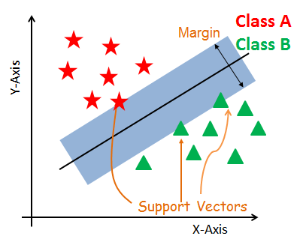

Support Vectors
Support vectors are the data points, which are closest to the hyperplane. These points will define the separating line better by calculating margins. These points are more relevant to the construction of the classifier.

Hyperplane
A hyperplane is a decision plane which separates between a set of objects having different class memberships.

Margin
A margin is a gap between the two lines on the closest class points. This is calculated as the perpendicular distance from the line to support vectors or closest points. If the margin is larger in between the classes, then it is considered a good margin, a smaller margin is a bad margin.

How does SVM work?
The main objective is to segregate the given dataset in the best possible way. The distance between the either nearest points is known as the margin. The objective is to select a hyperplane with the maximum possible margin between support vectors in the given dataset. SVM searches for the maximum marginal hyperplane in the following steps:
- Generate hyperplanes which segregates the classes in the best way. Left-hand side figure showing three hyperplanes black, blue and orange. Here, the blue and orange have higher classification error, but the black is separating the two classes correctly.
- Select the right hyperplane with the maximum segregation from the either nearest data points as shown in the right-hand side figure.
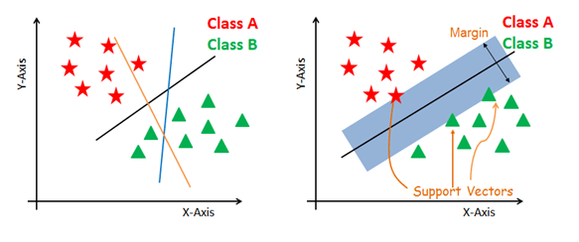

Dealing with non-linear and inseparable planes
Some problems can’t be solved using linear hyperplane, as shown in the figure below (left-hand side).
In such situation, SVM uses a kernel trick to transform the input space to a higher dimensional space as shown on the right. The data points are plotted on the x-axis and z-axis (Z is the squared sum of both x and y: z=x^2=y^2). Now you can easily segregate these points using linear separation.
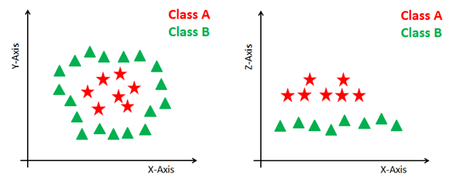

SVM Kernels
The SVM algorithm is implemented in practice using a kernel. A kernel transforms an input data space into the required form. SVM uses a technique called the kernel trick. Here, the kernel takes a low-dimensional input space and transforms it into a higher dimensional space. In other words, you can say that it converts nonseparable problem to separable problems by adding more dimension to it. It is most useful in non-linear separation problem. Kernel trick helps you to build a more accurate classifier.
- Linear Kernel A linear kernel can be used as normal dot product any two given observations. The product between two vectors is the sum of the multiplication of each pair of input values.
- Polynomial Kernel A polynomial kernel is a more generalized form of the linear kernel. The polynomial kernel can distinguish curved or nonlinear input space.
- Radial Basis Function Kernel The Radial basis function kernel is a popular kernel function commonly used in support vector machine classification. RBF can map an input space in infinite dimensional space.

Implementation
In the model the building part, you can use the cancer dataset, which is a very famous multi-class classification problem. This dataset is computed from a digitized image of a fine needle aspirate (FNA) of a breast mass. They describe characteristics of the cell nuclei present in the image.
The dataset comprises 30 features (mean radius, mean texture, mean perimeter, mean area, mean smoothness, mean compactness, mean concavity, mean concave points, mean symmetry, mean fractal dimension, radius error, texture error, perimeter error, area error, smoothness error, compactness error, concavity error, concave points error, symmetry error, fractal dimension error, worst radius, worst texture, worst perimeter, worst area, worst smoothness, worst compactness, worst concavity, worst concave points, worst symmetry, and worst fractal dimension) and a target (type of cancer).
This data has two types of cancer classes: malignant (harmful) and benign (not harmful). Here, you can build a model to classify the type of cancer. The dataset is available in the scikit-learn library or you can also download it from the UCI Machine Learning Library.

#Import scikit-learn dataset library
from sklearn import datasets

#Load dataset
cancer = datasets.load_breast_cancer()

#Exploring Data
print("Features: ", cancer.feature_names)

# print the label type of cancer('malignant' 'benign')
print("Labels: ", cancer.target_names)

# print data(feature)shape
cancer.data.shape

# print the cancer labels (0:malignant, 1:benign)
print(cancer.target)

# Import train_test_split function
from sklearn.model_selection import train_test_split

# Split dataset into training set and test set
X_train, X_test, y_train, y_test = train_test_split(cancer.data, cancer.target, test_size=0.3,random_state=109) # 70% training and 30% test

#Import svm model
from sklearn import svm

#Create a svm Classifier
clf = svm.SVC(kernel='linear') # Linear Kernel

#Train the model using the training sets
clf.fit(X_train, y_train)

#Predict the response for test dataset
________________________________ #to be coded by the student

#Import scikit-learn metrics module for accuracy calculation
from sklearn import metrics

# Model Accuracy: how often is the classifier correct?

____________________________________# to be coded by the student

Lab Tasks:
(CLO4, Marks 4) Complete the code above to determine the Prediction Results of the classifier and also determine its accuracy? Comment on the accuracy of the classifier
(CLO 6, Marks 1) Perform properly handling of lab.

Further Tasks:
- (CLO4, Marks 2) In the same cancer classification problem, now change the proportion of Train and Test data and determine the variation of the classifier accuracy, Tabulate these results and then sketch a graph of Classifier Accuracy Vs percentage training data used. Analyze the graph and comment if there is some optimum value of training data percentage for best prediction results. Why in practice using large amount of training data not be possible in real scenarios
- (CLO4, Marks 3) Now decrease the features in the training data from 30 to 5 in steps of -5, for constant Train/Test split of 70/30. Tabulate these results and then sketch a graph of Classifier Accuracy Vs No of features used. Analyze the graph and comment if there is some optimum value of No of features for best prediction results.

AIR UNIVERITY
Department of Mechatronics
College of Engineering

ARTIFICIAL INTELLIGENCE LAB
LAB 10
LAB11

Lab Objective: Clustering- the K-means algorithm
Class ID: _____________________ Lab Date: November 17, 2020

Student’s ID: __________________
Lab 10
Lab  11 | Clustering- the K-means algorithm
PLO’s | PLO3 – Design and Development |  | Bloom’s  Taxonomy | C3 – Apply

LAB TASK PERFORMANCE
CLO’s | Aspects of Assessments | Excellent  (75-100%) | Average  (50-75%) | Poor  (<50%) | M
CLO2  100% | Design & Development Design solution for problem that meets specified needs by using the concept of artificial intelligence. | A complete solution / Explain necessary requirements according to task description with great use of time and resource material. | Solution was complete but need minor modifications /student could have followed specification more closely. | Solution was complete but did not work, needed several modifications / did not make correct use of resource material or instructions.

Total Marks: 10

Graded by Engineer: _____________________________ Date: ____________________

Remarks: ___________________________________________________________________________

Objective:

- Make attendee familiar with the concept of unsupervised learning
- Make attendee understand the k-means clustering and the elbow method
- Hands-on activity

K-Means Clustering

K-means clustering is one of the simplest and popular unsupervised machine learning algorithms. Typically, unsupervised algorithms make inferences from datasets using only input vectors without referring to known, or labelled, outcomes. You’ll define a target number k, which refers to the number of centroids you need in the dataset. A centroid is the imaginary or real location representing the center of the cluster. Every data point is allocated to each of the clusters through reducing the in-cluster sum of squares. In other words, the K-means algorithm identifies k number of centroids, and then allocates every data point to the nearest cluster, while keeping the centroids as small as possible. The ‘means’ in the K-means refers to averaging of the data; that is, finding the centroid.

The K-means algorithm in data mining starts with a first group of randomly selected centroids, which are used as the beginning points for every cluster, and then performs iterative (repetitive) calculations to optimize the positions of the centroids

It halts creating and optimizing clusters when either:

- The centroids have stabilized — there is no change in their values because the clustering has been successful.
- The defined number of iterations has been achieved.

Implementation

Let’s implement k-means clustering using a famous dataset: the Iris dataset. This dataset contains 3 classes of 50 instances each and each class refers to a type of iris plant. The dataset has four features: sepal length, sepal width, petal length, and petal width. The fifth column is for species, which holds the value for these types of plants.

import numpy as np
import pandas as pd
import matplotlib.pyplot as plt
from sklearn import datasets
from sklearn.cluster import KMeans

#import the dataset
df = pd.read_csv('iris.data') ##for ipython you need to upload the data using specific commands as discussed in previous labs
df.head(10)#to view the first 10 rows
##save all features in dataframe df to variable x
x = df.iloc[:, [0,1,2,3]].values
## We start by arbitrarily choosing K=5
kmeans5 = KMeans(n_clusters=5)
y_kmeans5 = kmeans5.fit_predict(x)
print(y_kmeans5)
kmeans5.cluster_centers_

## Now how do we know if the K=5 is an optimal value
## We use the elbow method to determine the optimal number of clusters

Error =[]
for i in range(1, 11):
kmeans = KMeans(n_clusters = i).fit(x)
kmeans.fit(x)
Error.append(kmeans.inertia_)
import matplotlib.pyplot as plt
plt.plot(range(1, 11), Error)
plt.title('Elbow method')
plt.xlabel('No of clusters')
plt.ylabel('Error')
plt.show()

#so the optimal value of K is between 2 and 4
#Let’s implement k-means again using k=3

kmeans3 = __________________#generate a handle for 3 clusters (to be coded by the student)
y_kmeans3 = _____________________ ## fit the model using the given data ‘x’ (to be coded by the student)
print(y_kmeans3)

kmeans3.cluster_centers_

plt.scatter(x[:,0],x[:,1], c=y_kmeans3, cmap='rainbow')

Lab Task:
(CLO5, Marks 4) ) In the pseudocode discussed in the lab generate a K-means handle using three clusters. By completing the code for the incomplete statements in the above code. What are the centroid clusters generated. Determine pair wise Euclidean distance between each cluster center. Explain why the scatter plot shows cluster points anomalies.
(CLO 6, Marks 1) Perform properly handling of lab.

Further Tasks:
(CLO5, Marks 5) Reduce the number of features selected as in above activity from 4 to 2 by selecting the 3rd and 4th feature only. Now again use the elbow method to determine the optimum number of clusters. Do they still remain between 2 to 4 or change? Do the anomalies reduce if only 2 features had been selected instead of 4. .Give detailed analysis of your findings with justification for the change recorded.

AIR UNIVERITY
Department of Mechatronics
College of Engineering

ARTIFICIAL INTELLIGENCE LAB
LAB 11
LAB12

Lab Objective: The K-Medoids Clustering
Class ID: _____________________ Lab Date: November 21, 2020

Student’s ID: __________________
Lab 11
Lab  12 | The K-Medoids Clustering
PLO’s | PLO3 – Design and Development |  | Bloom’s  Taxonomy | C3 – Apply

LAB TASK PERFORMANCE
CLO’s | Aspects of Assessments | Excellent  (75-100%) | Average  (50-75%) | Poor  (<50%) | M
CLO5  100% | Design & Development Design solution for problem that meets specified needs by using the concept of artificial intelligence. | A complete solution / Explain necessary requirements according to task description with great use of time and resource material. | Solution was complete but need minor modifications /student could have followed specification more closely. | Solution was complete but did not work, needed several modifications / did not make correct use of resource material or instructions.

Total Marks: 10

Graded by Engineer: _____________________________ Date: ____________________

Remarks: ___________________________________________________________________________

Objective:

- Make attendee familiar with the concept of mean-sensitivity to outlier data
- Make attendee understand the k-medoids clustering
- Hands-on activity

K-Medoids Clustering

The k-medoids or partitioning around medoids (PAM) algorithm is a clustering algorithm reminiscent of the k-means algorithm. Both the k-means and k-medoids algorithms are partitional (breaking the dataset up into groups) and both attempt to minimize the distance between points labeled to be in a cluster and a point designated as the center of that cluster. In contrast to the k-means algorithm, k-medoids chooses data points as centers (medoids or exemplars) and can be used with arbitrary distances, while in k-means the centre of a cluster is not necessarily one of the input data points (it is the average between the points in the cluster
k-medoid is a classical partitioning technique of clustering, which clusters the data set of n objects into k clusters, with the number k of clusters assumed known a priori (which implies that the programmer must specify k before the execution of the algorithm). The "goodness" of the given value of k can be assessed with methods such as the silhouette method.
It is more robust to noise and outliers as compared to k-means because it minimizes a sum of pairwise dissimilarities instead of a sum of squared Euclidean distances.
A medoid can be defined as the object of a cluster whose average dissimilarity to all the objects in the cluster is minimal, that is, it is a most centrally located point in the cluster.

The Algorithm
We first start looking at the dissimilarity function. There are many choices but here, we will use the common Minkowski Distance Function of a given order. The algorithm that we will be implementing is called the Partitioning Around Medoids (PAM) algorithm (Kaufman and Rousseeuw 1990). It can be summarized as below:
- Initialization: randomly select 𝑘 of the 𝑚 data points as the medoids
- Assignment: associate each data point to the closest medoid based on the Minkowski distance
- Update: for each medoid 𝑗 and each data point 𝑖 associated with 𝑗, swap 𝑗 and 𝑖 and compute the total cost of the configuration (which is, the average dissimilarity of 𝑖 to all the data points associated to 𝑗). Select the medoid 𝑗 with the lowest cost of the configuration. Iterate between steps 2 and 3 until there is no change in the assignments.

In the code that follows, it will be convenient to use our usual “data matrix” convention, that is, in the data matrix 𝑋, each row is one of 𝑚 observations and each column, 𝑥, is one of 𝑓 features.

Data Preparation

We will use a copy of Iris Data Set from the sklearn library. Students are required to use the MinMaxScaler class from the same sklearn library. Below is the scaled data:

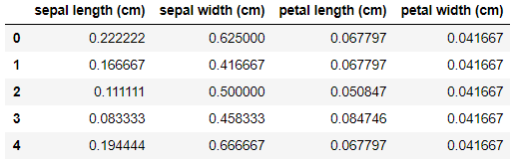
There are 4 features which might not be ideal for visualization and fitting of the clustering model since some of them might be highly correlated. Therefore, we will employ the Principal Component Analysis (PCA) to transform 4-dimensional data into 3-dimensional data while keeping the significance of those predictors with the PCA class from sklearn. The dimensionally-reduced data is as below:

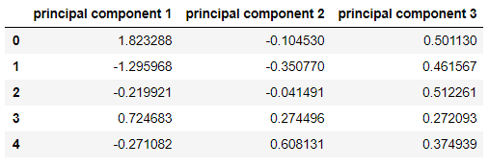

Implementation

1. Medoid Initialization
To start the algorithm, we need an initial guess. Let’s randomly choose 𝑘 observations from the data. In this case, 𝑘 = 3, representing 3 different types of iris.
Next, we will create a function, init_medoids(X, k), so that it randomly selects 𝑘 of the given observations to serve as medoids. It should return a NumPy array of size 𝑘×𝑑, where 𝑑 is the number of columns of X.
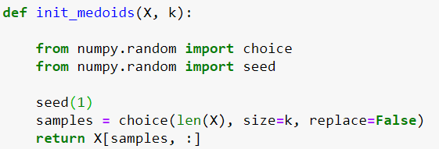

2. Computing Distances

Implementinga function that computes a distance matrix, 𝑆 = (s_𝑖𝑗) such that s_𝑖𝑗 = 𝑑^ 𝑝_𝑖𝑗 is the Minkowski distance of order 𝑝 from point 𝑥_𝑖 to medoid 𝜇_𝑖. It should return a NumPy matrix 𝑆 with shape (𝑚,). (Take p=2 for Euclidean distance)
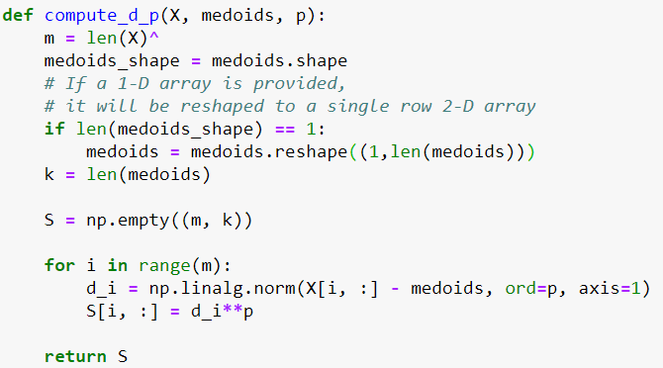

3. Cluster Assignment
Now we build a function that acts on the distance matrix S to assign a “cluster label” of 0, 1, 2 to each point using the minimum distance to find the “most similar” medoid.
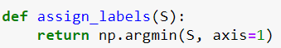
4. Swap Test
In this step, for each medoid 𝑗 and each data point 𝑖 associated to 𝑗 swap 𝑗 and 𝑖 and compute the total cost of the configuration (that is the average dissimilarity of 𝑖 to all the data points, ∑𝑠_𝑖𝑗) as Step 3. Select the medoid 𝑗 with the lowest cost of the configuration.
That is, for each cluster, search if any of the points in the cluster decreases the average dissimilarity coefficient. Select the point that decreases this coefficient the most as the new medoid for this cluster.
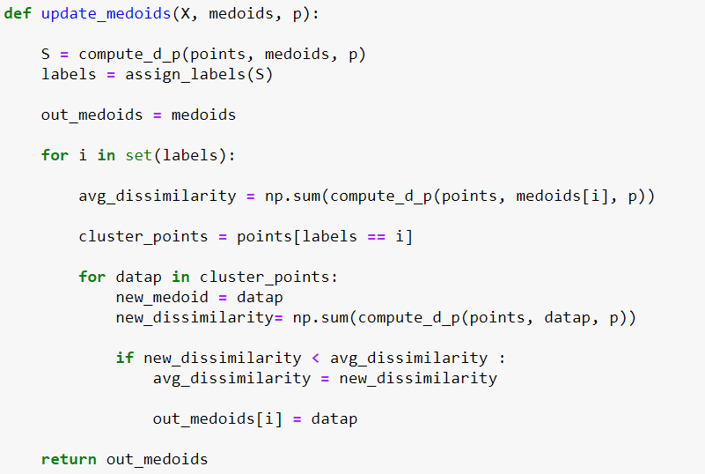

Lastly, we also need a function that checks whether the medoids have “moved,” given two instances of the medoid values. This is the function to check whether the medoids no longer move and the iteration should be stopped.
4. Putting all together
When we combined all the functions above, we essentially combine the steps of a K-Medoids Algorithm.
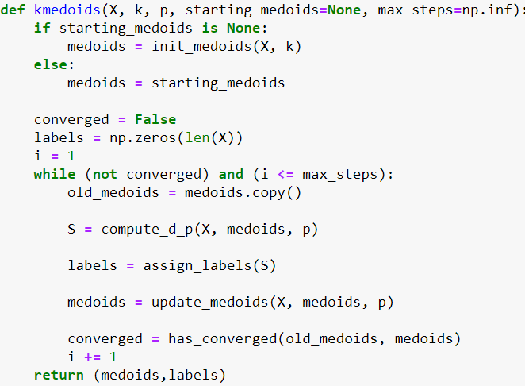
Lab Task:
(CLO5, Marks 6) Complete the code above as per step wise instructions. Some steps like PCA have been covered in previous weeks labs. Perform the data normalization as indicated in data preparation step and match your results as shown in the manual. Perform PCA on data and match your results as shown in the manual

((CLO 6, Marks 1) Perform properly handling of lab.

Further Task:
How is Minkowski Distance computation different from Euclidean Distance computation used for K Means clustering algorithm.

Appendix
# Imports
import pandas as pd
import numpy as np
import matplotlib.pyplot as plt
from mpl_toolkits.mplot3d import Axes3D
from sklearn import datasets
from sklearn.decomposition import PCA

# Dataset
iris = datasets.load_iris()
data = pd.DataFrame(iris.data,columns = iris.feature_names)

target = iris.target_names
labels = iris.target

#Scaling
from sklearn.preprocessing import MinMaxScaler
scaler = MinMaxScaler()
data = pd.DataFrame(scaler.fit_transform(data), columns=data.columns)

#PCA Transformation
from sklearn.decomposition import PCA
pca = PCA(n_components=3)
principalComponents = pca.fit_transform(data)
PCAdf = pd.DataFrame(data = principalComponents , columns = ['principal component 1', 'principal component 2','principal component 3'])

datapoints = PCAdf.values
m, f = datapoints.shape
k = 3

#Visualization
fig = plt.figure(1, figsize=(8, 6))
ax = Axes3D(fig, elev=-150, azim=110)
X_reduced = datapoints
ax.scatter(X_reduced[:, 0], X_reduced[:, 1], X_reduced[:, 2], c=labels,
cmap=plt.cm.Set1, edgecolor='k', s=40)
ax.set_title("First three PCA directions")
ax.set_xlabel("principal component 1")
ax.w_xaxis.set_ticklabels([])
ax.set_ylabel("principal component 1")
ax.w_yaxis.set_ticklabels([])
ax.set_zlabel("principal component 1")
ax.w_zaxis.set_ticklabels([])
plt.show()

def init_medoids(X, k):
from numpy.random import choice
from numpy.random import seed

seed(1)
samples = choice(len(X), size=k, replace=False)
return X[samples, :]

medoids_initial = init_medoids(datapoints, 3)

def compute_d_p(X, medoids, p):
m = len(X)
medoids_shape = medoids.shape
# If a 1-D array is provided,
# it will be reshaped to a single row 2-D array
if len(medoids_shape) == 1:
medoids = medoids.reshape((1,len(medoids)))
k = len(medoids)

S = np.empty((m, k))

for i in range(m):
d_i = np.linalg.norm(X[i, :] - medoids, ord=p, axis=1)
S[i, :] = d_i**p

return S

S = compute_d_p(datapoints, medoids_initial, 2)

def assign_labels(S):
return np.argmin(S, axis=1)

labels = assign_labels(S)

def update_medoids(X, medoids, p):

S = compute_d_p(datapoints, medoids, p)
labels = assign_labels(S)

out_medoids = medoids

for i in set(labels):

avg_dissimilarity = np.sum(compute_d_p(datapoints, medoids[i], p))

cluster_points = datapoints[labels == i]

for datap in cluster_points:
new_medoid = datap
new_dissimilarity= np.sum(compute_d_p(datapoints, datap, p))

if new_dissimilarity < avg_dissimilarity :
avg_dissimilarity = new_dissimilarity

out_medoids[i] = datap

return out_medoids

def has_converged(old_medoids, medoids):
return set([tuple(x) for x in old_medoids]) == set([tuple(x) for x in medoids])

#Full algorithm
def kmedoids(X, k, p, starting_medoids=None, max_steps=np.inf):
if starting_medoids is None:
medoids = init_medoids(X, k)
else:
medoids = starting_medoids

converged = False
labels = np.zeros(len(X))
i = 1
while (not converged) and (i <= max_steps):
old_medoids = medoids.copy()

S = compute_d_p(X, medoids, p)

labels = assign_labels(S)

medoids = update_medoids(X, medoids, p)

converged = has_converged(old_medoids, medoids)
i += 1
return (medoids,labels)

results = kmedoids(datapoints, 3, 2)
final_medoids = results[0]
data['clusters'] = results[1]

#Count
def mark_matches(a, b, exact=False):
"""
Given two Numpy arrays of {0, 1} labels, returns a new boolean
array indicating at which locations the input arrays have the
same label (i.e., the corresponding entry is True).

This function can consider "inexact" matches. That is, if `exact`
is False, then the function will assume the {0, 1} labels may be
regarded as the same up to a swapping of the labels. This feature
allows

a == [0, 0, 1, 1, 0, 1, 1]
b == [1, 1, 0, 0, 1, 0, 0]

to be regarded as equal. (That is, use `exact=False` when you
only care about "relative" labeling.)
"""
assert a.shape == b.shape
a_int = a.astype(dtype=int)
b_int = b.astype(dtype=int)
all_axes = tuple(range(len(a.shape)))
assert ((a_int == 0) | (a_int == 1) | (a_int == 2)).all()
assert ((b_int == 0) | (b_int == 1) | (b_int == 2)).all()

exact_matches = (a_int == b_int)
if exact:
return exact_matches

assert exact == False
num_exact_matches = np.sum(exact_matches)
if (2*num_exact_matches) >= np.prod (a.shape):
return exact_matches
return exact_matches == False # Invert

def count_matches(a, b, exact=False):
"""
Given two sets of {0, 1} labels, returns the number of mismatches.

This function can consider "inexact" matches. That is, if `exact`
is False, then the function will assume the {0, 1} labels may be
regarded as similar up to a swapping of the labels. This feature
allows

a == [0, 0, 1, 1, 0, 1, 1]
b == [1, 1, 0, 0, 1, 0, 0]

to be regarded as equal. (That is, use `exact=False` when you
only care about "relative" labeling.)
"""
matches = mark_matches(a, b, exact=exact)
return np.sum(matches)

n_matches = count_matches(labels, data['clusters'])
print(n_matches,
"matches out of",
len(data), "data points",
"(~ {:.1f}%)".format(100.0 * n_matches / len(labels)))

AIR UNIVERITY
Department of Mechatronics
College of Engineering

ARTIFICIAL INTELLIGENCE LAB
LAB 12
LAB03

Lab Objective: Feature selection strategies to select the most important features from data
Class ID: _____________________ Lab Date: September 15, 2020

Student’s ID: __________________
Lab 12
Lab  03 | Feature selection strategies to select the most important features from data
PLO’s | PLO3 – Design and Development |  | Bloom’s  Taxonomy | C3 – Apply

LAB TASK PERFORMANCE
CLO’s | Aspects of Assessments | Excellent  (75-100%) | Average  (50-75%) | Poor  (<50%) | M
CLO2  100% | Design & Development Design solution for problem that meets specified needs by using the concept of artificial intelligence. | A complete solution / Explain necessary requirements according to task description with great use of time and resource material. | Solution was complete but need minor modifications /student could have followed specification more closely. | Solution was complete but did not work, needed several modifications / did not make correct use of resource material or instructions.

Total Marks: 10

Graded by Engineer: _____________________________ Date: ____________________

Remarks: ___________________________________________________________________________

Objective:

- Make attendee familiar with the concept of feature selection
- Make attendee understand the difference between feature selection and feature extraction (dimensionality reduction)
- Hands-on activity on real data set using the state-of-art Scikit tools for robust feature selection

Feature or Attribute Selection

In machine learning and data science facets of AI, feature selection, also known as variable selection, attribute selection or variable subset selection, is the process of selecting a subset of relevant features (variables, predictors) for use in model construction. Feature selection techniques are used for several reasons:
- simplification of models to make them easier to interpret by researchers/users,^{[1]}
- shorter training times,
- to avoid the curse of dimensionality,
- enhanced generalization by reducing overfitting^{[2]} (formally, reduction of variance^{[1]})
The central premise when using a feature selection technique is that the data contains some features that are either redundant or irrelevant, and can thus be removed without incurring much loss of information. Redundant and irrelevant are two distinct notions, since one relevant feature may be redundant in the presence of another relevant feature with which it is strongly correlated.^{[3]}
Feature selection techniques should be distinguished from feature extraction. Feature extraction creates new features from functions of the original features, whereas feature selection returns a subset of the features. Feature selection techniques are often used in domains where there are many features and comparatively few samples (or data points). Archetypal cases for the application of feature selection include the analysis of written texts and DNA microarray data, where there are many thousands of features, and a few tens to hundreds of samples.

Various strategies are used for the purpose of feature selection. In this lab we shall perform hands-on activity on real-world data set to perform feature selection using the state-of-the-art Scikit toolbox.

Hands-on Activity

The scikit-learn library provides the SelectKBest class that can be used with a suite of different statistical tests to select a specific number of features. We need to install this package
We will consider a diabetes dataset to demonstrate feature selection. The database is available online and can be downloaded from: https://www.kaggle.com/uciml/pima-indians-diabetes-database

We know from data description that there are 8 attributes in the data and the 9th column represents the class (Y/N). So we have numerical inputs and categorical output i.e. the output is a class therefore this is a classification problem:

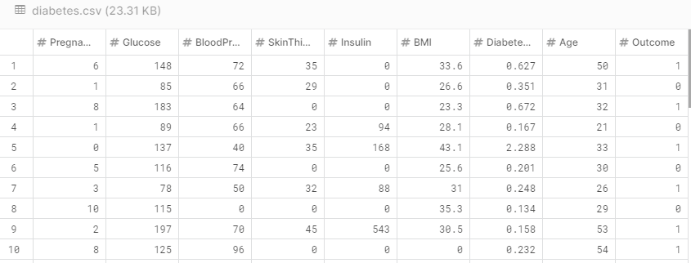

We load the data:

import numpy as np
import pandas as pd #package to fetch the data
from sklearn.feature_selection import SelectKBest
from sklearn.feature_selection import f_classif #ANOVA F-value criterion###

df1=pd.read_csv('E:/Courses/ArtificialIntelligence/Fall2021/Lab/AI Lab Manuals/diabetes.csv')
print (df1.shape)

print (list(df1.columns) )

#We arrange data by having a data matrix X and a class vector Y

np.shape(df1)
array=df1.values#data with class label as 9th column
#print (array.dtype)
array = array.astype('float64')
X=array[:,0:8]#data without class label
y=array[:,8]#class label

print ("Feature data dimension", X.shape)
print (y.shape)

select=SelectKBest(f_classif,k=4) ##handle generation
z = select.fit_transform(X,y)
features=fit.transform(X)
filter = select.get_support()

print("After selecting best 4 features:", z.shape)
print (np.shape(features))

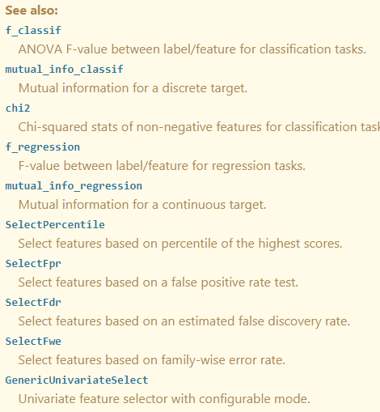
Lab Task:
(CLO2, Marks 4) Complete hands-on activities as prescribed above. Write additional code lines to find out the name of columns which are selected as features. Explain in detail how select KBest function selects the most distinguishing features. Explain the mathematical principle behind it. Write in your own words.
(CLO 6, Marks 1) Perform properly handling of lab.

Further Tasks:
In the home task you will get a chance to perform feature selection on IRIS dataset. IRIS is considered to be a fairly easy data to practice fundamental concepts in AI and machine learning. The dataset is readily available in the famous ‘scikit’ package of Python as discussed in class. You are required to find the most significant feature based on the concept of class relevance. Follow the following steps:
- (CLO2, Marks 1) Load the IRIS dataset
- (CLO2, Marks 1) Fetch the data in a variable ‘X’ and the target values in variable ‘y’
- (CLO2, Marks 3) Now use a ‘for’ loop to iterate through all features one by one calculating the Pearson’s correlation coefficient of each feature with the class variable. Store all coefficients in an array ‘a’.[Hint: Use >>np.corrcoef() command]. Which is the most relevant feature (you are required to give the feature name e.g sepal length, sepal width etc)? What is the class relevance (i.e. correlation coefficient) for this feature?

