AIR UNIVERITY
Department of Electrical
College of Engineering

ARTIFICIAL INTELLIGENCE LAB

LAB05
LAB 04

Lab Objective: Least Square Regression using Gradient Descent

Class ID: _____________________ LabDate:September 29, 2020

Student’s ID: __________________
Lab 04
Lab  05 | Least Square Regression using Gradient Descent
PLO’s | PLO3 – Design and Development |  | Bloom’s  Taxonomy | C3 – Apply

LAB TASK PERFORMANCE
CLO’s | Aspects of Assessments | Excellent  (75-100%) | Average  (50-75%) | Poor  (<50%) | M
CLO2  100% | Design & Development Design solution for problem that meets specified needs by using the concept of artificial intelligence. | A complete solution / Explain necessary requirements according to task description with great use of time and resource material. | Solution was complete but need minor modifications /student could have followed specification more closely. | Solution was complete but did not work, needed several modifications / did not make correct use of resource material or instructions.

Total Marks: 10

Graded by Engineer: _____________________________ Date: ____________________

Remarks: ___________________________________________________________________________

Objective:

- Make attendee familiar with the concept of linear regression
- Elaborate the application of gradient descent for linear regression also called as LMS
- Hands-on implementation on Python

Linear Regression

Linear regression is a linear approach to modelling the relationship between a scalar response (or dependent variable) and one or more explanatory variables (or independent variables). The case of one explanatory variable is called simple linear regression or univariate linear regression.

It is a supervised learning concept, for example in the figure below we have size of houses on the x-axis (input variable) and price of houses on the y-axis (output variable). The data points show the given data set and we are required to learn a model which can predict the unknown output variable (y) on a given test input ‘x’.

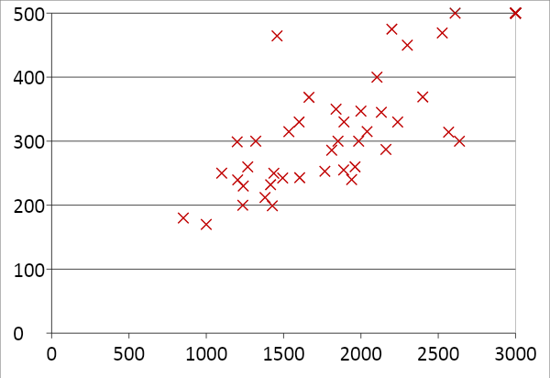

We define our model:
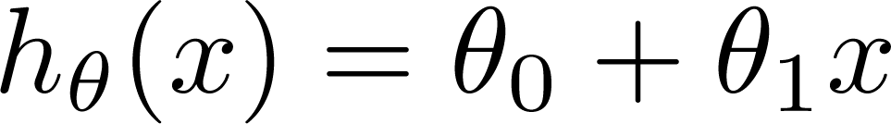
Where \thetas are called as the parameters of the model and are need to be computed carefully. Essentially we use the concept of gradient descent minimization on a squared error cost function:

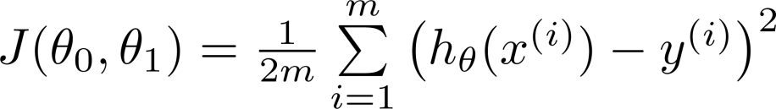
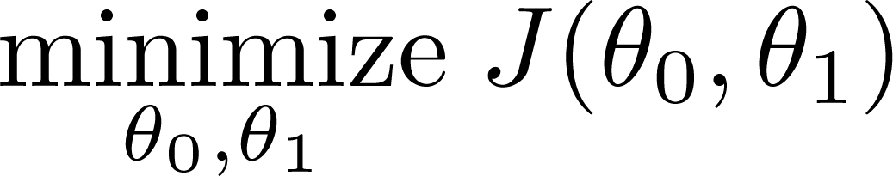

Application of gradient descent will result in the following update rules (derivation needs to be covered during lab):

Hands-on Activity

In this activity we will use the concept of least square regression to iteratively learn and perform predictive analysis on stock-exchange data:

import pandas as pd
import numpy as np
import matplotlib.pyplot as plt

Stock_Market = {'Year': [2017,2017,2017,2017,2017,2017,2017,2017,2017,2017,2017,2017,2016,2016,2016,2016,2016,2016,2016,2016,2016,2016,2016,2016],
'Month': [12, 11,10,9,8,7,6,5,4,3,2,1,12,11,10,9,8,7,6,5,4,3,2,1],
'Interest_Rate': [2.75,2.5,2.5,2.5,2.5,2.5,2.5,2.25,2.25,2.25,2,2,2,1.75,1.75,1.75,1.75,1.75,1.75,1.75,1.75,1.75,1.75,1.75],
'Unemployment_Rate': [5.3,5.3,5.3,5.3,5.4,5.6,5.5,5.5,5.5,5.6,5.7,5.9,6,5.9,5.8,6.1,6.2,6.1,6.1,6.1,5.9,6.2,6.2,6.1],
'Stock_Index_Price': [1464,1394,1357,1293,1256,1254,1234,1195,1159,1167,1130,1075,1047,965,943,958,971,949,884,866,876,822,704,719]
}

df = pd.DataFrame(Stock_Market,columns=['Year','Month','Interest_Rate','Unemployment_Rate','Stock_Index_Price'])

print (df)

x=df.Interest_Rate #We take only one input variable 'x' i.e interest rate
y=df.Stock_Index_Price ##Output variable 'y' i.e. stock index price

theta_0=10
theta_1=10
iters=1000
alpha=0.1
m=x.size
J=np.zeros([1,iters])

for i in range(iters):

h_x = theta_0 + theta_1*x
theta_0 = theta_0 - _____________ #update rule to be inserted by student
theta_1 = theta_1 - ____________ #update rule to be inserted by student

J[0,i]=(1/2*m)*sum(((theta_0+theta_1*x)-y)**2)

#print(J)
print("iteration", i, "loss", J[0,i], "theta_0=",theta_0,"theta_1=",theta_1)
# plt.plot(J.T)
plt.plot(10*np.log10(J.T))
plt.show()

plt.scatter(x,y)
plt.plot(x,theta_0+theta_1*x)
plt.show()

Lab Task:
(CLO 4, Marks 9) Write the code in proper python syntax for the update statements for theta0 and theta1 in the above python code based on the derived equations. You will obtain two graphs for the output.
Sketch screen shots here and analyze the behavior exhibited by the two graphs.
Analyze the change in behavior of the graphs if the number of iterations are progressively varied from 100 to 1000 in steps of 100 keeping alpha constant. Comment on the final values of theta0 and theta1, explaining if any change is seen or expected.
Analyze the change in the behavior of the graphs if the learning rate is varied from 0.0001 to 0.1 keeping iterations constant. Comment on it explaining the change.

Now repeat the above activity but choosing the parameters Unemployment Rate and Stock Index Price. How do the new calculated parameters theta0 and theta1 compare to the previously calculated ones.

(CLO 6, Marks 1) Perform properly handling of lab.

