AIR UNIVERITY
Department of Mechatronics
College of Engineering

ARTIFICIAL INTELLIGENCE LAB
LAB 06
LAB07

Lab Objective: Ordinary Least Square Regression (OLS) hands-on real data
Class ID: _____________________ LabDate:

Student’s ID: __________________

Lab  LAB 06  07 | Ordinary Least Square Regression (OLS) hands-on real data
PLO’s | PLO3 – Design and Development |  | Bloom’s  Taxonomy | C3 – Apply

LAB TASK PERFORMANCE
CLO’s | Aspects of Assessments | Excellent  (75-100%) | Average  (50-75%) | Poor  (<50%) | M
CLO2  100% | Design & Development Design solution for problem that meets specified needs by using the concept of artificial intelligence. | A complete solution / Explain necessary requirements according to task description with great use of time and resource material. | Solution was complete but need minor modifications /student could have followed specification more closely. | Solution was complete but did not work, needed several modifications / did not make correct use of resource material or instructions.

Total Marks: 10

Graded by Engineer: _____________________________ Date: ____________________

Remarks: ___________________________________________________________________________

Objective:

- Make attendee familiar with the concept of univariate ordinary least square regression (OLS)
- Make attendee understand multivariate OLS
- Hands-on activity on real data set using the vectorized implementation of multivariate OLS

Ordinary Least Square Regression (OLS)

Linear regression, also called Ordinary Least-Squares (OLS) Regression, is probably the most commonly used technique in Statistical Learning. It is also the oldest, dating back to the eighteenth century and the work of Carl Friedrich Gauss and Adrien-Marie Legendre. It is also one of the easier and more intuitive techniques to understand, and it provides a good basis for learning more advanced concepts and techniques.

Let us take a simple linear regression to begin with. We want to find the best fit line through a set of data points: (x1, y1), (x2, y2), … (x_m, y_m).
If we can find a slope and an intercept for a single line that passes through all the possible data points, then that is the best fit line. But in most of the cases, such a line does not exist! So we resolve to finding a line such that when a connecting line is drawn parallel to the y-axis from the data points to the regression line, which measures the error of each data point, the sum of all such errors should be minimum. We take an example and define some notations:

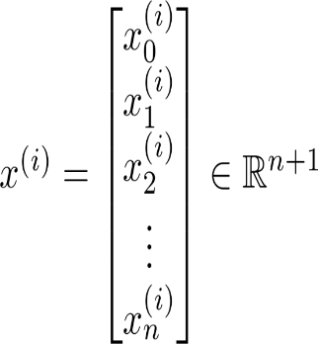

Let’s consider a hypothetical data:

 | Size (feet²) | Number of bedrooms | Number of floors | Age of home (years) | Price ($1000)
1 | 2104 | 5 | 1 | 45 | 460
1 | 1416 | 3 | 2 | 40 | 232
1 | 1534 | 3 | 2 | 30 | 315
1 | 852 | 2 | 1 | 36 | 178
1 | 3000 | 4 | 1 | 38 | 540

The formulation will be:

$$y=Xθ$$

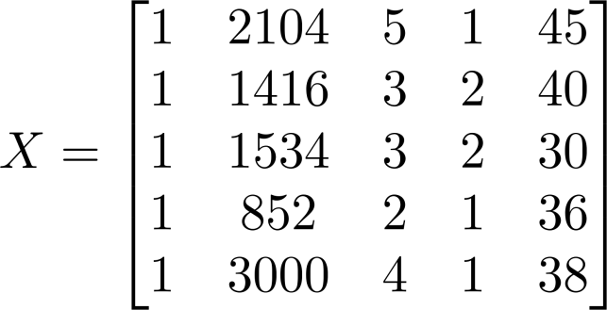
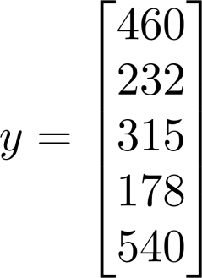

Our problem is to find the unknown vector of parameters:

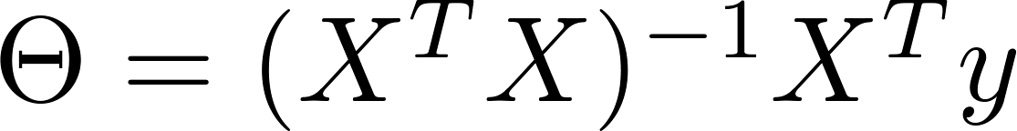

Once the vector of parameters is known, we can easily perform prediction on the unknown data

Hands-on Activity

We shall perform experiments on the Sklearn built-in data set “Boston Housing Data”.

import matplotlib.pyplot as plt
import numpy as np
from sklearn import datasets, linear_model, metrics

# load the boston dataset
boston = datasets.load_boston(return_X_y=False)

##note that if we put return_X_y=True, the output will be in form of tuples and will not be easy to read
##sklearn therefore recommends to put this false for easy access to the data

## now we can explore this data using different commands

print(boston.feature_names) #gives you names of the features#
print(boston.data.shape)## gives you the size of the data
print(boston.target.shape) ## gives you dimensions of the target variable etc

# defining feature matrix(X) and response vector(y)
X = boston.data
y = boston.target
X.shape
y.shape
#now as you can see dimensions of y are showing empty space in col. This is an issue in python and should be fixed

y=y.reshape(-1,1)##this will put y in one column and infer the number of rows automatically

X=np.insert(X,0,np.ones(X.shape[0]),axis=1)#adding the col of ones#

# splitting X and y into training and testing sets, we are going for a 60-40 split
from sklearn.model_selection import train_test_split
X_train, X_test, y_train, y_test = train_test_split(X, y, test_size=0.4,
random_state=1)

##Let's do OLS manually first

tmp1=(np.linalg.inv(np.matmul(X_train.T,X_train)))
tmp2=np.matmul(tmp1,X_train.T)
theta = np.matmul(tmp2,y_train)

Note to read the dataset you can alternately use

df1=pd.read_csv(‘E:/Courses/ArtificialIntelligence/Fall2021/Lab/AI Lab Manuals/diabetes.csv’)

(if the dataset file is provided to you as a csv file)

Or you may read it off the URL directly using

import pandas as pd
import numpy as np

data_url = "http://lib.stat.cmu.edu/datasets/boston"
raw_df = pd.read_csv(data_url, sep="\s+", skiprows=22, header=None)
data = np.hstack([raw_df.values[::2, :], raw_df.values[1::2, :2]])
target = raw_df.values[1::2, 2]

print (raw_df.shape)
print (data.shape)
print (target.shape)

Convert the above code for Spyder environment as explained in class.

Lab Task:
(CLO4, Marks 4) Complete hands-on activities as prescribed above.
(CLO 6, Marks 1) Perform properly handling of lab.

Post Lab Task:
- (CLO4, Marks 2) Perform predictions on the test data X_test and store your predicted values in ‘y_pred’.

- (CLO4, Marks 2) Also plot your predicted values against the true values to see how accurate your predictions are, you may use the following code:

fig, ax = plt.subplots()
ax.plot(y_test,"r-")
ax.plot(y_pred.T)

Give detailed comments on the accuracy obtained?

- Explain why the theoretical value of unknown vector is obtained through using pseudo inverse

And not just simply

$$θ=X^{-1}y$$

