 | Air University  MID TERM Examination: Spring 2026 |  | Student ID:____________
 | Paper Type: Subjective  Note: To be solved on Answer book only |  | Time Allowed: 2 Hours
Subject: Artificial Intelligence |  | Total Time Allowed: 02 Hrs
Course Code: MTE-3321 |  | FM Name: Muhammad Hussain  Total Marks: 50
Class: Fall-2022
Section(s): A |  | FM Signature:
Special Instructions:
INSTRUCTIONS
- Attempt this part after submitting the MCQ section.
- Rough work or writing on question paper will be considered as use of unfair means.
- Tables/calculators allowed/not allowed.

Q1. (CLO-01 & PLO-01: C2) Marks (5+5+5+5)

- Explain the concept of Artificial Intelligence (AI) and the core objective behind the Turing Test.
- Explain the role of an Agent in AI.
- Explain the working of a Simple Reflex Agent and a Goal-Based Agent, including a diagram for each.
- Explain the four components of the PEAS Model and how each component contributes to an agent’s environment.

Q2. (CLO-02 & PLO-02: C3) Marks (15+15)

- Explain Uninformed Search. Also define Depth-First Search (DFS) and specify the data structure used by DFS to manage its frontier.
Explain the following properties of DFS
- Completeness
- Optimality
- Time Complexity

Apply DFS on the tree given below. Starting from the initial node S, trace the execution of DFS until the goal node G is found. List the exact sequence of expanded nodes and the final solution path returned by DFS.

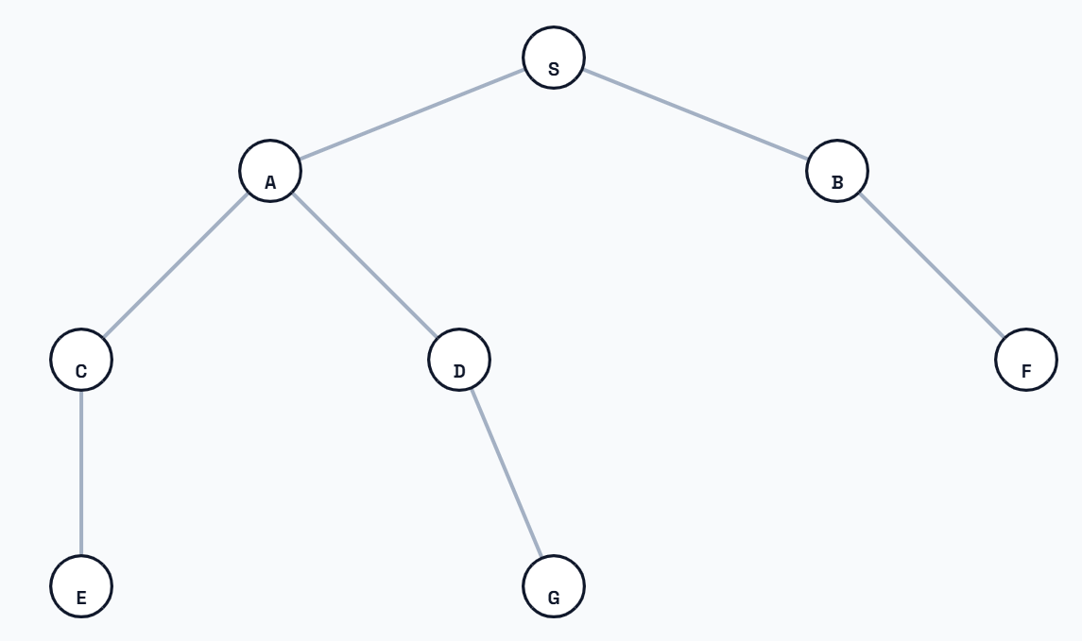

- Explain the working of Uniform-Cost Search (UCS) and identify the data structure used by Uniform-Cost Search (UCS) to manage its open list (node list).
Explain the following properties of Uniform-Cost Search (UCS):

  - Completeness
  - Optimality (considering both positive and negative step costs)

Apply UCS on the tree given below. Starting from the initial node S, trace the execution of UCS until the goal node G is found. List the final solution path returned by UCS.

