Online Grocery Reordering Behavior Finale Report

Dataset Overview
The dataset consists of multiple CSV files describing orders, products, and user.
Order.csv | Order-level metadata | (3,421,083, 7)
Products | Product information | (49,688, 4)
Aisles | Aisle categories | (134, 2)
Departments | Department categories | (21, 2)
Order products prior | Historical purchases | (32,434,489, 4)
Order products train | Training purchases | (1,384,617, 4)

After merging all relevant tables, the final dataset contains:
- Total rows: 33,819,106
- Total columns: 20
Key statistics:
- Unique users: 206,209
- Unique orders: 3,346,083
- Unique products: 49,685

Data Quality & Missing Values

One column has missing values (days_since_prior_order) with 6.14%

Class distribution

Class(1) reordered 59%

Class(2) not reordered 41%

The number of items per order (cart size) shows the following statistics:
- Mean: 10.1 items
- Median: 8 items
- 25th percentile: 5 items
- 75th percentile: 14 items
- Maximum: 145 items
Insight:
- Most orders contain a moderate number of items.
- A small number of very large cart exist, likely representing bulk or business purchases.

And here are the visualization that show the distributions of different features and the reorder rate by time(hour and week) and lastly did in the EDA and visualization looking at the correlations between numerical features that gave an insight(Findings “No extremely strong linear correlations with the target” and “ Weak to moderate relationships suggest that nonlinear models may perform better”) other distribiutions gave us good insights too.

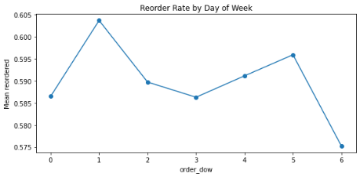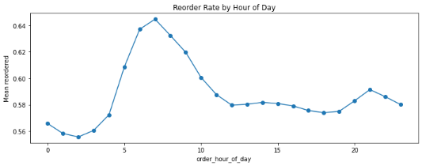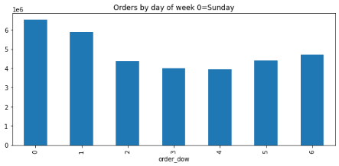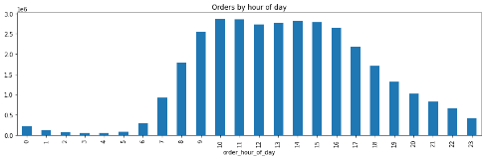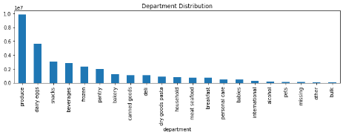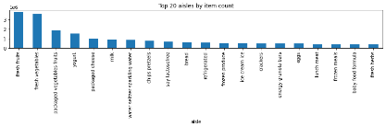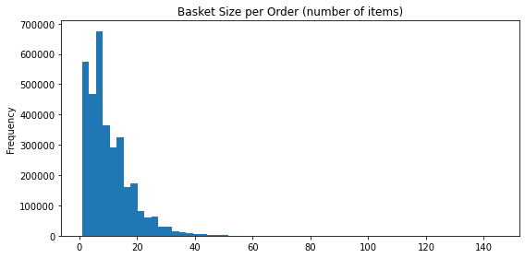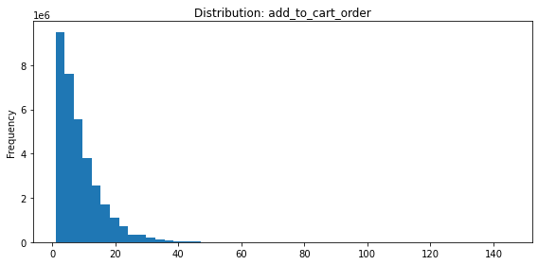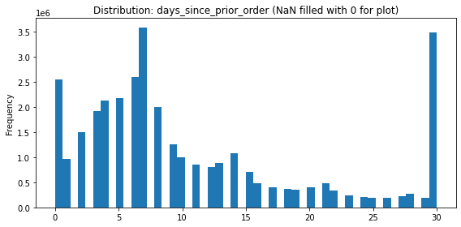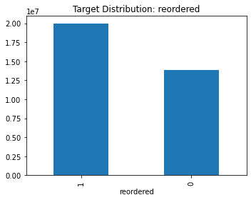
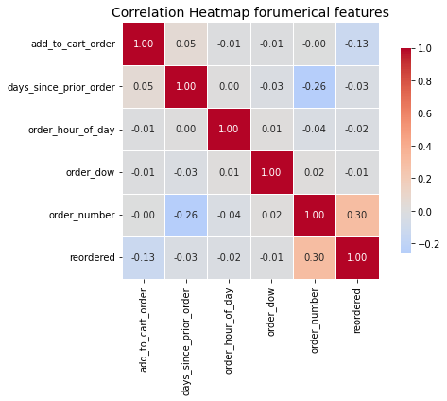

Feature engineering : next day…

