HUSSAIN ALI L1F26BSCS0296
TASK 8: FLOWCHART
Ticket Generator
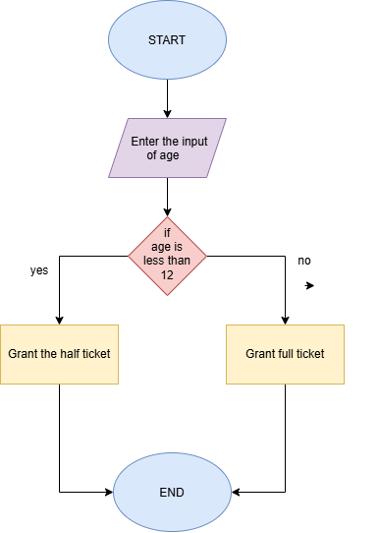

TABLE:

No | Age | Age <12 | Ticket printed
1 | 8 | Yes | Half
2 | 12 | No | Full
3 | 30 | yes | Half

TASK 7: FLOWCHART
Weather app:

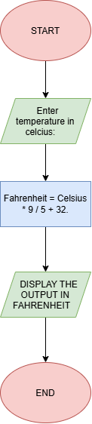

TASK 3:
Predict the output:

No. | Expression | Your Prediction | Actual Output
1 | 10 + 5 * 2 | 20 | 20
2 | (10 + 5) * 2 | 30 | 30
3 | 20 - 5 - 3 | 12 | 12
4 | 100 / 7 | 14 | 14
5 | 100 % 7 | 2 | 2
6 | 2 * 3 + 8 / 4 - 1 | 7 | 7

TASK 6:

Variable | Your Prediction | Actual Output
total | 750 | 750
tax | 37 | 37
grandTotal | 787 | 787

