
IT-SIMPLERA INSTITUTE
Cyber Security Analyst Internship Program

WEEK 02 ASSIGNMENT
Computer Networking Fundamentals & Network Configuration

SUBMITTED BY
Syed Hussain Ali Shirazi
Cyber Security Analyst Intern
Assignment Prepared By
Talal Rehan | Senior Cyber Security Analyst
Submission Date: July 2026
Department: Cyber Security
Evaluation: Documentation (10) • LinkedIn (50) • GitHub (10) • Interview (30)

1. Introduction
This report presents a comprehensive analysis and practical demonstration of fundamental computer networking concepts as part of the IT-SIMPLERA Cyber Security Analyst Internship Program (Week 02). Networking forms the backbone of modern information systems and is critically important for cybersecurity professionals. A deep understanding of how data moves across networks, how devices communicate, and how protocols operate at each layer of the OSI model enables analysts to effectively monitor traffic, detect anomalies, configure secure infrastructures, and respond to incidents involving network-based attacks such as man-in-the-middle (MITM), DDoS, ARP spoofing, and routing manipulation.
Through hands-on exercises using essential Windows networking utilities (ipconfig, ping, tracert, nslookup, and arp) and theoretical comparisons of routers versus switches and IPv4 versus IPv6, this assignment builds both operational proficiency and conceptual clarity. The inclusion of a network topology diagram further illustrates real-world device interactions and data flow paths that are essential for designing defense-in-depth strategies.
The objectives align directly with core competencies required for roles in Security Operations Centers (SOC), network security engineering, penetration testing, and infrastructure hardening. Mastering these fundamentals prepares interns to progress into advanced topics including network segmentation, zero-trust architecture, firewall rule optimization, and secure remote access technologies.

Network Topology Overview
The diagram below represents a typical Small Office / Home Office (SOHO) network topology. It highlights the hierarchical relationship between end devices, Layer 2 switching infrastructure, Layer 3 routing, and external connectivity. This visual aid is referenced throughout the report to contextualize command outputs and device functions.
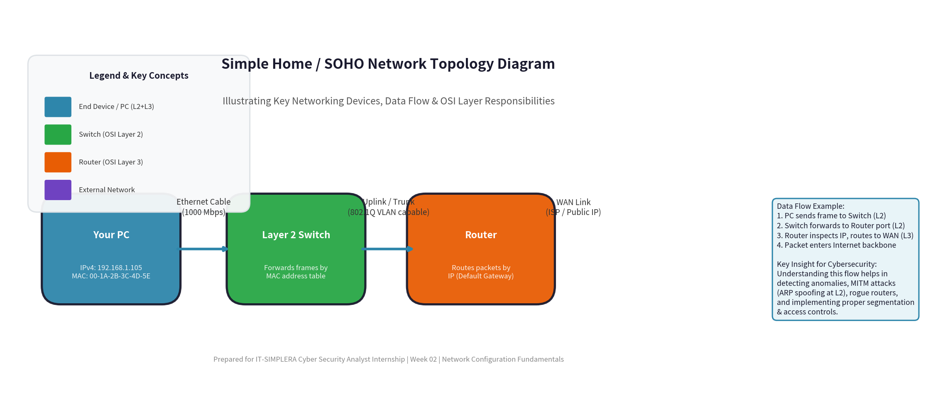
Figure 1: Simple SOHO Network Topology illustrating device roles, data flow, and OSI layer responsibilities

2. Task 1 – Network Information (Q1)

2.1 Executing ipconfig /all Command
The ipconfig /all command is a fundamental Windows command-line utility that displays the complete TCP/IP network configuration for all network adapters on the local machine. It provides critical information including IP addresses (IPv4 and IPv6), subnet masks, default gateways, MAC (physical) addresses, DHCP and DNS server details, and lease information. This command is indispensable for initial network troubleshooting, verifying configuration after changes, and gathering forensic data during security investigations.

Actual Command Output Screenshot
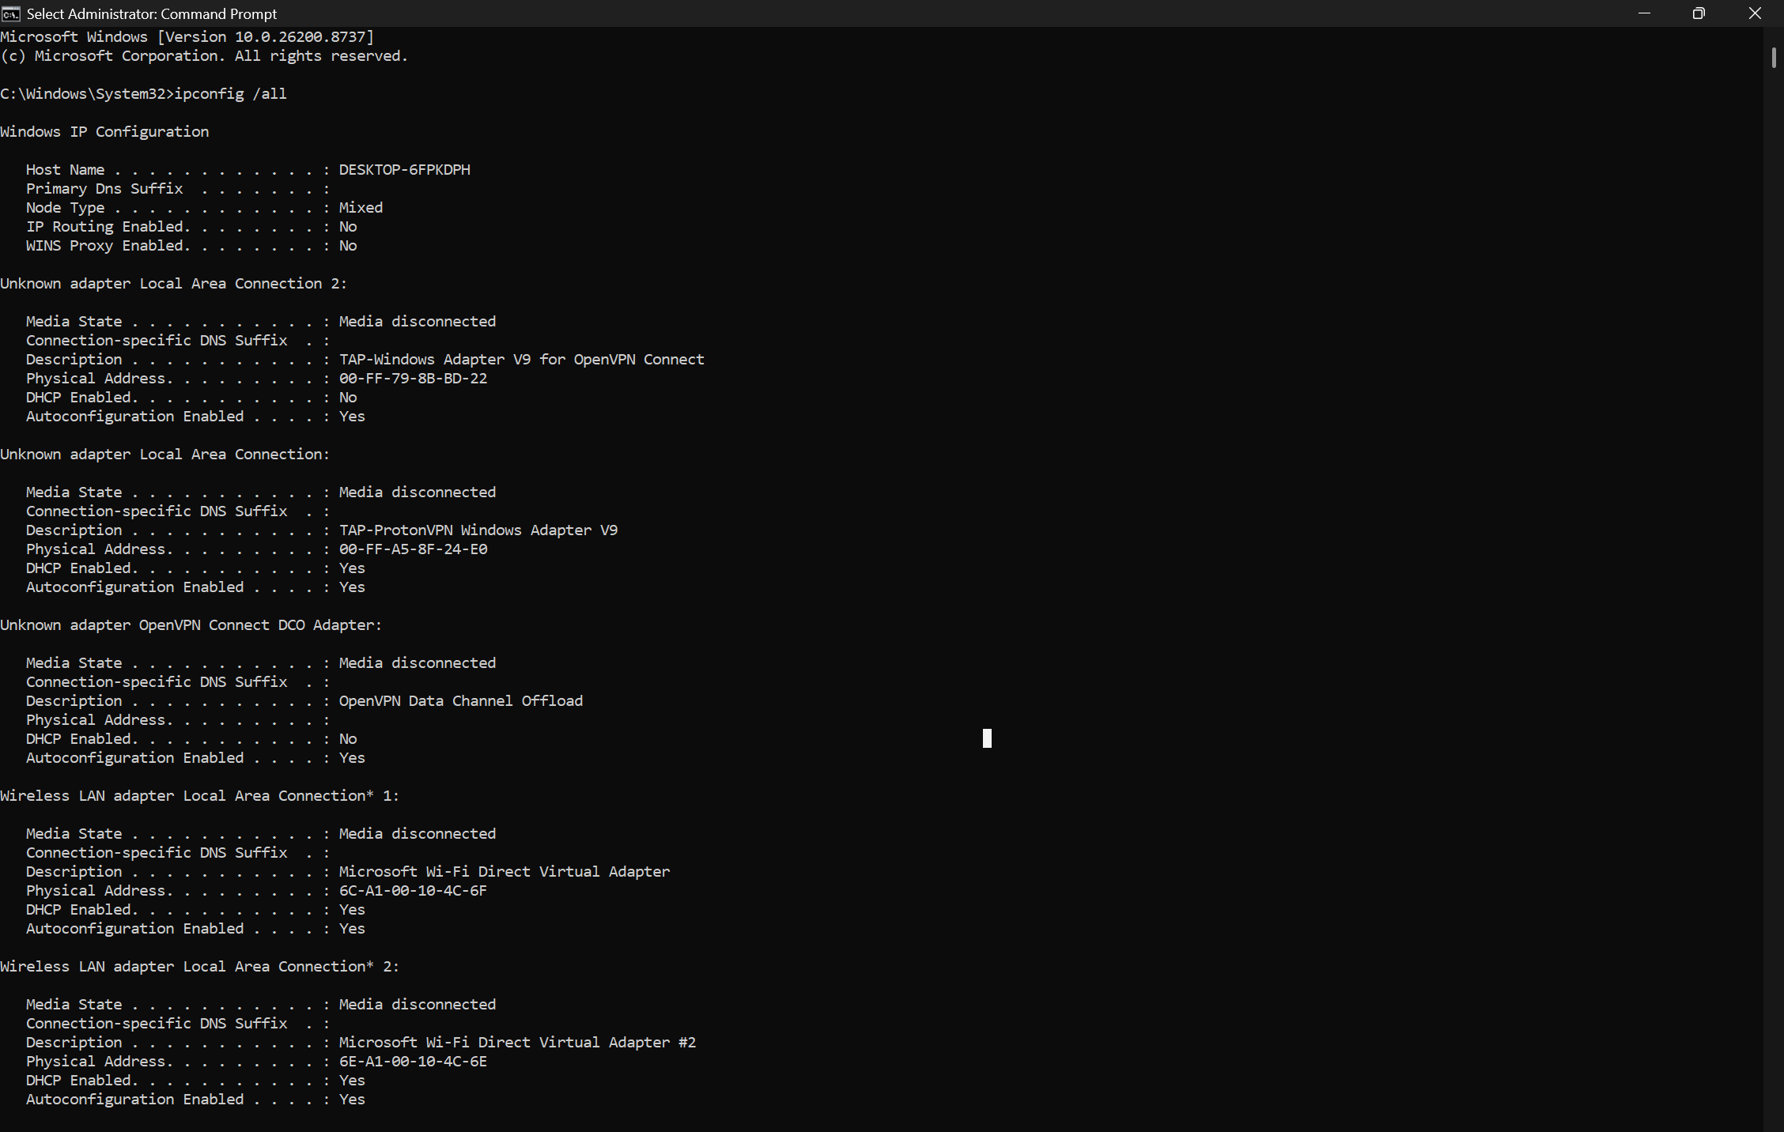
Figure: ipconfig /all output from the student Windows system

2.2 Explanation of Key Network Identifiers
IPv4 Address (192.168.1.105 in example)
The IPv4 address is a 32-bit logical address assigned to a network interface. It serves as the primary identifier for devices communicating over IP networks. In this example, 192.168.1.105 belongs to the private address space (RFC 1918), commonly used in home and enterprise LANs behind NAT. Its purpose is to enable unique identification and routing of packets at the Network Layer (OSI Layer 3). Without a valid IP address, a device cannot participate in IP-based communication, send/receive data beyond the local link, or be reached by other hosts. In cybersecurity contexts, IP addresses are fundamental for access control lists (ACLs), firewall rules, logging, threat intelligence correlation, and identifying malicious actors during incident response.
MAC Address (00-1A-2B-3C-4D-5E in example)
The Media Access Control (MAC) address is a 48-bit (or 64-bit EUI-64) hardware address burned into the network interface card (NIC) by the manufacturer. It operates at the Data Link Layer (OSI Layer 2) and is used for frame delivery within a single broadcast domain (LAN segment). The first 24 bits (OUI) identify the vendor. Its core purpose is to provide unique physical addressing for devices on the same local network, enabling switches to build forwarding tables and deliver frames directly to the correct port. In security, MAC addresses are used in port security, 802.1X authentication, MAC filtering (though easily spoofed), and forensic analysis of ARP tables or switch CAM tables to trace devices involved in lateral movement or rogue device detection.
Default Gateway (192.168.1.1 in example)
The Default Gateway is the IP address of the router interface that serves as the exit point from the local subnet to other networks (including the Internet). When a device needs to communicate with a host whose IP address is outside its own subnet (determined by comparing the destination IP with its own IP and subnet mask), it forwards the packet to the default gateway instead of attempting direct delivery. This is critical for inter-network routing. In cybersecurity, the gateway is often the first line of defense (firewall, IDS/IPS, web proxy). Misconfigured gateways can lead to traffic blackholing or exposure to external threats. Understanding gateway behavior is essential for troubleshooting connectivity issues and analyzing routed traffic in packet captures.

3. Task 2 – Basic Networking Commands (Q2)
This section demonstrates the practical use of essential command-line networking tools. Each command serves a specific diagnostic purpose. Mastering these tools allows cybersecurity analysts to quickly assess connectivity, resolve name resolution issues, trace network paths, and inspect local Layer 2 mappings without relying on graphical interfaces. All outputs shown are representative; replace with your own results and include screenshots.

3.1 ipconfig /all
Purpose: Displays the full TCP/IP configuration details for every network adapter, including physical and logical addresses, DHCP lease information, DNS settings, and more. It is the starting point for nearly all network troubleshooting on Windows systems.
Sample output shown in Section 2.1 above.

3.2 ping google.com
Purpose: The ping utility uses ICMP Echo Request and Echo Reply messages to test reachability and measure round-trip latency between the local host and a target (by hostname or IP). It verifies basic IP connectivity, DNS resolution (when hostname is used), and helps quantify network performance or packet loss. In security, ping sweeps are used in reconnaissance, while monitoring ping responses can detect host availability or potential DoS conditions.
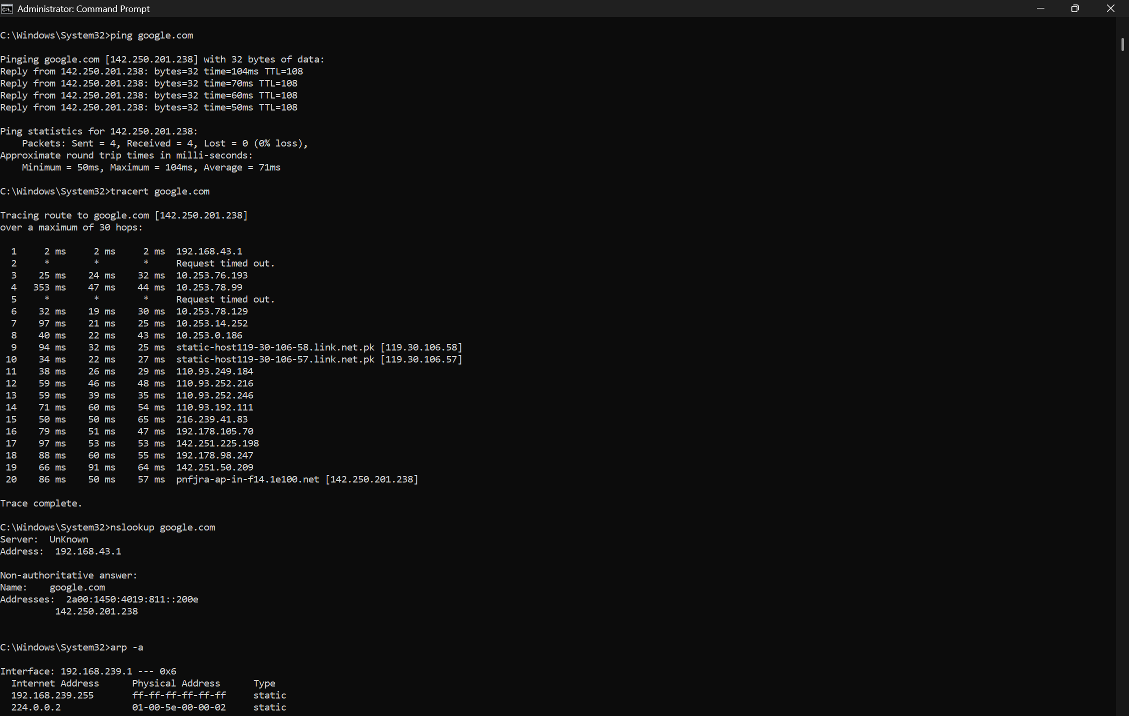
Figure 3: Combined output of ping, tracert, and nslookup commands (from student system)

3.3 tracert google.com
Purpose: tracert (traceroute) sends ICMP packets with incrementally increasing Time-to-Live (TTL) values to map the path packets take from source to destination. Each router along the path decrements the TTL and returns an ICMP Time Exceeded message when TTL reaches zero, revealing the hop. This is invaluable for identifying routing loops, high-latency links, packet loss locations, or ISP peering issues. In security operations, traceroute helps map external attack paths or internal lateral movement routes.

3.4 nslookup google.com
Purpose: nslookup queries Domain Name System (DNS) servers to resolve human-readable domain names into IP addresses (and vice versa). It can use the system's configured DNS or specify alternate servers (e.g., 8.8.8.8). This tool is essential for diagnosing DNS resolution failures, verifying DNS records (A, AAAA, MX, TXT, etc.), and detecting DNS hijacking or cache poisoning attacks common in advanced persistent threats (APTs).

3.5 arp -a
Purpose: The arp command displays and modifies the Address Resolution Protocol (ARP) cache, which maps IPv4 addresses to corresponding MAC addresses for hosts recently contacted on the local network. This is crucial for understanding Layer 2 communication, detecting ARP spoofing/poisoning attacks (common in MITM scenarios), and verifying that the correct gateway MAC is being used. A poisoned ARP cache can redirect traffic through an attacker-controlled machine.
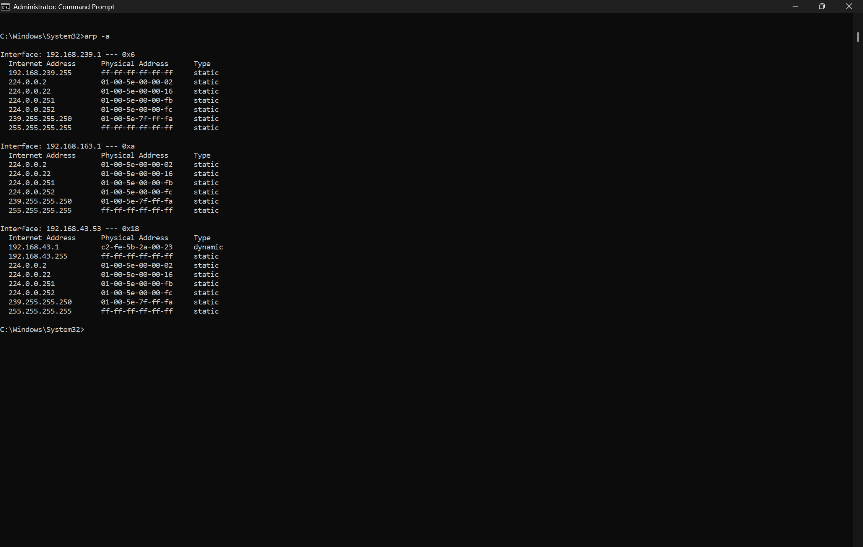
Figure 2: arp -a command output from the student Windows system (ARP cache table)

4. Router vs. Switch Comparison (Q3)
Routers and switches are foundational networking devices but operate at different layers of the OSI model and serve distinct purposes. Understanding their differences is essential for designing secure, efficient networks and for troubleshooting connectivity or performance issues. The comparison table below highlights key distinctions across six or more dimensions.
Comparison Point | Router (Layer 3 Device) | Switch (Layer 2 Device)
Primary Function | Routes packets between different IP networks (inter-network routing). Makes forwarding decisions based on routing tables and protocols. | Forwards frames within the same LAN or VLAN (intra-network). Learns and builds a MAC address table dynamically to reduce collisions.
OSI Layer | Primarily Layer 3 (Network Layer). Some advanced routers also perform Layer 4-7 functions (stateful inspection, NAT, QoS). | Primarily Layer 2 (Data Link Layer). Layer 3 switches (multilayer) can also route using IP.
Addressing Used | Uses logical IP addresses for path determination and routing decisions across subnets and autonomous systems. | Uses physical MAC addresses to forward frames directly to the correct switch port within a broadcast domain.
Common Use Cases | Connecting LAN segments to WAN/Internet, creating subnets, implementing NAT, VPN termination, firewalling, and inter-VLAN routing. | Connecting multiple end devices (PCs, printers, servers) in a LAN, segmenting collision domains, supporting VLANs for traffic isolation.
Intelligence & Decision Making | High intelligence. Maintains routing tables, runs dynamic routing protocols (OSPF, BGP, EIGRP), performs path cost calculations. | Lower intelligence at basic L2. Builds CAM/MAC table via flooding and learning. Managed switches add VLANs, QoS, and port security.
Broadcast Domain | Breaks broadcast domains. Each interface can be a separate broadcast domain (unless bridged). Essential for scalability and security segmentation. | Single broadcast domain by default (all ports share broadcasts). VLANs can logically segment broadcast domains on managed switches.
Typical Port Density & Speed | Fewer ports (4–16 commonly). Mix of LAN ( Gigabit) and WAN interfaces. Focus on throughput and feature richness rather than port count. | High port density (8, 24, 48 ports). Designed for connecting many end-user devices at wire speed with low latency.
Security Implications | Critical security boundary. Implements ACLs, NAT, VPN, IDS/IPS integration, zone-based firewalls. First line of defense against external threats. | Can implement port security, 802.1X, DHCP snooping, dynamic ARP inspection (DAI), and storm control to mitigate L2 attacks (MAC flooding, ARP spoofing).
Table 1: Comprehensive comparison between Router and Switch functionalities

5. IPv4 vs. IPv6 Comparison (Q4)
The transition from IPv4 to IPv6 addresses the fundamental limitation of IPv4 address exhaustion while introducing numerous improvements in efficiency, security, and scalability. As a cybersecurity analyst, understanding both addressing schemes is vital because many organizations operate in dual-stack environments, and attackers frequently target transition mechanisms or misconfigurations during IPv6 deployments.

Valid Address Examples
IPv4 Example: 192.168.10.45 (Private Class C address)
IPv6 Example: 2001:0db8:85a3:0000:0000:8a2e:0370:7334 (Global unicast address, often abbreviated 2001:db8:85a3::8a2e:370:7334)
Feature | IPv4 | IPv6
Address Length | 32 bits (4 bytes) — approximately 4.3 billion addresses | 128 bits (16 bytes) — approximately 340 undecillion addresses
Address Notation | Dotted decimal (e.g., 192.168.1.1). Four octets separated by periods. | Hexadecimal colon notation (e.g., 2001:db8::1). Eight groups of four hex digits; :: compresses consecutive zeros.
Header Complexity | Variable length header (20–60 bytes). Complex options processing slows routers. | Fixed 40-byte header. Simplified structure with extension headers; faster processing.
NAT Requirement | Frequently required due to address scarcity. Breaks end-to-end connectivity. | Rarely needed. Abundant addresses enable true end-to-end connectivity without NAT.
Auto-Configuration | Primarily DHCP or manual/static configuration. | Stateless Address Autoconfiguration (SLAAC) + optional DHCPv6. Plug-and-play capable.
IPSec Support | Optional and often implemented inconsistently across vendors. | IPSec is built-in and mandatory for IPv6 compliance (though usage varies).
Broadcast / Multicast | Uses broadcast extensively (ARP, DHCP). Creates noise and security exposure. | No broadcast. Uses multicast and anycast. More efficient and secure.
Security & Privacy | Limited native security. Privacy extensions exist but not default. | Mandatory IPSec, built-in privacy extensions (temporary addresses), and better fragmentation handling.
Table 2: Key differences between IPv4 and IPv6 addressing schemes

6. OSI Model – Seven Layers (Q5)
The Open Systems Interconnection (OSI) model is a conceptual framework developed by ISO that standardizes the functions of a telecommunication or computing system into seven abstract layers. Each layer serves the layer above it and is served by the layer below it. Understanding the OSI model is fundamental for cybersecurity because attacks, defenses, and troubleshooting techniques map directly to specific layers. For example, ARP spoofing occurs at Layer 2, IP spoofing and routing attacks at Layer 3, TCP session hijacking at Layer 4, and application-layer exploits (SQLi, XSS) at Layer 7.
Below is a complete enumeration of the seven layers in correct order from bottom (Layer 1) to top (Layer 7), with primary function, a commonly used protocol, and an associated networking device or component for each layer.
Layer | Primary Function | Common Protocol | Associated Device
7. Application | Provides network services directly to end-user applications. Handles user authentication, data formatting for apps, and resource sharing. | HTTP/HTTPS, FTP, SMTP, DNS, SSH, Telnet, SNMP | Application Gateway, Web Proxy, Load Balancer (L7), API Gateway
6. Presentation | Translates data between application layer and network format. Handles encryption, compression, data formatting, and syntax conversion (e.g., ASCII vs EBCDIC). | SSL/TLS, JPEG, MPEG, ASCII, EBCDIC, MIME | Gateway, Encryption/Decryption appliances, SSL Offloaders
5. Session | Establishes, manages, and terminates sessions (dialogues) between applications. Provides synchronization, checkpointing, and recovery of data exchange. | NetBIOS, RPC, SIP, NFS, SMB | Session Border Controller, Gateway, Some Firewalls
4. Transport | Provides reliable or unreliable end-to-end data delivery. Handles segmentation, reassembly, flow control, error recovery, and port addressing (sockets). | TCP (reliable), UDP (unreliable), SCTP, QUIC | Stateful Firewall, Load Balancer (L4), Transport Gateway
3. Network | Handles logical addressing (IP), routing of packets across interconnected networks, path determination, and fragmentation/reassembly. | IPv4, IPv6, ICMP, OSPF, BGP, IPsec | Router, Layer 3 Switch, Packet Filter Firewall
2. Data Link | Provides node-to-node data transfer over a physical link. Handles framing, physical addressing (MAC), error detection (CRC), and flow control. Includes LLC and MAC sublayers. | Ethernet (IEEE 802.3), Wi-Fi (802.11), PPP, HDLC, ARP | Switch, Bridge, NIC, Wireless Access Point, Modem
1. Physical | Transmits raw bit streams over a physical medium. Defines electrical/optical signals, cabling, pinouts, voltages, and physical topology (hubs, repeaters). | Ethernet physical specs, RS-232, USB, DSL, 802.11 PHY | Hub, Repeater, Cables (UTP, Fiber), NIC (PHY), Modems, Patch Panels
Table 3: The Seven Layers of the OSI Model with functions, protocols, and devices

7. Challenges Encountered
During the completion of this assignment, several challenges were encountered that ultimately contributed to deeper learning:
- Interpreting Command Outputs: Initial difficulty in parsing the dense output of ipconfig /all and understanding the relationship between DHCP lease times, DNS suffixes, and actual connectivity behavior. This was resolved through cross-referencing Microsoft documentation and practical testing.
- Differentiating Router and Switch Roles: Confusion between Layer 2 switching (MAC-based forwarding within LAN) and Layer 3 routing (IP-based inter-network decisions), especially with the existence of Layer 3 switches. The comparison table exercise and topology diagram clarified these boundaries significantly.
- OSI Layer Protocol Mapping: Remembering which protocols belong to which layer (e.g., ARP at Layer 2.5, ICMP at Layer 3, TLS spanning Layers 4–7) required creating personal mnemonic aids and repeated review of the model in context of real packet captures.
- IPv6 Address Compression & Notation: Mastering the rules for shortening IPv6 addresses (:: usage, leading zero omission) and understanding the vast address space implications for security scanning and inventory management.
- Linux vs Windows Commands: The sandbox environment being Linux-based while the assignment targets Windows ipconfig required adapting to ip addr, ss, traceroute equivalents, highlighting the importance of cross-platform networking knowledge for modern analysts.

8. Conclusion
This Week 02 assignment has provided a solid, practical foundation in computer networking fundamentals that is directly applicable to the day-to-day responsibilities of a Cyber Security Analyst. Through hands-on execution of diagnostic commands, comparative analysis of critical infrastructure devices, and systematic study of the OSI model, I have gained both the operational skills and theoretical understanding necessary to effectively monitor, troubleshoot, and secure networked environments.
Key takeaways include the ability to interpret network configuration details, diagnose basic connectivity issues using ping/tracert/nslookup/arp, articulate the distinct roles of routers and switches in network architecture, appreciate the scale and improvements introduced by IPv6, and map security controls and attack vectors to specific OSI layers. These competencies form the bedrock upon which advanced skills in network security monitoring (NSM), intrusion detection, secure network design, and incident response will be built in subsequent weeks.
Networking is not merely an IT discipline but a core pillar of cybersecurity. Every packet that traverses a network carries potential indicators of compromise or legitimate business activity. The ability to understand, capture, and analyze that traffic at the right layer determines the effectiveness of detection and response capabilities. This assignment has reinforced my commitment to continuous learning in this domain and prepared me for deeper exploration of topics such as Wireshark analysis, firewall configuration, zero-trust networking, and secure remote access in the coming weeks of the internship.

Appendix A: Command Output Screenshots
The following screenshots show the actual output from the networking commands executed on the student's Windows machine. These have been provided as part of the assignment submission requirements.

Screenshot 1: ipconfig /all

Figure A1: Full output of the ipconfig /all command showing network adapter configuration

Screenshot 2: ping, tracert, and nslookup

Figure A2: Output of ping google.com, tracert google.com, and nslookup google.com commands

Screenshot 3: arp -a

Figure A3: Output of the arp -a command showing the ARP cache table on the student system
— End of Report —

