CS-3009 Software Engineering

E-Val: Online Exam and Quiz Management System

Product Backlog

Team Name: Procrafters



Members:

I220827 – Muhammad Ali

I220902 – Hussain Ali Zaidi

I221186 – Abdullah bin Azeem

Submission Date: 23/03/2025

# Product Backlog Table

| **ID** | **User Story** | **Priority** | **Acceptance Criteria** | **Effort Estimate (Story Points)** |
| --- | --- | --- | --- | --- |
| 1 | As a User, I want to log in so that I can access my dashboard. | High | User is redirected to dashboard upon successful login. | 3 SP |
| 2 | As a Student, I want to register an account so that I can access quizzes. | High | Student account is created successfully. | 3 SP |
| 3 | As a Teacher, I want to register an account so that I can create and manage quizzes. | High | Teacher account is created successfully. | 3 SP |
| 4 | As a User, I want to reset my password so that I can regain access if I forget it. | Medium | Reset email is sent, and password is updated. | 2 SP |
| 5 | As a User, I want the system to verify my email upon registration to ensure security. | High | User receives an email verification link. | 1 SP |
| 6 | As a Teacher, I want to create quizzes so that my students can attempt them. | High | Teacher can add, edit, and publish quizzes. | 13 SP |
| 7 | As a Student, I want to attempt quizzes so that I can test my knowledge. | High | Quiz answers are recorded and submitted. | 8 SP |
| 8 | As a Teacher, I want to set a marking criteria for quizzes so that the system can grade them accordingly. | High | Teacher defines grading rules successfully. | 5 SP |
| 9 | As a System, I want to automatically grade quizzes based on predefined criteria so that students get instant results. | High | The system grades quizzes instantly. | 8 SP |
| 10 | As a Student, I want to review my past quiz attempts so that I can identify mistakes and improve. | Medium | Past quiz attempts are accessible. | 3 SP |
| 11 | As a School Admin, I want to assign teachers to classes so that they can manage exams and quizzes. | High | Teachers are assigned successfully. | 2 SP |
| 12 | As a Teacher, I want to view classes assigned to me so I can manage examinations, announcements, and student grades. | High | Teacher sees assigned classes. | 3 SP |
| 13 | As a Teacher, I want to track the progress of my entire class so that I can identify students who need help. | Medium | System generates performance reports. | 8 SP |
| 14 | As a Student, I want to enroll in an available class to take exams by either opting for it or getting an invitation from a teacher. | Medium | Student joins a class successfully. | 3 SP |
| 15 | As a Teacher, I want to add and view class materials so that students can access study resources. | Medium | Study materials are uploaded successfully. | 2 SP |
| 16 | As a Student, I want to view class materials so that I can access resources provided by my teacher. | Low | Students can access class materials. | 1 SP |
| 17 | As a Teacher, I want to view students' quiz scores so that I can assess their performance. | High | Teacher sees quiz results per student. | 5 SP |
| 18 | As a Student, I want to view my quiz scores so that I can see my performance on individual quizzes. | High | Student sees graded quiz scores. | 3 SP |
| 19 | As an Admin, I want to configure system settings so that I can manage platform behavior and security. | Low | Admin successfully updates settings. | 4 SP |
| 20 | As an Admin, I want to reset passwords for users so that I can assist them in regaining access. | Low | Admin resets passwords for users. | 3 SP |

# Prioritization Justification

* **High Priority Stories** are essential for the platform’s core functionality, including authentication, quiz management, and automatic grading.
* **Medium Priority Stories** focus on improving usability, tracking, and administrative features.
* **Low Priority Stories** (if applicable) would involve enhancements that are not immediately necessary for MVP but could be implemented later.

# Sprint Planning Notes

* **Sprint 1:** Focus on authentication (user registration, login, password reset, email verification).
* **Sprint 2:** Implement quiz creation and assignment by teacher. Handle Class assignment by Admin.
* **Sprint 3:** Develop class management, material uploads. Attempt Quiz by Student and automatic grading.

# Version Control

# Trello Board

Start: Showing Sprint 1 Items that were scheduled, done and leftover.

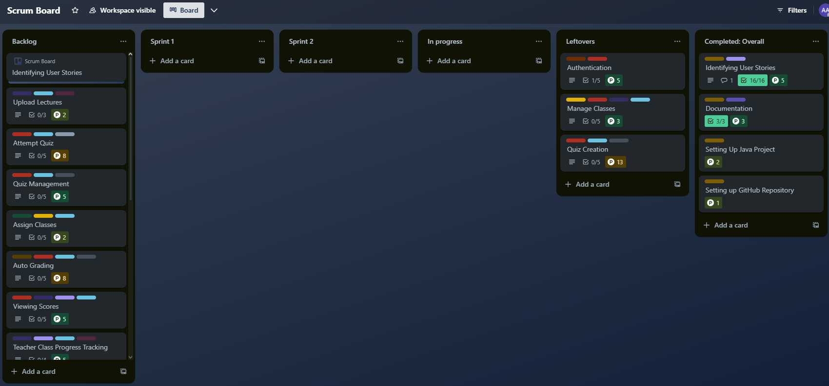

Sprint 2 Start: Leftovers moved to Sprint 2 along with new User Stories (Tasks)

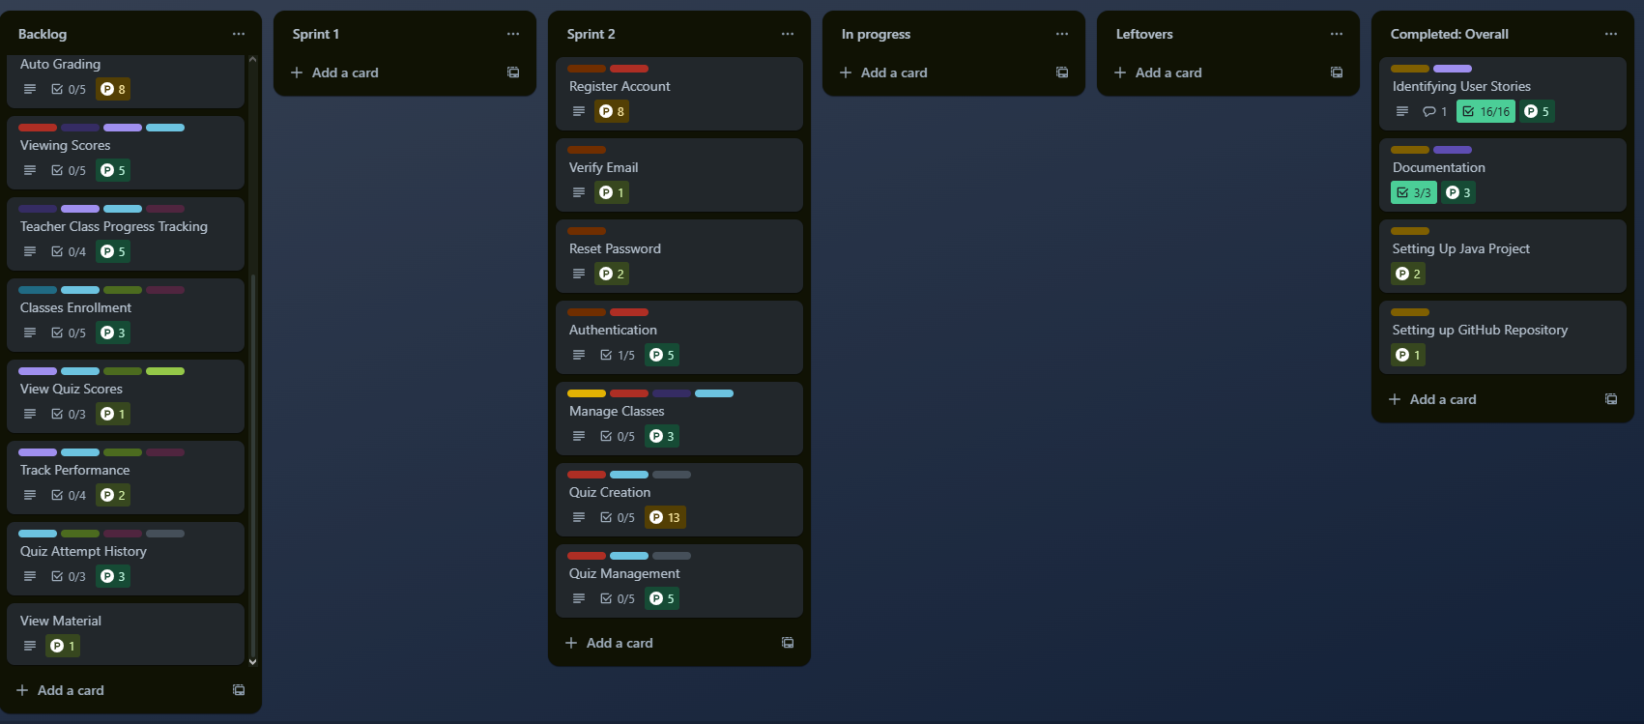

Mid Sprint: Some User Tasks in Progress

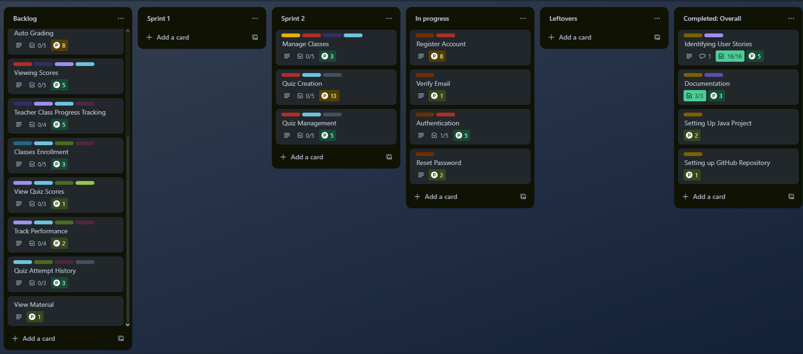

Sprint 2 End: Some Tasks done, few leftover.

