# Kubernetes_Ubuntu

Setup Kubernetes Cluster with Zero Cost

This tutorial will help you to setup Kubernetes cluster (1 Master and 2 worker Nodes) on your Laptop. You need have windows 10 with minimum 8 GB of RAM. We will bootstrap all 3 machine using vagrant and Oracle Virtual Box.

|  |  |  |
| --- | --- | --- |
| **Master** | **Worker1** | **Worker2** |
| 192.168.56.100 | 192.168.56.101 | 192.168.56.102 |

To start with, please install latest vagrant, virtual Box and Git on your windows and reboot it. Please make sure the VT-virtualisation is enable at BIOS.

Clone this repository and cd to Kubernetes_Ubuntu

Create Virtual Machines:

Please follow the following steps to create 3 ubuntu-18.04 boxes with Vagrant. Before start, we should know our Ethernet adapter VirtualBox Host-Only Network ips. It is required since each box created with Vagrant will have 10.0.2.15 for eth0 by default and we want to setup our own private ips which will help us to communicate internally and outside network(internet). You can get to know this ip by executing ipconfig in command prompt.

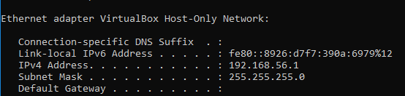

Once all the boxes are ready, you can login to those boxes by running "vagrant ssh" from respective directory/folder.

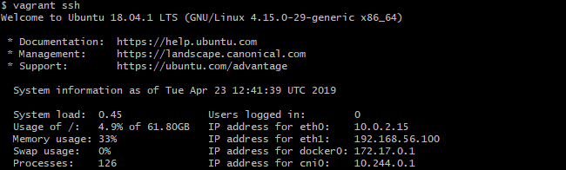

Run on only on Master:

sudo kubeadm init --pod-network-cidr=10.244.0.0/16 --apiserver-advertise-address=192.168.56.100 (as vagrant user).

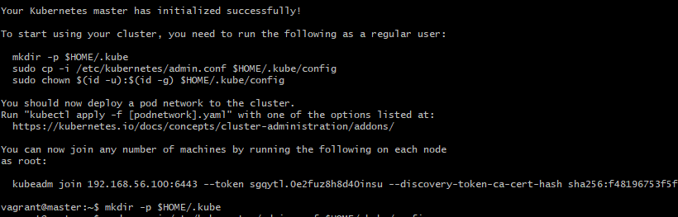

you will get the following output from above command:

Your Kubernetes master has initialized successfully!

**To start using your cluster, you need to run the following as a regular user:**

**mkdir -p $HOME/.kube**

**sudo cp -i /etc/kubernetes/admin.conf $HOME/.kube/config**

**sudo chown $(id -u):$(id -g) $HOME/.kube/config**

You should now deploy a pod network to the cluster.

Run "kubectl apply -f [podnetwork].yaml" with one of the options listed at:

<https://kubernetes.io/docs/concepts/cluster-administration/addons/>

**kubectl apply -f https://raw.githubusercontent.com/coreos/flannel/bc79dd1505b0c8681ece4de4c0d86c5cd2643275/Documentation/kube-flannel.yml**

**kubectl get nodes (wait for sometime, it status will become ready)**



You can now join any number of machines by running the following on each node(worker1 and worker2)

sudo kubeadm join 192.168.56.100:6443 --token sgqytl.0e2fuz8h8d40insu --discovery-token-ca-cert-hash sha256:f48196753dfdfddd



Run again **kubectl get nodes (wait for sometime, it status will become ready)**

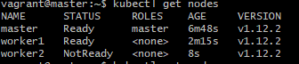

Congratulation! You have successfully setup the Kubernetes cluster. You can verify by running kubectl get nodes on master

We will deploy a apache pod and access it with service which exposed to Nodeport 30080:

cd /vagrant/apache on master instance, the apache directory containing

**deployment.yaml service.yaml**

create deployment by running

**kubectl create -f deployment.yaml**

**kubectl create -f service.yaml**

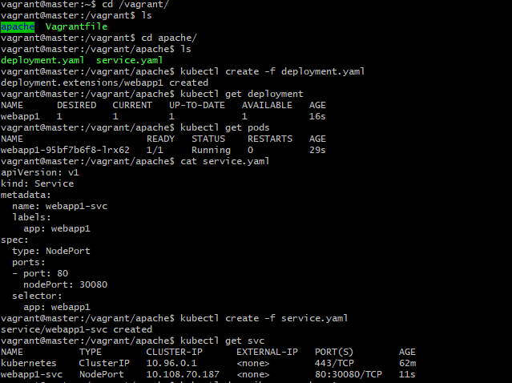

You can access the apache using one of nodeips such http://192.168.56.101:30080

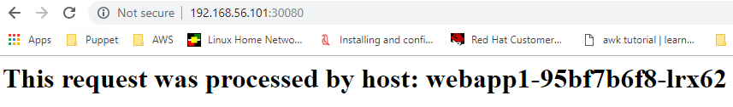

This completes the setup up kubernetes cluster setup and deployment of apache.